Bugs:

Many of the bugs in our game have been corrected but there are still a few glitches and shortcomings in our final project.

-Collision Detection: although it took us a large amount of time to finally get a functional system of collision detection, the system we have now is not perfect. The collisions are based off of rectangles but the majority of our objects are not rectangular. This means you can sometimes go through parts of objects that are blocked before you actually are touching the visual object. Also, diagonals do not work well with the system; when more than one directional key is being used at once, you are able to pass through an object. If you let go of the buttons you are pushed out of the object, because the game still recognizes you are not where you are supposed to be.

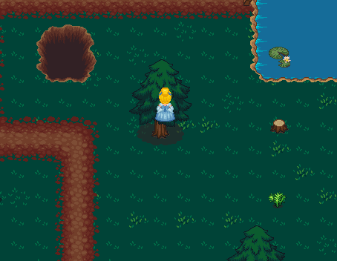

Silly Cinderella get out of the tree