# CS 255 System Design Document Template

**Aashish Shenoy**

## UML Diagrams

### UML Use Case Diagram

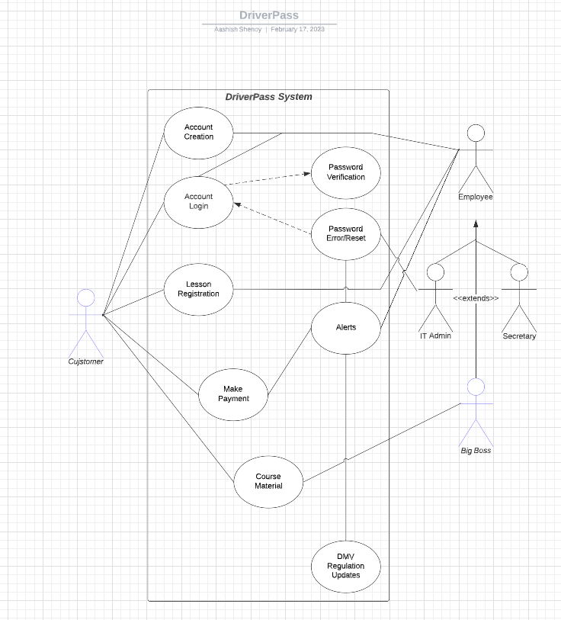

### UML Activity Diagrams

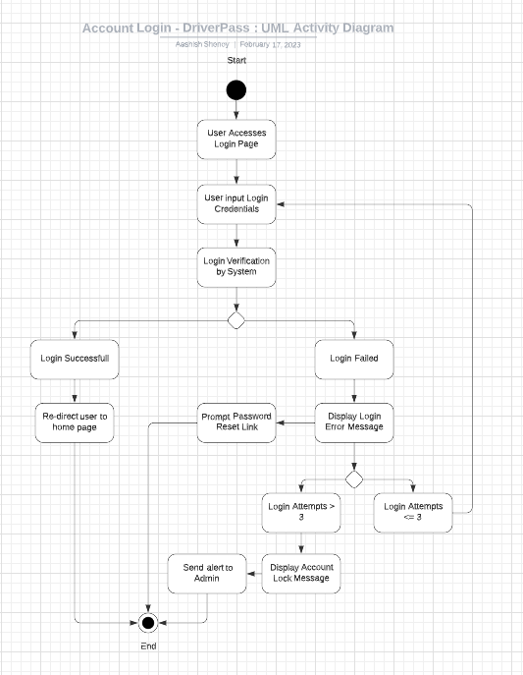

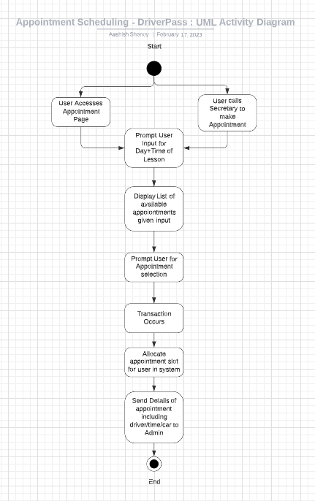

### UML Sequence Diagram

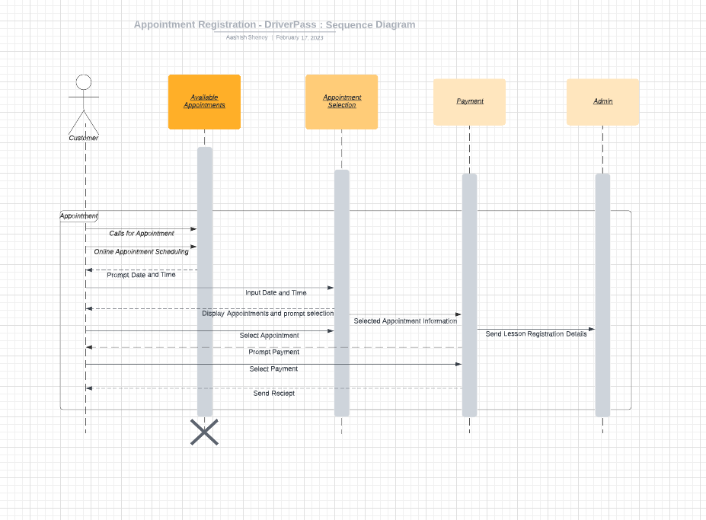

### UML Class Diagram

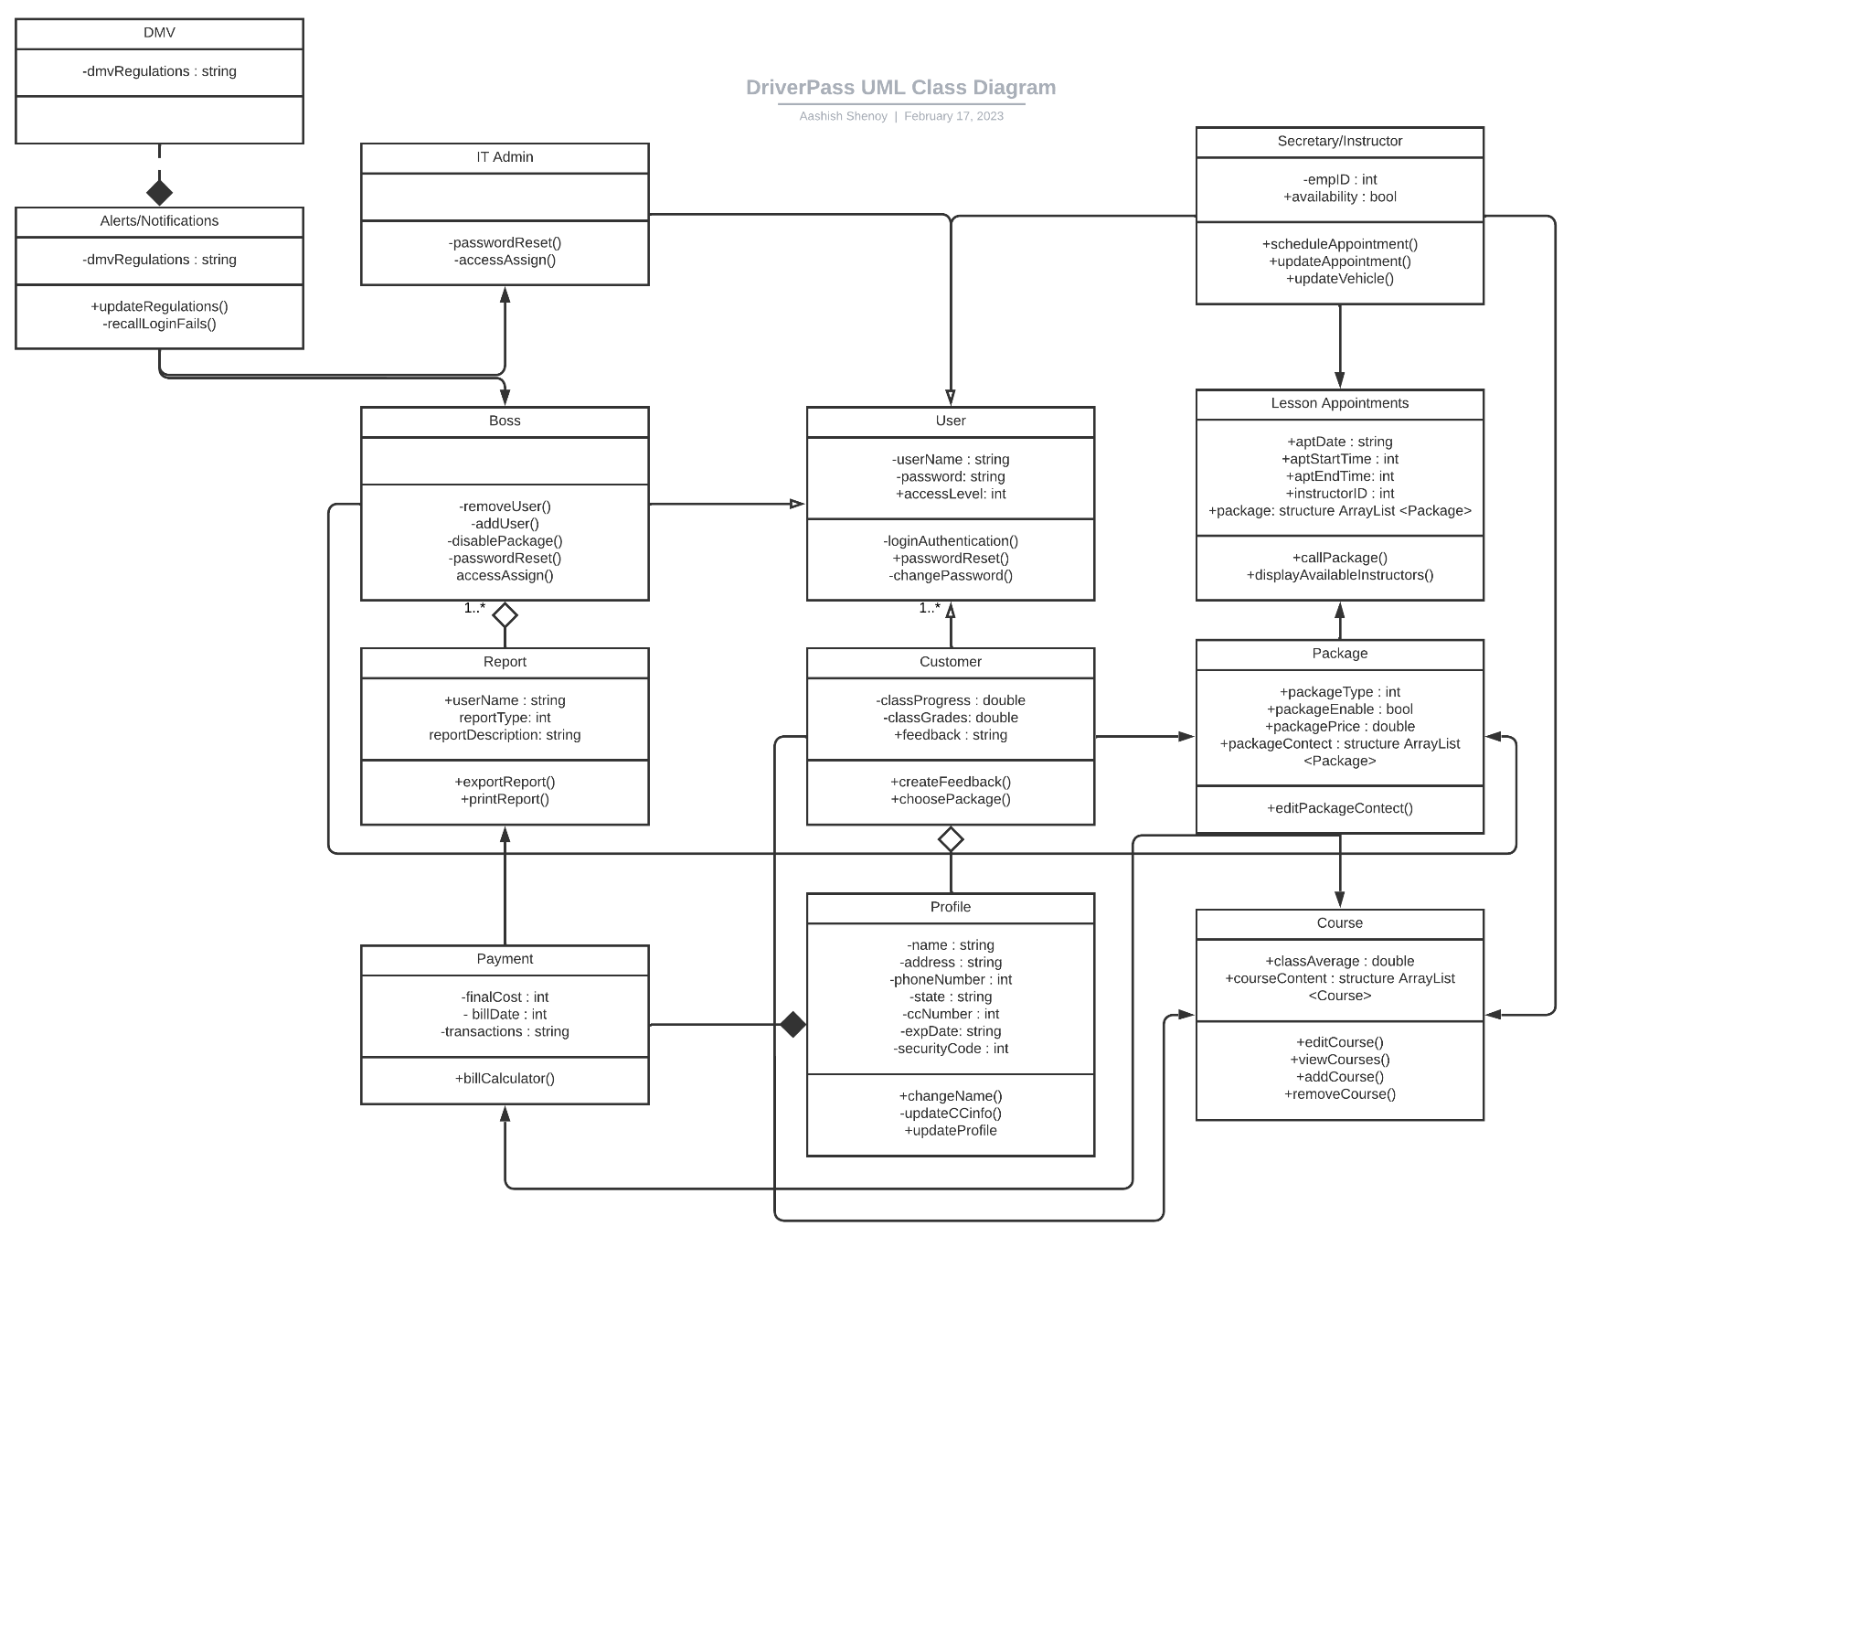

## Technical Requirements

* *Desktop computers, laptops, or tablets with accessories as needed.*
* *Operating system with a browser capable of accessing the internet.*
* *A database for storing student and lesson data.*
* *Cloud infrastructure or local servers to support software and data storage needs.*
* *Internet connectivity for cloud-based systems and remote access.*
* *Networking and security protocols to ensure the safety and privacy of student data.*
* *Backup and disaster recovery procedures to prevent data loss in case of system failure or cyber-attack.*
* *Payment Processing System.*