Statistical Data Mining

Home work 2

Ashwin Vijayakumar

Person number : 50249042
Class number : 03

Q1 ) To predict the number of applications received by fitting the various regression models .

a) Splitting the data into test and training is done using a random seed value on a sampling function .

set.seed(12345)
smp_size <- floor(0.80 * nrow(College))
train_ind <- sample(seq_len(nrow(College)), size = smp_size)
train_set <- College[train_ind, ]
test_set <- College[-train_ind, ]

The test error obtained using simple linear regression is : 1237730

b) To fit the ridge regression model , we choose the minum lambda obtained by performing the cross validation using the “cv” function .

cv.ridge = cv.glmnet( X , Y , alpha = 0)
best.lambdaridge <- cv.ridge$lambda.min # Best lambda is the minimum lambda
plot(cv.ridge)
ridge.pred <- predict(ridge.mod , s=best.lambdaridge , type= "coefficients")
ridge.pred2 <- predict(ridge.mod, s = best.lambdaridge , newx = Xnew , type = "response")
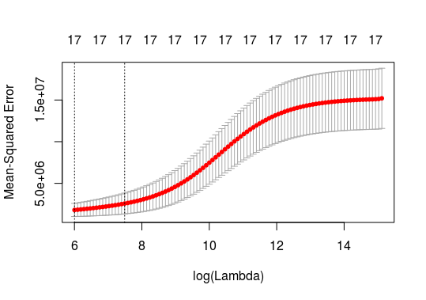

The test error obtained is : 1246508

c)We fit the lasso model similarly , but by passing alpha =1 .

lasso.mod <- glmnet (X , Y , alpha = 1)
##Lasso Regression after cross validation

cv.lasso = cv.glmnet(X , Y , alpha = 1)
best.lambdalasso <- cv.lasso$lambda.min # Best lambda is the minimum lambda
plot(cv.lasso)
lasso.pred <- predict(lasso.mod , s=best.lambdalasso , type= "coefficients")
lasso.pred2 <- predict(lasso.mod, s = best.lambdalasso , newx = Xnew , type = "response")

##Lasso Regression Error Calculation
yhat.lasso <- lasso.pred2
ytrue.lasso <- test_set$Apps
test_error_lasso <- mean((yhat.lasso - ytrue.lasso)^2) #Mean Squared Error

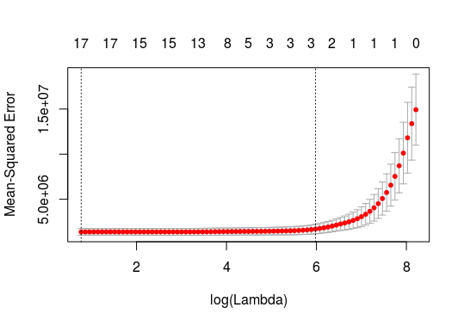

The test error obtained is : 1237472

d)We then perform the PCR using the pcr function , using parameters obtained after cross validation .

set.seed(12345)
pcr.fit = pcr( train_set$Apps ~ ., data= train_set , scale =TRUE ,validation = "CV")

We get the test error as : 1237730

e)We then perform PLS using the plsr function , using the parameters obtained after cross validation .

set.seed(12345)
pls.fit = plsr( train_set$Apps ~ ., data= train_set , scale =TRUE ,validation = "CV")

We get the test error as : 1237730

f) Based on the errors obtained , we can say that the errors are around the same for OLS , RIDGE , LASSO , PCA and PLS . Given the magnitude of the errors , prediction based on any of these models may not give accurate results .

Q2) The following question deals with predicting the number of people interested in purchasing insurance from the data set procured by the insurance company .

We extract the data set as follows :

##Creating the Data Frames
data_train <- read.delim("ticdata2000.txt" , sep = "\t" , header=FALSE)
train <- data.frame(X=data_train[,1:85] , Y=data_train[,86])
data_test <- read.delim("ticeval2000.txt" , sep = "\t" , header=FALSE )
data_target <- read.delim("tictgts2000.txt" , sep = "\t" , header=FALSE )
test <- data.frame(X=data_test[,1:85] , Y=data_target[,1] )

The OLS estimate and the errors after empoying the lasso and ridge are calculated as in Question 1 .

The Subset selection ( Forward and Backwards ) is performed using the following functions .

regfit.fwd <- regsubsets(train$Y~., data = train, nvmax = 85, method = "forward")
regfit.bwd <- regsubsets(train$Y~., data = train, nvmax = 85, method = "backward")

We study the influence of the various criterea ( BIC , RSS , Adj R2 and Cp) for both , the forward subset selection and backward subset selection models .

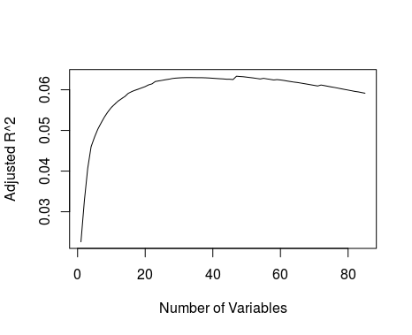
Forward :
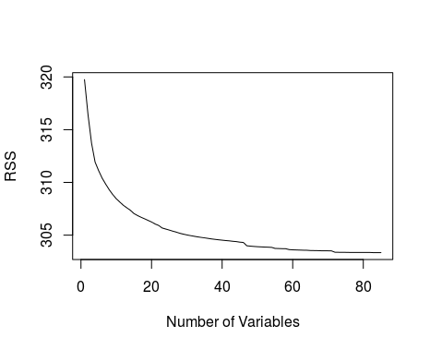

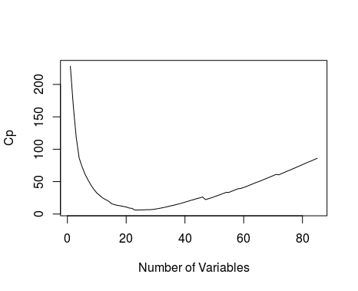
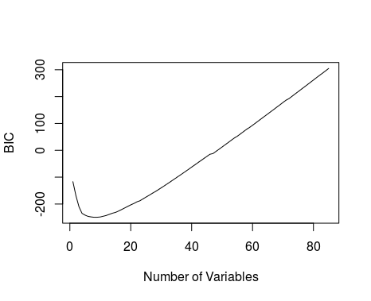

We can assume the best tradeoff is made when we select the subset of size : 20

Backward :
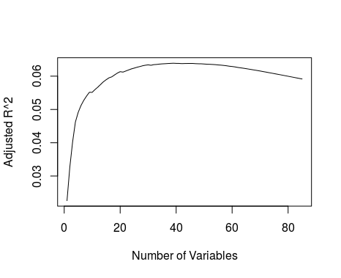
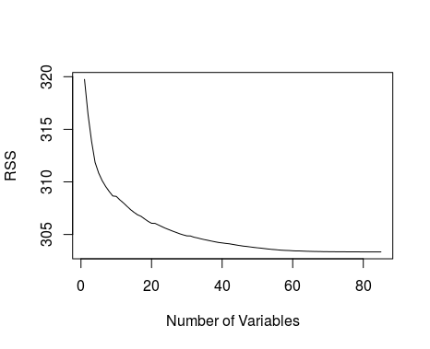

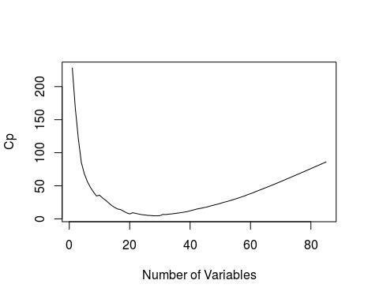
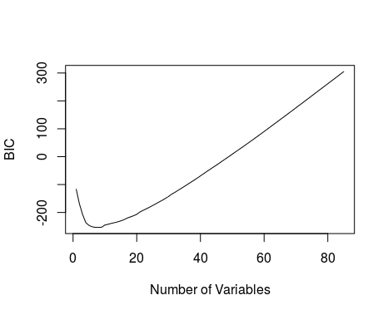

We can assume the best tradeoff is made when we select the subset of size : 20

Minimum_Error_fwd = min(my_sum_fwd$adjr2)
Minimum_Error_bwd = min(my_sum_bwd$adjr2)

The OLS estimate is : 0.053985

The error estimate using ridge regression is : 0.05370398

The error estimate using lasso regression is : 0.05375239

The error estimate for the best model in backward subset selection is : 0.02260583

The error estimate for the best model in forward subset selection is : 0.02260583

The error estimates using the subset selection method produce better results than the LASSO/RIDGE/OLS methods . To predict the number of insurance takers based on the 85 predictors , its best to perform linear regression using ordinary least squares as the loss function and either backwards/forward subset selection . The predictor values closer to '1' would mean that they would be interested and values closer to '0' mean they most probably would not .

Q3) In this problem , we try to simulate a case where the test error may not decrease upon increasing the number of features , unlike the case of training . To do this ,we first create a data set with 20 predictors and 1000 samples . Then we randomize the choice of zero's in the matrix .

##Generating a 1000 * 20 matrix from
X = replicate(20, rnorm(1000))

##GEnerating Error values
E = replicate(1, rnorm(1000))

##Generating Weight vector with zeroes
set.seed(333)
B = replicate(1, rnorm(20))
for(i in 1:20) {
if(i %in% sample(1:20 , 7)) {
B[i,1] = 0
}
}
B

## Generating Random Response

Y = X %*% B + E

We now divide this set into training and test .

##Division into Test and Training Sets
set.seed(12345)
train_ind <- sample(seq_len(1000), size = 100)
Z <- cbind(X,Y)
train_set <- Z[train_ind, ]
test_set <- Z[-train_ind, ]

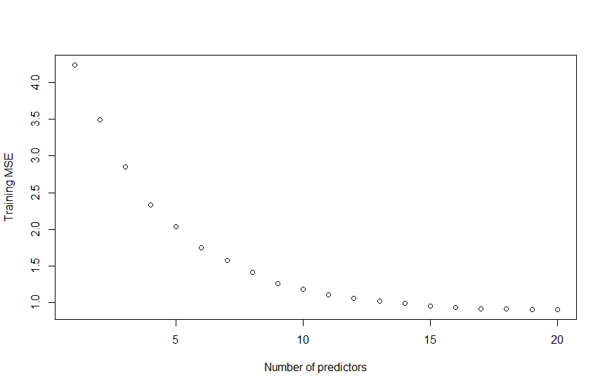

For the training data set , the least error is achieved when the number of predictors is 20 . This follows our initial assumption that training error decreases upon increasing the number of predictors .

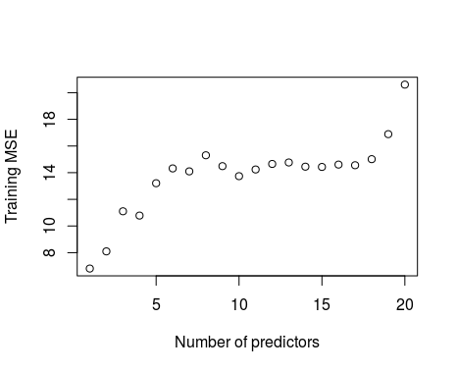

The model takes on the least error (in the test set ) for one predictor . Also the test error for number of predictors = 20 is high . The training error is minimum for 20 predictors whereas for the test data set , it is pretty high .

Its clear from above that the test error does not reduce consistently upon increasing the number of predictors , unlike the training data .

