**STOCK MAINTENANCE SYSTEM**

**PROBLEM STATEMENT:**

The Stock Maintenance system maintains the records of the stocks purchased and sold by a company. It also takes care of the product/item price, stock availability information, stock to be purchased , the date or time it is being brought or delivered and the transaction details.

Earlier stock maintenance was done manually. Considering the fact that the number of customers for purchase is increasing every year, a maintenance system is essential to meet the demand. So this system uses several programming and database techniques to elucidate the work involved in this process.

It also gives idea about the faults in the purchased product and the products that are to be replaced also been given. It helps customers to access information about the stock and retrieves the information.

**SOFTWARE REQUIREMENT SPECIFICATIONS:**

1. **INTRODUCTION:**

Stock maintenance system acts as an interface between the ‘customers’ and ‘sales person’. It aims at improving the efficiency in maintaining the stocks.

**PURPOSE:**

The entire process of stock maintenance was a cumbersome task .Every new detail was supposed to be manually fed. With increase in number of customers/suppliers, it would become more difficult. Hence a stock maintenance system was important wherein information and database could be managed easily.

**SCOPE:**

* The System provides an interface to the customer to fill in details about the products required.
* To decrease the efforts of people maintaining stock details of any company.
* The sales person is concerned with the issue of items and can use this system.
* Provide a communication platform between the customer and the sales person.

**DEFINITIONS, ACRONYMS AND SYNONYMS:**

* **HTML**

Hyper Text Markup Language- Markup Language used for creating web pages.

* **J2EE**

Java 2 Enterprise Edition is a programming platform java platform for developing and running distributed java applications.

* **HTTP**

Hyper Text Transfer Protocol- Protocol used by the World Wide Web that defines how messages are formatted and transmitted, and what actions Web servers and browsers should take in response to various commands

1. **OVERALL DESCRIPTION:**

* **PRODUCT PERSPECTIVE:**

The Stock Maintenance system acts as an interface between the ‘customer’ and the ‘sales person’. The system tries to provide an interactive environment with strong database management technique to assure no leakage or manipulation of data.

* **User Interface :**
* The Software uses GUI.
* It has fields where the customers/suppliers can enter their personal/professional information like name , login id , address etc.
* It has buttons to ‘login’ , ‘register’ , ‘edit information’ , ’purchase’ , ’sell’ , ‘check details’ , ‘payment’.
* Stock details are displayed using effective layout.
* **Software Interface:**
* This software interacts with the **OS.** It is compatible with Windows 7 and higher versions, UNIX, LINUX, MAC, Ubuntu.
* **Hardware Interface:**
* This software uses ***basic input/output peripherals*** (keyboard/mouse/touchscreen/joystick).
* It also uses the***Internet***.
* This software interacts with the ***Printer*** if the user intends to print bills/stock details.
* This software interacts with the***Scanner*** if the user intends to scan the documents as specified by the corresponding company.
* **Product functions**
* Registration
* Purchasing products
* Updating stock details.
* Selling goods
* Maintaining Customer and supplier details.
* **SOFTWARE REQUIREMENTS:**

* The webpages in the software are developed using HTML, CSS, PHP and JavaScript.
* Database management is achieved using SQL
* **HARDWARE REQUIREMENTS:**
* Basic peripherals like keyboard , mouse , printer (if payslip is to be printed) , scanner (if documents are  to be scanned) are needed.
* WLAN/Internet connection is mandatory.
* **FUNCTIONAL REQUIREMENTS:**
* **Maintaining Customer Details:**
* The records of every company/person who has ever dealt with the company are maintained in a systematic order.
* Details such as the good items, the number, price and dates of ordering and delivery are clearly specified.
* The customers can log in to verify the same.
* **Buying/Purchasing Products.**
* The software provides direct options to buy or sell any product.
* Payment options available for customer may vary depending on the amount.
* **Maintaining Supplier Details.**
* Every order the company ever placed is fed in the records.
* The name of the supplier, product items, prices and dates of ordering and delivery are clearly specified.
* The suppliers can log in to verify the same.
* **Stock Details:**
* Details of every product item is maintained with a strong and networked connection between customers and suppliers.
* For the management, maintaining physical information is difficult whereas maintaining a software and database for validation and storage is really simple , efficient and reliable.
* One can easily manage stock using this.
* **Updates:**
* Whenever any deficiency in the number of stock items (or) any sudden changes in the prices is observed, the software gives quick automatic updates/information to the person dealing with it.
* **NON-FUNCTIONAL REQUIREMENTS:**

1. It has an efficient mechanism to store the database , so the entire process of maintenance is quick and easy.
2. It is reliable in operations like dealing with sensitive data.
3. Delays involved are minimal provided internet connection is good and stable.
4. It is secure and usable.
5. **USER CHARACTERISTICS:**

* **CUSTOMER MODULE**

A customer can

* Register/ Login
* Check the commodity prices
* Check for product availability
* Buy product
* Rate the products
* **SUPPLIER MODULE**

Suppliers can

* Register/login
* Sell the stock
* Check for the prices
* **MANAGEMENT MODULE**

The management can

* Check stock availability
* Look for Suppliers
* Purchase wholesale products
* Sell items
* Retain Supplier/Consumer details
* Update Stock details/prices
* **BANK MODULE**
* To pay to the suppliers
* Allowing customers to pay through cheque or directly transferring it to the company account

1. **ASSUMPTIONS:**

* System is virus and other malware free.
* The user knows the basic operations of the computer.
* The corresponding examination management supports the functionalities provided by the application.

**DESIGN DOCUMENTATION:**

**TITLE:** STOCK MAINTENANCE SYSTEM

**INTRODUCTION:**

Stock maintenance system acts as an interface between the ‘customers’ and ‘sales person’. It aims at improving the efficiency in maintaining the stocks.

This software maintains the records of the stocks purchased and sold by a company. It also takes care of the product/item price, stock availability information, stock to be purchased , the date or time it is being brought or delivered and the transaction details.

It also gives idea about the faults in the purchased product and the products that are to be replaced also been given. It helps customers to access information about the stock and retrieves the information.

**PERSON’S INVOLVED:**

* **CUSTOMER**

A customer can

* Register/ Login
* Check the commodity prices
* Check for product availability
* Buy product
* Rate the products
* **SUPPLIER**

Suppliers can

* Register/login
* Sell the stock
* Check for the prices
* **MANAGEMENT**

The management can

* Check stock availability
* Look for Suppliers
* Purchase wholesale products
* Sell items
* Retain Supplier/Consumer details
* Update Stock details/prices
* **BANK**
* To pay to the suppliers
* Allowing customers to pay through cheque or directly transferring it to the company account

**PROBLEM:**

Initially maintaining the software personnel records caused the following problems:

1. **Manually maintain all records:**

All the details of the employees are maintained manually. This type of approach costs more since they have to be placed in a safe place taking care of the possible harms.

1. **Time Consuming Search :**

Since the records are maintained manually, one has to go through all the records to find required data. As the number of employees increases, it becomes more complicated to find information.

1. **Long procedures:**

Editing and deleting information of an employee involves long procedure. The candidate must first request, submit all the required proofs and wait for the acceptance.

1. **Difficult to keep track of employee work:**

As the number of employees in most of the companies are not usually low, keeping supervision on every member’s work is difficult. It is hard to maintain records of every employee’s daily task manually.

1. **Lengthy procedure to generate pay slip:**

As mentioned above , observing every member’s work is difficult. This results in an automatic procedure delay of calculating the pay. Moreover , then every employee should be personally informed about their salary , increments and cuts ( if any ) and be given the cheque.

**EXPECTED SOLUTION:**

The above problems of maintaining the records manually can be solved using an automated software, wherein every detail is fetched in the software. The Software Personnel Management system is an Interface between Employee and the Administrator responsible for effective management of employee details.

Either the employee or the management registers with the software. Daily updates about the presence of staff, hours worked by him/her, or any development in the project are loaded. Based on the data given and criteria set, the software automatically calculates the pay.

Hence It aims at improving the efficiency in the generation of Pay slip and reduces the complexities involved in it to the maximum possible extent. It also assures time saving search to find out background of an employee and his/her contribution to the organization i.e all the information about an employee will be available within seconds.

 Therefore, It makes it easy to generate statistical data or custom data, line finding a certain set of employee.

Following are the sections where this management system helped in improvement:

1. **Easily Editable Data:**

The software provides the functionality for employees to edit their personal Information without having to go through the procedural hinderence. All the required proofs can be scanned and attached to the file for easy validation.

1. **Time Saving Search:**

One doesn't need to go through all the records to find the required data. Only the name of candidate and related details must be provided to search for the record.

1. **Transparency:**

Employees can get all the relevant data of the company within seconds without having to go to the company office and requesting for seeking information. This is efficient and avoids inaccurate information.

1. **Traceable Employee Work:**

The manager can easily verify the work done by each individual employee. The software doesn’t provide this feature to the employees.

1. **Automation:**

Software personnel management system allows employees to record time card electronically and automatically generates pay slips based on number of hours worked and total amount of sales.

**TABLE:**

|  |  |  |
| --- | --- | --- |
| TASK | STARTING DATE | COMPLETION  DATE |
| Developing the home page with all the desired options | Jan 11,2019 | Jan 12,2019 |
| Developing a login/registration page for customers/suppliers | Jan 13, 2019 | Jan 15,2019 |
| Adding additional Registration fields for the manager | Jan 16,2019 | Jan 16,2019 |
| Designing a stock detail page | Jan 17,2019 | Jan 18,2019 |
| Designing an interactive page for customers to buy products | Jan 19,2019 | Jan 20,2019 |
| Writing code for categorizing and sorting Stock | Jan 21,2019 | Jan 24,2019 |
| Pictorial representation of information | Jan 24,2019 | Jan 26,2019 |
| Linking code with  the webpages | Jan 27,2019 | Jan 28,2019 |
| Providing temporary dataset | Jan 29,2019 | Jan 29,2019 |
| Testing and Improvements | Jan 29,2019 | Feb 2,2019 |
| Handing over the software to the company | Feb 3,2019 | - |
| Updating | Whenever required | - |

**TOOLS USED:**

* Rational rose

**DIAGRAMS:**

**1)USECASE DIAGRAM:**

* In the Unified Modeling Language (UML), a use case diagram can summarize the details of your system's users (also known as actors) and their interactions with the system.
* An effective use case diagram represents

scenarios in which your system or application interacts with people, organizations, or external systems.

* Basic notations used in use case diagram:
* **Actors:** The users that interact with a system. An actor can be a person, an organization, or an outside system that interacts with your application or system. They must be external objects that produce or consume data.
* **System:** A specific sequence of actions and interactions between actors and the system. A system may also be referred to as a scenario.
* **Use Case** : They represent the system's functions.

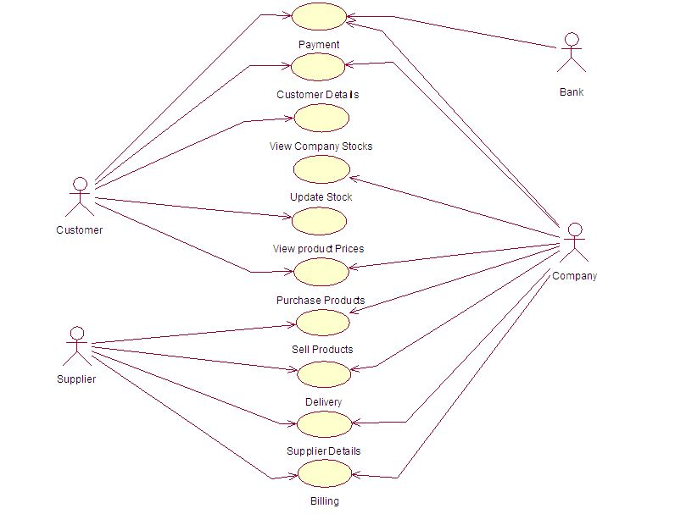

**2)CLASS DIAGRAM:**

* A class diagram in the Unified Modeling Language (UML) is a type of static structure diagram that describes the structure of a system by showing the system's classes, their attributes, operations (or methods), and the relationships among objects.
* A UML class diagram is made up of:
  + A set of classes and
  + A set of relationships between classes
* A class notation consists of three parts:
  + Class Name: The name of the class appears in the first partition.
  + Class Attributes: Attributes are shown in the second partition and map onto member variables (data members) in code.
  + Class Operations (Methods): Operations are shown in the third partition. They are services the class provides and map onto class methods in code
  + Class Relationships: A class may be involved in one or more relationships with other classes.

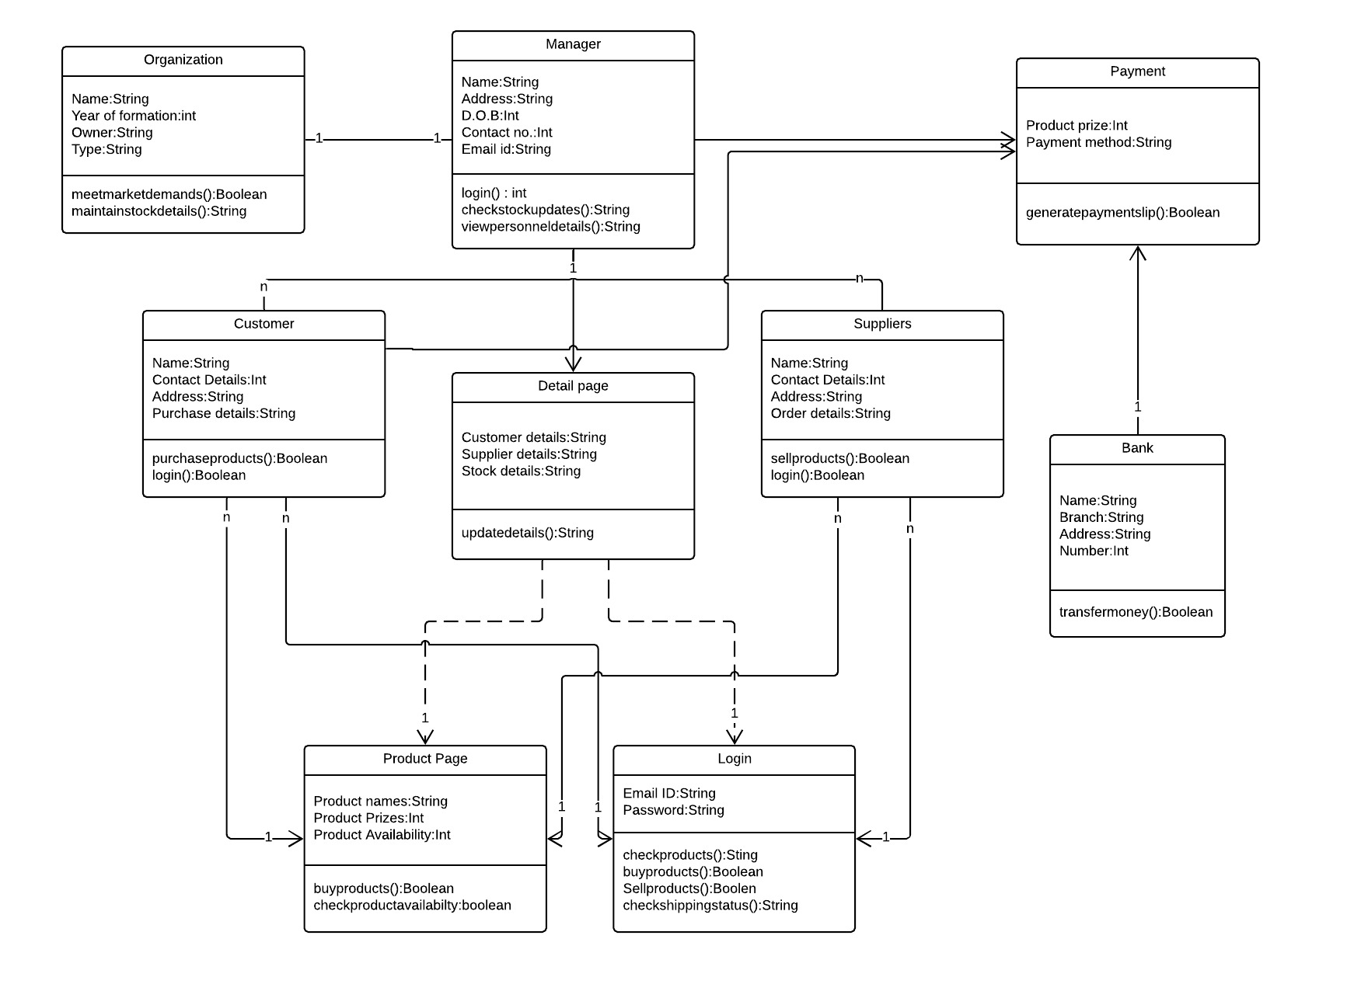

**3)SEQUENCE DIAGRAM**

Sequence Diagrams are interaction diagrams that detail how operations are carried out. They capture the interaction between objects in the context of a collaboration. Sequence Diagrams are time focus and they show the order of the interaction visually by using the vertical axis of the diagram to represent time what messages are sent and when.

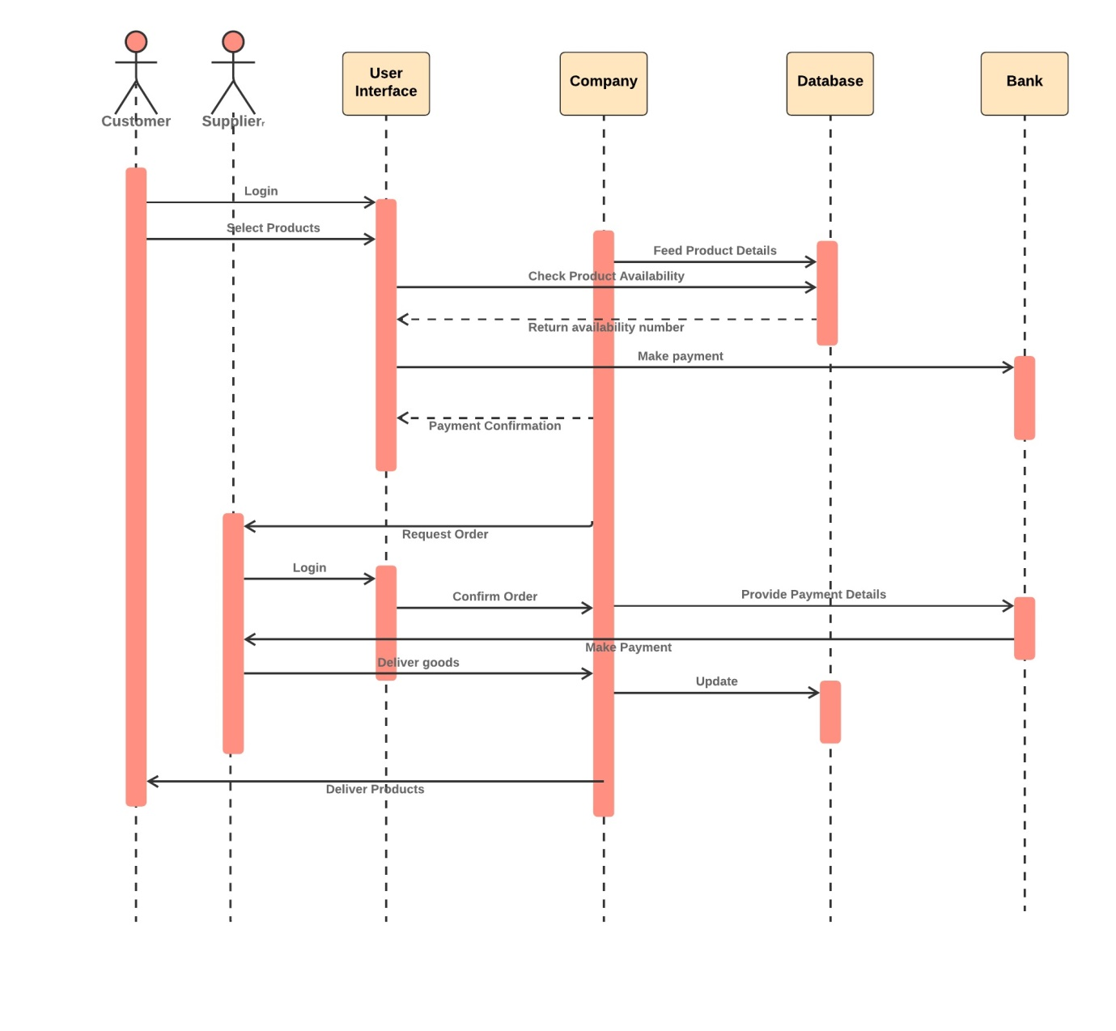

**4)COLLABORATION DIAGRAM**

A collaboration diagram, also called a communication diagram or interaction diagram, is an illustration of the relationships and interactions among [software](https://searchmicroservices.techtarget.com/definition/software) [object](https://searchmicroservices.techtarget.com/definition/object)s in the Unified Modeling Language (UML). A collaboration diagram resembles a [flowchart](https://whatis.techtarget.com/definition/flowchart) that portrays the roles, functionality and behavior of individual objects as well as the overall operation of the system in [real time](https://whatis.techtarget.com/definition/real-time). Objects are shown as rectangles with naming labels inside. These labels are preceded by colons and may be underlined. The relationships between the objects are shown as lines connecting the rectangles. The [message](https://whatis.techtarget.com/definition/message)s between objects are shown as arrows connecting the relevant rectangles along with labels that define the message sequencing.

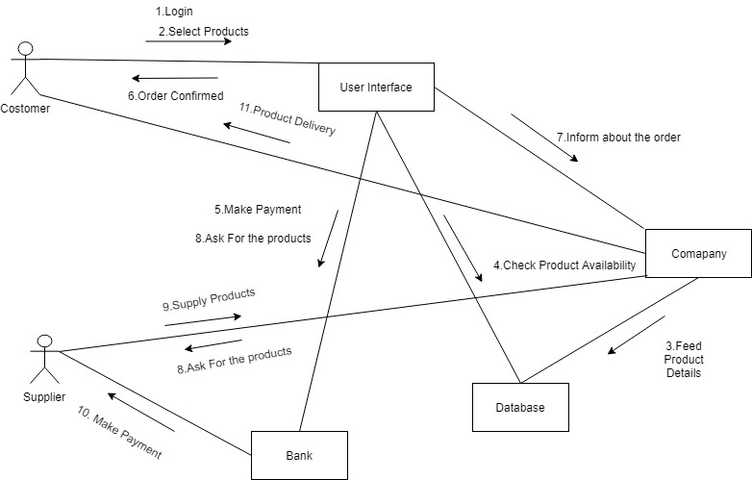

**5)ACTIVITY DIAGRAM**

Activity diagram is basically a flowchart to represent the flow from one activity to another activity. The activity can be described as an operation of the system. The control flow is drawn from one operation to another. This flow can be sequential, branched, or concurrent. Activity diagrams deal with all type of flow control by using different elements such as fork, join, etc.

The purpose of an activity diagram can be described as −

* Draw the activity flow of a system.
* Describe the sequence from one activity to another.
* Describe the parallel, branched and concurrent flow of the system.

Before drawing an activity diagram, we should identify the following elements

* Activities
* Association
* Conditions
* Constraints

Once the above-mentioned parameters are identified, we need to make a mental layout of the entire flow. This mental layout is then transformed into an activity diagram.

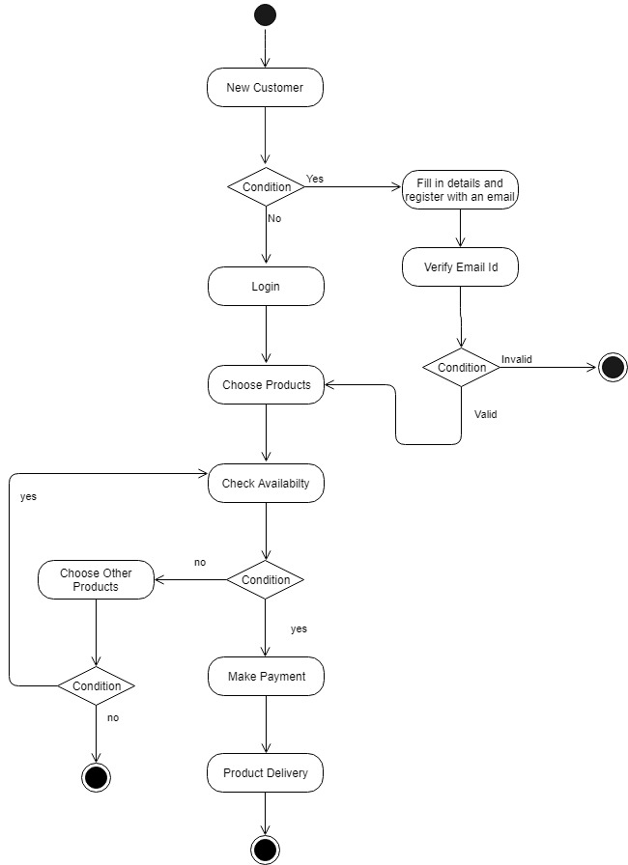

**6)COMPONENT DIAGRAM**

Component diagrams are different in terms of nature and behavior. They are used to model the physical aspects of a system. Physical aspects are the elements such as executables, libraries, files, documents, etc. which reside in a node.

Component diagrams are used to visualize the organization and relationships among components in a system. These diagrams are also used to make executable systems.

Their purpose can be summarized as −

* Visualize the components of a system.
* Construct executables by using forward and reverse engineering.
* Describe the organization and relationships of the components.

**7)DEPLOYMENT DIAGRAM**

A deployment diagram is a UML diagram type that shows the execution architecture of a system, including nodes such as hardware or software execution environments, and the middleware connecting them. They are typically used to visualize the physical hardware and software of a system. Using it you can understand how the system will be physically deployed on the hardware.

Deployment diagrams help model the hardware topology of a system compared to other UML diagram types which mostly outline the logical components of a system.

