1. **BitBucket Server Installation and Configuration**

**Step 1: Download the installer**

Download the installer for your operating system. ([www.atlassian.com/software/bitbucket/download](https://www.atlassian.com/software/bitbucket/download).)

Reference: <https://confluence.atlassian.com/bitbucketserver/bitbucket-server->installation-guide-867338382.html

**Step 2: Install Bitbucket**

1. Run the installer with an administrator account.
2. Choose **install a standard instance** and then click next.
3. When prompted, choose to start and launch Bitbucket in a browser.
4. Bitbucket will open in your default browser, and you're ready to start the setup wizard.
5. The application will be available at **http://localhost:7990**.

**Step 3: Set up Bitbucket**

The Setup Wizard runs automatically when you visit Bitbucket Server in your browser the first time it's started.

1. **Connect to your database – External Database (if any)**

Select External as your database, then choose a Database Type from the dropdown menu and enter the details of your database. If you plan to use MySQL, there's an extra step... (Please refer Install guide)

1. **Add the license key**

Follow the prompts and head to [my.atlassian.com](http://my.atlassian.com/) where you can generate a trial license. Be sure to register with your business email domain to access live chat and phone calls with Bitbucket product specialists.

1. **Create your administrator account**

* Enter details for the administrator account.
* Click either **Go to Bitbucket** - to go straight to the Bitbucket Server interface, or **Integrate with JIRA -**to create your connection with an existing JIRA application.

1. **Start using Bitbucket Server**

Bitbucket Server site is accessible from a URL like this: http://<computer_name_or_IP_address>:<port>

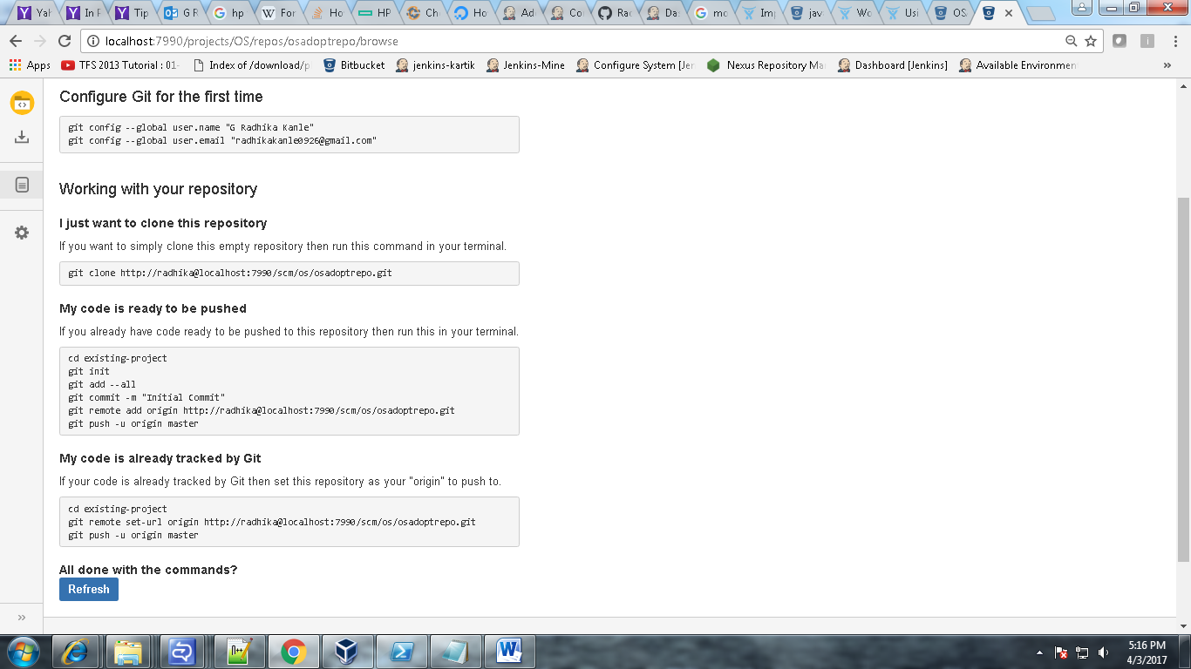

1. **Branching strategy**

**2.1 Branching types**



**Development**

This is generally the integration branch for feature work and is often the default branch (e.g. master) or a named branch such as develop. In a workflow using pull requests, this is usually the branch where new feature branches are targeted. In other cases, developers might commit directly to this branch.

### https://confluence.atlassian.com/bitbucketserver/files/776639968/776639980/2/1444173187073/icon-branch-model-feature.png Feature Feature branches are used for specific feature work or improvements. They generally branch from, and merge back into, the development branch, by means of pull requests

 **Production**

The production branch is used while deploying a release. It branches from, and merges back into, the development branch. In a Gitflow based workflow it is used to prepare for a new production release.

 **Release**

Release branches are used for release task and long-term maintenance of software versions. Typically, they branch from, and fixes are merged back into, the development branch. Merging into an older release branch allows for [automatic merging](https://confluence.atlassian.com/bitbucketserver/using-branches-in-bitbucket-server-776639968.html#UsingbranchesinBitbucketServer-automerge) to newer release branches as well as the development branch.

 **Bug fix**

Bug fix branches are typically used to fix release branches.

**2.2 Creating branches**

* Click on the repository tab
* Select the project
* Click on create branch
* Select the branch type.
* Provide the branch name.
* Click on create branch.

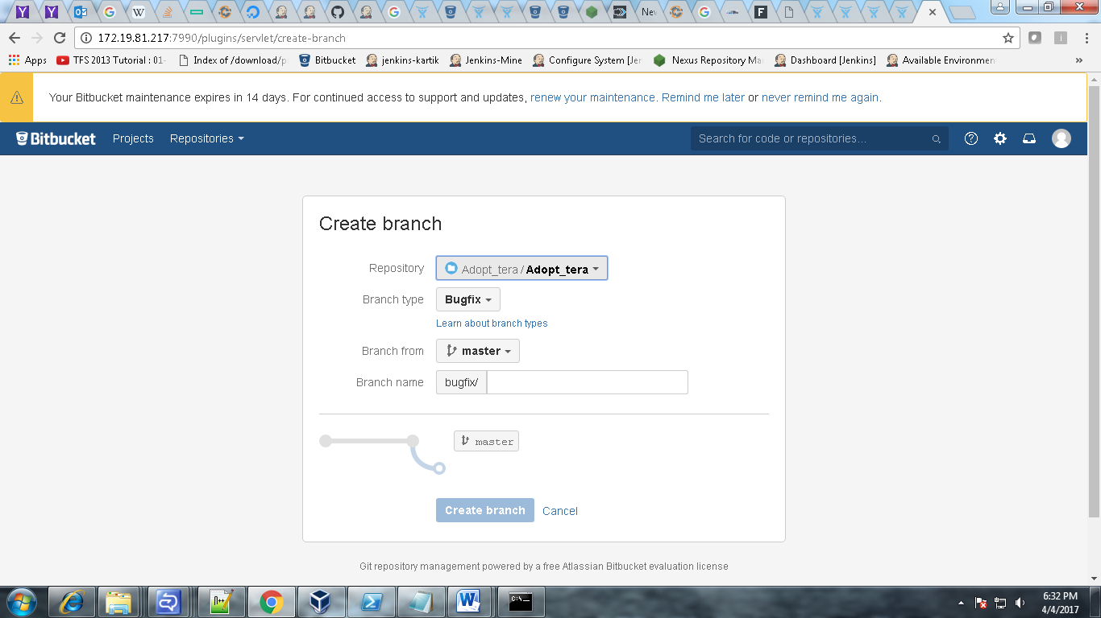

1. **Peer Review Process  
   3. 1. Create a pull request**1.Click Create pull request.  
   2. Select the branch with the changes you want to merge.  
   3. Check the destination repository and branch.  
   4. Add a title that can be easily recognized in notifications and the pull request list.

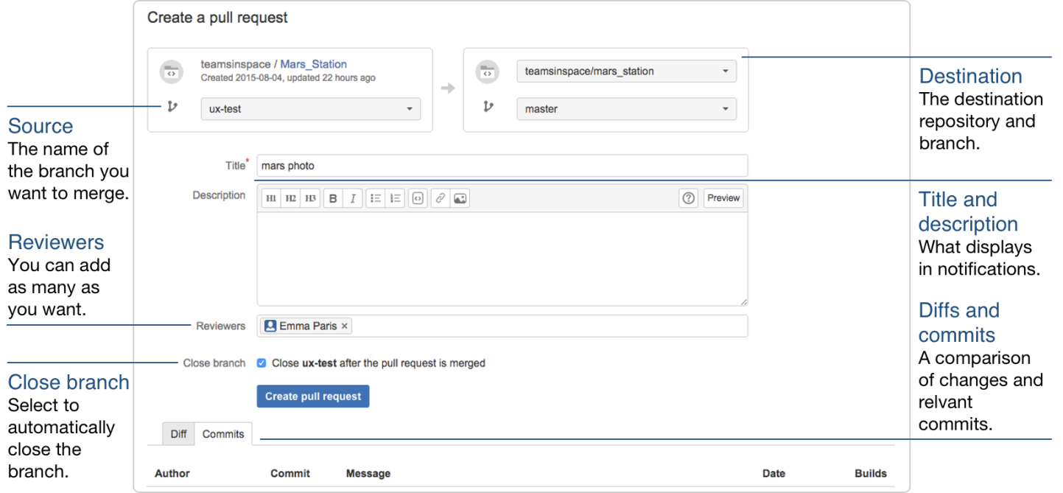

* 1. **Add reviewers to your pull request**

1. Select reviewers for this pull request to make key contributors aware of the changes and create an effective review.
2. Every reviewer can comment on the pull request and with a single click give their approval. If changes are made to the code, they can see those changes as soon as the new commit is made.
3. Additionally, the contributors you invite can decide to stop watching the pull request with a simple click.
4. Add reviewers to the pull request when you create it by entering their Bitbucket username or email address to the **Reviewers** section of the page.
5. Add reviewers to the pull request after it is in progress by clicking **Edit** button (between **Merge** and **Decline**) at the top of the request.
   1. **Check the build status on a pull request**
6. If build system runs a build when you make a commit, you can see the status of the build(s) on each commit.
7. After you create a pull request, its **Overview** tab includes the build status for all the commits on that pull request. Click the **Commits** tab to see the builds statuses separated by commits.

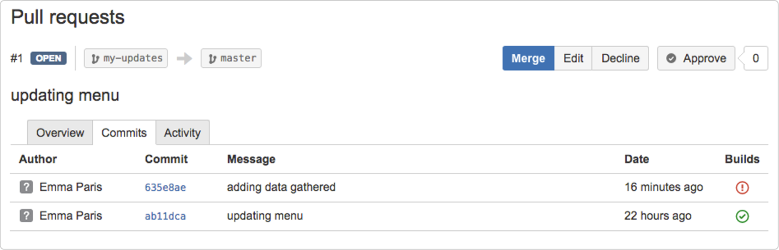

* 1. **Accept a pull request**

1. Go to your repository.  
2. Click Pull Requests in the navigation bar.  
3. A list of incoming pull requests under the open context.  
4. Click a pull request on the list.  
5. The pull request details appear and the view defaults to the Diff context.

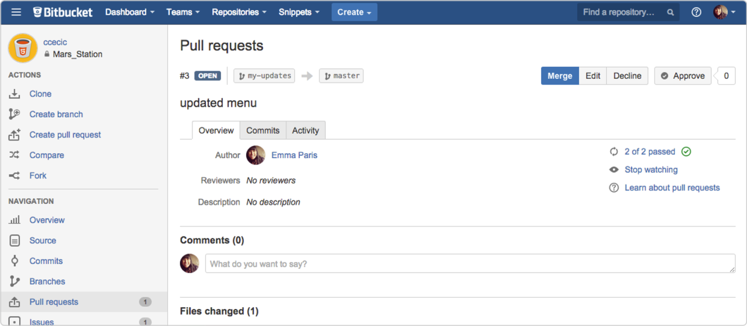

Fig 3.4.1

* 1. **Merge a Pull Request**

Merging your changes is the final stage of the pull request process.

1. Click the **Merge** button.

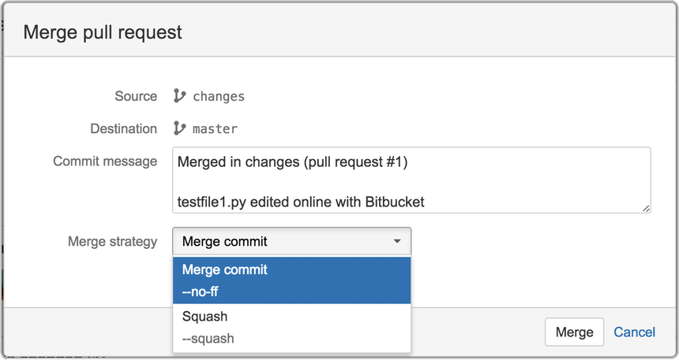

Fig 5.1.1

1. (Optional) Update the **Commit message** with more details.
2. (For Git repositories only) Select a **Merge strategy** from the two options:
   1. **Merge commit**—Keeps all commits from your source branch and makes them part of the destination branch.  
      This option is the same as entering git merge --no-ff in the command line.
   2. **Squash**—combines your commits when you merge the source branch into the destination branch.  
      This option is the same as entering git merge --squash in the command line.

For more details on these two types of merge strategies, refer to the rest of this section.

1. (Optional) If you're merging two branches in the same repository, you can select the **Close source branch** checkbox to remove the branch from the list of repository branches.
2. Click the **Merge** button.
   1. **Decline a pull request**

To decline a pull request navigate to the pull request and click the **Decline** button in the top left of the page.

To view a declined pull request:   
1. Navigate to the repository with the pull request.  
2. Click **Pull requests** in the left hand navigation.  
3. Click **Declined.**4**.** Select the declined pull request you want to view.

1. **Creating the project and moving the source code**

**4.1 Creating the project in the bitbucket**

1. Click on the project tab.  
2. Click on create project.  
3. Provide Project name, Project key.  
4. Click on create project.

* 1. **Moving the source code   
     4.2.1 Import an existing, unversioned code project into Bitbucket Server**  
     Assuming you have Git installed on your local machine, then:   
     a. Locally, change to the root directory of your existing source.  
     b. [Initialize the project](http://atlassian.com/git/tutorial/git-basics#!init) by running the following commands in the terminal:
     + - * git init
         * git add --all
         * git commit -m "Initial Commit”

1. Log into Bitbucket Server and [create a new repository](https://confluence.atlassian.com/bitbucketserver/creating-repositories-776639815.html).
2. Locate the clone URL in the nav panel on the left (for example:  https://username@your.bitbucket.domain:7999/yourproject/repo.git).
3. Push your files to the repository by running the following commands in the terminal

* git remote add origin <https://username@your.bitbucket.domain:7999/yourproject/repo.git>
* git push -u origin master

1. The repository is now available in Bitbucket Server

**4.2.2. Import code using the web interface**

We can import code and its version/branching history into Bitbucket Server from existing Git projects hosted with Bitbucket Cloud, GitHub, GitHub Enterprise, or a standalone Git repository using the web interface.

* While viewing a project within Bitbucket Server click **Import repository** in the sidebar.
* Select a source to import code from, provide the required information and then click **Connect**.
  1. **For Bitbucket Cloud**, include the Username and [App password](https://bitbucket.org/account/admin/app-passwords) for the account to import from, and ensure read access for team, project, and repository are enabled.
* Choose the repository to import.
* Click **Import**.