Task 1 -

How to transfer the files from Jenkins workspace (Windows machine) to the target sever (Linux machine) by using ssh command.

Ans-

PSCP, the PuTTY Secure Copy client, is a tool for transferring files securely between computers using an SSH connection (from Windows to Linux).

Steps :-

First Download pscp.exe file from the below link –

<http://www.chiark.greenend.org.uk/~sgtatham/putty/latest.html>

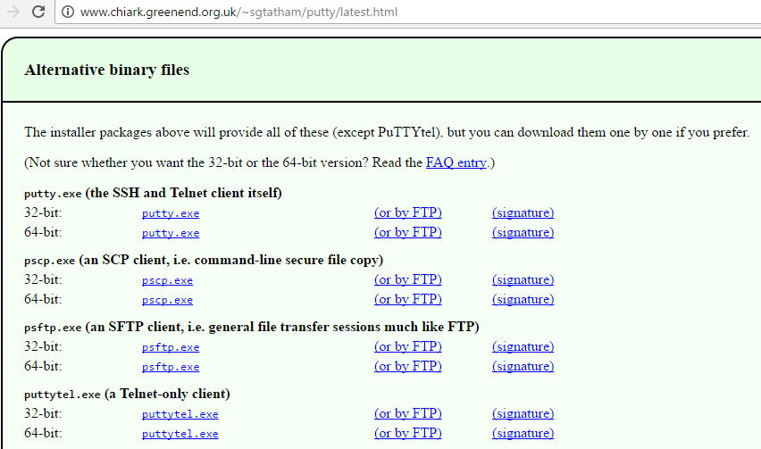

Select 🡪 pscp.exe **(an SCP client, i.e. command-line secure file copy)** 64-bit

To start PSCP it will need either to be on your PATH or in your current directory. Or To add the directory containing PSCP to your PATH environment variable, type into the console window:

set PATH=C:\path\to\putty\directory;%PATH%

2. To start PSCP I went into its PATH or in its current directory (i.e, C:\Users\AJ00453184\Downloads) through ‘Command Prompt’

you can just type pscp on its own to bring up either a usage message(if its working properly) or an error message.

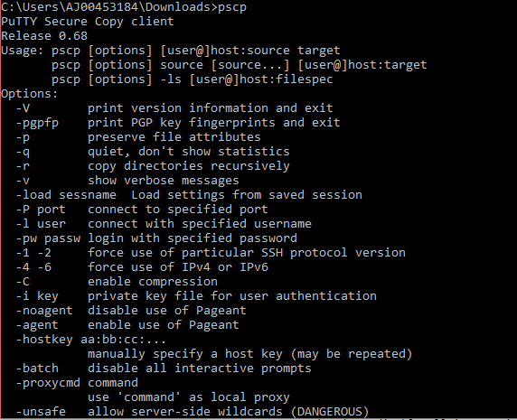

3.

**To transfer the files from Jenkins workspace (Windows machine) to the target sever (Linux machine) by using ssh command** –

Go to manage Jenkins 🡪 manage plugins 🡪 Click on ‘Available’ tab 🡪 search for SSH plugin 🡪 click on ‘Install without restart’ then check in ‘installed’ tab whether it got installed or not as below -

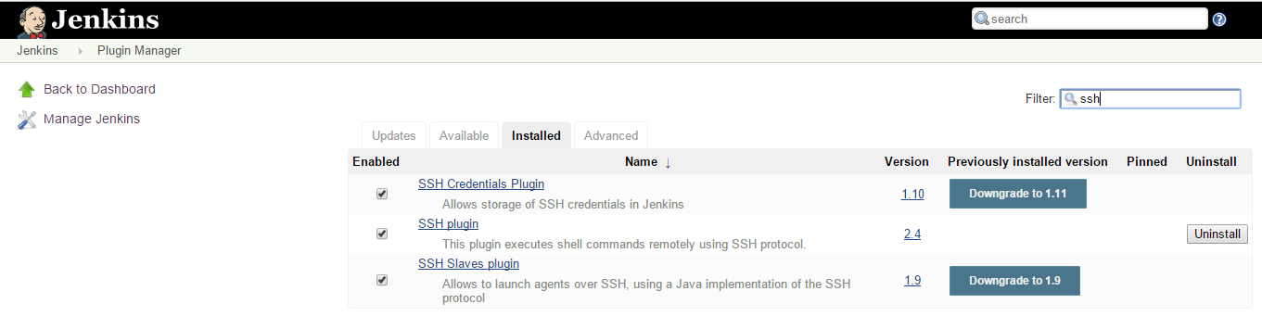

Now, we have to configure the SSH server (in our case it’s a linux server) that you want to deploy to:

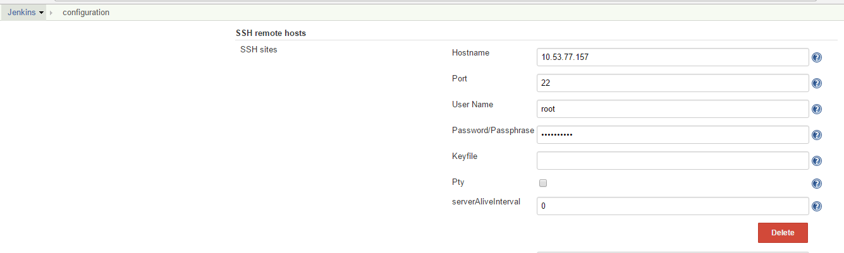

Create a ‘New_Item’ (i.e, SCP) 🡪Go to ‘configure’ 🡪Click on ‘Add Build Step’ 🡪 Select ‘Execute shell script on remote host using ssh’ as shown below and put the below command to transfer file from jenkins workspace (i.e, C:\Users\AJ00453184\.jenkins\jobs\Tera_Adopt_BUILD_PACKAGE\workspace\target\tera.war) to a directory in linux (i.e, /etc/windir) –

First, do 🡪 pushd < to the location where your pscp.exe is present >

pscp –pw <provide your linux machine password>

<source_file_path> <target_server_user>@<target_server_name>:<destination_folder_path>

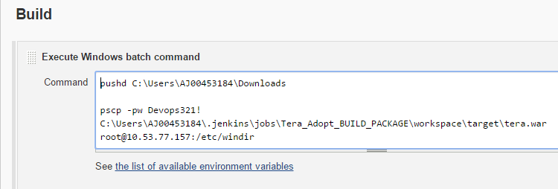

Then, do ‘Build Now’ the job – SCP 🡪 you’ll be able to see the Console Output as below –

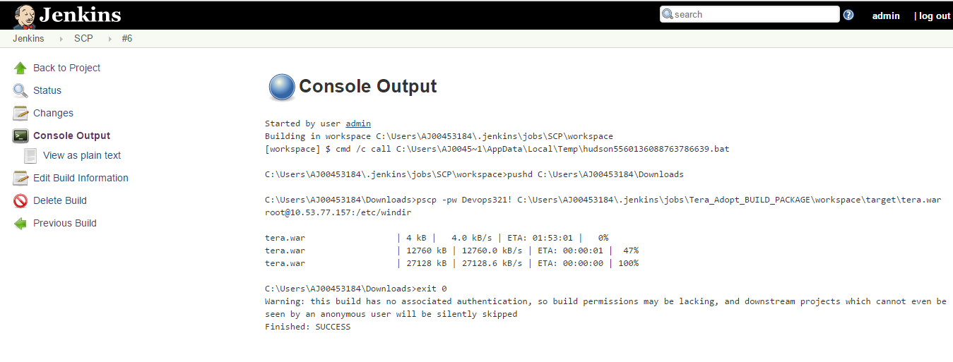

You can also check in linux machine 🡪Login to Linux Machine (using Putty) 🡪 Go to the directory (i.e, /etc/windir using linux commands) where you have put that file

Below are the linux command :-







Here you will be able to see a file named ‘Tera.war’

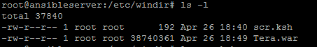

OR,

CASE-2: **To transfer the files from Jenkins workspace (Linux machine: 10.53.77.157) to the target sever (Linux machine:** **10.53.77.150) by using Ssh command**

Steps:-

First, we have to install ‘scp’ in source Linux Machine (**10.53.77.157**), you can check whether scp is installed on it by just type: - scp

You will get below screen with usage message –

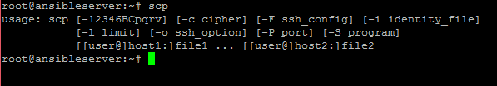

1. I have created 1 job named ‘windir’ in jenkins in linux machine (10.53.77.157)

Jenkins URL - <http://10.53.77.157:8080/>

1. In its configuration ,I have done checkout from git as below - 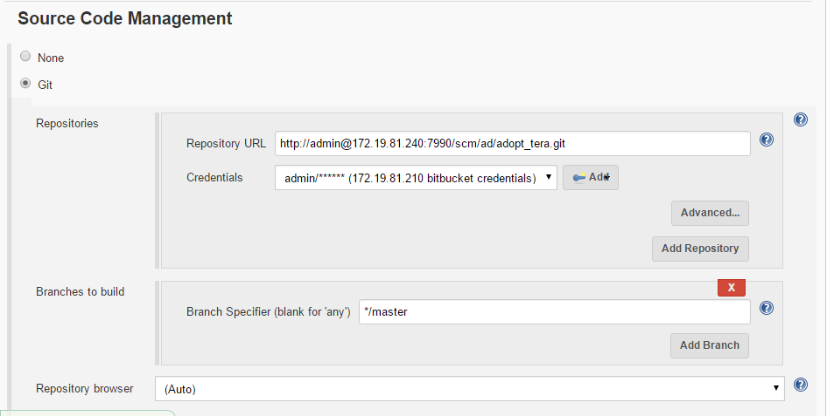

to do ‘clean package’ which in turn will create a .war file for the project checkout from git above.

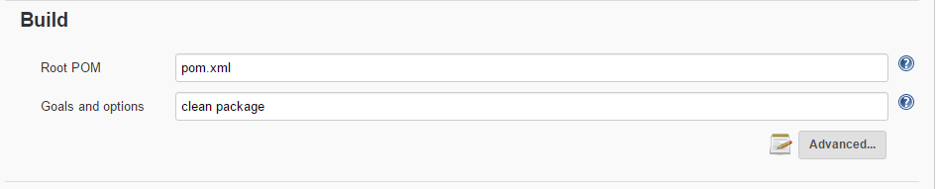

1. Now, we can be able to see ‘Tera_adopt.war’ file inside that Jenkins Job (i.e, windir) workspace as below –

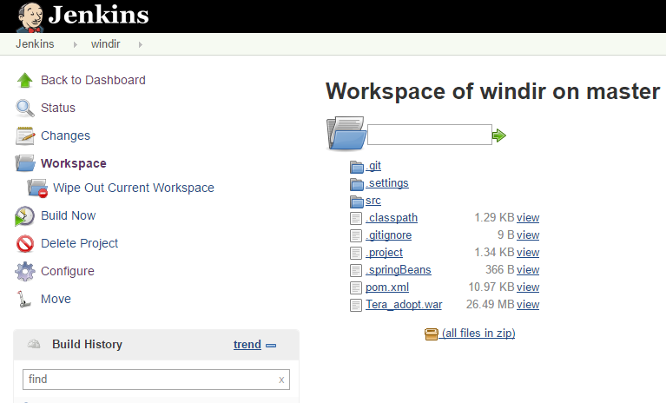

1. Then Go to same Jenkins Job ‘windir’ 🡪 configure 🡪Add Build Step ‘execute shell script on remote host using ssh’ 🡪 type the command below 🡪

NOTE :- Pushd <to the location where that windir job workspace is there, from where you will pick the .war file>

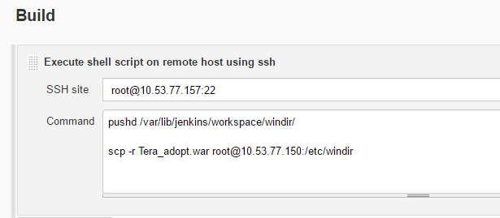

scp -r <source_file_name> <target_server_user>@<target_server_name>:<destination_folder_path>

Now, we can go to that target linux machine (10.53.77.150) 🡪 we will be able to find Tera_adopt.war .

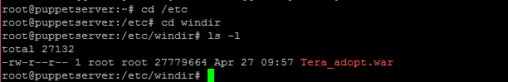

Task 2 -

How to configure Jenkins to trigger the deployment script. The deployment script is .ksh file format.

Ans-

Pre-requisite:

Ksh - should be installed (in that linux machine where you are trying to keep that .ksh file )

First, check whether ksh is installed or not. If we are getting below message means, you have to install it.

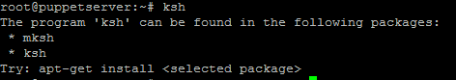

To install type – apt-get install ksh

Then it will install it as below -

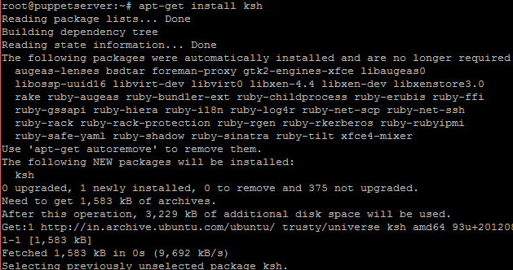

I have created a .ksh file inside which I have kept my deployment script.

I have defined my Deployment script as below – to take a war file or artifact from Nexus(i.e, http://10.53.77.155:8085/nexus/content/repositories/teravirtual [/com/devops/tera/1.0.1-BUILD-SNAPSHOT/tera-1.0.1-BUILD-20160802.130553-7.war](http://10.53.77.155:8085/nexus/service/local/repositories/teravirtual/content/com/devops/tera/1.0.1-BUILD-SNAPSHOT/tera-1.0.1-BUILD-20160802.130553-7.war)) and keep it inside a directory in Linux Machine with a name Tera.war (i.e, /etc/windir/Tera.war)

curl -L "http://10.53.77.155:8085/nexus/content/repositories/teravirtual [/com/devops/tera/1.0.1-BUILD-SNAPSHOT/tera-1.0.1-BUILD-20160802.130553-7.war](http://10.53.77.155:8085/nexus/service/local/repositories/teravirtual/content/com/devops/tera/1.0.1-BUILD-SNAPSHOT/tera-1.0.1-BUILD-20160802.130553-7.war)" -o /etc/windir/Tera.war -u admin:admin123

Jenkins job configuration to trigger that .ksh file in linux server –

Do

cd <to that directory where you want to keep that file>

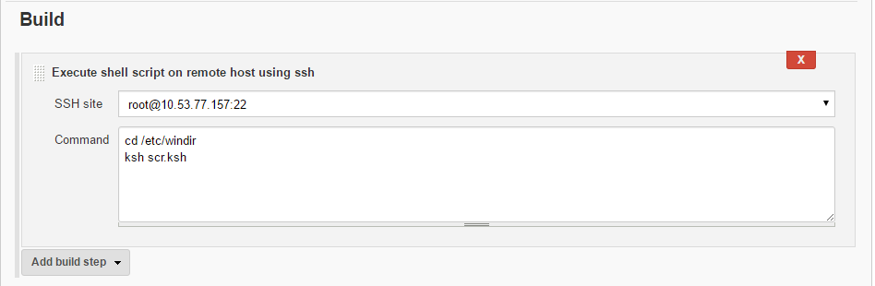

Task 3.

In Jenkins, how to pass the parameters while triggering the deployment script. While executing the deployment script, it has to pop up the text field to enter the parameters.

I have used 2 string parameters –

1. ARTIFACTPATH – a path of a particular artifact (highlighted below)in nexus apart from repository path

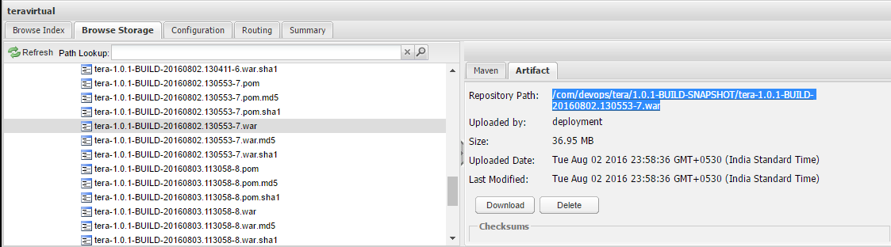

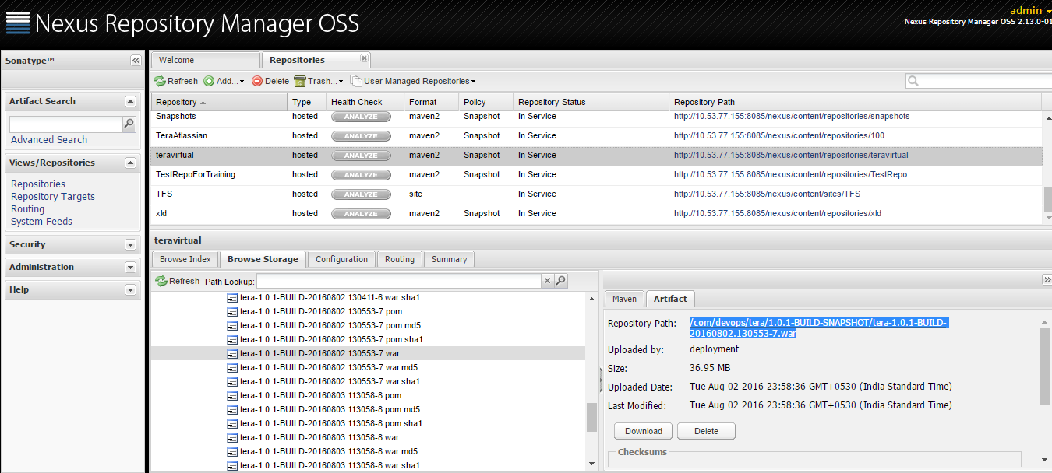

1. NEWARTIFACTNAME – the name with what you want to keep it in target linux machine.

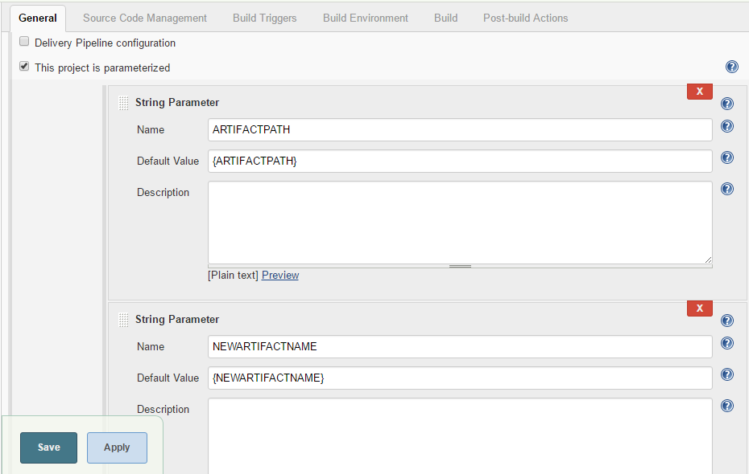

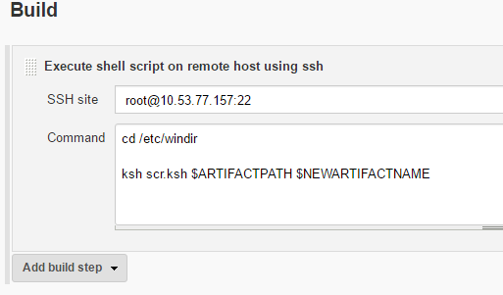

And, the .ksh file for this (with parameters) will be as below –

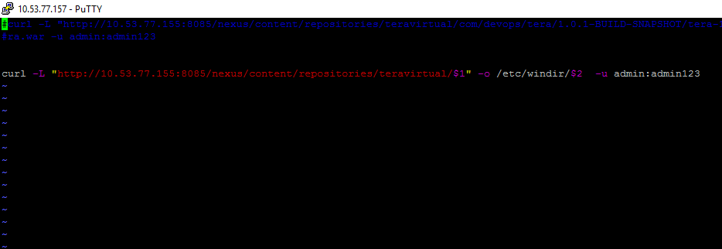

curl -L "http://10.53.77.155:8085/nexus/content/repositories/teravirtual/$1" -o /etc/windir/$2 -u admin:admin123

$1 – parameter1

$2 – parameter 2