**JENKINS**

1. **Installation and configuration**

* Download the Jenkins war from below website

[**https://jenkins.io/download/**](https://jenkins.io/download/)

* After downloading the war file run the below command in the command prompt.

**Java –jar Jenkins.war**

* Once the Jenkins is fully up and running, access the url like below,

http:<IP_ADDRESS_OF_THE_SYS>:8080

* To install Jenkins as a windows service, go to manage Jenkins click on install as windows service,

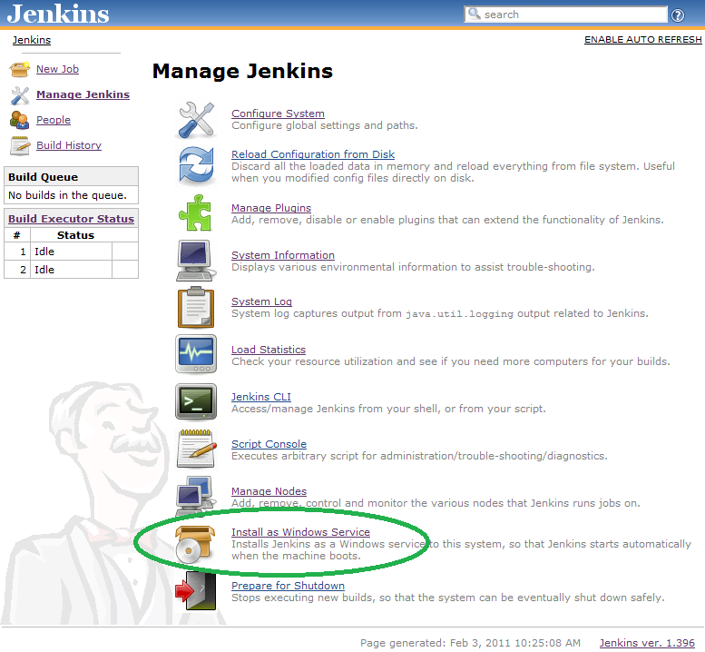

* The "Install as Windows Service" link indicated above will not appear if Jenkins is already running as a service on the machine. You can verify that Jenkins is running as a service by launching the Services app from the Windows Start Menu and looking for a running service called "jenkins" among the list of all windows services running on the machine.

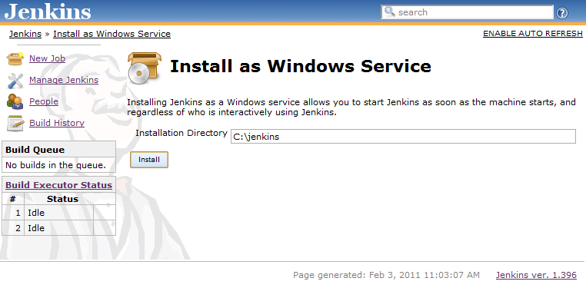

* Choose the directory where Jenkins shall be installed (directory must already exist. If not create it before hand). This will become JENKINS_HOME and used to store data files and programs alike.  
  Upon successful completion of the installation, you should see a page asking you to restart Jenkins.

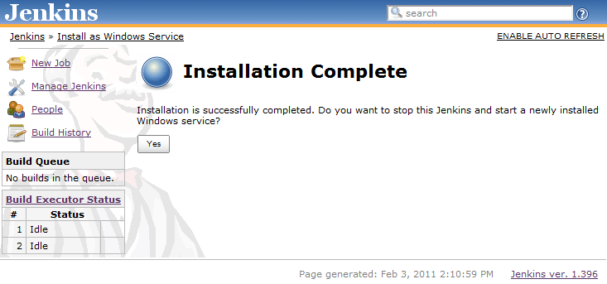

* At this point you can use the service manager to confirm that Jenkins is running as a service.

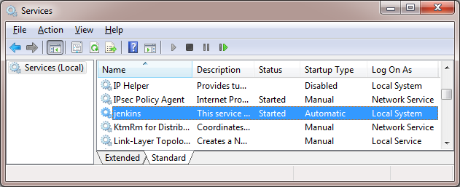

1. **Creating and configuring jobs**

* Go to [**http://localhost:8080**](http://localhost:8080/) in your browser.
* For creating a job click on New Item.

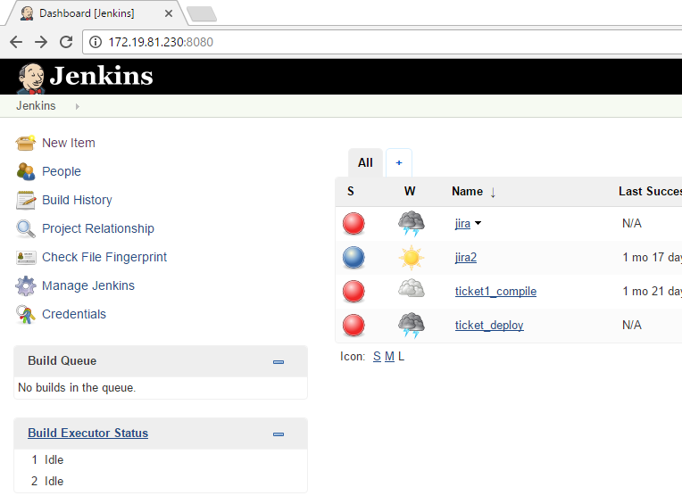

* Enter a project name and select the type of project.

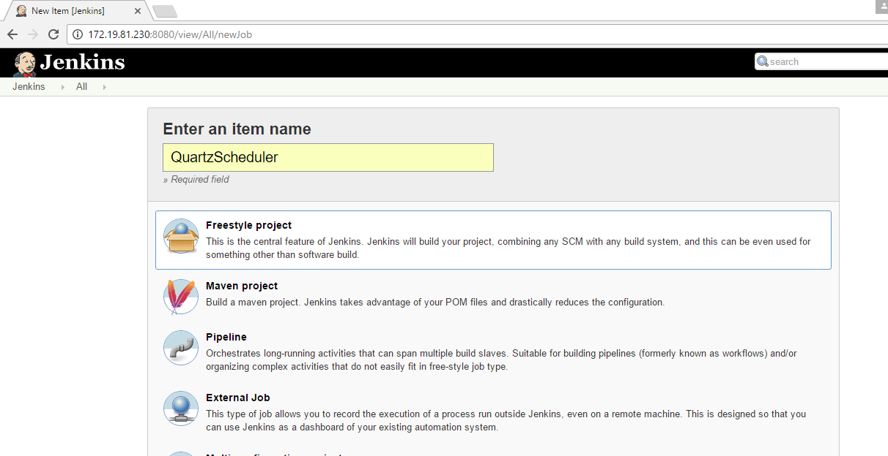

* Fill in configuration details

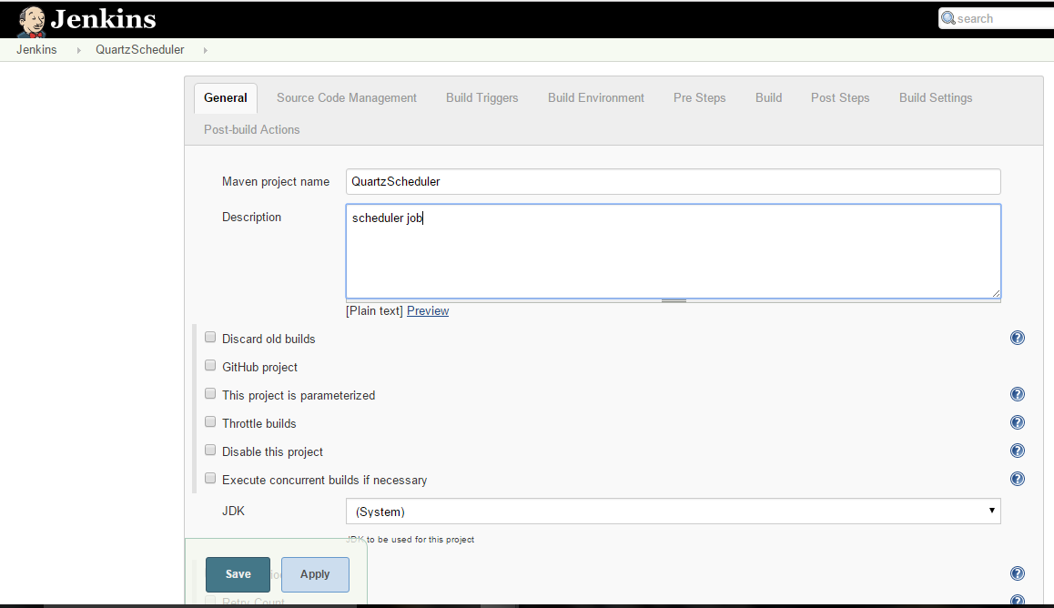

* For source code management provide the configuration details as shown and apply your configurations and save

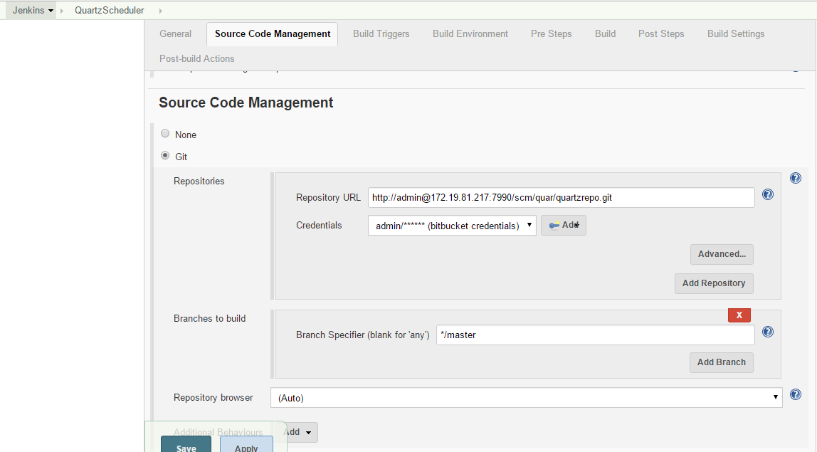

* Now build the job using the option Build now.
* You can check the build details in the build history tab

