- When utilizing the Type Text feature with multi-line code blocks, please note that formatting may become misaligned. When pasting code, reformatting may be necessary in certain cases. It is strongly recommended to review and reformat the code in a plain-text editor (such as Notepad) prior to execution.
- Use Case 02 – Build a Supply Chain Disruption Response App using SQL database in Microsoft Fabric
- Introduction
- In today's dynamic global economy, supply chain disruptions can significantly impact business operations. To address these challenges, Microsoft Fabric offers a powerful platform for building responsive, data-driven applications. This tutorial demonstrates how to leverage Microsoft Fabric's SQL capabilities to build a Supply Chain Disruption Response App. Through a series of guided exercises, users will learn to create and manage SQL databases, ingest and analyze data, and visualize insights using integrated tools like Power BI and Fabric Notebooks.
- Objective
- Create and configure a SQL database within Microsoft Fabric.
- Ingest and manipulate supply chain data using T-SQL and data pipelines.
- Perform advanced data analysis and create views for reporting and visualization.
- Utilize the SQL analytics endpoint and GraphQL API to build interactive applications.
- Develop and share insightful Power BI reports based on real-time supply chain data.
- Exercise 1 – Create a New Fabric Workspace
- The objective is to create a new Fabric workspace. By the end, participants will confidently set up, manage, and collaborate within their own Fabric workspaces.
- Task-1: Sign-In to Microsoft Fabric
- Follow these steps to start your Fabric capacity trial and become the Capacity administrator of that trial.
- Open your browser and browse the Microsoft Fabric Page https://app.fabric.microsoft.com/
- In the Microsoft Fabric window, enter your given credentials, and click on the Submit button.
- 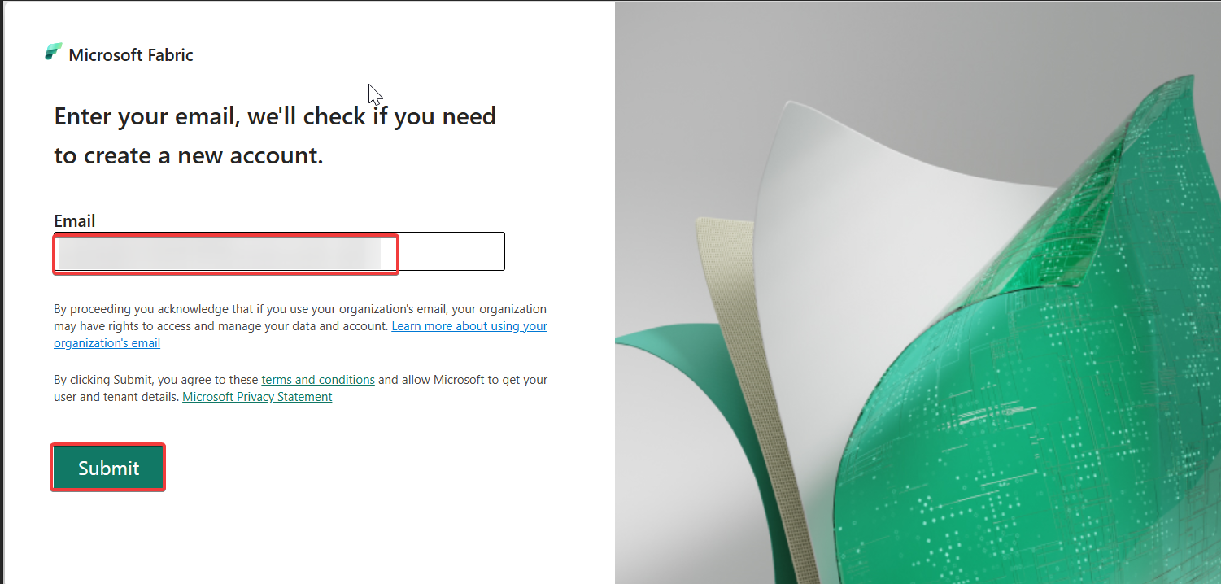
- Then, In the Microsoft window enter the password and click on the Sign in button.
- 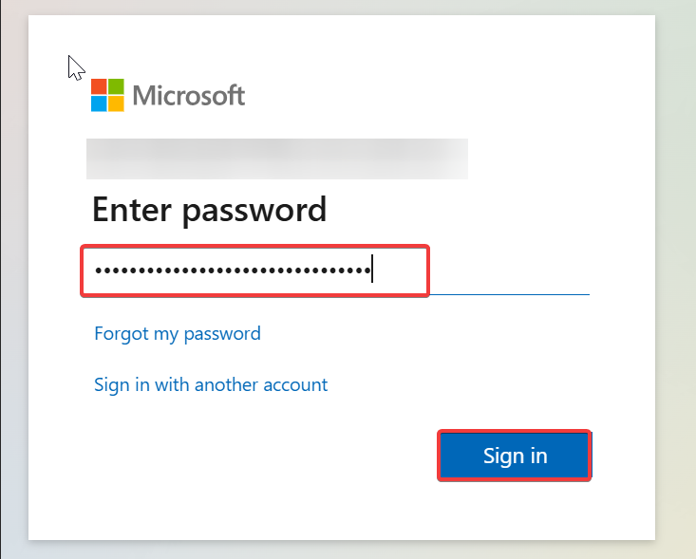
- In Stay signed in? window, click on the Yes button.
- 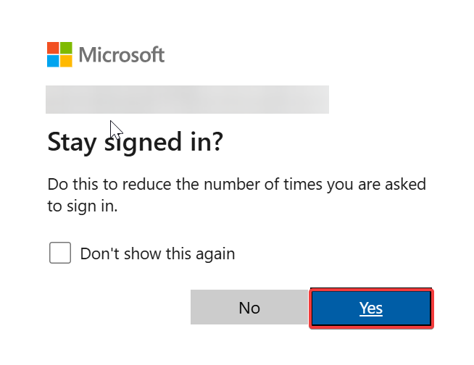
- You’ll be navigated to the Microsoft Fabric Home Page.
- 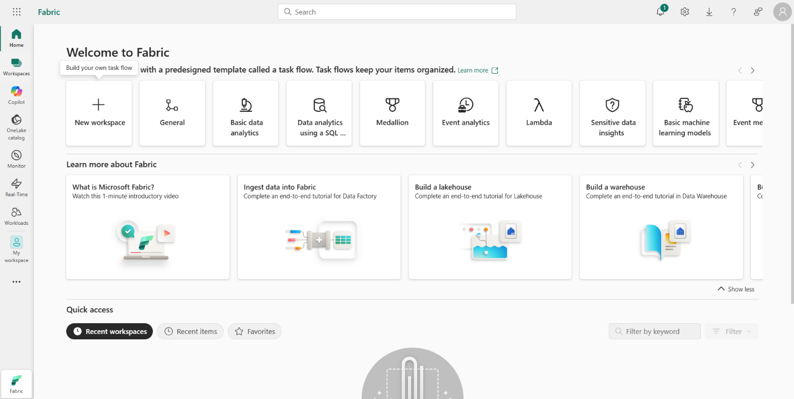
- Task-3: Create a New Fabric Workspace
- You can use an existing workspace or create a new Fabric workspace. In workspaces, you create collections of items such as lakehouses, warehouses, and reports. You must be a member of the Admin or Member roles for the workspace to create a SQL database.
- To create a workspace:
- Navigate to the Microsoft Fabric Home Page.
- 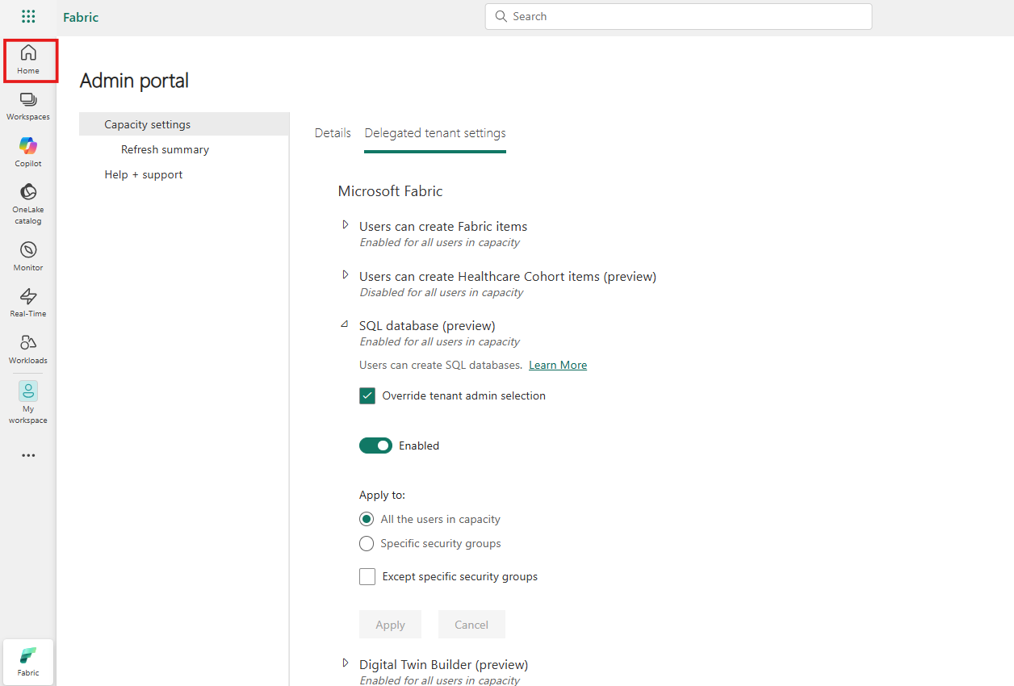
- In the Fabric home page, select +New workspace.
- 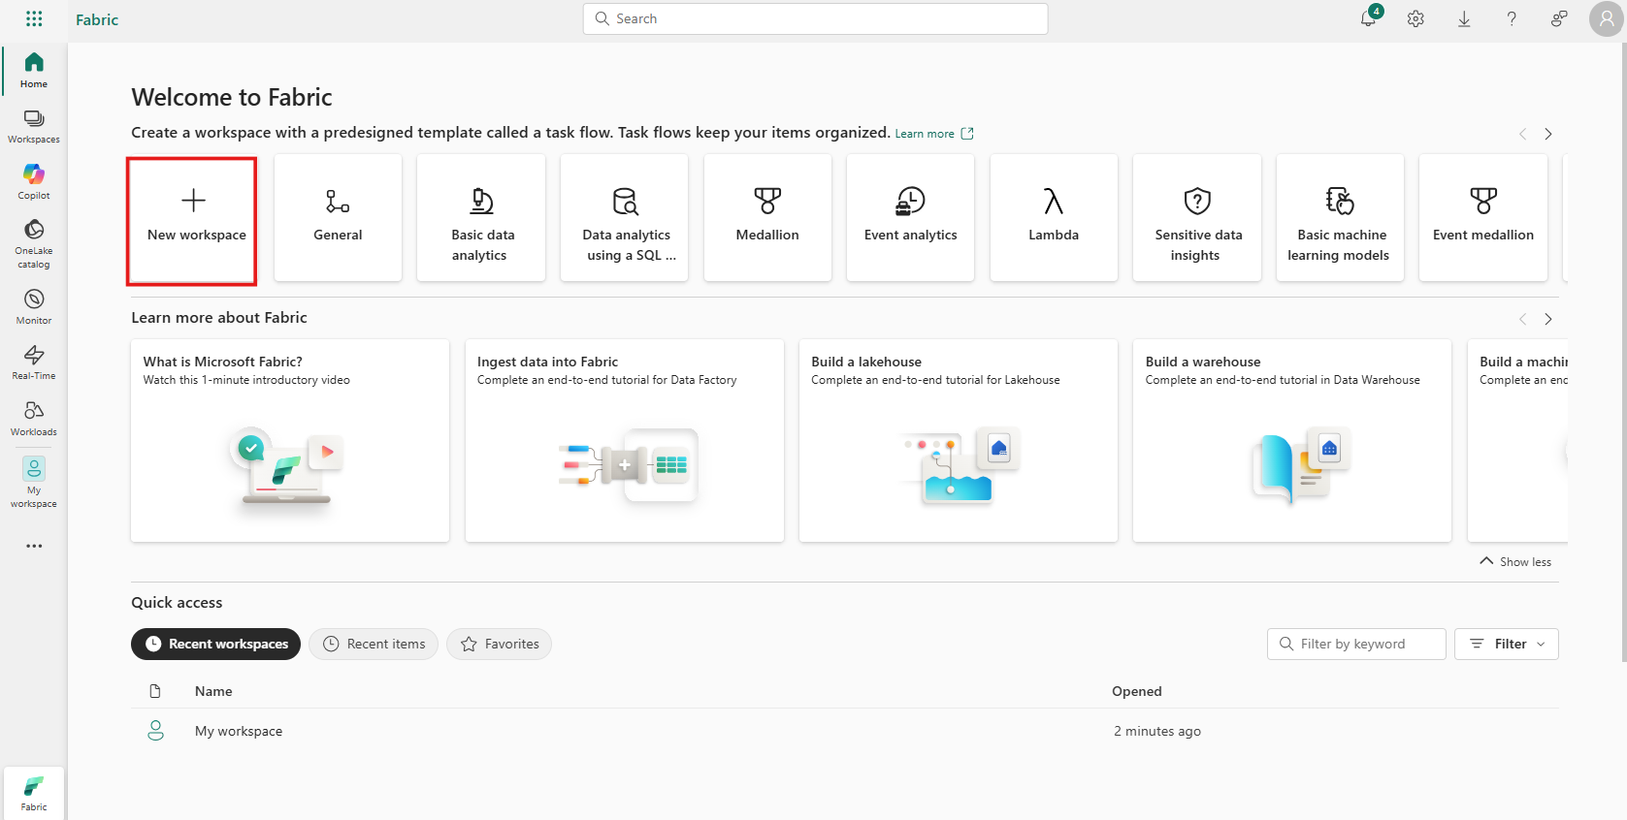
- In the Create a workspace tab, enter the following details and click on the Apply button.
Title | Title
Name | Supply Chain Analytics Workspace - 66566716
Advanced Section
License mode | select Fabric capacity
Semantic model storage format | select Small semantic model storage format
- 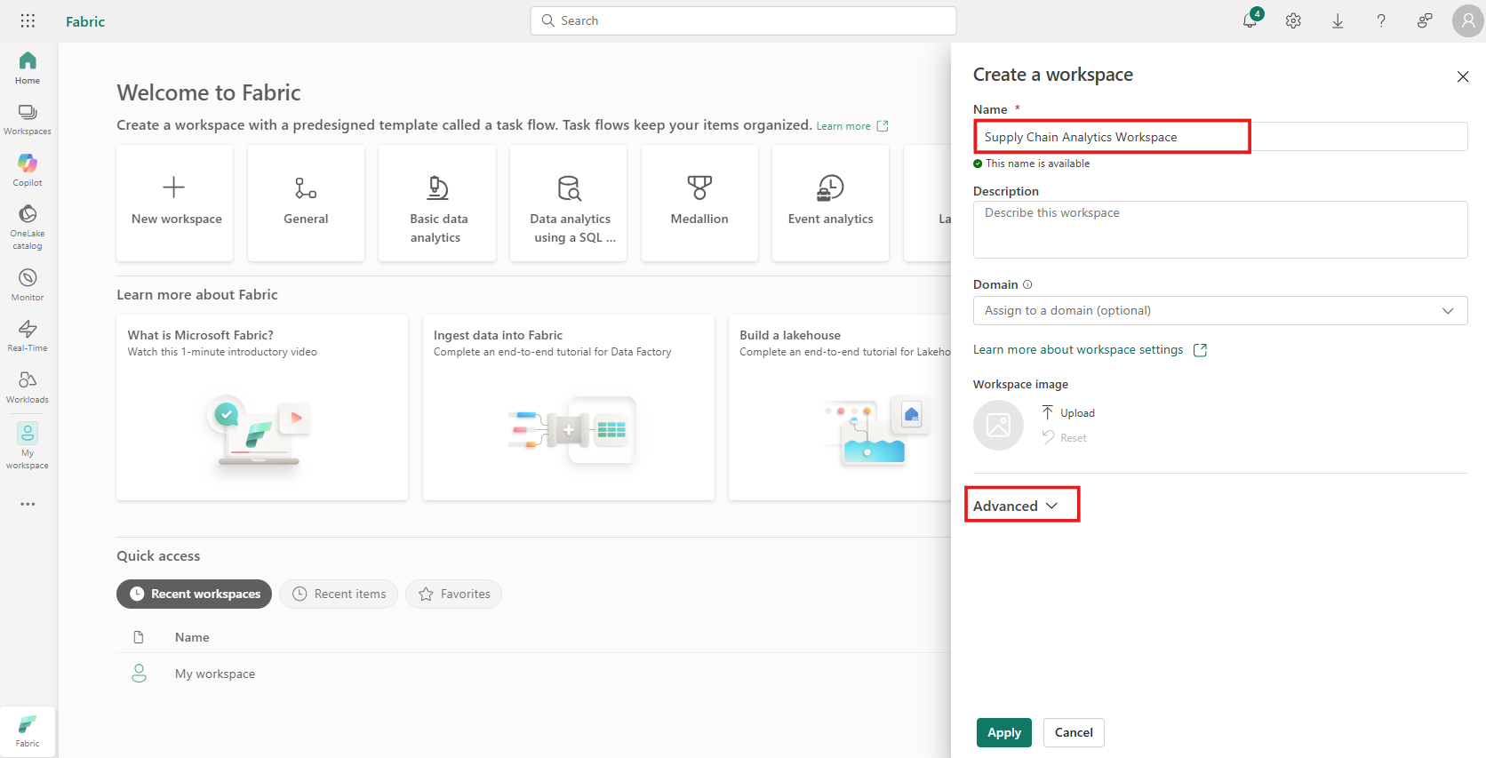
- 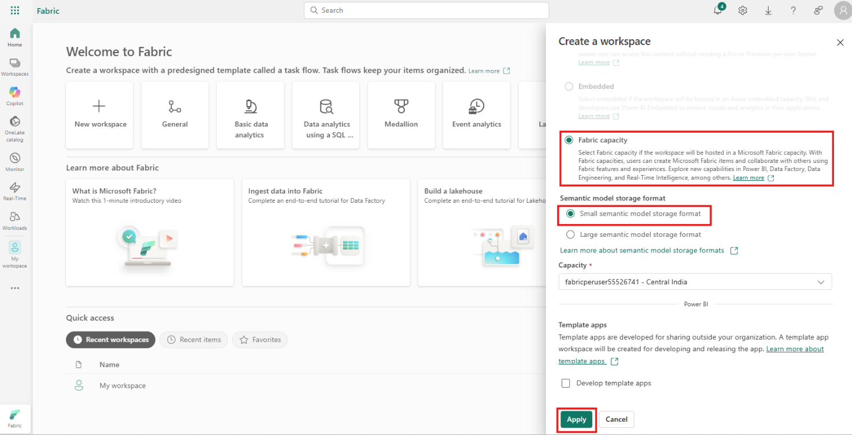
- 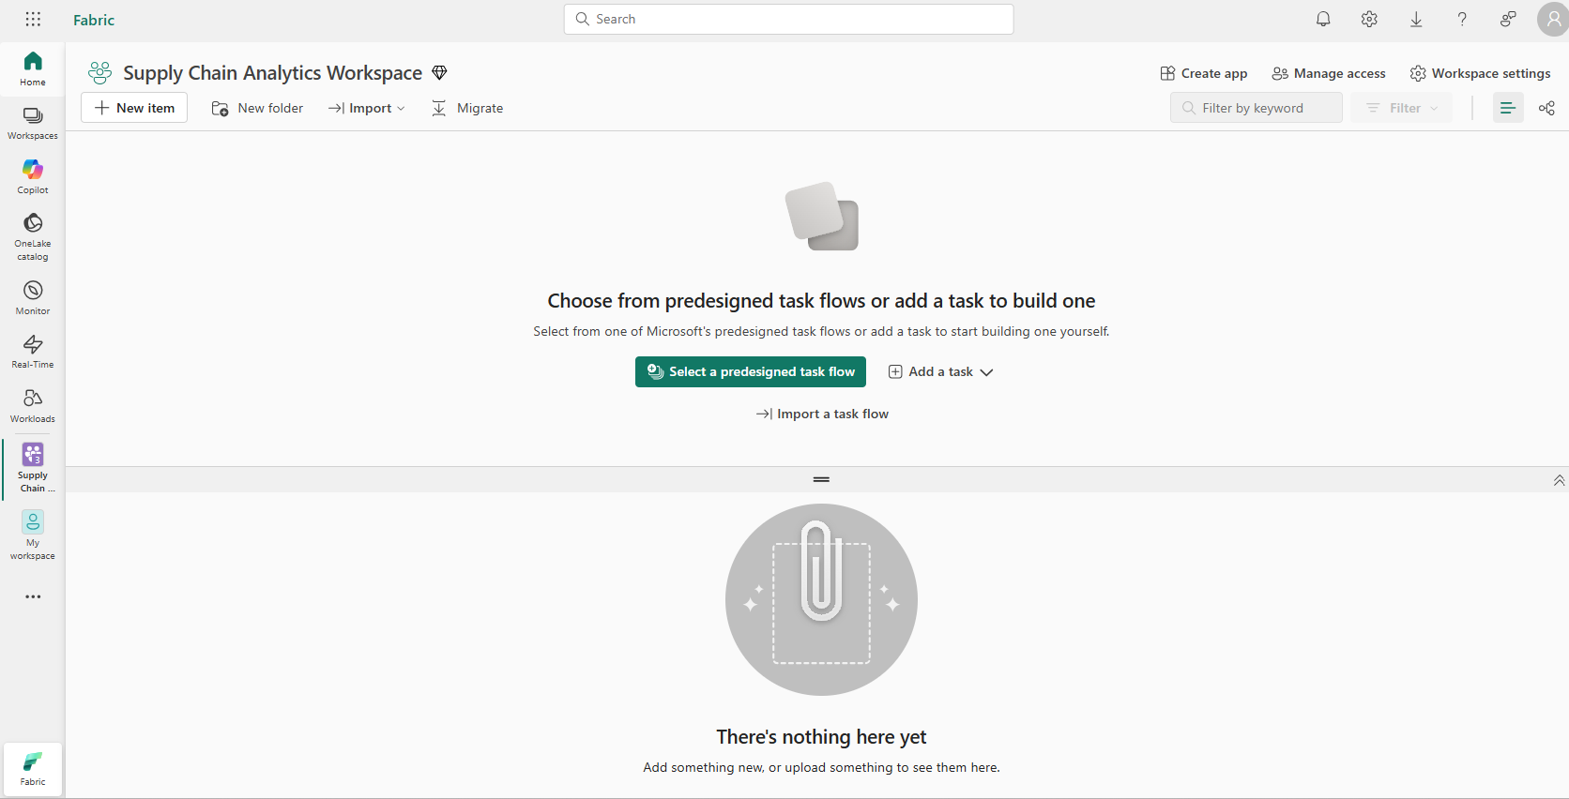
- Exercise 2 – Create a SQL Database in Microsoft Fabric
- In the Fabric Portal, click on + New Item, search for SQL databases, and select SQL database tile.
- 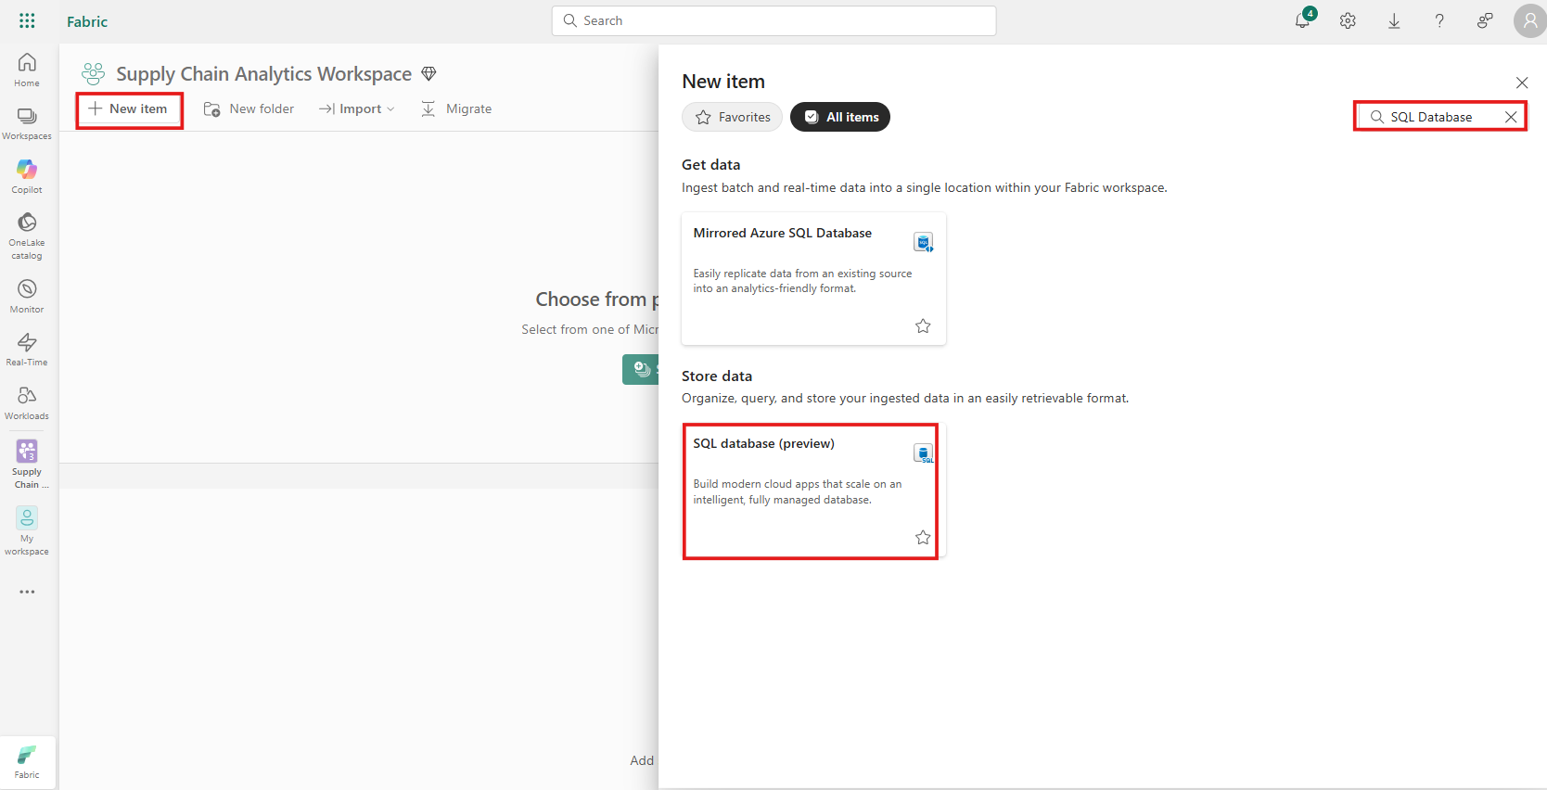
- Provide a name for the New Database as supply_chain_analytics_database Select Create button.
- 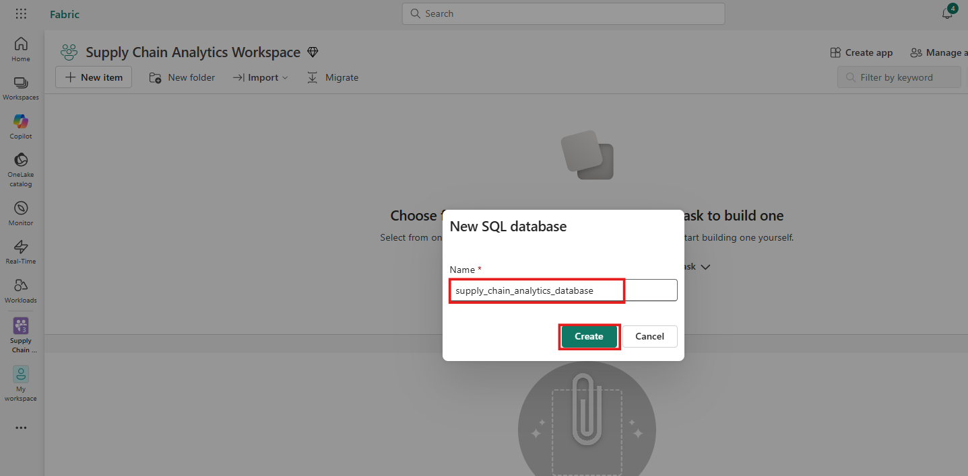
- 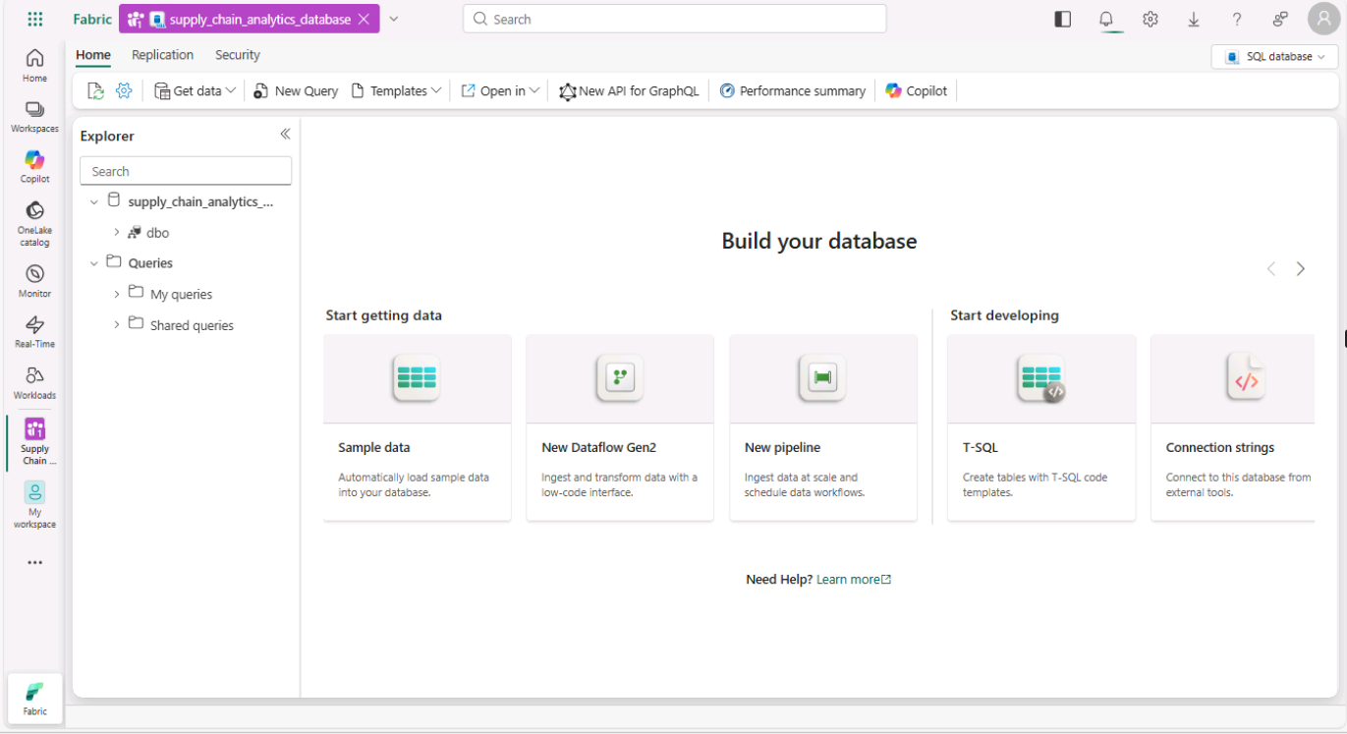
- Exercise 3 – Ingest sample data and create objects and data
- Task-1: Open the Query Editor in the Fabric Portal
- Once the new database is created, open the database's home page. Select Sample Data.
- 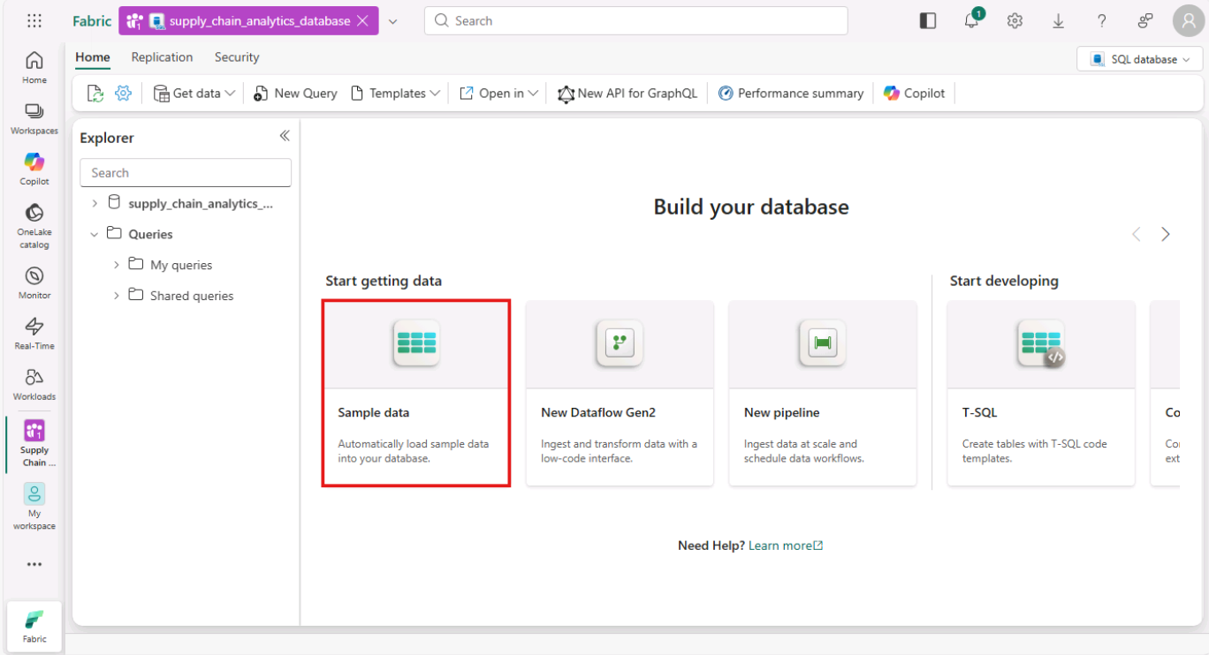
- Check the Notifications area to ensure the import is complete before you proceed.
- 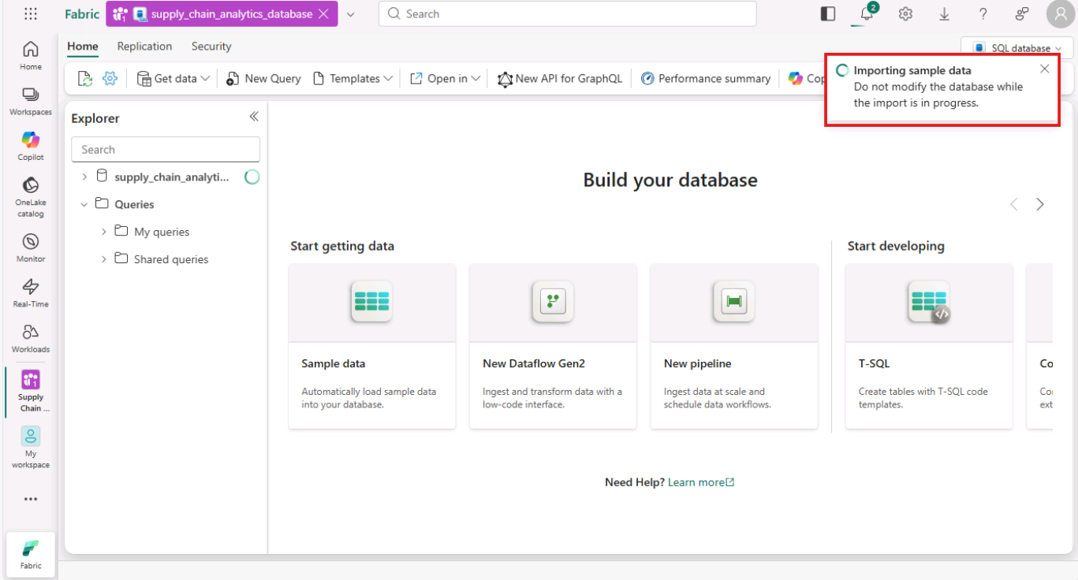
- Notifications show you when the import of the sample data is complete. Your SQL database in Fabric now contains the SalesLT schema and associated tables.
- 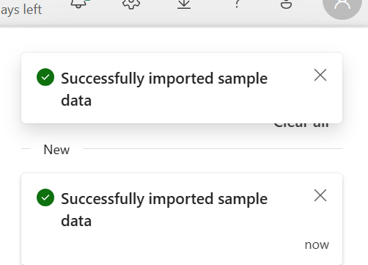
- Task-2: Use the SQL database in the SQL Editor (Copilot)
- In your database view, start by selecting New Query from the icon bar. This brings up a query editor.
- 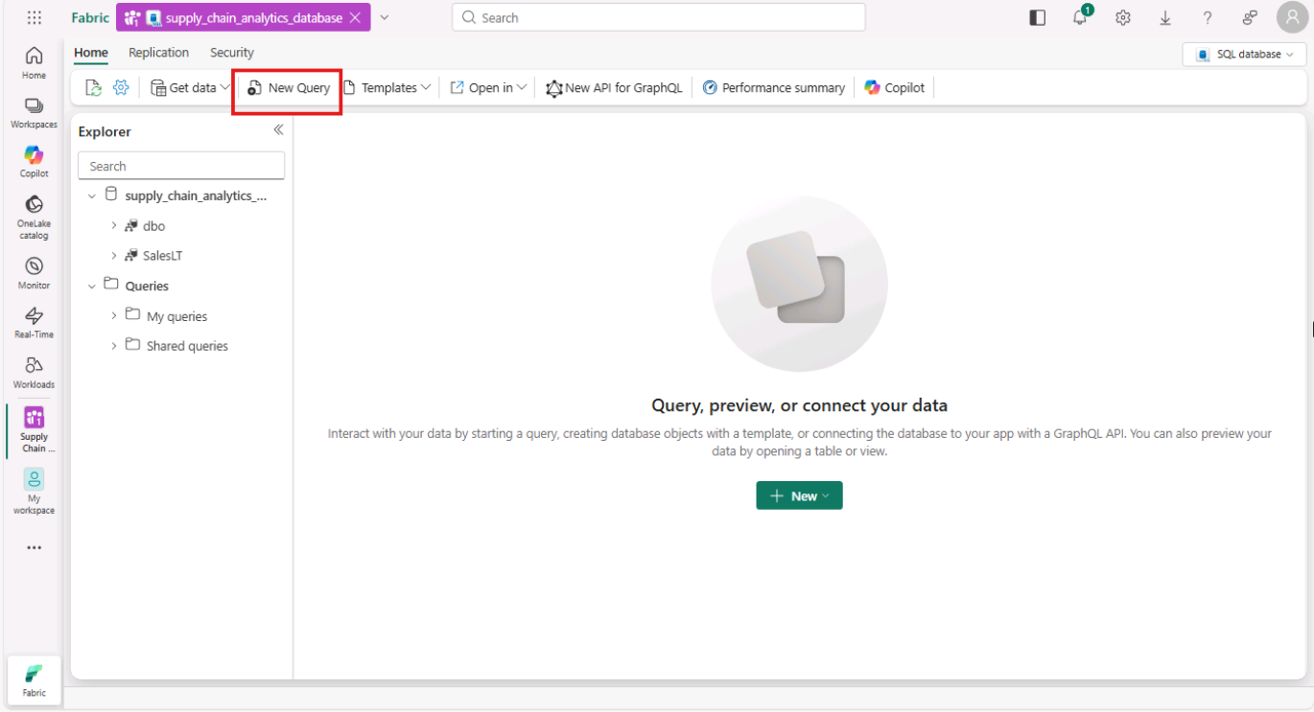
- Type a T-SQL comment at the top of the query, such as:
- -- Create a query that shows the total number of customers
- Press Enter. You’ll get a result similar to this one:
- 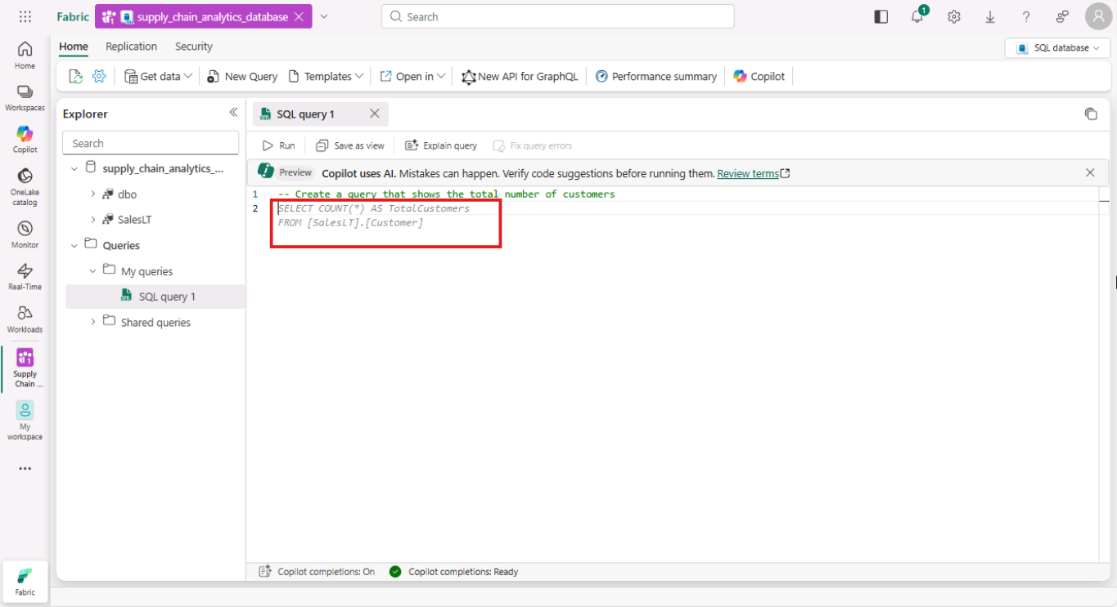
- Pressing the Tab key implements the suggested code:
- 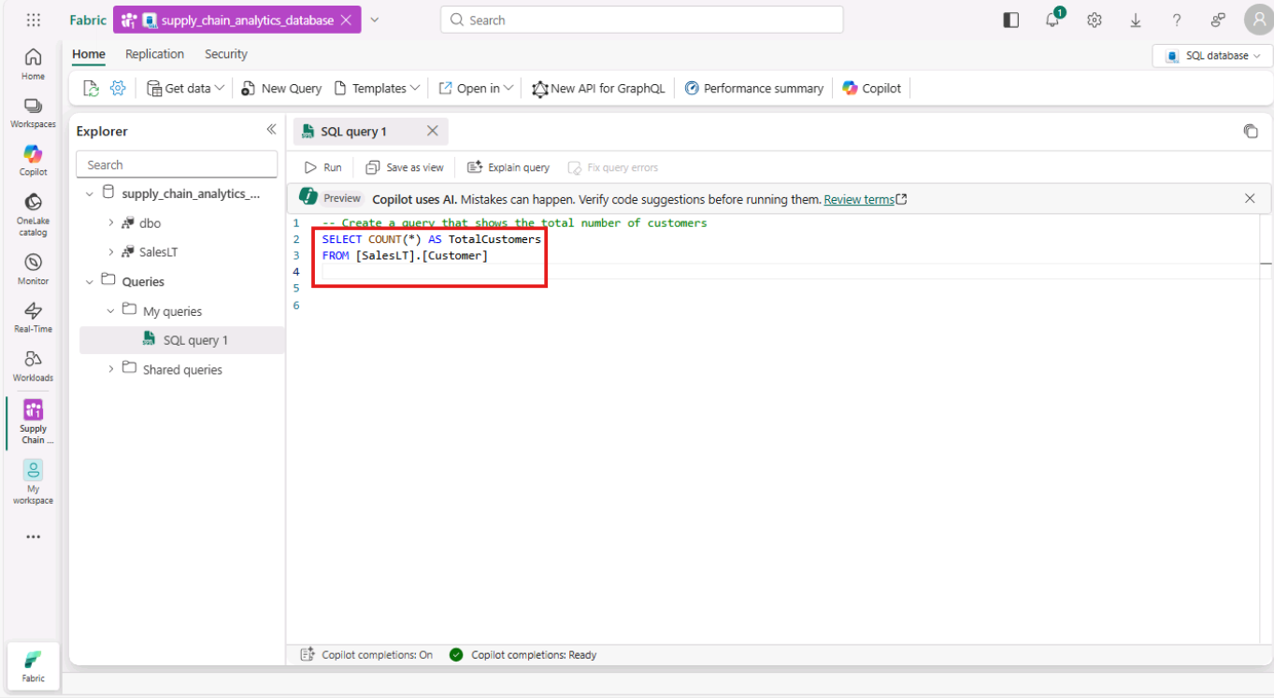
- Select Run button to run the query and review the results based on the query.
- 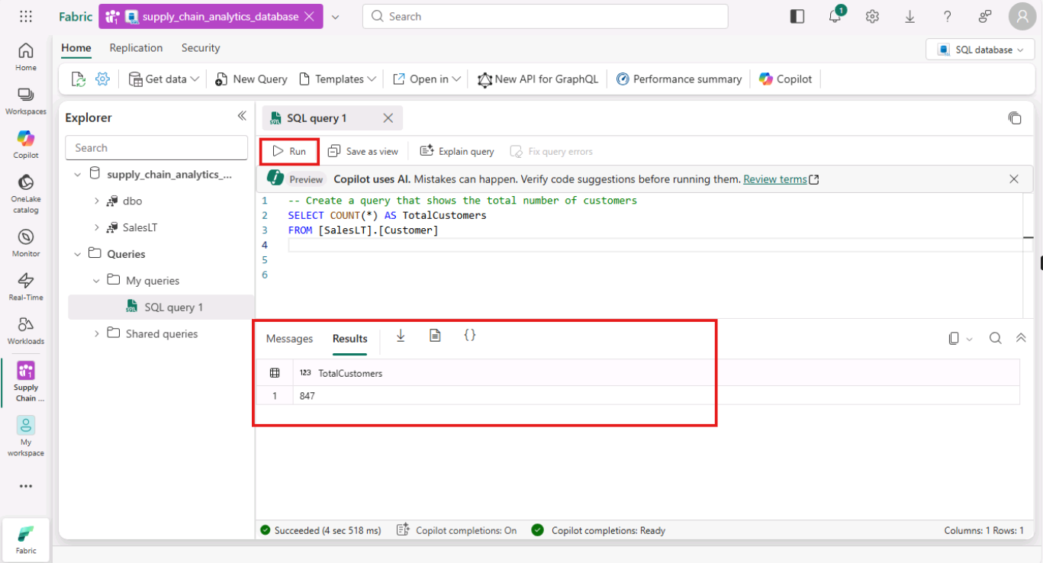
- Select Explain query from the icon bar of the Query Editor.
- 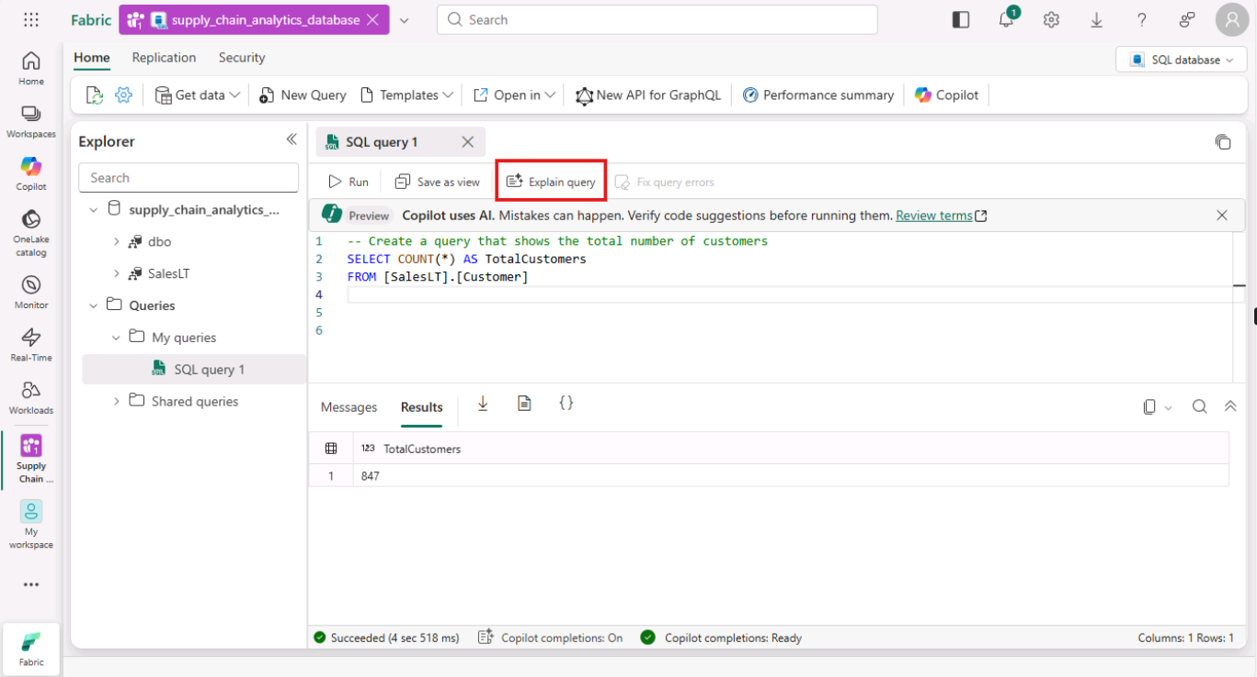
- Explain query option is used when you want to insert comments in your code to explain each major step.
- 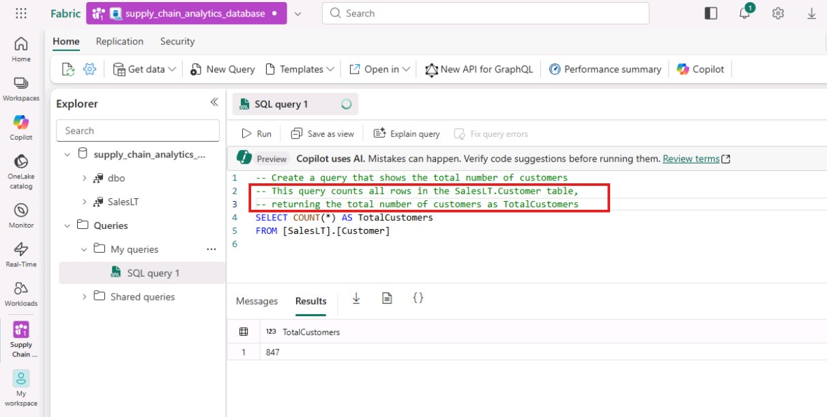
- Task-3: Insert data using Transact-SQL
- The following steps use a T-SQL script to create a schema, table, and data for the simulated data for supply chain analysis.
- Select the New Query button in the toolbar of the SQL database to create a new query.
- 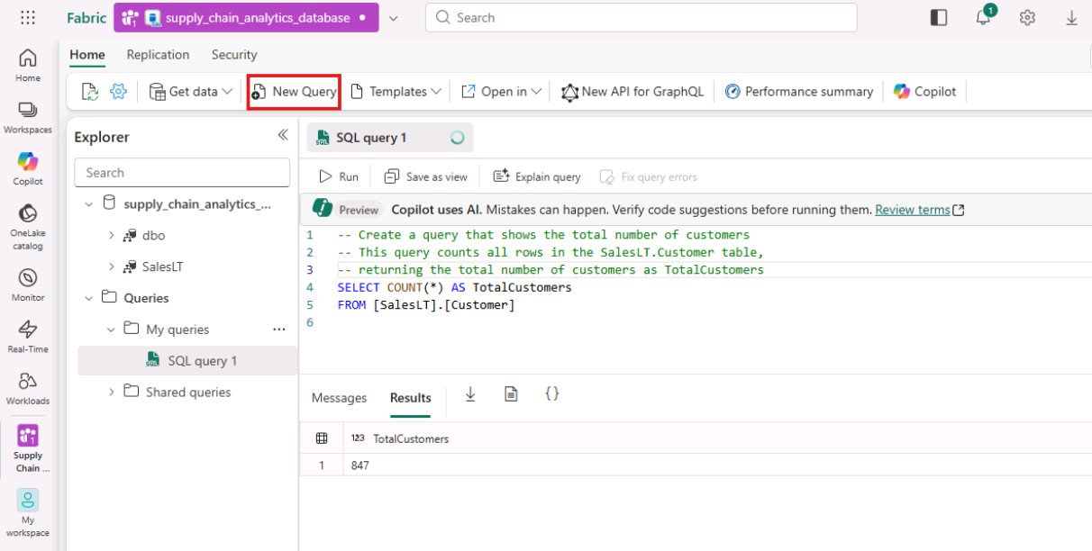
- Paste the following script in the Query area and select Run to execute it. The following T-SQL script
  - Creates a schema named SupplyChain.
  - Creates a table named SupplyChain.Warehouse.
  - Populates the SupplyChain.Warehouse table with some randomly created product data from SalesLT.Product.
- TypeCopy
- /* Create the Tutorial Schema called SupplyChain for all tutorial objects */
- CREATE SCHEMA SupplyChain;
- GO

- /* Create a Warehouse table in the Tutorial Schema
- NOTE: This table is just a set of INT's as Keys,
- tertiary tables will be added later
- */

- CREATE TABLE SupplyChain.Warehouse (
- ProductID INT PRIMARY KEY -- ProductID to link to Products and Sales tables
- , ComponentID INT -- Component Identifier, for this tutorial we assume one per product, would normalize into more tables
- , SupplierID INT -- Supplier Identifier, would normalize into more tables
- , SupplierLocationID INT -- Supplier Location Identifier, would normalize into more tables
- , QuantityOnHand INT); -- Current amount of components in warehouse
- GO

- /* Insert data from the Products table into the Warehouse table. Generate other data for this tutorial */
- INSERT INTO SupplyChain.Warehouse (ProductID, ComponentID, SupplierID, SupplierLocationID, QuantityOnHand)
- SELECT p.ProductID,
- ABS(CHECKSUM(NEWID())) % 10 + 1 AS ComponentID,
- ABS(CHECKSUM(NEWID())) % 10 + 1 AS SupplierID,
- ABS(CHECKSUM(NEWID())) % 10 + 1 AS SupplierLocationID,
- ABS(CHECKSUM(NEWID())) % 100 + 1 AS QuantityOnHand
- FROM [SalesLT].[Product] AS p;
- GO
- 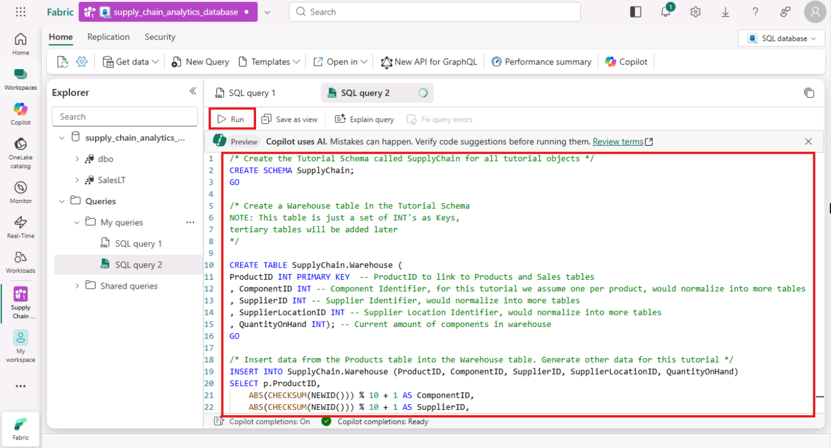
- 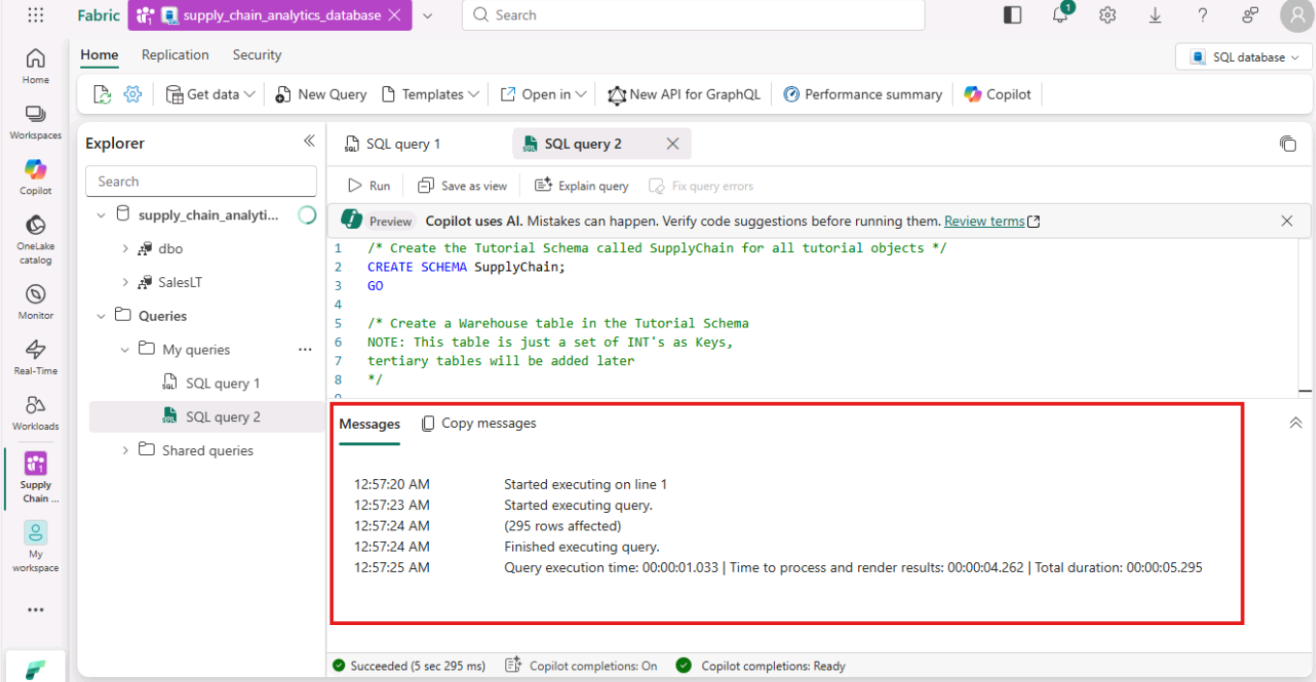
- Your SQL database in Fabric database now includes Warehouse information. You'll use this data in a later step in this tutorial.
- Expand the SupplyChain and then the Tables section from the Explorer pane. You can select these tables in the Explorer pane, and the table data is displayed – no need to write a query to see it.
- 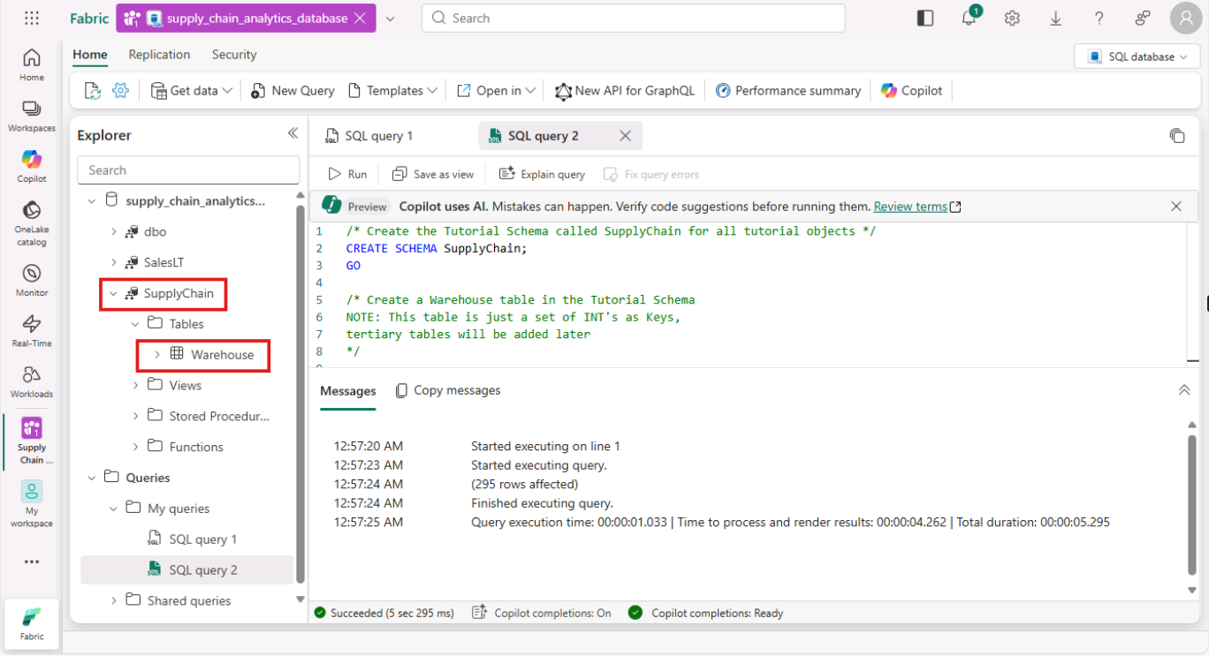
- 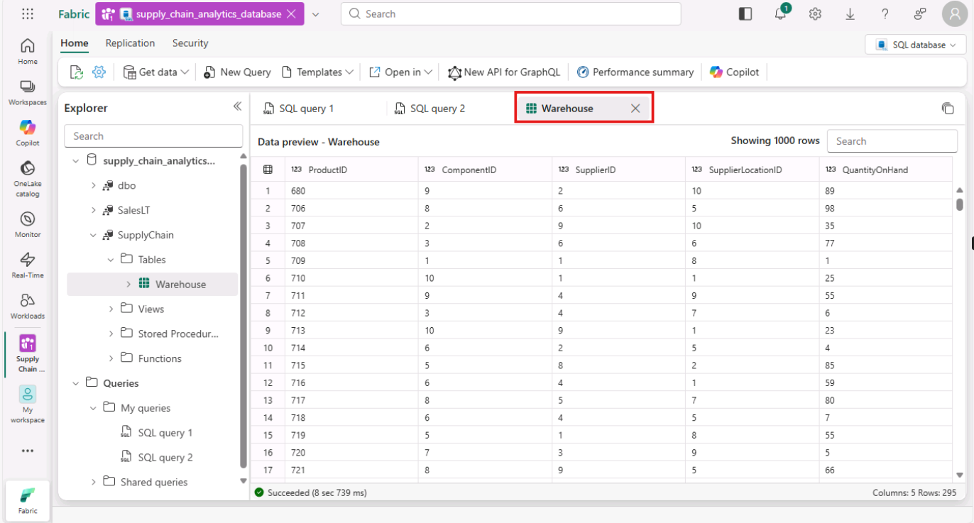
- Task-4: Insert data using a Microsoft Fabric Pipeline
- Another way you can import data into and export data out of your SQL database in Fabric is to use a Microsoft Fabric Data Pipeline. Data pipelines offer an alternative to using commands, instead using a graphical user interface. A data pipeline is a logical grouping of activities that together perform a data ingestion task. Pipelines allow you to manage extract, transform, and load (ETL) activities instead of managing each one individually.
- Microsoft Fabric Pipelines can contain a Dataflow. Dataflow Gen2 uses a Power Query interface that allows you to perform transformations and other operations on the data. You'll use this interface to bring in data from the Northwind Traders company, which Contoso partners with. They're currently using the same suppliers, so you'll import their data and show the names of these suppliers using a view that you'll create in another step in this tutorial.
- To get started, open the SQL database view of the sample database in the Fabric portal.
- Select the Get Data button from the menu bar and select New Dataflow Gen2
- 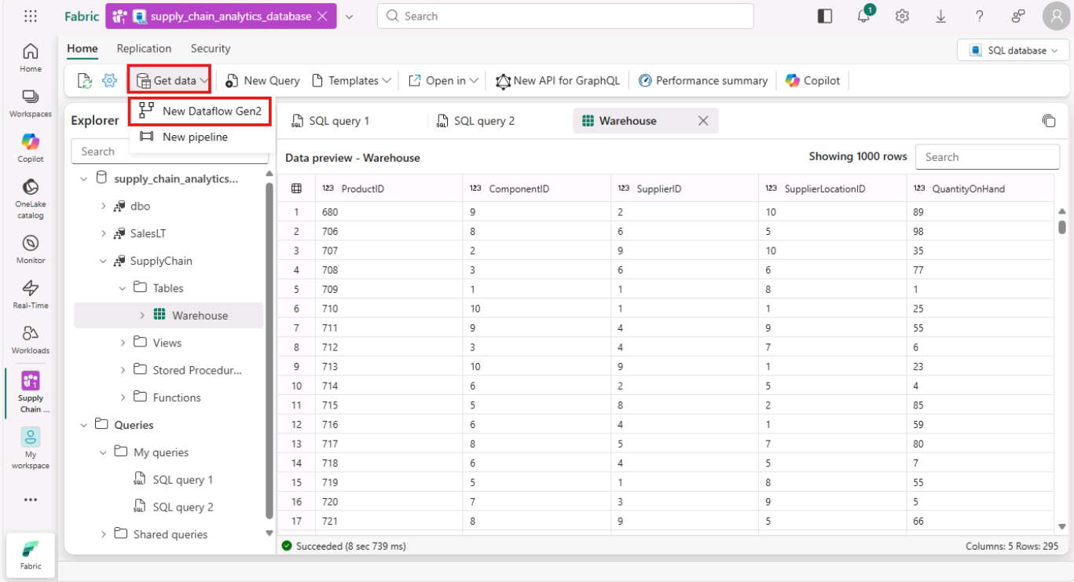
- Keep the name as is for now and click on Create
- 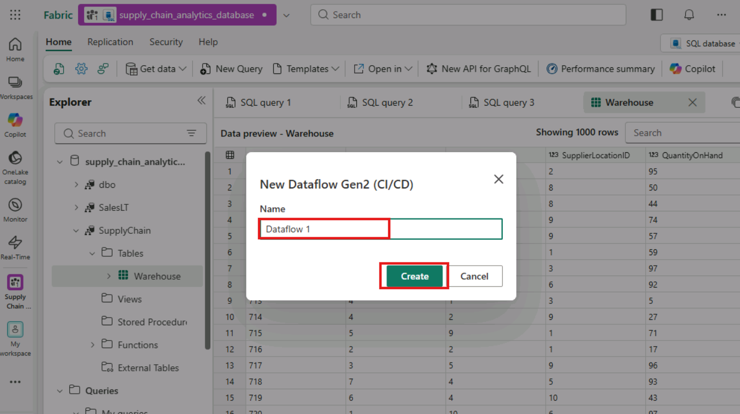
- In the Power Query view, select the Get Data button. This starts a guided process rather than jumping to a particular data area.
- 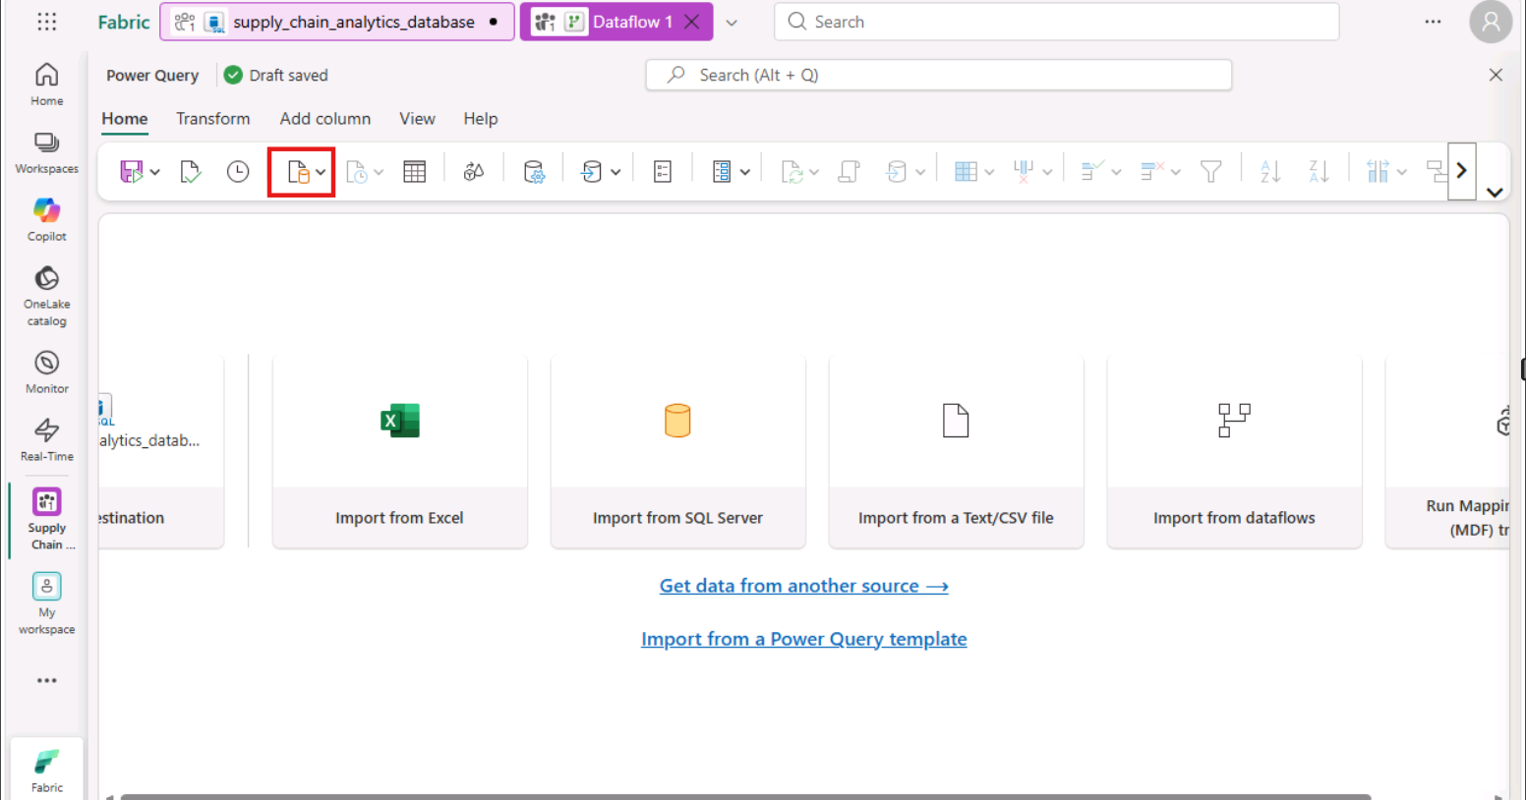
- In the search box of the Choose Data Source, view type OData and Select OData from the New sources results.
- 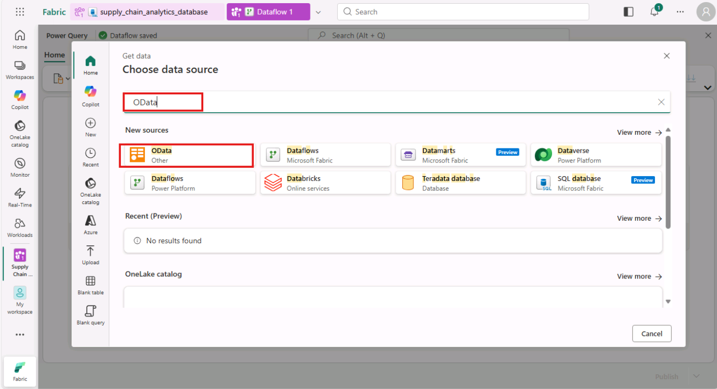
- In the URL text box of the Connect to data source view, type the text: https://services.odata.org/v4/northwind/northwind.svc/ for the Open Data feed of the Northwind sample database. Select the Next button to continue.
- 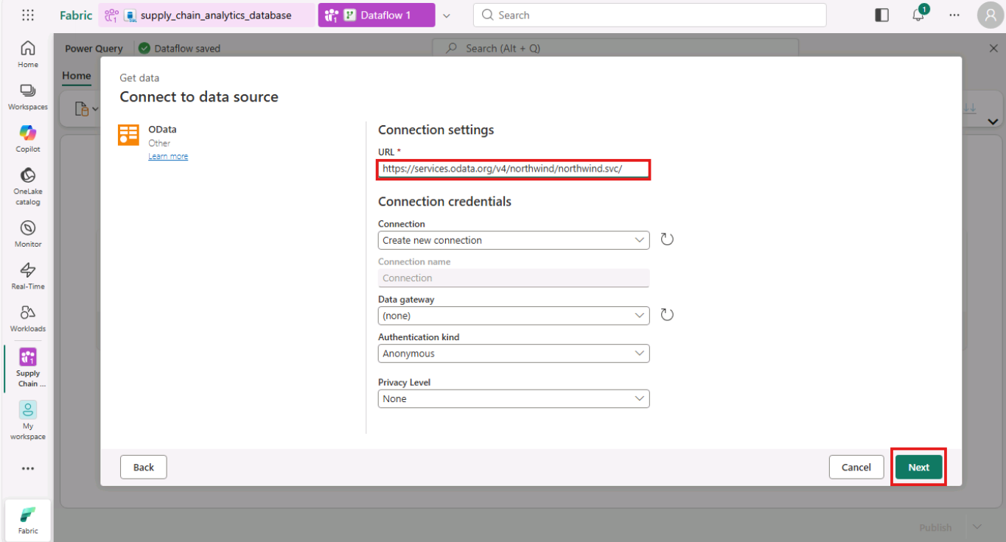
- From the Choose data window, select only the Suppliers table from the display options, review the table and proceed with clicking on Create button.
- 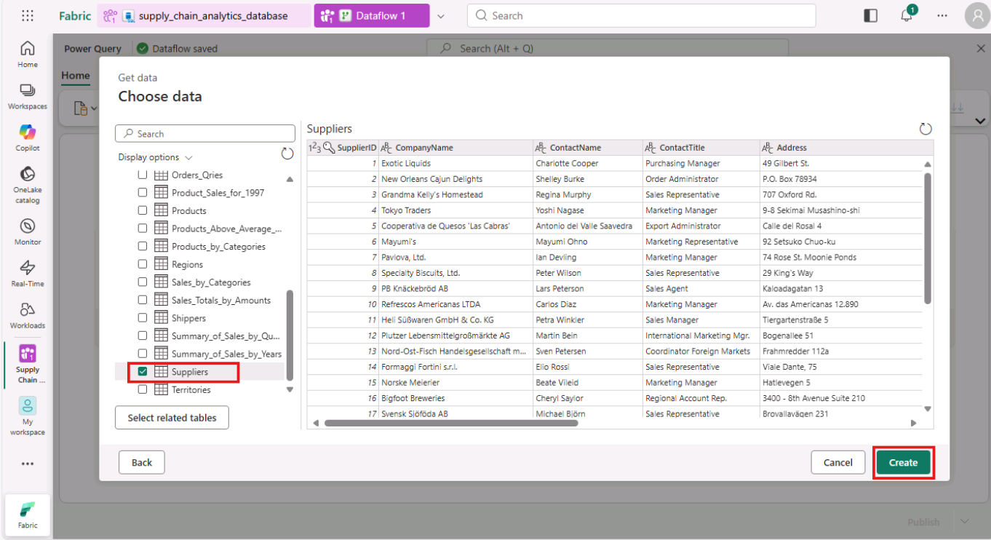
- In the Data Destination section, make sure to check that the SQL database is connected.
- 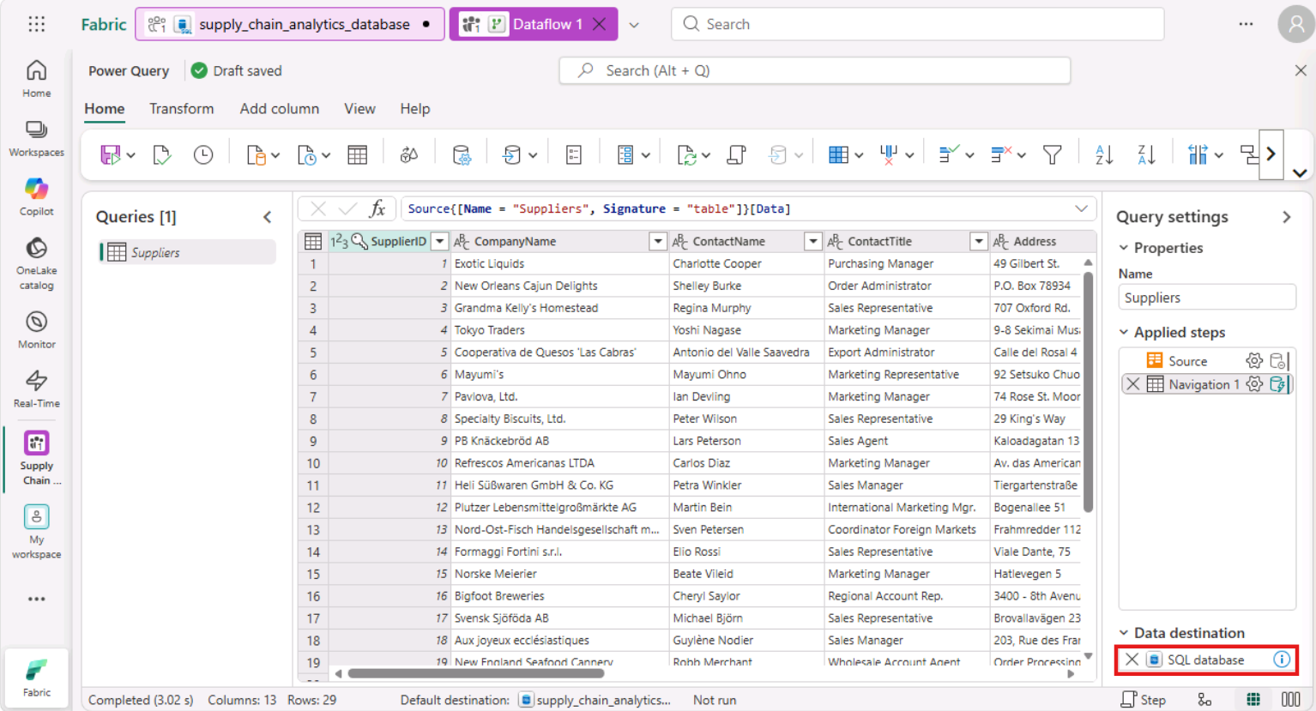
- Select the Save & run button to start the data transfer.
- 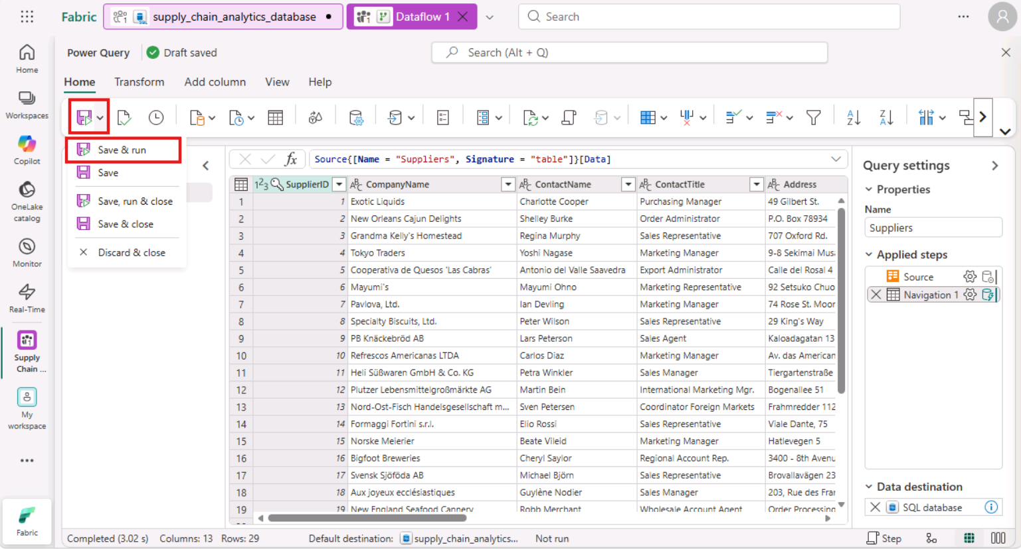
- Navigate to the workspace page, where you can find the new Dataflow item. Wait until you see that the dataflow is published successfully.
- 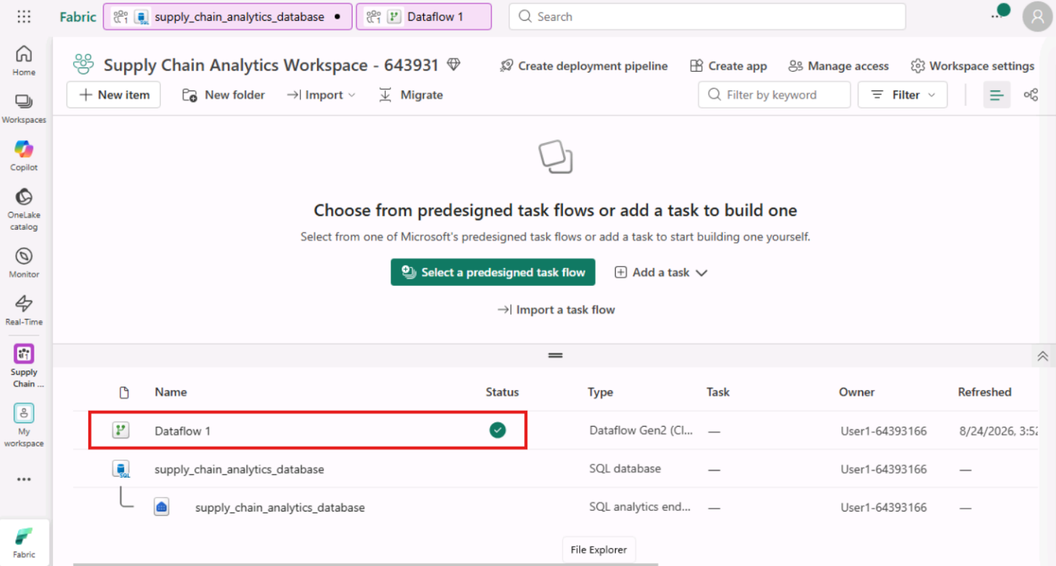
- Select supply_chain_analytics_database SQL database.
- 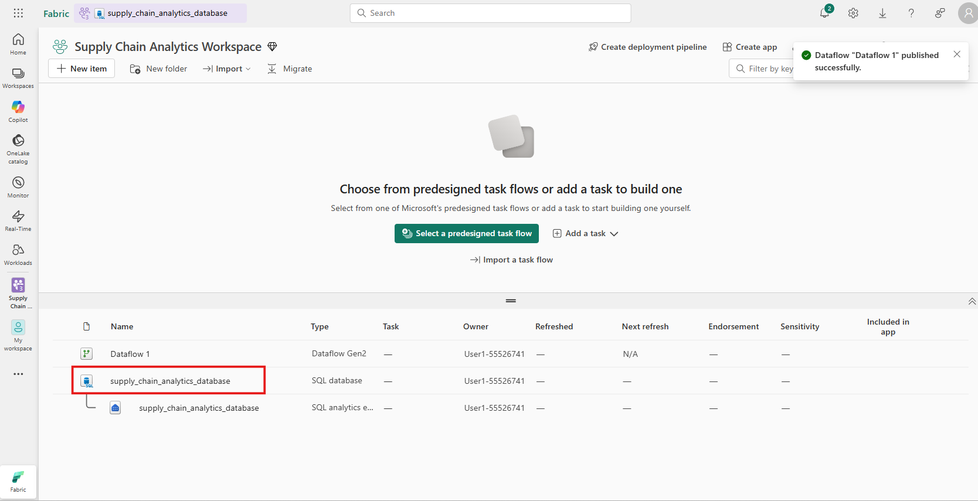
- Refresh the database by clicking on the three dots (…) beside supply_chain_analytics_database , then navigate and click on Refresh.
- 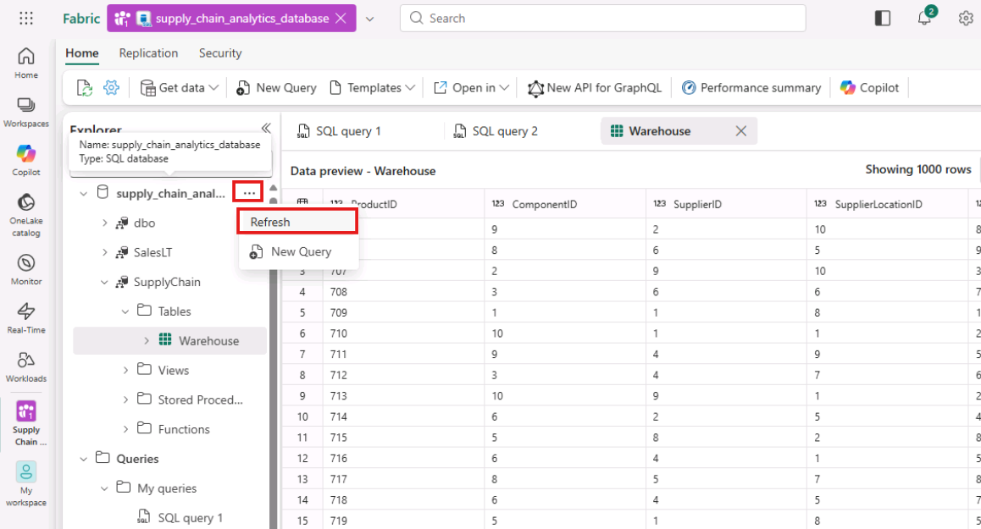
- In the Explorer, expand the dbo > Tables schema to display the new table named Suppliers.
- 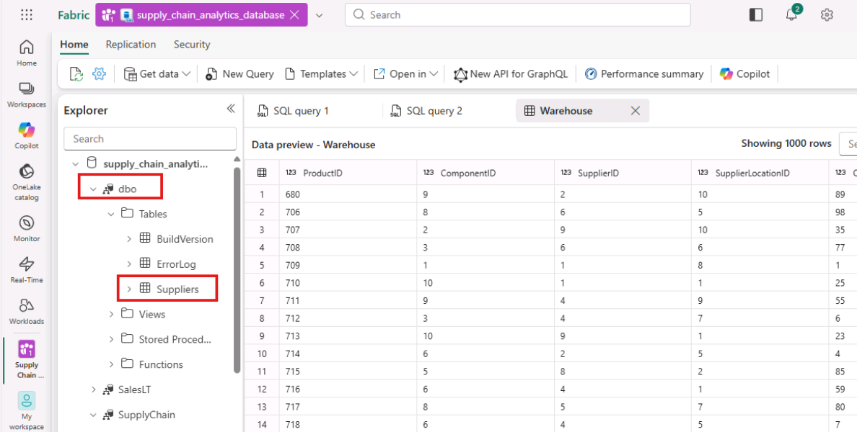
- The data is now ingested into your database. You can now create a query that combines the data from the Suppliers table using this tertiary table. You'll do this later in the tutorial.
- Exercise 4 – Query the database and Review autonomous features
- Task-1: Transact-SQL Queries
- You can type Transact-SQL (T-SQL) statements in a query window.
- In ribbon of the database in the Fabric portal, select the New Query button.
- 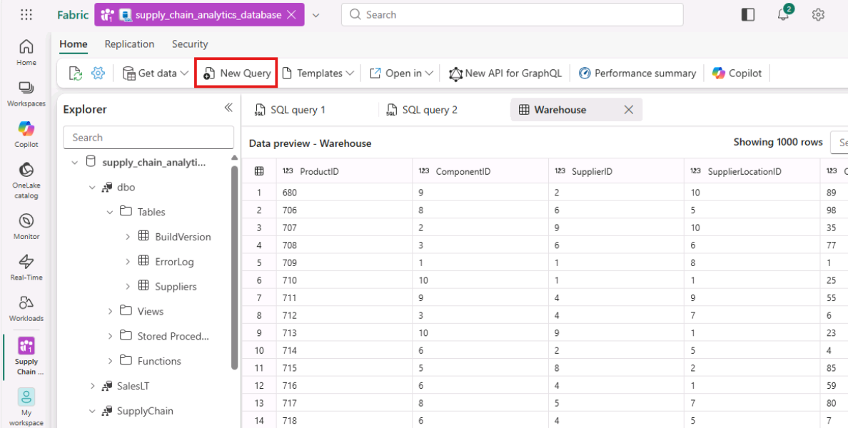
- Copy the following T-SQL script and paste it in the query window. This sample script performs a simple TOP 10 query, and creates a view based on a simple analytical T-SQL query. Select the Run button in the toolbar to execute the T-SQL query.
- TypeCopy
- -- Show the top 10 selling items
- SELECT TOP 10
- [P].[ProductID],
- [P].[Name],
- SUM([SOD].[OrderQty]) AS TotalQuantitySold
- FROM [SalesLT].[Product] AS P
- INNER JOIN [SalesLT].[SalesOrderDetail] AS SOD ON [P].[ProductID] = [SOD].[ProductID]
- GROUP BY [P].[ProductID], [P].[Name]
- ORDER BY TotalQuantitySold DESC;
- GO

- /* Create View that will be used in the SQL GraphQL Endpoint */
- CREATE VIEW SupplyChain.vProductsbySuppliers AS
- SELECT COUNT(a.ProductID) AS ProductCount
- , a.SupplierLocationID
- , b.CompanyName
- FROM SupplyChain.Warehouse AS a
- INNER JOIN dbo.Suppliers AS b ON a.SupplierID = b.SupplierID
- GROUP BY a.SupplierLocationID, b.CompanyName;
- GO
- 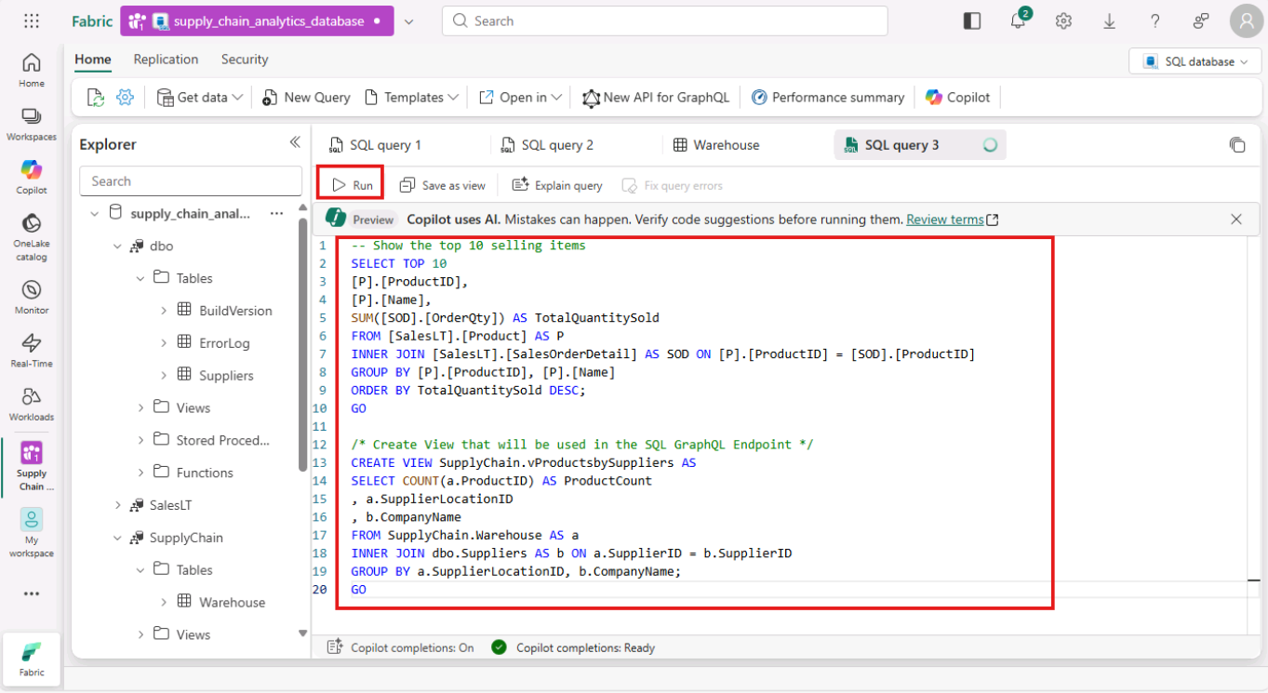
- 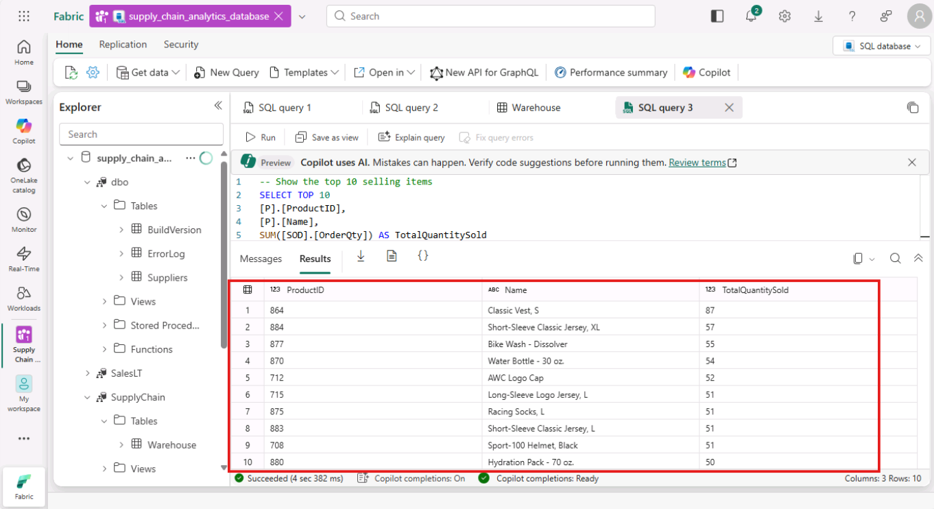
- Task-2: Performance Monitoring in SQL database in Fabric
- As your queries run in your SQL database in Fabric, the system collects performance metrics to display in the Performance Dashboard. You can use the Performance Dashboard to view database performance metrics, to identify performance bottlenecks, and find solutions to performance issues.
- On the Home toolbar in the Query with the SQL query editor, select Performance summary.
- 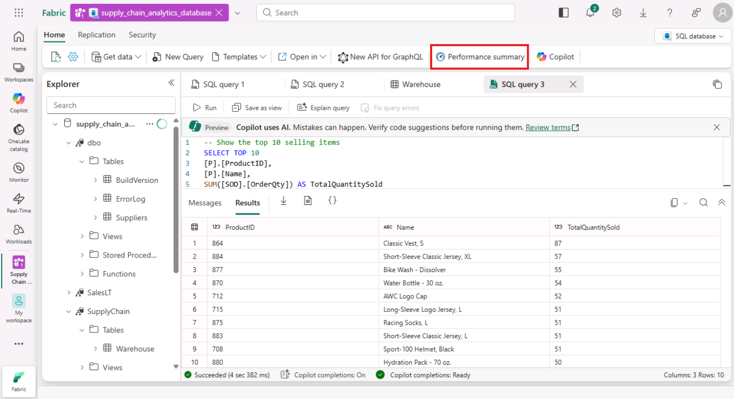
- The entire performance summary is displayed such as CPU consumption, Allocated size, User connections etc.
- 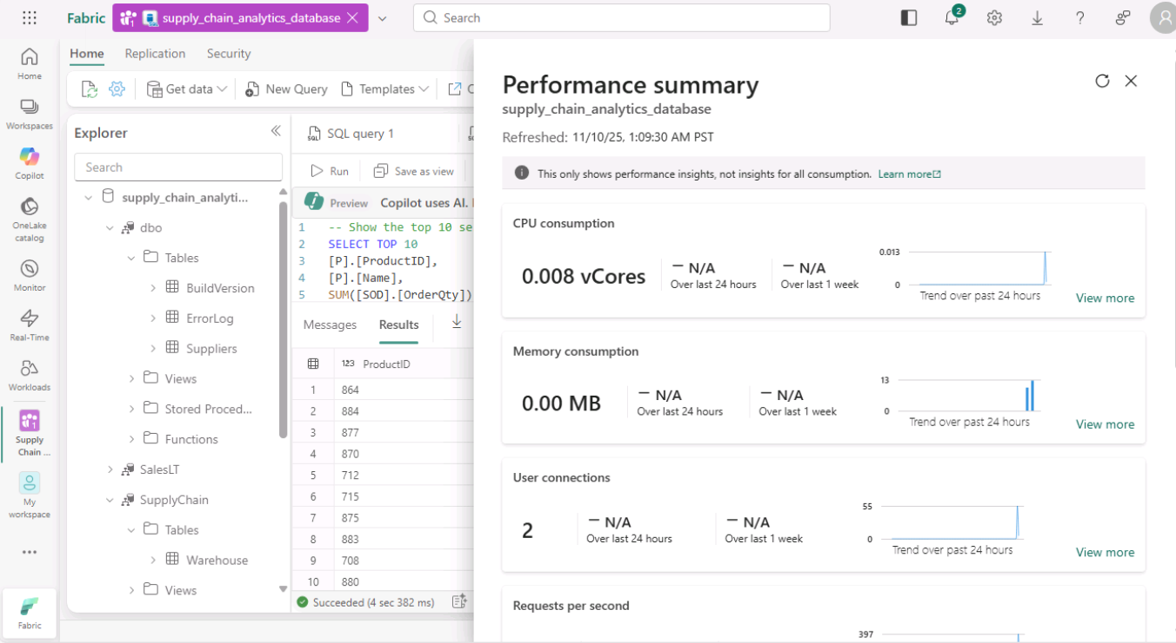
- To check the performance of Automatic Indexing, click on View More in the Automatic Index section.
- 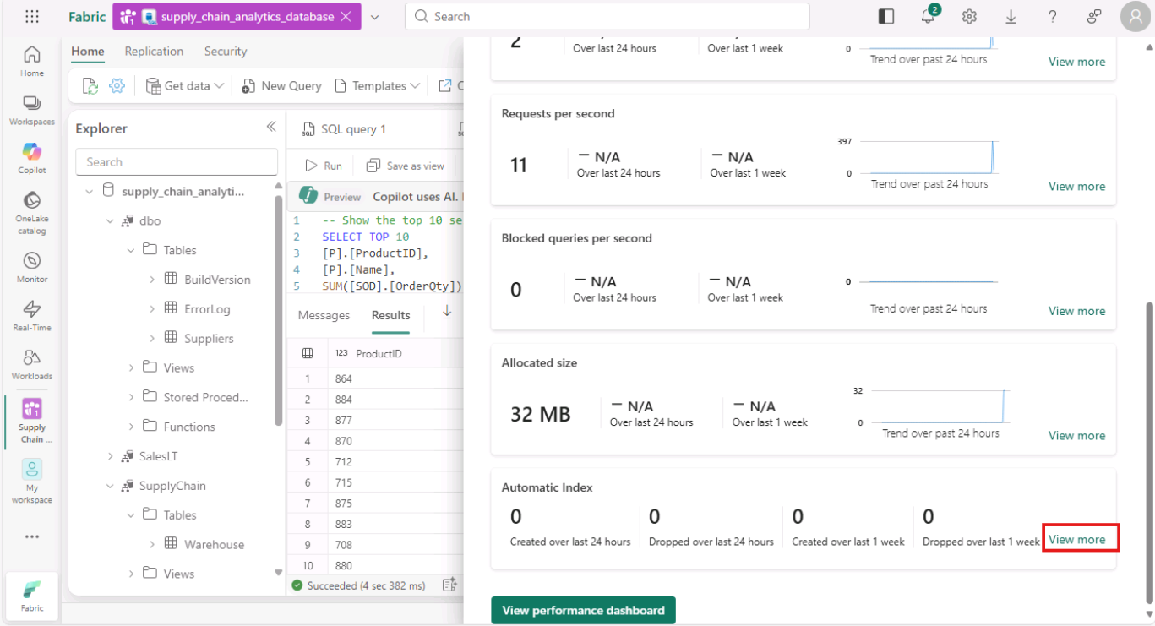
- In the Fabric portal, the Automatic Index tab shows a history and status of automatically created indexes
- 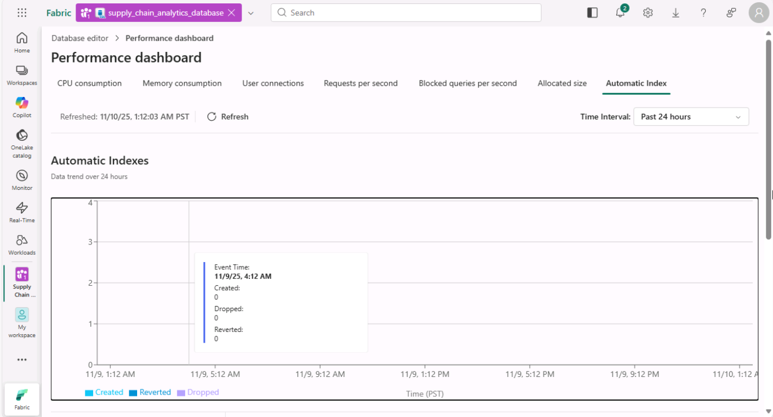
- Task-3: Backups in SQL database in Fabric
- SQL database in Fabric automatically takes backups for you, and you can see these backups in the properties that you access through the database view of the Fabric portal.
- Click on the Database editor to go back to the database page.
- 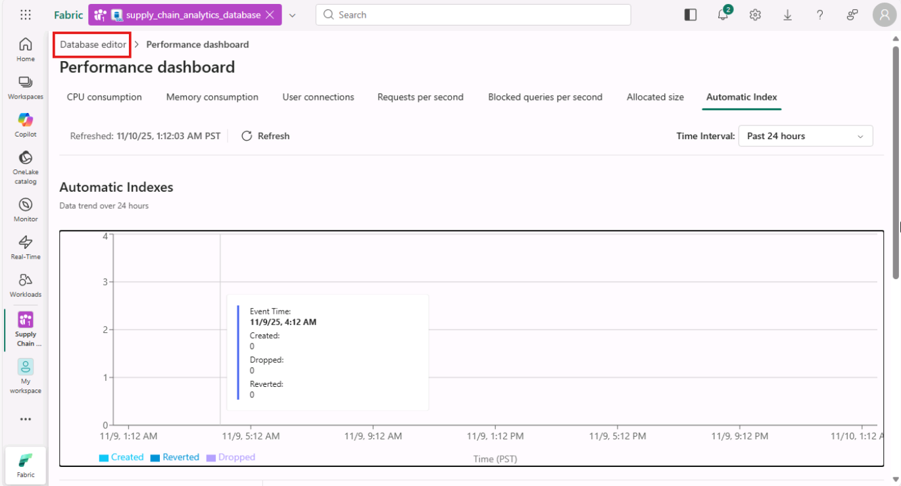
- Select the Settings icon in the toolbar.
- 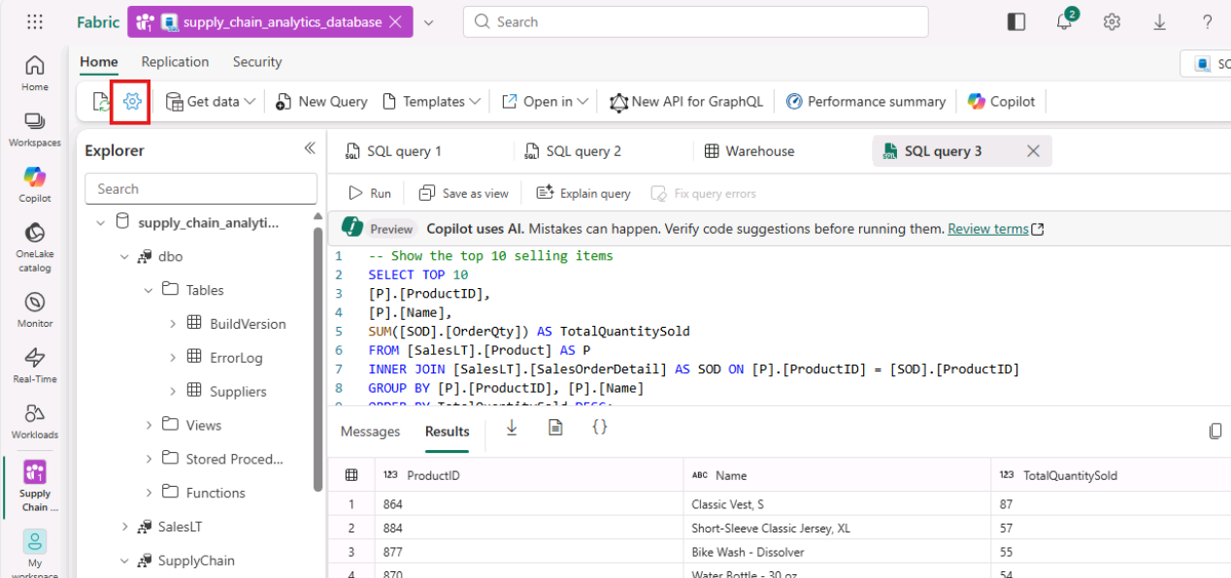
- Select the Backup retention policy page. This view shows the recent point in time backups that have been taken on your database.
- 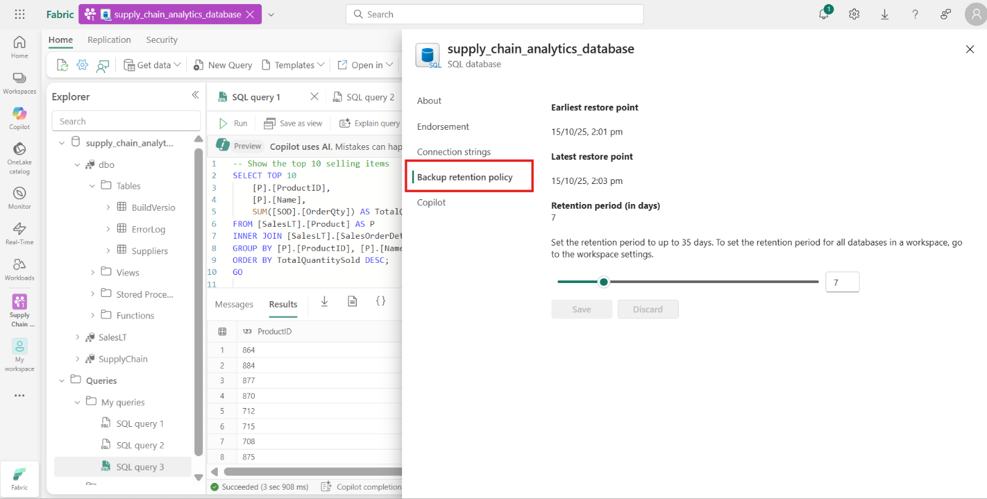
- Click on the Close.
- 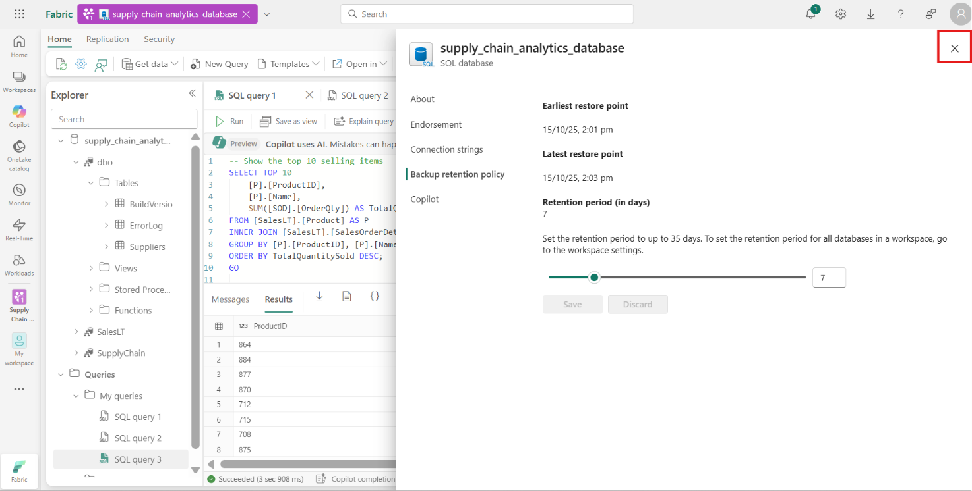
- Exercise 5 – Use the SQL analytics endpoint to query data
- Task-1: Query the data with the SQL analytics endpoint
- You can query any of the mirrored data in the SQL analytics endpoint using standard Transact-SQL statements that are compatible with a Fabric warehouse.
- You can access this mirrored data by selecting the SQL analytics endpoint in your Workspace view.
- If you are unable to select the Endpoint view, go back to the Supply Chain Analytics Workspace overview page, and select the database type: SQL Analytics Endpoint.
- 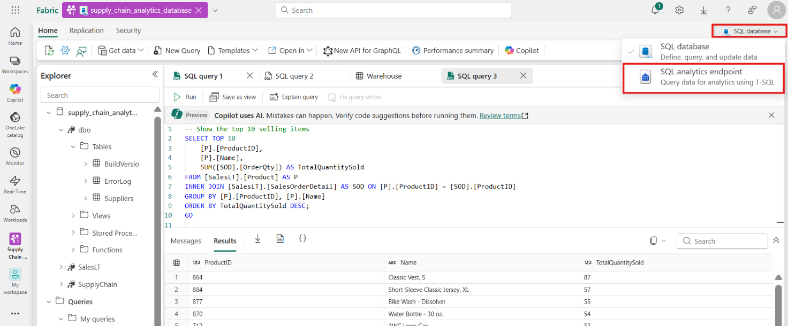
- 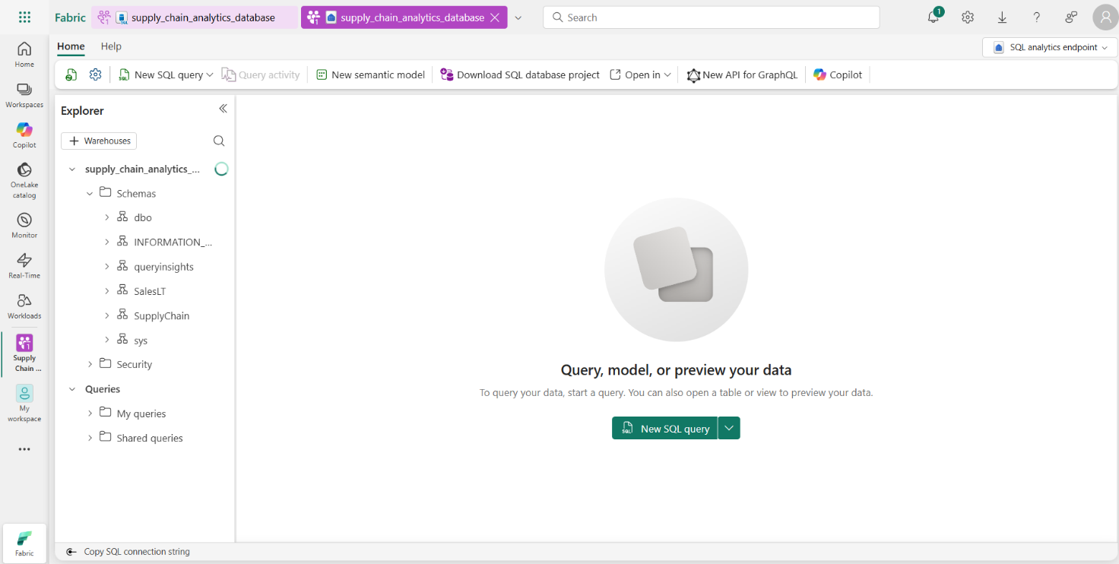
- On the WideWorldImporters page, click on New SQL query.
- 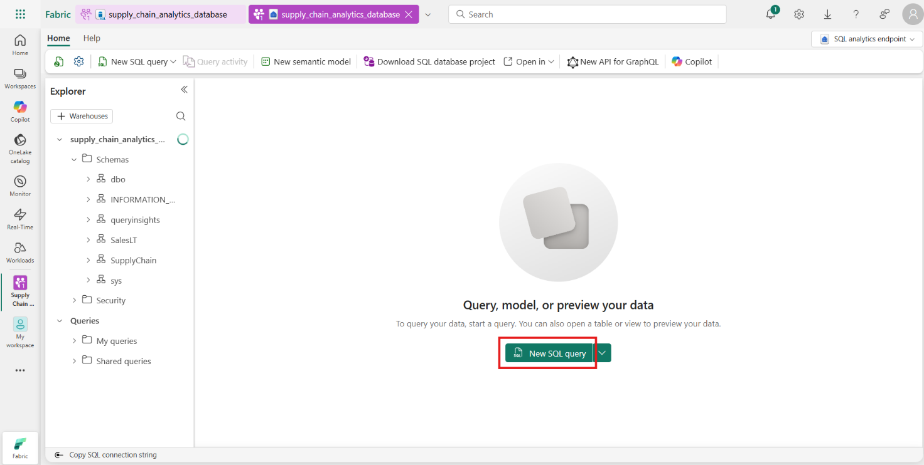
- 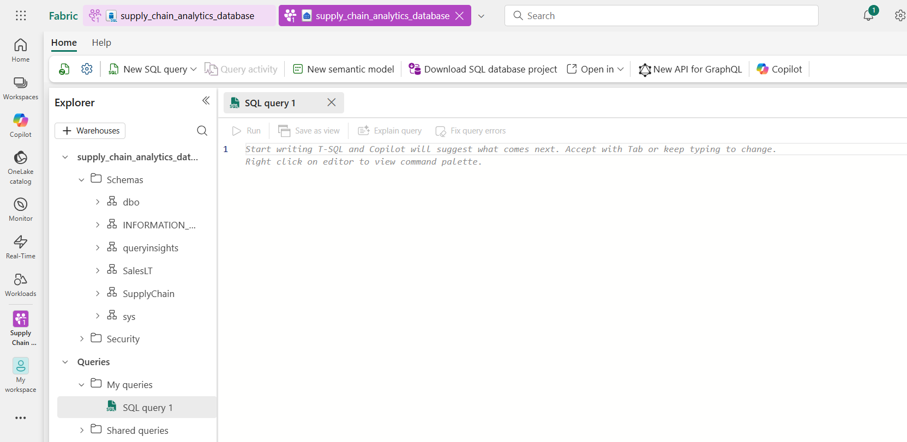
- In this step, create a view over the mirrored data, and then create a report to show the results.
- Ensure you're in the SQL analytics endpoint, and then open a new Query window using the icon bar that depicts a paper with the letters SQL and paste the following Transact-SQL Code and select Run to execute it.
- TypeCopy
- CREATE VIEW SupplyChain.vProductsBySupplier AS
- -- View for total products each supplier
- SELECT sod.ProductID
- , sup.CompanyName
- , SUM(sod.OrderQty) AS TotalOrderQty
- FROM SalesLT.SalesOrderHeader AS soh
- INNER JOIN SalesLT.SalesOrderDetail AS sod
- ON soh.SalesOrderID = sod.SalesOrderID
- INNER JOIN SupplyChain.Warehouse AS sc
- ON sod.ProductID = sc.ProductID
- INNER JOIN dbo.Suppliers AS sup
- ON sc.SupplierID = sup.SupplierID
- GROUP BY sup.CompanyName, sod.ProductID;
- GO
- CREATE VIEW SupplyChain.vSalesByDate AS
- -- Product Sales by date and month
- SELECT YEAR(OrderDate) AS SalesYear
- , MONTH(OrderDate) AS SalesMonth
- , ProductID
- , SUM(OrderQty) AS TotalQuantity
- FROM SalesLT.SalesOrderDetail AS SOD
- INNER JOIN SalesLT.SalesOrderHeader AS SOH
- ON SOD.SalesOrderID = SOH.SalesOrderID
- GROUP BY YEAR(OrderDate), MONTH(OrderDate), ProductID;
- GO
- CREATE VIEW SupplyChain.vTotalProductsByVendorLocation AS
- -- View for total products by each supplier by location
- SELECT wh.SupplierLocationID AS 'Location'
- , vpbs.CompanyName AS 'Supplier'
- , SUM(vpbs.TotalOrderQty) AS 'TotalQuantityPurchased'
- FROM SupplyChain.vProductsBySupplier AS vpbs
- INNER JOIN SupplyChain.Warehouse AS wh
- ON vpbs.ProductID = wh.ProductID
- GROUP BY wh.SupplierLocationID, vpbs.CompanyName;
- GO
- 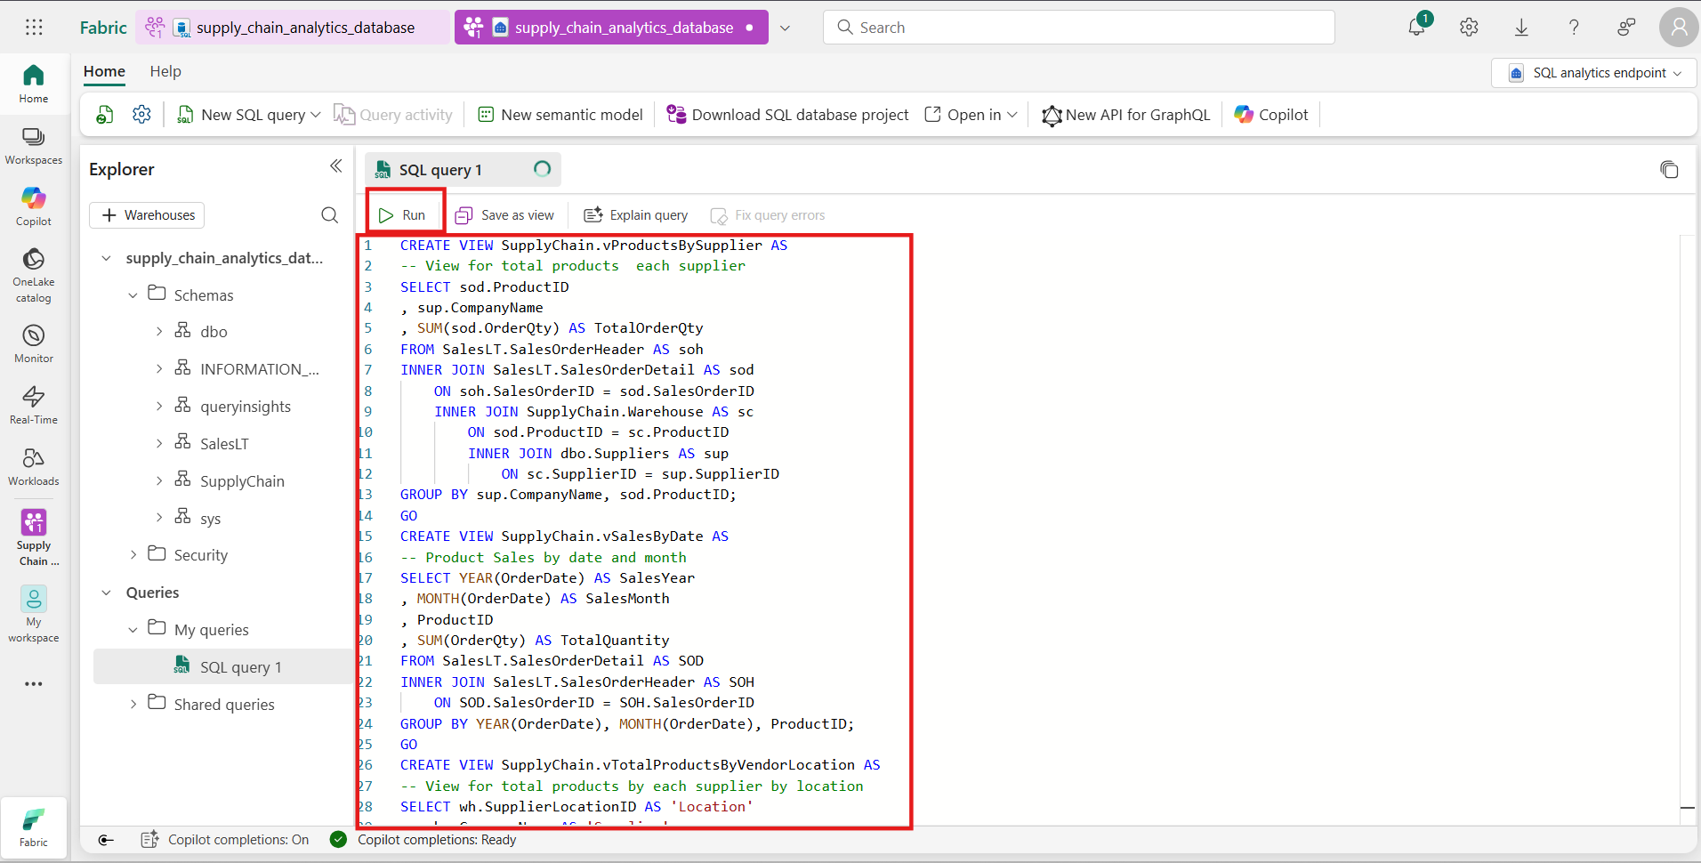
- 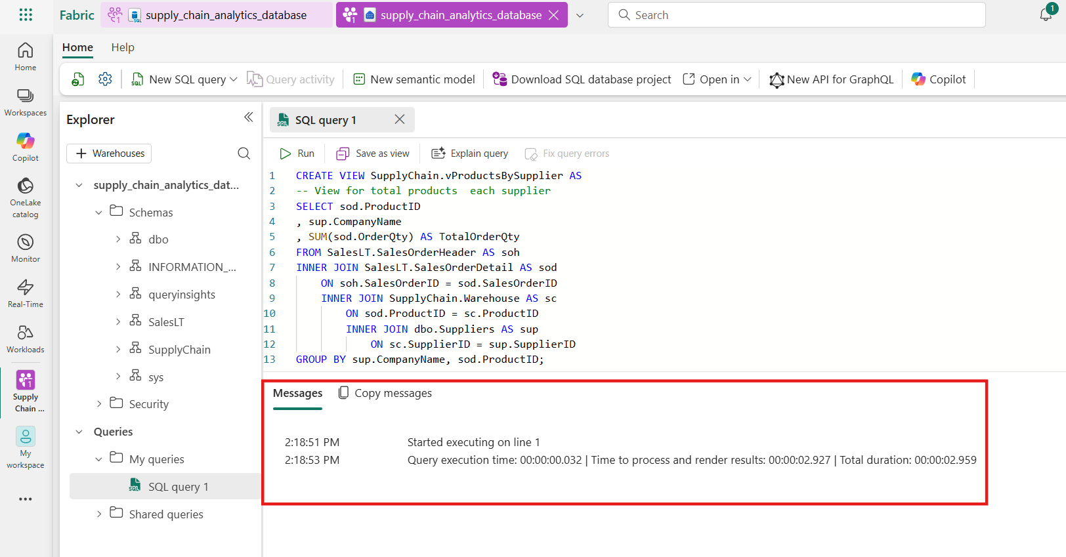
- This T-SQL query creates three new SQL views under the SupplyChain schema as
  - SupplyChain.vProductsBySupplier, SupplyChain.vSalesByDate, and SupplyChain.vTotalProductsByVendorLocation
- 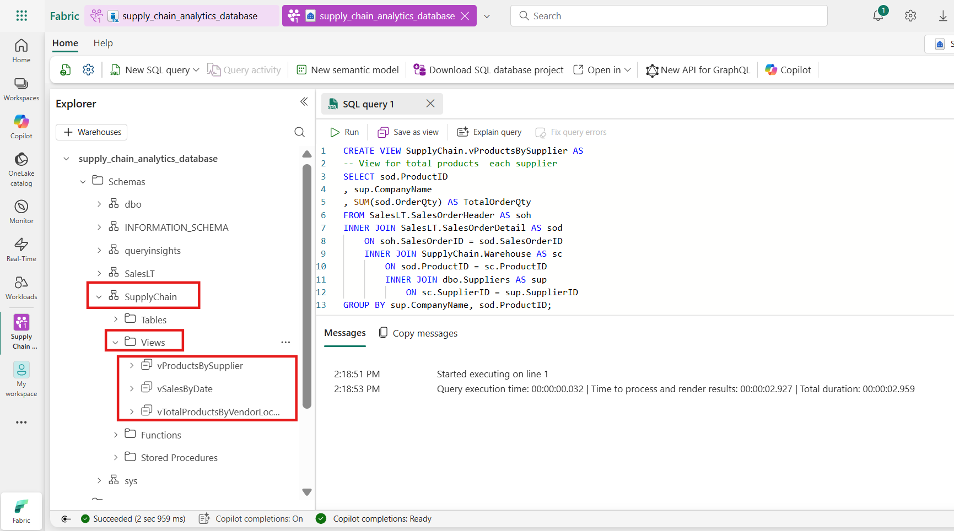
- You can now use these views in analytics and reporting. You will create a report using these views in the further steps.
- Exercise 6 – Create and share visualizations.
- Task-1: Find the connection strings to the SQL database.
- Click on supply_chain_analytics_database from the top navigation tab.
- 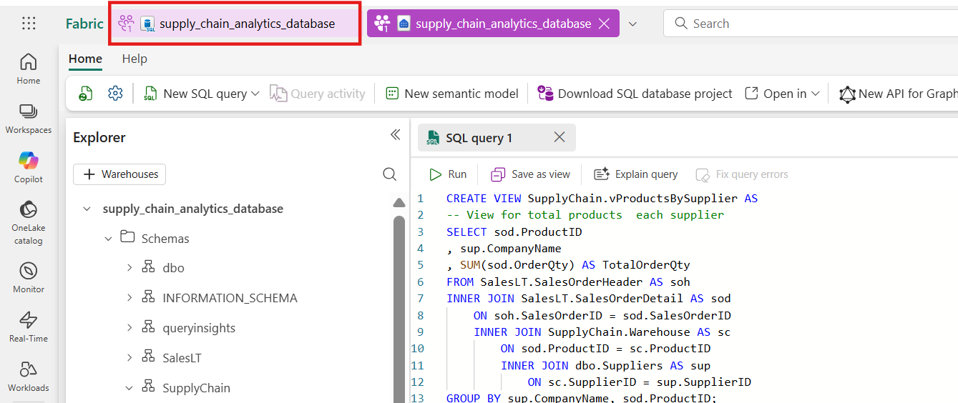
- To get your server and database name, open your SQL database in Fabric portal view and select the Settings button in the icon bar.
- 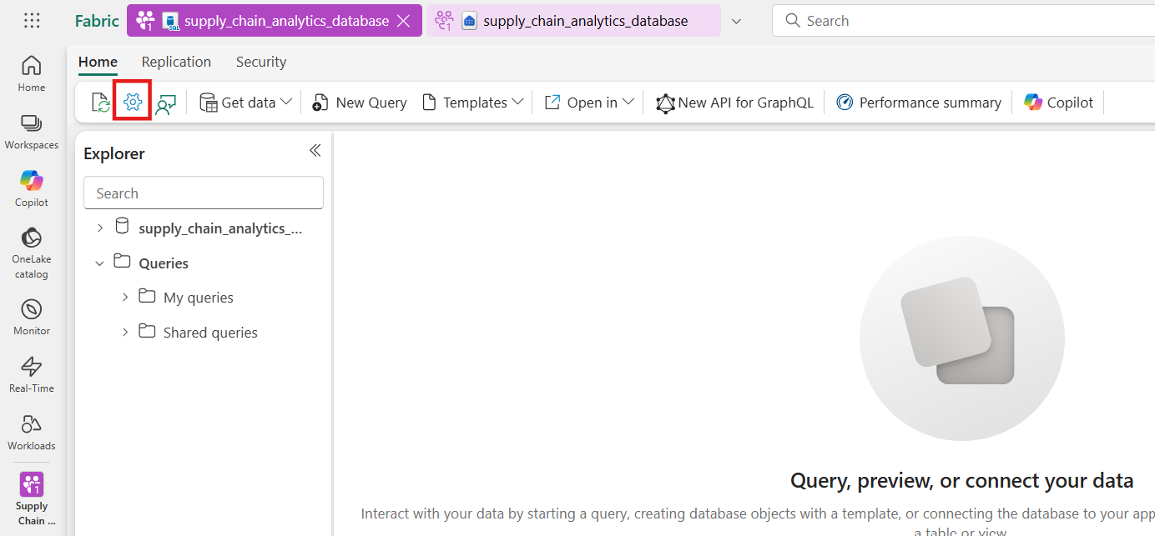
- Select Connection Strings and you'll see a long string that starts with Data Source… From there, select the text between the characters between DataSource and 1433. Ensure that you select the entire set of characters there and nothing more for the server name.
- 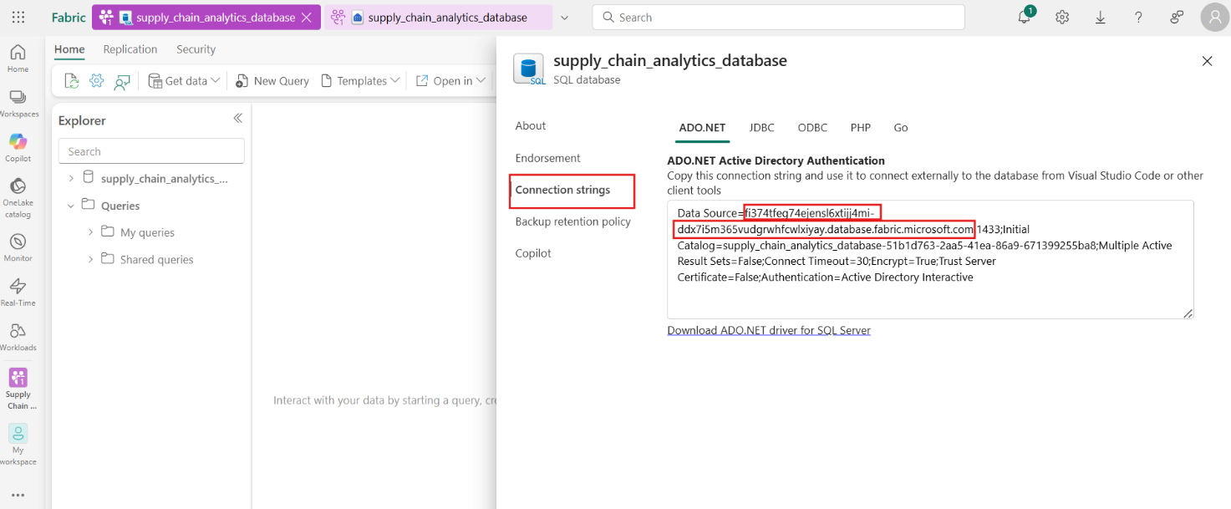
- For the database name, select all the characters between the characters Initial Catalog= and ;MultipleActiveResultSets.
- 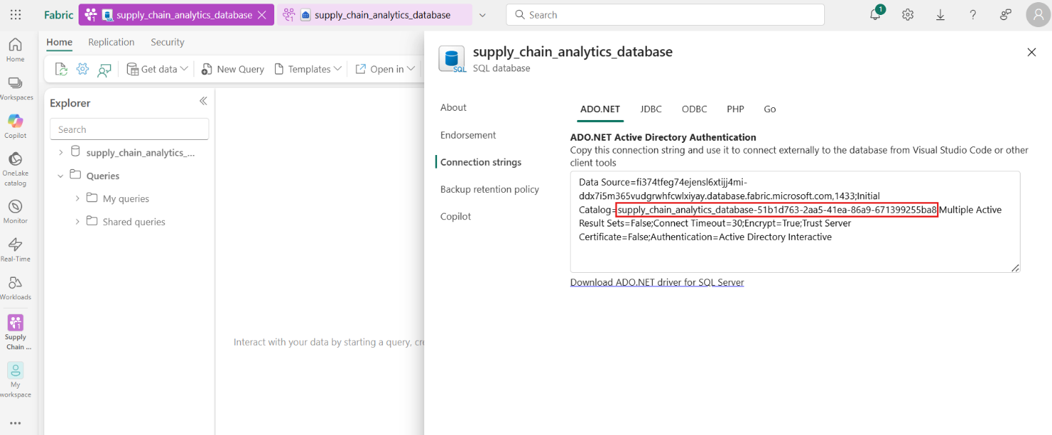
- Close the Settings menu.
- 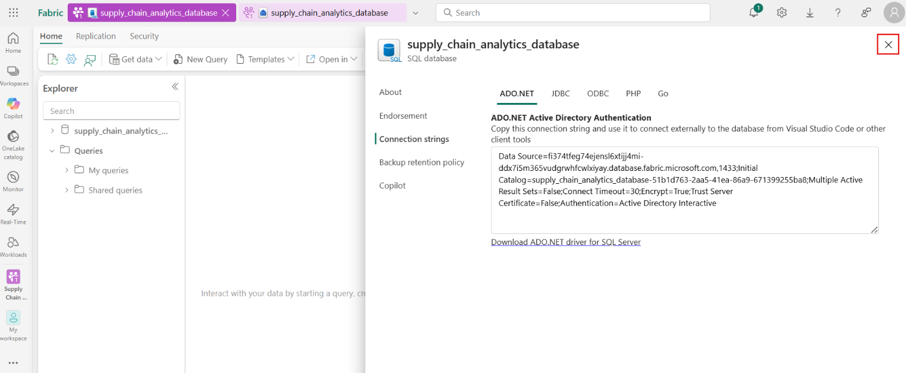
- You can now use these SQL strings in your connection area for tools such as Power BI or SQL Server Management Studio. For Visual Studio Code with the mssql extension, you can paste the entire connection string in the first text box where you make a database connection, so you don't have to select only the server and database names.
- Task-2: Power BI visualization creation
- As you work with the SQL analytics endpoint, it creates a Data model of the assets. This is an abstracted view of your data and how it's displayed and the relationship between entities. Some of the defaults the system takes might not be as you desire, so you'll now change one portion of the data model for this SQL analytics endpoint to have a specific outcome.
- Click on supply_chain_analytics_database SQL analytics endpoint from the top navigation tab.
- 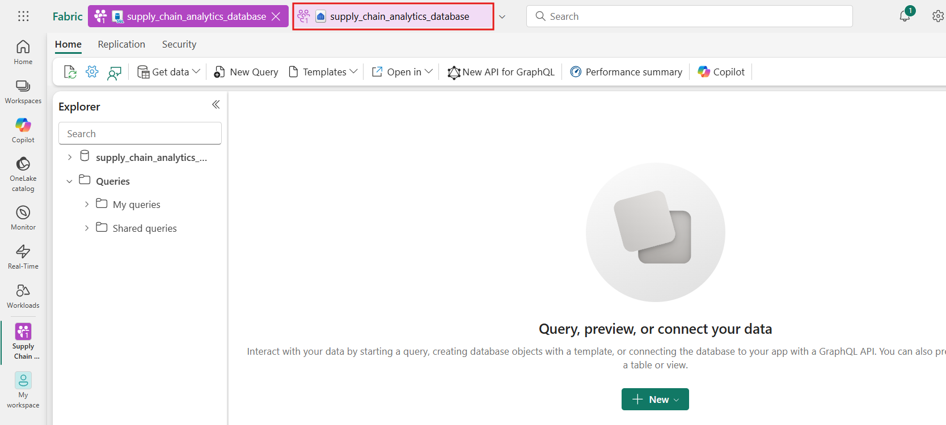
- Click on the New Semantic model under the Home tab.
- 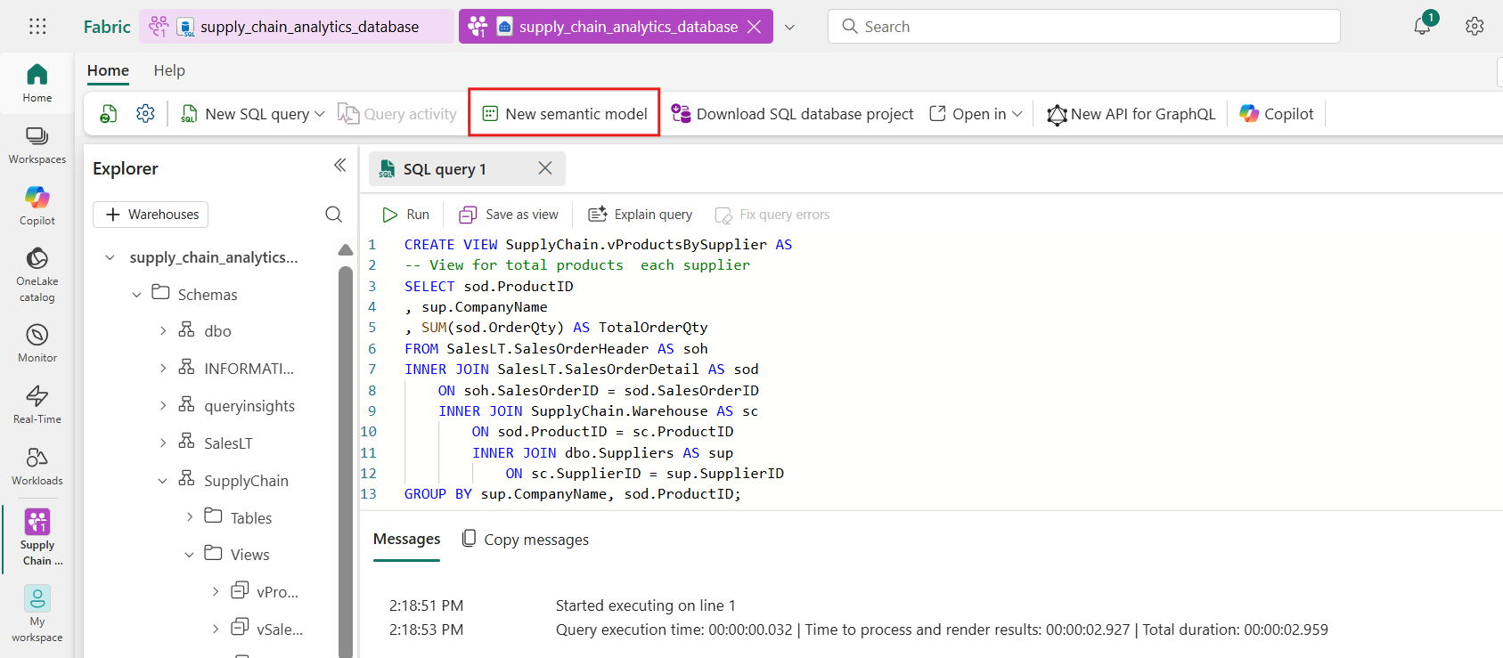
- Select all the tables in dbo and SupplyChain schema. Also, include the three views you have created in SupplyChain.
- 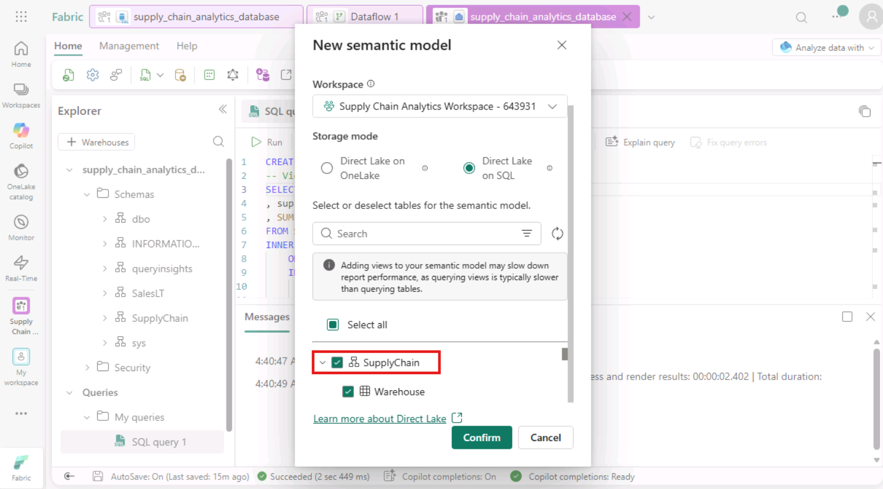
- 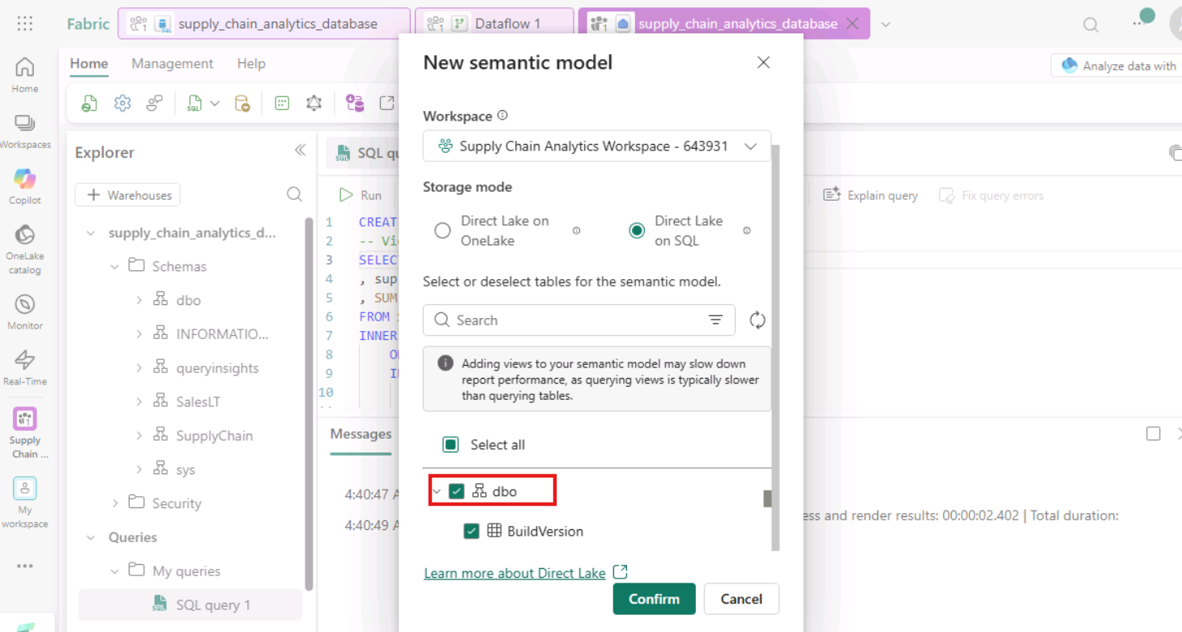
- Now, provide the name of the new semantic model as supplychain-model and click on Confirm.
- 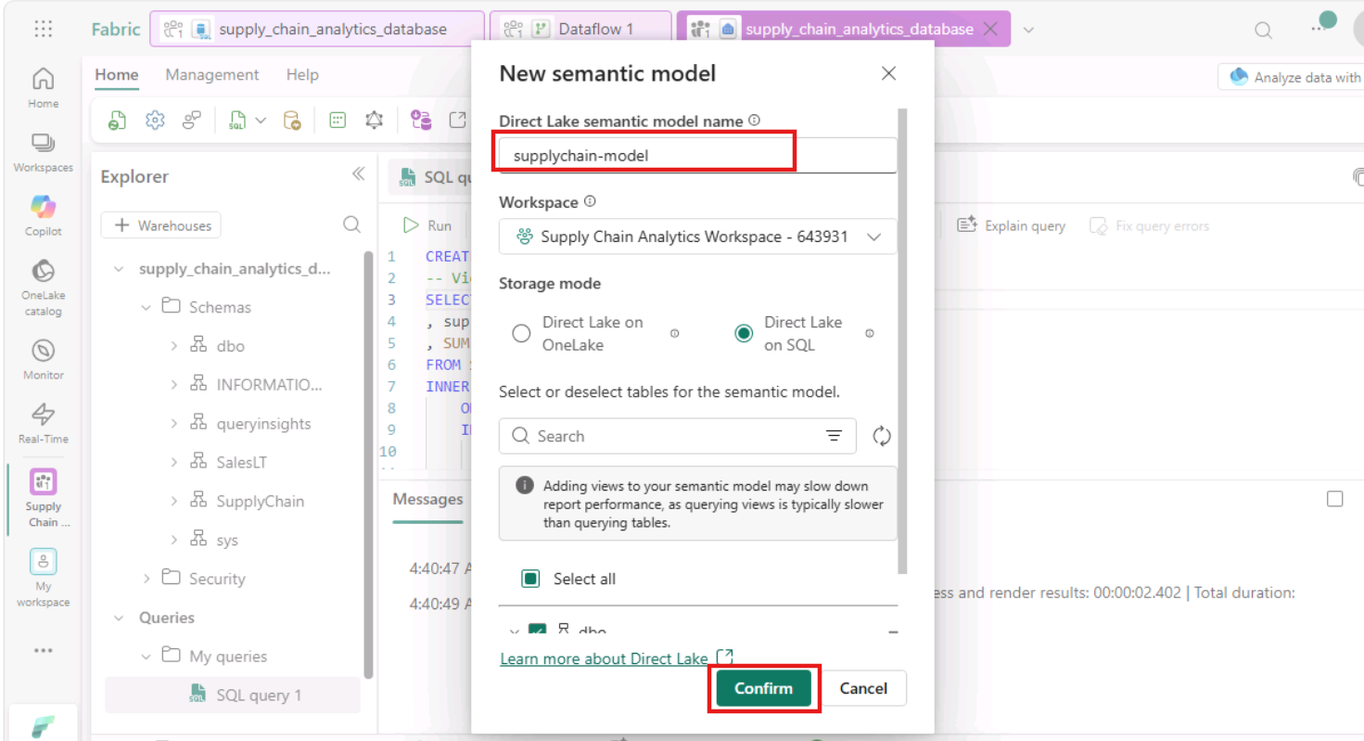
- Navigate to the workspace and open the semantic model created.
- 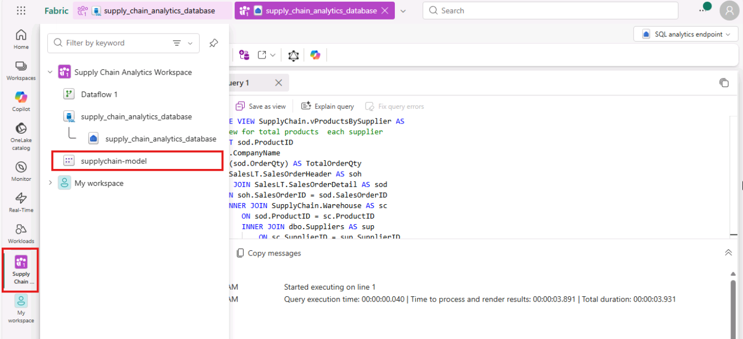
- Make sure the semantic model is in Editing view to make any changes.
- 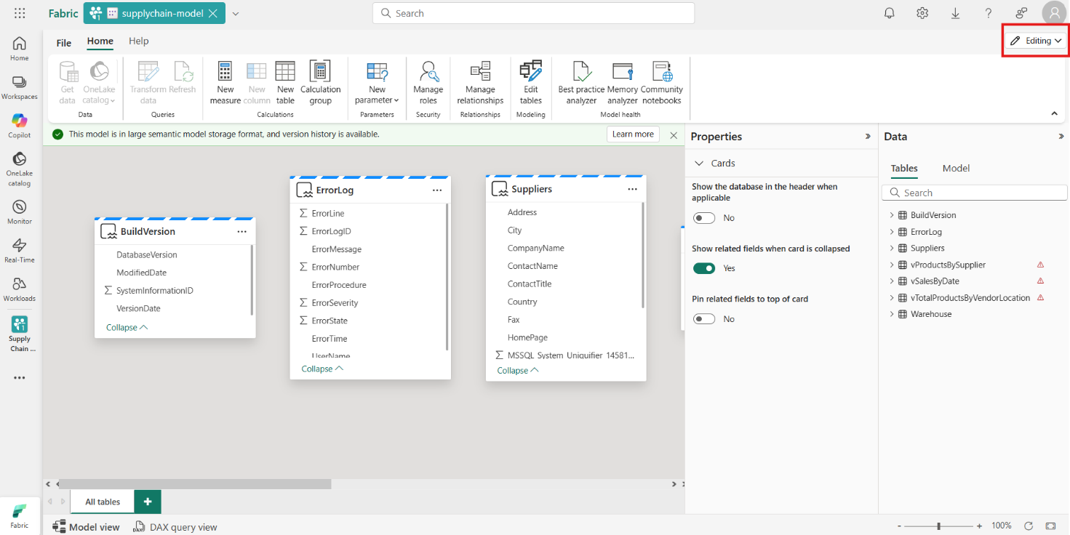
- From the resulting view, zoom in and scroll over until you see the vTotalProductsByVendorLocation object.
- 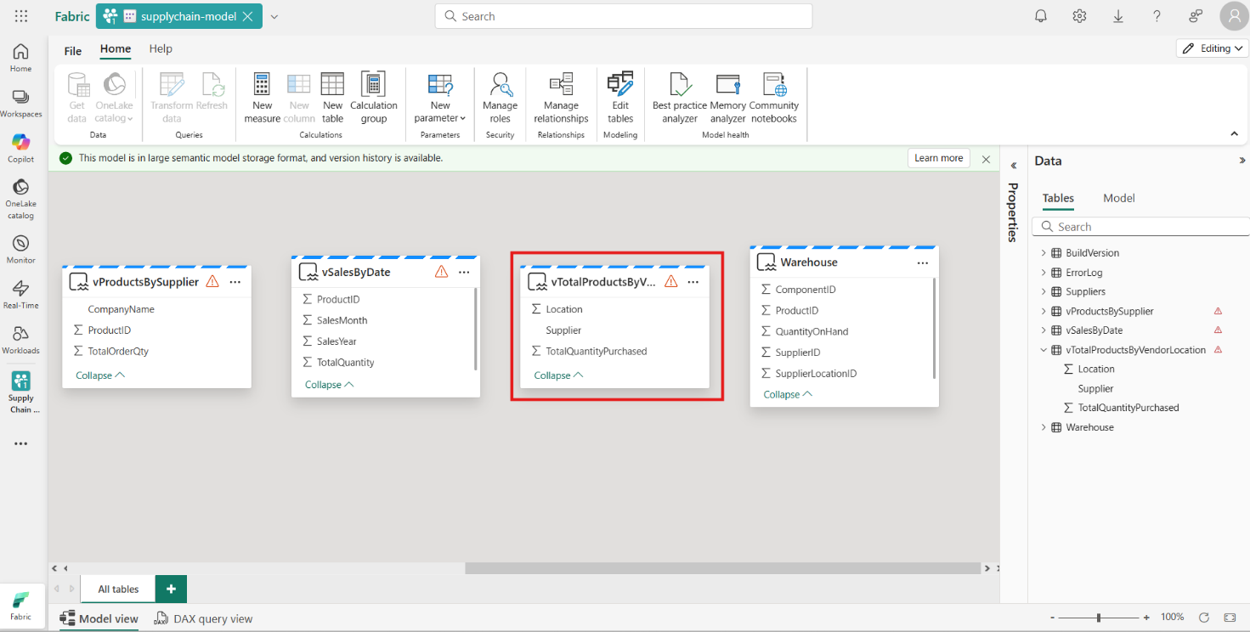
- In the properties, select the Location field, and expand the Advanced properties section. You might need to scroll to find it. Set the value of Summarize by to None. This ensures that when the field is used, it's a discrete number, not a mathematical summarization of that number.
- 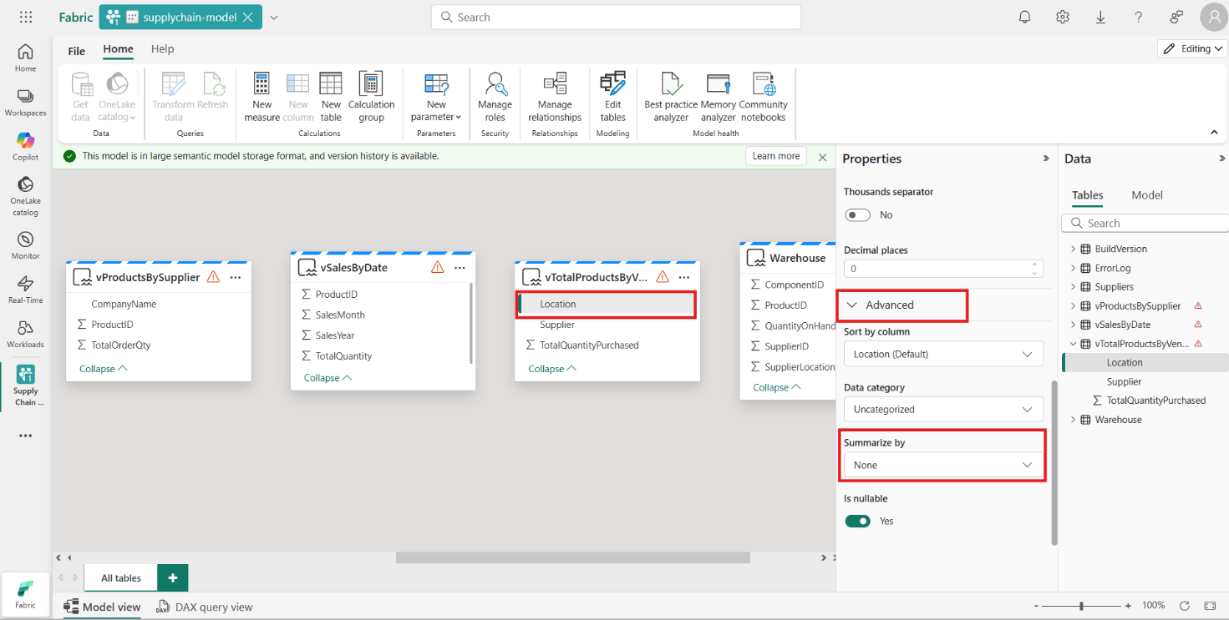
- Task-3: Create a report
- Here, the task is to create a report based on the views you created in the SQL analytics endpoint in previous steps.
- From the semantic model page, navigate to ‘File’ option and select ‘create a new report’ option.
- 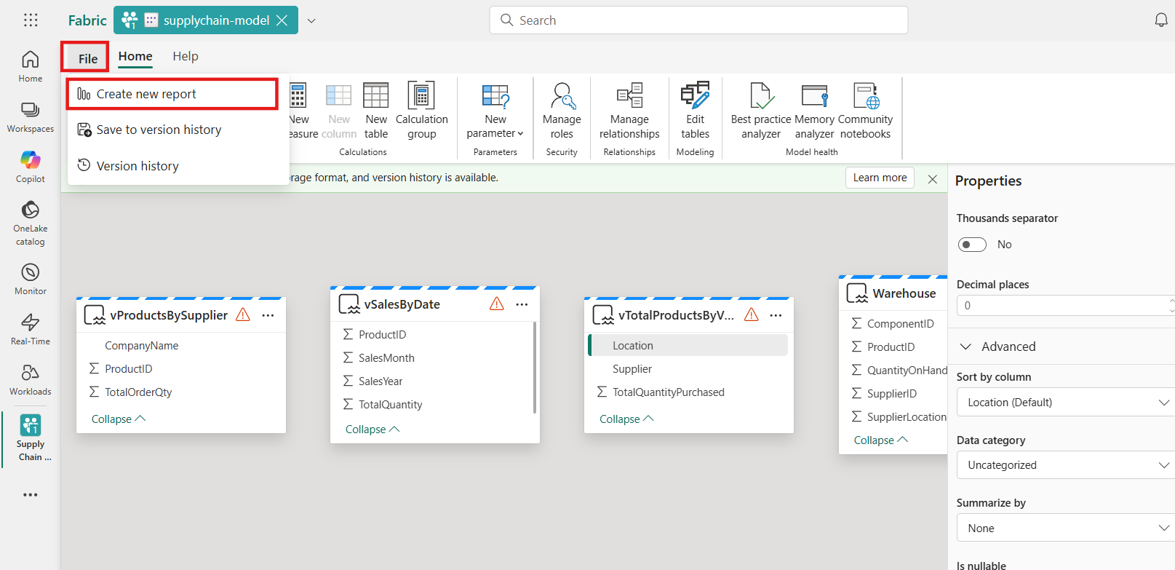
- Now the Power BI canvas appears.
- 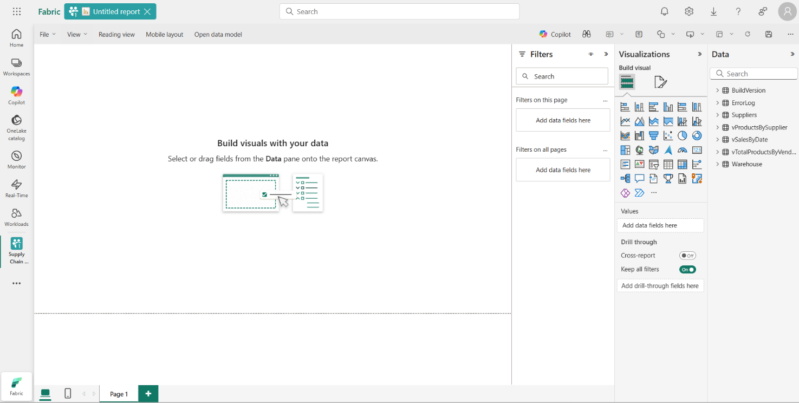
- Expand the vTotalProductsByVendorLocation data object. Select each of the fields you see there. The report takes a moment to gather the results to a text view. You can size this text box if desired.
- 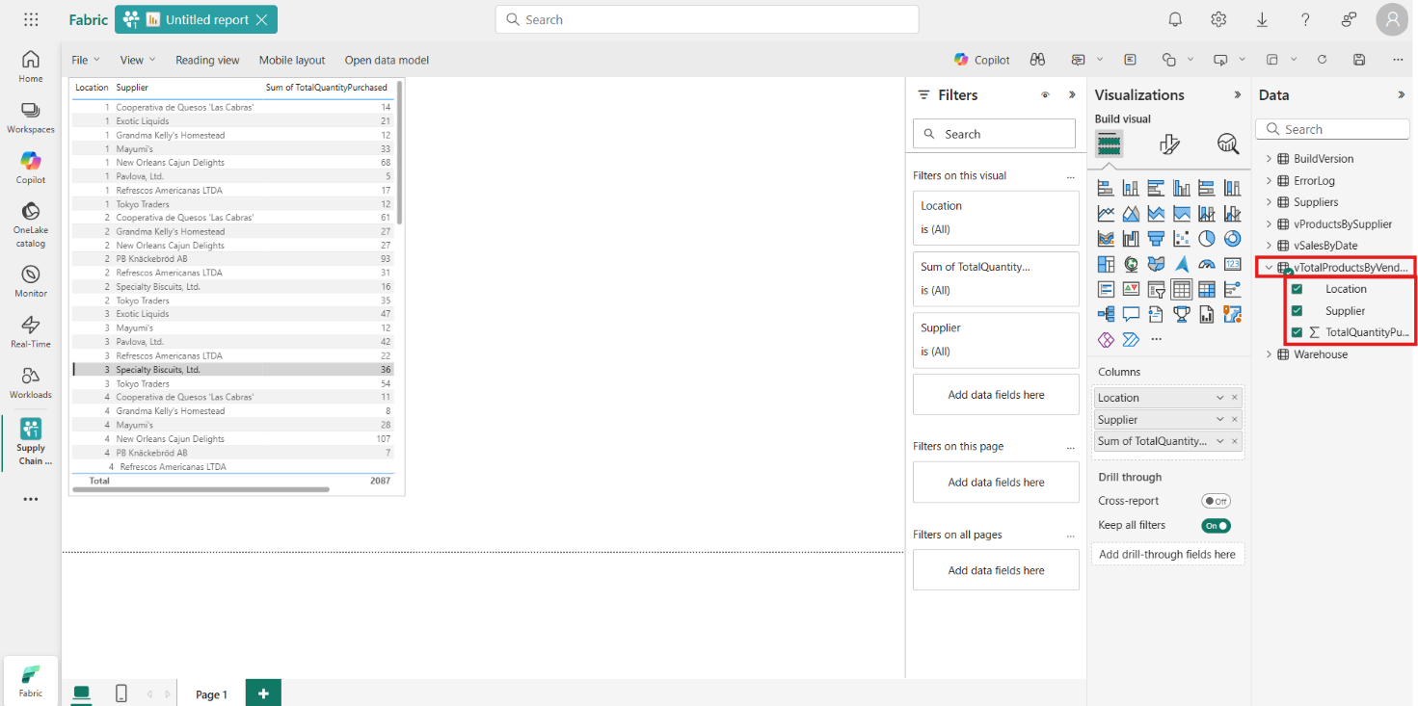
- Select in a blank area of the report canvas.
- 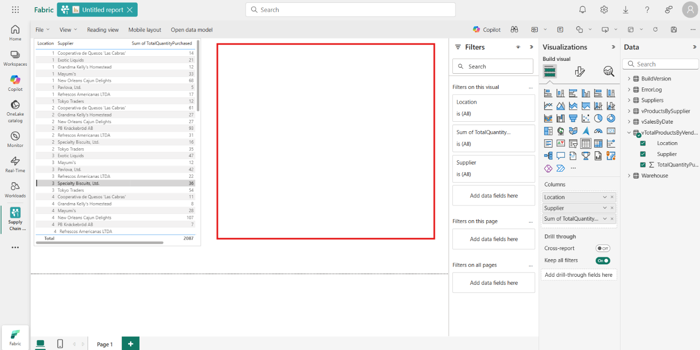
- Select Location in the Data fields area.
- 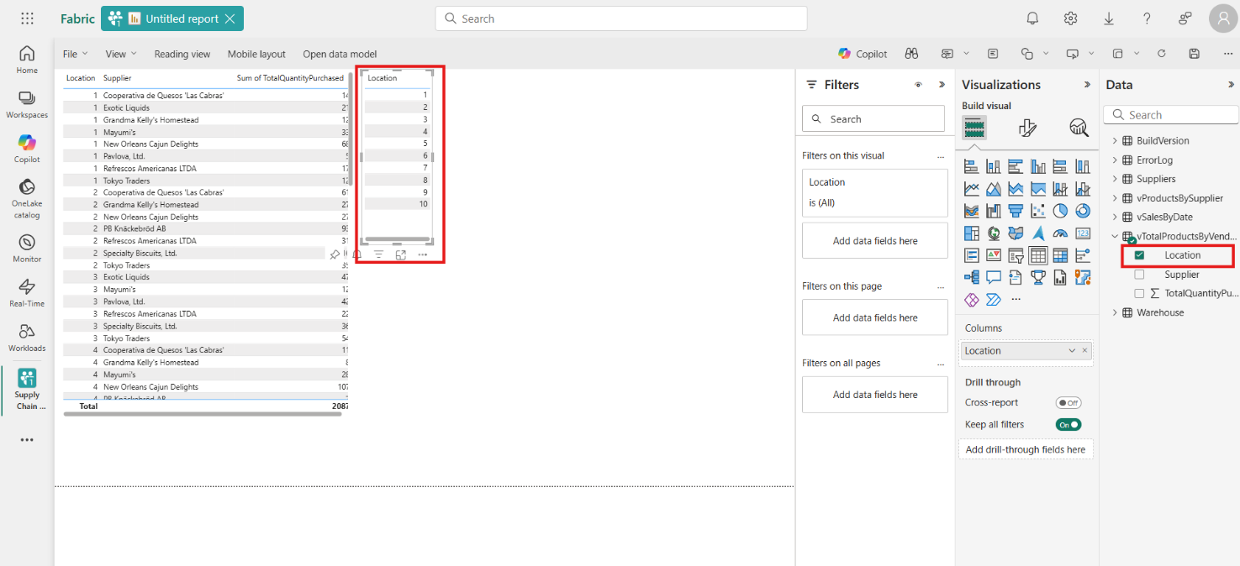
- Select a value in the box you just created – notice how the first selection of values follows the selection you make in the second box. Select that same value again to clear the selection.
- 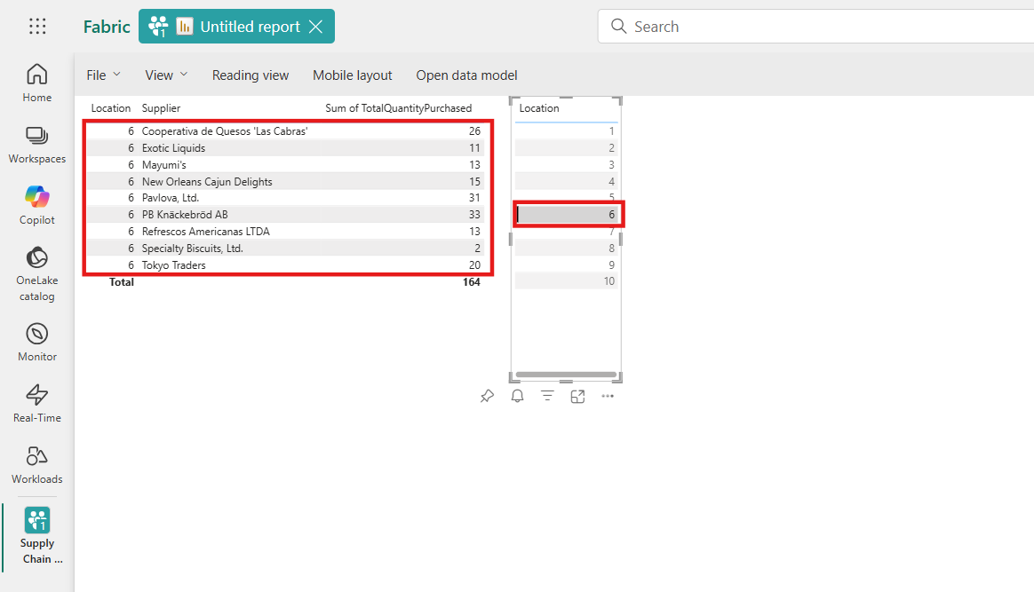
- Select in a blank area of the reporting canvas, and then select the Supplier field.
- 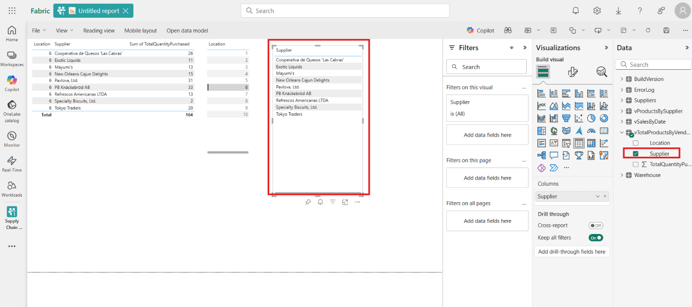
- Once again, you can select the name of a supplier and the first selection shows the results of just that supplier.
- 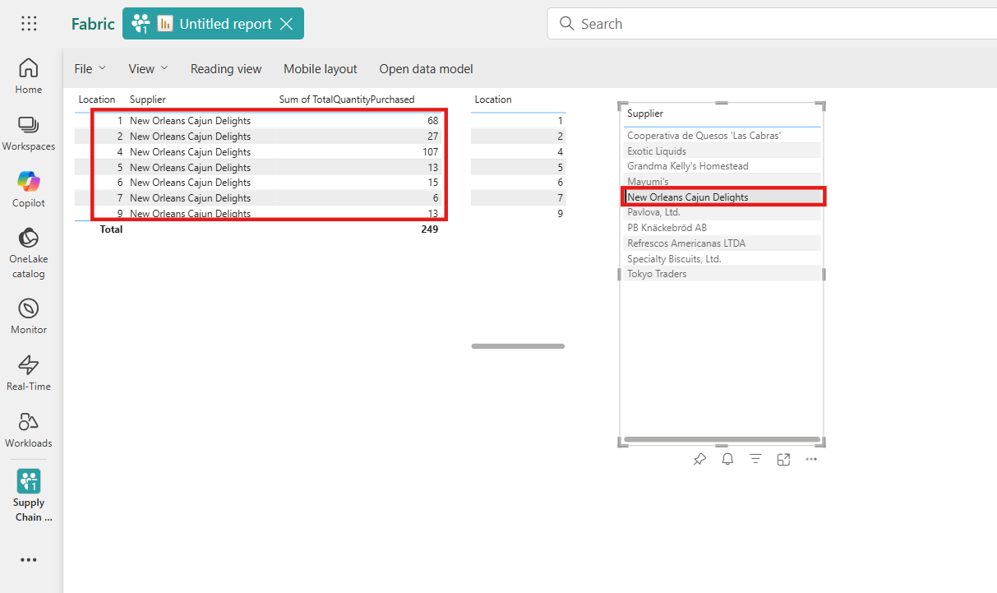
- Task-4: Save the Power BI item
- You can save and share your report with other people in your organization.
- Select the Save button in the icon box.
- 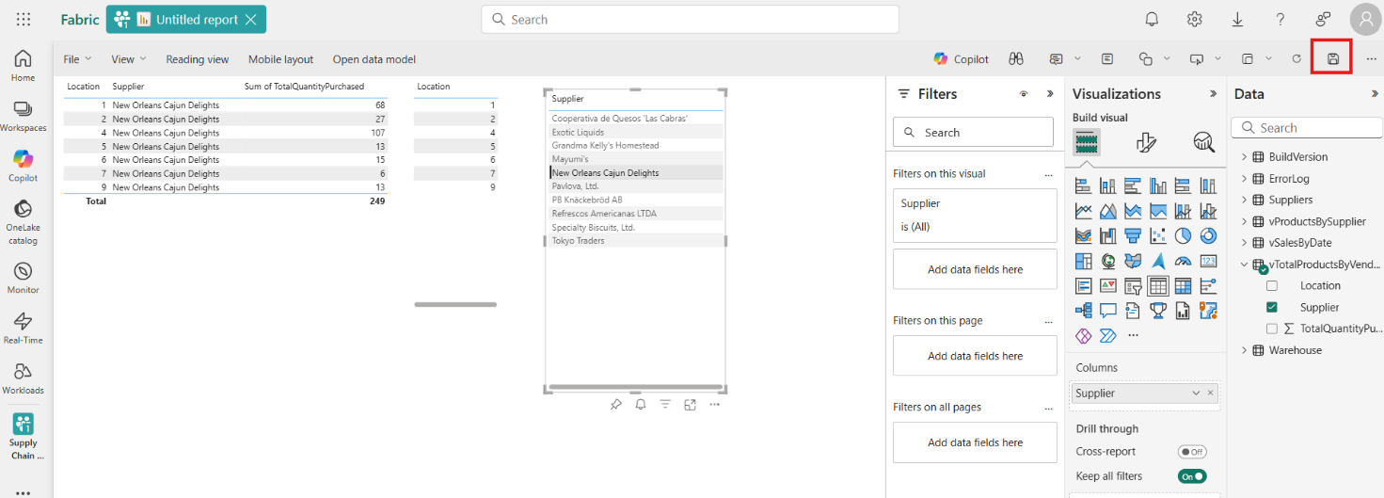
- Name the report suppliers_by_location_report and ensure you select the correct Workspace for this tutorial. Select Save button.
- 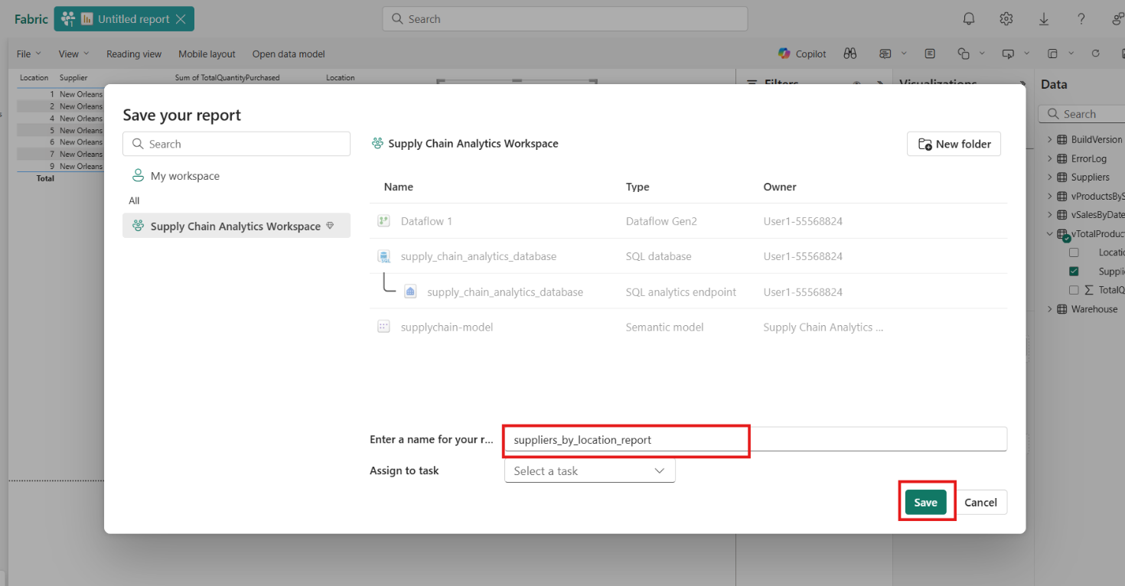
- 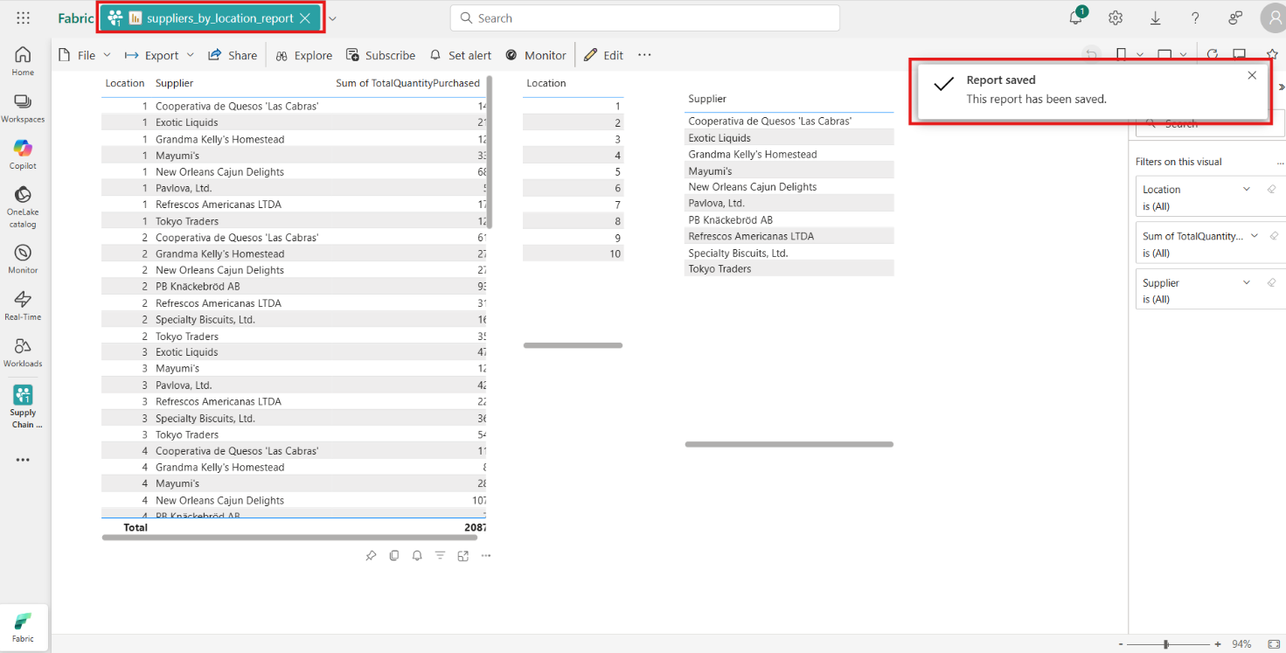
- Exercise 7 – Perform data analysis using Microsoft Fabric Notebooks
- Task-1: Data analysis with T-SQL notebooks
- Click on Supply Chain Analytics Workspace from the left-sided navigation bar.
- 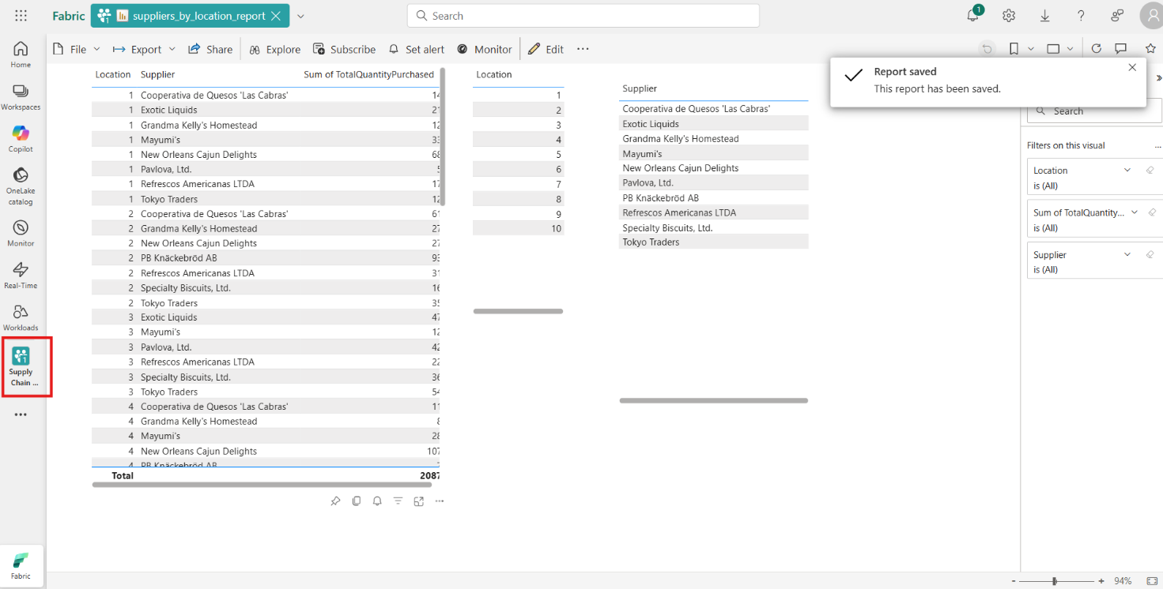
- Select the workspace name again.
- 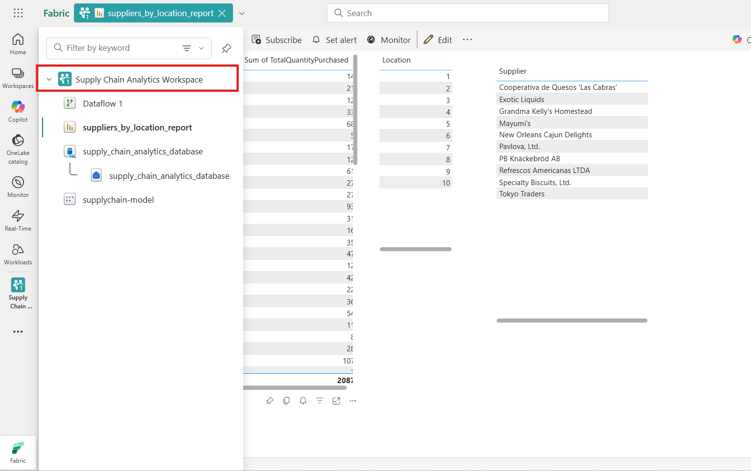
- In the Fabric page, select +New item. Then, select Notebook tile. Leave the default naming.
- 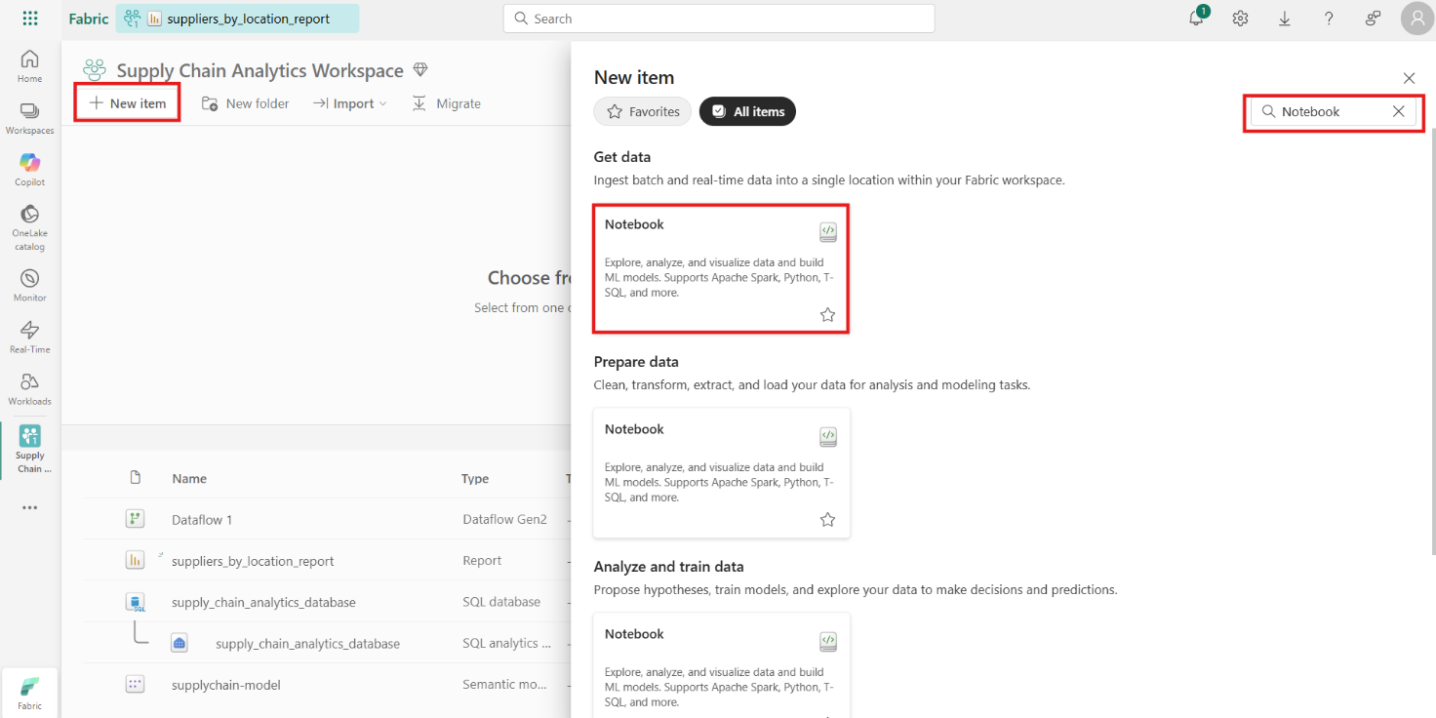
- In the icon bar, change the environment from PySpark (Python) to T-SQL.
- 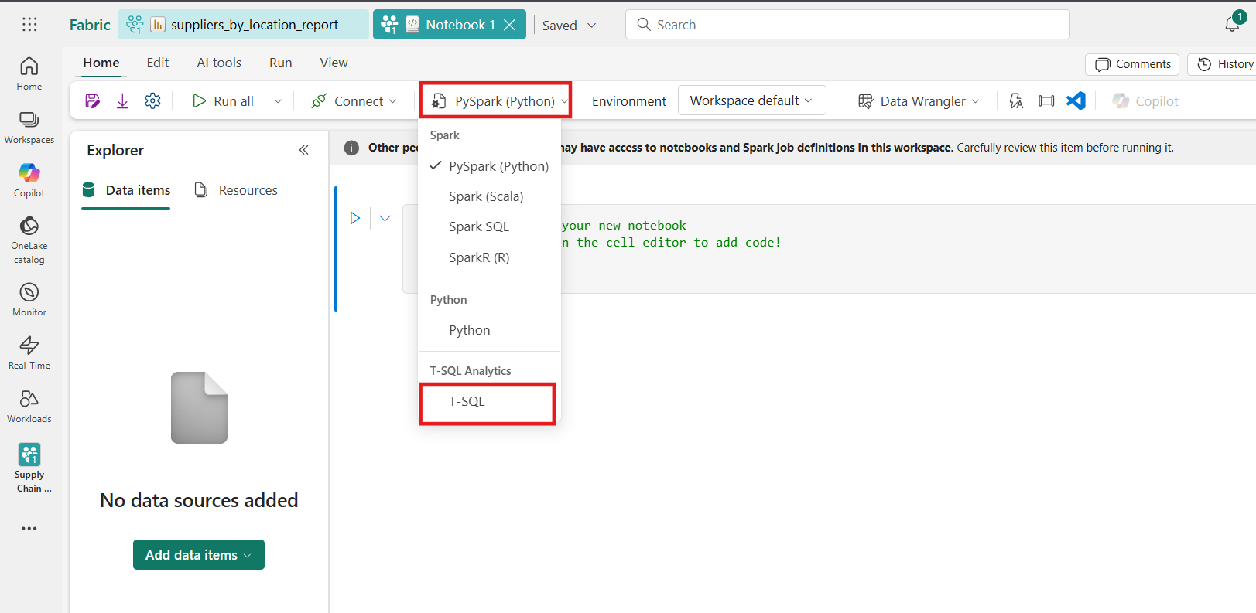
- In each code cell, there is a drop-down list for the code language. In the first cell in the Notebook, change the code language from PySpark (Python) to T-SQL.
- 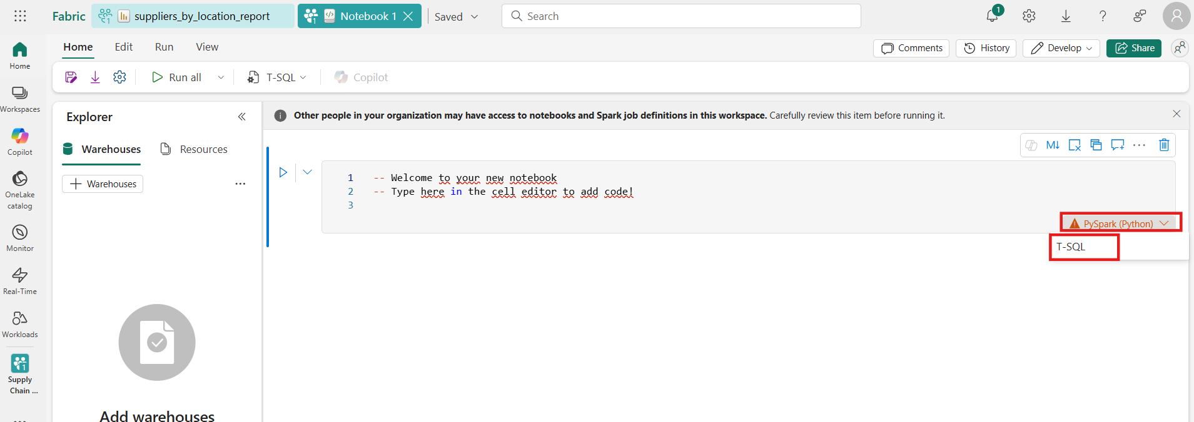
- Select Add data items and from the dropdown From OneLake catalog.
- 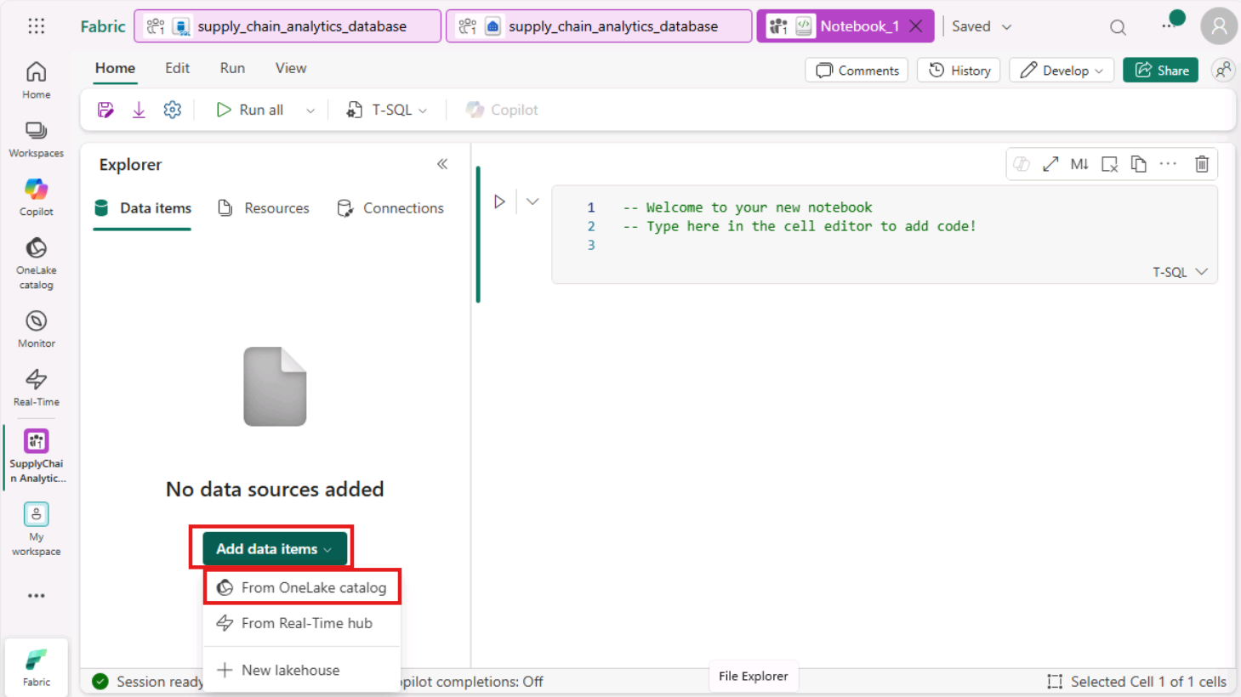
- Select the SQL analytics endpoint object that is named supply_chain_analytics_database. Select Confirm.
- 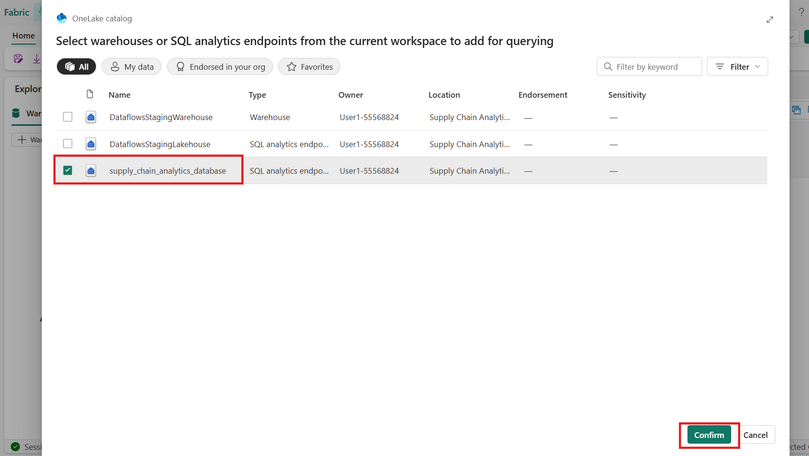
- 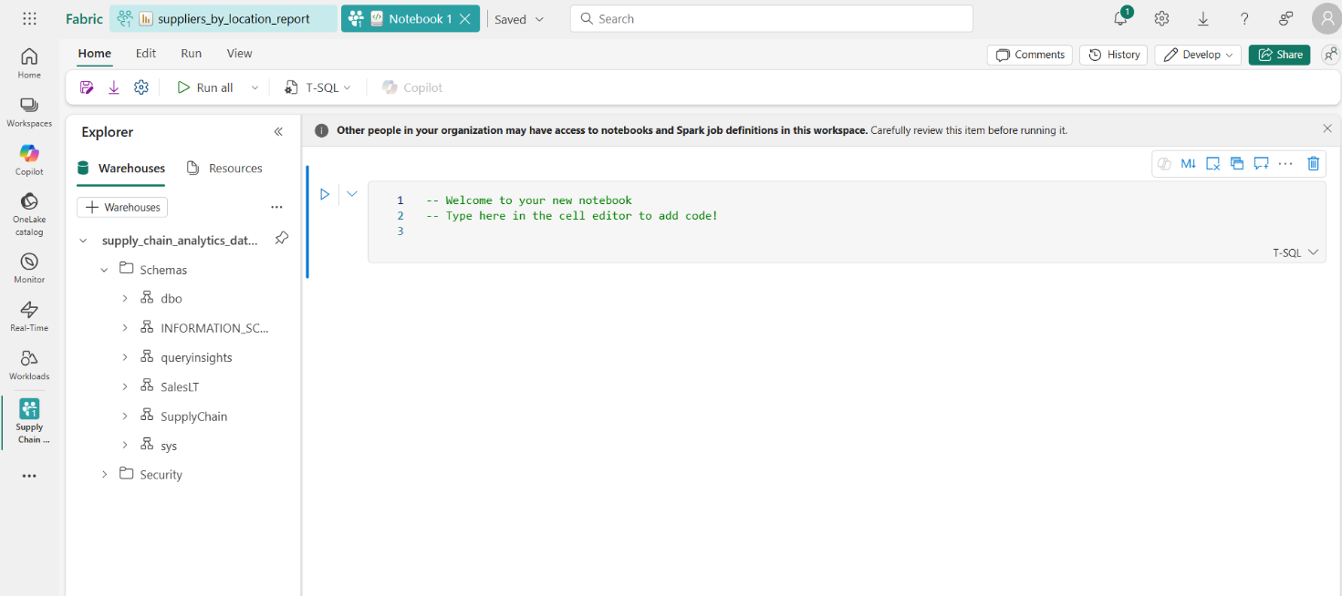
- Expand the database, expand Schemas. Expand the SupplyChain schema. Expand Views, and locate the SQL view named vProductsBySupplier.
- 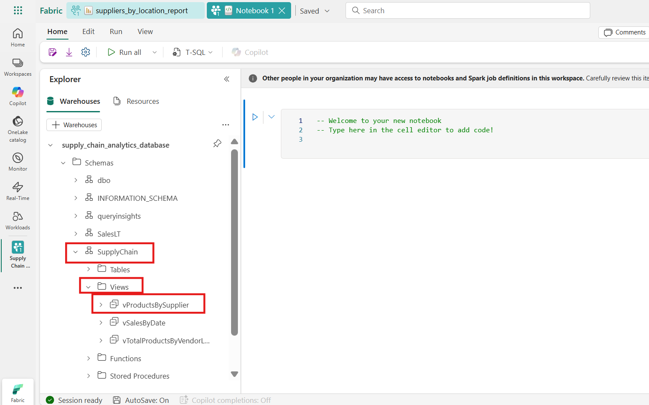
- Select the ellipses next to that view. and select the option that says SELECT TOP 100.
- 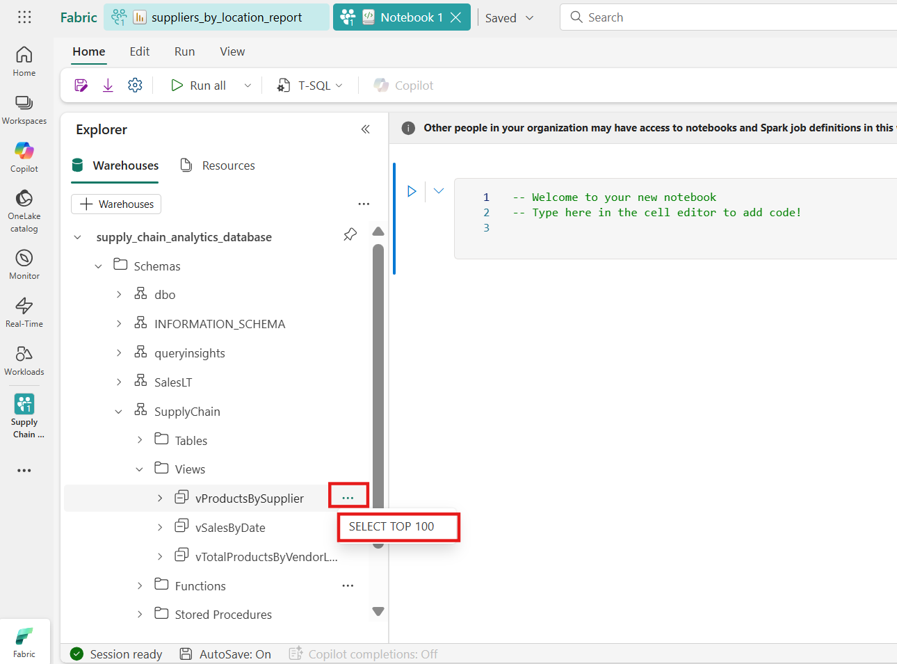
- This creates a cell with T-SQL code that has the statements pre-populated for you. Select the Run Cell button for the cell to run the query and return the results.
- 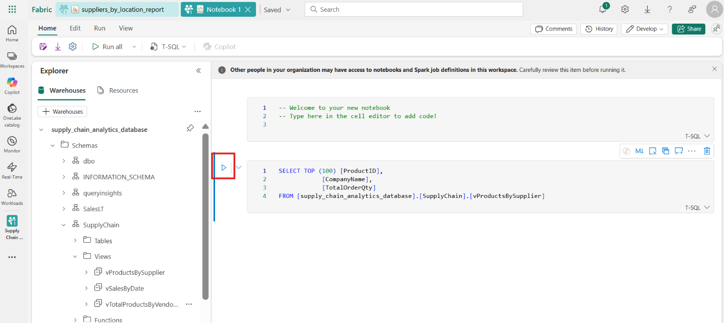
- 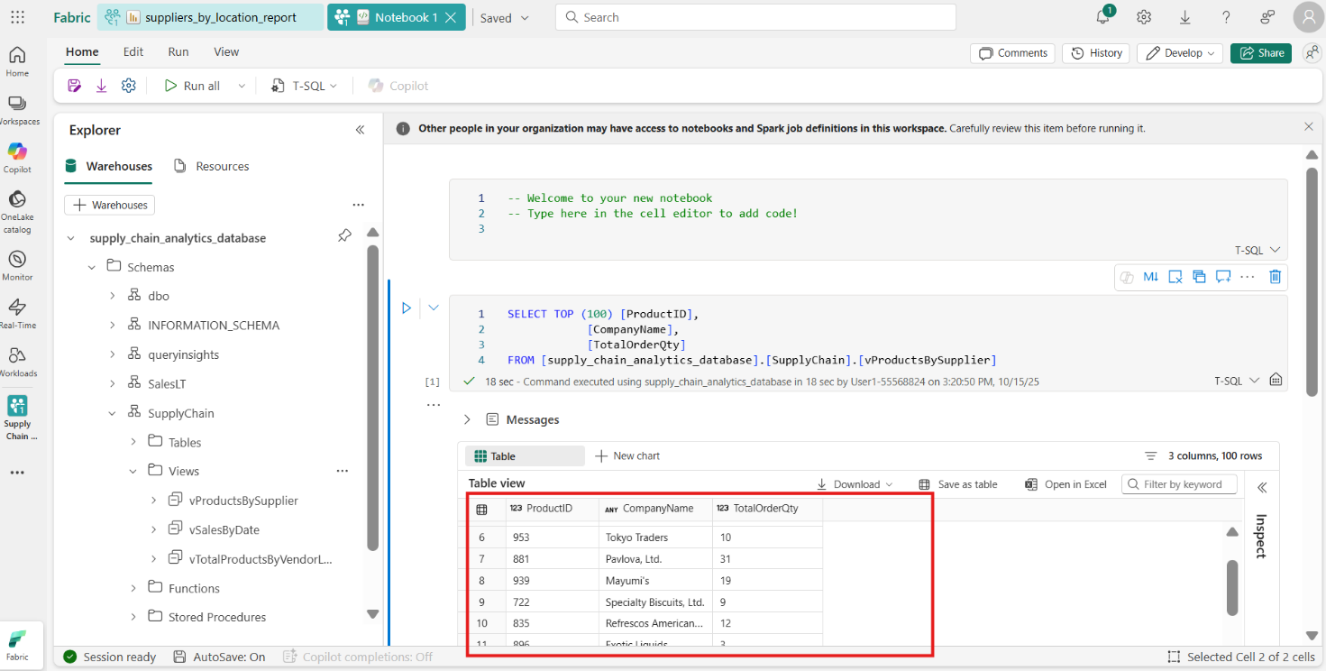
- In the results, you can see not only the data requested, but buttons that allow you to view charts, save the data as another table, download, and more.
- 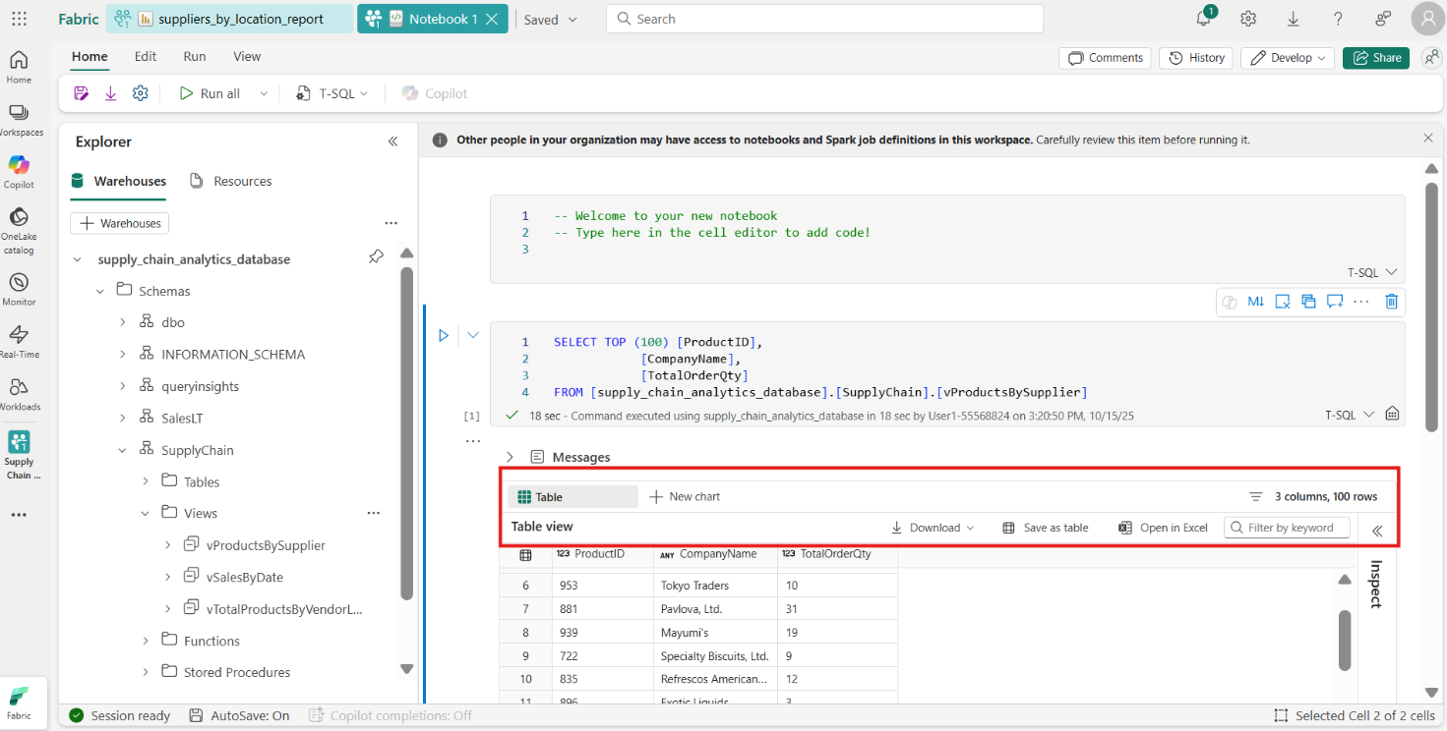
- To the side of the results you can see a new pane with quick inspection of the data elements, showing minimum and maximum values, missing data, and unique counts of the data returned.
- 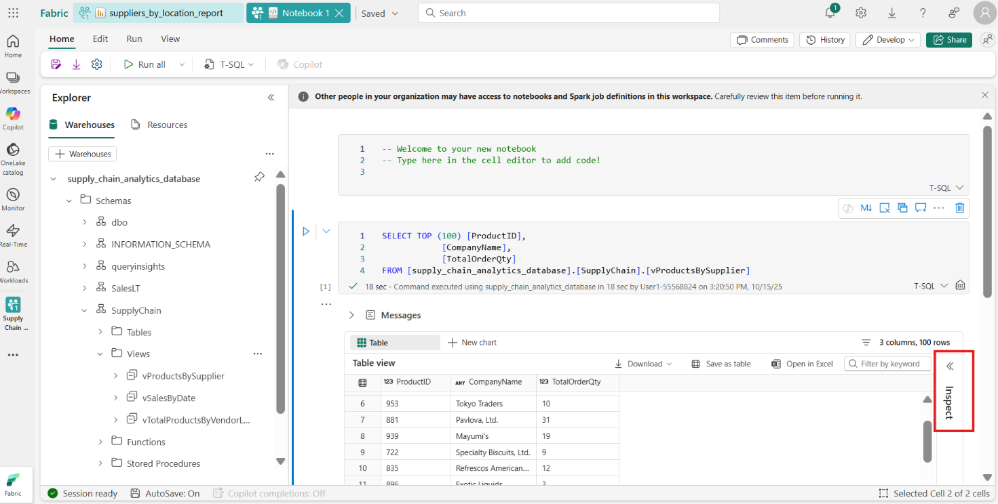
- 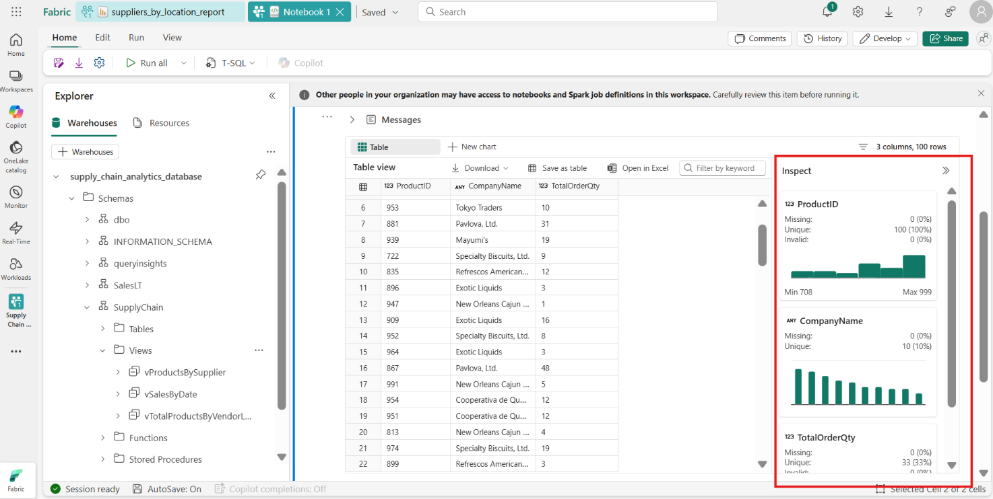
- Hovering between the code cells shows you a menu to add another cell. Select the + Markdown button.
- 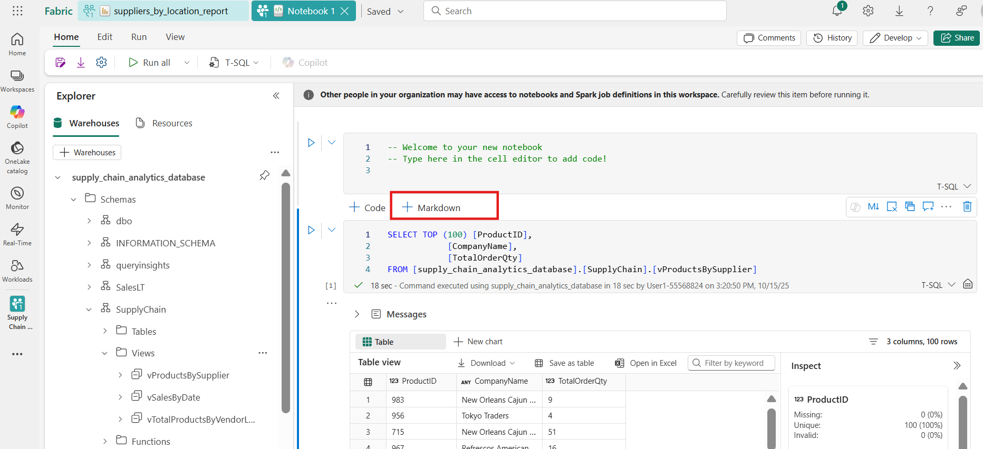
- 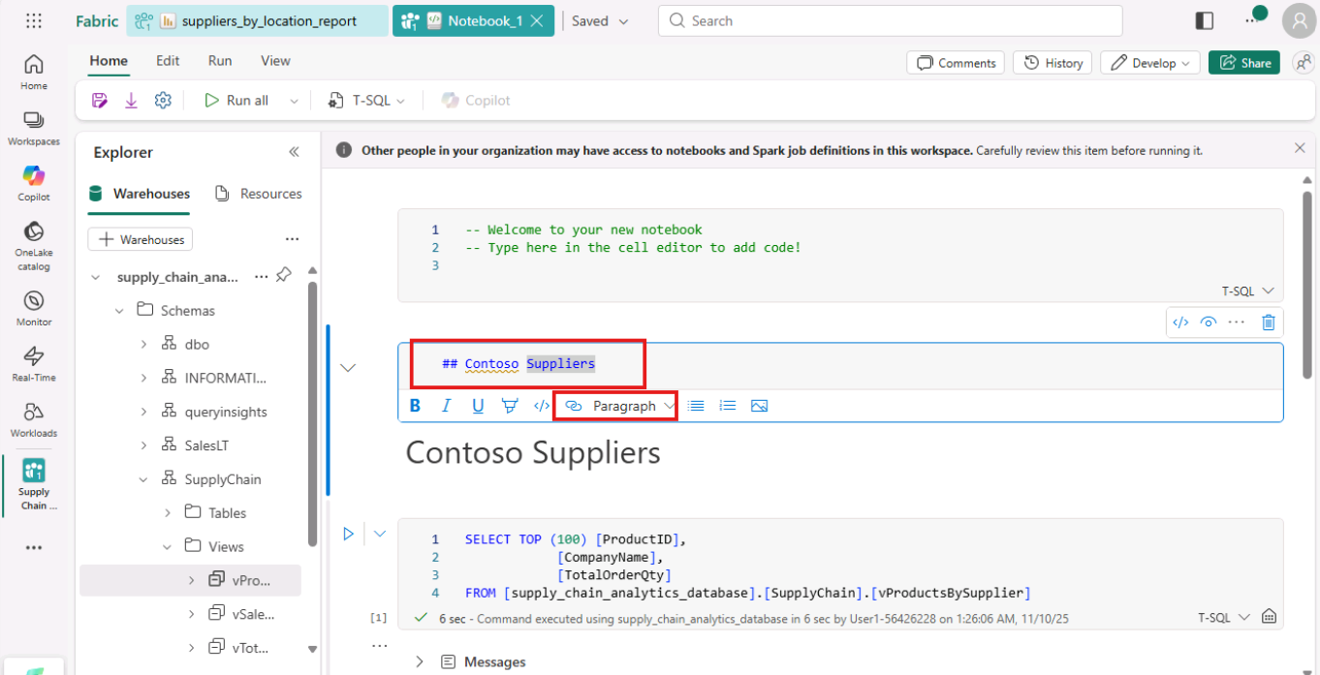
- This places a text-based field where you can add information. Styling for the text is available in the icon bar, or you can select the \</> button to work with Markdown directly. The result of the formatting show as a preview of the formatted text.
- 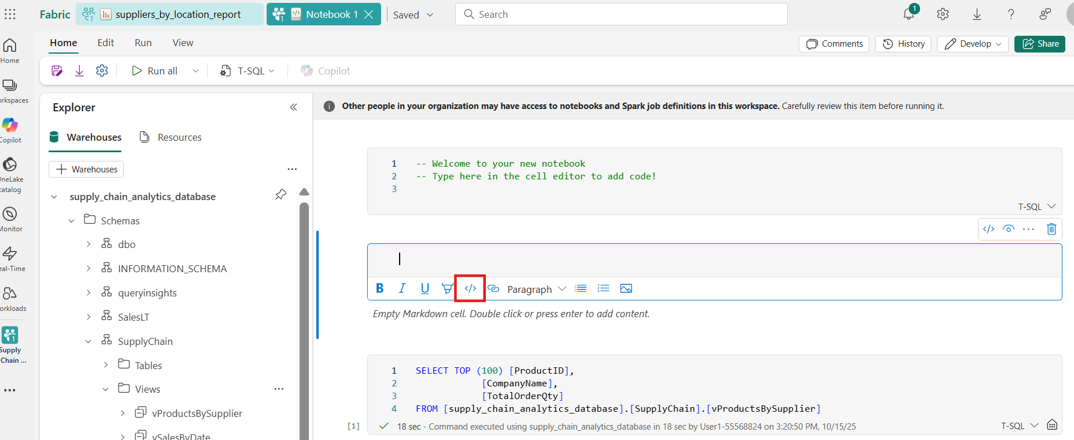
- 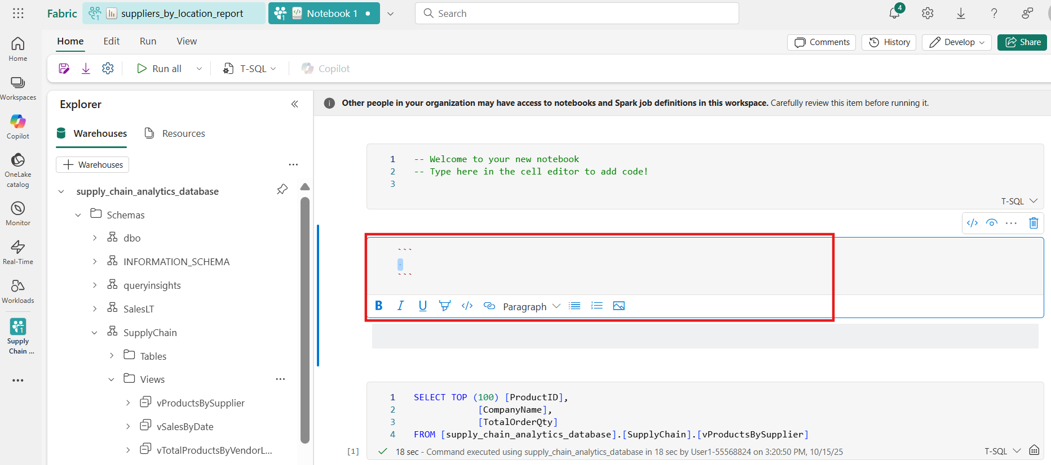
- Select the Save As icon in the ribbon.
- 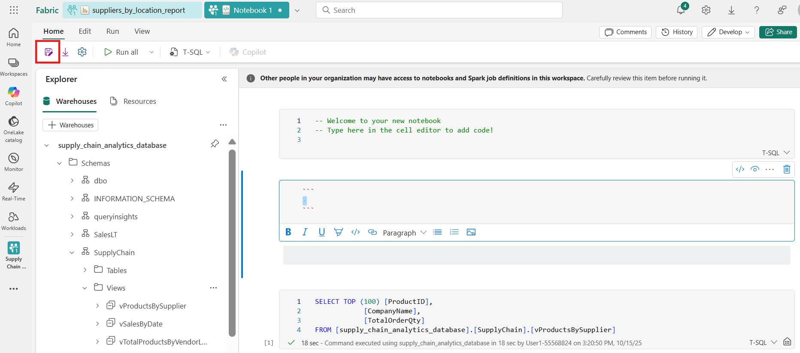
- Enter the text products_by_suppliers_notebook. Ensure you set the location to your tutorial Workspace. Select the Save button to save the notebook.
- 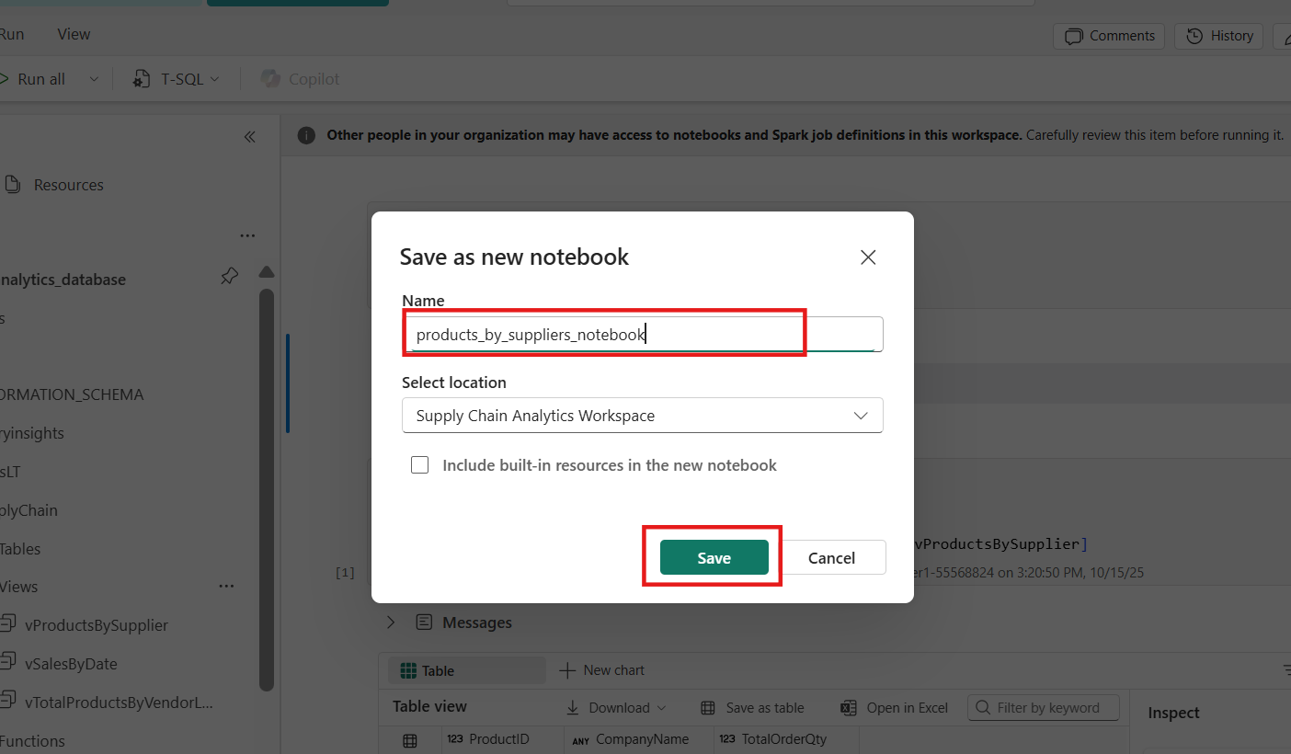
- 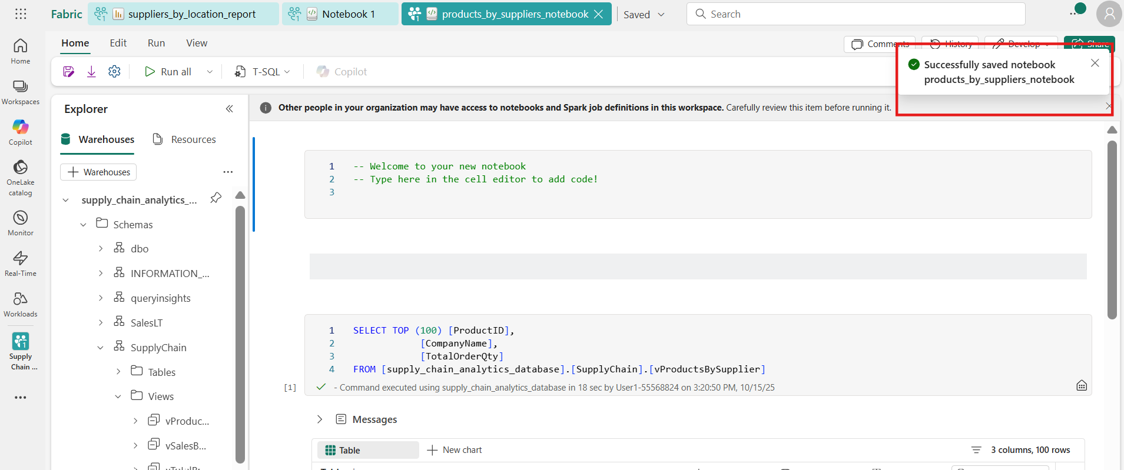
- Exercise 8 – Create an application with DevOps and GraphQL API
- Task-1: Create a repository in the Azure DevOps project
- Open a new tab on your browser and paste this url to navigate to Azure DevOps: https://dev.azure.com/ADOCourseOrg04 and Sign in with the given credentials.
- 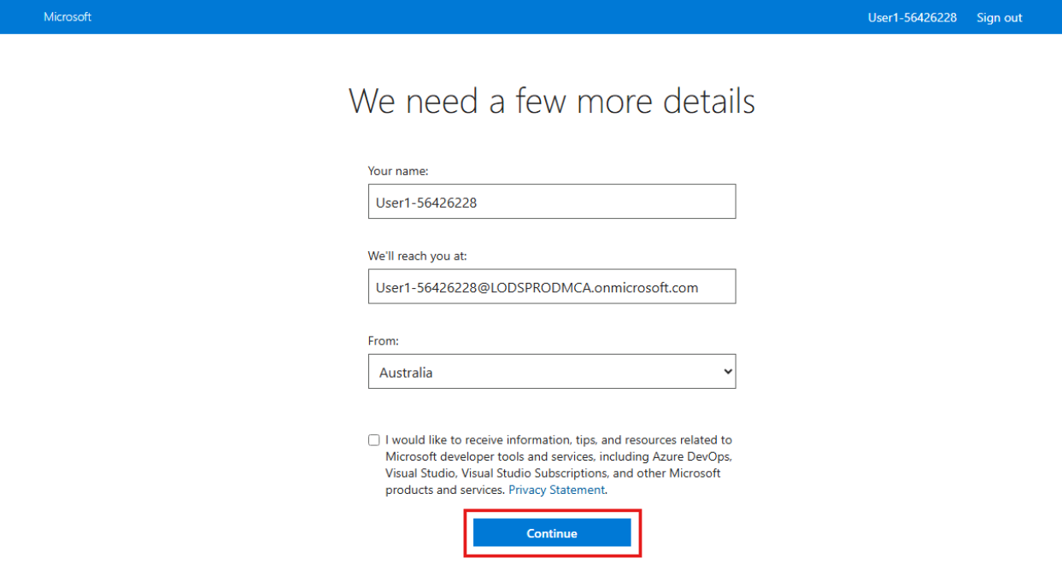
- Select your project ‘Supply-Chain-Disruption-App’
- 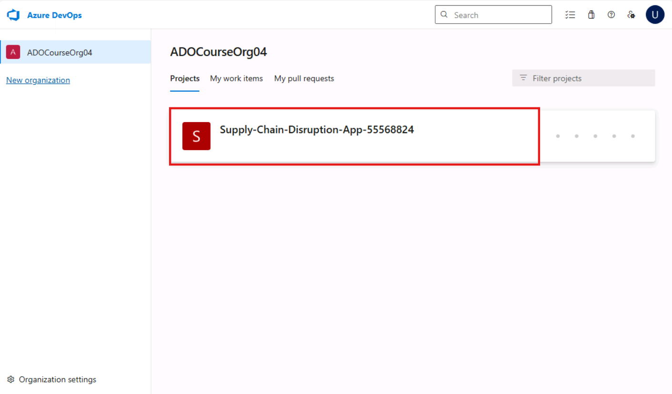
- Navigate to Files option under Repos section. From the repo drop-down at the top, select new repository.
- 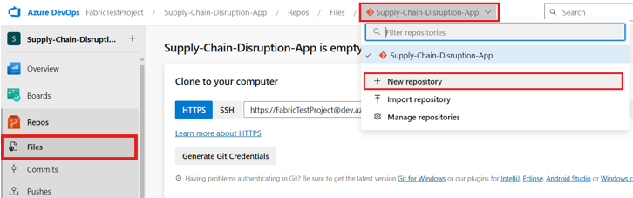
- In the Create a new repository dialog, verify that Git is the repository type and enter a name – SupplyChainAnalytics for your new repository. To add a README, check the checkbox.
- When you're happy with the repo name and choices, select Create.
- 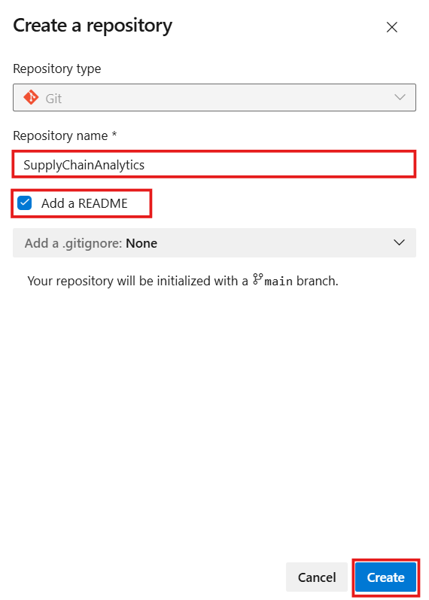
- Task-2: Connect your workspace to the source control (Azure DevOps)
- Navigate to Fabric portal, go to the workspace you want to connect and select Workspace settings from top-right corner.
- 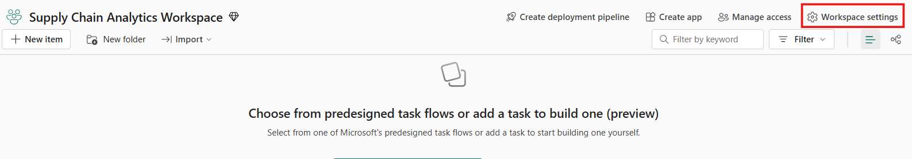
- Under Git Integration settings, select Azure DevOps as your Git provider and the Entra user as well. Click on Connect.
- 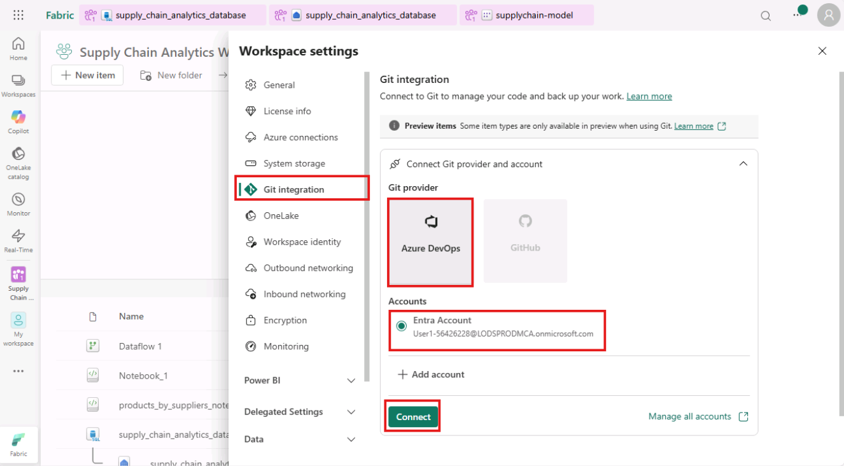
- You'll be automatically signed into the Azure Repos account registered to the Microsoft Entra user signed into Fabric.
- Provide Repository Details:
  - Organization: Select your Azure DevOps organization ADOCourseOrg from the dropdown.
  - Project: Choose the project Supply-Chain-Disruption-App where your repository is located.
  - Git Repository: Select the repository i.e., SupplyChainAnalytics.
  - Branch: Specify the main branch you want to connect the workspace.
  - Git Folder: Specify a folder within the branch where Fabric items will be stored. If not created already in Azure DevOps portal, it’ll be created from here as well. You can mention the folder name as SampleWorkload.
- Click on Connect and Sync.
- 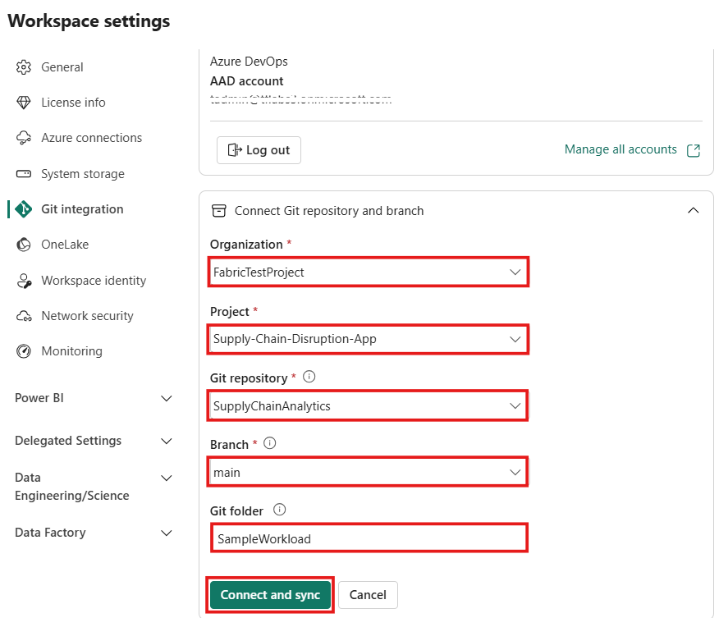
- Now that you have mentioned the folder name which not created earlier, give a confirmation by clicking on Create and Sync to establish the connection and synchronize the workspace with the Git repository.
- 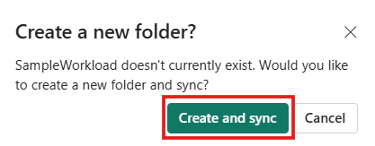
- Workspace is now connected to the source control. The items in the workspace will automatically by synced. It might take 5-10 mins. Ensure that the Workspace is set up to be under source control and all objects show Synced status.
- 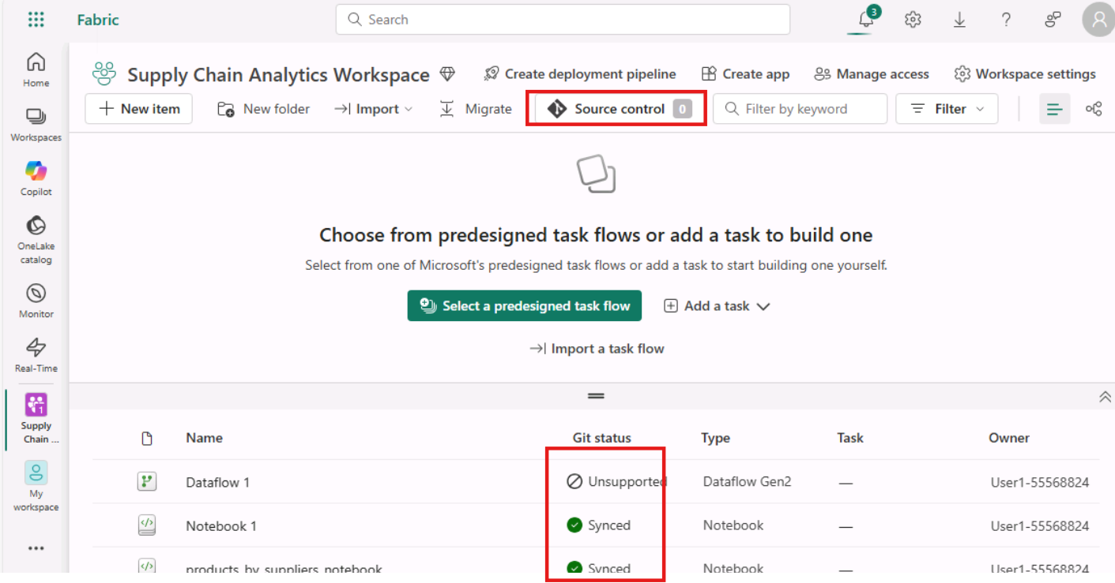
- In the Workspace view, you'll see the git icon, the branch you selected, and a message about the last time the Workspace was synchronized with source control. Next to the date and time, you'll see an identifier link for the specific location in your Azure DevOps environment. Open that link to continue.
- 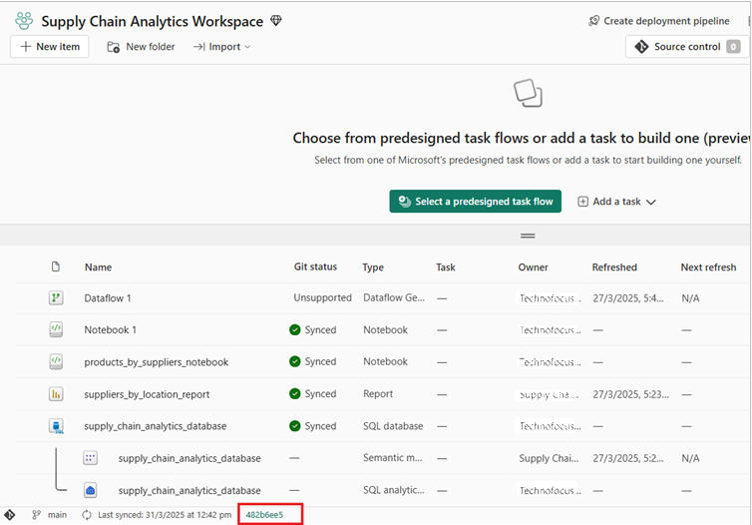
- 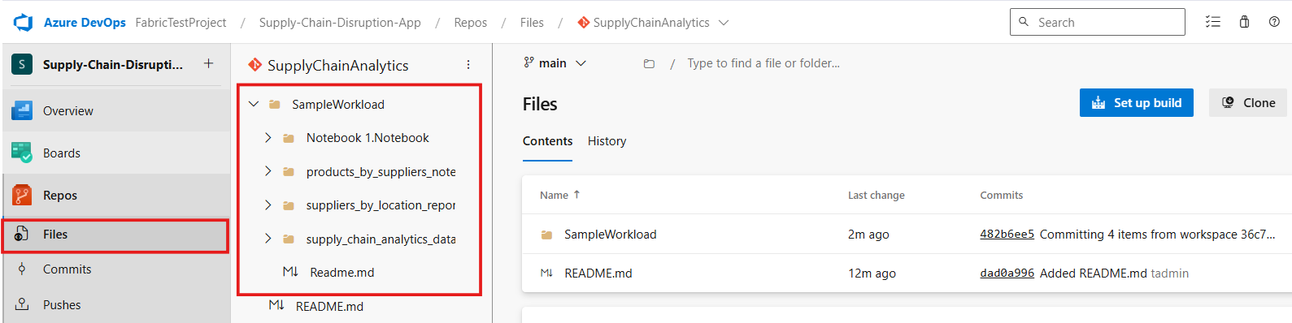Once inside the Azure DevOps environment, select the Files item in the explorer pane. The objects synchronized with your SQL database in Fabric and the repository are displayed.
- Task-3: Interact with SQL Database object schemas from source control in Azure Devops
- Expand the suppy_chain_analytics_database.SQLDatabase, then dbo, then Tables and then Suppliers.sql object.
- 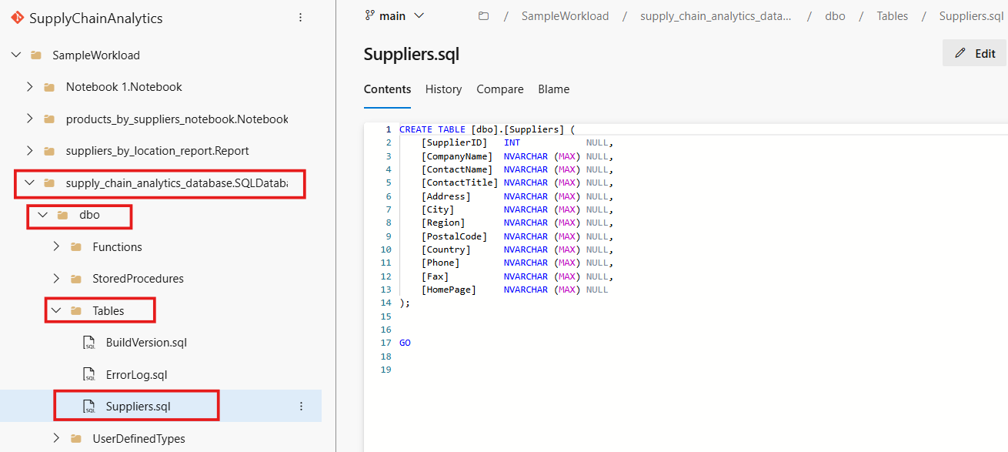
- Notice the T-SQL definition of the table in the object contents. In a production coding environment, this object would be altered using development tools such as Visual Studio, or Visual Studio Code. In this lab, we are using Azure DevOps source control to make some changes to the database objects in the further steps.
- Locate the [Fax] column definition line and select the Edit button. Edit the column definition to [Fax] NVARCHAR (255) NULL,.
- 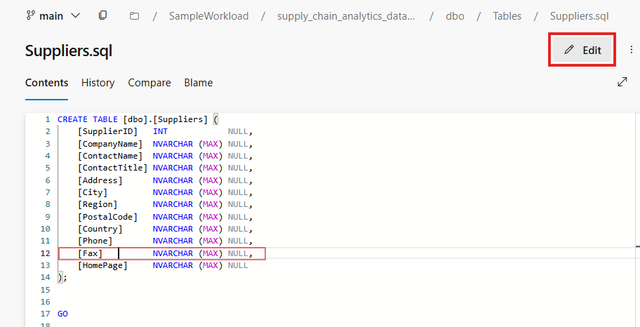
- Select the Commit button.
- 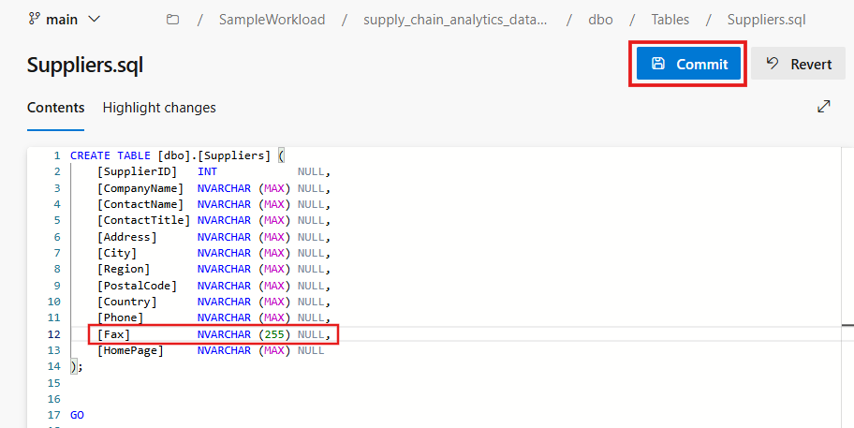
- Fill out the Commit message box that appears with the following: Updated Suppliers.sql [Fax] column and select the Commit button. Try to be descriptive of every change in source control, for your and your team's benefit.
- 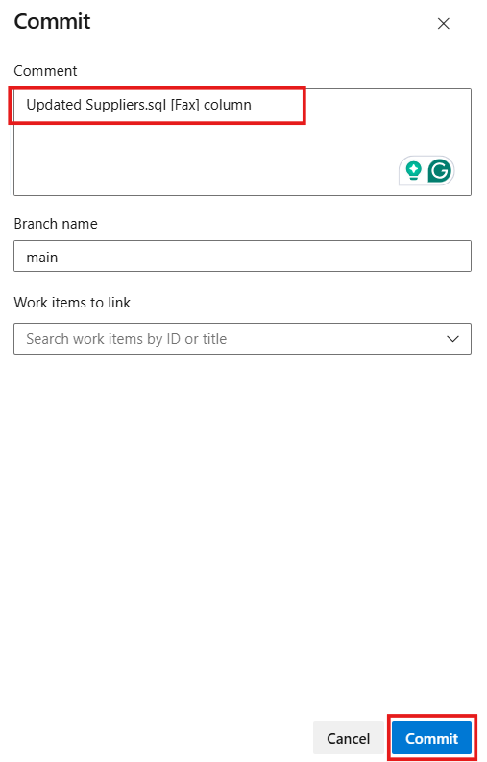
- The commit writes the change to the repository.
- 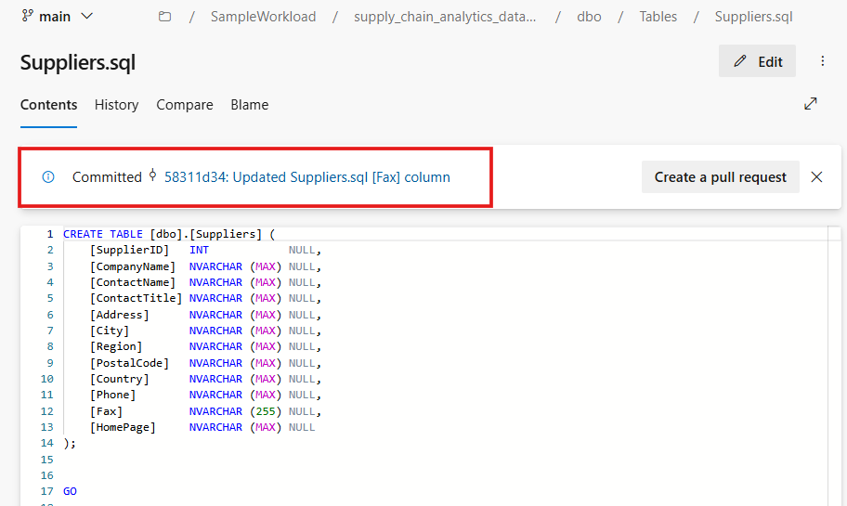
- Switch back to the SQL database in Fabric portal, and refresh the page and then select Source Control. You have one update pending.
- 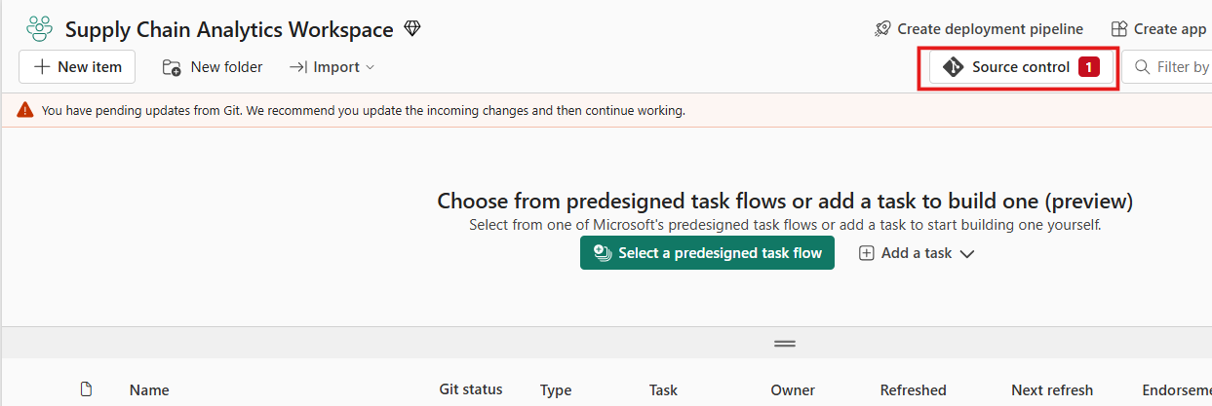
- In production, you'll review these changes. Select the Update All button. The update might take some time.
- 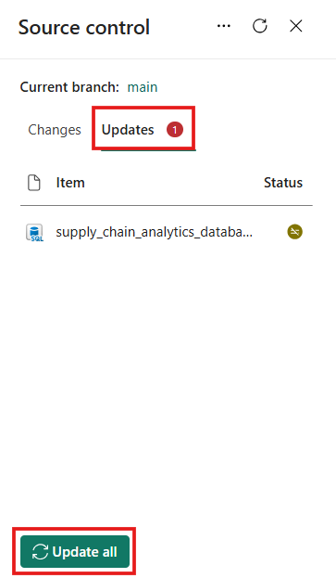
- Select the supply_chain_analytics_database from the workspace.
- 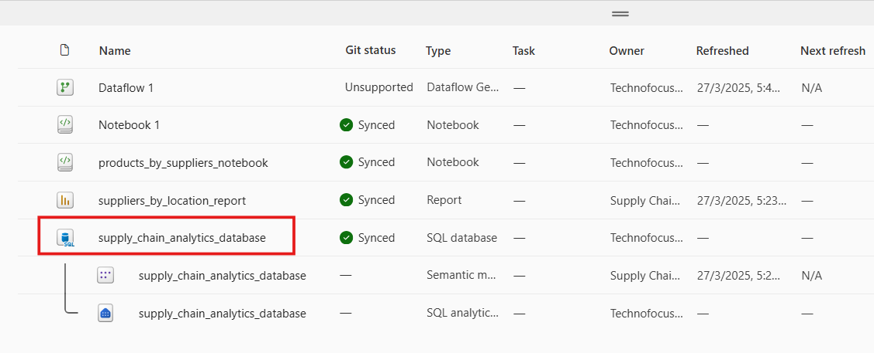
- Open a new query window in your SQL database. Copy and paste the following T-SQL code to see the changes to the table live in the database:
- SELECT * FROM INFORMATION_SCHEMA.COLUMNS WHERE TABLE_NAME = 'Suppliers';
- 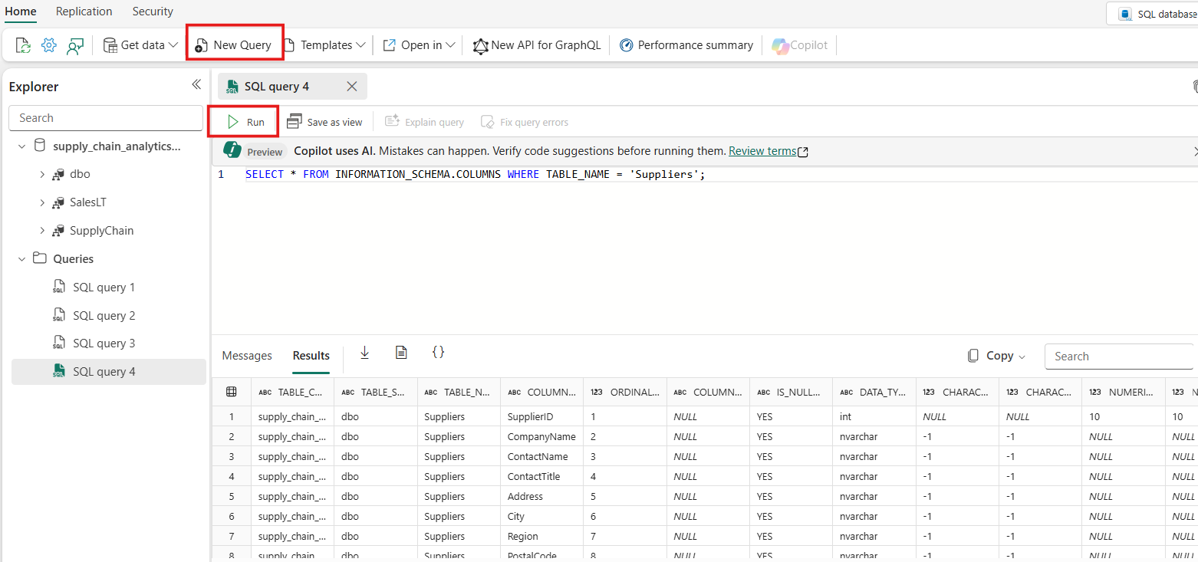
- Enter the following T-SQL code that query to add a column named Notes to the Suppliers table. Highlight just that section of code and select the Run button:
- ALTER TABLE Suppliers ADD Notes NVARCHAR(MAX);
- 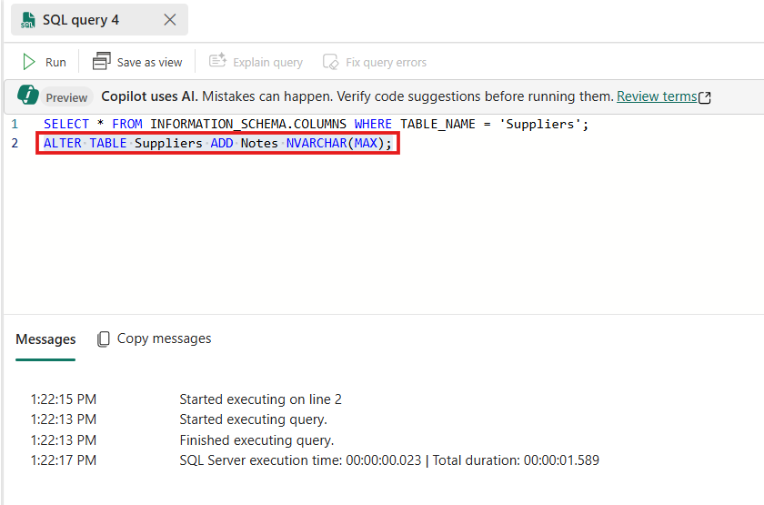
- Now return to the tutorial Workspace in the Fabric portal.
- Select the Source Control button and notice that rather than an Update, your system shows a Change request. Select the check box next to the object name and then select the Commit button.
- 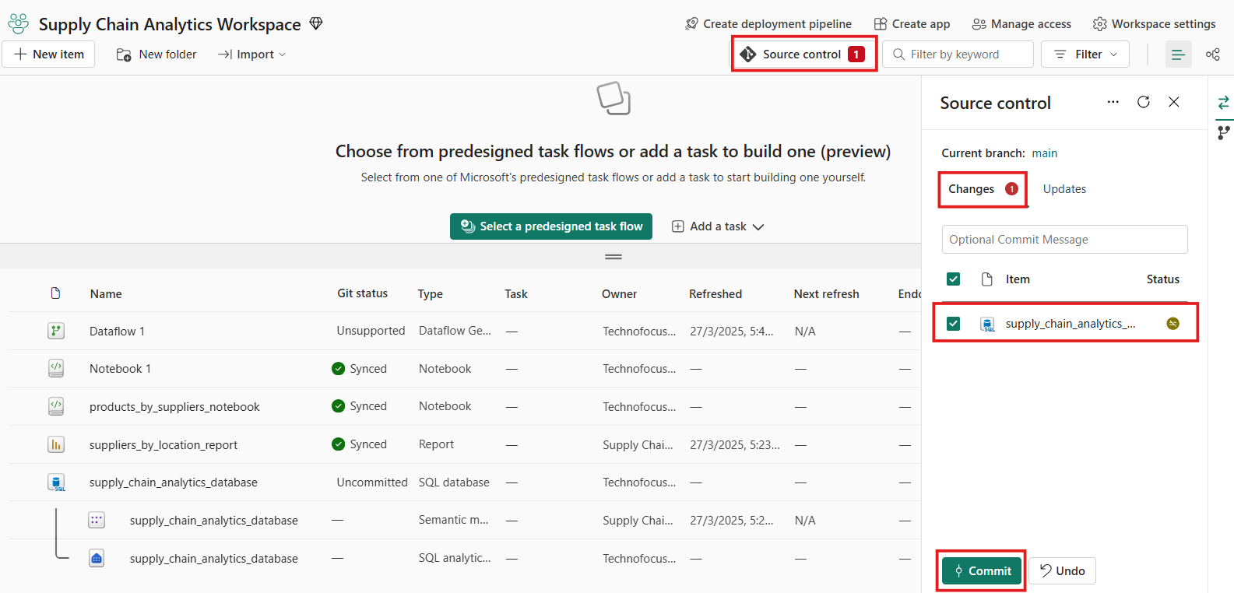
- The system commits the changes made in the query editor, and you can return to the Azure DevOps Portal and navigate to the Files area and the dbo Schema and then the Tables and Suppliers object to see the new column. (You might need to refresh the page to see the change.)
- 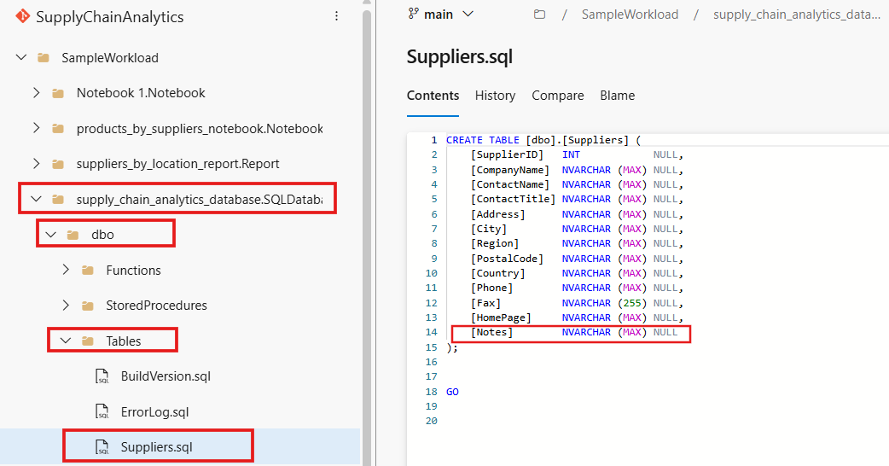
- You've now seen how you can interact with your SQL database object schemas from your source control in Azure DevOps.
- Exercise 9: Setup and Configure the GraphQL API
- To create the API for GraphQL that you'll use for an application:
- On the workspace page, select +New item. Then, select API for GraphQL tile.
- 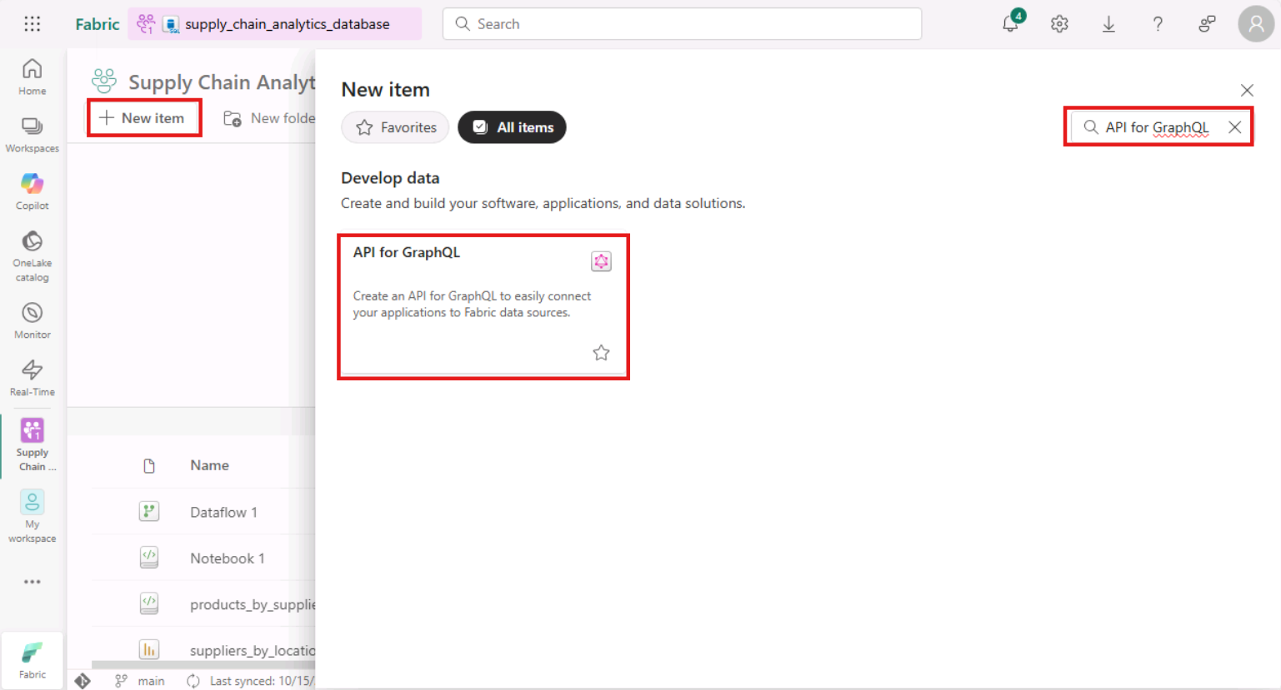
- Enter the text supplier_impact_gql for the Name for your item and select Create.
- 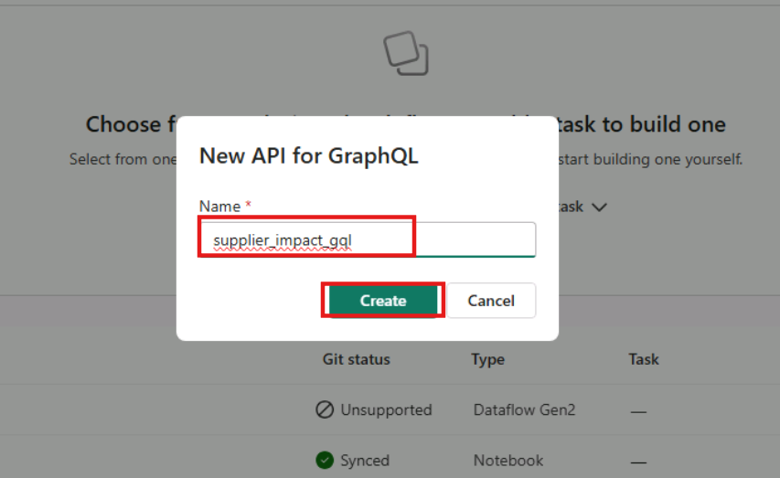
- Select data source card displayed to add the data for GraphQL.
- 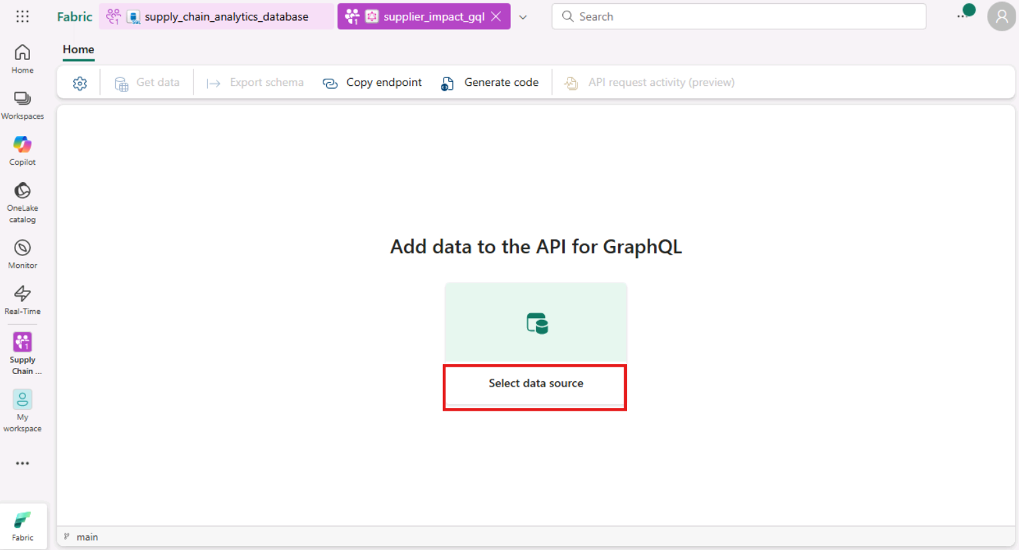
- On Choose connectivity option dialog box, select Connect to Fabric data sources with single-on (SSo) authentication and click on Ok button.
- 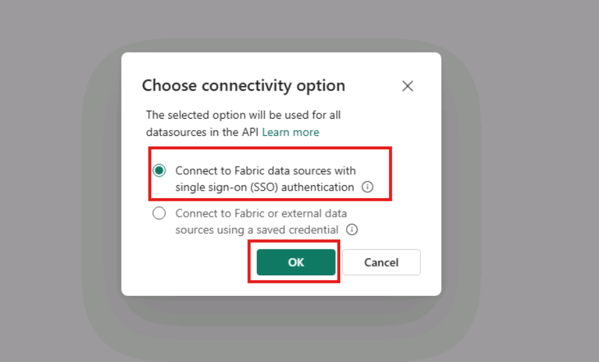
- In the OneLake catalog tab, select the supply_chain_analytics_database and click on the 'Connect' button
- 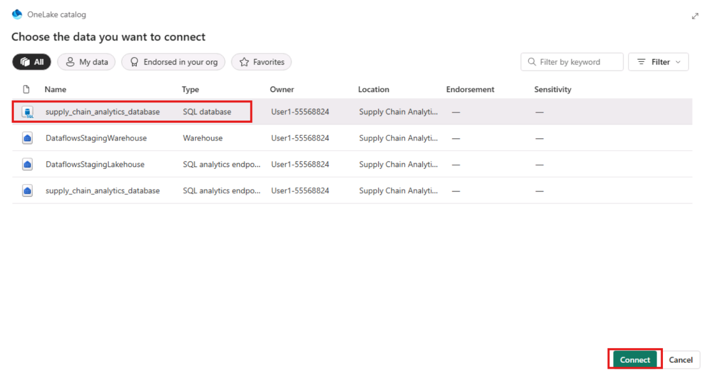
- You are presented with a Choose Data panel. Scroll until you find SupplyChain.vProductsBySuppliers, the view you created earlier in this tutorial. Select it and click on Load button.
- 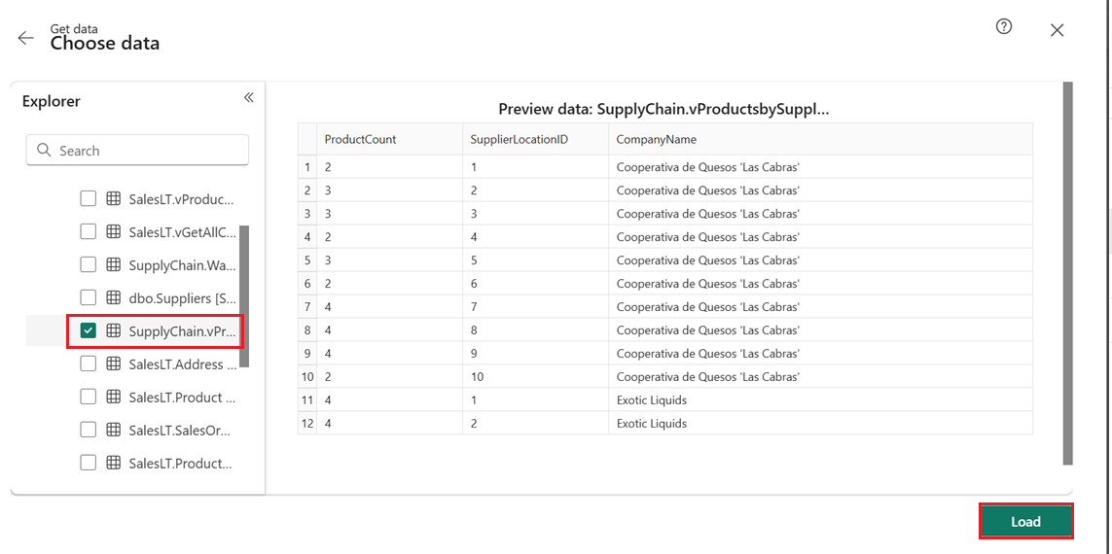
- In the Query1 panel, replace the text you see there with the following GraphQL query string:
- query { vProductsbySuppliers(filter: { SupplierLocationID: { eq: 7 }}) { items { CompanyName SupplierLocationID ProductCount } } }
- Select the Run button in the Query1 window. The results of the GraphQL query are returned to the Results window in JSON format.
- 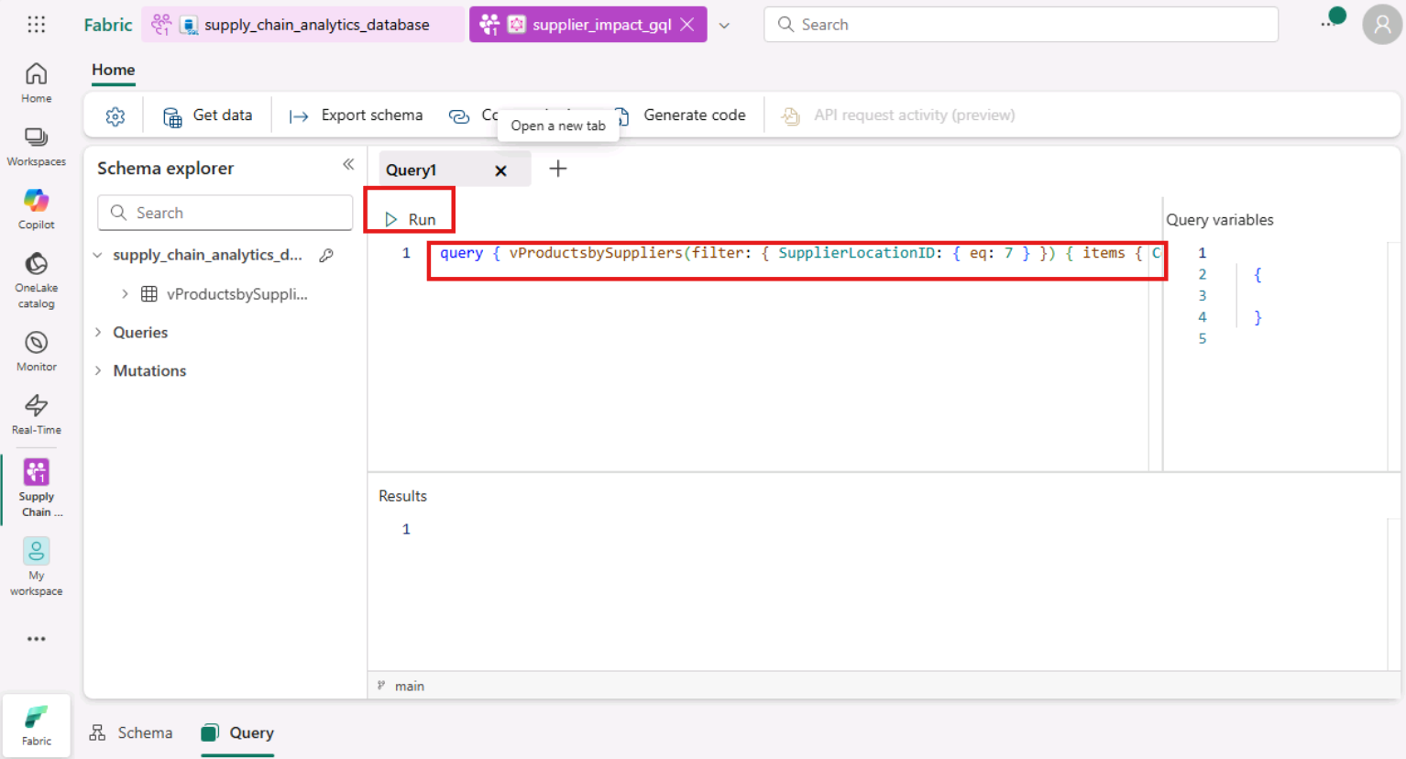
- 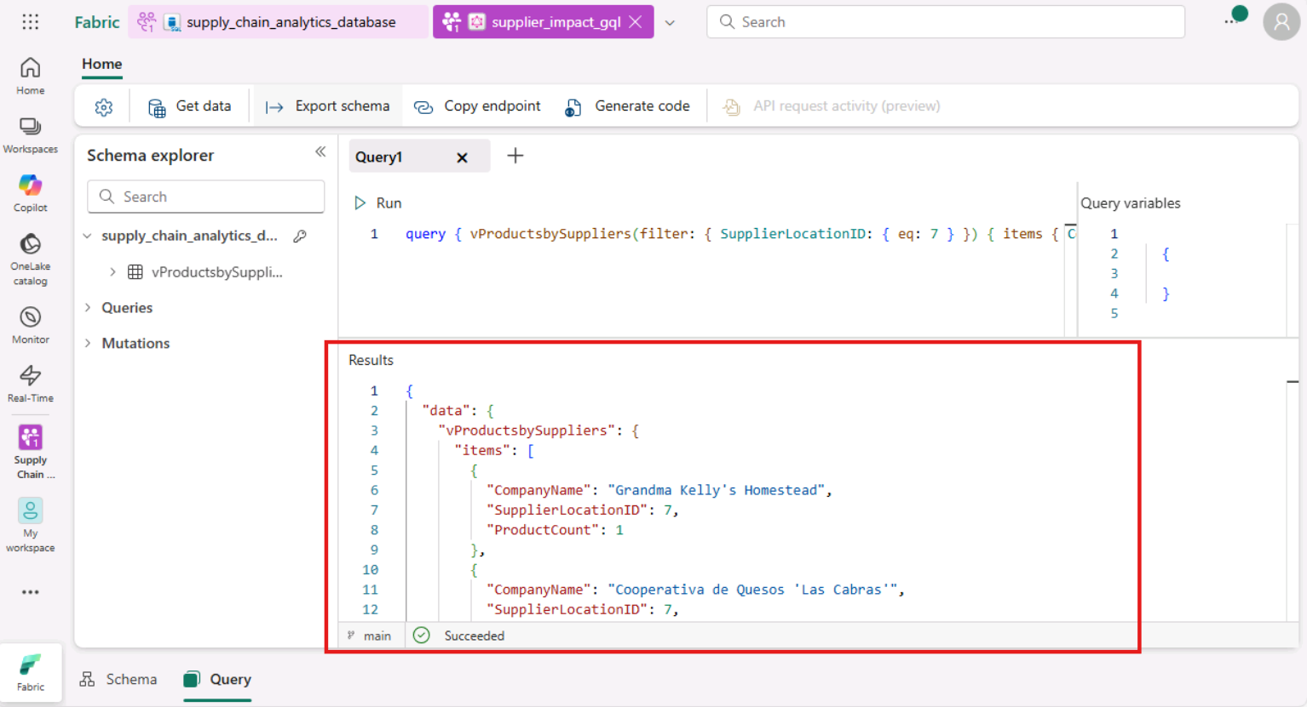
- Select the Copy endpoint button in the ribbon.
- 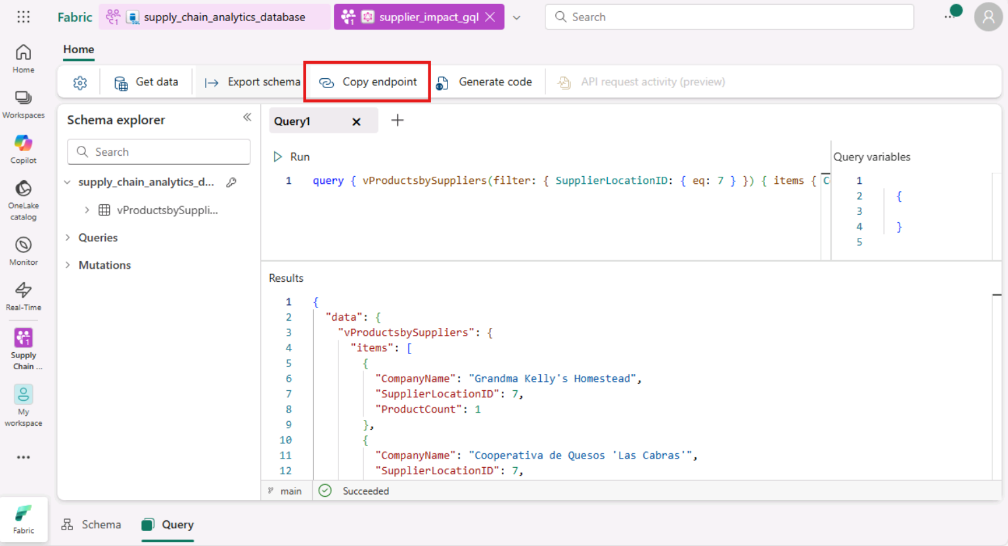
- Select the Copy button when the Copy link panel appears. Store this string in a notepad or other location to be used in the sample application for this tutorial.
- 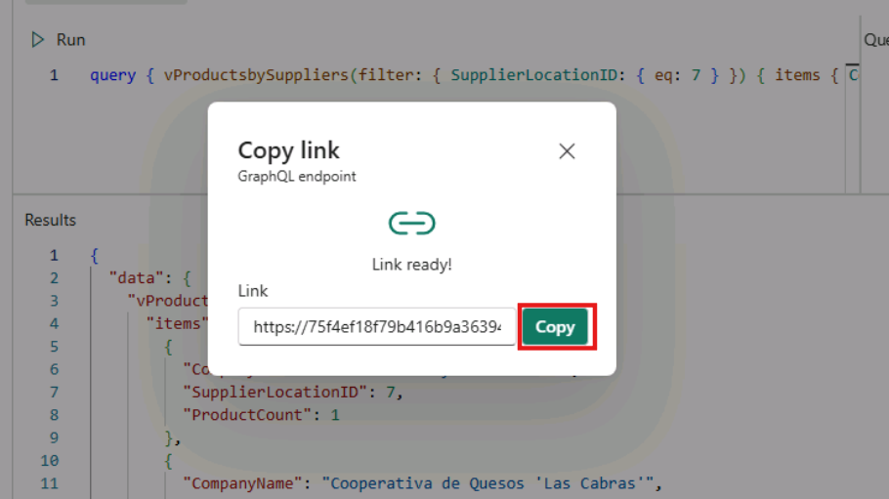
- 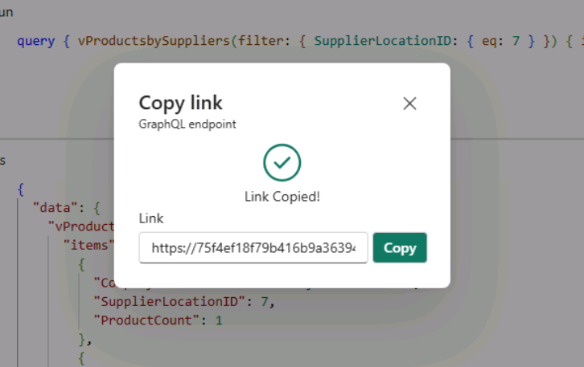
- Your API for GraphQL is now ready to accept connections and requests. You can use the API editor to test and prototype GraphQL queries and the Schema explorer to verify the data types and fields exposed in the API.
- Exercise 10 – Create a web application using the SQL database in Fabric API for GraphQL
- In this exercise, we will be creating an application that shows all affected Suppliers if a Location has a supply chain break, due to natural disasters or other interruptions. This code shows how to create an ASP.NET application that uses a GraphQL Query to access a Query in the SQL In Fabric GraphQL endpoint you created in the previous task.
- Task-1: Install .NET SDK for your operating system
- Navigate to this URL to download .NET SDK - https://dotnet.microsoft.com/en-us/download
- You will find the following webpage once you go to the above website. The latest version at this point is .NET 9.0, which provides Standard-Term Support and is recommended. Click on Download .NET SDK x64.
- 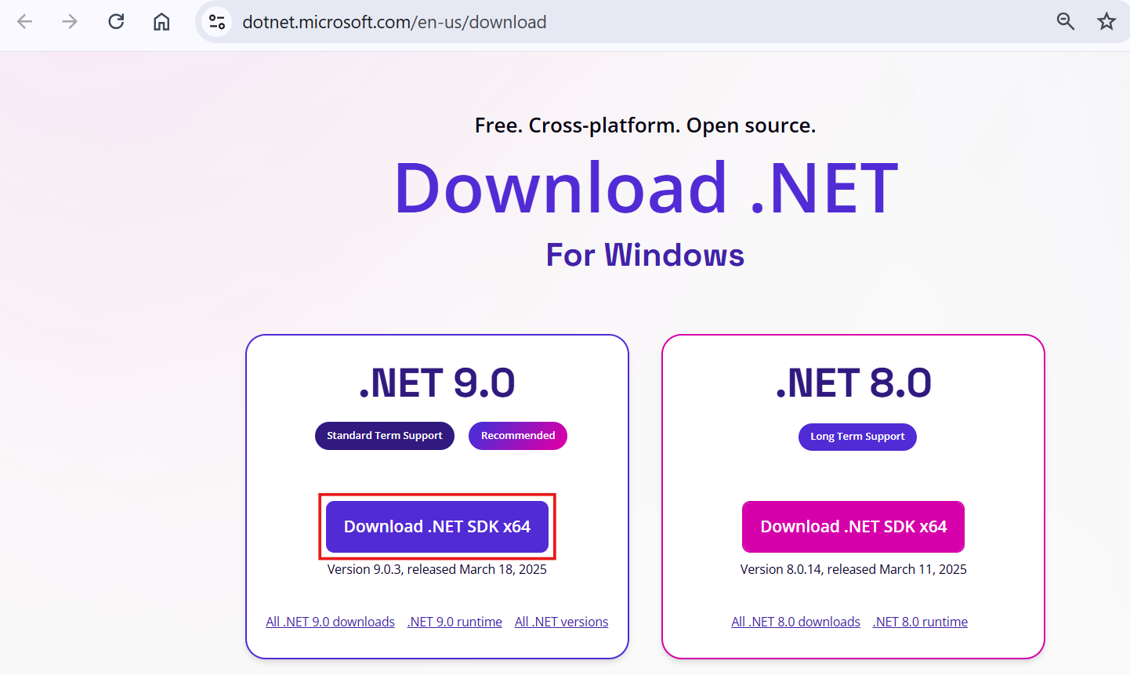
- Once you download the .NET SDK, install it by double-clicking the downloaded exe file. Once you click on the EXE, it will open the following window. In this window, click on the Install button.
- 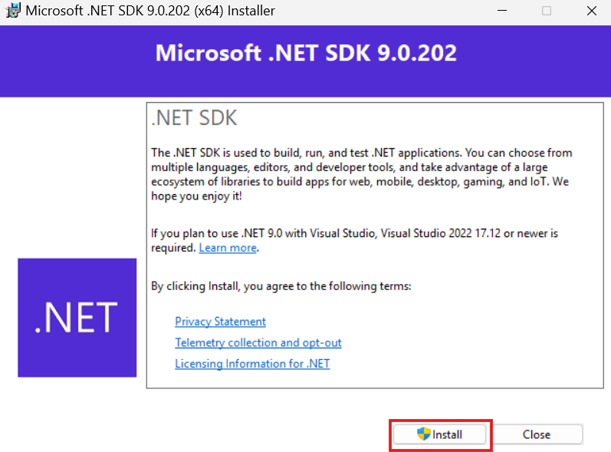
- If everything is fine, once the installation is completed, you will get the following message saying the installation was successful: Click on the Close button.
- 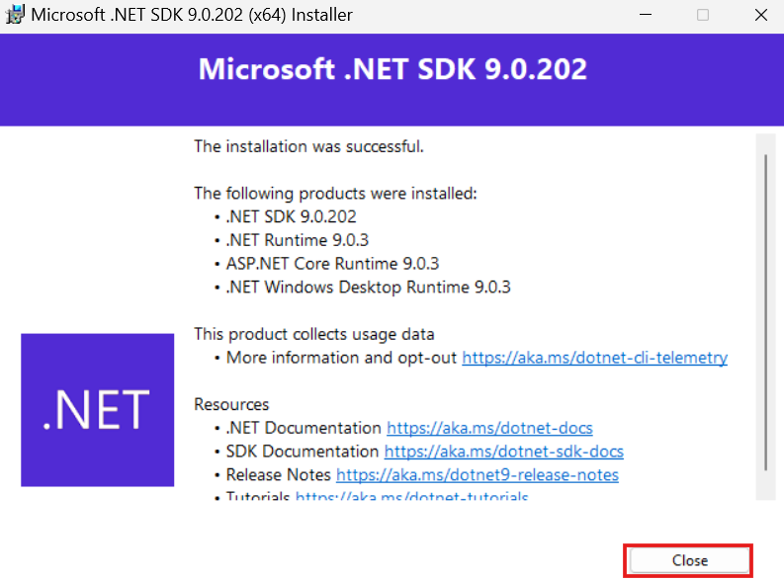
- Now, to verify what version is installed on your machine, type the dotnet –version command in the command prompt and press the enter button.
- 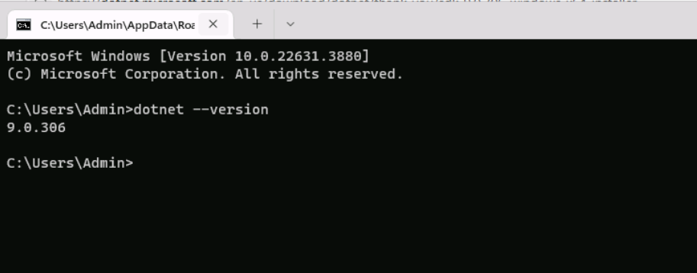
- Task-2: Creating a web application in Visual Studio Code
- You can refer https://github.com/Azure-Samples/siftutorial/blob/main/README.md for this particular task.
- Open Visual Studio Code, click on the three dots at the top pane and select Terminal and then New terminal option from the drop-down.
- 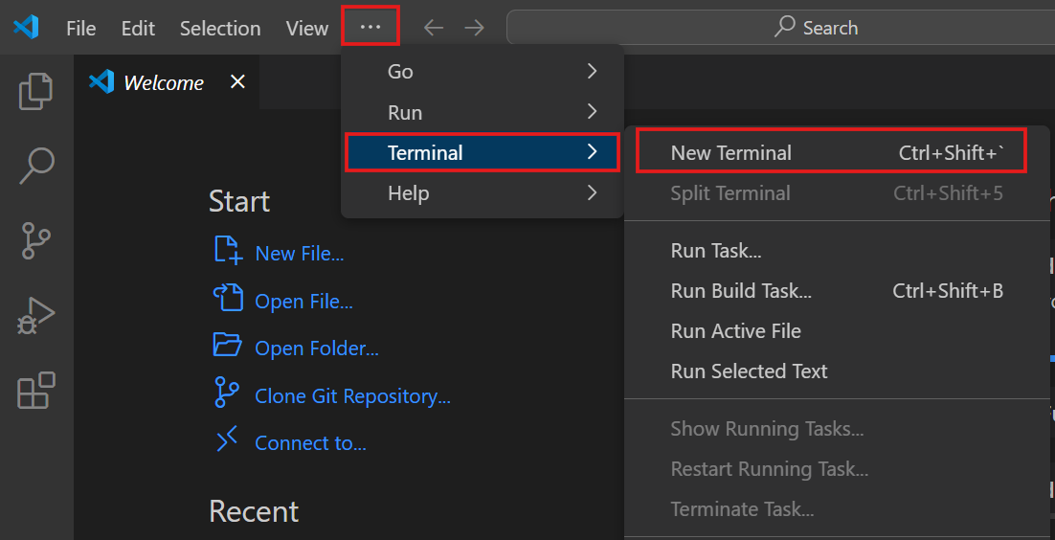
- Open a terminal or command prompt. Run the following commands one by one to create a new ASP.NET Core web application.
- TypeCopy
- dotnet new webapp -n GraphQLWebApp
- TypeCopy
- cd GraphQLWebApp
- This command will create a new ASP.NET Core Web App project in the directory mentioned. You can check the directory, there must be a GraphQLWebApp folder created.
- 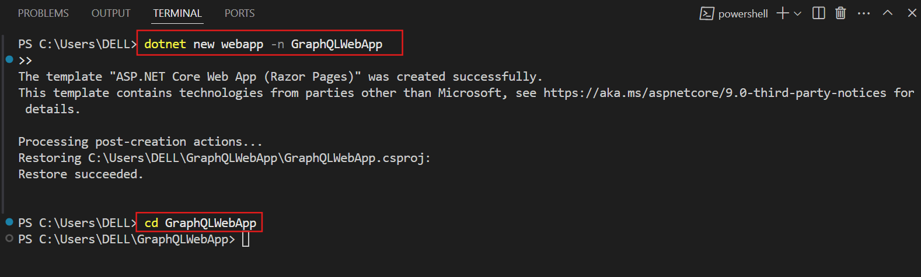
- Now to proceed, open the web app folder in Visual Studio Code by navigating to File option in the top pane, select Open Folder option from the drop down and select the web app folder named GraphQLWebApp from the directory.
- 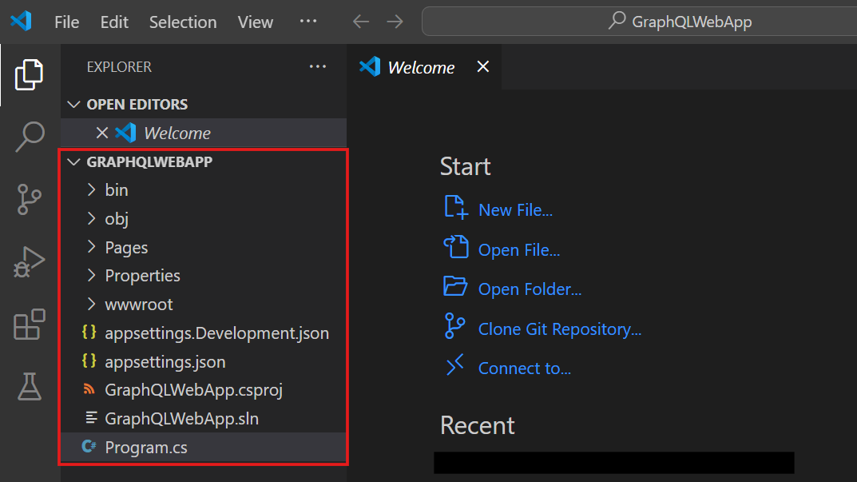
- Open the terminal again and check your NuGet configuration otherwise the installation of packages in the next step will throw an error. Run this command:
- TypeCopy
- dotnet nuget list source
- 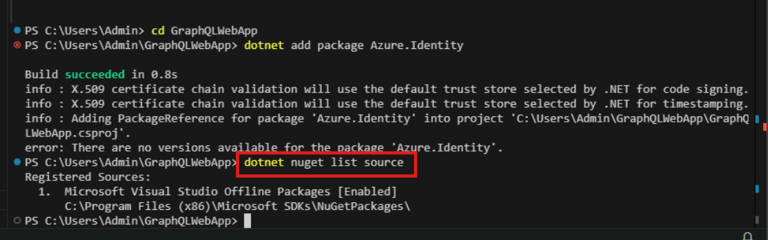
- If you don’t see nuget.org, add it manually:
- TypeCopy
- dotnet nuget add source https://api.nuget.org/v3/index.json -n nuget.org
- 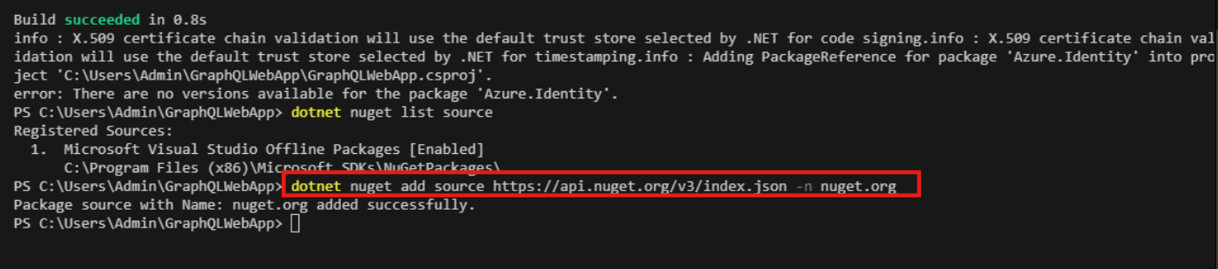
- Now, again verify NuGet configuration:
- TypeCopy
- dotnet nuget list source
- 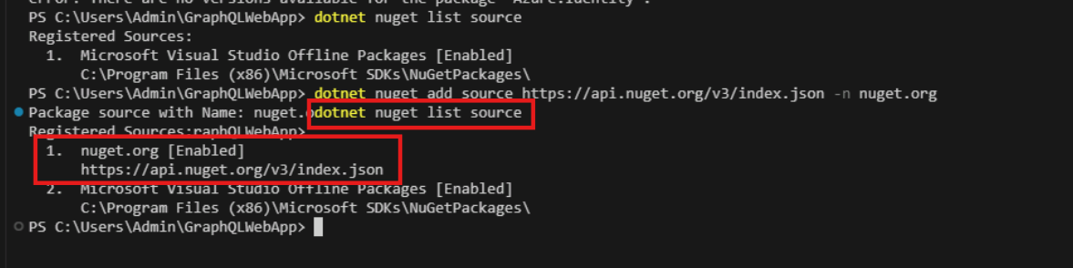
- Add the necessary packages:
- Run the following commands one by one to add the required packages:
- TypeCopy
- dotnet add package Azure.Identity
- TypeCopy
- dotnet add package GraphQL
- TypeCopy
- dotnet add package GraphQL.Client
- TypeCopy
- dotnet add package GraphQL.Client.Serializer.Newtonsoft
- 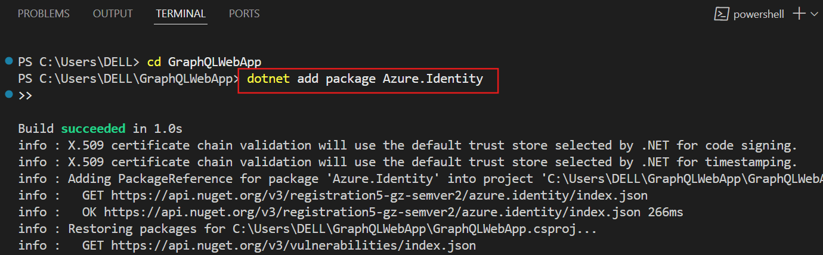
- 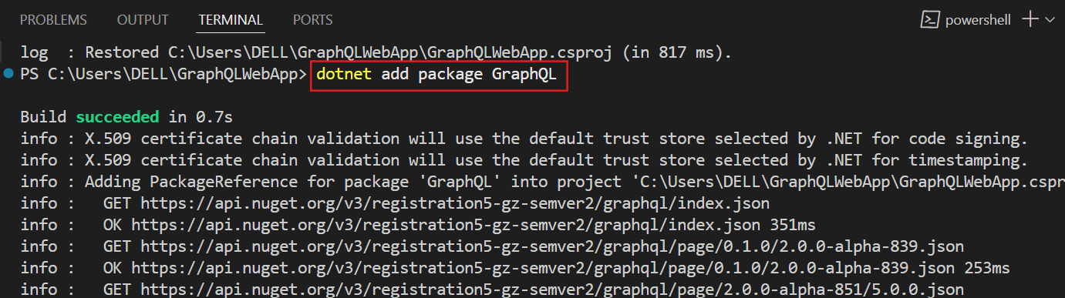
- 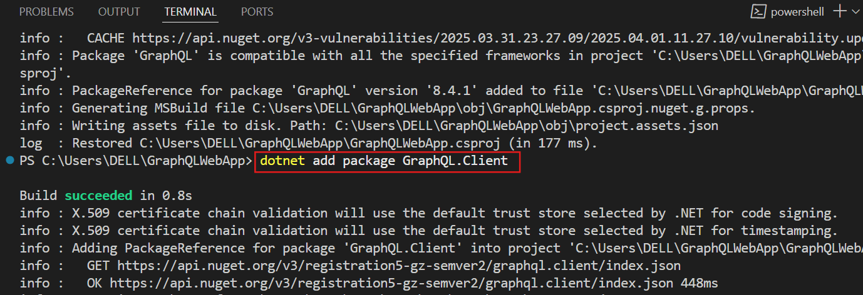
- 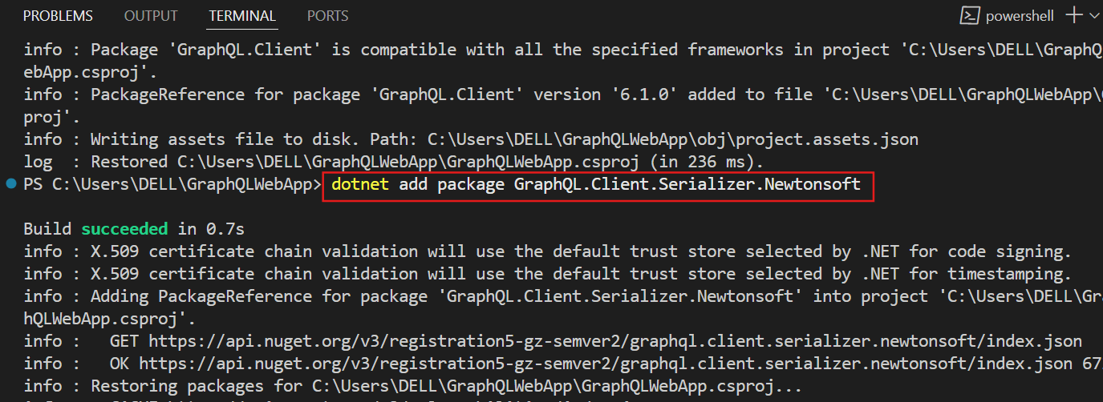
- Add the Azure CLI software and log in to your subscription:
- Run the following command to add the required software:
- TypeCopy
- winget install -e --id Microsoft.AzureCLI
- 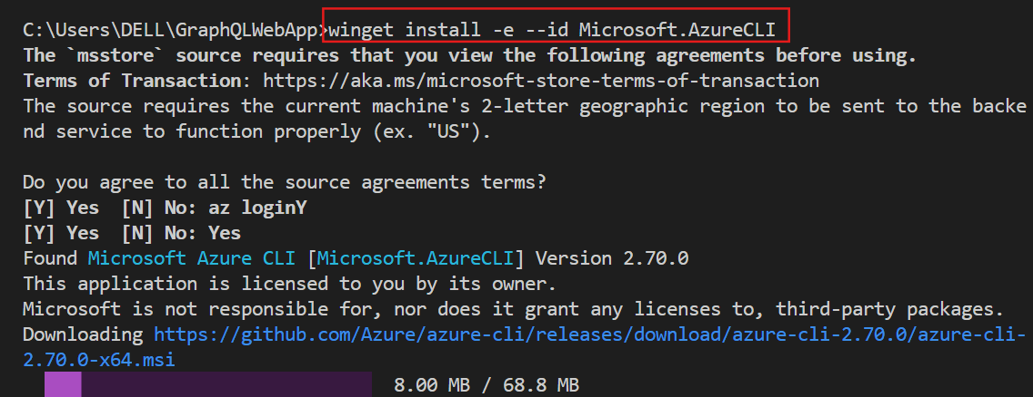
- 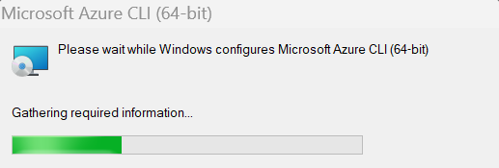
- 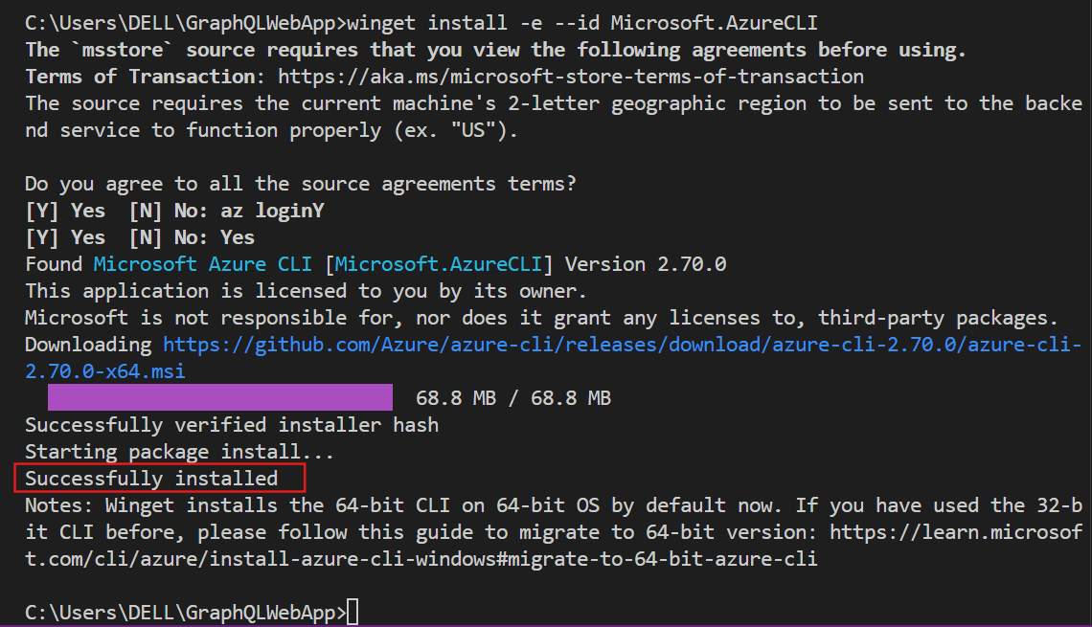
- Install the Azure CLI Tools extension.
- 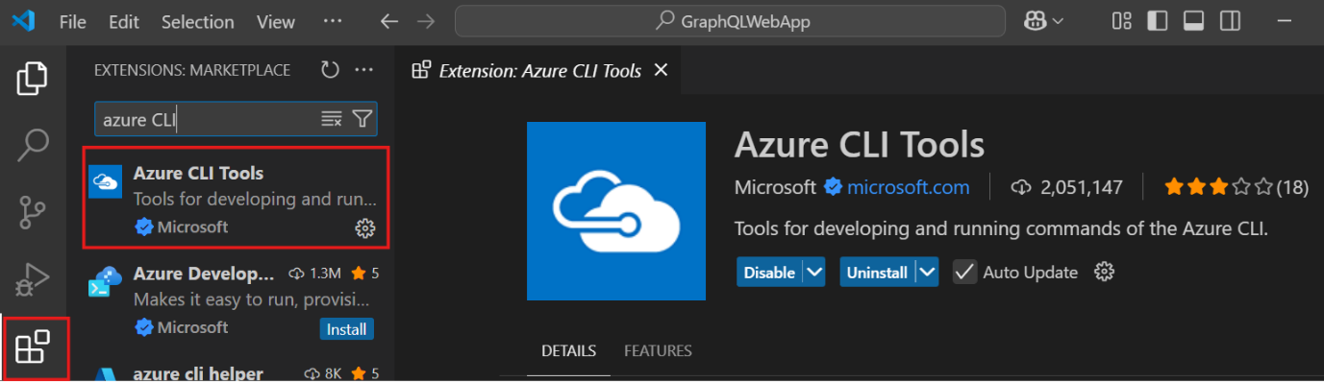
- Note: Before running az login and to prevent the error that ‘az term not recognised’, make sure to restart the VS Code and then run the az login command.
- Run the following command to login with your Entra User credentials.
- TypeCopy
- az login
- On the login window, select Work or School Account to login.
- 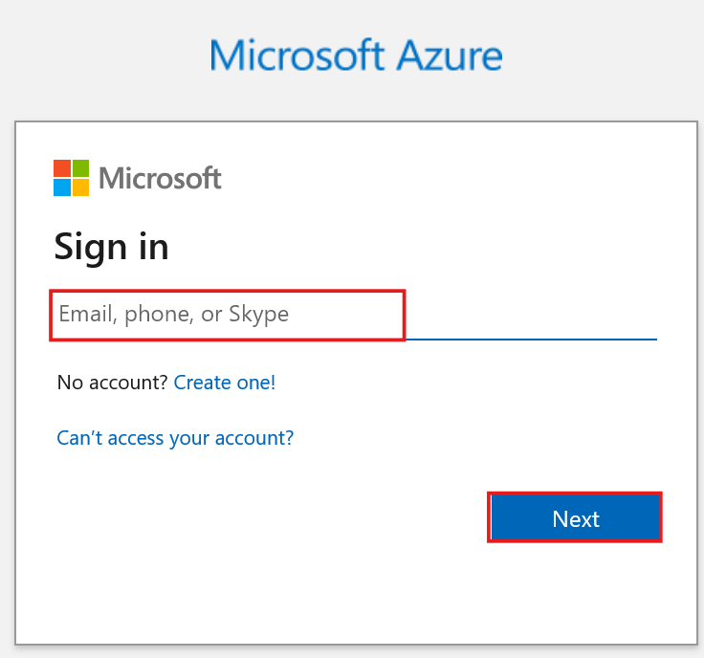
- Modify the Program.cs file:
  - Open the Program.cs file and replace its content with the following code. You can also copy this entire code from this reference link: https://github.com/Azure-Samples/siftutorial/blob/main/README.md
- TypeCopy
- /* Program.cs
- Purpose: This tuorial program shows how to create a simple web application that uses a GraphQL query to return data from a Power BI dataset.
- Uses the GraphQL.Client library to send the query to the Power BI service, and then displays the results in a web page.
- Uses the DefaultAzureCredential class from the Azure.Identity library to authenticate with Azure Active Directory and
- get an access token to use in the query.
- It uses the WebApplication class from the Microsoft.AspNetCore.Components.WebAssembly.Hosting library to create a web application,
- and the GraphQLHttpClient class from the GraphQL.Client library to send the query.
- It also uses the GraphQLHttpRequest class from the GraphQL.Client library to define the query, and the NewtonsoftJsonSerializer
- class from the GraphQL.Client.Serializer.Newtonsoft library to serialize the response.
- We use the WriteAsync method of the HttpResponse class to write the HTML response to the web page.

- Requirements: To run this program, you need to have the .NET SDK installed on your machine.
- You also need to have an Azure subscription and a Power BI dataset with a GraphQL API enabled.
- You should install the required libraries with the following commands:

- dotnet add package GraphQL.Client --version 3.3.0
- dotnet add package GraphQL.Client.Serializer.Newtonsoft --version 3.3.0
- dotnet add package Microsoft.AspNetCore.Components.WebAssembly.Hosting --version 5.0.7
- dotnet add package Azure.Identity --version 1.4.1

- Author: Buck Woody, Microft Corporation
- Last Modified: 2021.09.01
- */

- // Set up your libraries
- using GraphQL.Client.Http;
- using GraphQL.Client.Serializer.Newtonsoft;
- using Azure.Identity;

- // Make a connection to Azure, and get a token
- var credential = new DefaultAzureCredential();
- var token = await credential.GetTokenAsync(new Azure.Core.TokenRequestContext(new[] { "https://analysis.windows.net/powerbi/api/.default" }));

- // Set up your web application
- var builder = WebApplication.CreateBuilder(args);
- // Add services to the container.
- builder.Services.AddRazorPages();
- // Build the application
- var app = builder.Build();

- // Configure the HTTP request pipeline.
- app.UseStaticFiles();
- app.UseRouting();

- // Add the Razor pages
- app.MapRazorPages();
- // Add the GraphQL query initial web page
- app.MapGet("/", async context =>
- {
- var html = @"
- <!DOCTYPE html>
- <html lang='en'>
- <head>
- <meta charset='UTF-8'>
- <meta name='viewport' content='width=device-width, initial-scale=1.0'>
- <title>Product Count by Suppliers</title>
- <link rel='stylesheet' href='https://stackpath.bootstrapcdn.com/bootstrap/4.3.1/css/bootstrap.min.css'>

- <style>
- .form-inline .form-control {
- width: auto;
- flex: 0 0 50px; /* Adjust the width as needed */
- }
- .form-inline .btn {
- margin-left: 10px; /* Adjust the margin as needed */
- }
- </style>
- </head>

- <body>
- <div class='container mt-5'>
- <img src='./contoso.png' alt='Contoso Logo' width='200'>
- <h3>Product Count by Suppliers</h3>
- <p><i>Supplier Network Control Center - Supplier Sector Impact Zones by Product (Function NCC-1701)</i></p>
- <p>Enter the impacted Location ID for the Supplier that is facing the outage. The system will return the other Suppliers within that impact area and show the count of items each Supplier provides to Manufacturing.</p>
- <form method='get' action='/graphql' class='form-inline'>
- <label for='locationId' class='mr-2'>Location ID:</label>
- <input type='text' class='form-control' id='locationId' name='locationId' required>
- <button type='submit' class='btn btn-primary'>Search</button>
- </form>
- <div id='result'></div>
- </div>
- </body>

- </html>";
- // Return the HTML
- await context.Response.WriteAsync(html);
- });

- // Add the GraphQL query
- app.MapGet("/graphql", async context =>
- {
- var locationId = context.Request.Query["locationId"];
- if (string.IsNullOrEmpty(locationId))
- {
- await context.Response.WriteAsync("Location ID is required.");
- return;
- }

- // Set up the GraphQL client - your endpoint goes here
- var graphQLOptions = new GraphQLHttpClientOptions
- {
- EndPoint = new Uri("ReplaceWithYourGraphQLEndpointAddress"),
- MediaType = "application/json",
- };

- // Set up the client with headers, use the token
- var graphQLClient = new GraphQLHttpClient(graphQLOptions, new NewtonsoftJsonSerializer());
- graphQLClient.HttpClient.DefaultRequestHeaders.Authorization = new System.Net.Http.Headers.AuthenticationHeaderValue("Bearer", token.Token);
- graphQLClient.Options.IsValidResponseToDeserialize = response => response.IsSuccessStatusCode;
- // Set up the GraphQL query - you could make this a variable if you wanted to
- var query = new GraphQLHttpRequest
- {
- Query = $@"query {{ vProductsbySuppliers(filter: {{ SupplierLocationID: {{ eq: {locationId} }} }})
- {{ items
- {{ CompanyName SupplierLocationID ProductCount }}
- }}
- }}"
- };
- // Send the query
- var graphQLResponse = await graphQLClient.SendQueryAsync<dynamic>(query);
- var items = graphQLResponse.Data.vProductsbySuppliers.items;

- // Build the HTML response from the query
- var html = @"
- <!DOCTYPE html>
- <html>
- <head>
- <link rel='stylesheet' href='https://stackpath.bootstrapcdn.com/bootstrap/4.3.1/css/bootstrap.min.css'>
- </head>
- <body>
- <div class='container'>
- <img src='./contoso.png' alt='Contoso Logo' width='200'>
- <h2>Product Count by Suppliers</h2>
- <table class='table table-striped'>
- <thead>
- <tr>
- <th>Company Name</th>
- <th>Supplier Location ID</th>
- <th>Product Count</th>
- </tr>
- </thead>
- <tbody>";

- foreach (var item in items)
- {
- html += $"<tr><td>{item.CompanyName}</td><td>{item.SupplierLocationID}</td><td>{item.ProductCount}</td></tr>";
- }

- html += @"
- </tbody>
- </table>
- </div>
- </body>
- </html>";
- // Return the HTML
- await context.Response.WriteAsync(html);
- });
- // Run the application
- app.Run();
- Note: So that you know, you have copied a GraphQL endpoint while creating the GraphQL API in the previous exercise. Replace the GraphQL endpoint in only one place in the program.cs file as shown in the image below.
- 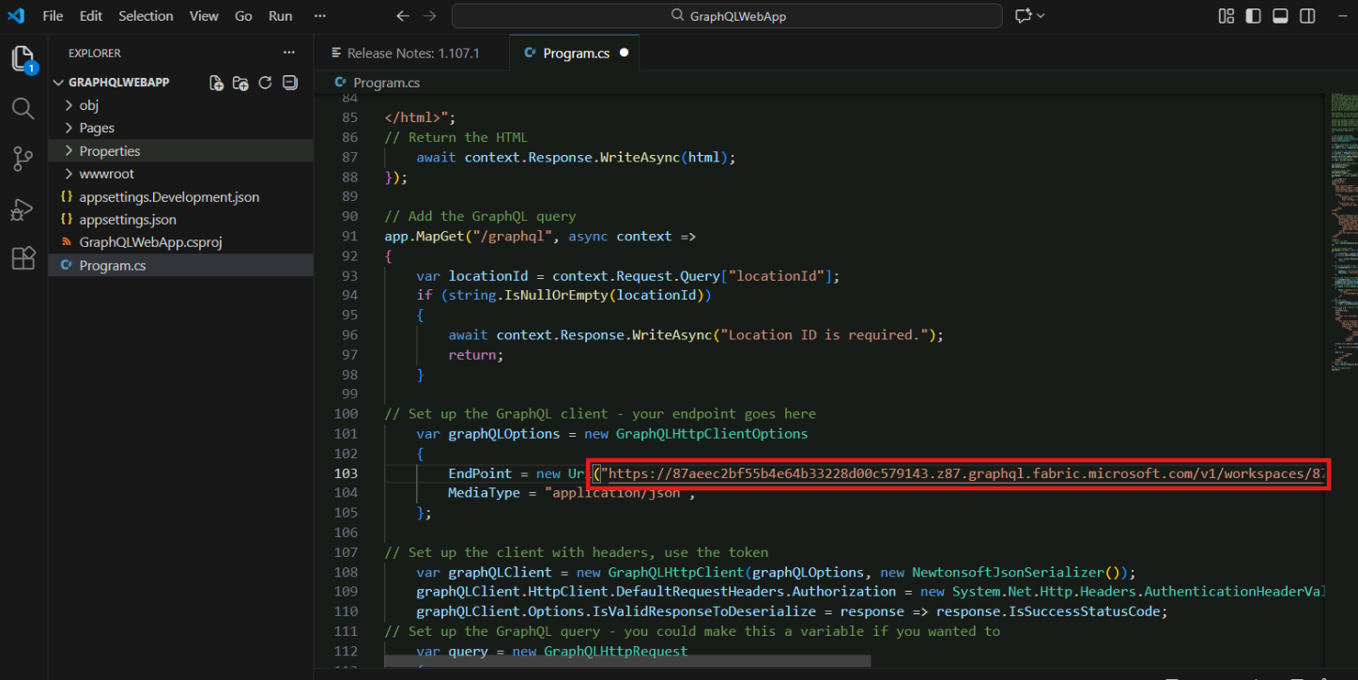
- 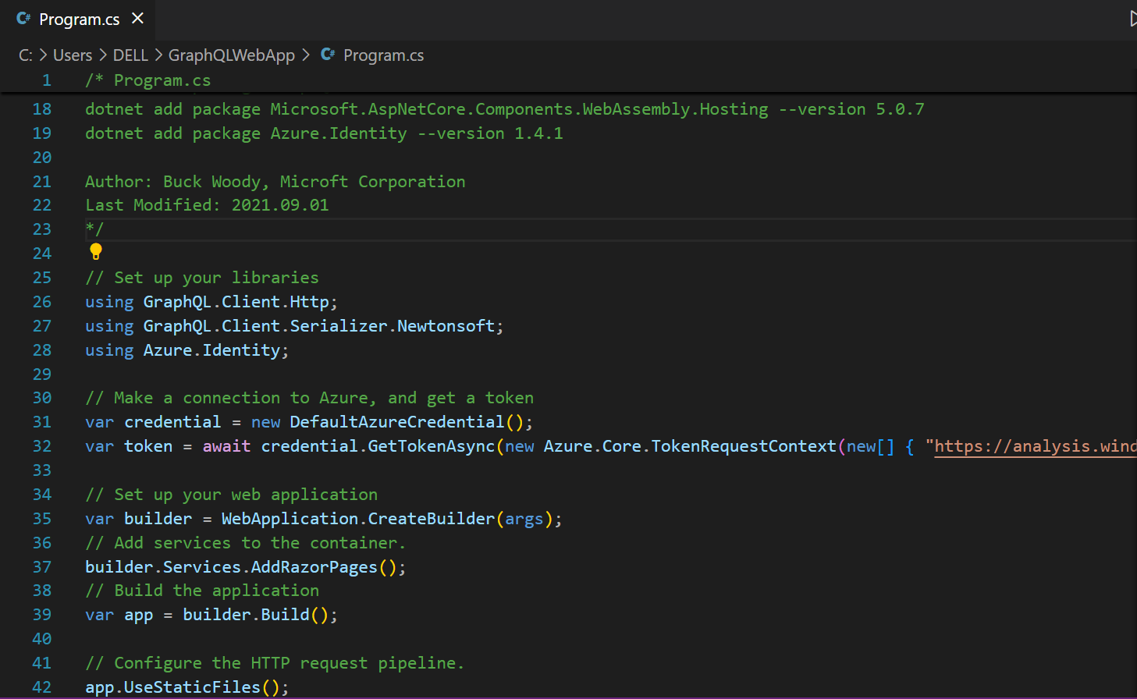
- Run the application:
  - In the terminal or command prompt, run the following command to start the application:
- TypeCopy
- dotnet run
- Access the application:
  - Right-click on the line in your command window that looks similar to http://localhost:5261 to see the output of your GraphQL query.
- 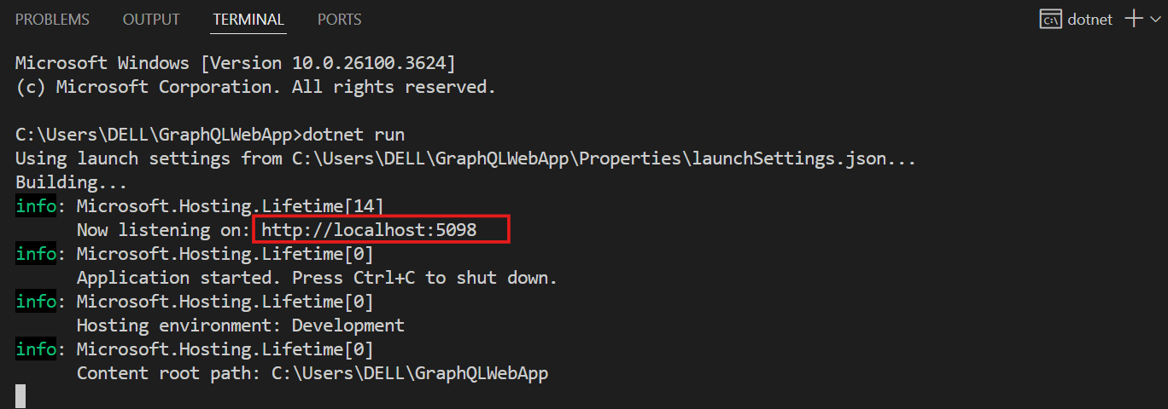
- 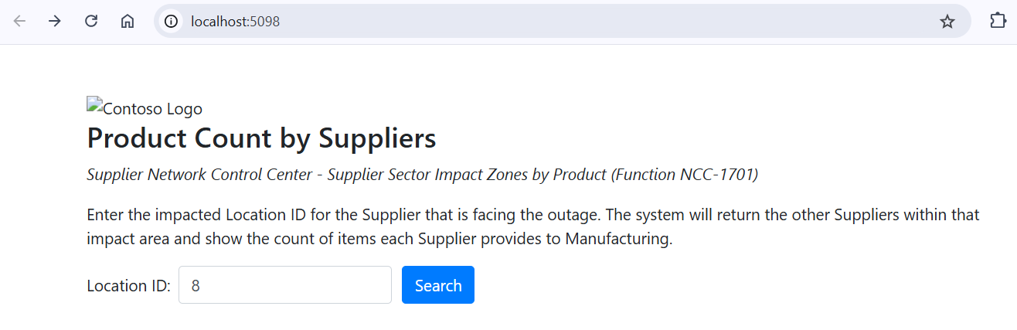
- 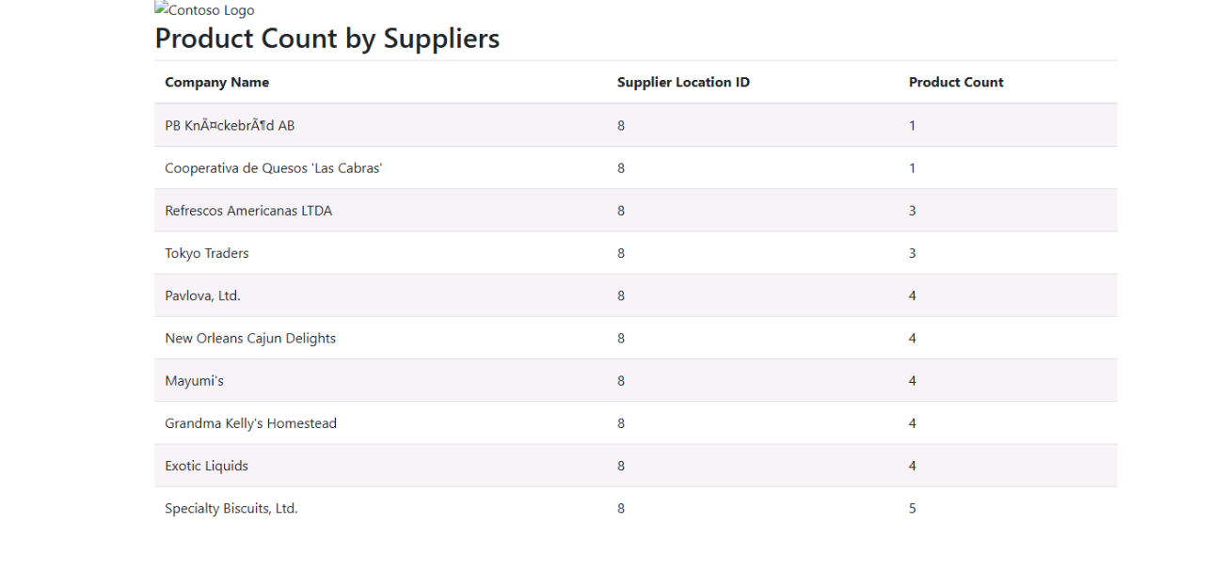
- Exercise 10 – Clean up resources
- In the left navigation bar, select the icon for your workspace to view all of the items it contains.
- 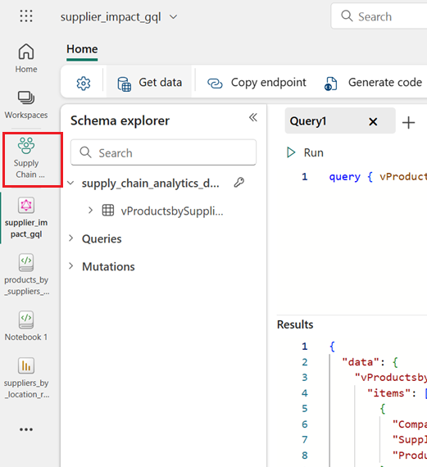
- In the menu on the top toolbar, select Workspace settings.
- 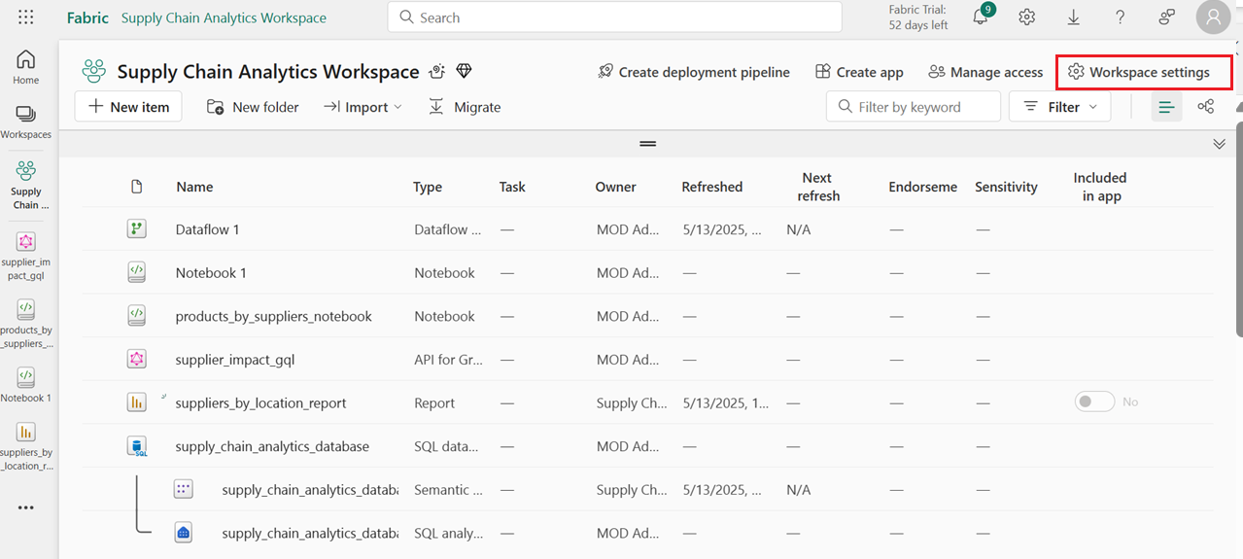
- In the General section, select Remove this workspace.
- 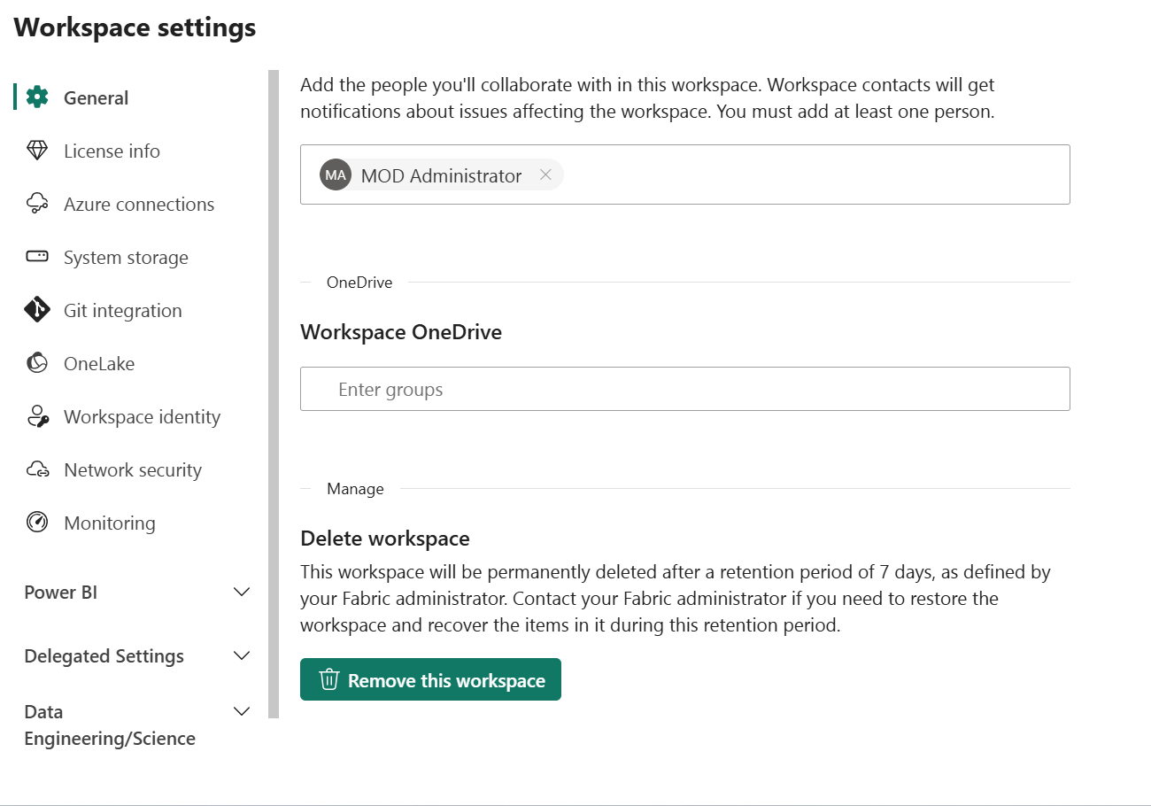
- 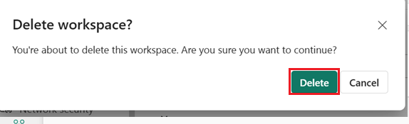
- Summary
- This usecase provides a comprehensive, hands-on guide to building a Supply Chain Disruption Response App using Microsoft Fabric's SQL database features. It walks users through creating a workspace, setting up a SQL database, ingesting sample and external data, and performing data transformations. Users also learn to create analytical views, monitor performance, and visualize data using Power BI. The tutorial concludes with the setup of a GraphQL API for application integration and guidance on cleaning up resources. By completing this tutorial, users gain practical experience in managing and analyzing supply chain data within a unified analytics environment.

