- Use Case 1 – Build scalable data solutions with SQL database in Microsoft Fabric
- Introduction
In this Lab, you’ll get hands-on with the SQL database in Microsoft Fabric. We'll begin by setting up a Fabric SQL database and loading sample data followed by trying out the Copilot-assisted querying (including NL2SQL). From there, you'll learn how to expose your data through APIs, connect seamlessly to applications, analytics and Power BI, and explore building Retrieval-Augmented Generation (RAG) application using SQL database in Microsoft Fabric.
The focus of this lab is to understand how to design, build, and operationalize end-to-end AI-ready applications using SQL database in Fabric as the core data backbone.
- Objectives
In this lab, you will:
- Create and query a SQL database in Microsoft Fabric.
- Use Copilot to generate and fix SQL queries.
- Build vector embeddings and perform semantic search.
- Integrate Azure OpenAI to create a RAG workflow.
- Expose results through a GraphQL API.
- Build a Power BI report using Copilot in SQL analytics endpoint.
- Exercise 1 – Setting up the Environment
- Task-1: Create a New Fabric Workspace
In this section of the lab, we will be logging into the Microsoft Fabric Portal and create a new Fabric Workspace.
- Open a web browser and browse to https://app.fabric.microsoft.com
- Sign in using the email address and click on Submit.
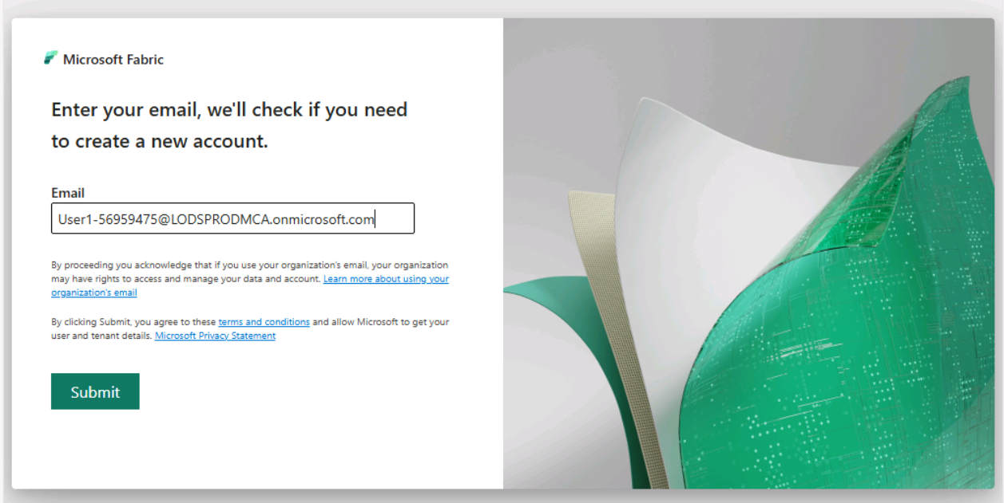
- Enter Password to proceed with the sign in and click on Sign in button.
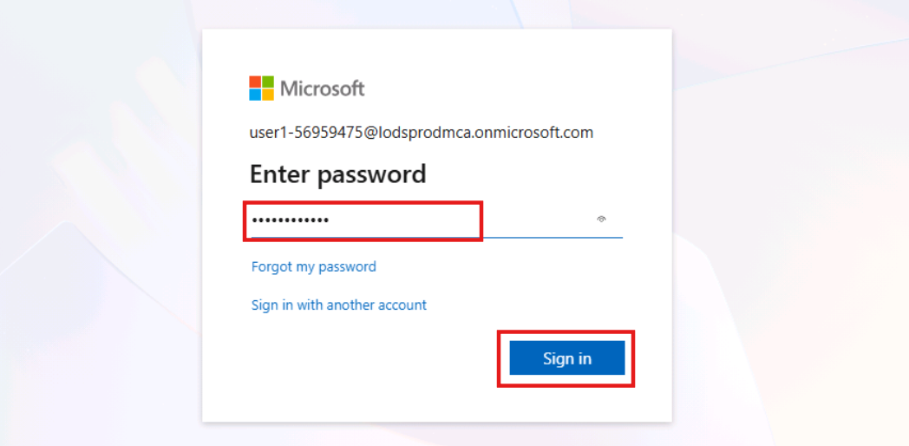
- If prompted to stay signed in, select Yes.
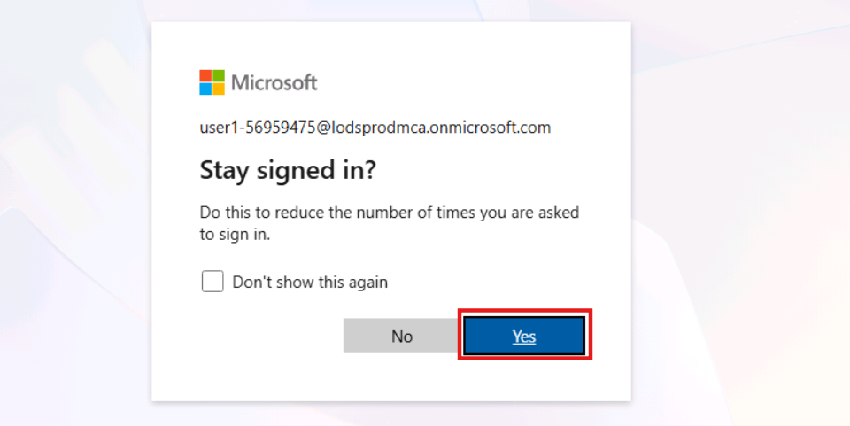
- You’ll be navigated to Microsoft Fabric Home Page. Select + New workspace.
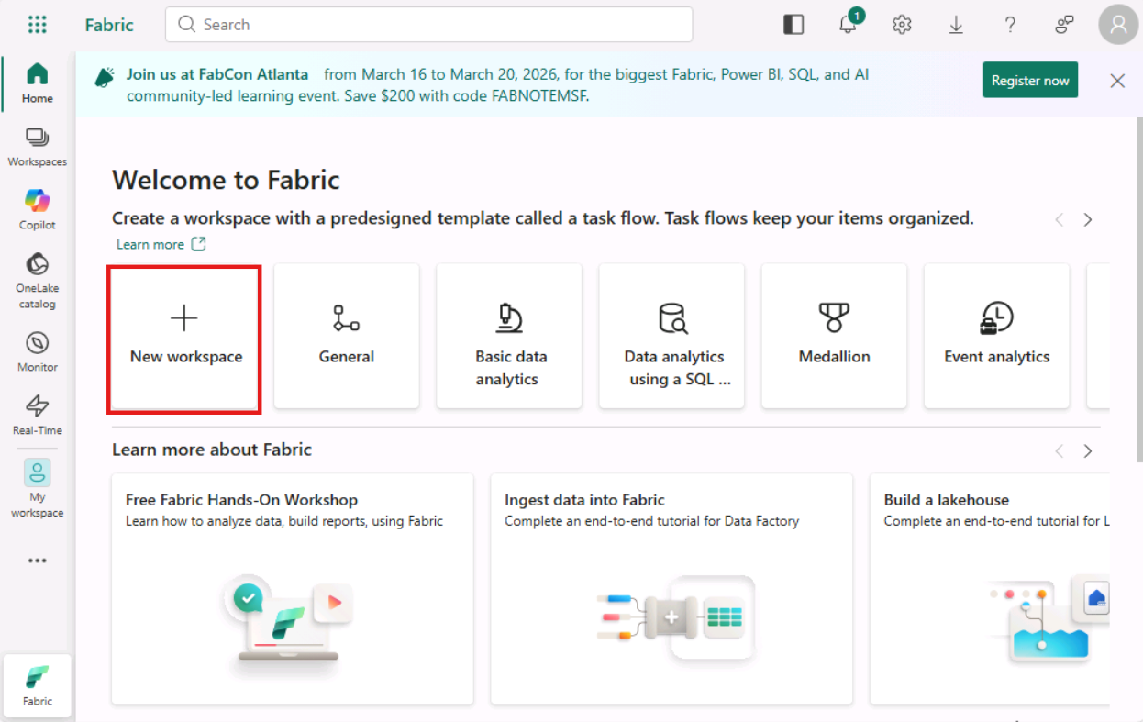
- In the Create a workspace tab, enter the following details and click on the Apply button.
  - Workspace name – Enter SQLDatabase-66838558
  - Advanced: Semantic Model storage format - Small semantic model storage format
  - Advanced: License mode – Fabric capacity
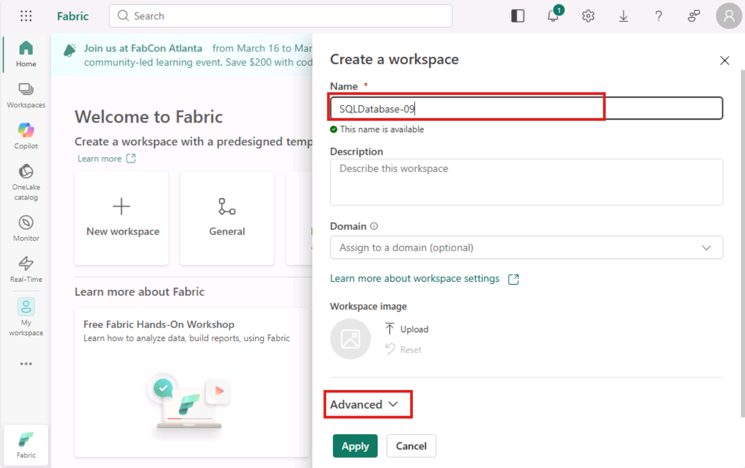
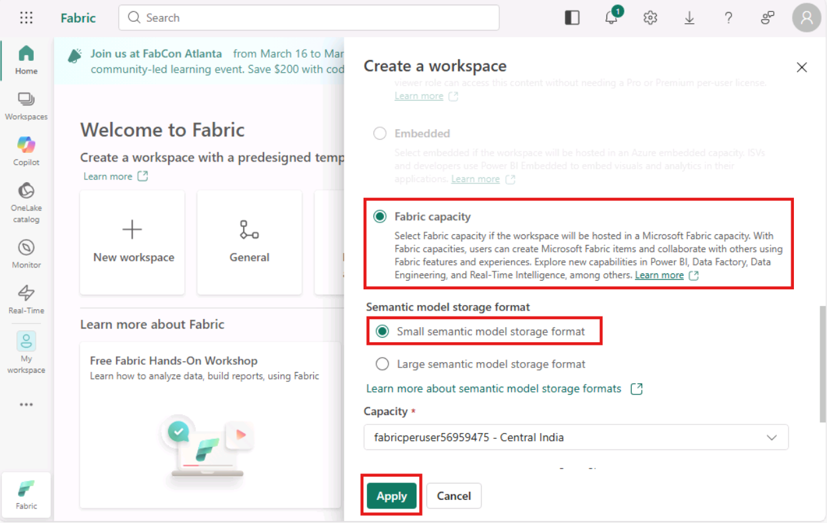
- Task-2: Create a SQL Database in Microsoft Fabric
In this section you will create a SQL database and load it with data.
- You’ll be navigated to the workspace page. Click the New item button on the top left of the page.
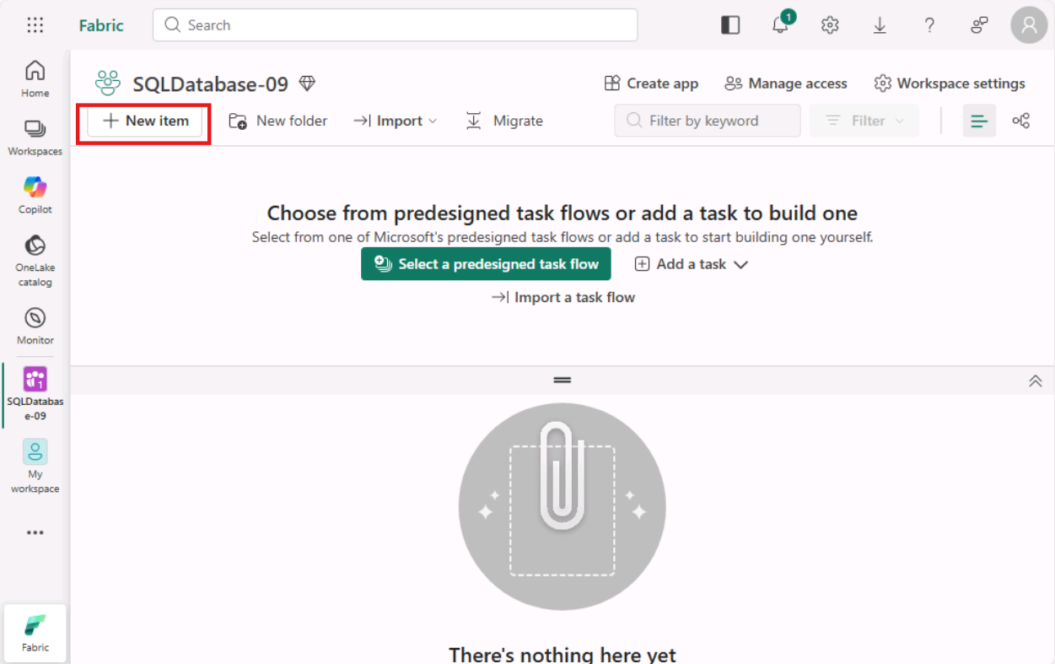
- In the New item blade on the right, use the Filter by item type search box to search for SQL and select SQL database tile.
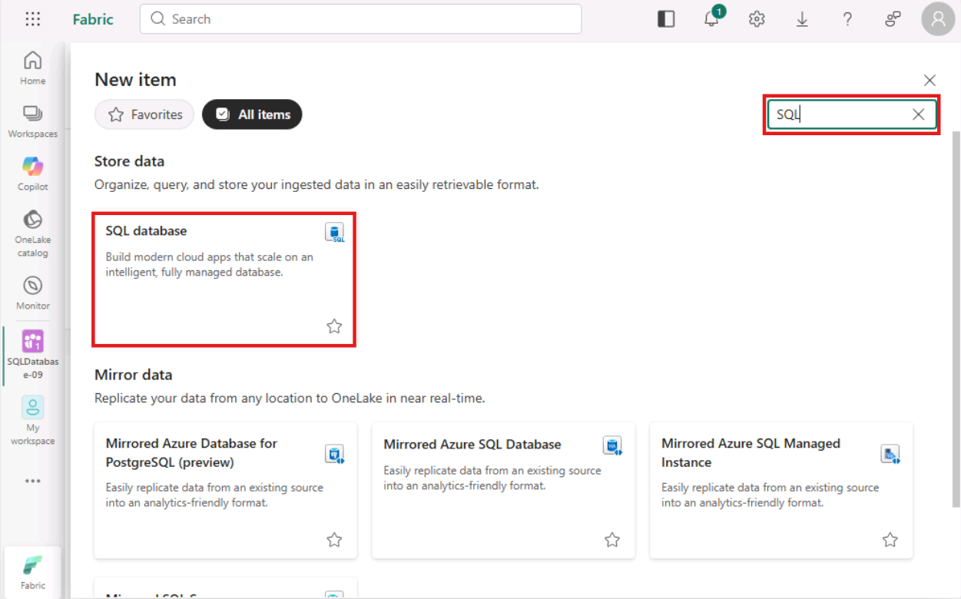
- In the New SQL database dialog window, enter a unique name as LabSQLdb for the database and click the Create button.
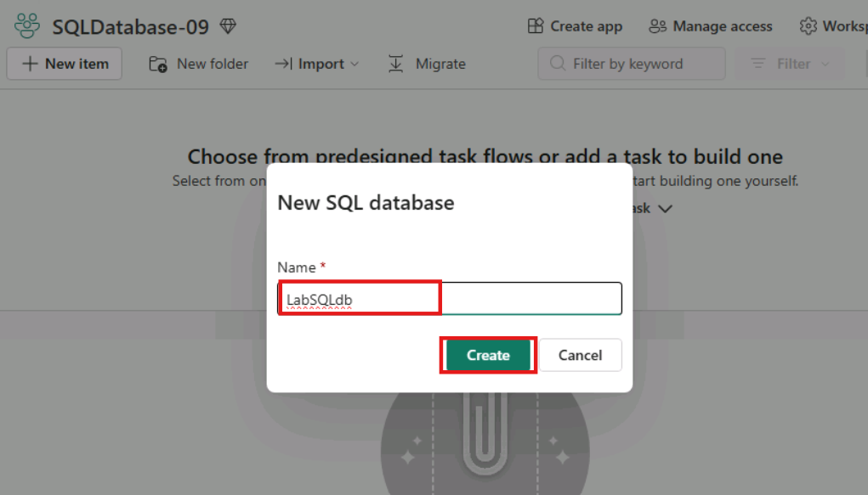
- Once the database is finished creating, you will be taken to SQL database's home page.
- Task-3: Load the database with Sample data
- You need some sample data in the database to work with. Click the Sample data tile right on the database home page to load sample data.
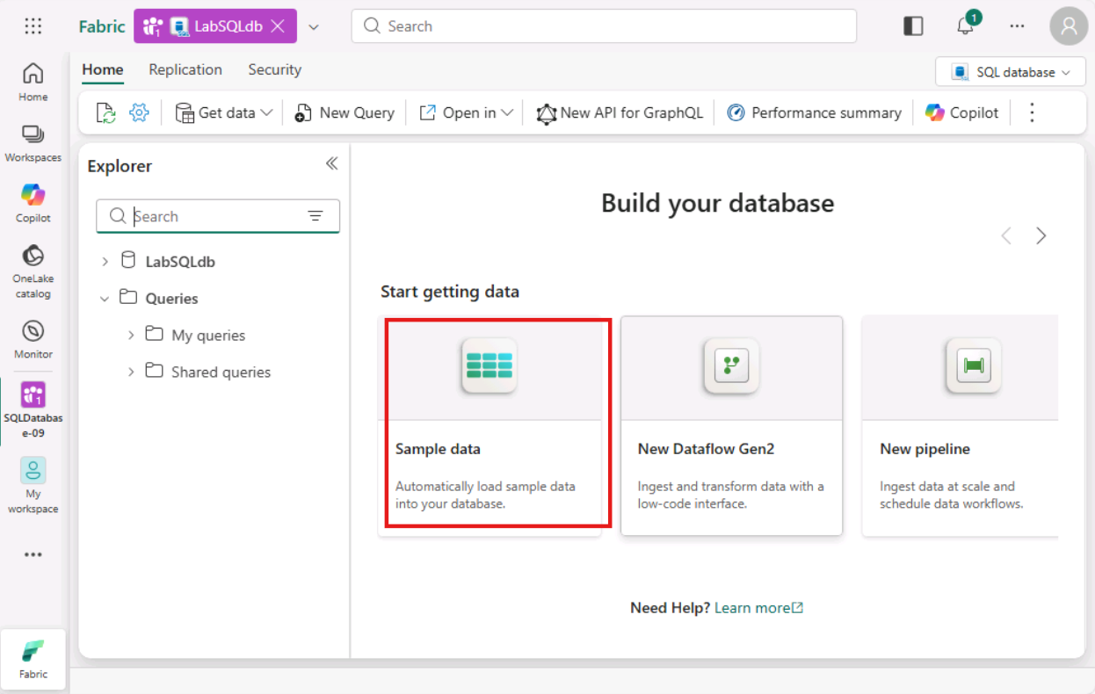
- In the upper right corner of the database home page, you will see a notification indicating that the data is being loaded into the database.
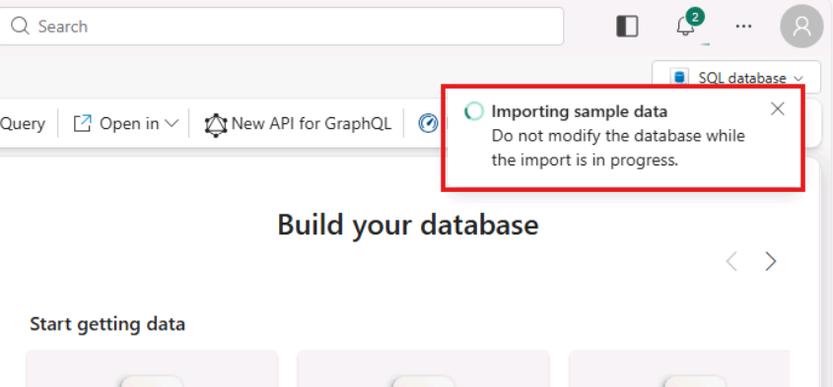
- Allow this process to run (about 45-90 seconds) until you see a notification indicating that the data was successfully loaded into the database.
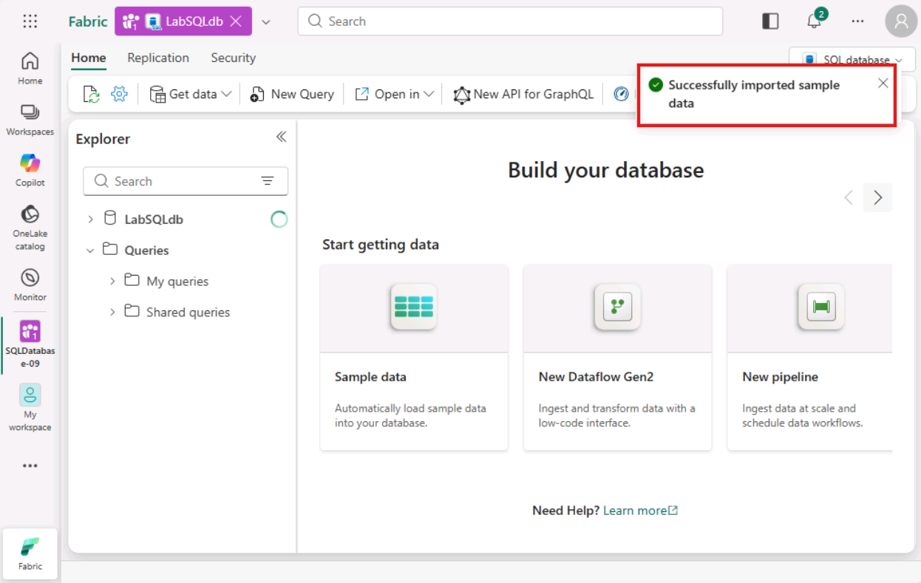
- Look at the Database Explorer area on the left of the page. Here, click the dropdown arrow next to the database to see a list of database schemas. Make sure SalesLT sample data is successfully loaded in the database.
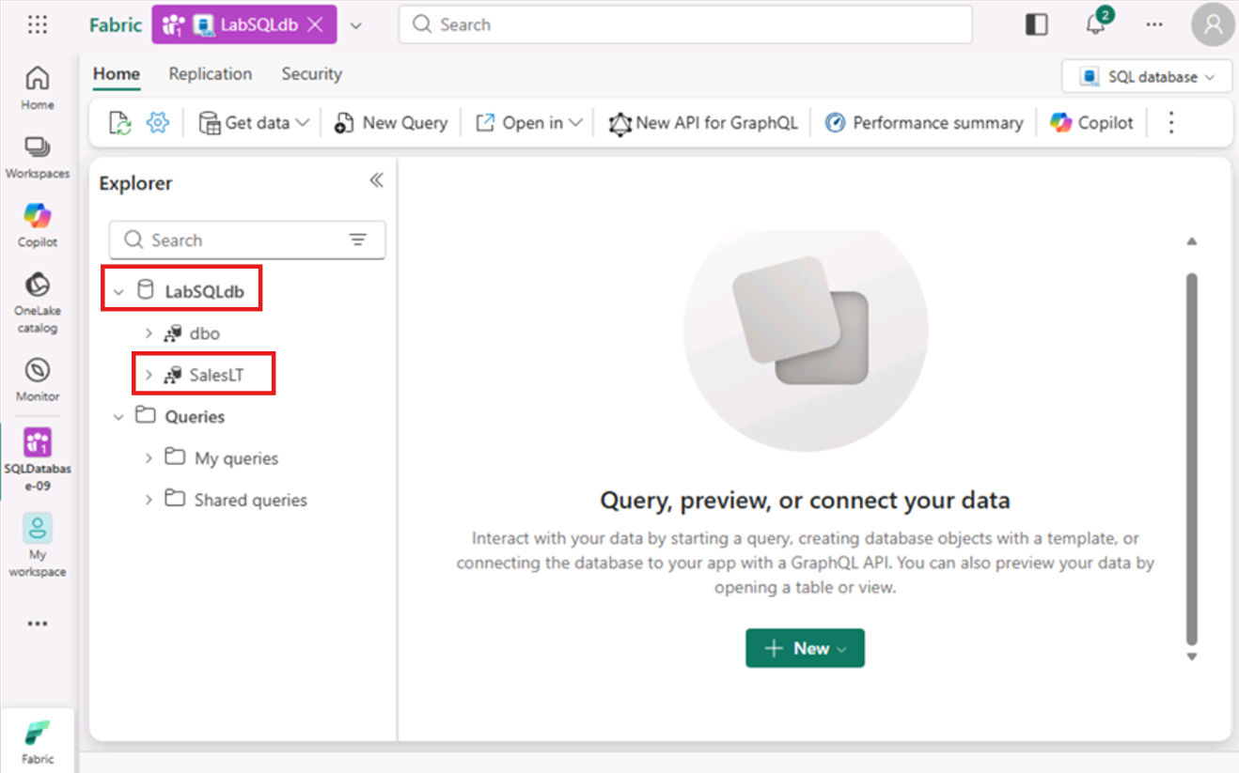
- Task-4: Working with the SQL database in Microsoft Fabric
In this next section, we will be focused on using the Web Editor for SQL database in Microsoft Fabric.
- Expand the SalesLT schema, followed by expanding the Tables folder. Then click on the Address table.
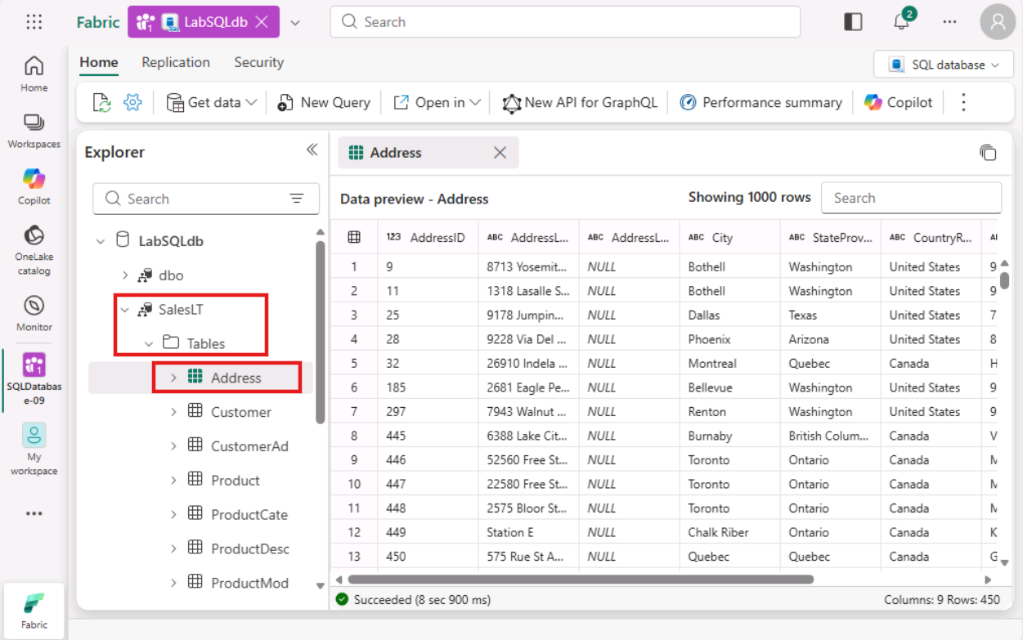
- After browsing the data in the Address table, click the New Query button on the toolbar.
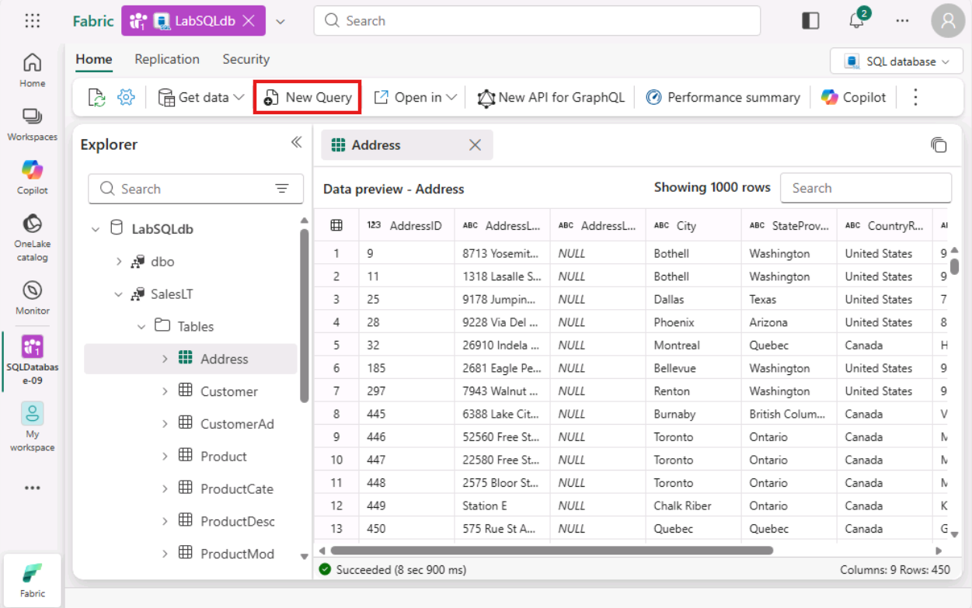
- This will open a new query window that we will use to work directly with the database. Copy and paste the following code into the query window:
- TypeCopy
- SELECT * FROM [SalesLT].[Product]
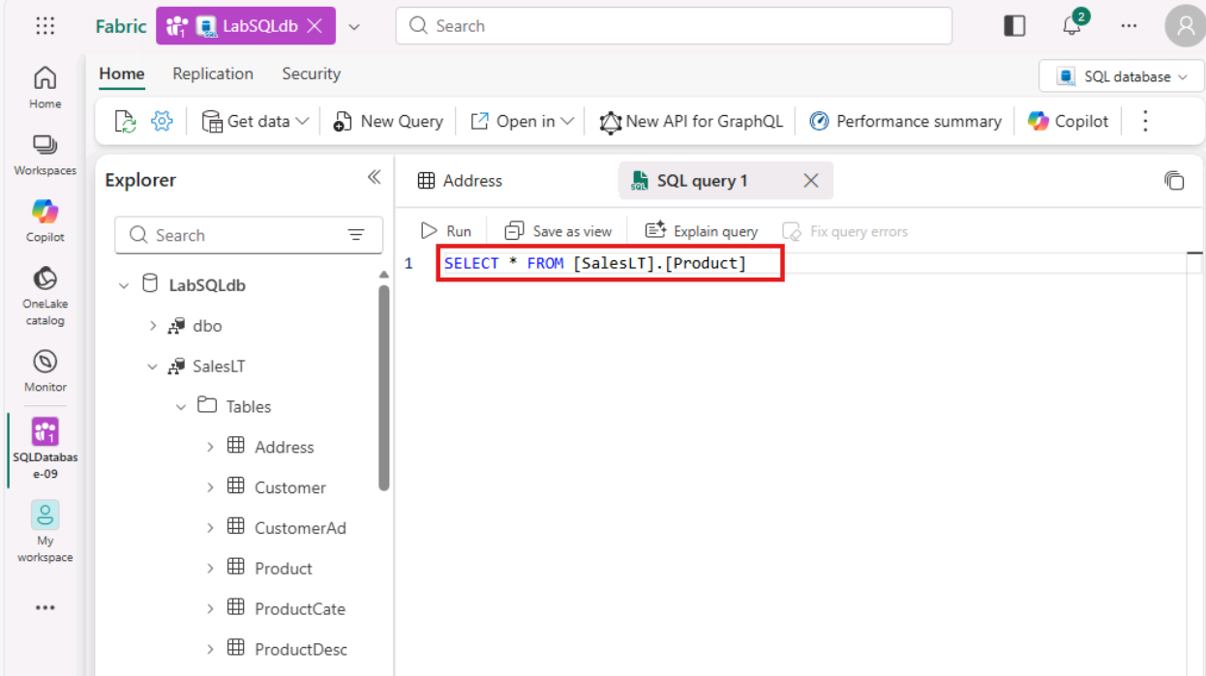
- Once the code is in the query window, click the Run button. You will see the results of the query on the bottom of the query window.
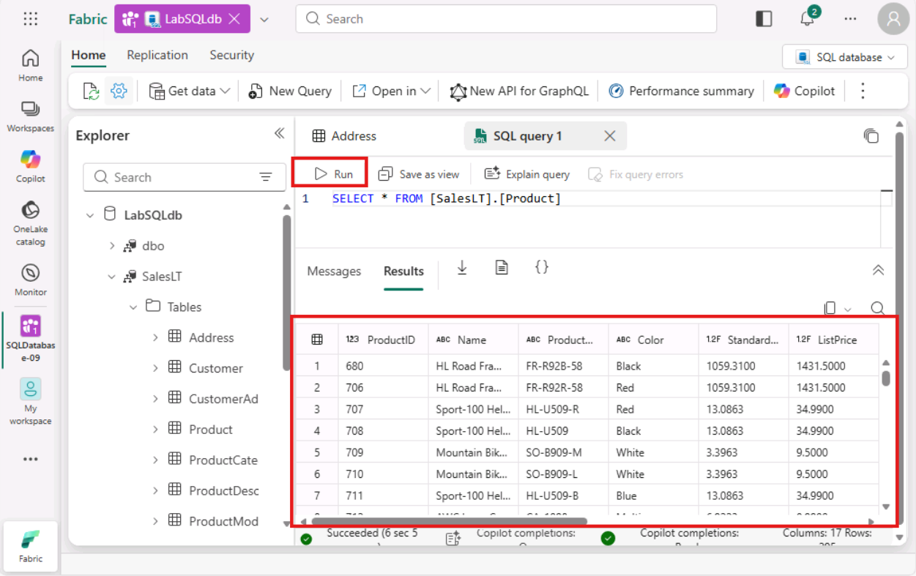
- Task-5: Exploring SQL analytics Endpoint
With the data from your SQL database automatically mirrored in OneLake, you can write cross-database queries, joining data from other SQL databases, mirrored databases, warehouses, and Lakehouses. All this is currently possible with using T-SQL queries on the SQL analytics endpoint - a SQL-based experience to analyse OneLake data.
Important Note: Please refresh the browser before you move to next step.
- To access SQL analytics endpoint, switch to SQL analytics endpoint mode from the top right corner.
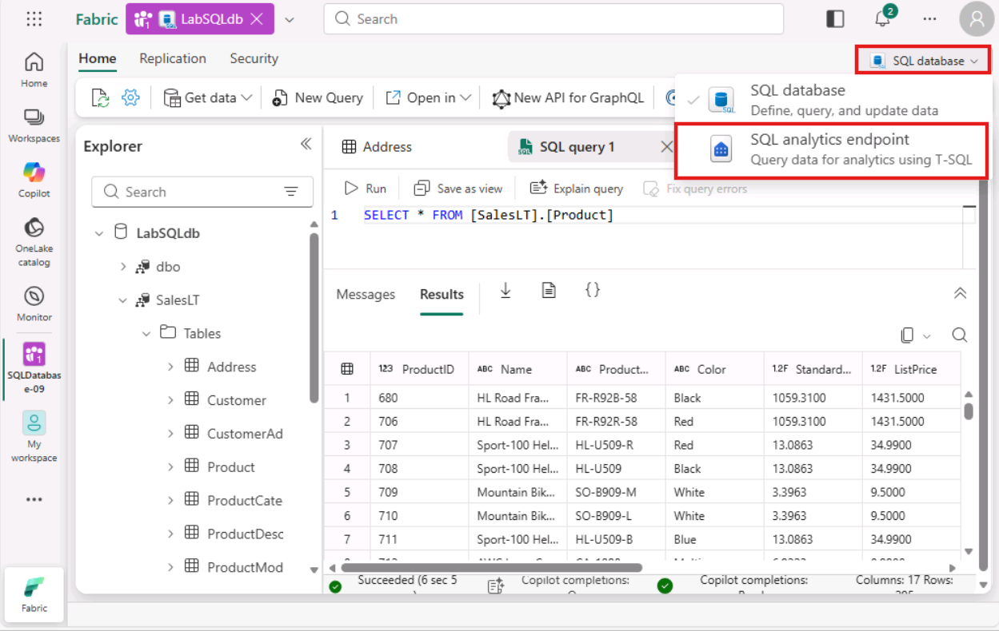
- In SQL analytics endpoint, select a New SQL query.
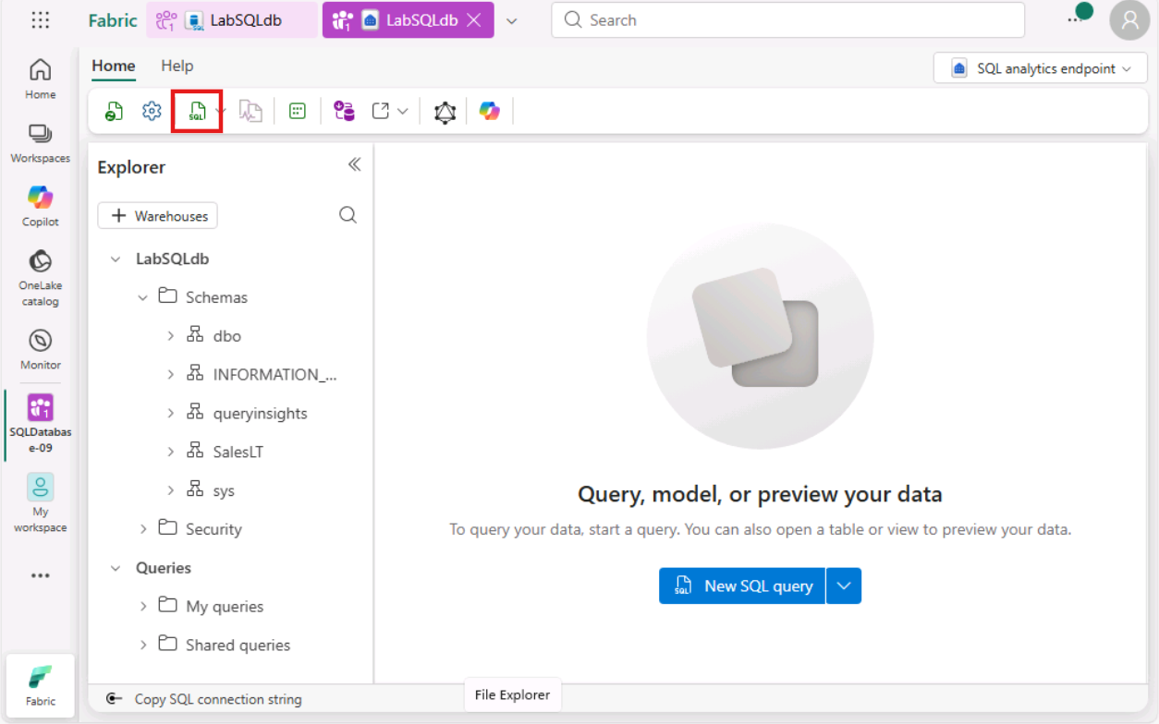
- Enter the following code into the query window:
- TypeCopy
- SELECT * FROM [SalesLT].[Product]
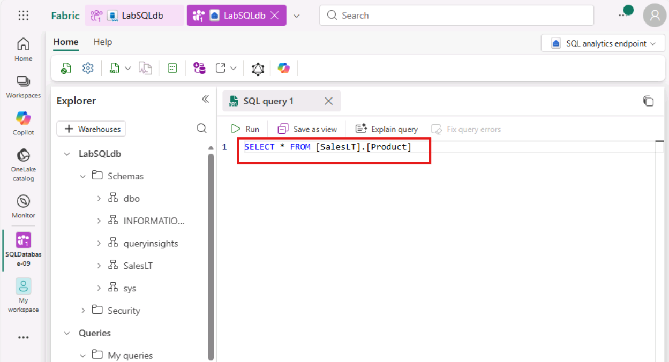
- Click on Run to see the results.
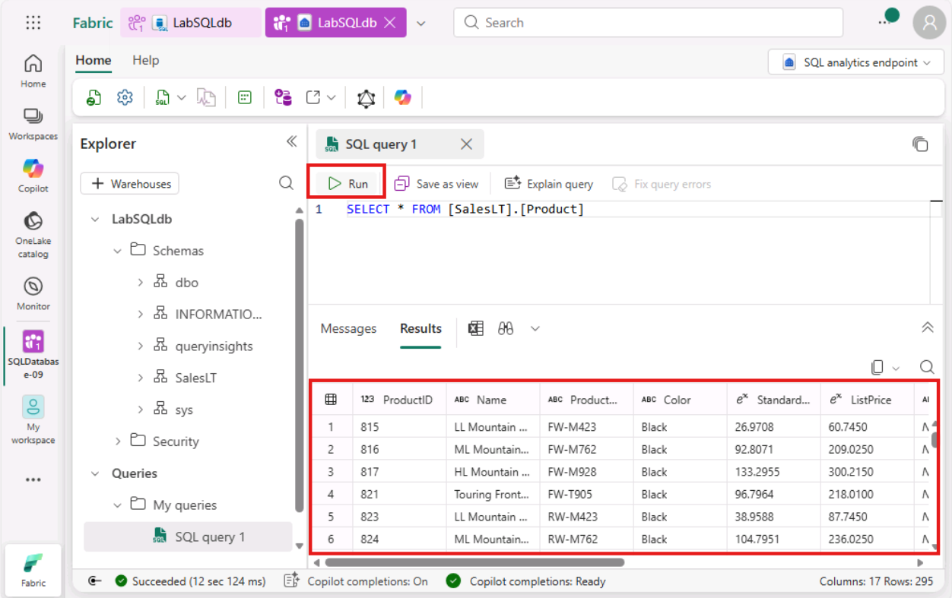
- To switch back to SQL database, select SQL database option from the top navigation pane.
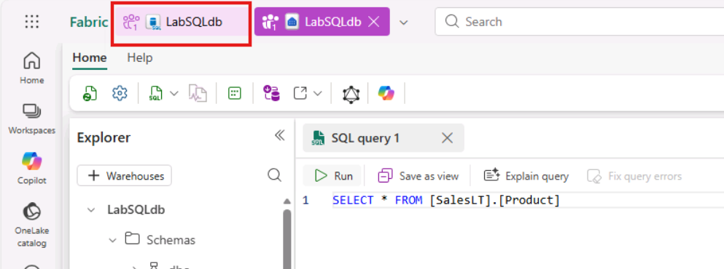
- Database replication to OneLake can be monitored from the replication status of your database. Click Replication tab on top left corner and select Monitor replication.
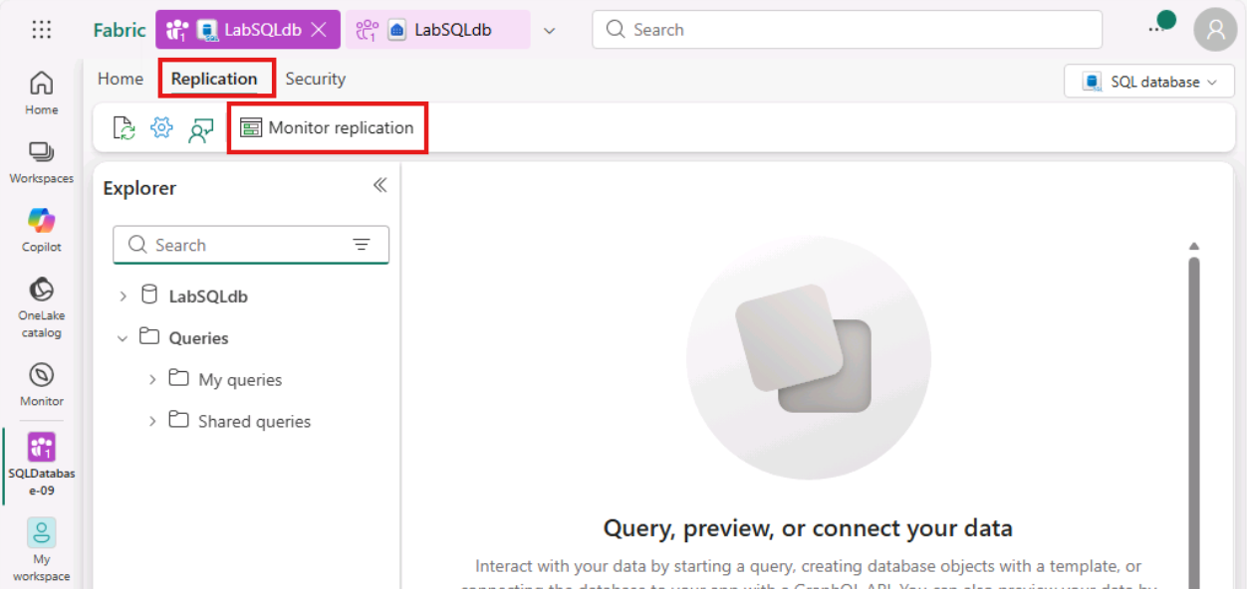
- This will open up a blade on the right side that demonstrates the status and the last mirroring refresh time.
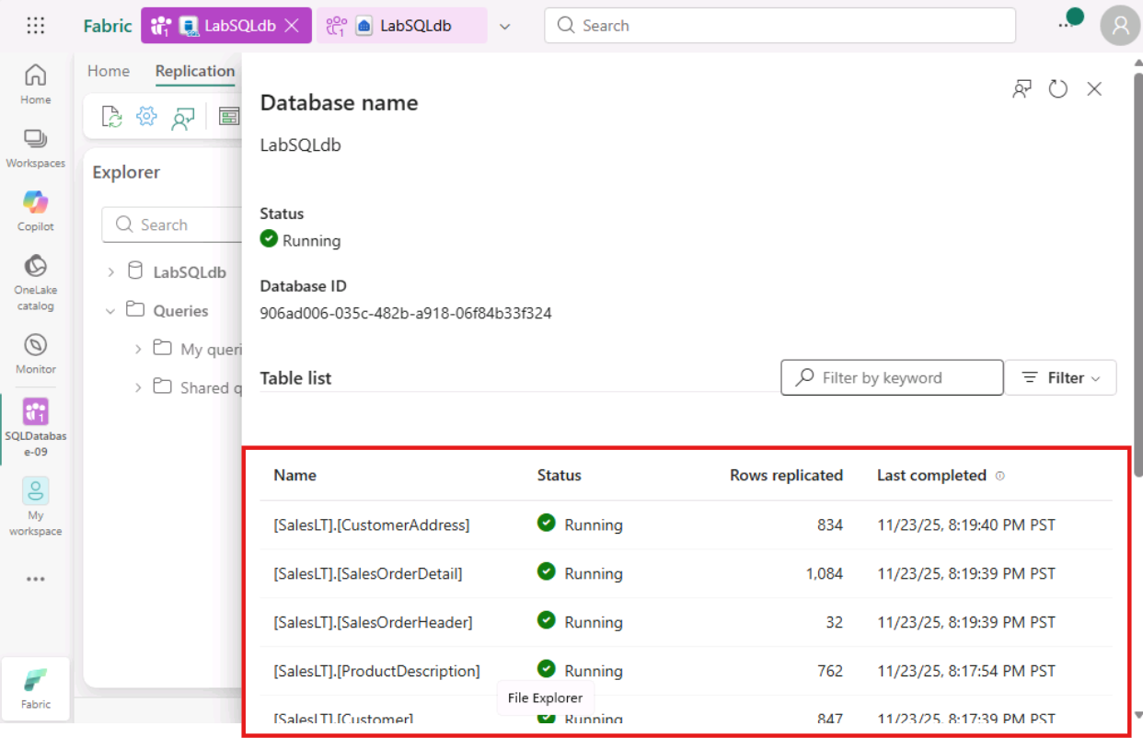
- Close the Monitor Replication pane by clicking on the X icon.
- Exercise 2 – Copilot Capabilities for SQL database in Microsoft Fabric
In this exercise, you will use Copilot to assist with T-SQL queries, including auto suggestions, fixing error, and natural language query to increase developer efficiency and analyse your data!
- Task-1: Using Copilot within the query editor
In the Query Editor you can use T-SQL comments as a way to write Copilot prompts. After finishing a prompt press Enter or Space and Copilot will process your request and suggest SQL code to complete your query.
- Select the New Query button on the tool bar as you did in previous module.
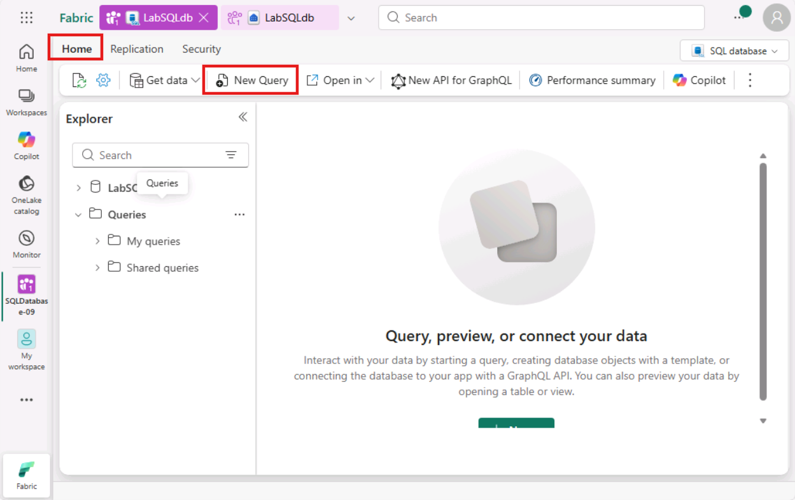
- Enter the below prompt in the query editor and press Enter.
--Create a query to get the product that is selling the most
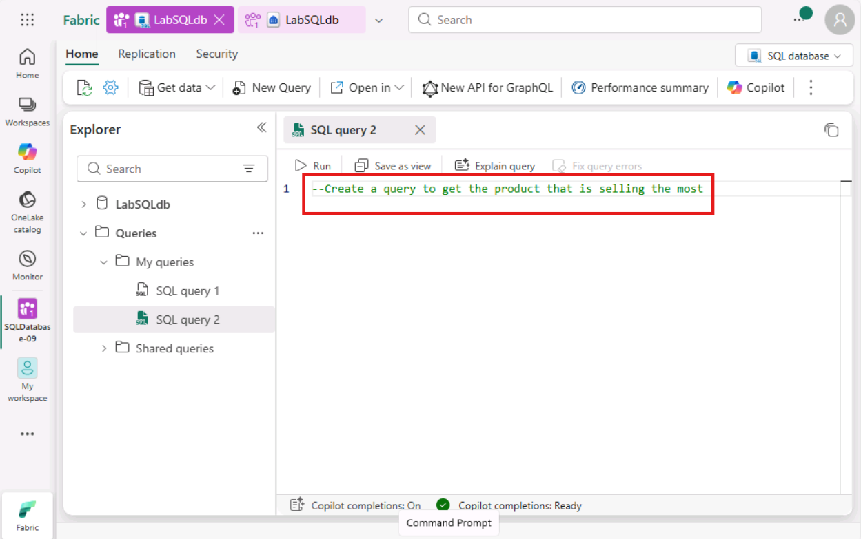
- Watch for the loading spinner at the bottom of the editor to track progress and observe how code suggestion appear in the query window.
Note: Copilot responses may not match what is shown in the screenshot but will provide similar results.
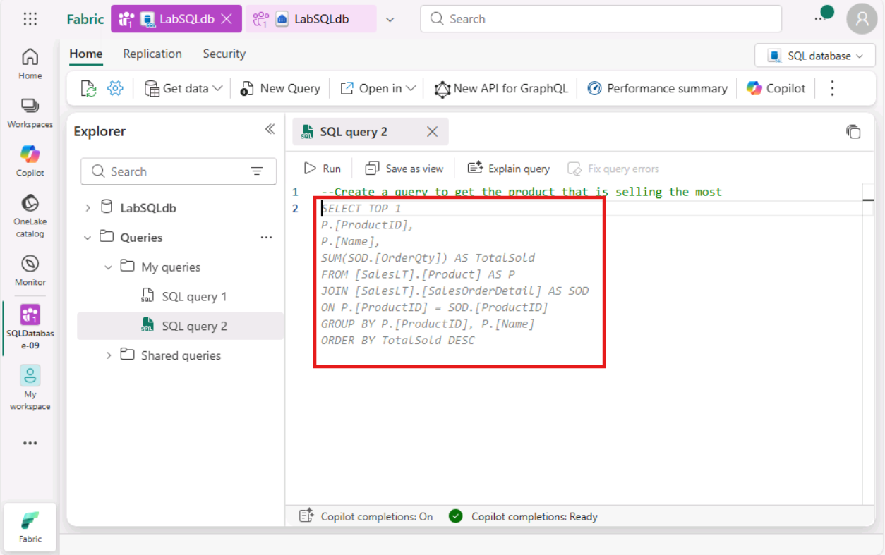
- Press the Tab key on your keyboard to accept the suggestion.
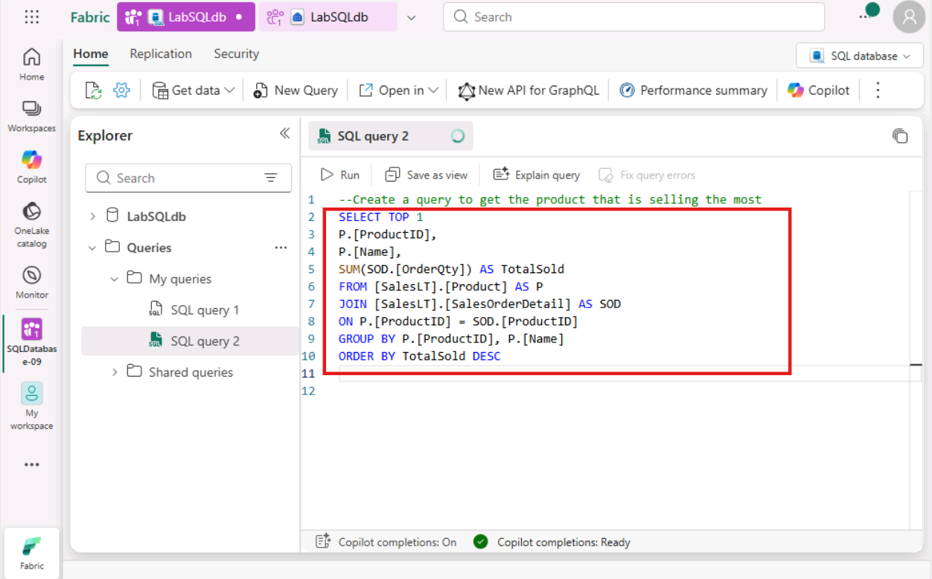
- Select the query and click on the Run icon.
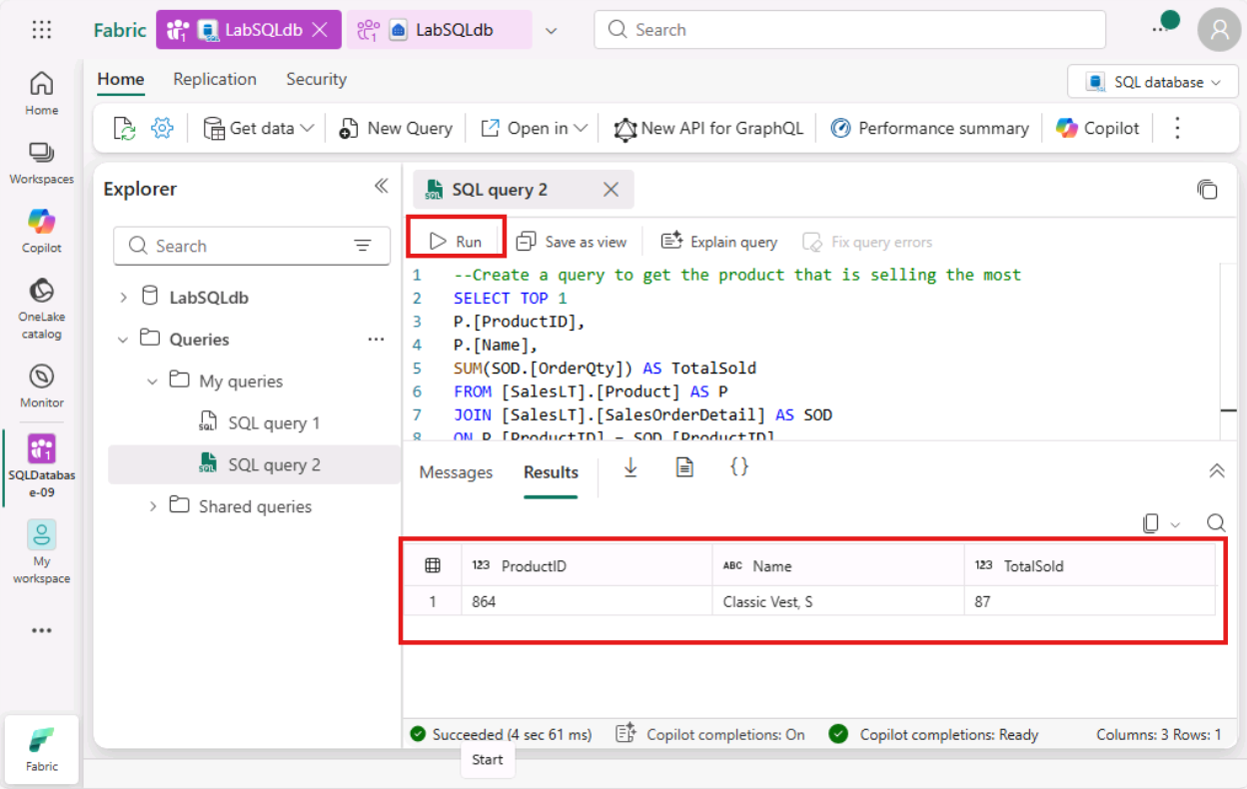
- Task-2: Copilot Quick Actions within the Query Window
- Select the New Query button on the tool bar.
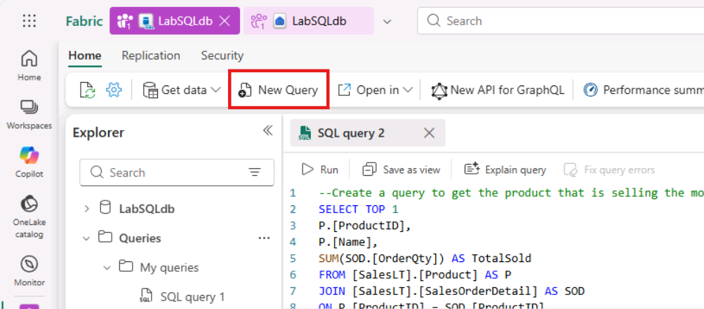
- Open a new query window and paste the following T-SQL with a syntax error and click on the Run icon.
- TypeCopy
- SELECT c.CustomerID, c.FirstName,c.LastName,
- COUNT(so.SalesOrderID) AS TotalPurchases,
- SUM(so.SubTotal) AS TotalSpent,
- AVG(so.SubTotal) AS AverageOrderValue,
- MAX(so.OrderDate) AS LastPurchaseDate
- FROM
- SalesLT.Customer AS c JOIN SalesLT.SalesOrderHeader AS so ON c.CustomerID = so.CustomerID
- GROUP BY c.CustomerID, c.FName, c.LName ORDER BY TotalSpent DESC;
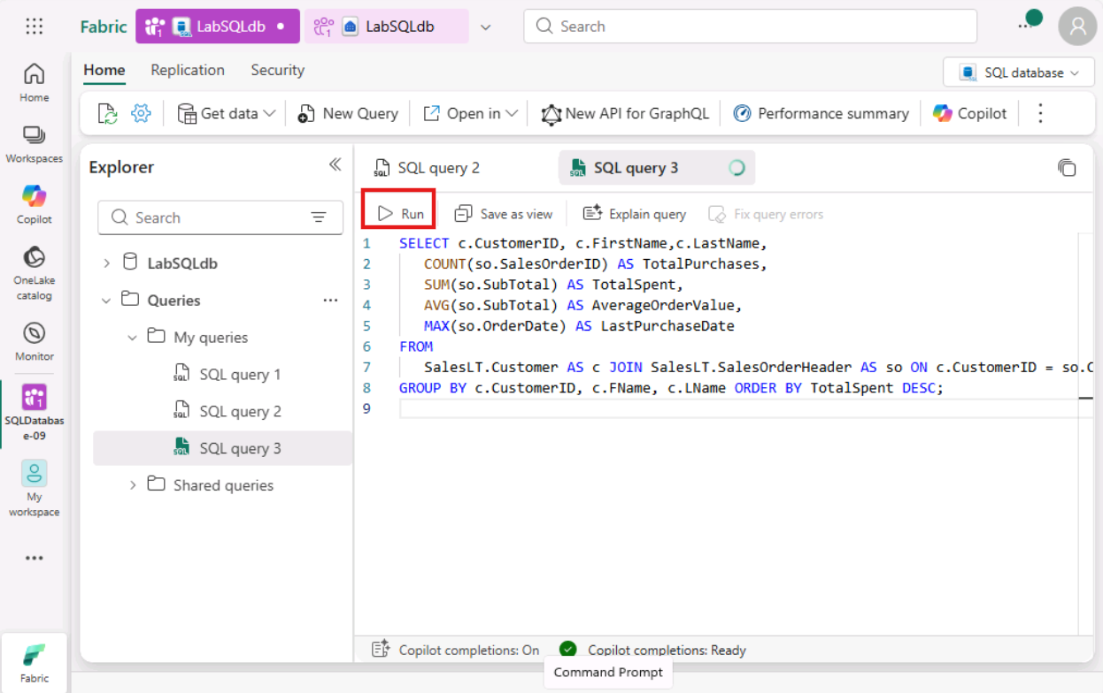
- Observe the T-SQL errors (issue) and then select Fix query errors.
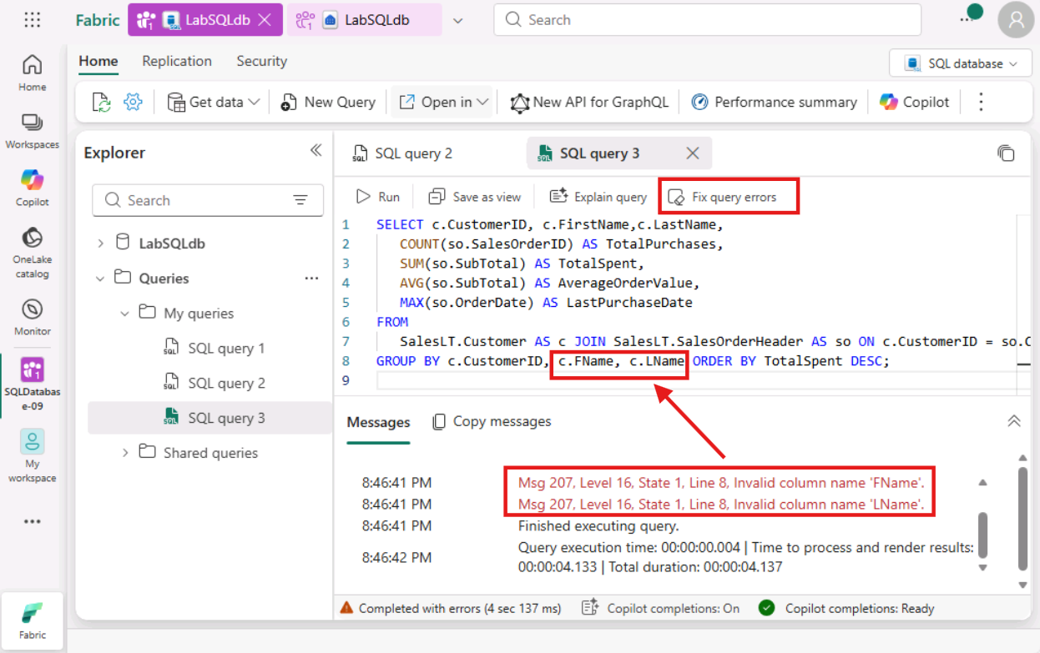
- Observe the updated T-SQL along with the comment that clearly states where the issue was in the T-SQL.
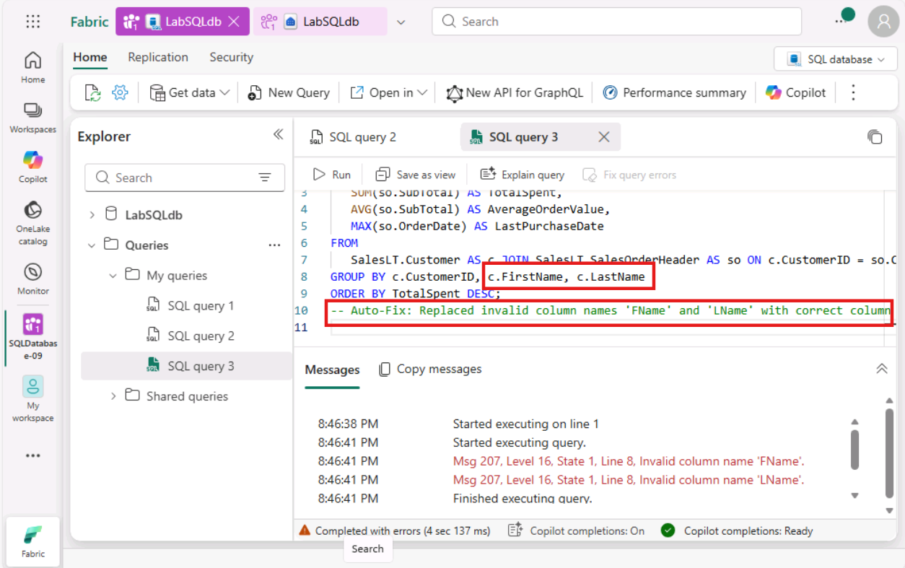
- Now, click Run to see the results without any errors.
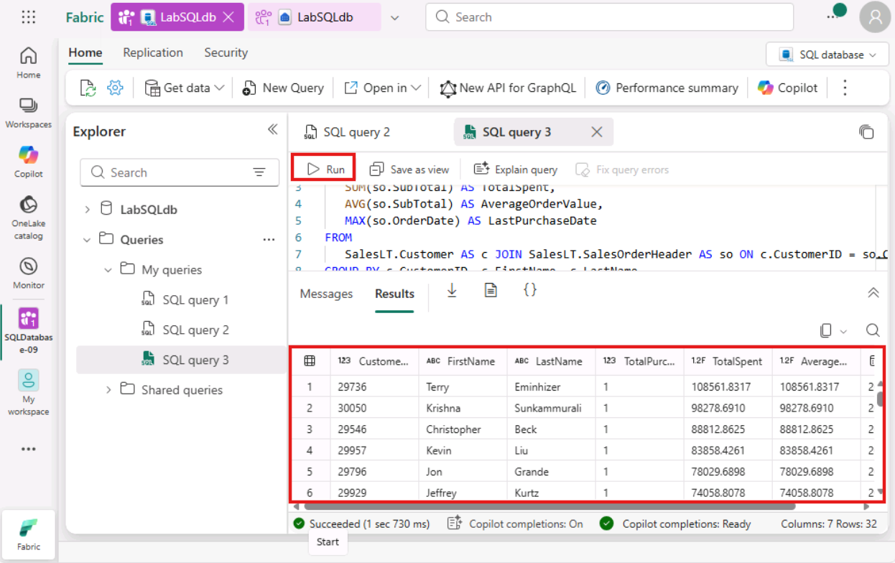
- Aside from fixing the T-SQL errors, Copilot can also explain a T-SQL to you. Select Explain query and Copilot will add comments to your T-SQL explaining the T-SQL.
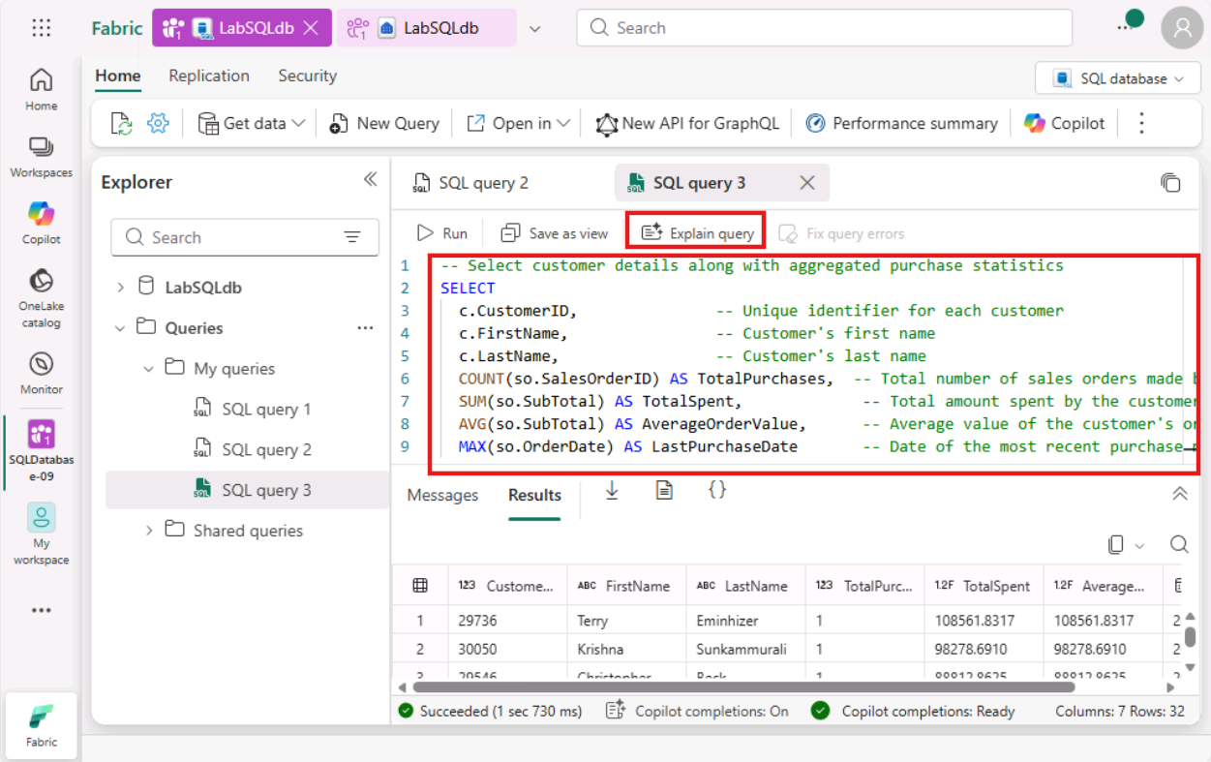
- Task-3: Using Copilot Chat Pane - Natural Language to SQL
- Open the New Query window.
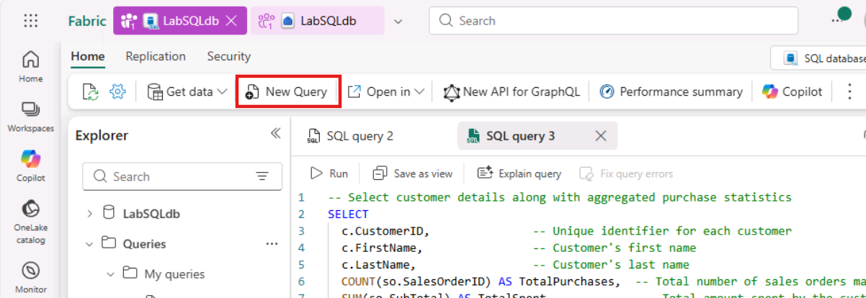
- Select the Copilot option from the Home tab.
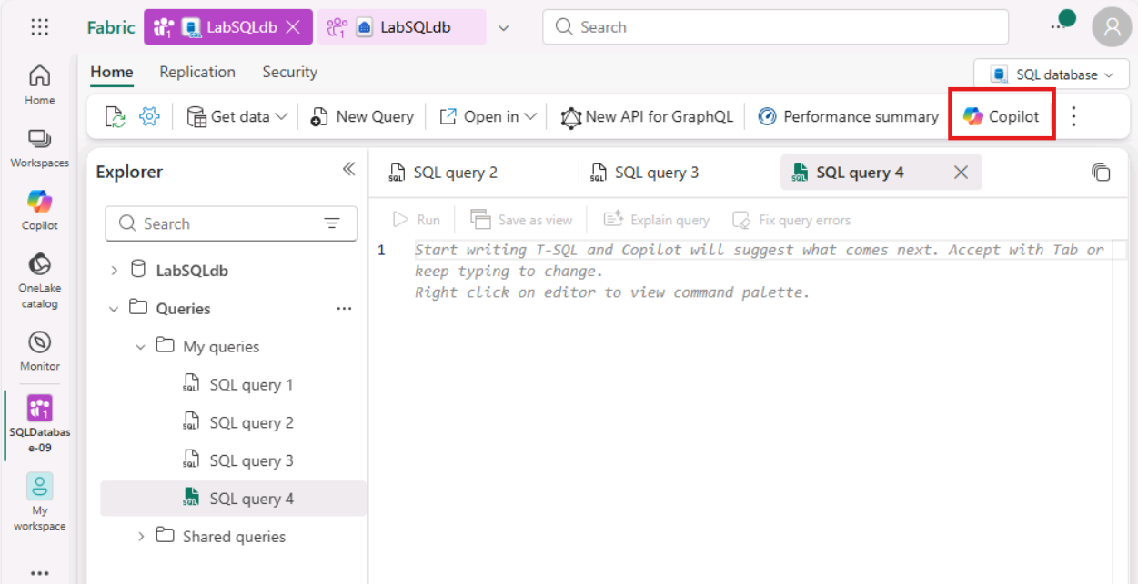
- Click on the Get started button.
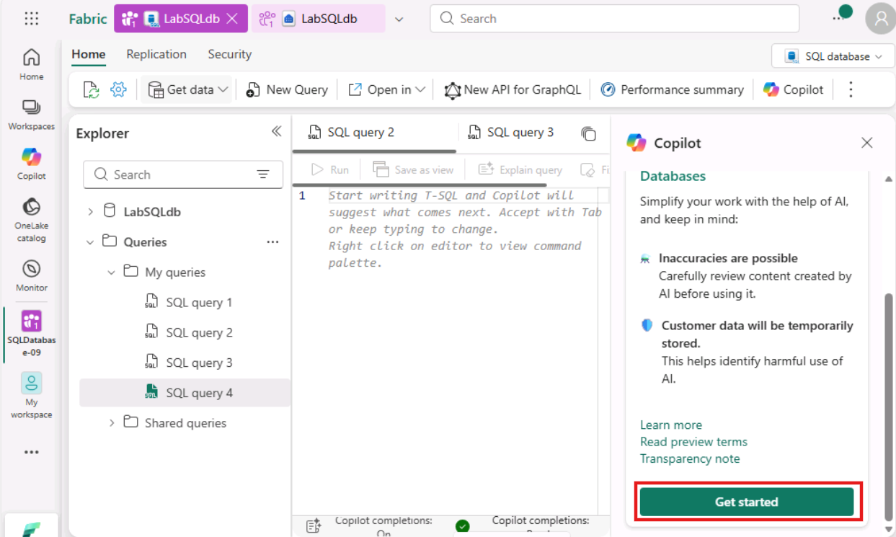
- Paste the following prompt in the Copilot chat box and click on Send button.
Write a query that will return the most sold product.
Note: Copilot might not show the right results the first time. Please ask the same question again.
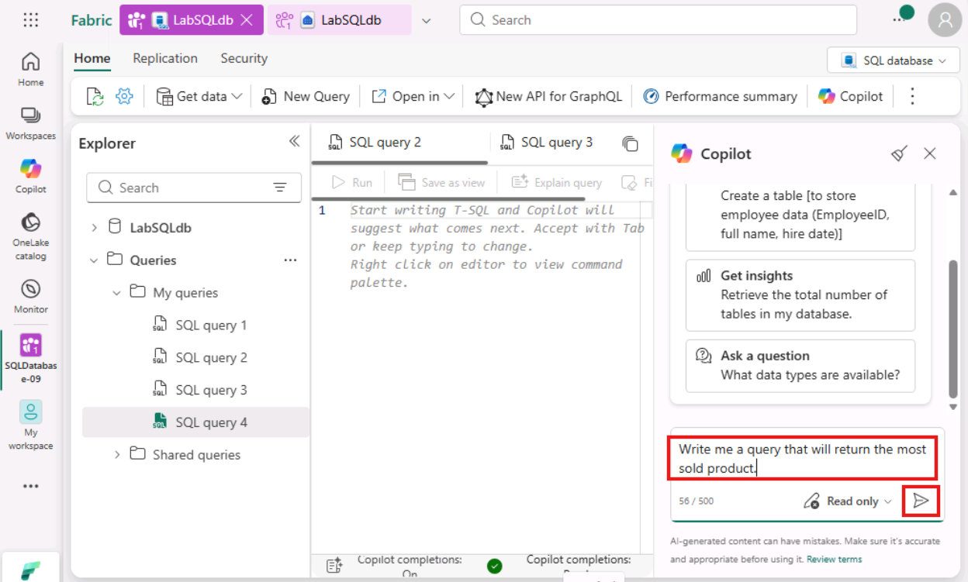
- Read the answer now and select the Insert button to input code into the query window.
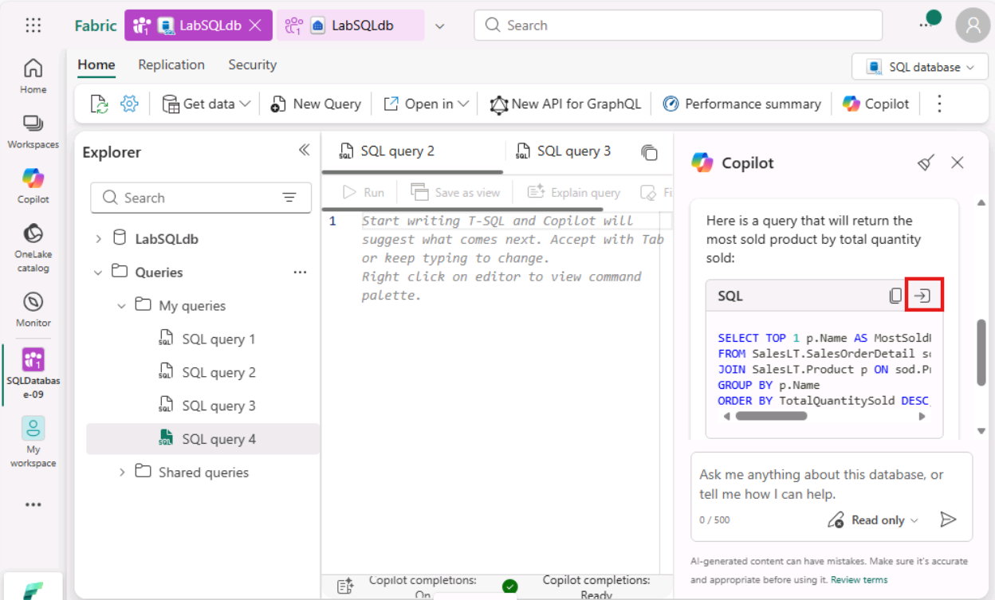
- Click on the Run icon and check the Results.
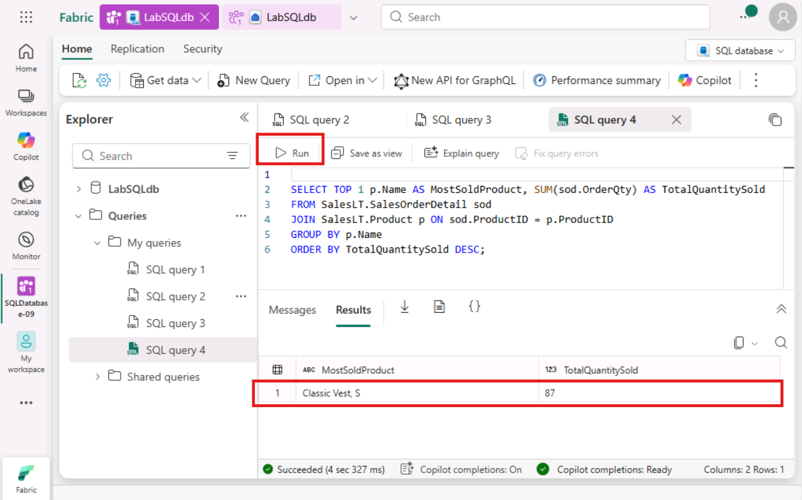
- Task-4: Chat Pane - Get results from Copilot
- Another way to use Copilot is to ask it to get results for you. Open the New Query window.
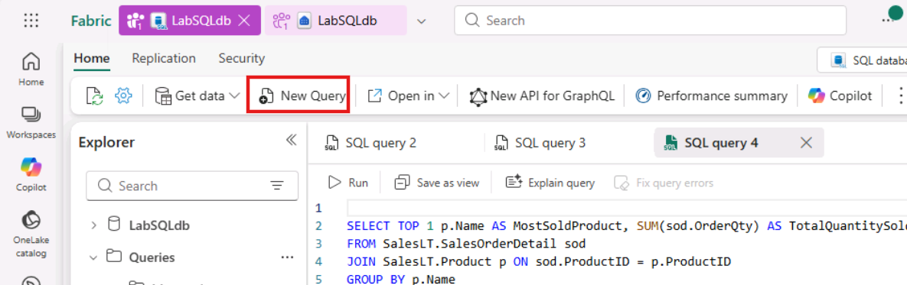
- Paste the following question in the Copilot box and click on Send button.
What is the most sold product?
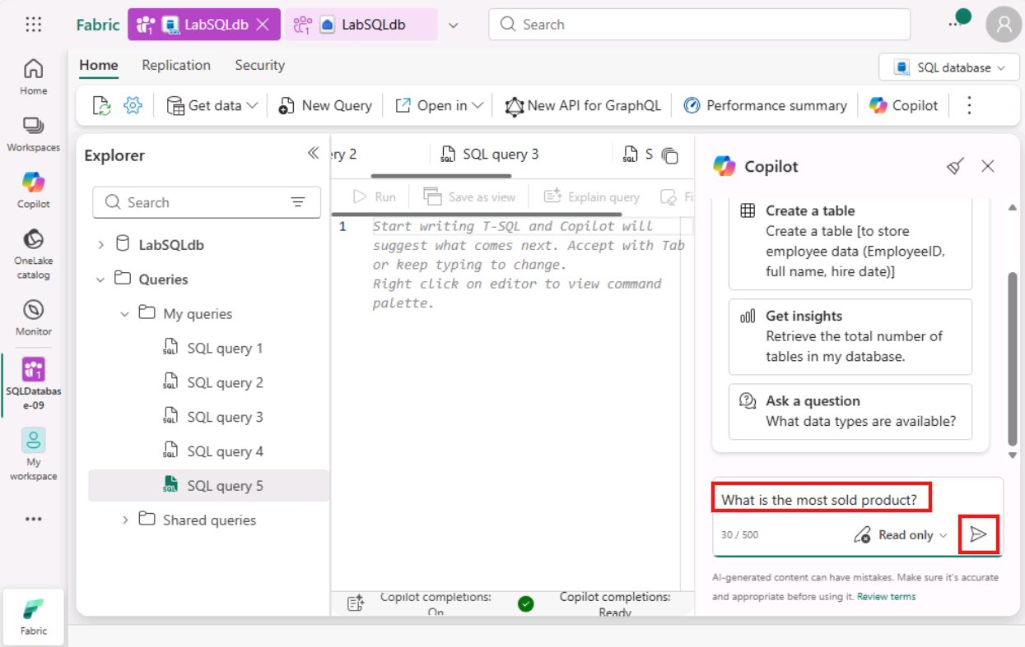
- Observe that Copilot has returned the results in the Chat pane.
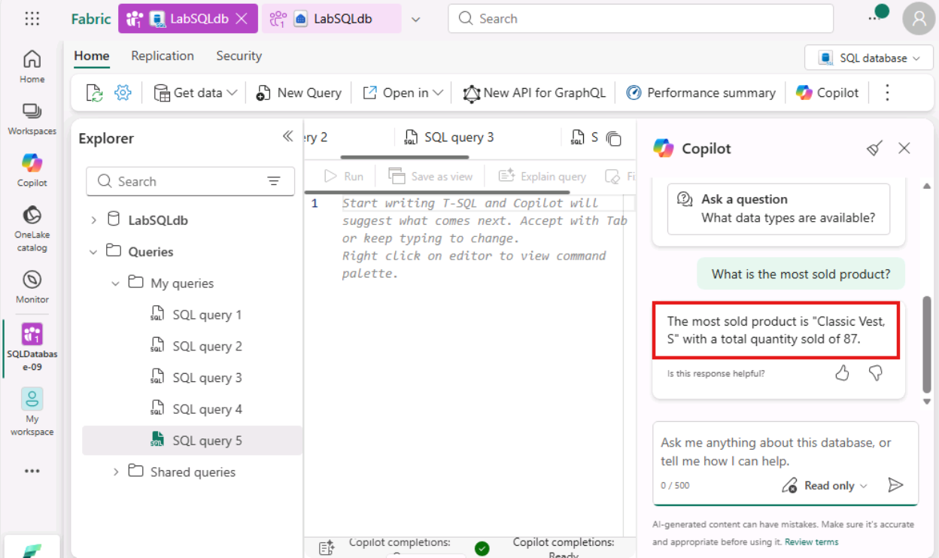
- Task-5: Chat Pane – Write (with approval)
- Copilot is also able to write and execute queries on top of your database (with approval). You can choose Read and write (with approval) option from the dropdown.
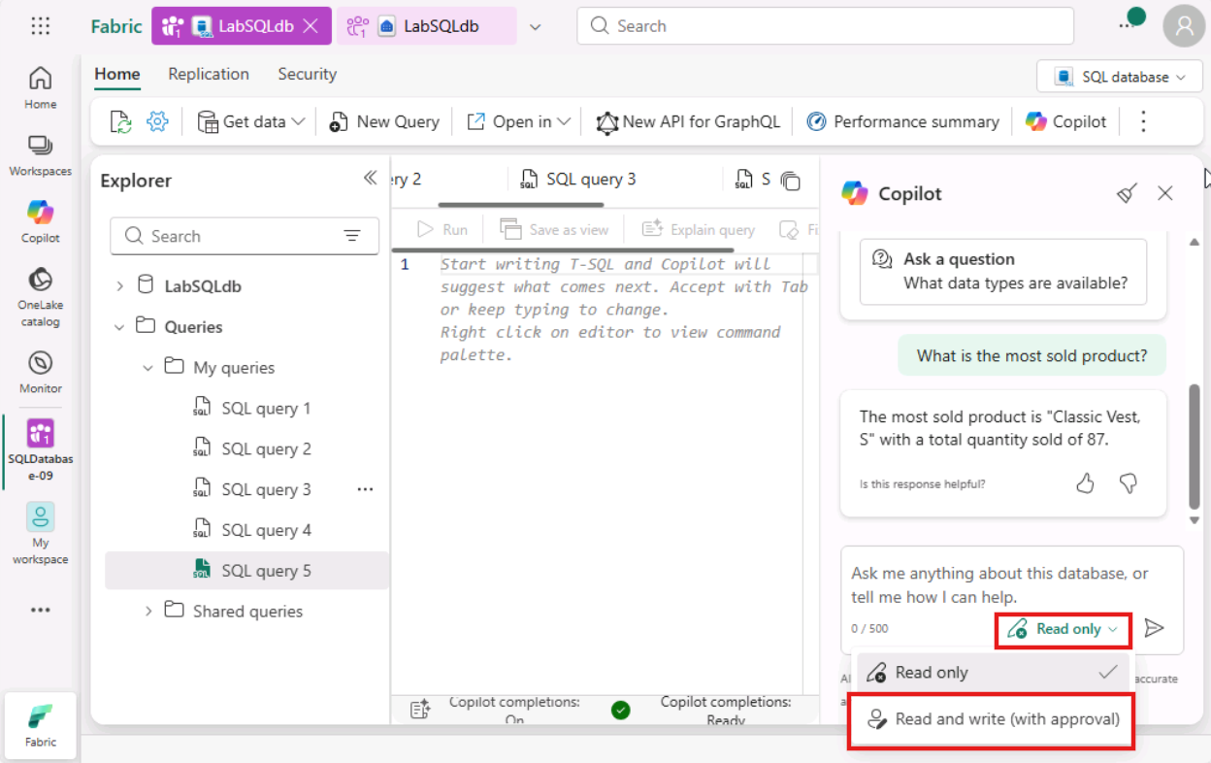
- Paste the following question in the Copilot chat box and click on Send button.
Create a view in the SalesLT schema using this query and execute it.
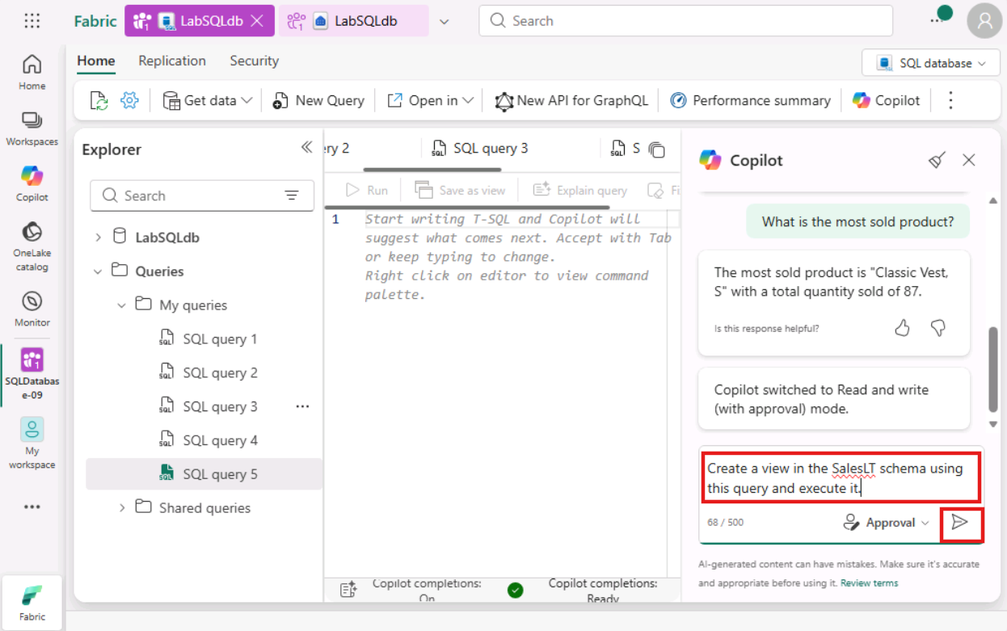
- Observe the Copilot's response and select Run to execute the given query on top of your database.
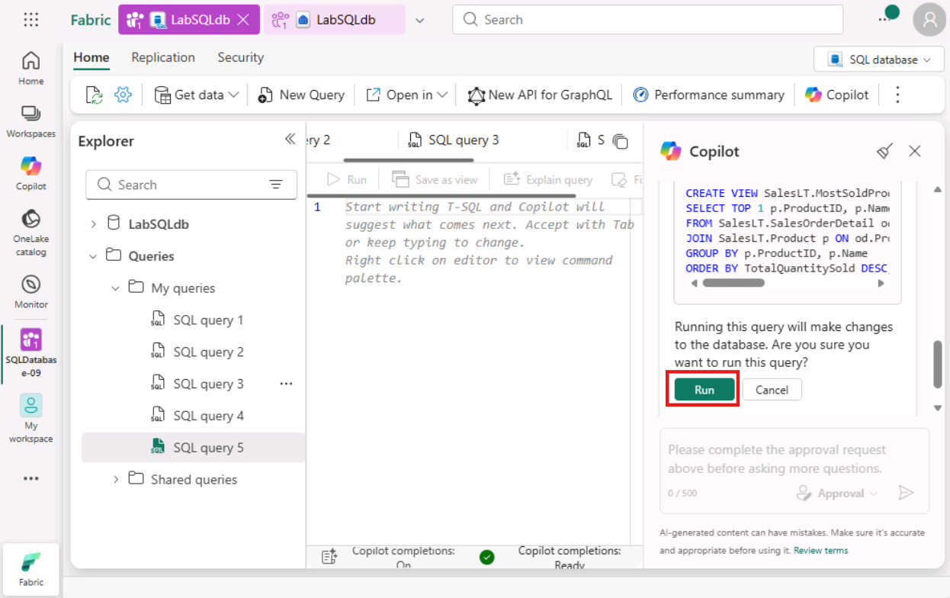
- Wait a few seconds while Copilot executes the query. It will give a confirmation that the view is now created under SalesLT schema.
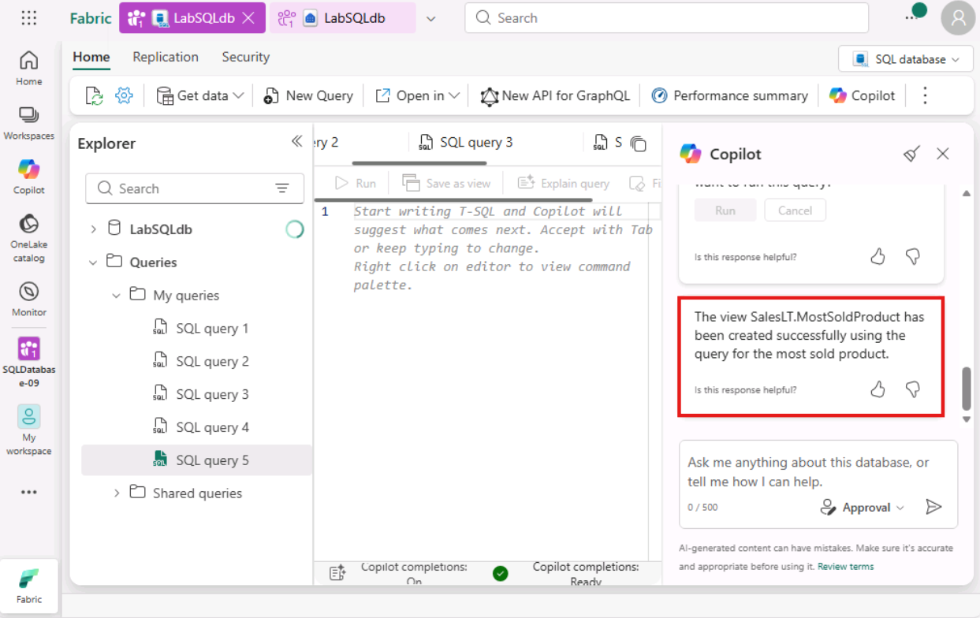
- In the Explorer pane on the left, expand the SalesLT schema. Open the Views folder, then select/click the view you just created. Review the displayed results to validate that the data matches your expectations.
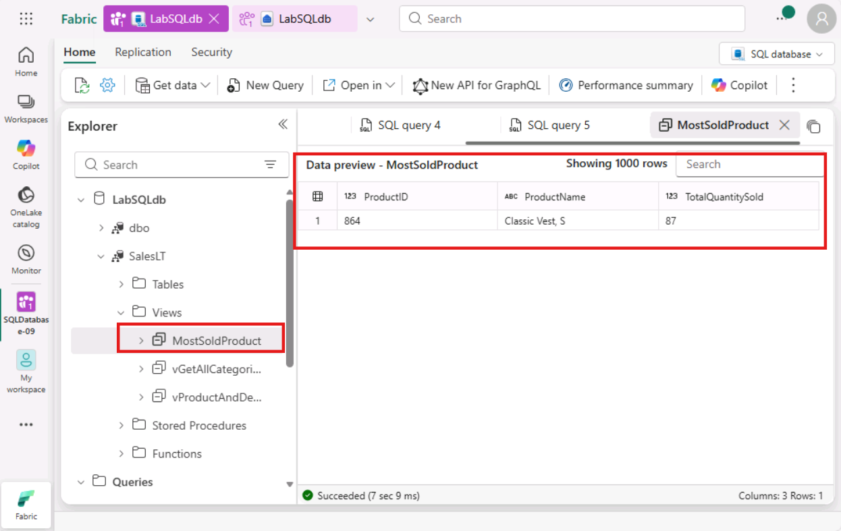
- Exercise 3 – RAG Architecture Simulation using SQL Database
In this exercise, you will explore how vector embeddings and Retrieval-Augmented Generation (RAG) can be leveraged to generate intelligent product recommendations.
- Task-1: Create OpenAI resource in Azure Portal
- Navigate to Azure portal- https://portal.azure.com/. As you’re already signed in with the credentials on Microsoft Fabric Portal. Your credentials are saved. Just click on Next button to proceed.
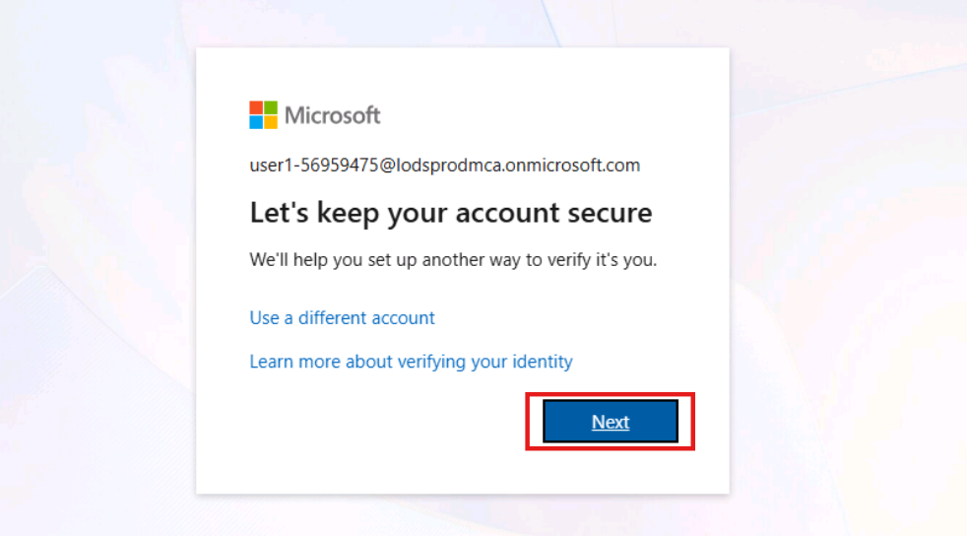
- You are navigated to Azure Portal Home Page. Search for OpenAI in the search bar at the top and select it from the search results.
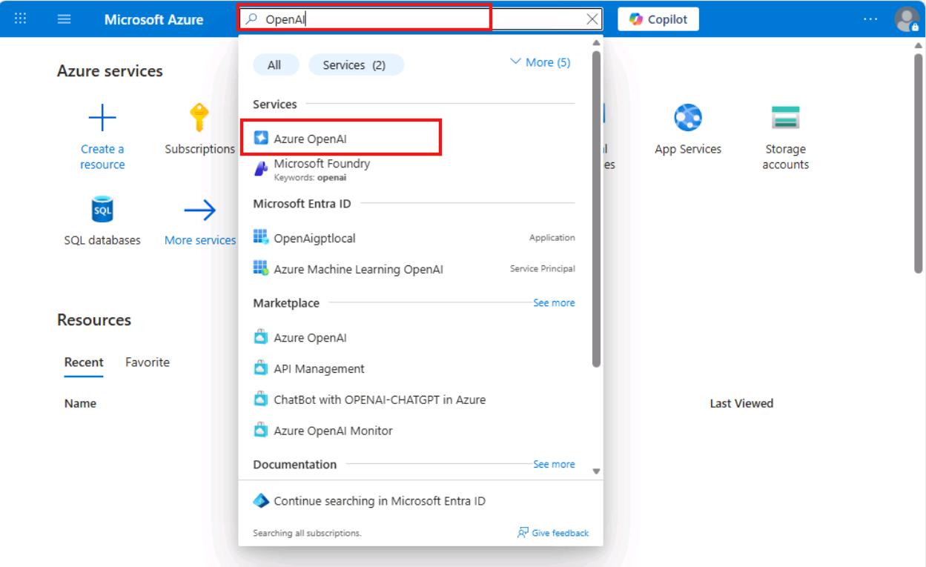
- Click on Create dropdown and choose Azure OpenAI.
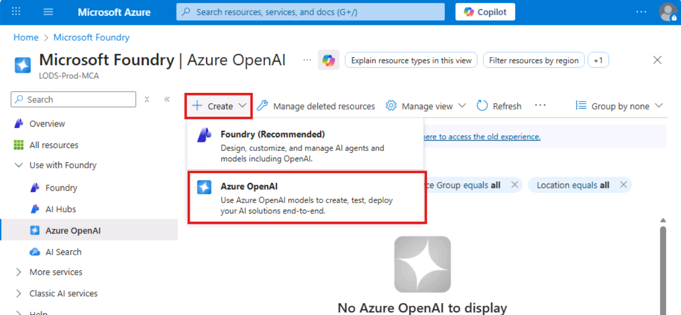
- Choose ResourceGroup1 as your resource group.
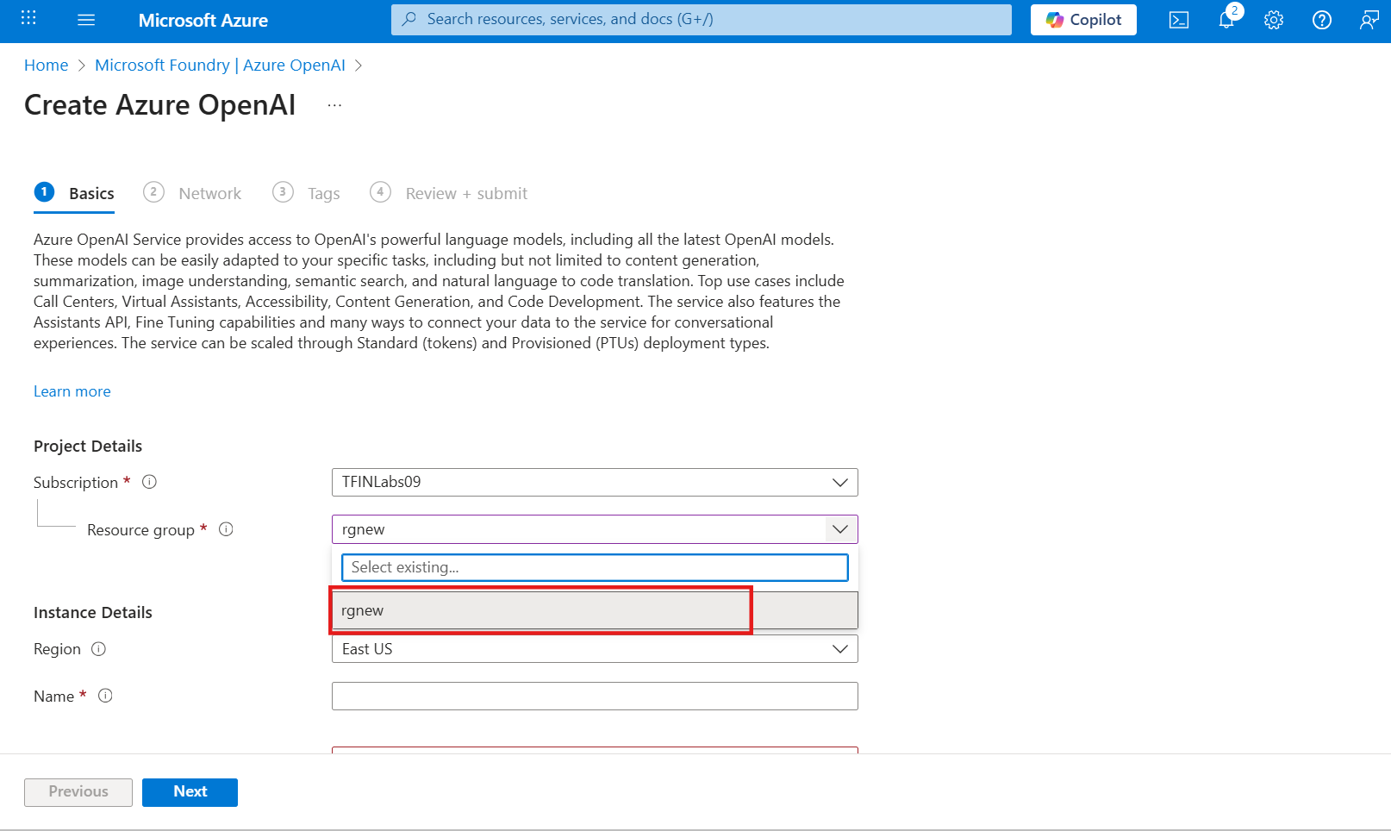
- Provide the following details:
  - Region: westus3
  - Name: azure-openai-test-66838558
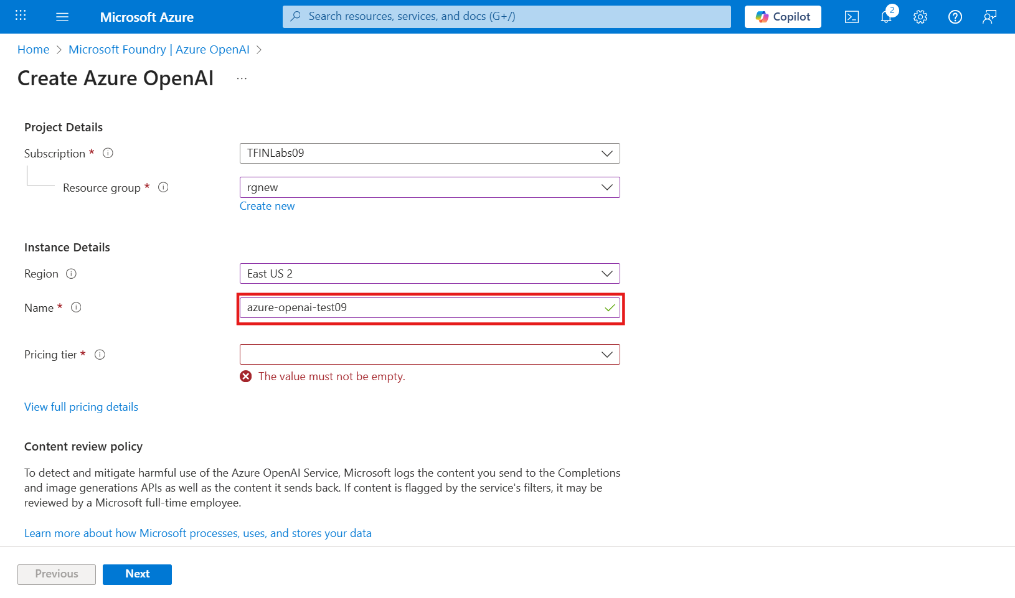
- Choose the Pricing tier as Standard S0 and proceed by clicking on Next.
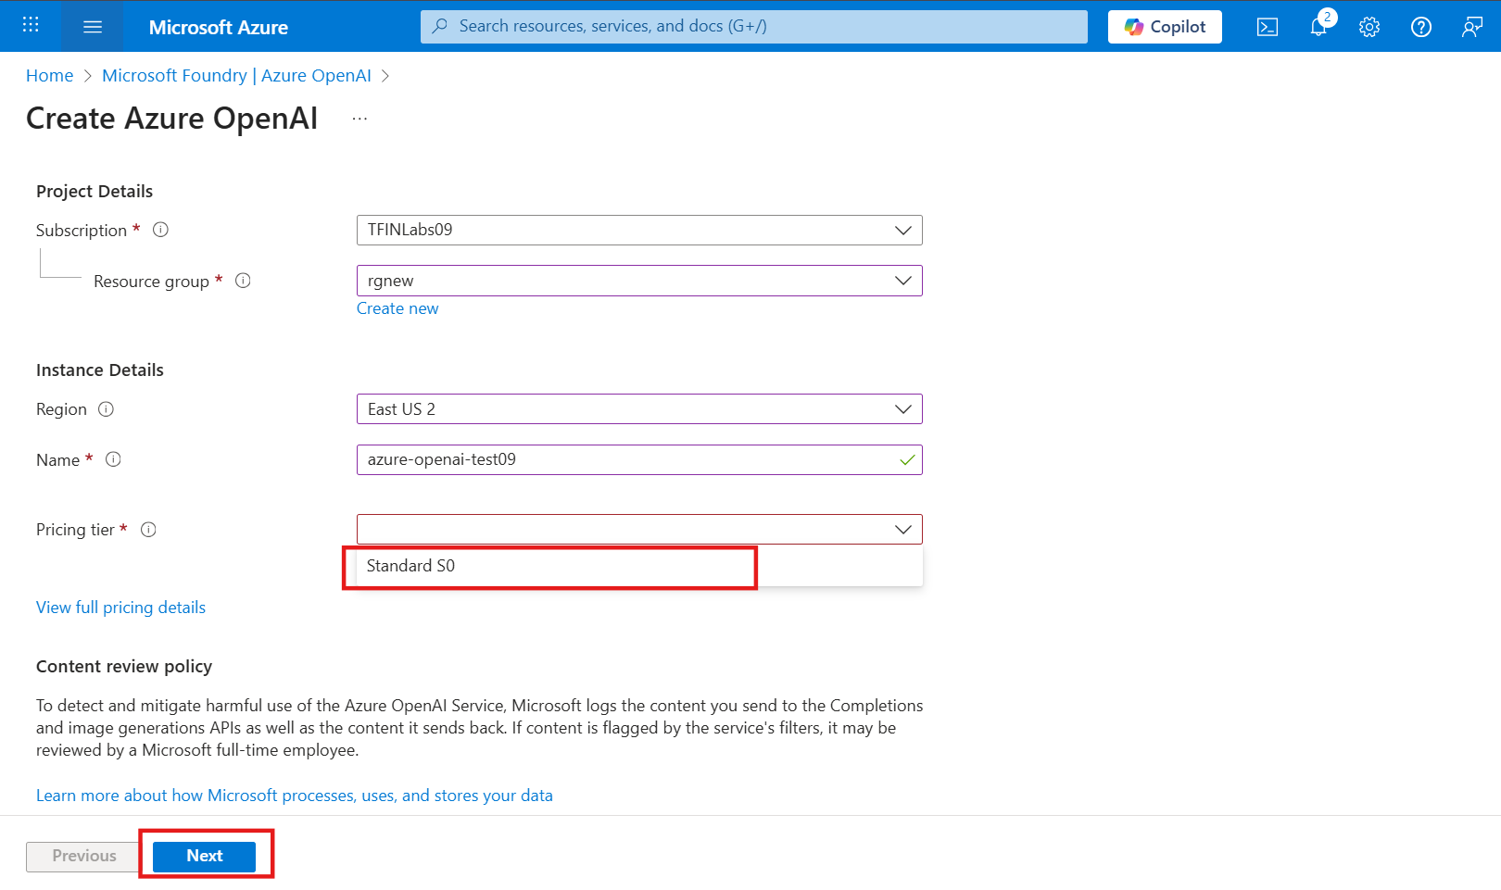
- On the Networking tab, keep the settings as default and click on Next.
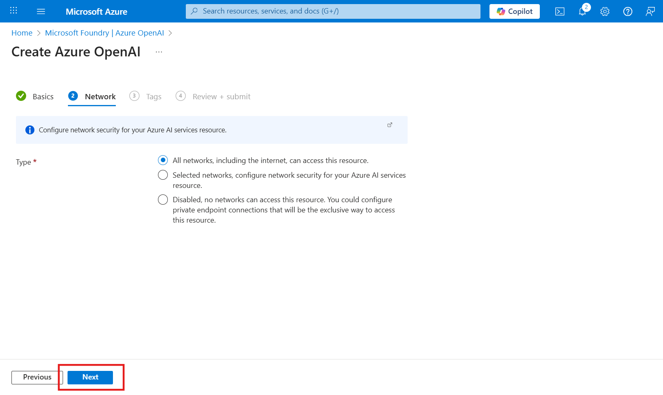
- On the Tags tab, keep it as is and proceed with the Next button.
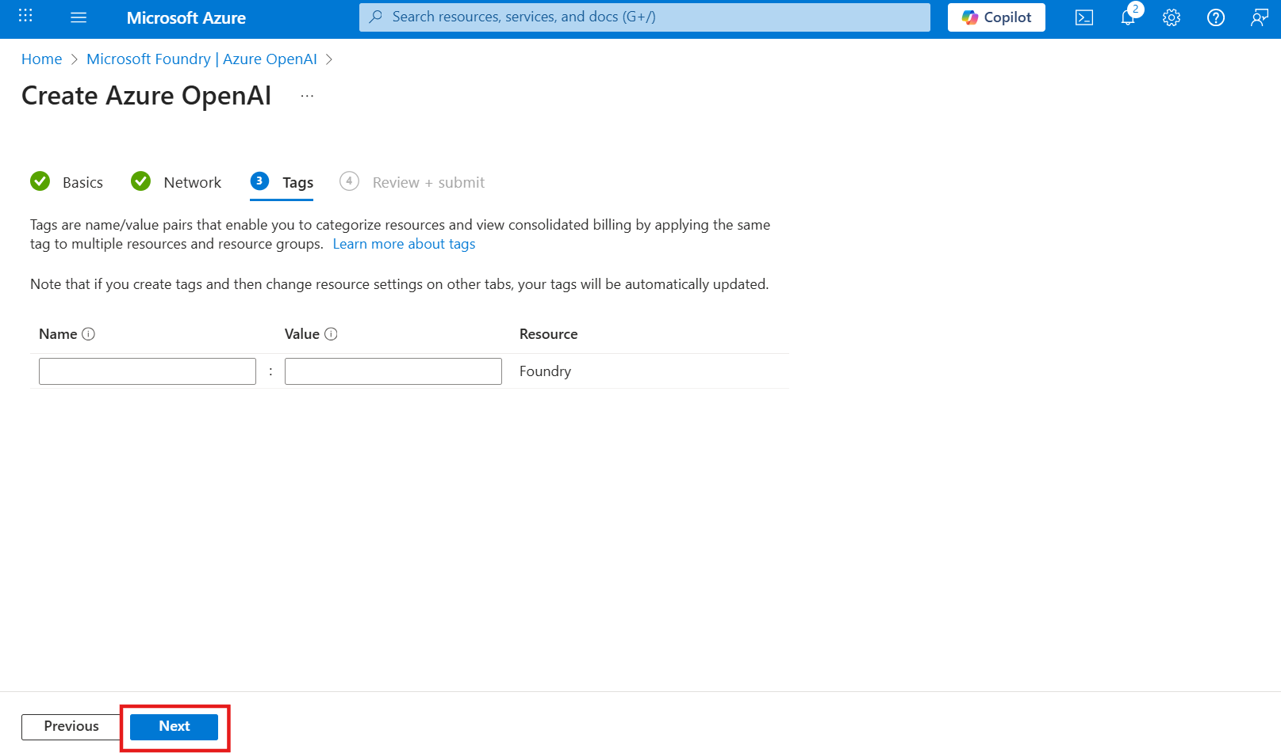
- Review the basics section and click on Create to start the deployment.
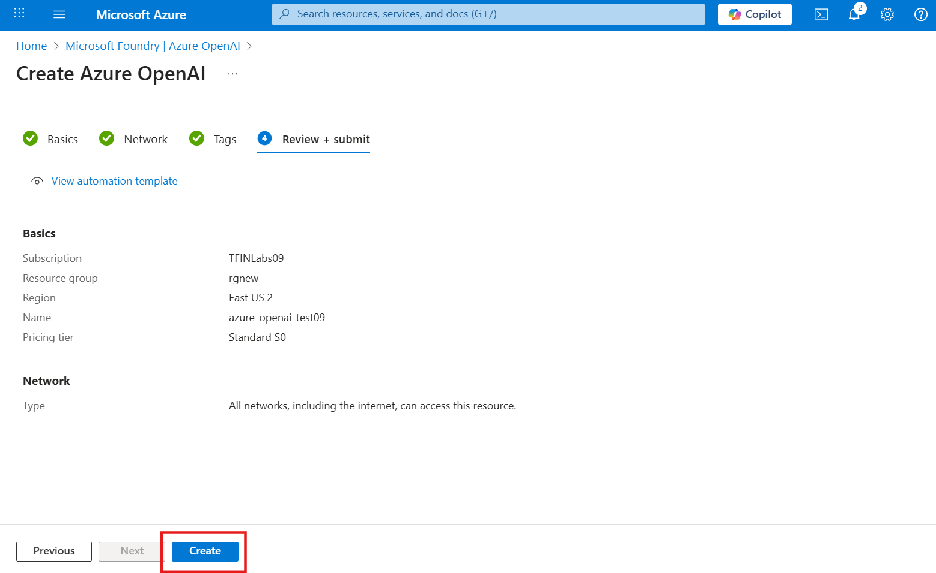
- The deployment is completed. Navigate to Go to resource.
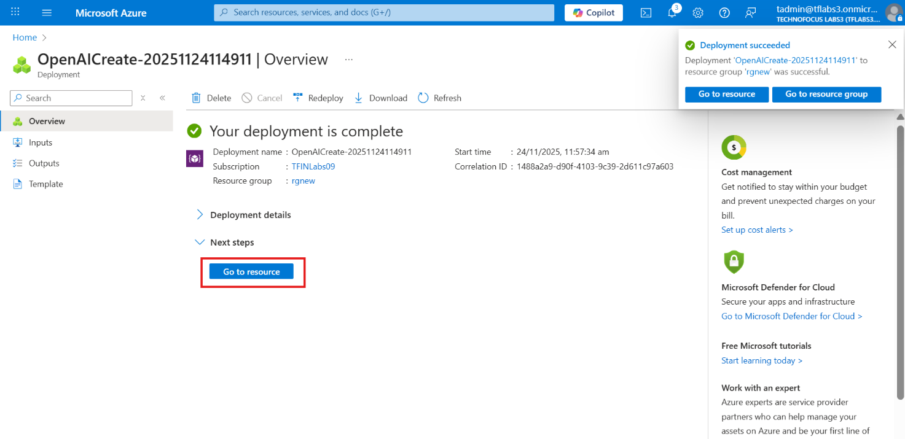
- Expand Resource Management and select Key and Endpoint option.
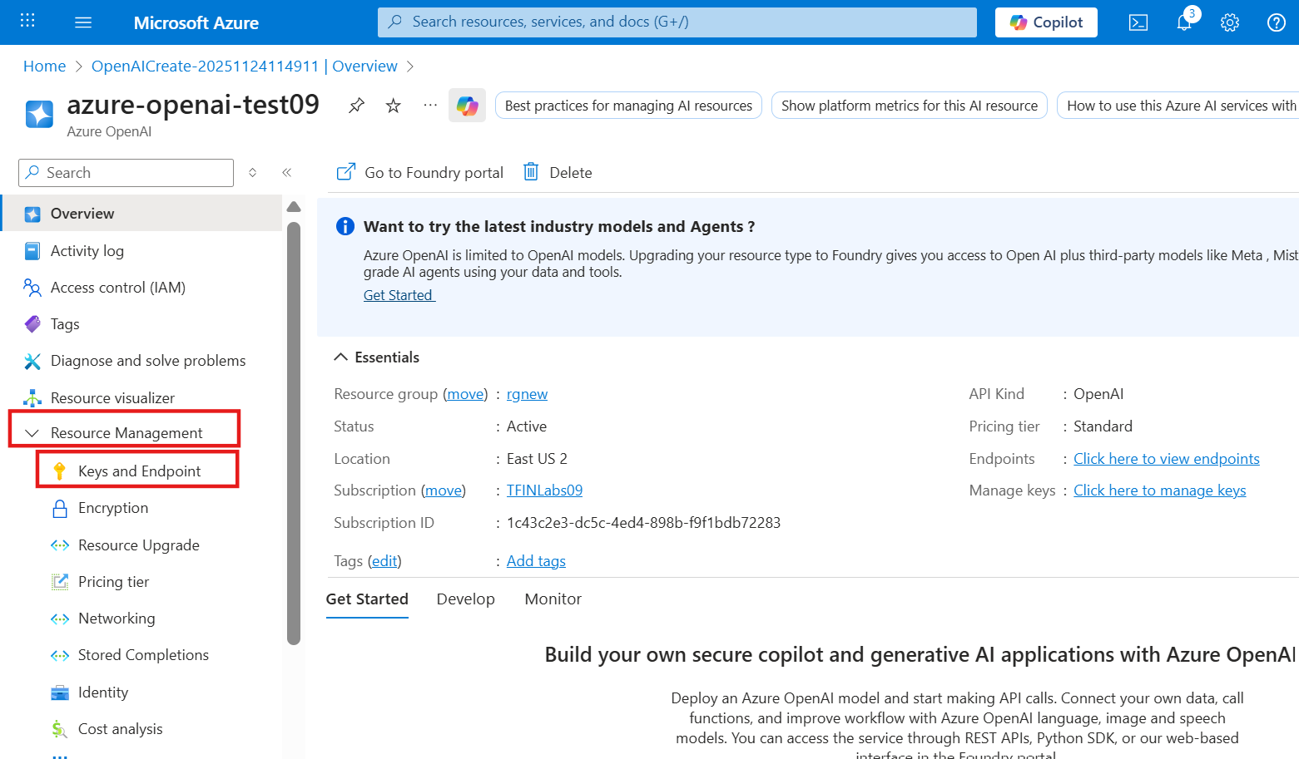
- You can copy the OpenAI key and Endpoint to use it in further steps wherever required.
Note: Copy and paste the key and Endpoint in the notepad.
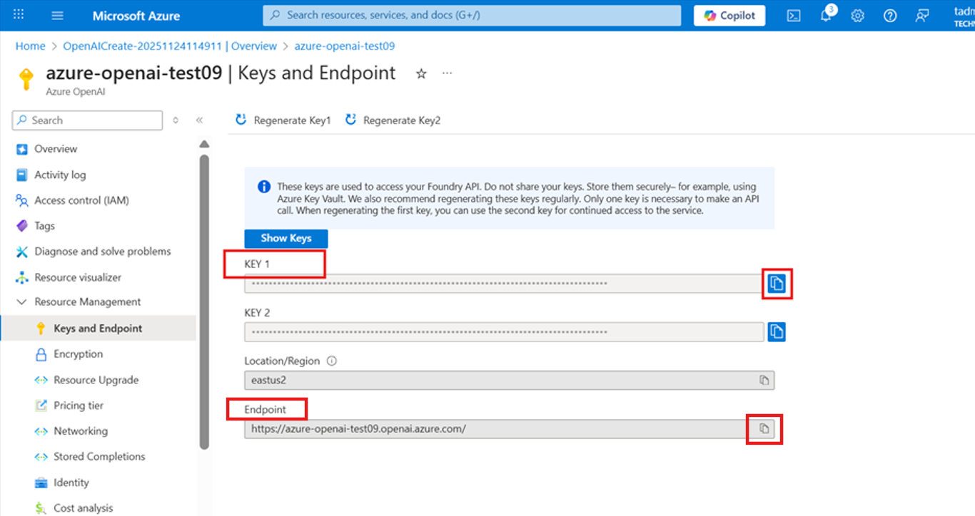
- Task-2: Create Model Deployments- (text-embedding-ada-002 and GPT-5)
- Navigate to Overview tab and go to Foundry portal.
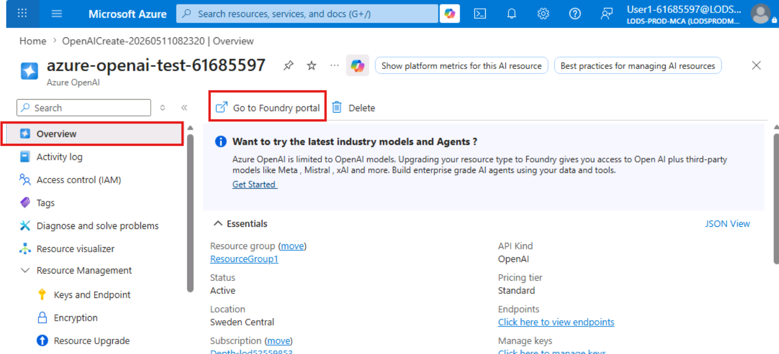
- You will be redirected to the Microsoft Foundry Portal. Click Skip on the pop-up.
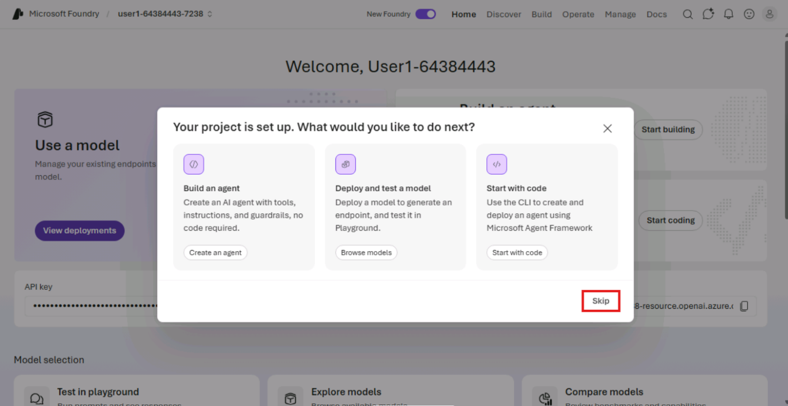
- Select the dropdown at the top and select View all resources.
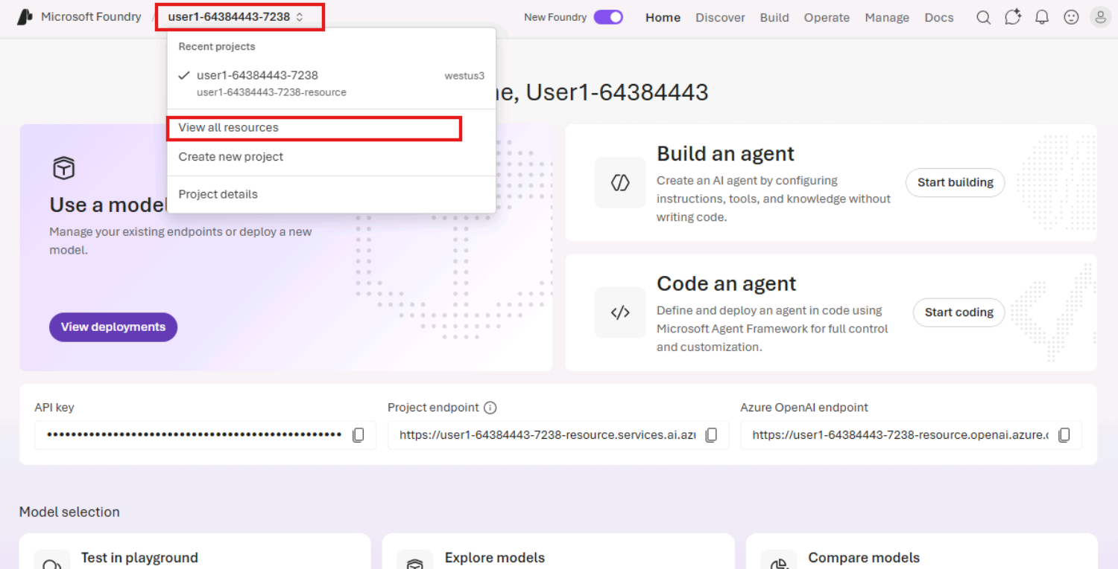
- Select the OpenAI resource and click on Open in Foundry Classic.
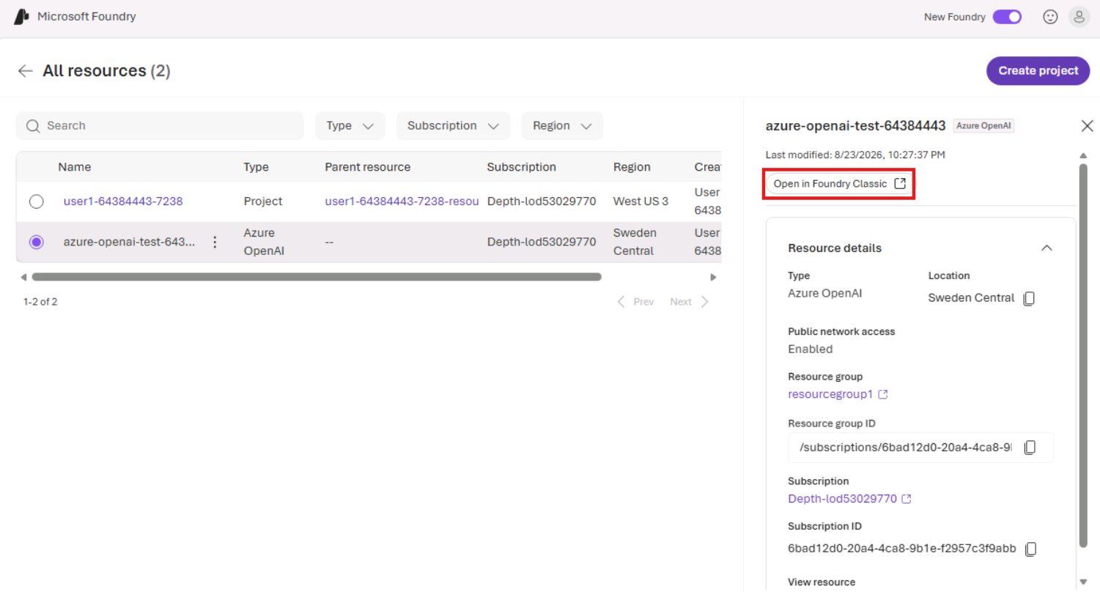
- Scroll down and go to Deployments from the left navigation pane.
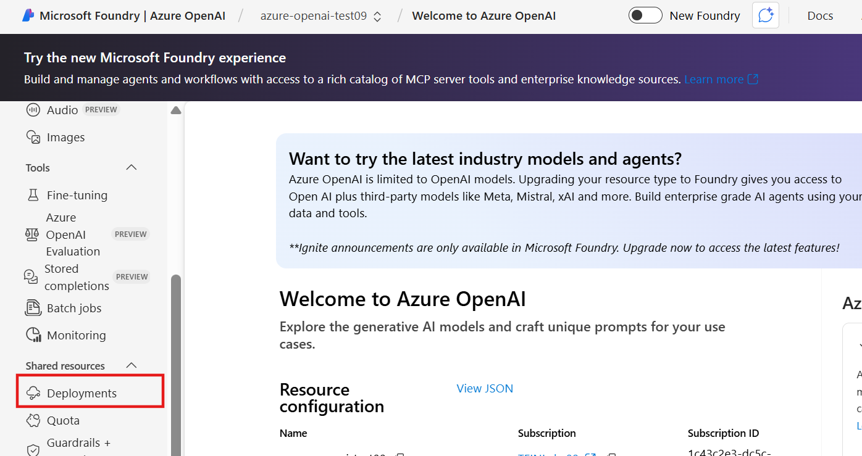
- Click ‘+ Deploy model’ dropdown and select Deploy base model.
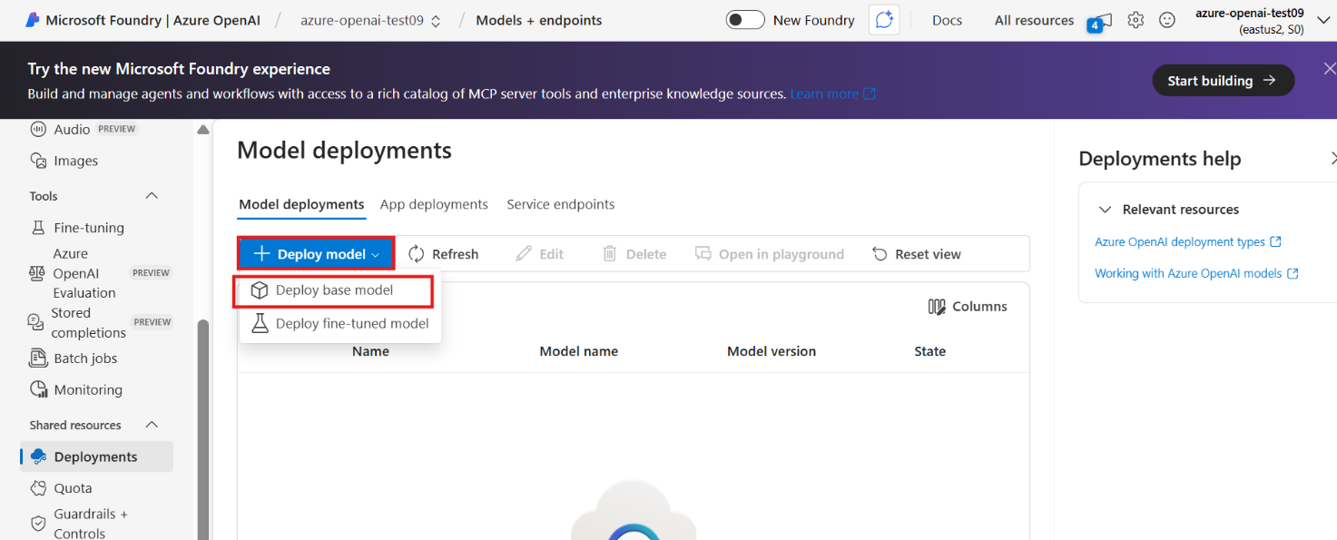
- In the model list, search for text-embedding-ada-002, select it and click on Confirm.
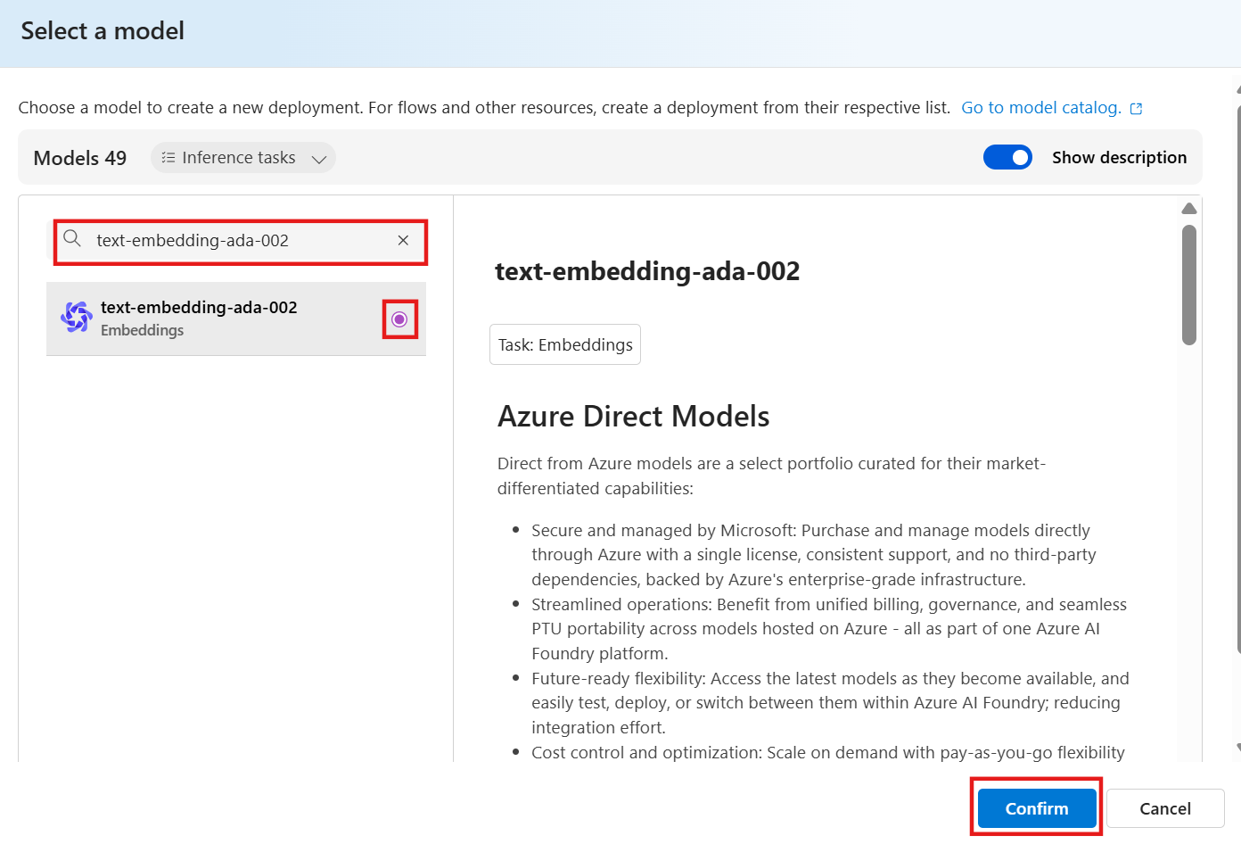
- Keep the deployment name as it is (text-embedding-ada-002) and click on Deploy button.
Note: If you change the deployment name, you will have to replace the name in the further query as well. For this lab, keep the name as it is.
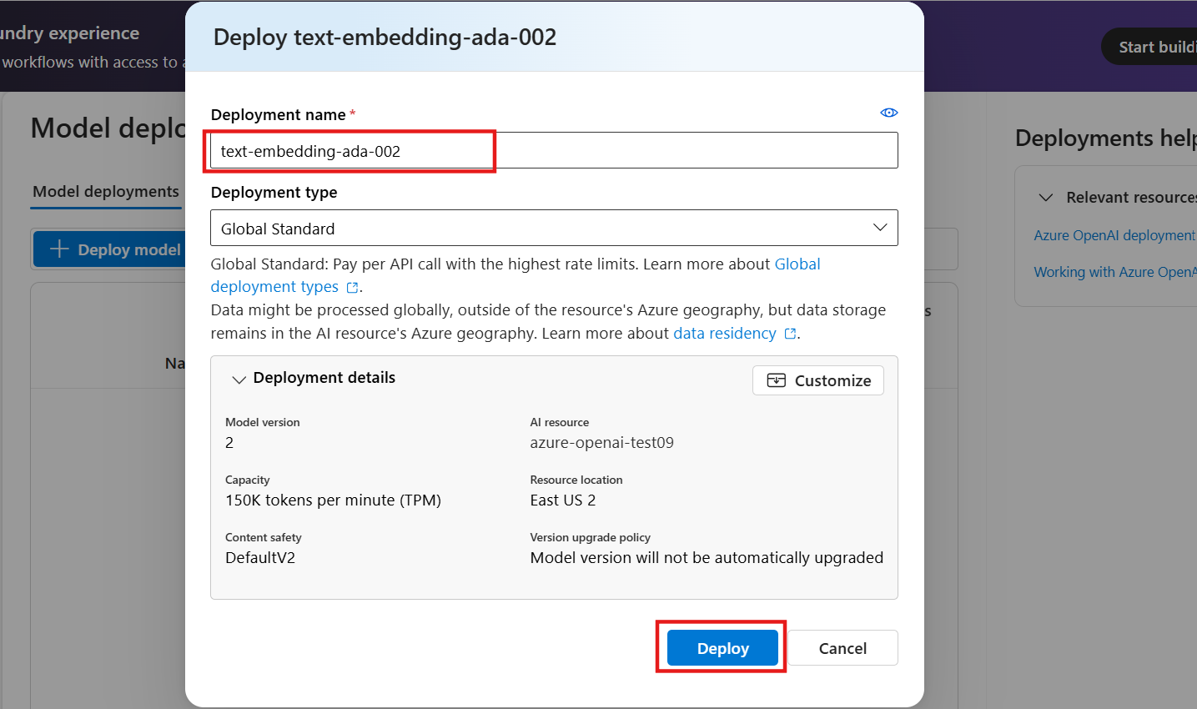
- Deployment will take 5-10 seconds. When completed, you will see it in the list: embeddings — text-embedding-ada-002 — Succeeded
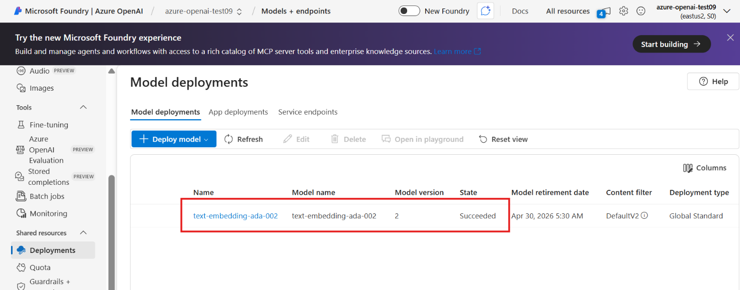
- Make sure you copy the Target URL for text-embedding-ada-002 model and save in the notepad for the further tasks.
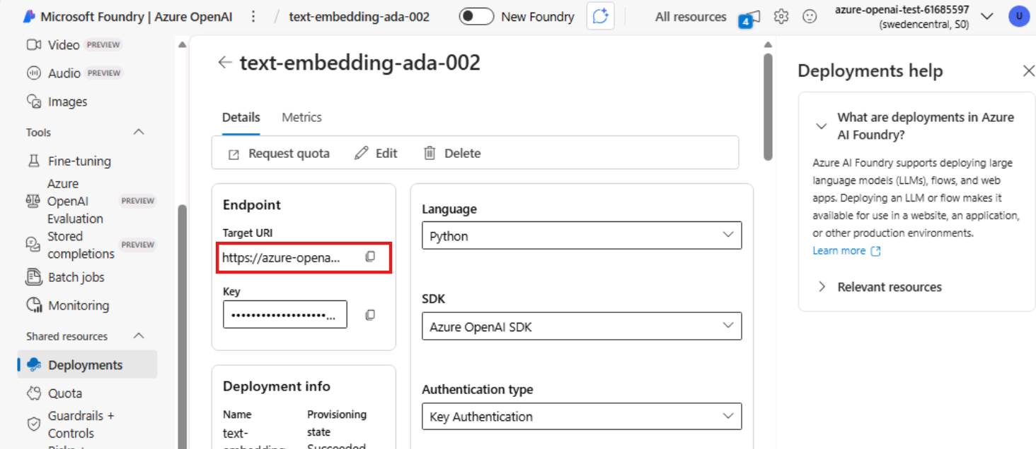
- Deploy the second model – GPT-5. Select Deploy base model from the deploy model dropdown.
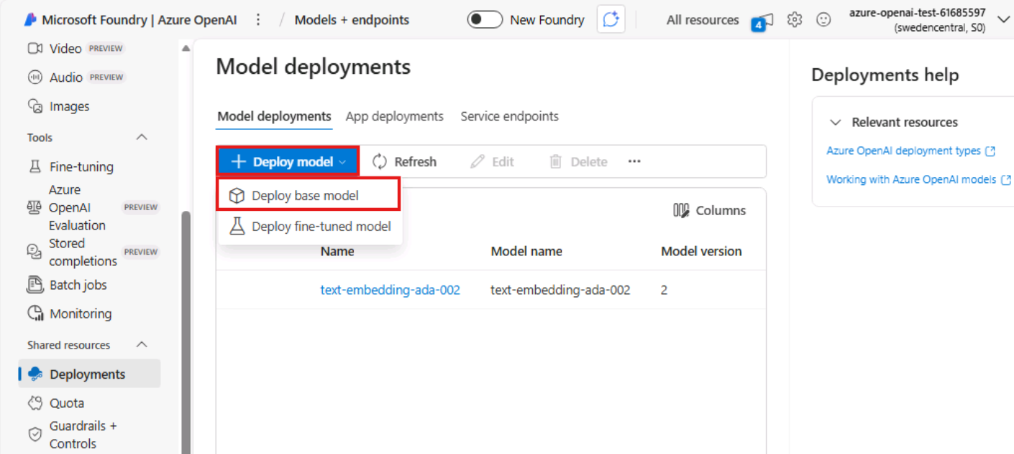
- Search for gpt-5 model, select it and click on Confirm to proceed.
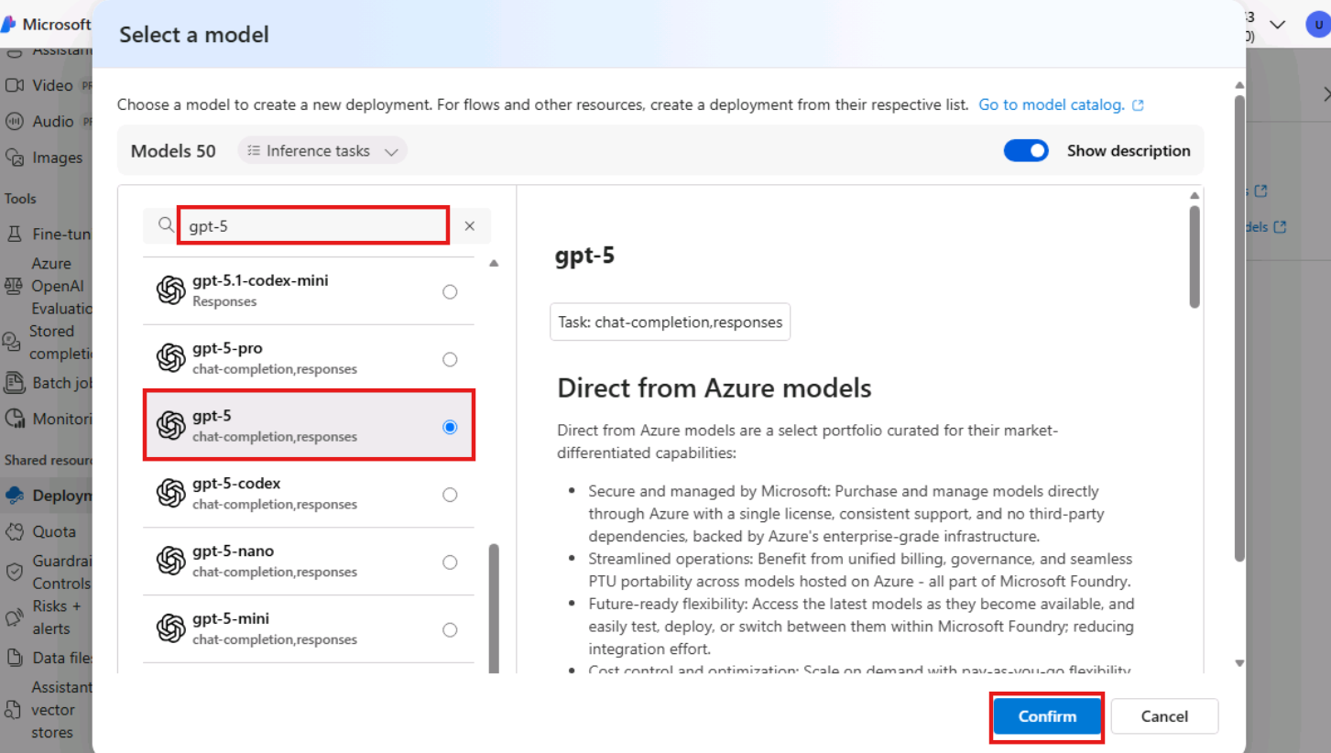
- Make sure Global Standard version is selected for gpt-5 model and click on Deploy.
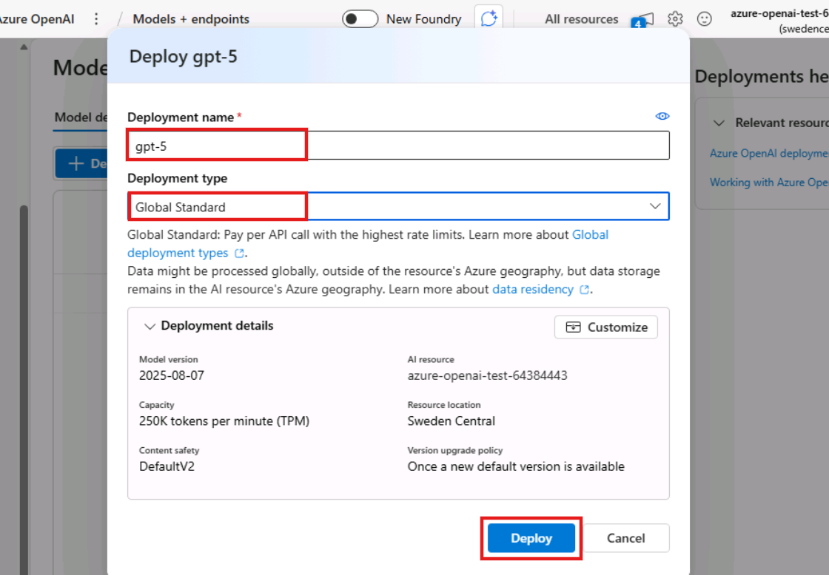
- The gpt-5 model deployment is now succeeded. Make sure you copy the Target URL to Notepad for further tasks.
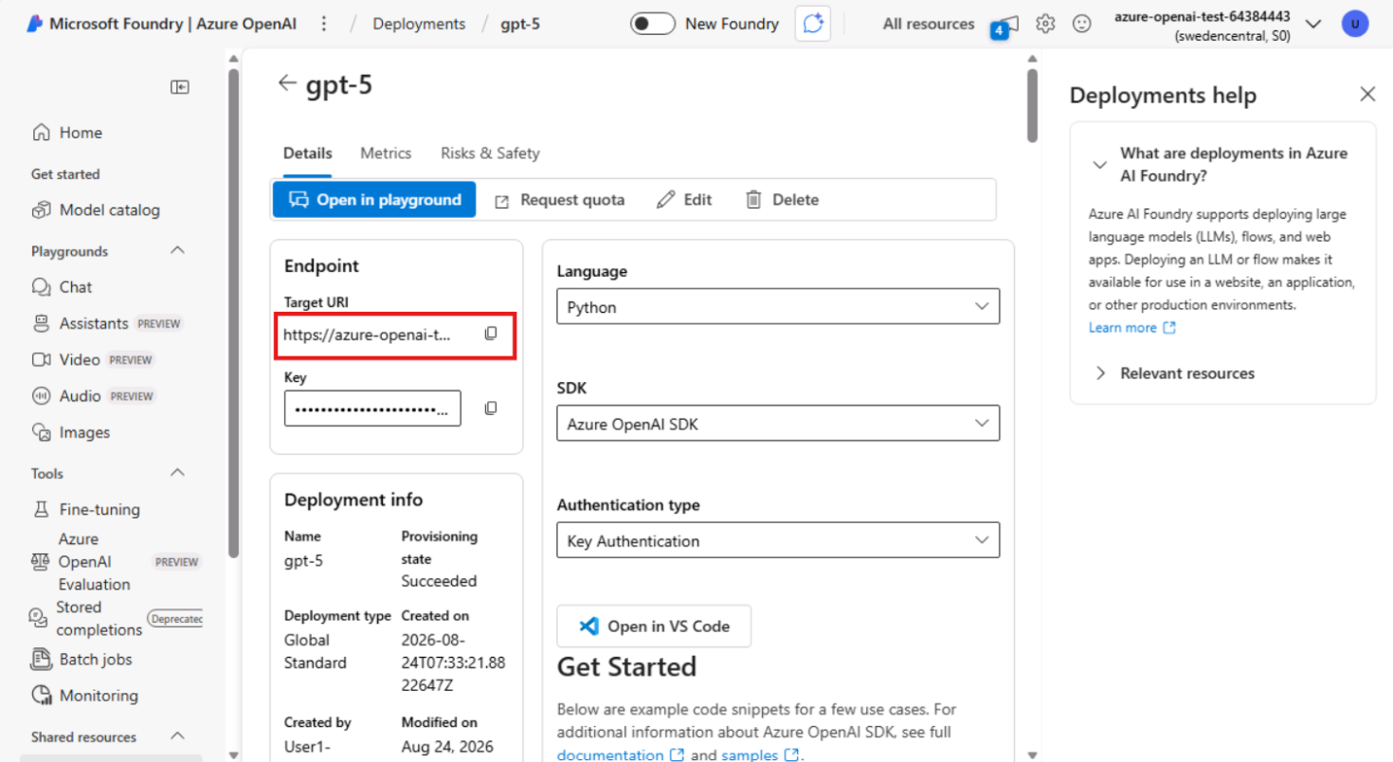
- Task-3: Setup of database credential
A database scoped credential is a record in the database that contains authentication information for connecting to a resource outside the database. For this task, we will be creating one that contains the api key for connecting to Azure OpenAI services.
- Navigate to the Microsoft Fabric portal and open a new query editor window.
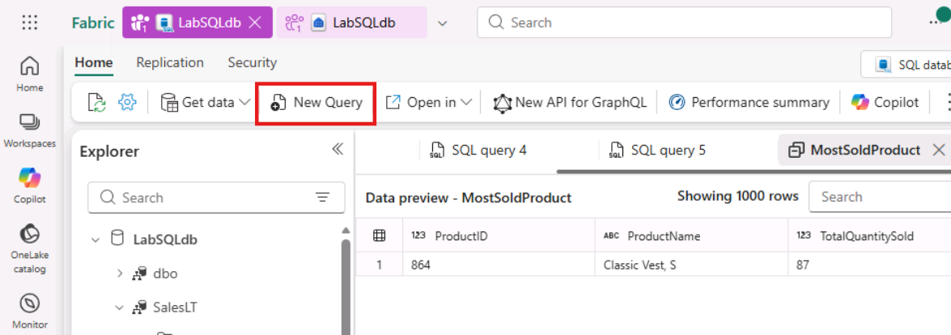
- Copy and Paste the below code and click the Run button. This code is used to create a database scoped credential with Azure OpenAI endpoint.
Note: Make sure you replace the OpenAI endpoint and key wherever required in the query.
- TypeCopy
- -- Create a master key for the database
- if not exists(select * from sys.symmetric_keys where [name] = '##MS_DatabaseMasterKey##')
- begin
- create master key encryption by password = N'V3RYStr0NGP@ssw0rd!';
- end
- go

- -- Create the database scoped credential for Azure OpenAI
- if not exists(select * from sys.database_scoped_credentials where [name] = 'https://AI_ENDPOINT_SERVERNAME.openai.azure.com/')
- begin
- create database scoped credential [https://AI_ENDPOINT_SERVERNAME.openai.azure.com/]
- with identity = 'HTTPEndpointHeaders', secret = '{"api-key":"YOUR_OPENAI_KEY"}';
- end
- go
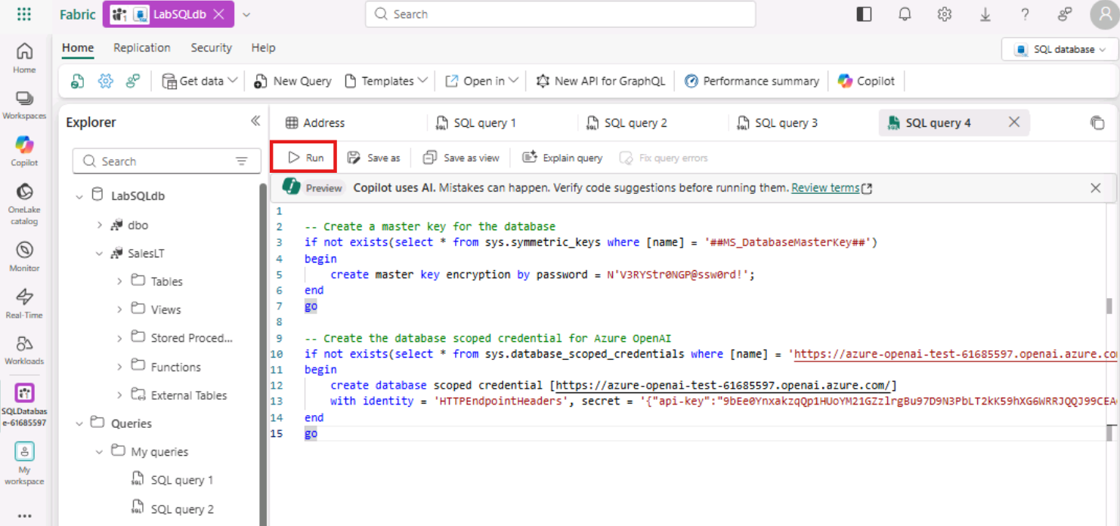
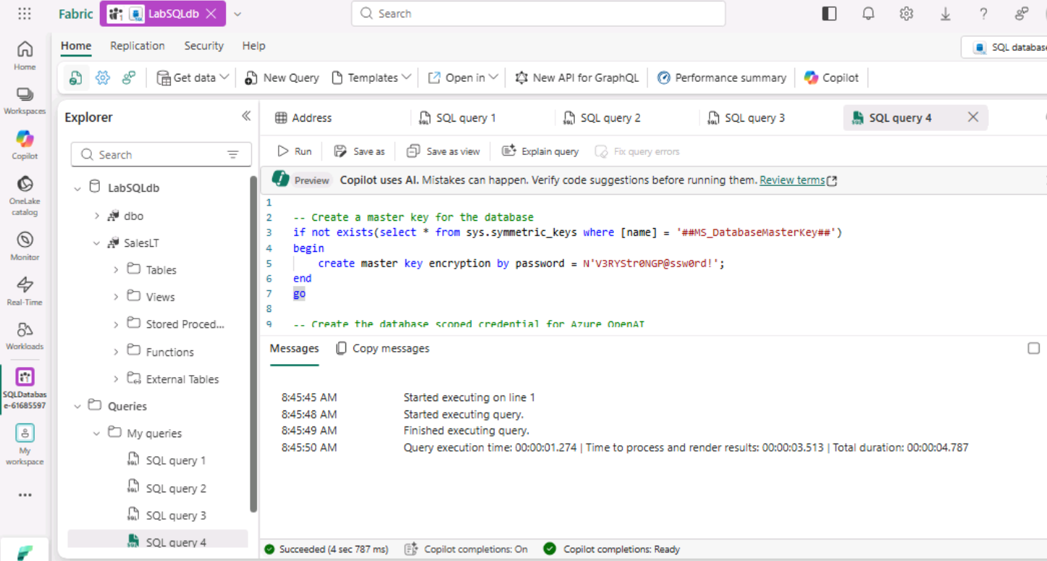
- Let's test the connectivity to Azure OpenAI and see the ability to call external REST endpoints in action. Copy and paste the following code into a blank query editor in Microsoft Fabric:
Note: Replace the gpt-5 Target URL in the first line and OpenAI Endpoint in the credential
- TypeCopy
- declare @url nvarchar(4000) = N'https://AI_ENDPOINT_SERVERNAME.openai.azure.com/openai/deployments/gpt-4/chat/completions?api-version=2024-06-01';
- declare @payload nvarchar(max) = N'{"messages":[{"role":"system","content":"You are an expert joke teller."},
- {"role":"system","content":"tell me a joke about a llama walking into a bar"}]}'
- declare @ret int, @response nvarchar(max);

- exec @ret = sp_invoke_external_rest_endpoint
- @url = @url,
- @method = 'POST',
- @payload = @payload,
- @credential = [https://AI_ENDPOINT_SERVERNAME.openai.azure.com/],
- @timeout = 230,
- @response = @response output;

- select json_value(@response, '$.result.choices[0].message.content') as "Amazing, Awesome, Stupendous Joke";
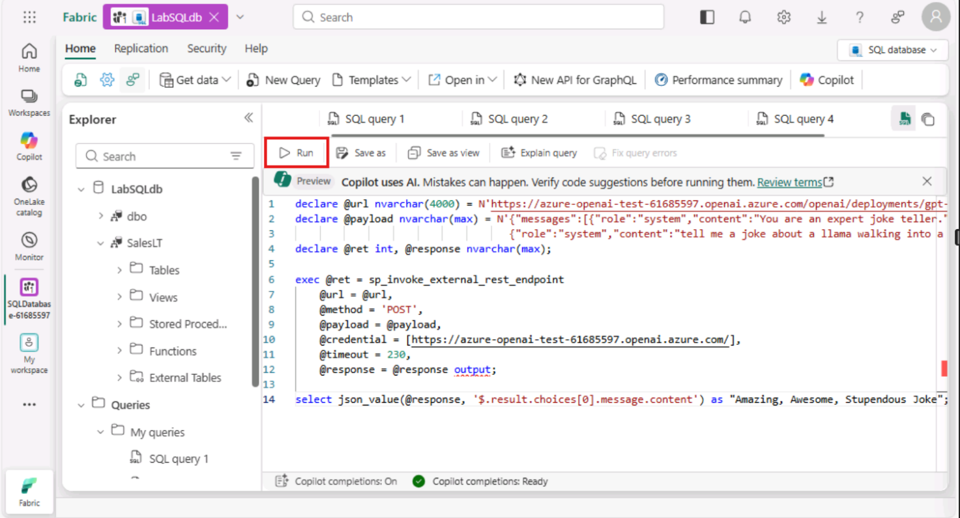
- Click the run button on the query sheet. The result will be an amazing joke you can tell your friends and family!
Question: tell me a joke about a llama walking into a bar.
Response: A llama walks into a bar and the bartender says, "Hey, why the long face?" The llama replies, "I'm just here to meet my alpaca friend, he always packs the good jokes!"
Classic alpaca joke.
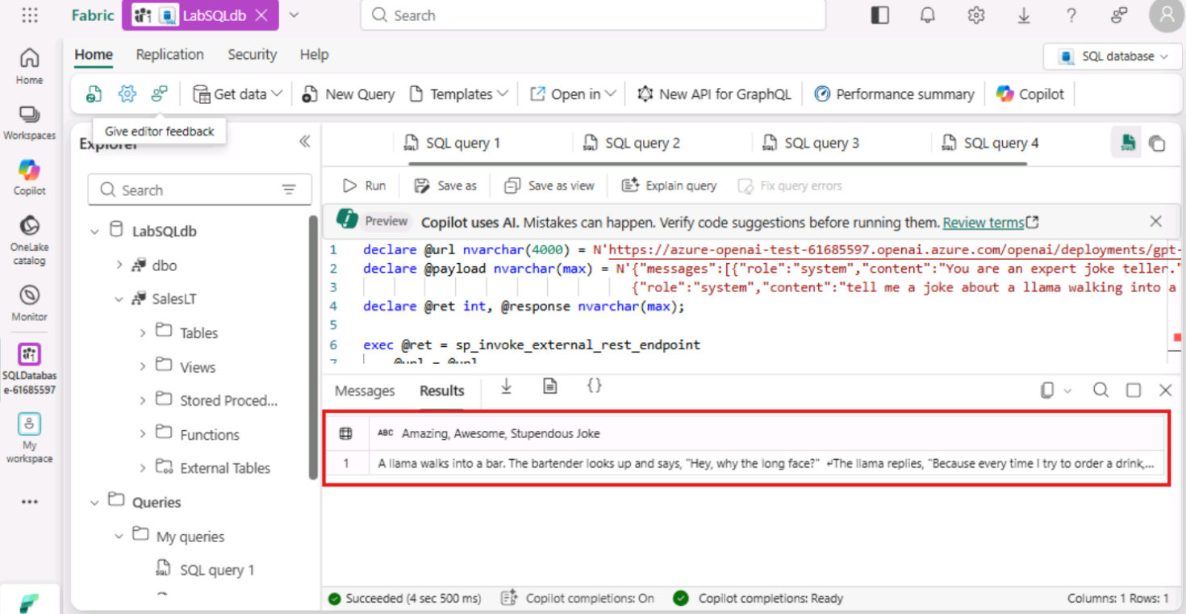
- Task-4: Create embeddings for relational data
An embedding is a special format of data representation that machine learning models and algorithms can easily use. The embedding is an information dense representation of the semantic meaning of a piece of text. Each embedding is a vector of floating-point numbers. Vector embeddings can help with semantic search by capturing the semantic similarity between terms. For example, "cat" and "kitty" have similar meanings, even though they are spelled differently. Embeddings created and stored in the Azure SQL Database in Microsoft Fabric during this lab will power a vector similarity search in a chat app you will build.
- Open a new query editor window. copy and paste the following code. This code calls an Azure OpenAI embeddings endpoint. The result will be a JSON array of vectors.
Note: Replace the text-embedding-ada-002 target URL in the first line of the query and replace the OpenAI endpoint in the credential.
- TypeCopy
- declare @url nvarchar(4000) = N'https://AI_ENDPOINT_SERVERNAME.openai.azure.com/openai/deployments/text-embedding-ada-002/embeddings?api-version=2024-06-01';
- declare @message nvarchar(max) = 'Hello World!';
- declare @payload nvarchar(max) = N'{"input": "' + @message + '"}';

- declare @ret int, @response nvarchar(max);

- exec @ret = sp_invoke_external_rest_endpoint
- @url = @url,
- @method = 'POST',
- @payload = @payload,
- @credential = [https://AI_ENDPOINT_SERVERNAME.openai.azure.com/],
- @timeout = 230,
- @response = @response output;

- select json_query(@response, '$.result.data[0].embedding') as "JSON Vector Array";
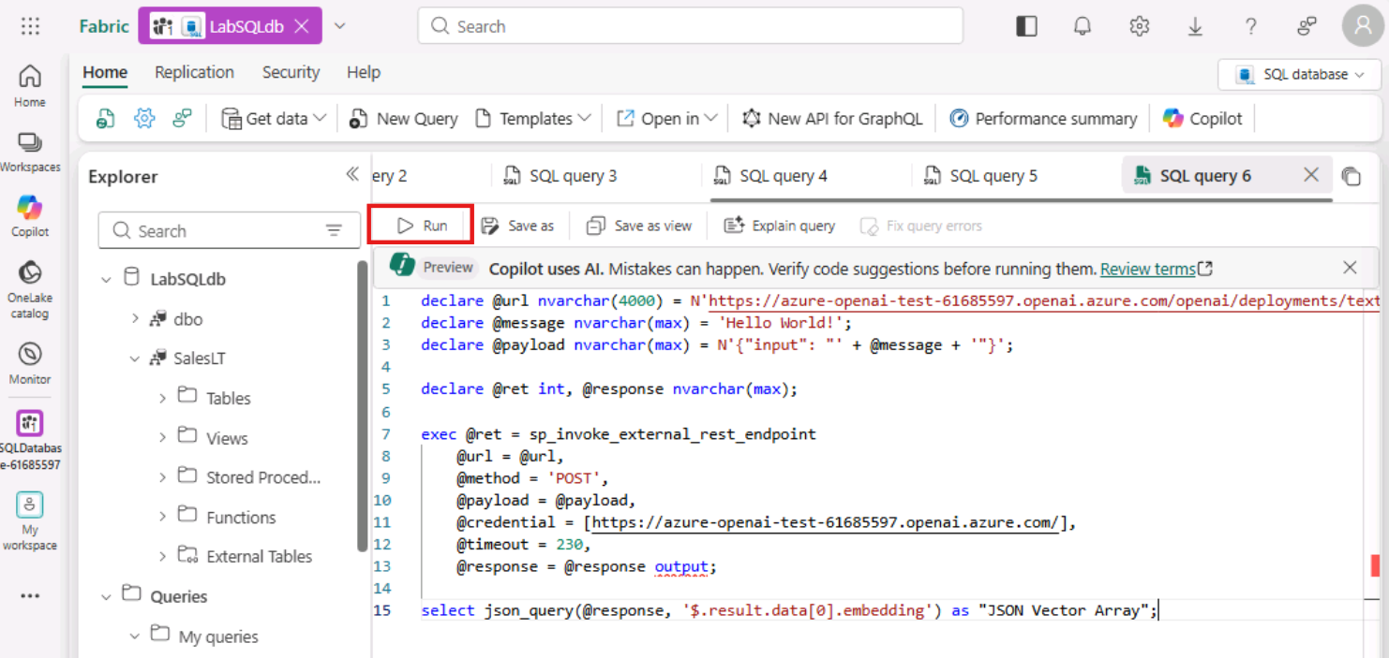
- Again, click the run button on the query sheet.
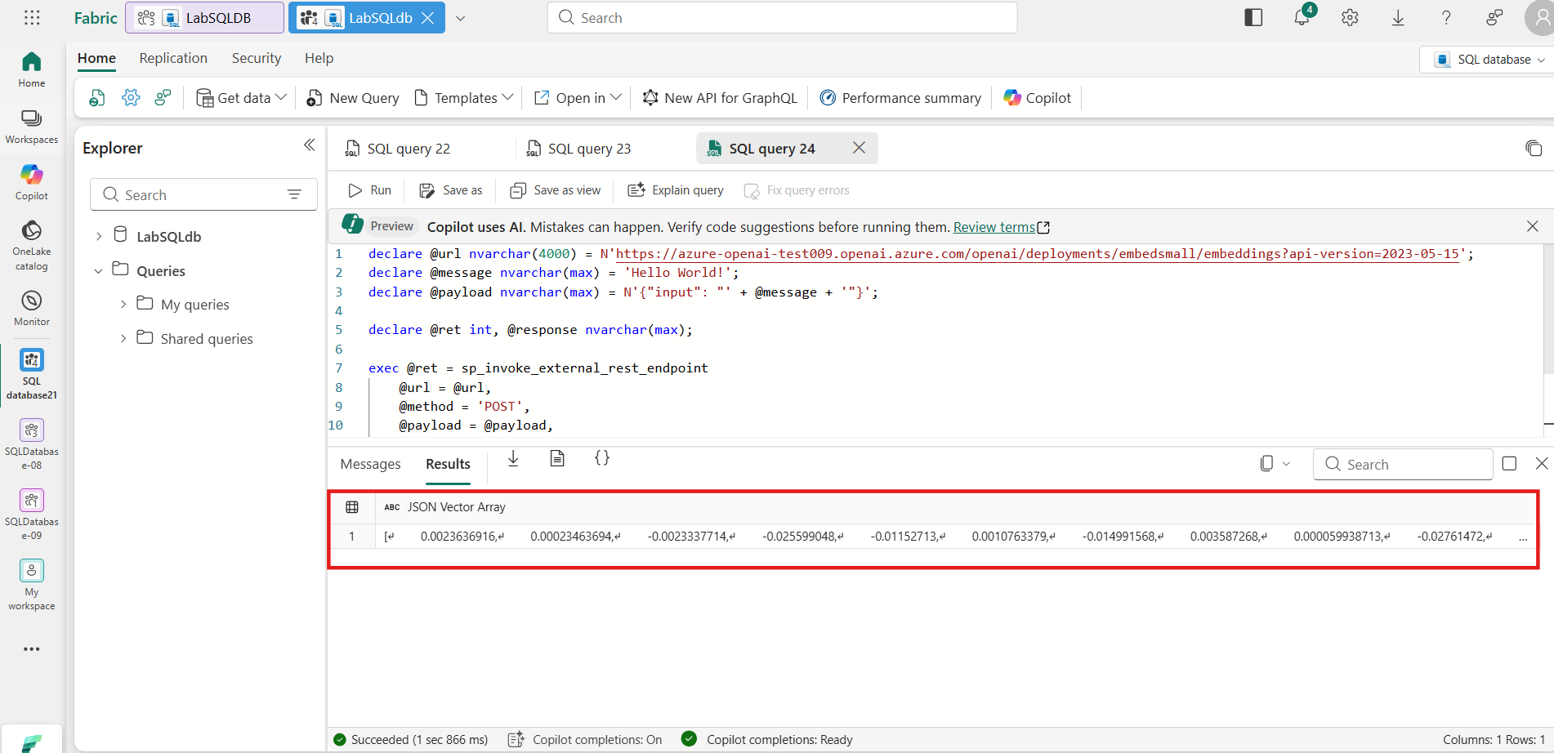
- In a new query sheet or an existing bank one in VS Code, copy and paste the following T-SQL:
- TypeCopy
- alter table [SalesLT].[Product]
- add embeddings VECTOR(1536), chunk nvarchar(2000);
This code adds a vector datatype column to the Product table. It also adds a column named chunk where we will store the text we send over to the embeddings REST endpoint.
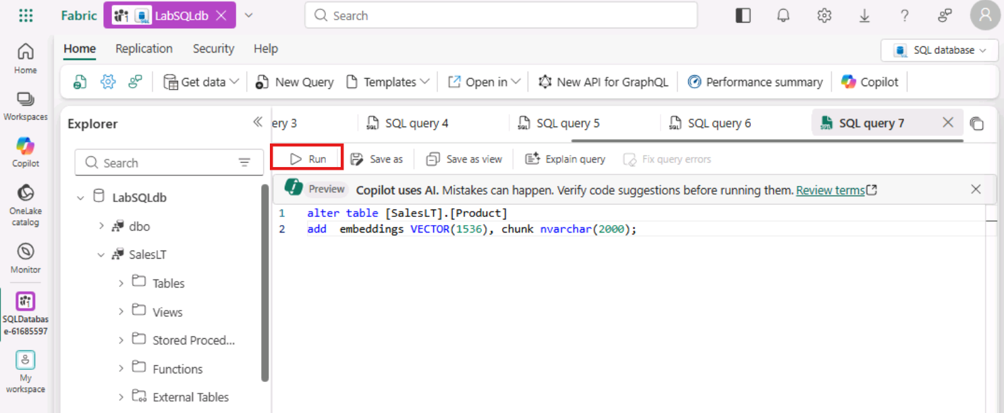
- Then, click the run button on the query sheet.
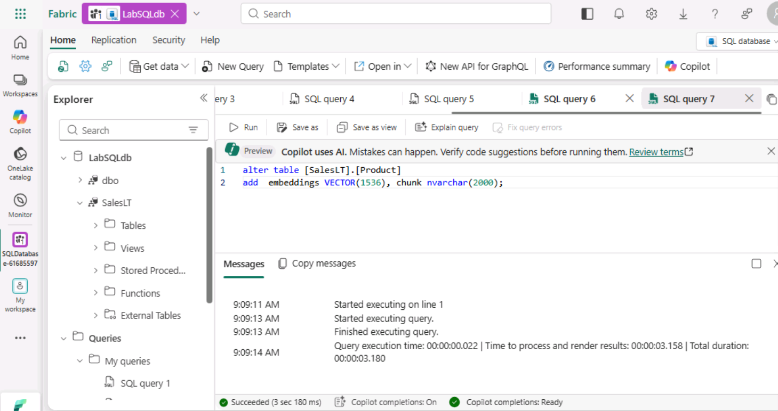
- Next, we are going to use the External REST Endpoint Invocation procedure (sp_invoke_external_rest_endpoint) to create a stored procedure that will create embeddings for text we supply as an input. Copy and paste the following code into a blank query editor in Microsoft Fabric:
Note: Replace the text-embedding target URL and OpenAI endpoint in the query.
- TypeCopy
- create or alter procedure dbo.create_embeddings
- (
- @input_text nvarchar(max),
- @embedding vector(1536) output
- )
- AS
- BEGIN
- declare @url varchar(max) = 'https://AI_ENDPOINT_SERVERNAME.openai.azure.com/openai/deployments/text-embedding-ada-002/embeddings?api-version=2024-06-01';
- declare @payload nvarchar(max) = json_object('input': @input_text);
- declare @response nvarchar(max);
- declare @retval int;

- -- Call to Azure OpenAI to get the embedding of the search text
- begin try
- exec @retval = sp_invoke_external_rest_endpoint
- @url = @url,
- @method = 'POST',
- @credential = [https://AI_ENDPOINT_SERVERNAME.openai.azure.com/],
- @payload = @payload,
- @response = @response output;
- end try
- begin catch
- select
- 'SQL' as error_source,
- error_number() as error_code,
- error_message() as error_message
- return;
- end catch
- if (@retval != 0) begin
- select
- 'OPENAI' as error_source,
- json_value(@response, '$.result.error.code') as error_code,
- json_value(@response, '$.result.error.message') as error_message,
- @response as error_response
- return;
- end
- -- Parse the embedding returned by Azure OpenAI
- declare @json_embedding nvarchar(max) = json_query(@response, '$.result.data[0].embedding');

- -- Convert the JSON array to a vector and set return parameter
- set @embedding = CAST(@json_embedding AS VECTOR(1536));
- END;
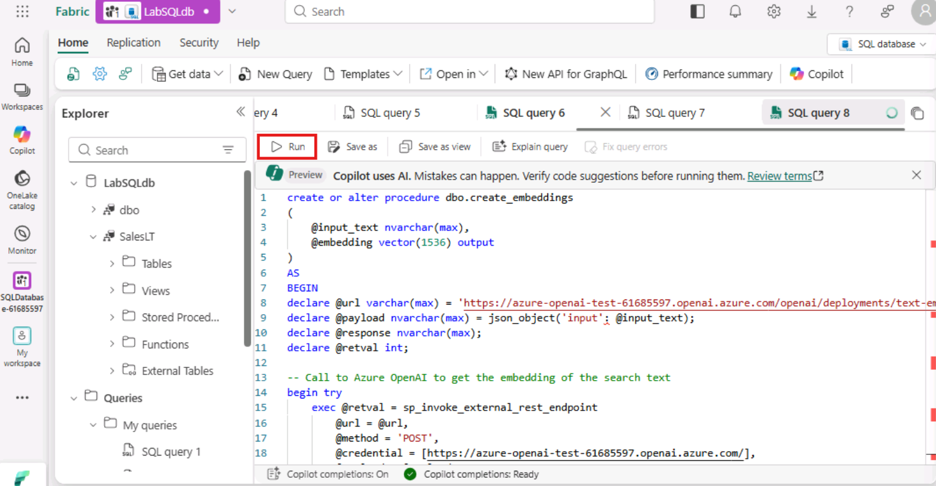
- Click the run button on the query sheet to create the procedure in the database.
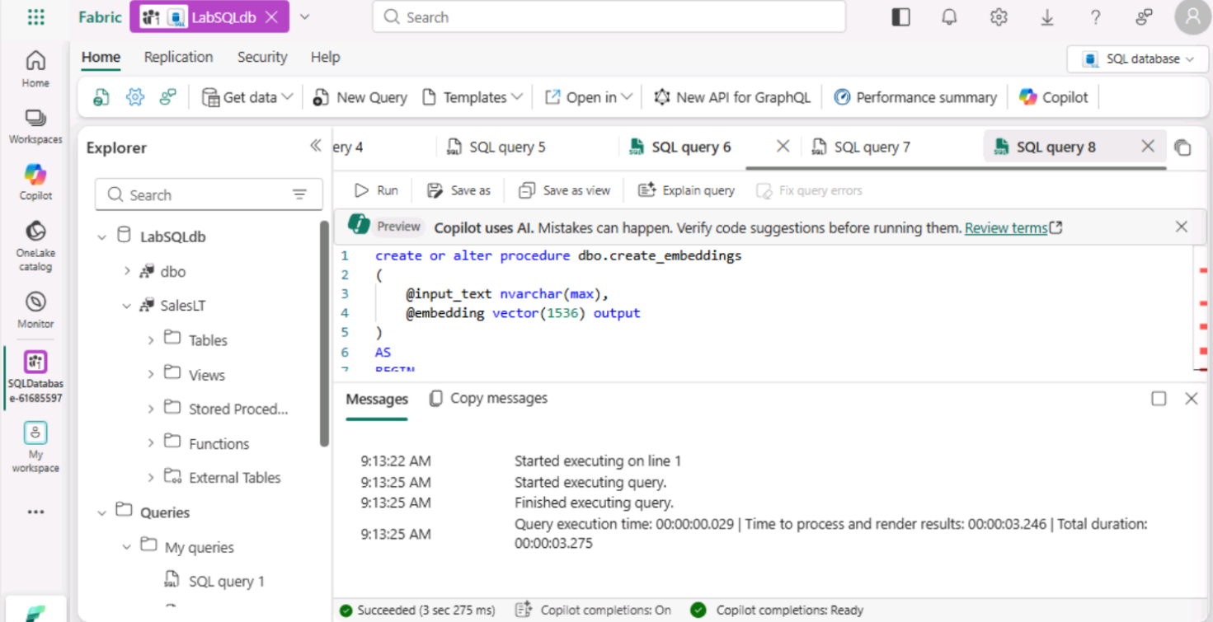
- Again, open a new query editor. Run the following T-SQL in a blank query editor in Microsoft Fabric to create embeddings for all products in the Products table:
- TypeCopy
- SET NOCOUNT ON
- DROP TABLE IF EXISTS #MYTEMP
- DECLARE @ProductID int
- declare @text nvarchar(max);
- declare @vector vector(1536);
- SELECT * INTO #MYTEMP FROM [SalesLT].Product
- SELECT @ProductID = ProductID FROM #MYTEMP
- SELECT TOP(1) @ProductID = ProductID FROM #MYTEMP
- WHILE @@ROWCOUNT <> 0
- BEGIN
- set @text = (SELECT p.Name + ' '+ ISNULL(p.Color,'No Color') + ' '+ c.Name + ' '+ m.Name + ' '+ ISNULL(d.Description,'')
- FROM
- [SalesLT].[ProductCategory] c,
- [SalesLT].[ProductModel] m,
- [SalesLT].[Product] p
- LEFT OUTER JOIN
- [SalesLT].[vProductAndDescription] d
- on p.ProductID = d.ProductID
- and d.Culture = 'en'
- where p.ProductCategoryID = c.ProductCategoryID
- and p.ProductModelID = m.ProductModelID
- and p.ProductID = @ProductID);
- exec dbo.create_embeddings @text, @vector output;
- update [SalesLT].[Product] set [embeddings] = @vector, [chunk] = @text where ProductID = @ProductID;
- DELETE FROM #MYTEMP WHERE ProductID = @ProductID
- SELECT TOP(1) @ProductID = ProductID FROM #MYTEMP
- END
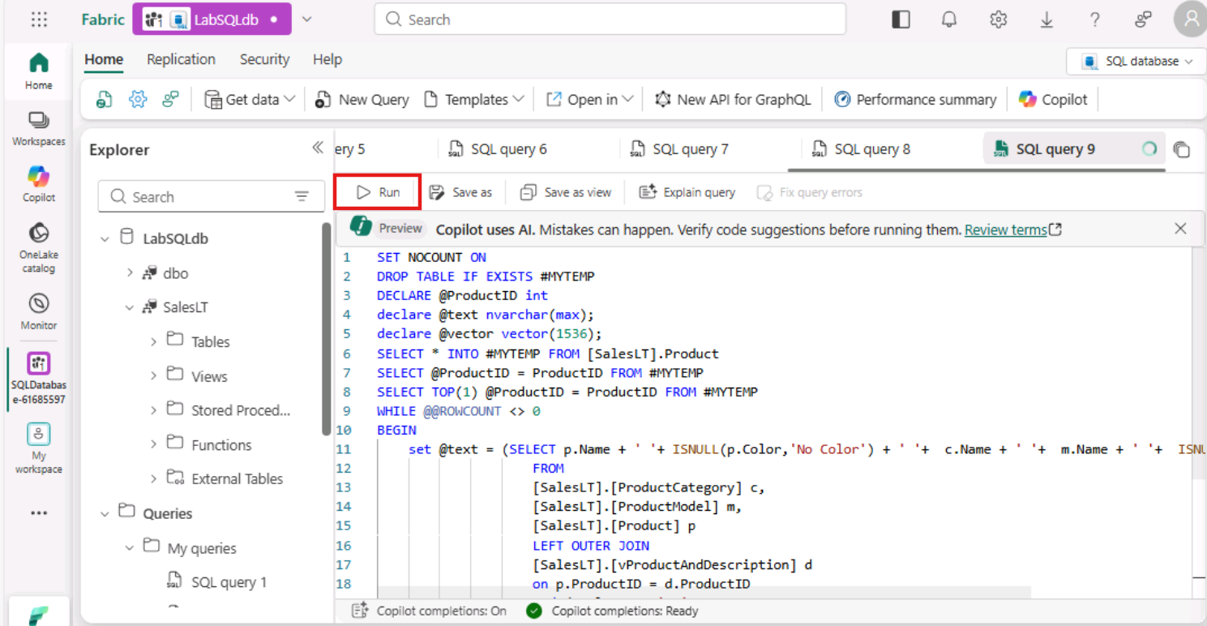
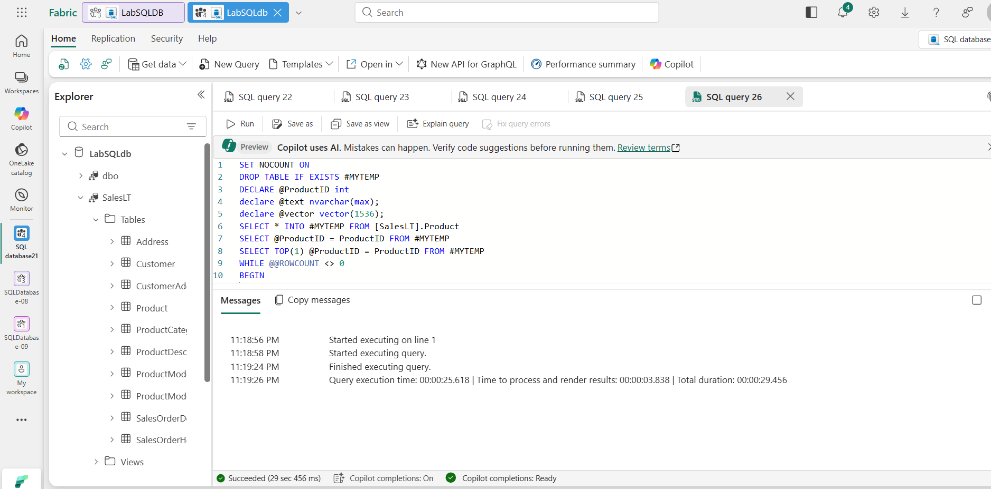
- To ensure all the embeddings were created, run the following code and you should get 0 for the result.
- TypeCopy
- select count(*) from SalesLT.Product where embeddings is null;
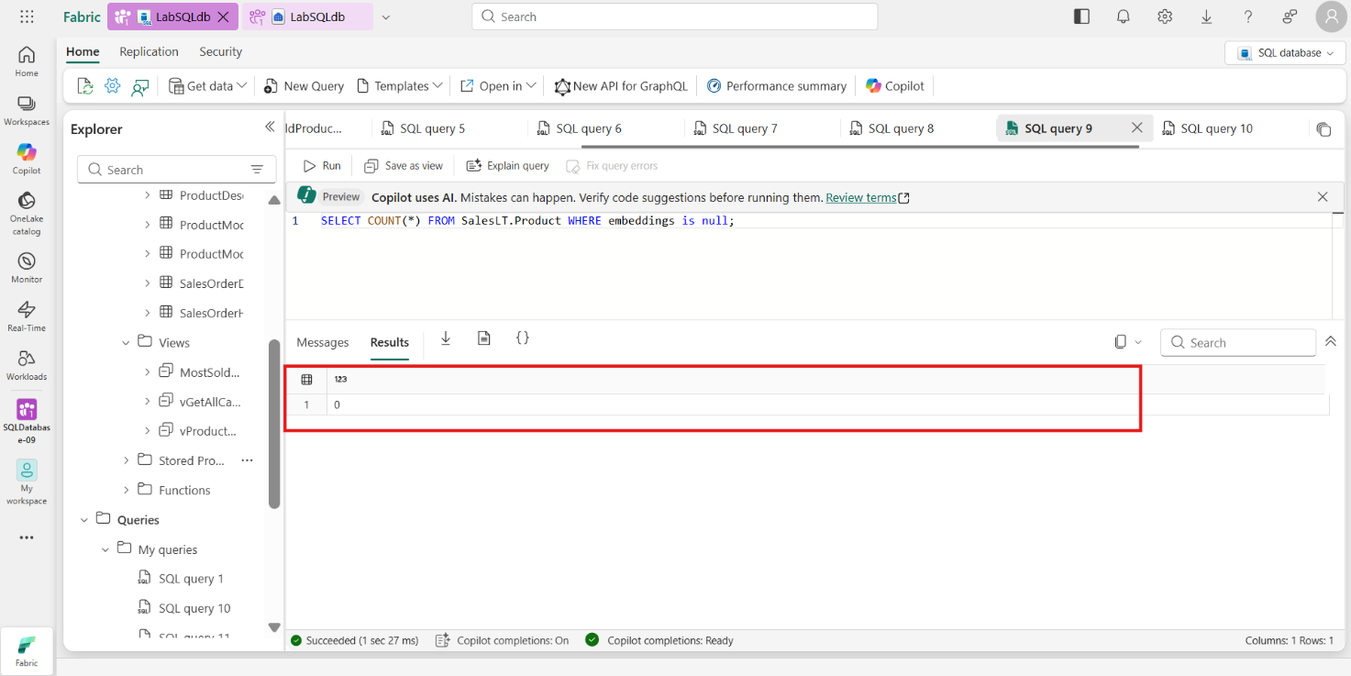
- Open a new query editor.
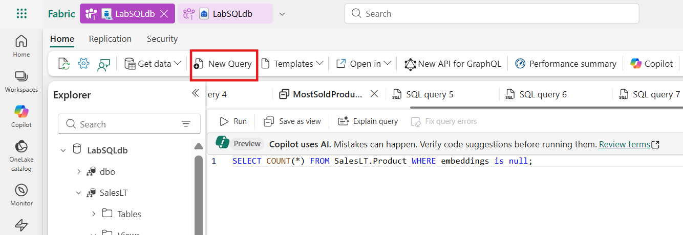
- Run the query to see the results of the above update to the Products table. You can see that the chunk column is the combination of multiple data points about a product and the embeddings column contains the vector arrays.
- TypeCopy
- select top 10 chunk, embeddings from SalesLT.Product
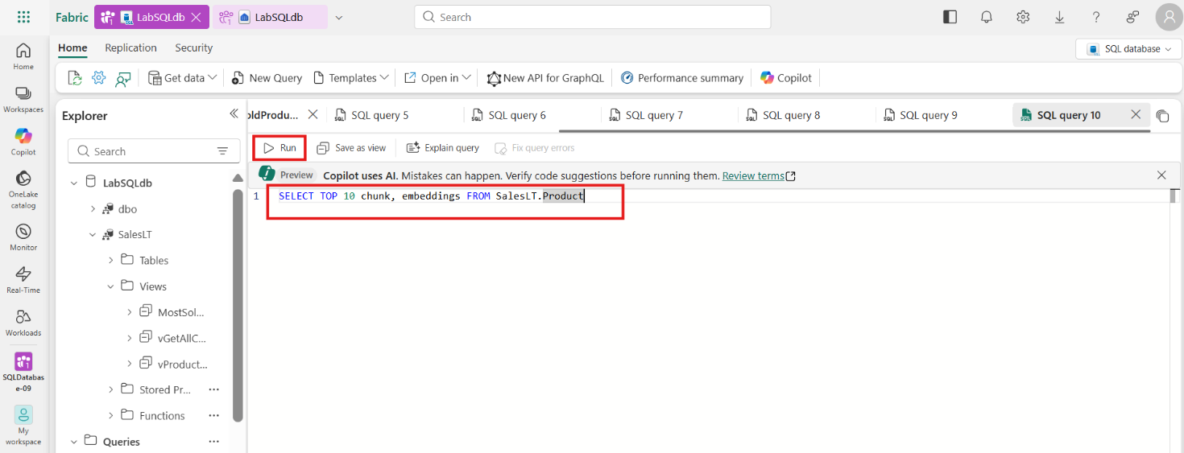
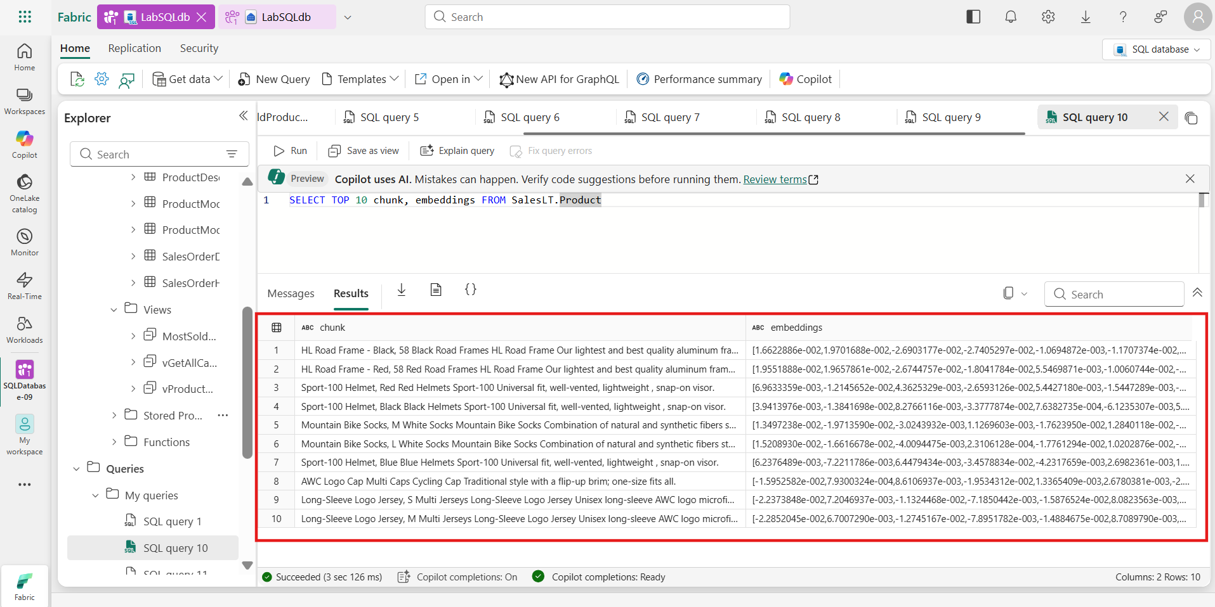
- Task-5: Vector Similarity Searching
Vector similarity searching is a technique used to find and retrieve data points that are similar to a given query, based on their vector representations.
The VECTOR_DISTANCE function is a new feature of the SQL Database in fabric that can calculate the distance between two vectors enabling similarity searching right in the database. You will be using this function in samples as well as in the RAG chat application; both utilizing the vectors you just created for the Products table.
- The first query will pose the question "I am looking for a red bike and I dont want to spend a lot". The key words that should help with our similarity search are red, bike, and don’t want to spend a lot. Run the following SQL in a new query window:
- TypeCopy
- declare @search_text nvarchar(max) = 'I am looking for a red bike and I dont want to spend a lot'
- declare @search_vector vector(1536)
- exec dbo.create_embeddings @search_text, @search_vector output;
- SELECT TOP(4)
- p.ProductID, p.Name , p.chunk,
- vector_distance('cosine', @search_vector, p.embeddings) AS distance
- FROM [SalesLT].[Product] p
- ORDER BY distance
Results show that the search found exactly that, an affordable red bike. The distance column shows us how similar it found the results to be using VECTOR_DISTANCE, with a lower score being a better match.
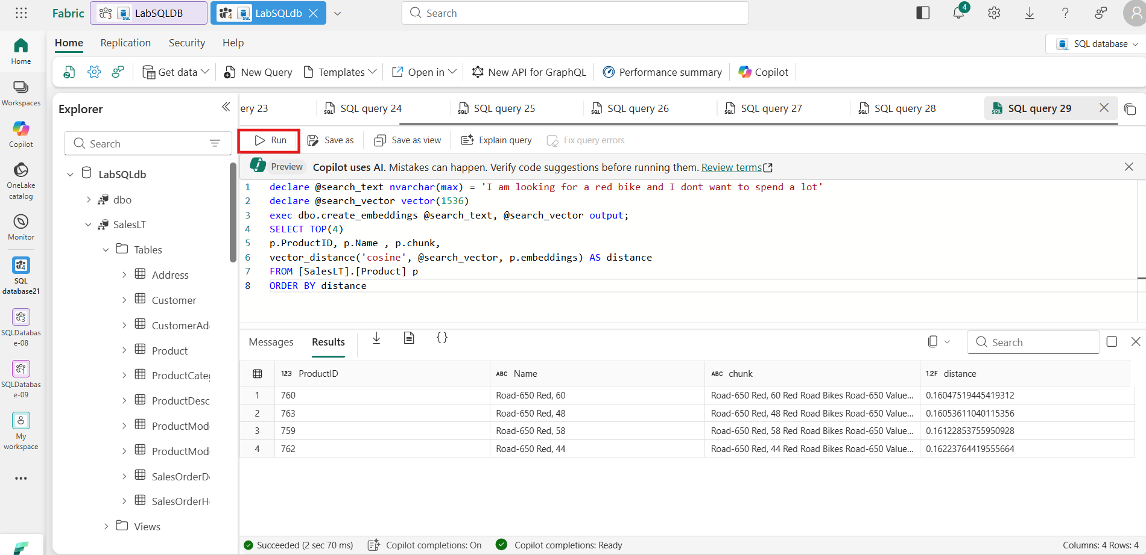
- Open a new query window editor. The next search will be looking for a safe lightweight helmet. Run the following SQL in a blank query editor in Microsoft Fabric:
- TypeCopy
- declare @search_text nvarchar(max) = 'I am looking for a safe helmet that does not weigh much'
- declare @search_vector vector(1536)
- exec dbo.create_embeddings @search_text, @search_vector output;
- SELECT TOP(4)
- p.ProductID, p.Name , p.chunk,
- vector_distance('cosine', @search_vector, p.embeddings) AS distance
- FROM [SalesLT].[Product] p
- ORDER BY distance
With the results returning lightweight helmets. There is one result that is not a helmet but a vest but as you can see, the distance score is higher for this result than the 3 helmet scores.
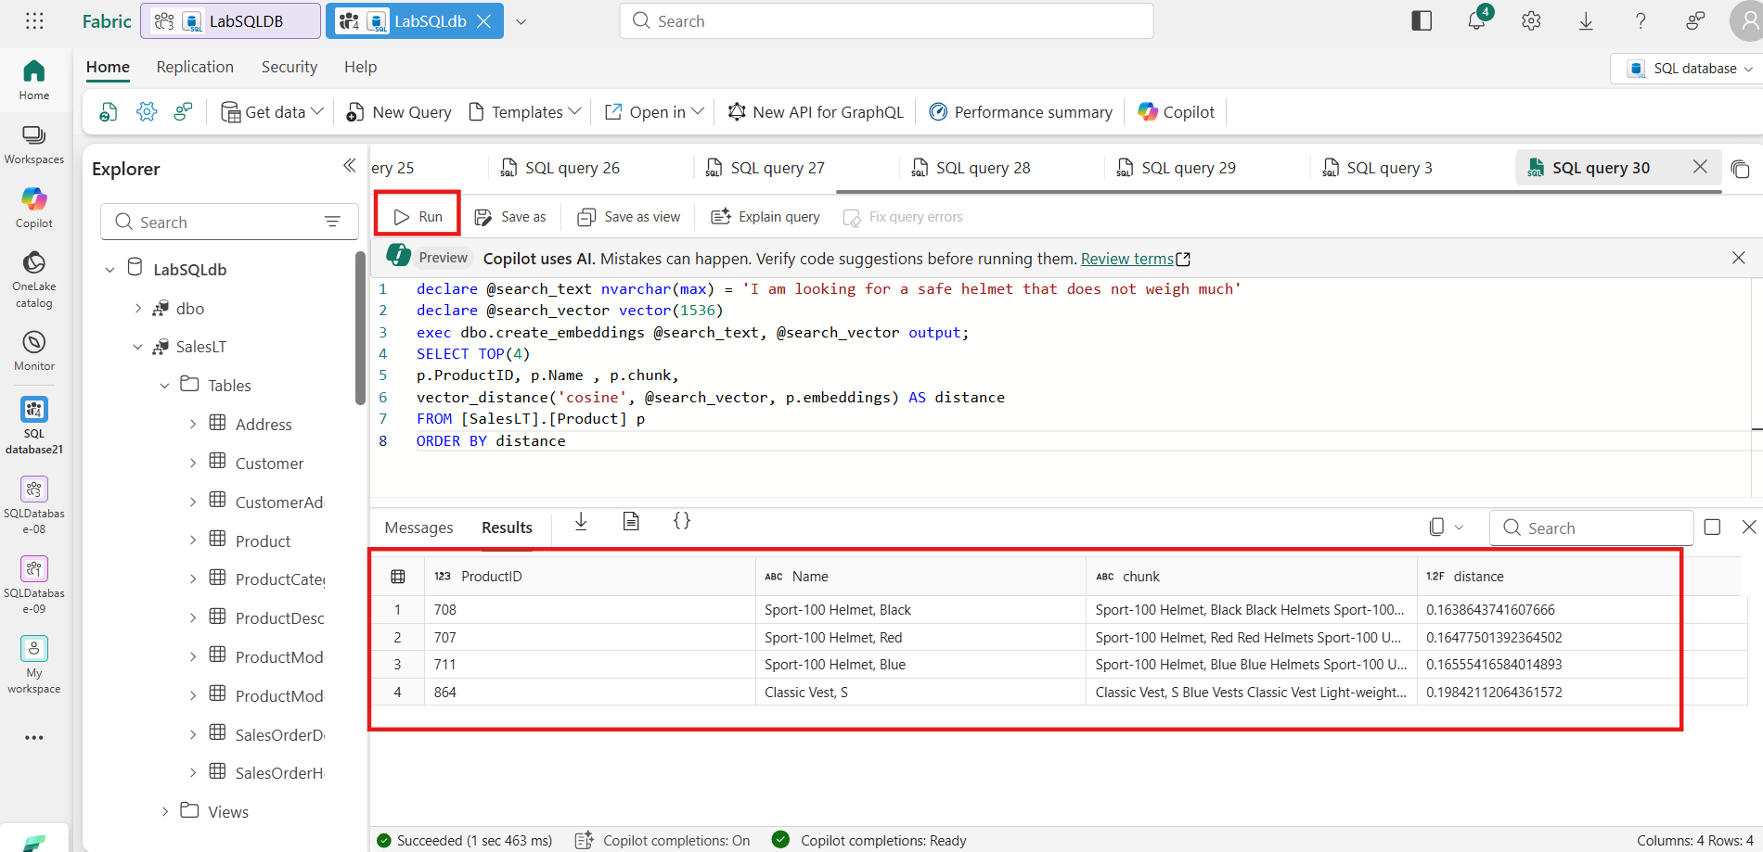
- In the previous 2 examples, we were clear on what we were looking for; cheap red bike, light helmet. In this next example, we are going to have the search flex its AI muscles a bit by saying we want a bike seat that needs to be good on trails. This will require the search to look for adjacent values that have something in common with trails. Run the following SQL in a blank query editor in Microsoft Fabric to see the results.
- TypeCopy
- declare @search_text nvarchar(max) = 'Do you sell any padded seats that are good on trails?'
- declare @search_vector vector(1536)
- exec dbo.create_embeddings @search_text, @search_vector output;
- SELECT TOP(4)
- p.ProductID, p.Name , p.chunk,
- vector_distance('cosine', @search_vector, p.embeddings) AS distance
- FROM [SalesLT].[Product] p
- ORDER BY distance
These results are very interesting for it found products based on word meanings such as absorb shocks and bumps and foam-padded. It was able to make connections to riding conditions on trails and find products that would fit that need.
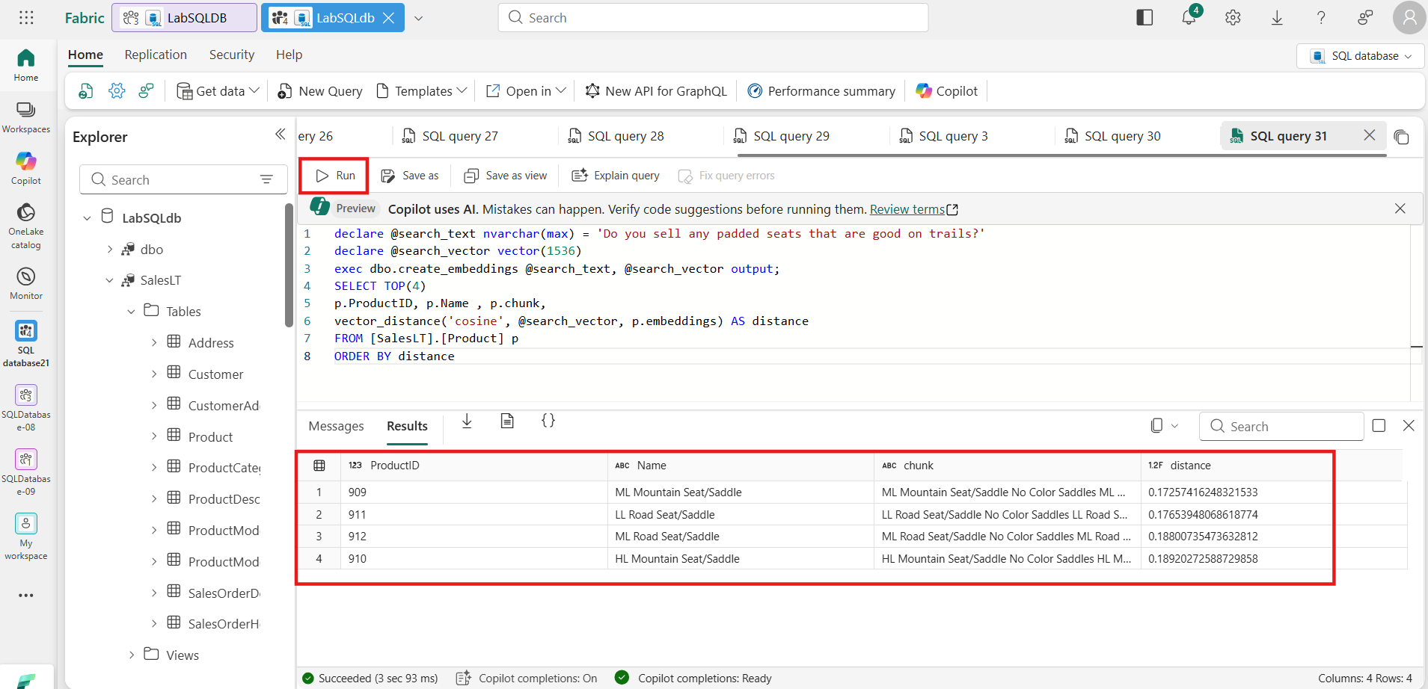
- Create a new stored procedure to find products. Copy and Paste the below code in a new query window and click Run:
- TypeCopy
- create or alter procedure [dbo].[find_products]
- @text nvarchar(max),
- @top int = 10,
- @min_similarity decimal(19,16) = 0.80
- as
- if (@text is null) return;
- declare @retval int, @qv vector(1536);
- exec @retval = dbo.create_embeddings @text, @qv output;
- if (@retval != 0) return;
- with vector_results as (
- SELECT
- p.Name as product_name,
- ISNULL(p.Color,'No Color') as product_color,
- c.Name as category_name,
- m.Name as model_name,
- d.Description as product_description,
- p.ListPrice as list_price,
- p.weight as product_weight,
- vector_distance('cosine', @qv, p.embeddings) AS distance
- FROM
- [SalesLT].[Product] p,
- [SalesLT].[ProductCategory] c,
- [SalesLT].[ProductModel] m,
- [SalesLT].[vProductAndDescription] d
- where p.ProductID = d.ProductID
- and p.ProductCategoryID = c.ProductCategoryID
- and p.ProductModelID = m.ProductModelID
- and p.ProductID = d.ProductID
- and d.Culture = 'en')
- select TOP(@top) product_name, product_color, category_name, model_name, product_description, list_price, product_weight, distance
- from vector_results
- where (1-distance) > @min_similarity
- order by
- distance asc;
- GO
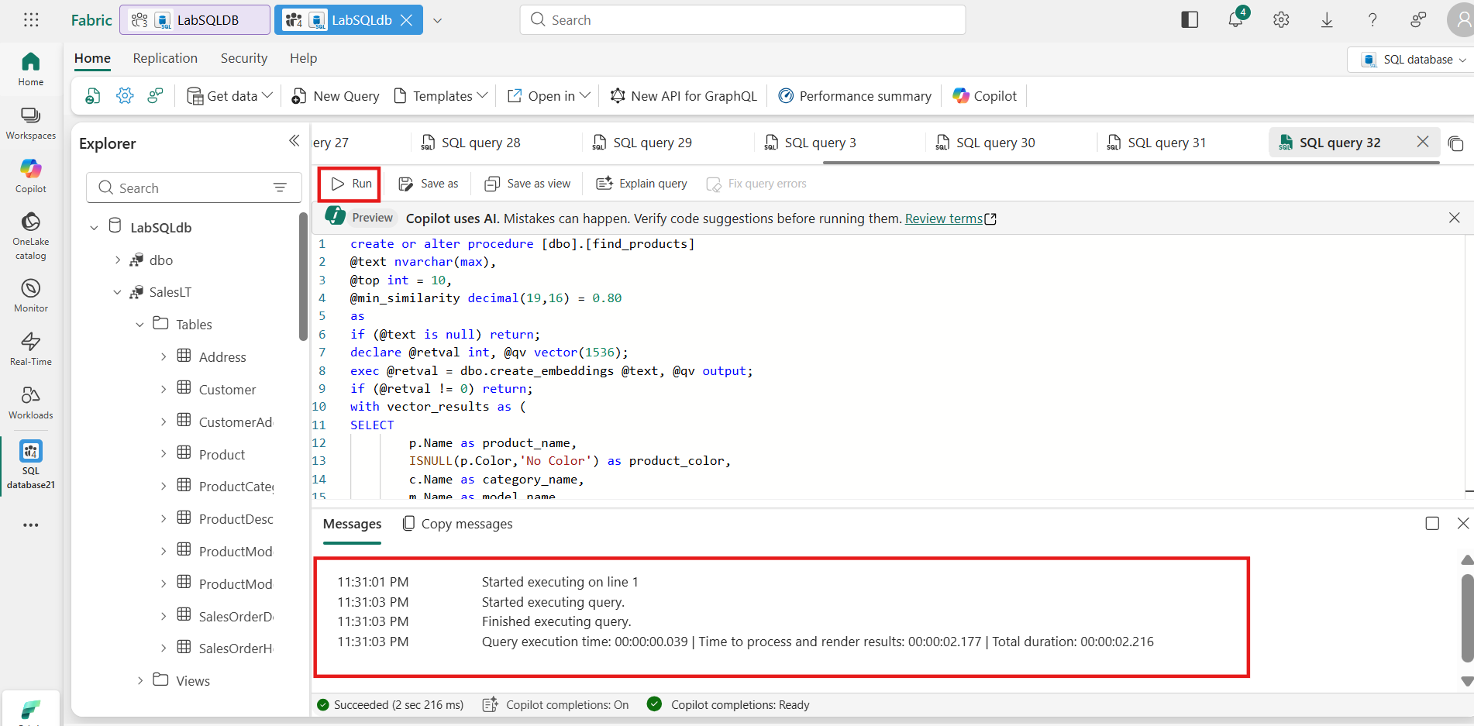
- Next, you need to encapsulate the STORED PROCEDURE into a wrapper so that the result set can be utilized by our GraphQL endpoint. Using the WITH RESULT SET syntax allows you to change the names and data types of the returning result set. This is needed in this example because the usage of sp_invoke_external_rest_endpoint and the return output from extended stored procedures
Copy and Paste the below code and click Run:
- TypeCopy
- create or alter procedure [find_products_api]
- @text nvarchar(max)
- as
- exec find_products @text
- with RESULT SETS
- (
- (
- product_name NVARCHAR(200),
- product_color NVARCHAR(50),
- category_name NVARCHAR(50),
- model_name NVARCHAR(50),
- product_description NVARCHAR(max),
- list_price INT,
- product_weight INT,
- distance float
- )
- )
- GO
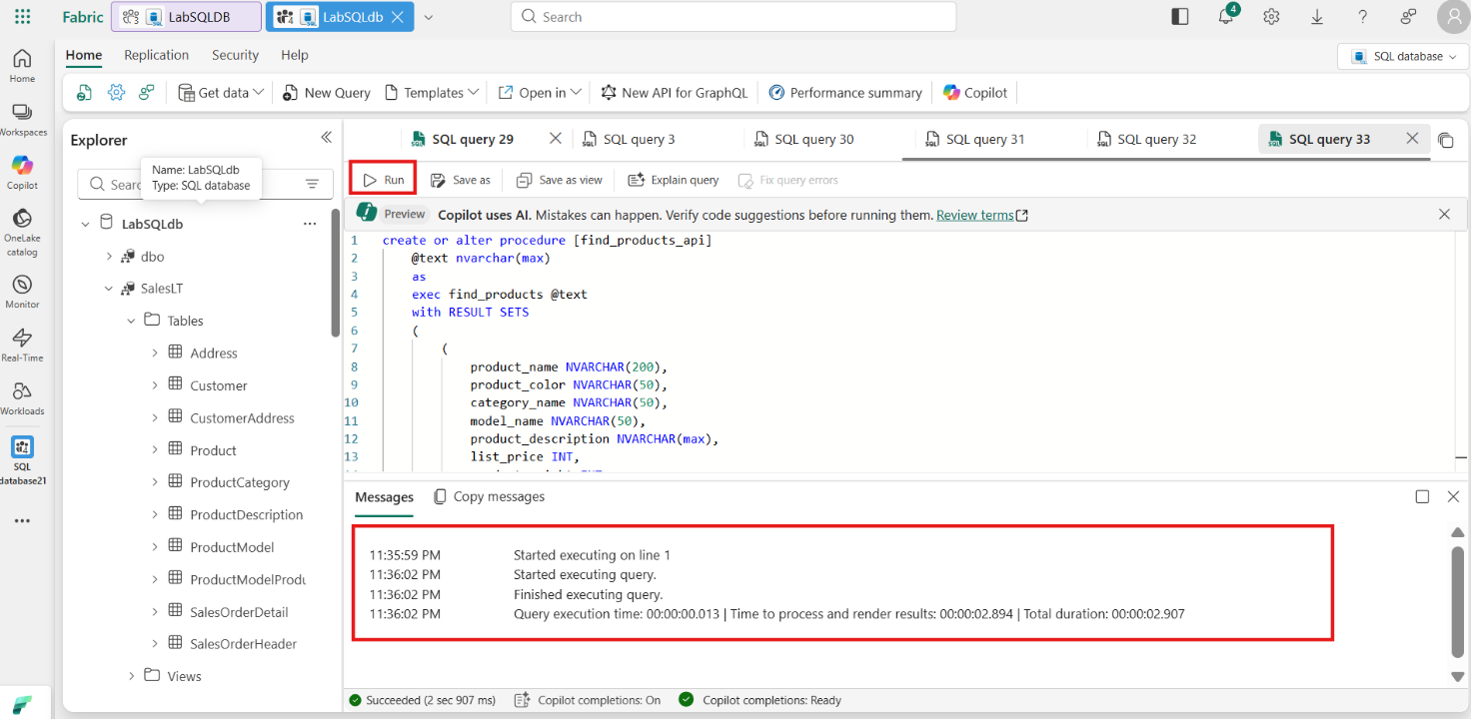
- You can test this newly created procedure to see how it will interact with the GraphQL API by running the following SQL in a blank query editor in Microsoft Fabric:
- TypeCopy
- exec find_products_api 'I am looking for a red bike'
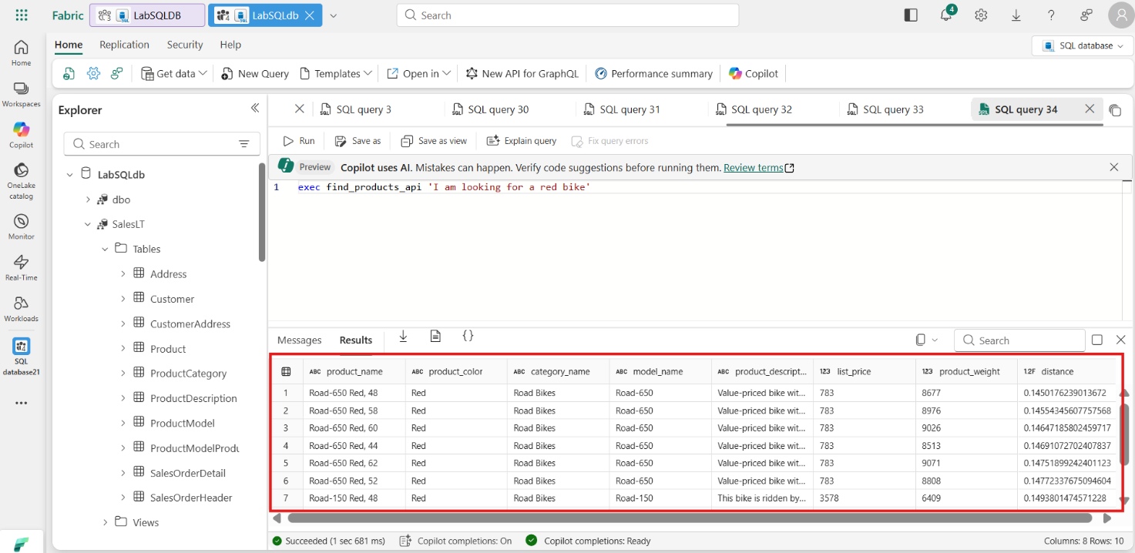
Congratulations! In this exercise, you learned how to build a RAG application using SQL database in fabric, and Azure OpenAI. You explored generating vector embeddings for relational data, performing semantic similarity searches with SQL.
- Exercise 4 – Build GraphQL API for RAG Applications
In this exercise, you will be deploying a GraphQL API that uses embeddings, vector similarity search, and relational data to return a set of products that could be used by a chat application leveraging a Large Language Model (LLM). You will create a stored procedure that will be used by the GraphQL API for taking in questions and returning products.
- Task-1: Chat Completion
Let's create a new stored procedure to create a new flow that not only uses vector similarity search to get products based on a question asked by a user, but to take the results, pass them to Azure OpenAI Chat Completion, and craft an answer they would typically see with an AI chat application.
- Open a new query window editor.
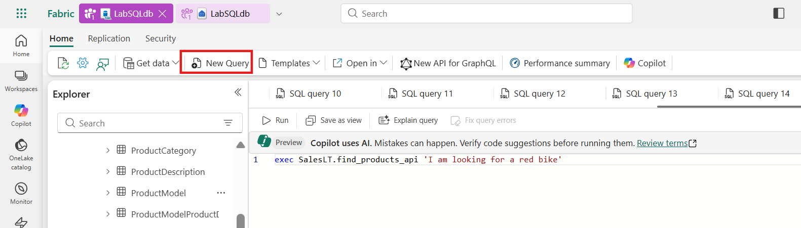
- The first step in augmenting our RAG application API is to create a stored procedure that takes the retrieved products and passes them in a prompt to an Azure OpenAI Chat Completion REST endpoint. The prompt consists of telling the endpoint who they are, what products they have to work with, and the exact question that was asked by the user.
Copy/Paste the below T-SQL Code in a new query window and Run the code:
- TypeCopy
- CREATE OR ALTER PROCEDURE [dbo].[prompt_answer]
- @user_question nvarchar(max),
- @products nvarchar(max),
- @answer nvarchar(max) output

- AS

- declare @url nvarchar(4000) = N'https://AI_ENDPOINT_SERVERNAME.openai.azure.com/openai/deployments/gpt-4/chat/completions?api-version=2024-06-01';
- declare @payload nvarchar(max) = N'{
- "messages": [
- {
- "role": "system",
- "content": "You are a sales assistant who helps customers find the right products for their question and activities."
- },
- {
- "role": "user",
- "content": "The products available are the following: ' + @products + '"
- },
- {
- "role": "user",
- "content": " ' + @user_question + '"
- }
- ]
- }';

- declare @ret int, @response nvarchar(max);

- exec @ret = sp_invoke_external_rest_endpoint
- @url = @url,
- @method = 'POST',
- @payload = @payload,
- @credential = [https://AI_ENDPOINT_SERVERNAME.openai.azure.com/],
- @timeout = 230,
- @response = @response output;

- select json_value(@response, '$.result.choices[0].message.content');

- GO
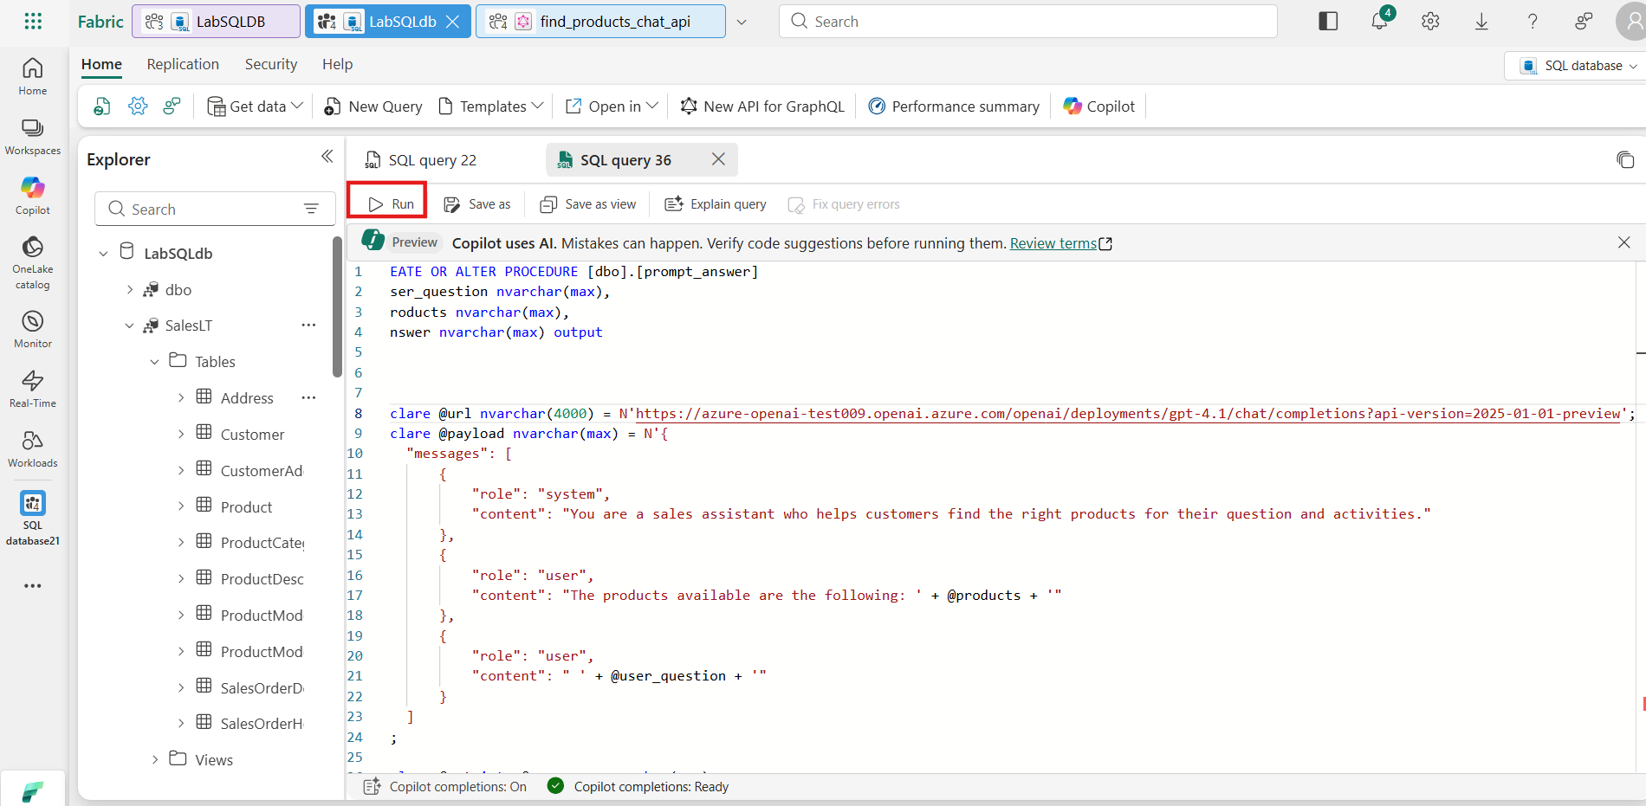
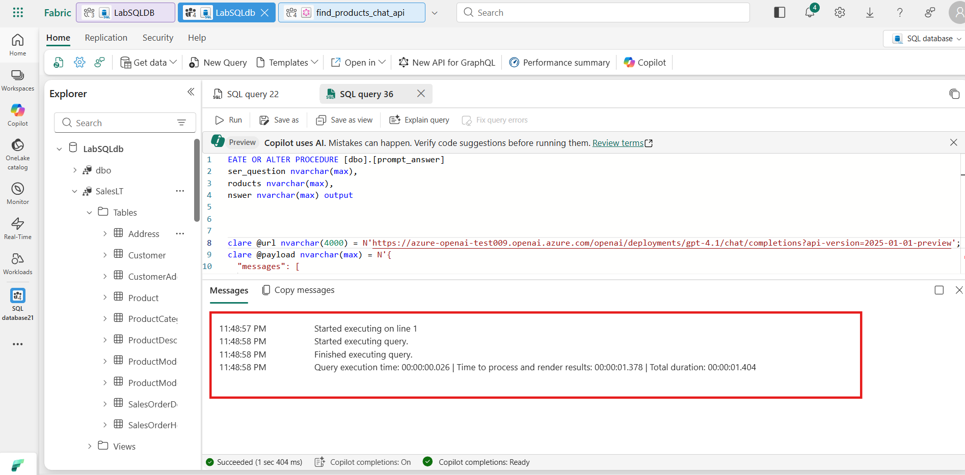
- Now that you have created the chat completion stored procedure, we need to create a new find_products_chat stored procedure that adds a call to this chat completion endpoint.
Copy/Paste the below T-SQL Code in a new query window and Run the code:
- TypeCopy
- create or alter procedure [dbo].[find_products_chat]
- @text nvarchar(max),
- @top int = 3,
- @min_similarity decimal(19,16) = 0.70
- as
- if (@text is null) return;
- declare @retval int, @qv vector(1536), @products_json nvarchar(max), @answer nvarchar(max);
- exec @retval = dbo.create_embeddings @text, @qv output;
- if (@retval != 0) return;
- with vector_results as (
- SELECT
- p.Name as product_name,
- ISNULL(p.Color,'No Color') as product_color,
- c.Name as category_name,
- m.Name as model_name,
- d.Description as product_description,
- p.ListPrice as list_price,
- p.weight as product_weight,
- vector_distance('cosine', @qv, p.embeddings) AS distance
- FROM
- [SalesLT].[Product] p,
- [SalesLT].[ProductCategory] c,
- [SalesLT].[ProductModel] m,
- [SalesLT].[vProductAndDescription] d
- where p.ProductID = d.ProductID
- and p.ProductCategoryID = c.ProductCategoryID
- and p.ProductModelID = m.ProductModelID
- and p.ProductID = d.ProductID
- and d.Culture = 'en')
- select
- top(@top)
- @products_json = (STRING_AGG (CONVERT(NVARCHAR(max),CONCAT(
- product_name, ' ' ,
- product_color, ' ',
- category_name, ' ',
- model_name, ' ',
- product_description, ' ',
- list_price, ' ',
- product_weight )), CHAR(13)))
- from vector_results
- where (1-distance) > @min_similarity
- group by distance
- order by
- distance asc;

- set @products_json = (select REPLACE(REPLACE(@products_json, CHAR(13), ' , '), CHAR(10), ' , '));

- exec [dbo].[prompt_answer] @text, @products_json, @answer output;

- GO
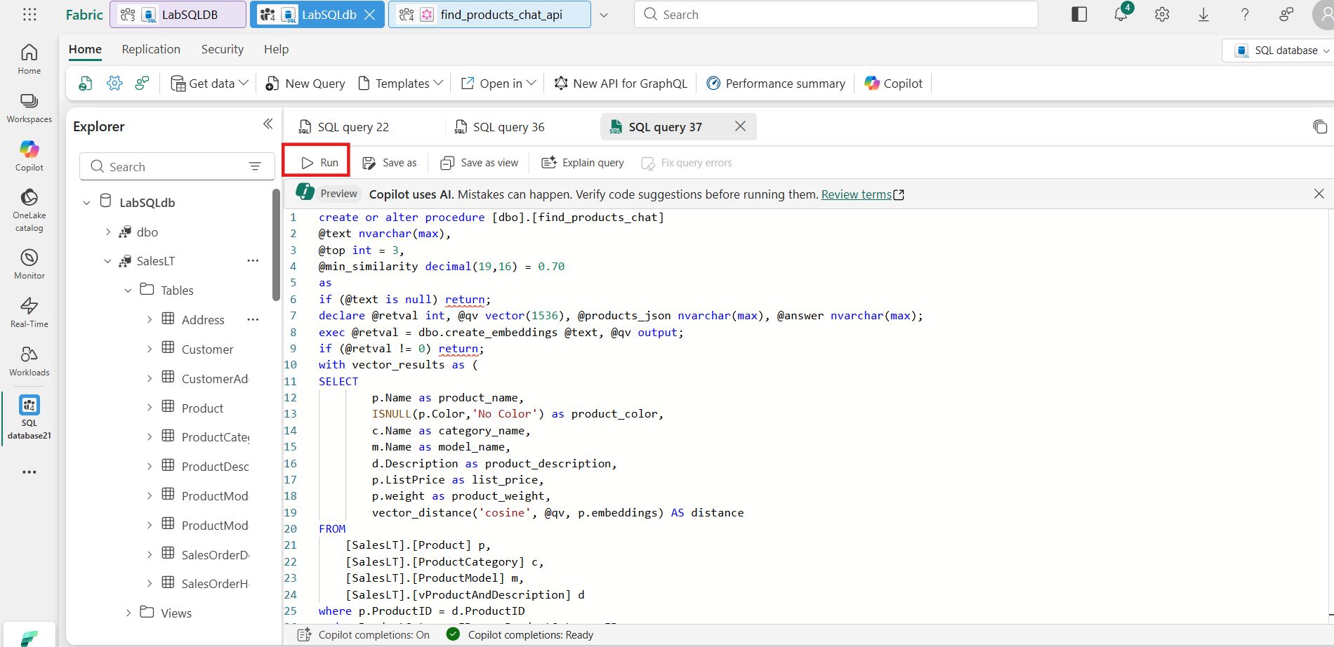
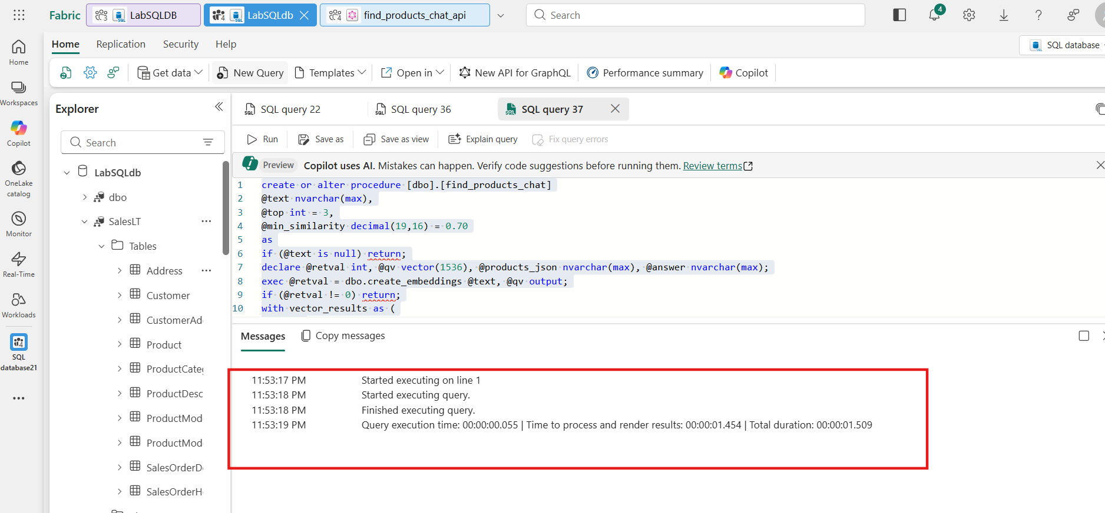
- The last step before we can create a GraphQL endpoint is to wrap the new find products chat stored procedure. Copy/Paste the below T-SQL Code in a new query window and Run the code:
- TypeCopy
- create or alter procedure [find_products_chat_api]
- @text nvarchar(max)
- as
- exec find_products_chat @text
- with RESULT SETS
- (
- (
- answer NVARCHAR(max)
- )
- )
- GO
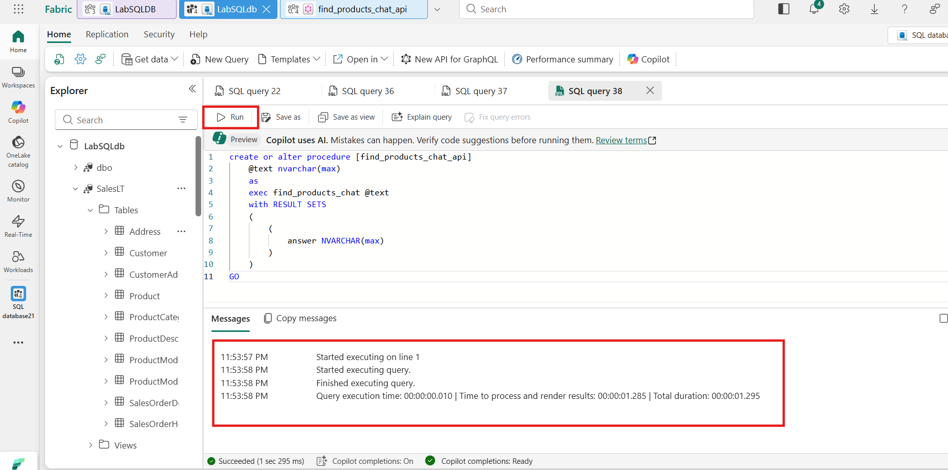
- You can test this new procedure to see how Azure OpenAI will answer a question with product data. Copy/Paste the below T-SQL Code in a new query window and Run the code:
- TypeCopy
- exec find_products_chat_api 'I am looking for a red bike'
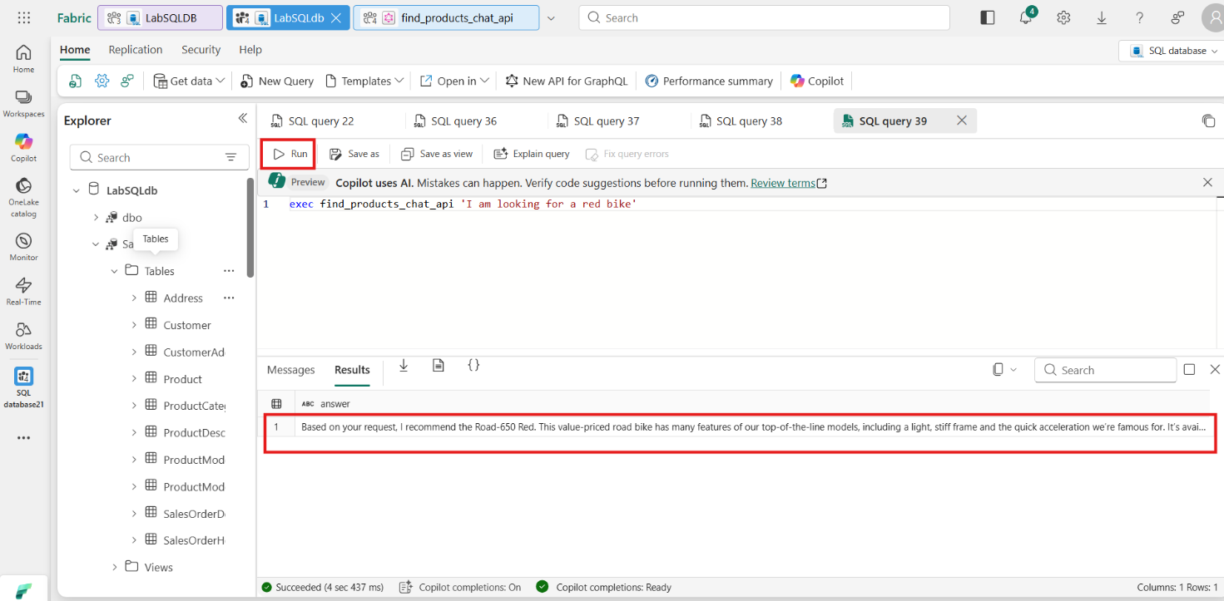
- Task-2: Create GraphQL API
- To create the GraphQL API, click on the New API for GraphQL button on the toolbar.
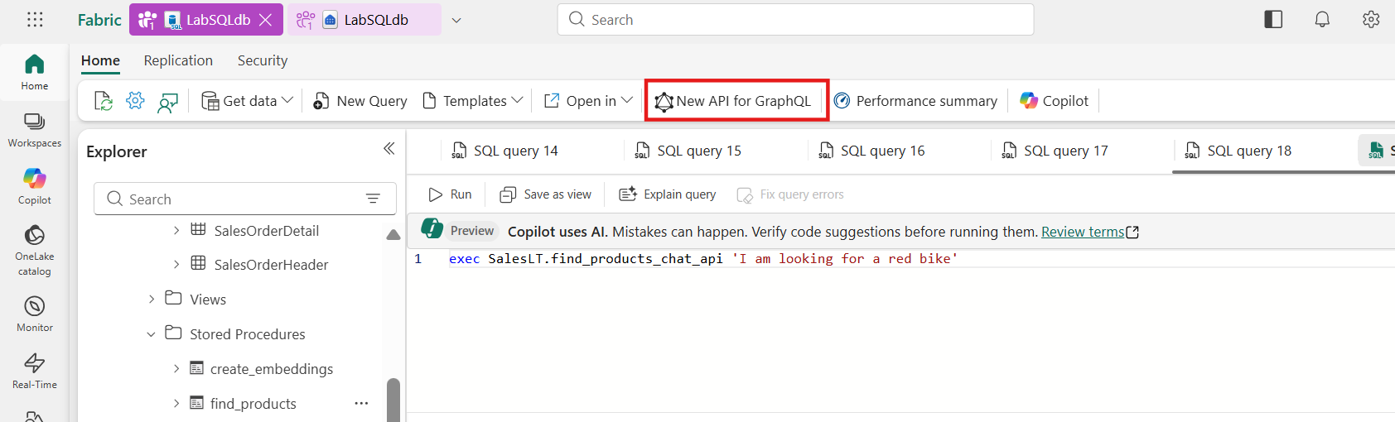
- In the New API for GraphQL dialog box, use the Name Field and name the API find_products_chat_api. After naming the API, click the Create button.
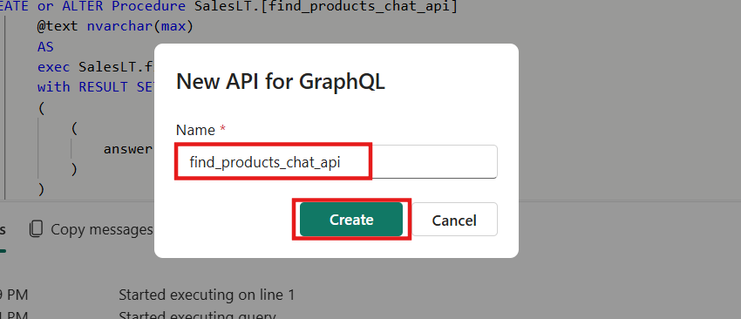
- Choose the stored procedure in the results. You can ensure it is the find_products_api stored procedure by hovering over it with your mouse/pointer. It will also indicate the selected database item in the preview section. It should state "Preview data: dbo.find_products_api". Click on Load button.
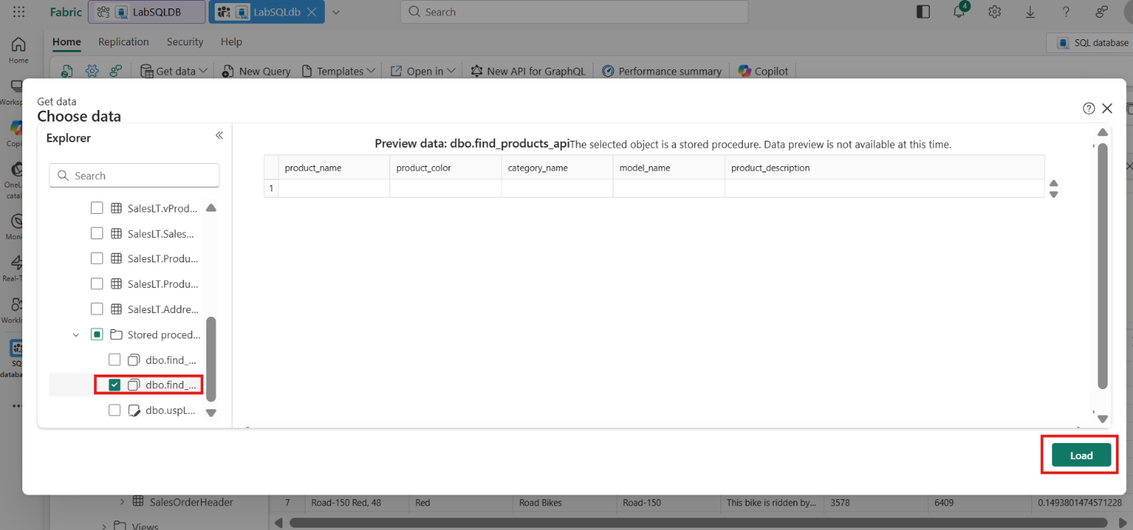
- You will now be on the GraphQL Query editor page. Copy/Paste the below code in the GraphQL query editor.
- TypeCopy
- query {
- executefind_products_api(text: "I am looking for a red bike") {
- product_name
- product_color
- category_name
- model_name
- product_description
- list_price
- product_weight
- distance
- }
- }
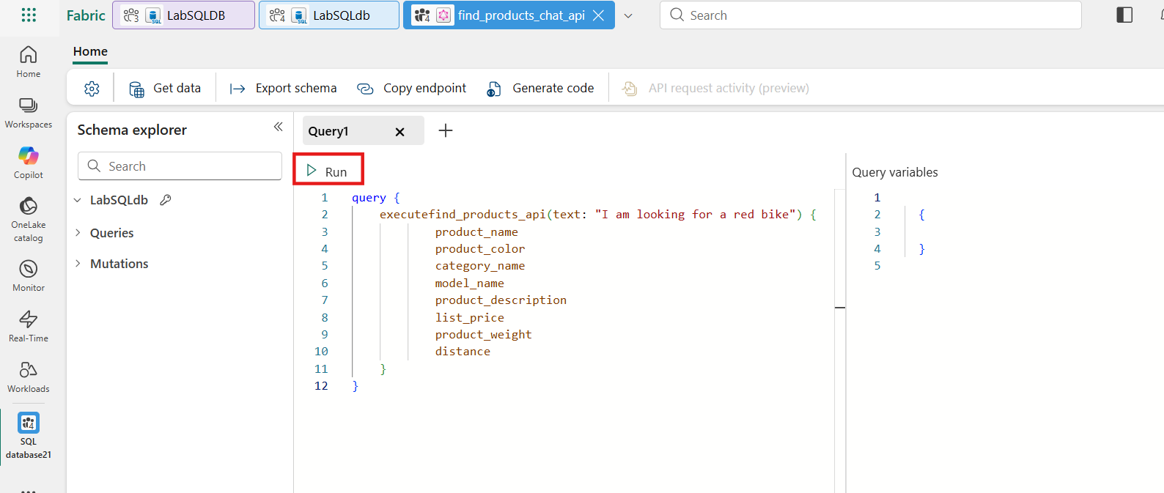
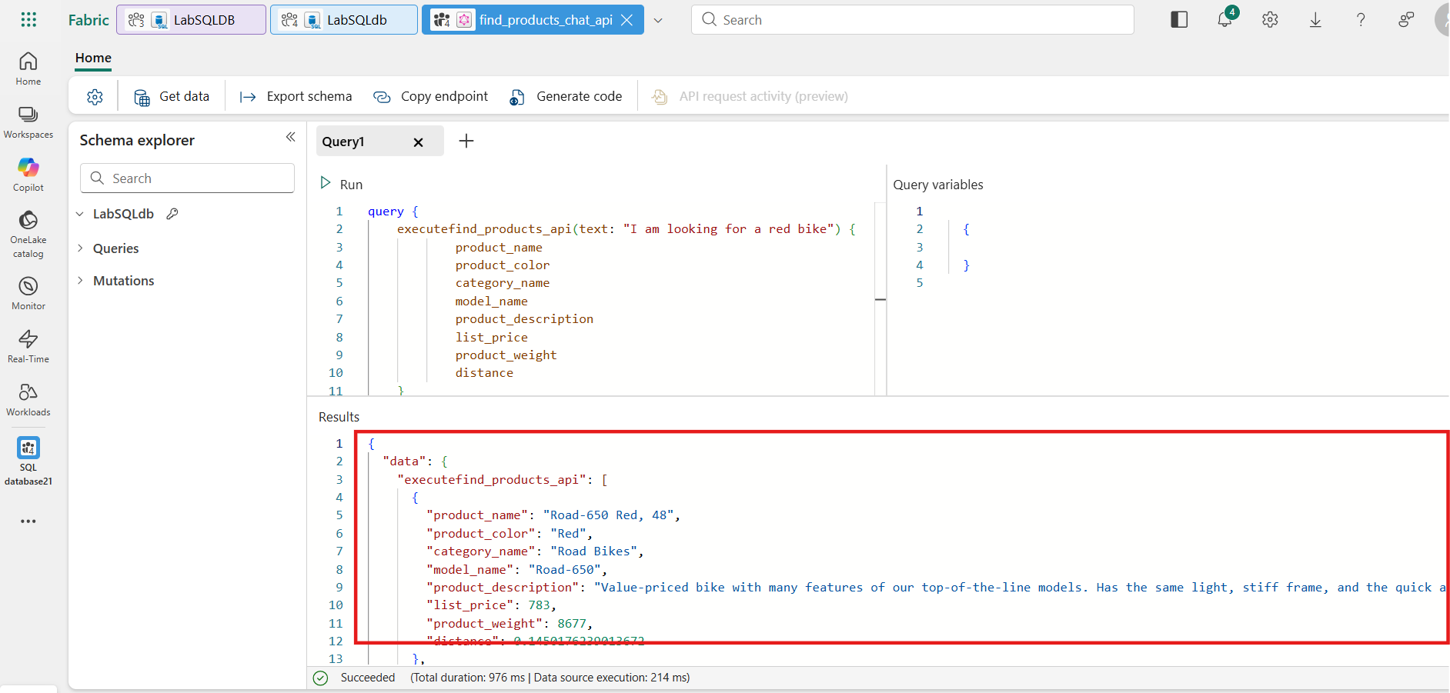
The API you just created could now be handed off to an application developer to be included in a RAG application that uses vector similarity search and data from the database.
Congratulations!! In this exercise, you learned how to build a RAG application using SQL database in fabric, and Azure OpenAI. You explored generating vector embeddings for relational data, performing semantic similarity searches with SQL, and integrating natural language responses via GPT-5
- Exercise 5 – Create a Power BI Report from a SQL analytics endpoint in Microsoft Fabric with Copilot
In this exercise, you'll learn how to leverage the power of Microsoft Fabric's integrated analytics capabilities to create compelling Power BI reports using Copilot assistance. This module demonstrates the seamless connection between SQL database in Fabric and Power BI reporting through SQL analytics endpoints.
It's easy to quickly create reports in Power BI with SQL analytics endpoint in Fabric using Copilot.
- Task-1: Build a new report with Copilot
- Navigate to SQL analytics endpoint from the top navigation pane.
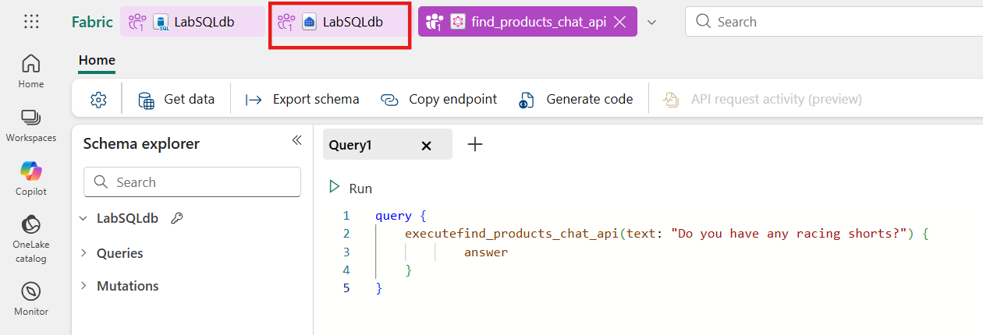
- On the SQL database analytics endpoint details page, click the New semantic model from the ribbon.
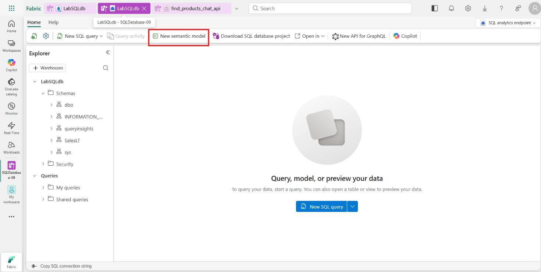
- When the New semantic model window opens, enter the name product_insight, complete the workspace details, and click select all tables to create the semantic model. Click on Confirm to proceed.
[IMPORTANT] If tables are not visible. Click Refresh icon next to Search bar.
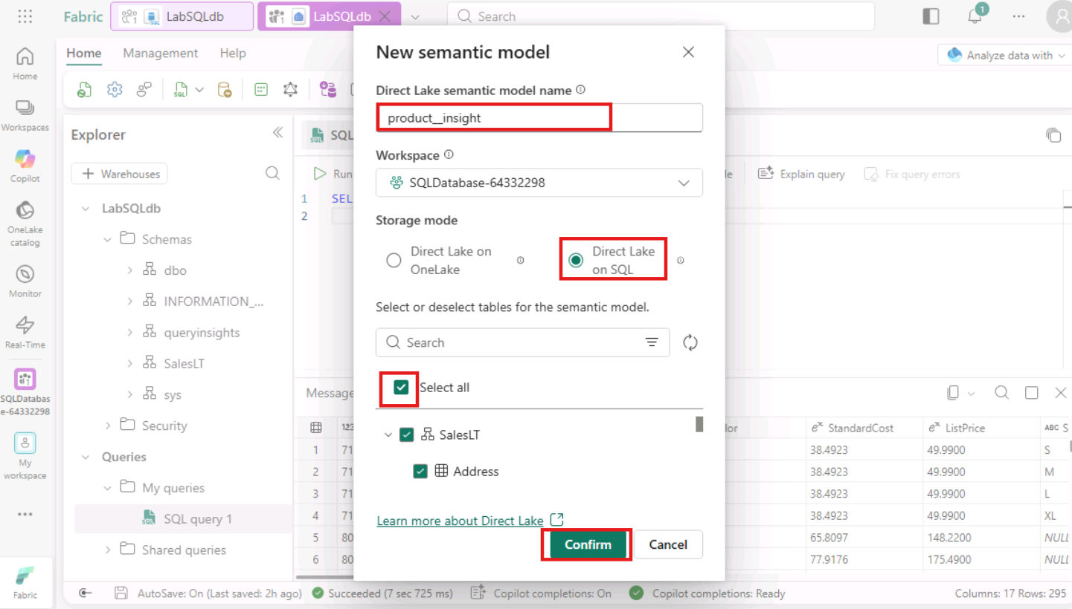
- Click on the workspace and look for the newly created semantic model - product_insight. Select the product_insight semantic model.
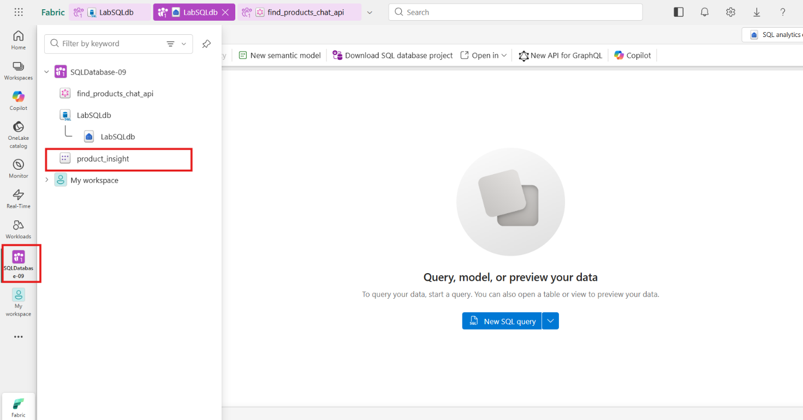
- Navigate to File and select Create new report option.
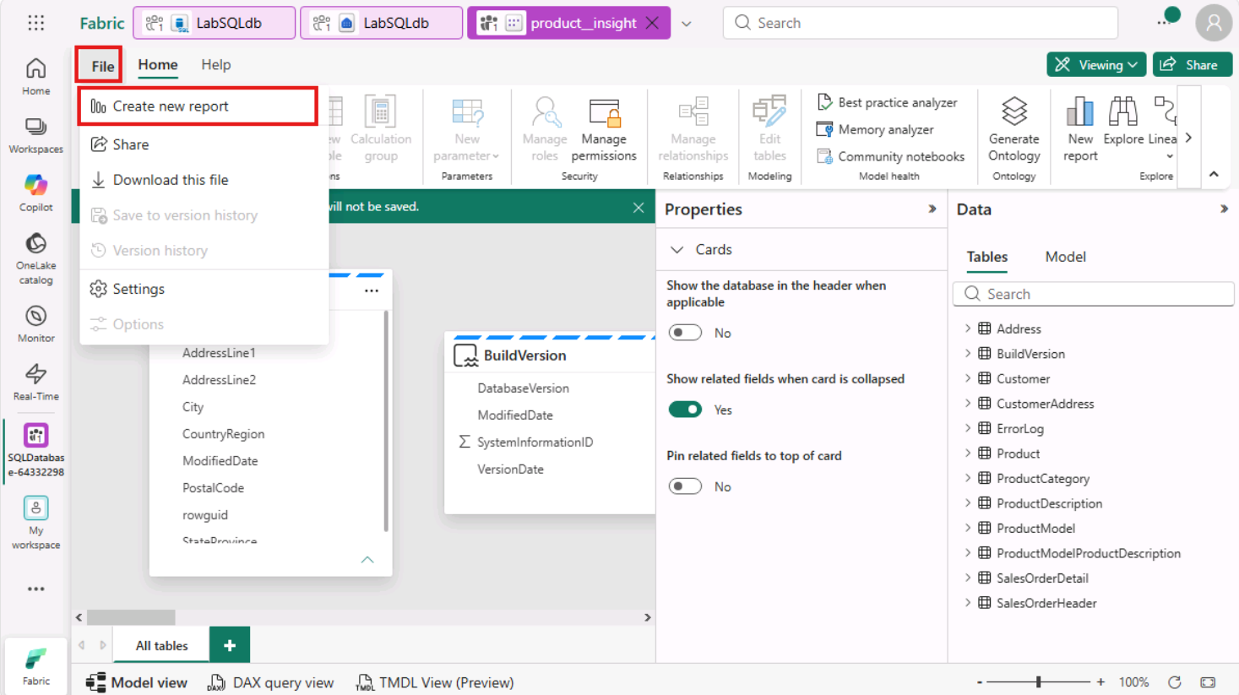
- Click on Copilot. On the right side of the page, the Copilot blade opens.
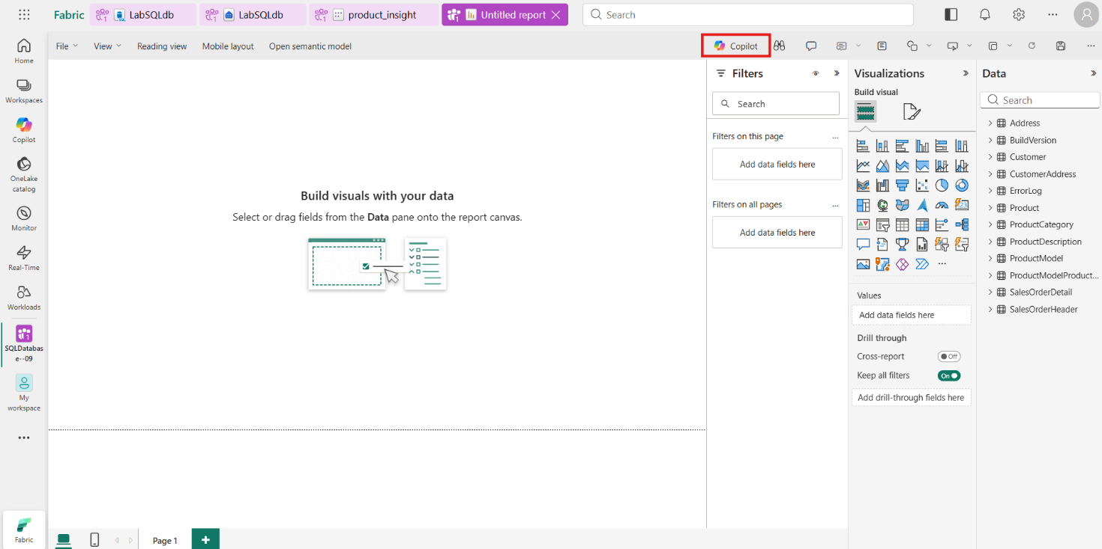
- Click on the Get Started button.
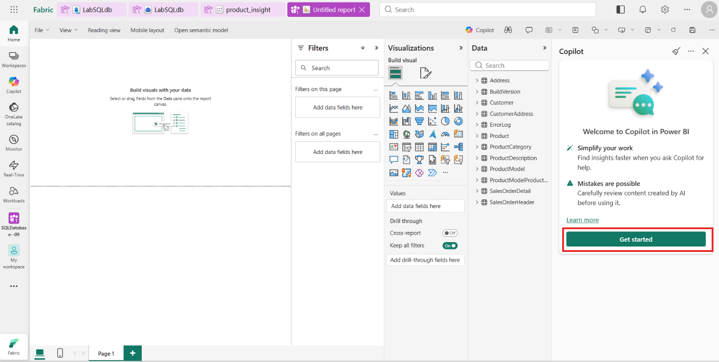
- Copilot presents some questions to get you started. Click Suggest content for a new report page.
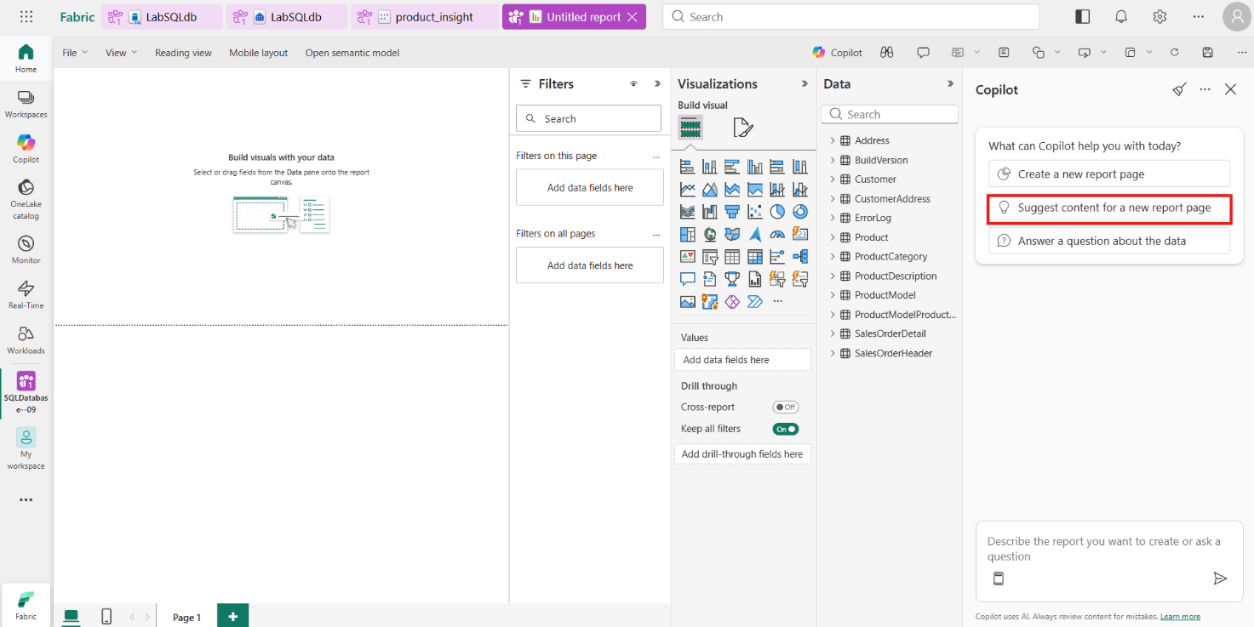
- Suggested outlines for your report are returned by Copilot based on the data it has access to in the analytics endpoint.
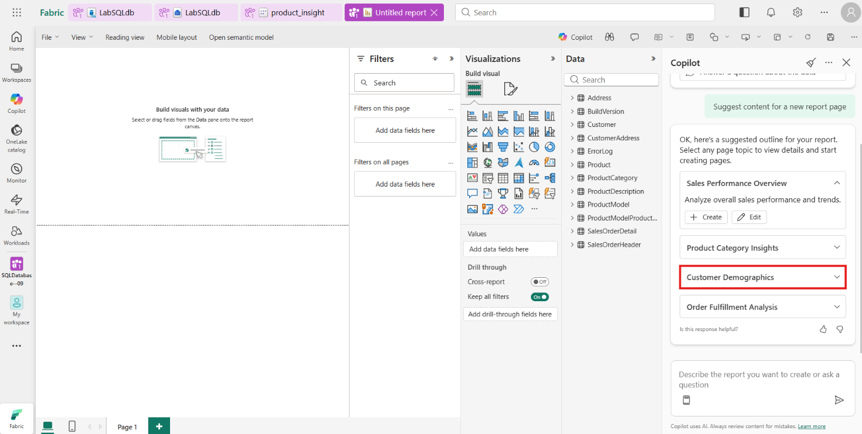
- You can review the selections by expanding their cards to see a quick description about the report.
- Click the Create button for the Customer Demographics report or any other report you would like to create.
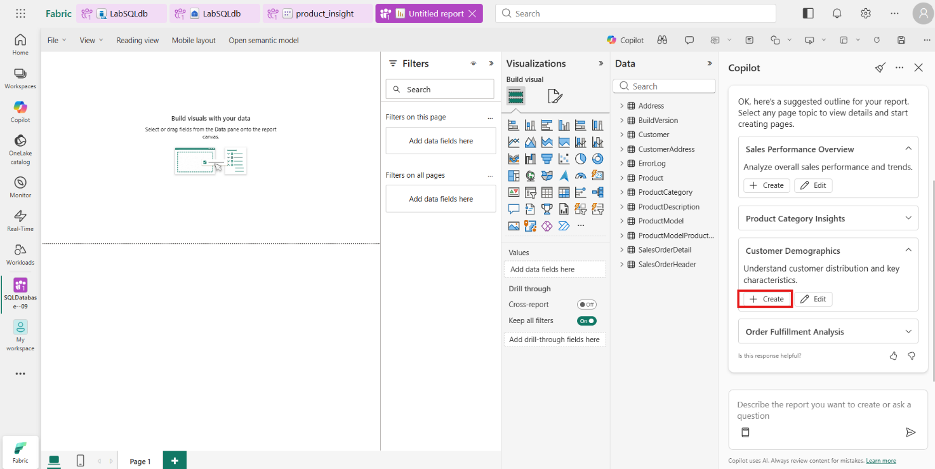
- Copilot will then begin creating your report.
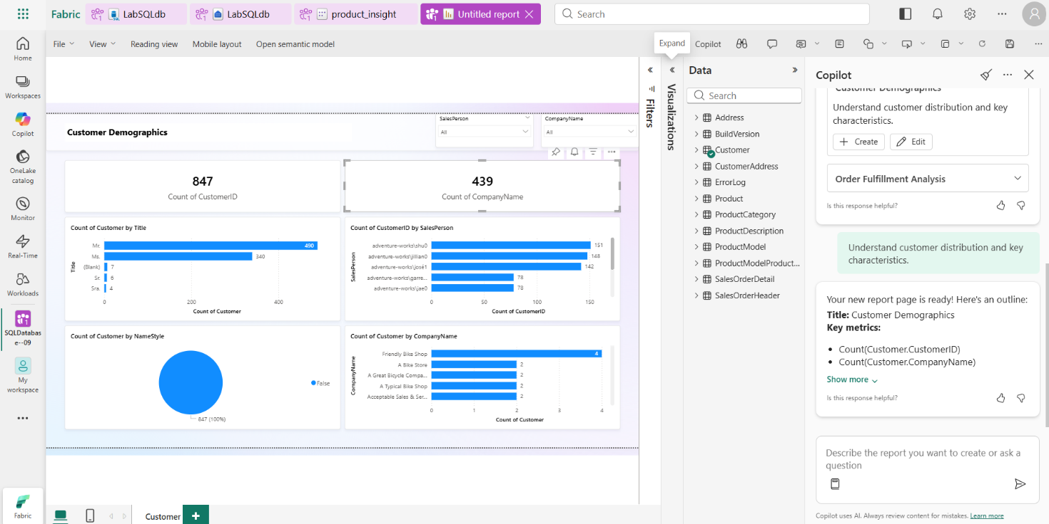
- You now have a Power BI report of your SQL database data!
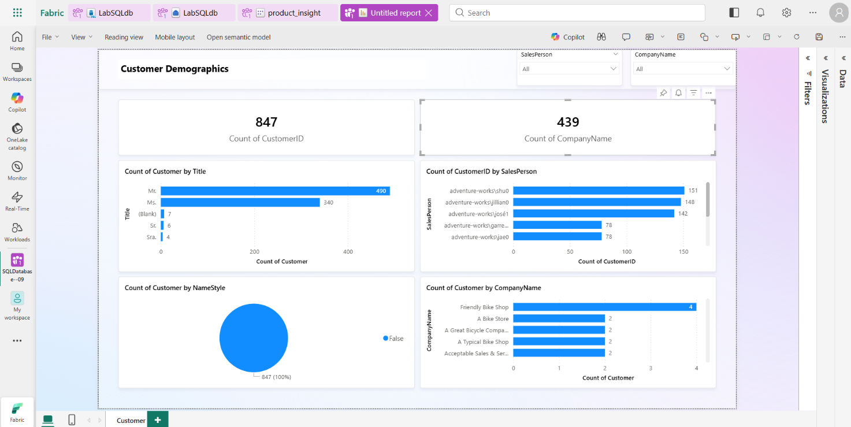
- Conclusion
Congratulations on successfully completing a comprehensive hands-on journey in building scalable, AI-ready data solutions using SQL Database in Microsoft Fabric. This lab offered an end-to-end experience in designing, building, and operationalizing modern data solutions, covering key areas such as an introduction to SQL Database in Fabric, exploring Copilot capabilities for SQL Database, implementing Retrieval-Augmented Generation (RAG) with Azure OpenAI, developing GraphQL APIs for RAG applications, and creating insightful Power BI reports using semantic models.

