
East West University
Lab Report 3

Course Name: Machine learning
Course Code: CSE 475
Section No:05

Submitted to:
Dr. Md. Tauhid Bin Iqbal
Department of Computer Science & Engineering

Submitted By:
Name : Monika Asha Momo
ID: 2023-1-60-180

Abstract
We compare bagging, random forest, AdaBoost, XGBoost, soft voting and stacking against a single decision tree on the Breast Cancer Wisconsin (Diagnostic) data (569 samples, 30 features, 37.3 % malignant). Models are compared by nested 5-fold stratified cross-validation on an 80 % training split; a 20 % stratified test set is used only for final reporting. Soft voting and stacking tie for the best CV macro-F1 (0.9765 ± 0.01), well above the single tree (0.918 ± 0.035). Soft voting is carried forward; at a cost-minimising threshold of 0.198, chosen from out-of-fold predictions and frozen before test evaluation, it makes 1 false negative and 2 false positives on the test set (cost 12, versus 30 at the 0.5 threshold), with ROC AUC 0.9967 and PR AUC 0.9954. The test set is small (114 rows), so these figures carry noticeable uncertainty.

1. Introduction
Ensembles combine several learners to obtain a predictor that is more accurate or more stable than any single member. Bagging and random forests average many high-variance trees trained on bootstrap samples; boosting (AdaBoost, XGBoost) fits weak learners sequentially, each concentrating on the errors of its predecessors; voting and stacking combine heterogeneous models. In cancer screening the two error types are not equally costly, so we additionally evaluate threshold-dependent metrics and a cost-sensitive operating point in which a missed malignancy (false negative, FN) costs ten times a false alarm (false positive, FP). Malignant is the positive class throughout.

2. Data and Methods

2.1 Data
The file data.csv has 569 rows: 357 benign and 212 malignant. The 30 predictors are the mean, standard error and worst value of ten nuclear measurements (radius, texture, perimeter, area, smoothness, compactness, concavity, concave points, symmetry, fractal dimension). The identifier column and an entirely empty trailing column were removed; there are no missing values in the remaining columns.
Table 1. Class distribution (full dataset).
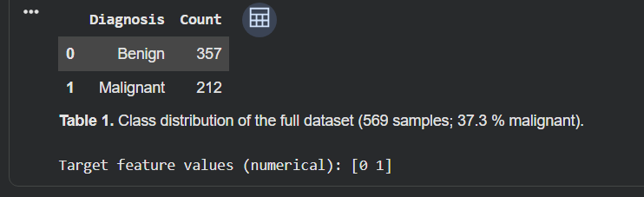

2.2 Protocol
- A stratified 80:20 split (seed 42) gives 455 training and 114 test rows. All random components use seed 42 and the notebook runs top to bottom deterministically.
- Models: single decision tree (baseline); Bagging (100 trees); Random Forest (300 trees); AdaBoost and XGBoost (max depth 3), each tuned over a 3 × 3 grid of n_estimators and learning_rate with an inner 3-fold CV scored by macro-F1; soft VotingClassifier and StackingClassifier over standardised logistic regression, Random Forest and XGBoost (the stacker uses a logistic-regression meta-learner and 5-fold internal CV).
- Comparison: 5-fold stratified CV on the training set reporting mean ± SD of accuracy and macro-F1 and the fit time per fold. For the tuned models the grid search is run inside each outer fold (nested CV), so their CV scores are not optimistic; their fit time includes the tuning.
- Threshold: out-of-fold probabilities of the selected model are obtained by 5-fold CV on the training set; the threshold minimising 10·FN + FP is chosen and frozen before the test set is used for that model. Ties among equally cheap thresholds are resolved by their median.
- Metrics computed by hand from confusion-matrix entries (precision = TP/(TP+FP), recall = TP/(TP+FN), specificity = TN/(TN+FP), F1 = 2PR/(P+R)) and verified against scikit-learn. ROC and precision–recall curves use the test-set probabilities.
- Software: scikit-learn, XGBoost, pandas, matplotlib (Python).

3. Results

3.1 Random Forest and AdaBoost across splits and ensemble sizes (lab task)
Table 2 reports test accuracy for the three train:test splits and four ensemble sizes. Both models reach ≥ 0.94 everywhere. Accuracy is generally lowest with n_estimators = 10 and flattens from 50 trees onward; AdaBoost is slightly ahead at 80:20 and 70:30 for n ≥ 50, while the 90:10 split reaches 1.000 for both models at 100 and 150 trees. The 90:10 test set has only 57 rows, so one error changes accuracy by 1.8 points; with one split per cell, differences of one or two samples should not be interpreted as a genuine ranking.
Table 2. Test accuracy for each train:test split and n_estimators (RF = Random Forest, Ada = AdaBoost).
 | Split 90:10 |  | Split 80:20 |  | Split 70:30
n_estimators | RF | Ada | RF | Ada | RF | Ada
10 | 0.9649 | 0.9649 | 0.9649 | 0.9386 | 0.9474 | 0.9591
50 | 1.0000 | 0.9825 | 0.9737 | 0.9825 | 0.9649 | 0.9825
100 | 1.0000 | 1.0000 | 0.9737 | 0.9737 | 0.9649 | 0.9766
150 | 1.0000 | 1.0000 | 0.9649 | 0.9737 | 0.9708 | 0.9766

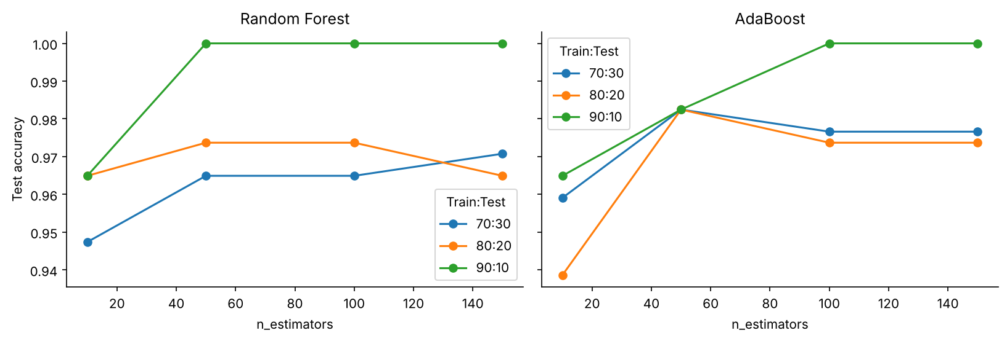
Figure 1. Test accuracy versus n_estimators for the three splits (left: Random Forest, right: AdaBoost).

3.2 Cross-validated model comparison (Tasks 1–5)
Table 3 gives the nested 5-fold results on the training set. The single tree is clearly the weakest and the most variable (macro-F1 0.918 ± 0.035; it fits the training set perfectly but scores 0.930 accuracy on the test set). Every ensemble improves it: bagging and Random Forest to ≈ 0.96, tuned XGBoost to 0.965, tuned AdaBoost to 0.974, and soft voting and stacking to 0.9765. Fold-to-fold SD also falls from 0.035 to 0.008–0.018 for most ensembles. Differences among the top four models (≤ 0.4 points of macro-F1) are smaller than one standard deviation and should not be over-read. Soft voting and stacking are tied at four decimals; soft voting was selected on the accuracy tie-break (also tied) and by order, and its measured fit time is lower than stacking's.
Table 3. 5-fold stratified CV on the training set: mean ± SD of accuracy and macro-F1, and fit time per fold (tuned models include the nested grid search).
Model | Accuracy | Macro-F1 | Fit time / fold (s)
Decision Tree (baseline) | 0.9231 ± 0.0326 | 0.9175 ± 0.0352 | 0.03 ± 0.01
Bagging | 0.9626 ± 0.0226 | 0.9599 ± 0.0241 | 1.83 ± 0.34
Random Forest | 0.9604 ± 0.0164 | 0.9574 ± 0.0178 | 1.29 ± 0.20
AdaBoost (tuned) | 0.9758 ± 0.0082 | 0.9740 ± 0.0089 | 12.19 ± 1.72
XGBoost (tuned) | 0.9670 ± 0.0120 | 0.9646 ± 0.0129 | 3.01 ± 0.79
Soft Voting (LR+RF+XGB) | 0.9780 ± 0.0098 | 0.9765 ± 0.0105 | 0.78 ± 0.11
Stacking (LR+RF+XGB) | 0.9780 ± 0.0070 | 0.9765 ± 0.0075 | 5.10 ± 0.89

Grid search on the full training set chose n_estimators = 200 with learning_rate = 1.0 for AdaBoost (inner-CV macro-F1 0.9695) and n_estimators = 200 with learning_rate = 0.03 for XGBoost (0.9574). Both selected the largest ensemble size in the grid, so a larger grid might help. Fit times are from the Google Colab run of the notebook; they are single-run, machine-dependent measurements (the ordering of the fast models, e.g. voting at 0.78 s versus bagging at 1.83 s, is not meaningful and probably reflects machine load) and indicate order of magnitude only.

3.3 Threshold selection (Task 8)
Out-of-fold probabilities from the soft-voting model give a cost of 64 at the default 0.5 threshold and 48 at the minimum, reached at 0.198 (Figure 2). This minimum is a single candidate on 455 rows, so it is somewhat noisy; the cost curve is a step function and neighbouring thresholds are only slightly worse. The value 0.198 was frozen before the test set was used.
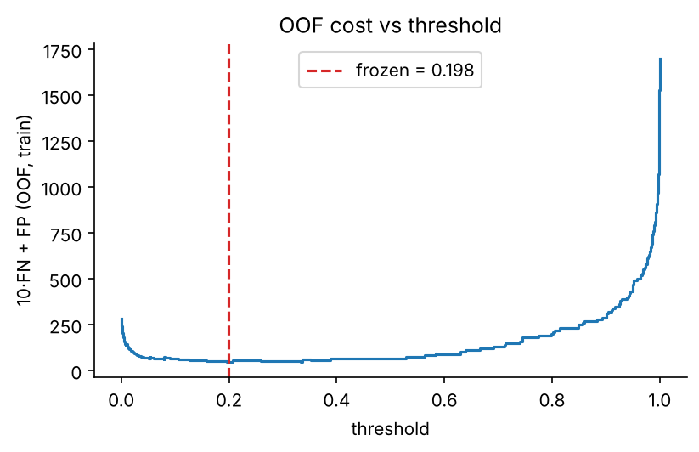
Figure 2. Out-of-fold cost 10·FN + FP on the training set versus threshold; dashed line = frozen threshold 0.198.

3.4 Test-set performance of the selected model (Tasks 6–8)
Figure 3 shows the test confusion matrix at the frozen threshold: TN = 70, FP = 2, FN = 1, TP = 41. From these entries, precision = 41/43 = 0.9535, recall = 41/42 = 0.9762, specificity = 70/72 = 0.9722 and F1 = 2·0.9535·0.9762/(0.9535 + 0.9762) = 0.9647; scikit-learn returns identical values (Table 4).
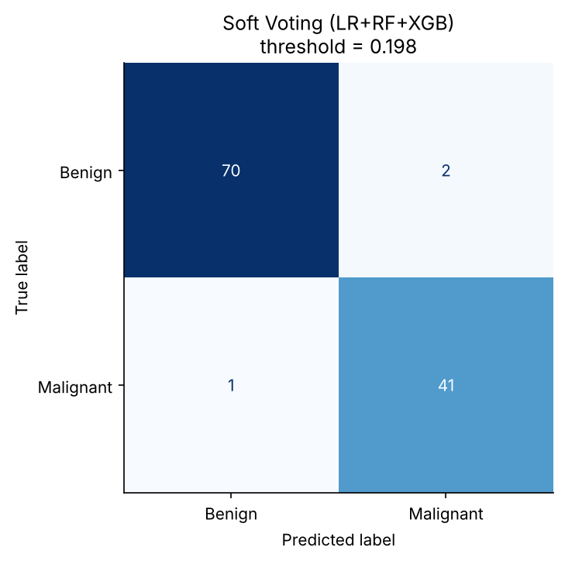
Figure 3. Test confusion matrix of the soft-voting model at threshold 0.198.
Table 4. Metrics computed by hand from the confusion matrix and verified with scikit-learn (all match).
Metric | Formula | By hand | scikit-learn
Precision | 41/(41+2) | 0.9535 | 0.9535
Recall | 41/(41+1) | 0.9762 | 0.9762
Specificity | 70/(70+2) | 0.9722 | 0.9722
F1 | 2PR/(P+R) | 0.9647 | 0.9647

Table 5 compares this with the default threshold. Lowering the threshold removes two of the three missed cancers at the price of two false alarms, reducing the test cost from 30 to 12. This is consistent with the 10:1 cost ratio, but the difference rests on two patients: the threshold should be judged on its out-of-fold justification, not on the test gain.
Table 5. Test-set results at threshold 0.5 and at the frozen threshold (cost = 10·FN + FP). The threshold was not tuned on the test set.
Threshold | TN | FP | FN | TP | Precision | Recall | Specificity | F1 | Cost
0.5 | 72 | 0 | 3 | 39 | 1.0000 | 0.9286 | 1.0000 | 0.9630 | 30
0.198 (frozen) | 70 | 2 | 1 | 41 | 0.9535 | 0.9762 | 0.9722 | 0.9647 | 12

3.5 ROC and precision–recall curves (Task 7)
The ROC AUC is 0.9967, the area under the precision–recall curve is 0.9954 (trapezoidal) and the average precision is 0.9954. The PR curve is the more informative of the two for an imbalanced problem; here the classes are only moderately imbalanced (37 % positive), so both tell the same story. The red markers show the frozen operating point, which sits in the upper-left (high-recall) region.
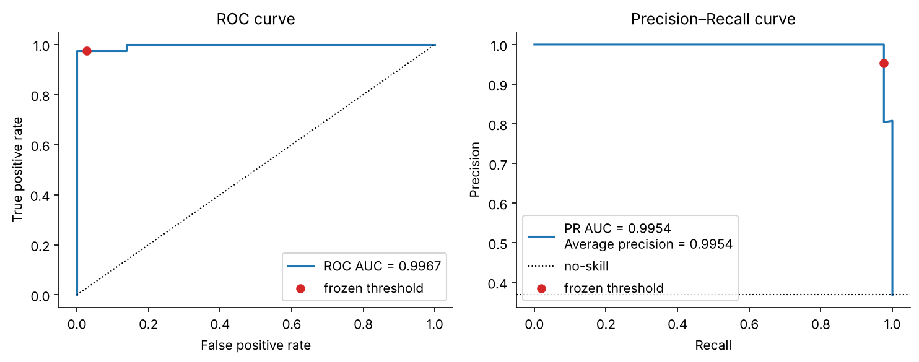
Figure 4. ROC (left) and precision–recall (right) curves on the test set; red dot = frozen threshold; dotted line = no-skill baseline.

3.6 Random Forest feature importances (Task 9)
The five most important features (Table 6, Figure 5) hold 57 % of the total importance. Three are size measures of the largest nuclei – perimeter_worst, area_worst and radius_worst – which are correlated at 0.98–0.99, so impurity-based importance is divided among them and they should be read as one 'nucleus size' signal rather than three independent ones. The other two, concave points_worst and concave points_mean (r = 0.91), quantify how many concave indentations the nuclear contour has, i.e. boundary irregularity. The picture is clinically plausible: malignant nuclei tend to be larger and more irregular. Caveats: impurity importance favours continuous and correlated features, and importances describe the model, not causal effects; permutation importance would be a useful cross-check.

Table 6. Top five Random Forest importances (500 trees, training set).
Feature | Importance
perimeter_worst | 0.1383
area_worst | 0.1295
concave points_worst | 0.1164
concave points_mean | 0.0951
radius_worst | 0.0917

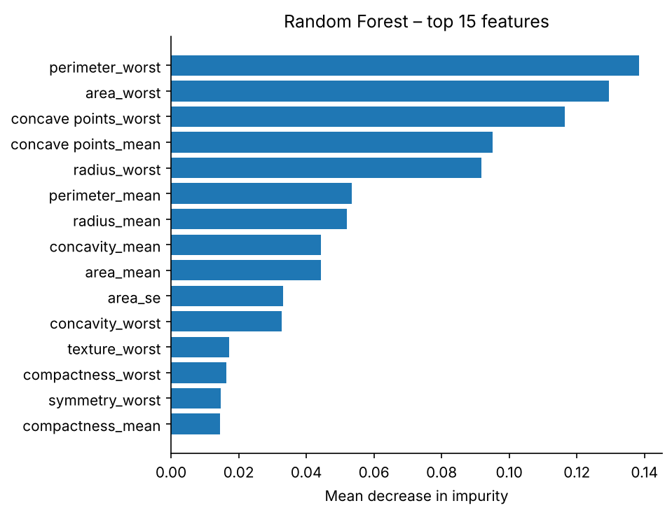
Figure 5. Random Forest feature importances (top 15).

4. Discussion and Limitations
- Ensembles consistently beat the single tree on both mean and spread of the CV scores, which agrees with the variance-reduction argument of Question 1. The best ensembles are statistically indistinguishable on this data; the choice of soft voting is justified by cost and simplicity, not by a demonstrated margin.
- All evidence comes from one dataset, one stratified split (seed 42) and a 114-row test set (42 malignant). A single error changes recall by 2.4 points. Repeated cross-validation or repeated splits would give more reliable confidence intervals.
- The threshold 0.198 is a single OOF minimum on a small set. A larger or repeated-CV estimate would stabilise it. The 10:1 cost ratio is an assumption of the task, not an estimate of real clinical costs.
- Hyper-parameter grids are small by design; both tuned models picked the largest n_estimators, so the optimum may lie outside the grid.

5. Answers to the Analysis Questions

Q1. Why does bagging often reduce variance and boosting reduce bias? Why are these only tendencies?
Bagging. A deep tree has low bias but high variance: small changes in the training set change its splits and predictions. Bagging trains B models on bootstrap resamples and averages (or votes) them. For B predictors with variance σ² and pairwise correlation ρ, the variance of the average is ρσ² + (1 − ρ)σ²/B. Averaging removes the second term, which shrinks as B grows, while the bias of the average equals the bias of a single member. Bagging therefore helps most when the base learner is unstable and low-bias, as in deep trees; random forests lower ρ further by sampling features at each split. In our CV results, bagging cut the tree's macro-F1 standard deviation from 0.035 to 0.024 and raised its mean from 0.918 to 0.960.
Boosting. Boosting builds an additive model in stages. AdaBoost re-weights the training samples so that each new weak learner focuses on what the current ensemble gets wrong; gradient boosting (XGBoost) fits each new tree to the gradient of the loss. A single stump is a high-bias model, but a weighted sum of many stumps can represent a far richer function, so the training error – the bias – is driven down stage by stage. This is why a depth-1 stump base learner can end up competitive with deep trees.
Why they are tendencies, not guarantees. (i) If the base learners are strongly correlated (ρ close to 1) or already stable (linear models, k-NN with large k), averaging removes little variance. (ii) A bootstrap sample contains only about 63 % of the distinct training points, so each member sees less data and can have somewhat higher bias; if the base learner is high-bias, bagging cannot fix it. (iii) Boosting reduces bias at the expense of variance: with label noise, outliers or too many rounds or too large a learning rate, it fits the noise, because misclassified points – often mislabelled ones – receive ever more weight, and the test error can rise. It also requires weak learners that beat chance on the re-weighted data. (iv) Both effects depend on the data, the base learner and hyper-parameters, and the theory describes expected behaviour; on a specific finite sample an ensemble can be no better, or even worse, than a single model. On this clean, nearly separable dataset both behave as expected, but that is an empirical observation about this data, not a rule.

Q2. Why is 99.2 % accuracy on a dataset with 0.8 % positives almost meaningless, and which two metrics should be demanded?
Accuracy is dominated by the majority class. With 0.8 % positives, a classifier that labels everybody negative is correct on 99.2 % of cases while detecting no disease at all (recall = 0). The reported accuracy is therefore exactly what a useless model would achieve, so it says nothing about the ability to find the positives. It also hides the error structure: in a screening test, FN (missed disease) and FP (false alarms) have very different consequences, and accuracy weighs them equally.
The two metrics to demand are recall (sensitivity) – the fraction of true positives that the test finds – and precision (positive predictive value) – the fraction of positive calls that are correct. Their trade-off is the point: because prevalence is so low, even a good specificity produces many false alarms. For example, among 1,000 people with 8 positives, a test with 90 % sensitivity and 99 % specificity finds 7.2 positives but raises 9.9 false alarms, so only about 42 % of positive results are real. The area under the precision–recall curve (or F1 at a stated threshold) is a good summary, and confidence intervals should accompany it because with 8 positives per 1,000 the estimates are noisy.

Q3. Why can recall not decrease, and why does precision often (but not always) fall, when the threshold is lowered from 0.5 to 0.2 on fixed scores?
Recall. With the scores fixed, the set of samples predicted positive at threshold 0.5 is {score ≥ 0.5}, which is a subset of {score ≥ 0.2}. Lowering the threshold can only add samples to the predicted-positive set. The number of actual positives P is fixed, so TP can only stay the same or increase (a true positive stays a true positive; a false negative can become a true positive), and recall = TP/P cannot decrease. Equivalently, FN cannot increase.
Precision. Precision = TP/(TP + FP). Lowering the threshold adds the samples with scores in [0.2, 0.5). Let these contain a true positives and b false positives. The new precision is (TP + a)/(TP + a + FP + b), which is a weighted mix of the old precision and the precision a/(a + b) of the added group. It falls exactly when the added group has a lower fraction of positives than the old predicted-positive set, which is typical because a well-calibrated score gives lower scores to samples that are less likely to be positive. It is not guaranteed: if the added group happens to be all (or mostly) true positives, precision stays equal or rises, for instance when the model is under-confident on a cluster of positives. Because the quantity depends on the particular scores and labels, precision is not monotone in the threshold, while recall is.
Empirical example from our test set: moving from 0.5 to 0.198 raised recall from 0.9286 to 0.9762 (FN: 3 → 1) while precision fell from 1.0000 to 0.9535 (FP: 0 → 2), exactly the typical pattern (Table 5).

6. Conclusion
Ensembles outperform a single decision tree on this data, and the best ensembles (soft voting, stacking, tuned AdaBoost) are within one standard deviation of each other. A frozen, cost-based threshold of 0.198 reduced missed malignancies on the test set from 3 to 1 at the price of two extra false alarms. All conclusions rest on a single dataset and a small test set; repeated evaluation would be needed before claiming a ranking of the top models.

