 East West University
LAB REPORT

Experiment 5

Course: Machine Learning

Course Code : cse475

Section: 05

Submitted By:
Monika Asha Momo

Student ID: 2023-1-60-180

Submitted to:

Dr. Md. Tauhid Bin Iqbal
Department of Computer Science & Engineering

Submission Date: 2.11.26

1. Objective
To mine frequent itemsets and association rules with Apriori, to reduce and visualise high-dimensional data with PCA and t-SNE, and to detect anomalies with a statistical method (Z-score rule) and a model-based method (Isolation Forest). All tasks are carried out on one dataset: brain tumour MRI images.

2. Background Theory

2.1 Association rules (Apriori)
Formula box – rule measures
Support(A) = (transactions containing A) / (all transactions)
Confidence(A → B) = support(A ∪ B) / support(A) = P(B | A)
Lift(A → B) = confidence(A → B) / support(B)
Lift ≈ 1 → A and B are independent (rule is only popularity); lift > 1 → positive association.
Apriori uses downward closure: every subset of a frequent itemset is also frequent, so candidates with an infrequent subset are pruned.

2.2 PCA and t-SNE
Formula box – PCA
Standardise: z = (x − μ) / σ (otherwise the largest-scaled feature dominates).
Explained-variance ratio of component k = λₖ / Σλ ; choose the smallest k with cumulative ratio ≥ 0.95.
PCA is linear, deterministic and can transform new data → valid preprocessing.

t-SNE preserves local neighbourhoods for visualisation only. Cluster distances, cluster sizes and the global layout are not meaningful; the picture changes with perplexity and seed; there is no transform for new points, so a classifier must never be trained on t-SNE coordinates.

2.3 Anomaly detection
Formula box – detection rules
Z-score rule: flag if |x − μ| / σ > 3 (univariate, assumes approximately normal data).
Isolation Forest: random trees; the anomaly score is high when few splits isolate the point (multivariate, distance-free).

3. Dataset and Preprocessing
The Brain Tumor MRI zip has Training and Testing folders, each with four class folders. All 7,023 images were pooled and a stratified random subsample of 5,000 images was drawn (seed 42). Every image was converted to grayscale, resized to 64 × 64 and scaled to 0–1, giving 4,096 features per image.
Table 1: Class distribution of the full dataset and the 5,000-image subsample.
Class | Full dataset | Subsample (5,000)
glioma | 1,621 | 1,154
meningioma | 1,645 | 1,171
notumor | 2,000 | 1,424
pituitary | 1,757 | 1,251
Total | 7,023 | 5,000

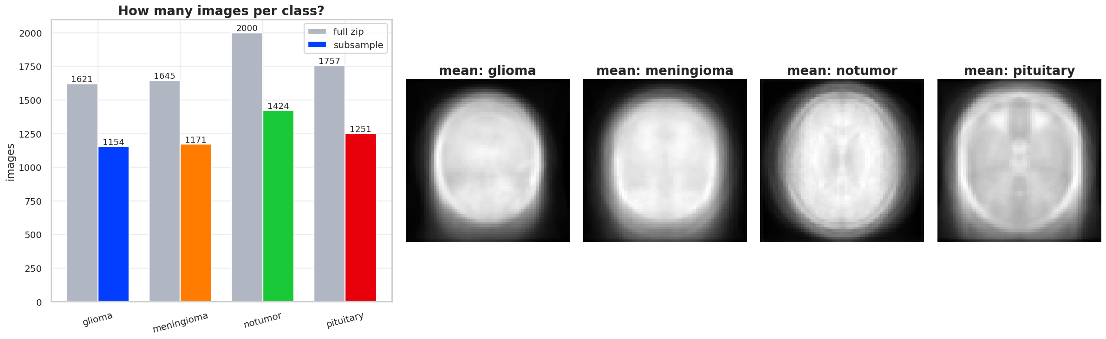
Figure 1: Class counts (left) and the average image of every class (right).
The classes are fairly balanced and the subsample keeps their proportions. The four average images all look like the same head-shaped blob with only small differences, so separating the classes from raw pixels is a hard problem.

4. Methodology and Results

4.1 Association rules (Tasks 1–3)
Task 1 – basket matrix. Apriori needs transactions, so each image is one transaction. Its items are (i) its class (e.g. class=glioma) and (ii) the brightness of each tile of a 4 × 4 grid laid over the image (R00 … R33). A tile’s mean intensity is compared with the same tile in all other images: bottom 20% = dark, top 20% = bright, otherwise normal. This gives 52 possible items (16 tiles × 3 levels + 4 classes) and 17 items per basket; the baskets are one-hot encoded with TransactionEncoder into a 5,000 × 52 matrix.
Task 2 – Apriori. min_support = 0.01, min_confidence = 0.3, itemsets up to 3 items. Result: 12,262 frequent itemsets and 29,735 rules.
Table 2: Top 5 rules by lift.
Antecedent | Consequent | Support | Confidence | Lift
R21=bright, R33=bright | R23=bright | 0.043 | 0.986 | 4.932
R21=bright, R33=bright | R32=bright | 0.043 | 0.982 | 4.909
R21=bright, R30=bright | R32=bright | 0.041 | 0.976 | 4.880
R22=bright, R33=bright | R23=bright | 0.046 | 0.975 | 4.873
R00=dark | R03=dark, R10=dark | 0.135 | 0.675 | 4.863

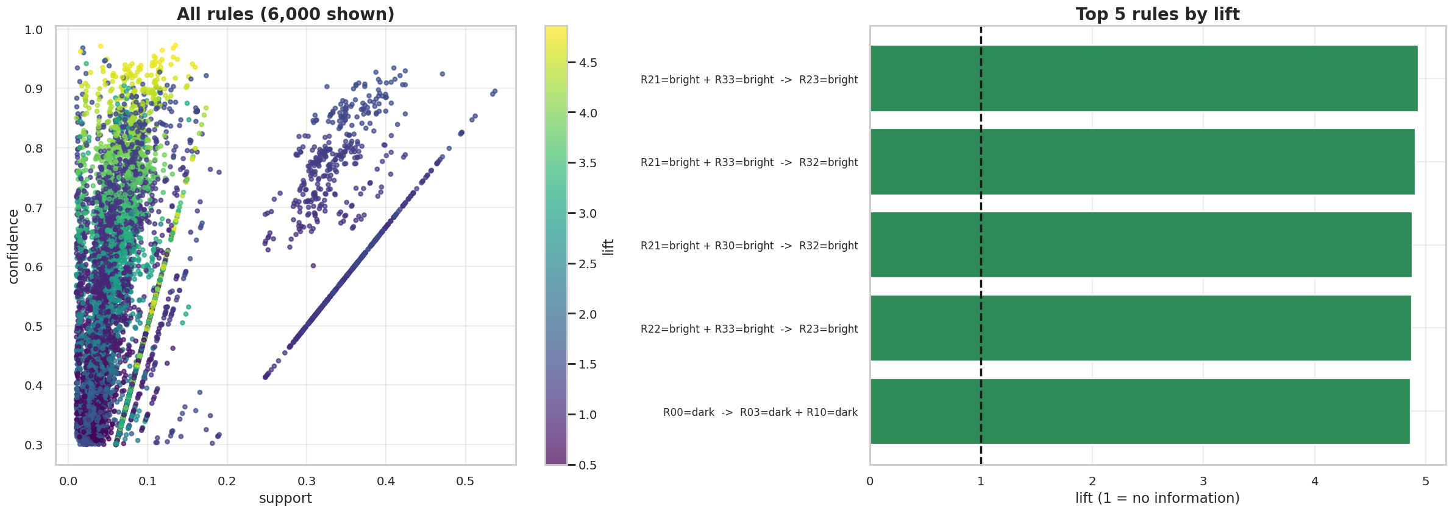
Figure 2: Support–confidence map of all rules (left) and the top 5 rules by lift (right).
Plain-language interpretation. Four of the five rules say: if two tiles are bright, the neighbouring tile is bright too (confidence ≈ 0.98, lift ≈ 4.9, i.e. about five times more likely than by chance). The fifth says: if the top-left tile is dark, the tiles next to it are dark too (confidence 0.68). Bright or dark areas therefore form large connected zones, so these rules describe the overall brightness/exposure of a scan, not the tumour type. They are strong but not useful for diagnosis; at most they could help to spot scans with different exposure.
Table 3: Top 5 rules that predict a tumour class (base rates: glioma 0.23, meningioma 0.23, notumor 0.28, pituitary 0.25).
Antecedent | Consequent | Support | Confidence | Lift
R03=dark, R21=dark | class=glioma | 0.059 | 0.907 | 3.932
R03=dark, R12=dark | class=glioma | 0.060 | 0.893 | 3.871
R00=dark, R21=dark | class=glioma | 0.058 | 0.892 | 3.866
R03=dark, R22=dark | class=glioma | 0.055 | 0.892 | 3.865
R00=dark, R22=dark | class=glioma | 0.053 | 0.887 | 3.843

Interpretation. When two particular tiles are both dark, about 91% of such images are gliomas – roughly 3.9 times the 23% average. This is a useful screening pattern, but it is only an association in a subsample and must not be used as a diagnosis.
Task 3 – high confidence, lift ≈ 1.
Table 4: A high-confidence rule that is not actionable.
Rule | Support | Confidence | Support of consequent | Lift
R23=dark, R32=normal → R02=normal | 0.045 | 0.600 | 0.600 | 1.000

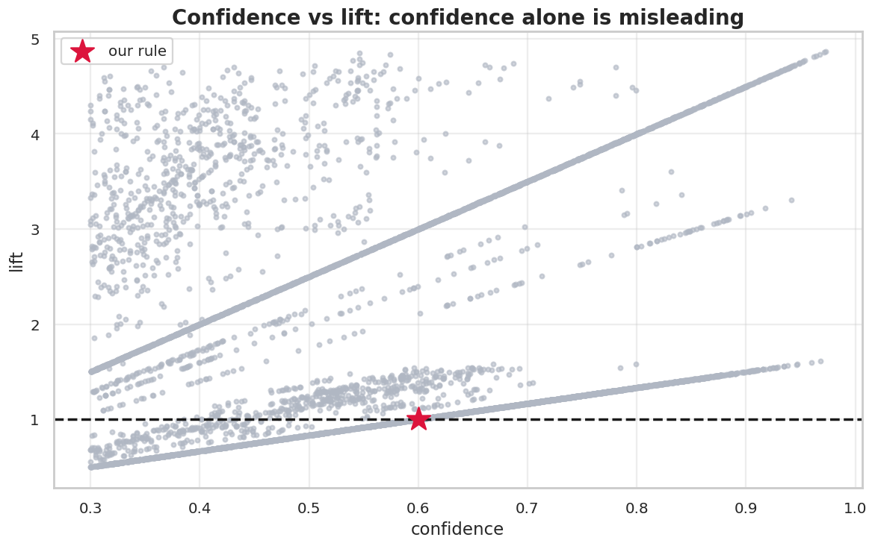
Figure 3: Every rule by confidence and lift; the star is the high-confidence rule with lift ≈ 1.
Why it is not actionable. Confidence is 0.60, but 60% of all images already have R02=normal, so P(R02=normal | antecedent) = P(R02=normal) and the antecedent changes the chance by 0.0 percentage points (lift = 1.00). The rule only reflects that “normal” is a popular item (it covers 60% of images by construction).

4.2 PCA (Tasks 4–5)
Task 4. The 4,096 pixel features were standardised and PCA was fitted. 477 components are needed to retain 95% of the variance (265 for 90%), so about 88% of the dimensions can be removed, but not more: image variance is spread over many directions.
Task 5. PC1 and PC2 explain only 22.3% + 10.8% = 33.1% of the variance. Pituitary images (red) lie mostly in the upper part, notumor images (green) are spread to the right and bottom, while glioma (blue) and meningioma (orange) overlap strongly in the lower left. Two components alone cannot separate the classes.
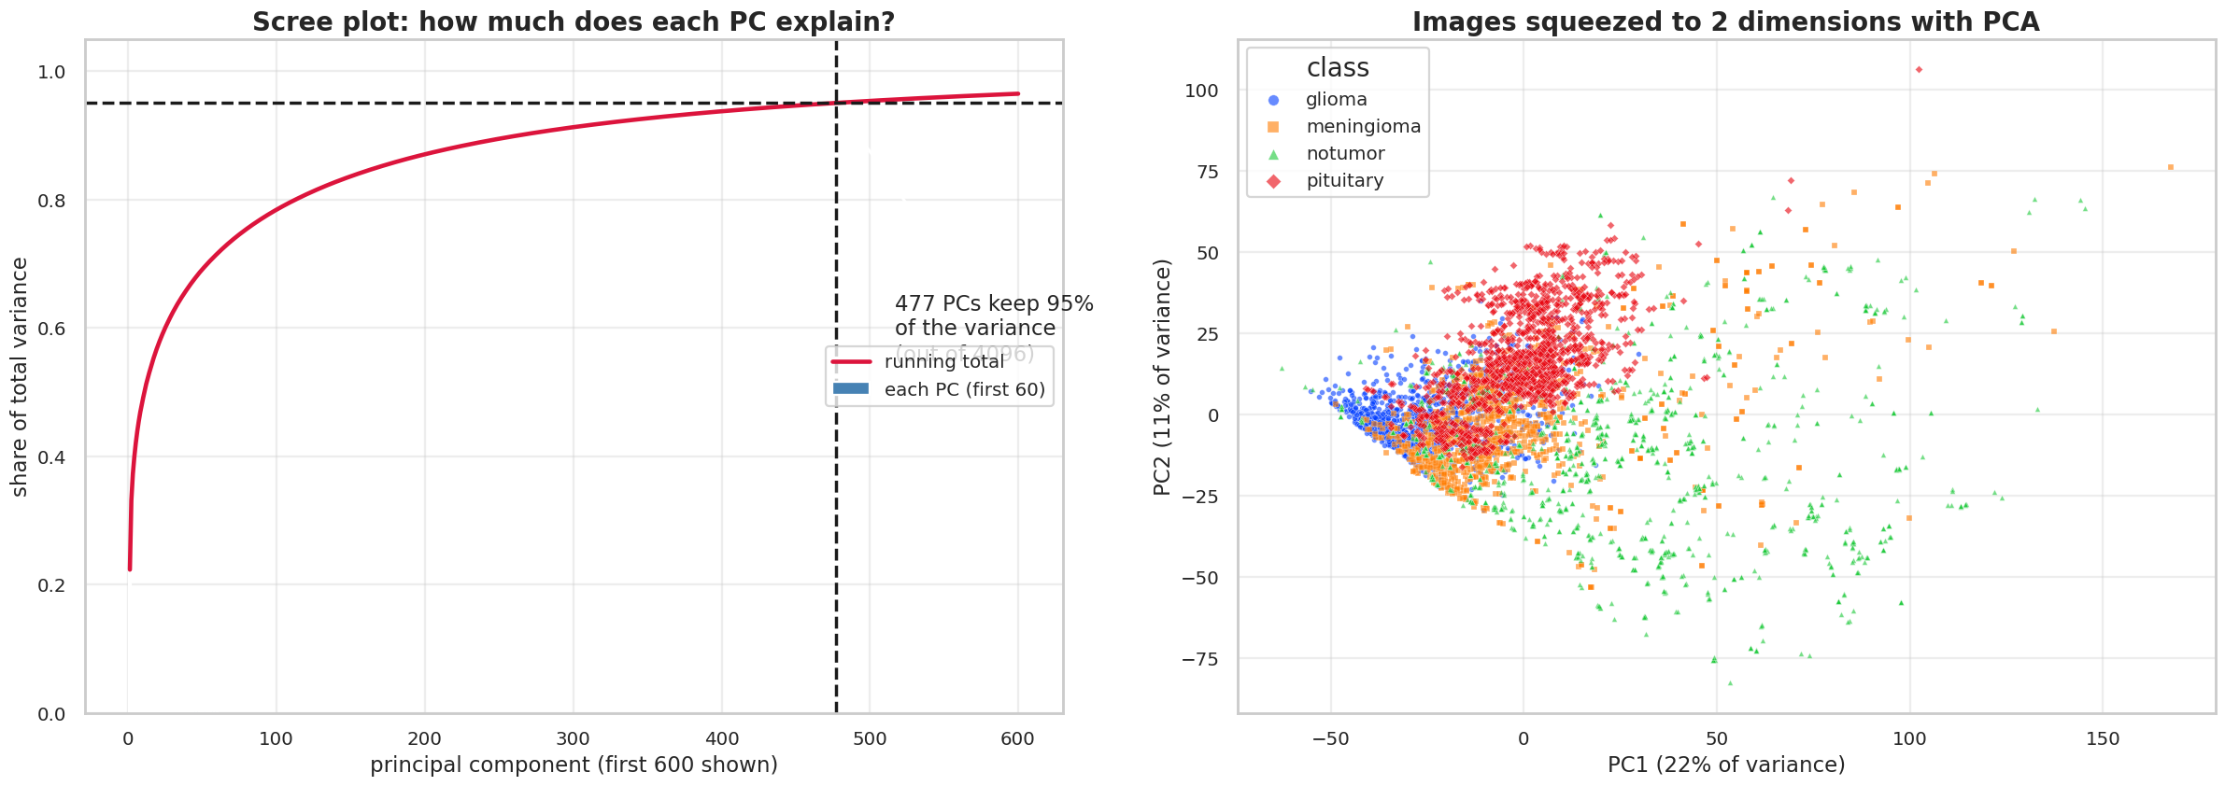
Figure 4: Cumulative explained-variance (scree) curve with the 95% line (left) and the first two principal components coloured by class (right).
Loadings. PC1 is positive almost everywhere, strongest inside the brain, so it is essentially the overall brightness of the scan. PC2 is negative inside the brain and positive around it, so it measures how much of the frame the head fills. The two biggest directions of variance describe exposure and zoom, not tumour type.
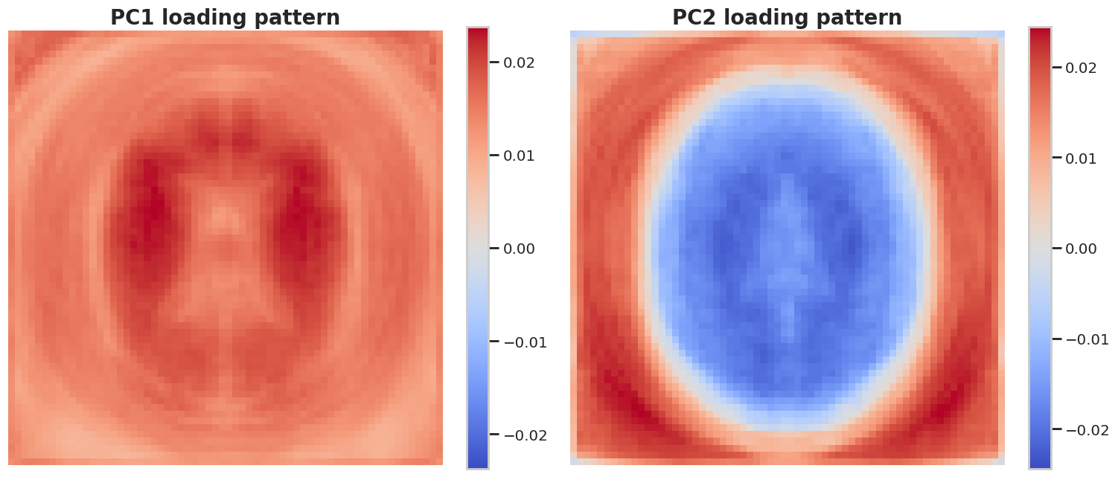
Figure 5: Pixel loadings of PC1 and PC2 (red = positive, blue = negative).

4.3 t-SNE (Task 6)
t-SNE was run with perplexity 5, 30 and 50 (init = PCA, seed 42). For speed it was applied to the first 50 principal components, a standard practice that also reduces noise (117 s in total).
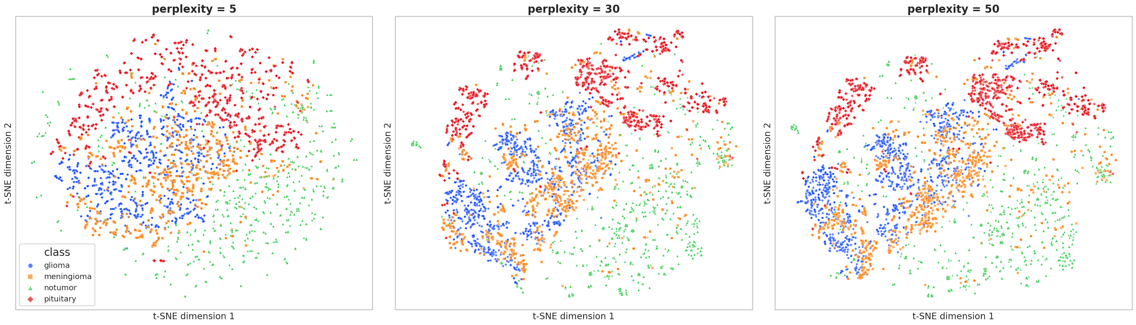
Figure 6: t-SNE maps at perplexity 5, 30 and 50 side by side (axes have no meaning).
Observation. At perplexity 5 the map is a diffuse cloud with small, noisy local groups. At 30 and 50, pituitary images form clear groups, notumor images spread over a wide area, and glioma and meningioma form neighbouring, partly overlapping groups – the same overlap seen in PCA. The shape of the groups changes with perplexity, so distances between groups and group sizes must not be interpreted. t-SNE is used for visualisation only.

4.4 Anomaly detection (Task 7)
The MRI data has no labelled anomalies, so 50 corrupted images (1%) were injected into the 5,000 images, made from random real images: heavy noise, saturated bright, blank/black and heavily blurred (about 12–13 of each, seed 42). Each image was summarised by 7 features: mean, standard deviation, skewness, kurtosis, entropy, edge density and fraction of non-black pixels. The Z-score rule (|z| > 3 on any feature) and Isolation Forest (300 trees, contamination = 0.02) were applied to these features, and the flags are shown on the PCA projection of the pixels.
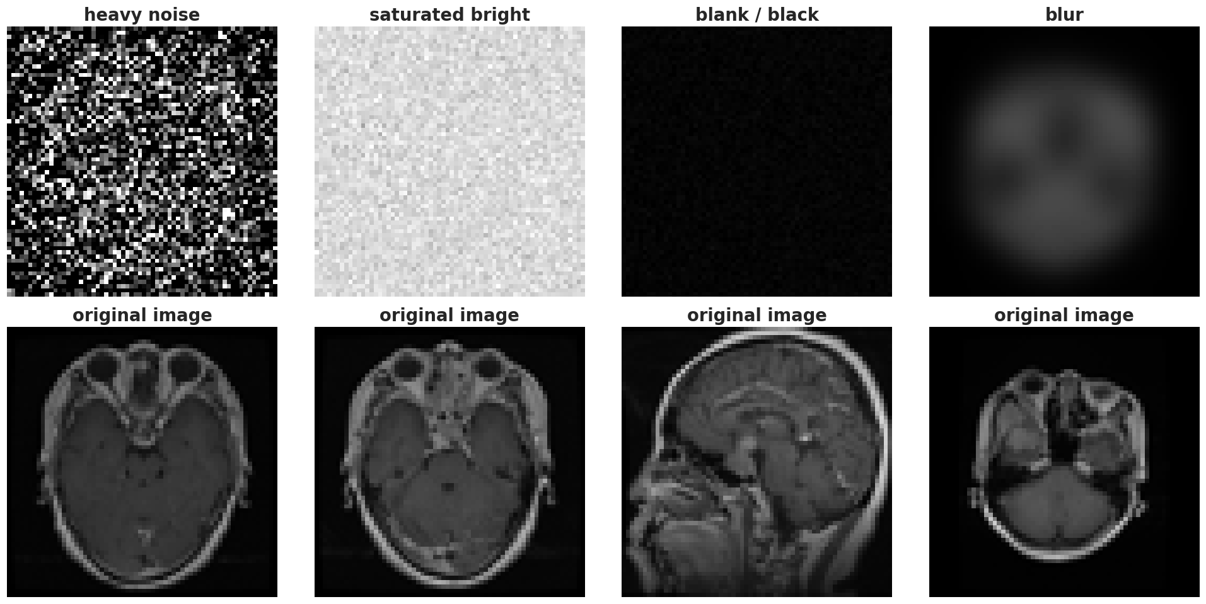
Figure 7: The four kinds of injected anomalies (top) and the real image each was made from (bottom).
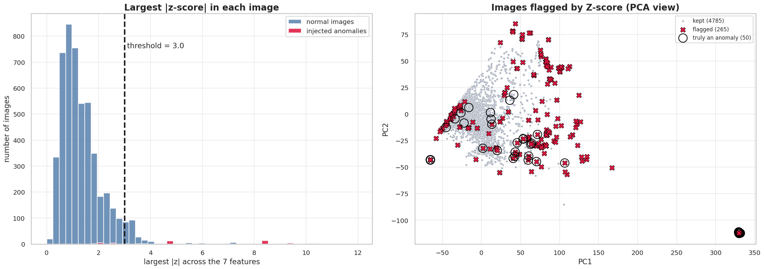
Figure 8: Z-score rule: largest |z| per image (left) and flagged images on the PCA projection (right).
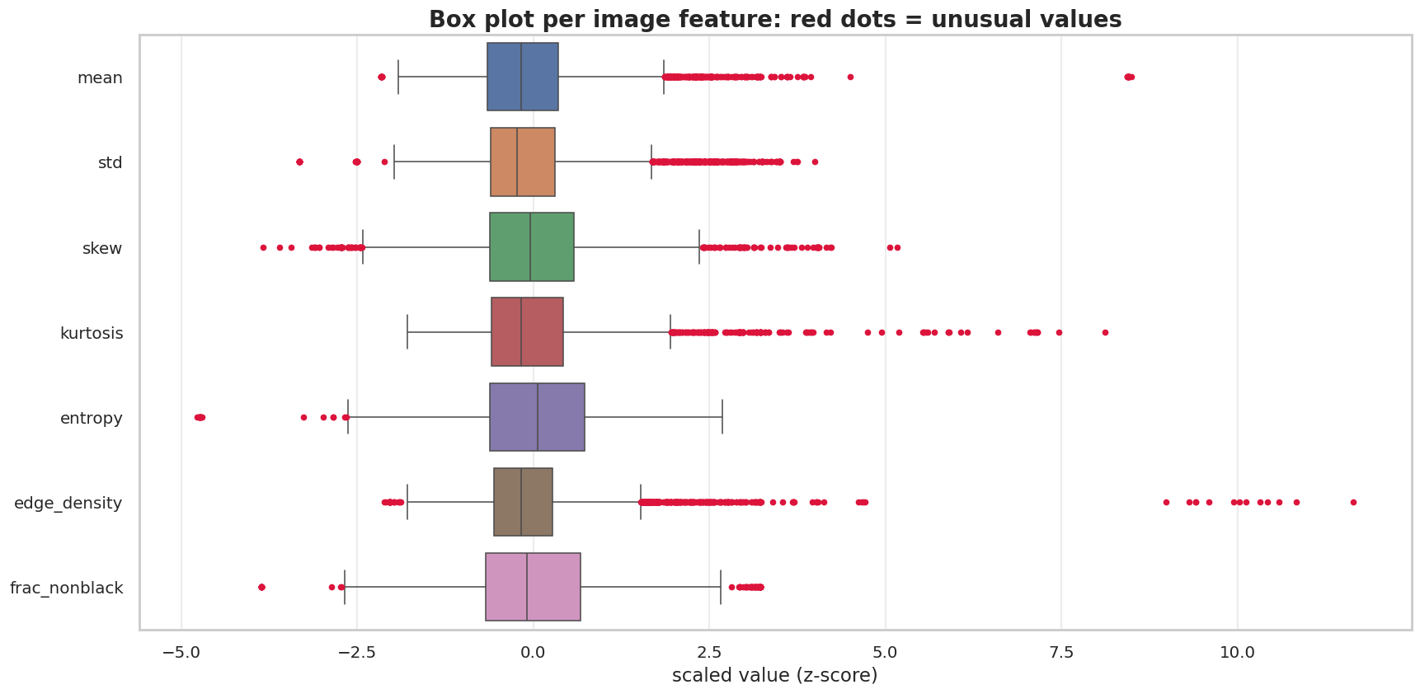
Figure 9: Box plot of the 7 standardised image features; red dots = unusual values, long one-sided tails = skewed data.
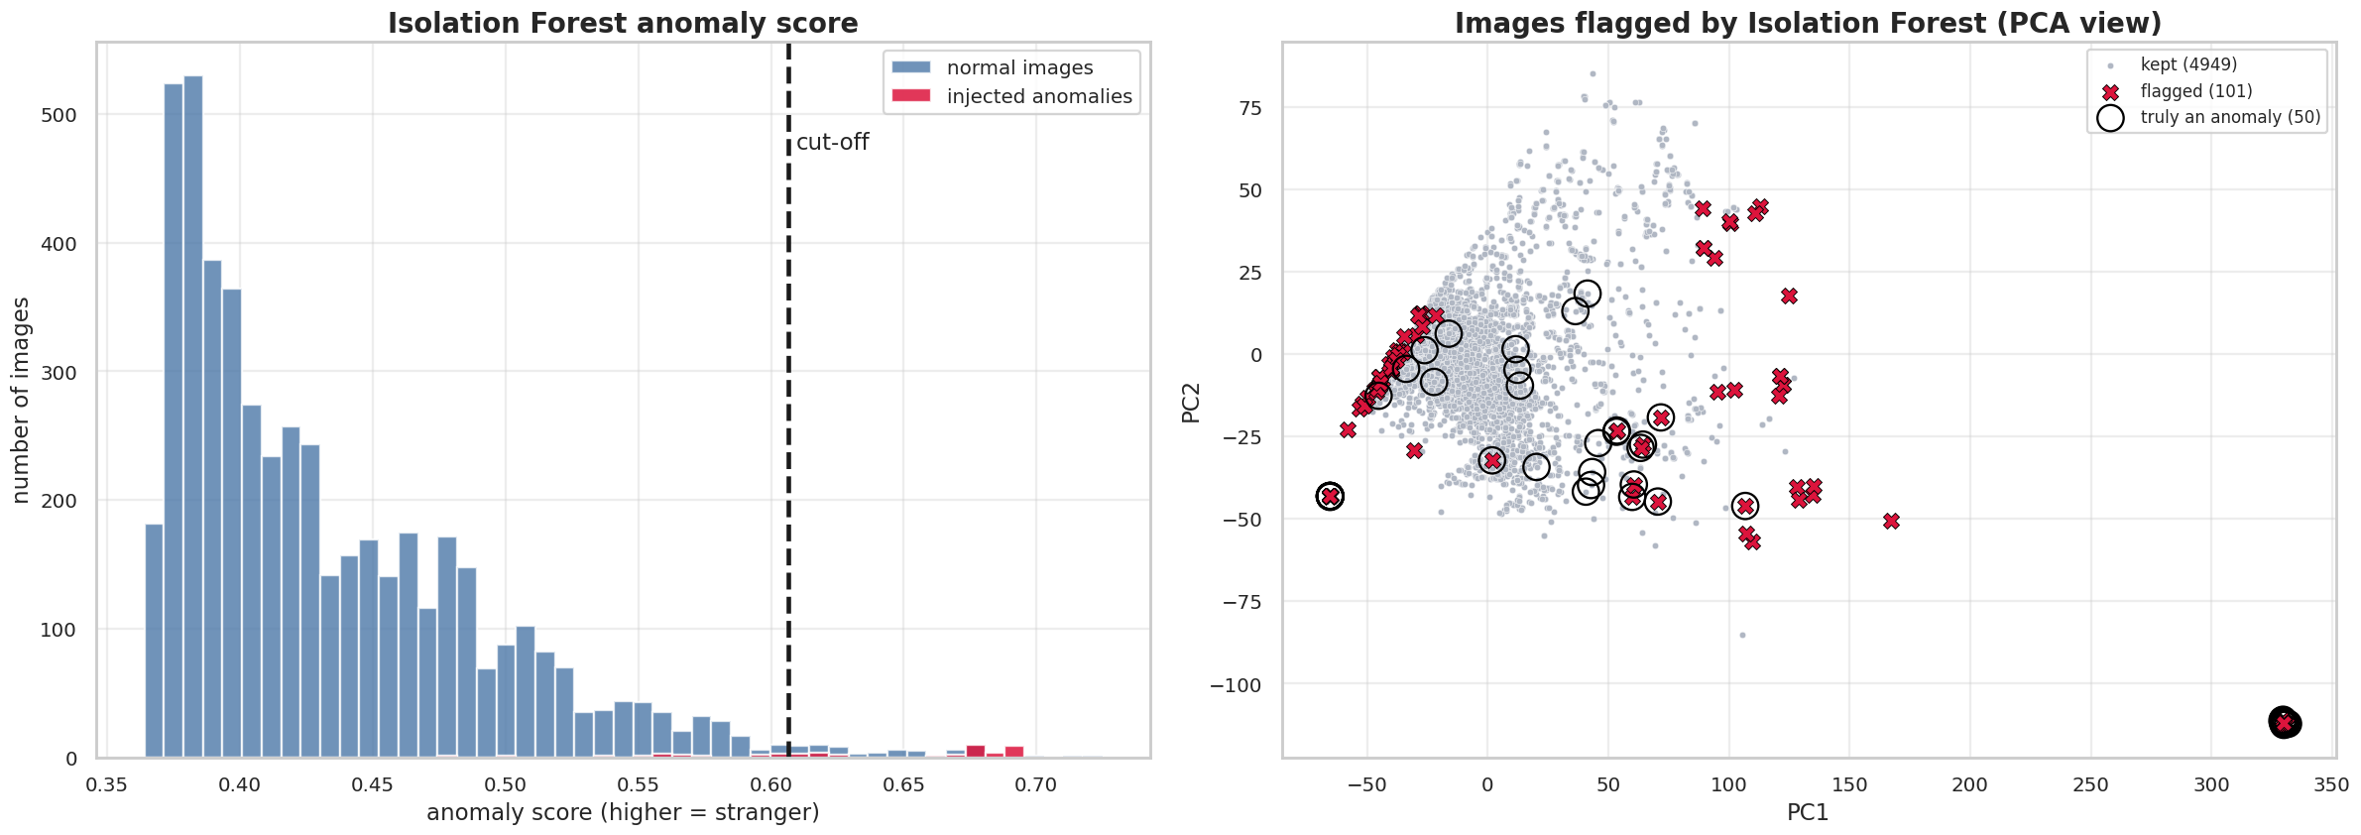
Figure 10: Isolation Forest: anomaly-score histogram (left) and flagged images on the PCA projection (right).
Table 5: Overlap of the two flag sets (rows = Z-score rule, columns = Isolation Forest).
 | IF: not flagged | IF: flagged | Total
Z-score: not flagged | 4,776 | 9 | 4,785
Z-score: flagged | 173 | 92 | 265
Total | 4,949 | 101 | 5,050

Overlap: 92 images flagged by both; 173 only by Z-score, 9 only by Isolation Forest (Jaccard = 0.336).
Table 6: Detection quality against the 50 injected anomalies.
Method | Flagged | TP | FP | FN | Precision | Recall | F1
Z-score | 265 | 41 | 224 | 9 | 0.155 | 0.82 | 0.260
Isolation Forest | 101 | 35 | 66 | 15 | 0.347 | 0.70 | 0.464
Both (AND) | 92 | 35 | 57 | 15 | 0.380 | 0.70 | 0.493
Either (OR) | 274 | 41 | 233 | 9 | 0.150 | 0.82 | 0.253

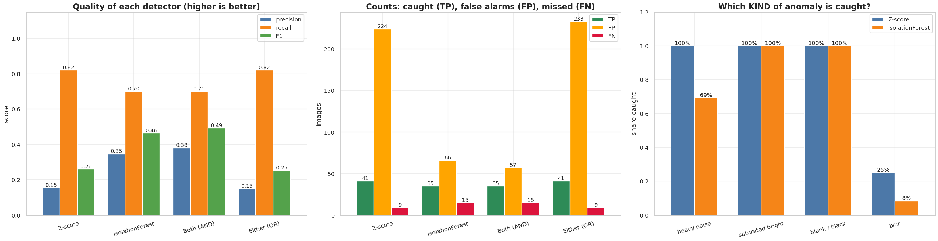
Figure 11: Precision/recall/F1 (left), TP/FP/FN counts (middle) and share of each anomaly kind that is caught (right).
Discussion.
- The Z-score rule has the higher recall (0.82) but flags 224 real images (precision 0.155). The reason is skewness: edge density 3.39, mean 2.37 and kurtosis 1.90 are strongly right-skewed, so ordinary bright or sharp scans lie beyond 3σ.
- Isolation Forest is more selective (66 false alarms, precision 0.347, F1 0.464) but misses more anomalies (recall 0.70). Its number of flags is set by the contamination parameter (2%), not by the data.
- By kind: heavy noise is caught 100% (Z-score) and 69% (IF); saturated-bright and blank images 100% by both; blur only 25% and 8%, because a blurred image looks like a soft real scan in the 7 summary features.
- Requiring both methods (AND) gives the best F1 (0.493); Either (OR) is no better than the Z-score rule alone.

4.5 Classifier on original vs PCA features (Task 8)
The same RBF SVM was trained on an 80/20 stratified split. PCA (95% variance) was fitted on the training split only, so no test information leaked into the reduction.
Table 7: SVM on original vs PCA-reduced features.
Features | No. of features | Test accuracy | Macro-F1 | Training time (s) | PCA fit time (s)
Original pixels | 4,096 | 0.887 | 0.881 | 14.1 | –
PCA 95% | 459 | 0.886 | 0.880 | 1.5 | 14.4

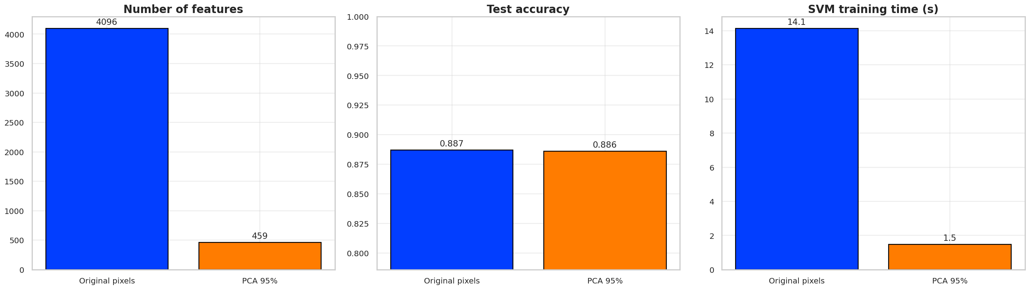
Figure 12: Number of features, accuracy and training time for original vs PCA features.
Discussion. Reducing 4,096 features to 459 (89% fewer) changes accuracy by only 0.001 and cuts SVM training from 14.1 s to 1.5 s. PCA fitting itself took 14.4 s, so for a single model there is almost no net time saving; the benefit appears when the same PCA is reused for many models or new images. (459 components here versus 477 in Section 4.2, because the PCA here is fitted on the training split only.)

5. Analysis Questions

Question 1
A rule {bread} → {milk} has confidence 0.72 and lift 1.02. Should the supermarket act on it?
Step-by-step
Support(milk) = confidence / lift = 0.72 / 1.02 = 0.706.
Bread buyers buy milk 72% of the time; all customers buy milk 70.6% of the time.
Increase = 0.72 − 0.706 = only 1.4 percentage points; lift 1.02 ≈ 1 means almost independent.

Answer: No. The high confidence is caused by milk being popular, not by bread. A promotion or shelf placement based on this rule would hardly change behaviour. Our Table 4 rule shows the same pattern (confidence 0.60 = base rate 0.60, lift 1.00).

Question 2
PCA keeps 95% of the variance with 12 of 64 components, yet accuracy drops. Why does variance retention not guarantee discriminative power?
PCA is unsupervised: it keeps the directions of largest variance without looking at the class labels. The variance that is kept may come from factors unrelated to the classes, while the 5% that is discarded may contain exactly the small differences that separate them. In our data the two largest PCs describe overall brightness and how much of the frame the head fills (Figure 5), not tumour type. A supervised method (LDA) or checking the classifier’s accuracy on the reduced data is needed.

Question 3
Why does the Z-score rule flag many legitimate rows on a right-skewed variable such as income, and what would you use instead?
A right-skewed variable has a long tail of legitimate large values. The tail inflates the standard deviation and pulls the mean, and the Z-score rule assumes a symmetric, roughly normal shape, so many ordinary large values exceed |z| > 3 and are flagged. Our own result shows this: the skewed image features made the Z-score rule flag 224 real images, against 66 for Isolation Forest.
Better choices: (i) log-transform the variable and then apply the Z-score rule; (ii) a robust rule such as the modified Z-score (median and MAD, threshold 3.5) or the IQR rule; (iii) a multivariate, distribution-free method such as Isolation Forest or LOF.

6. Conclusion
- Apriori on tile-brightness baskets found 29,735 rules. Neighbouring tiles share brightness (lift ≈ 4.9), and two dark tiles predict glioma with confidence 0.91 (lift 3.9). A rule with confidence 0.60 and lift 1.00 shows why confidence alone is misleading.
- PCA needs 477 of 4,096 components for 95% variance; PC1 + PC2 cover only 33.1% and do not separate glioma from meningioma. t-SNE shows local structure but is for visualisation only.
- Z-score caught 41/50 and Isolation Forest 35/50 injected anomalies, but the Z-score rule produced many more false alarms on skewed features (precision 0.155 vs 0.347); both almost missed blurred images.
- An SVM on 459 PCA components achieved the same accuracy (0.886 vs 0.887) as on 4,096 pixels, with about 10 times shorter training time.

Limitations
- The anomalies are injected (synthetic corruptions), so the detection scores show behaviour on obvious artefacts, not on real clinical anomalies.
- A 5,000-image subsample at 64 × 64 resolution was used; Apriori items depend on the 20%/80% thresholds and the 4 × 4 grid, and the dataset has no transaction data, so baskets were derived from image tiles; results come from one random split and seed.

