 East West University
LAB REPORT
Experiment 4

Unsupervised Learning I: Clustering Techniques
Course: Machine Learning
Course Code : cse475
Section: 05
Submitted by: Monika Asha Momo
Student ID: 2023-1-60-180
Submitted to:
Dr. Md. Tauhid Bin Iqbal
Department of Computer Science & Engineering

Submission Date: 26.10.26

1. Objective
The objective of this experiment is to apply and compare unsupervised clustering methods on the Mall Customers dataset, understand the effect of feature standardisation, select a reasonable number of clusters using the elbow and silhouette methods, compare centroid- and medoid-based clustering, examine agglomerative linkage strategies, tune DBSCAN, visualise clusters with PCA, and compare K-Means with DBSCAN on the non-convex make_moons dataset.

2. Dataset and Tools
The notebook uses the Mall Customers dataset with 200 records and five original columns: CustomerID, Gender, Age, Annual Income (k$), and Spending Score (1–100). CustomerID and Gender are excluded; the three numeric features Age, Annual Income (k$), and Spending Score are used for clustering. The notebook reports zero missing values.
Tools and libraries: Python, NumPy, pandas, Matplotlib, SciPy, and scikit-learn. The random seed is fixed at 42. Numeric features are transformed using StandardScaler.

3. Methodology / Procedure
- Load the dataset and select Age, Annual Income (k$), and Spending Score.
- Standardise the three features with z-score scaling.
- Run K-Means for k = 2 through 10, recording WCSS and silhouette score; select k using the highest silhouette score and cross-check the elbow.
- Run K-Medoids at the selected k and compare medoids with K-Means centroids.
- Run agglomerative clustering with single, complete, and average linkage; inspect dendrograms and cophenetic correlation.
- Use the k-distance plot to guide DBSCAN parameter selection. The notebook uses min_samples = 6 and eps = 0.55.
- Use PCA to project the standardised data to two dimensions for visual comparison.
- Compare clusterings using WCSS, silhouette, Davies–Bouldin, and Dunn indices. For DBSCAN, noise points are excluded from the scores and coverage is reported.
- Generate 500 make_moons samples with noise 0.05 and random_state 42, standardise them, and compare K-Means (k=2) with DBSCAN (eps=0.2, min_samples=5).

4. Results and Discussion

4.1 Feature Standardisation
Feature | Mean (raw) | Std. dev. (raw) | Minimum | Maximum
Age | 38.85 | 13.97 | 18 | 70
Annual Income (k$) | 60.56 | 26.26 | 15 | 137
Spending Score (1–100) | 50.20 | 25.82 | 1 | 99

After standardisation, each feature has a mean approximately equal to 0 and standard deviation equal to 1. The notebook reports an Adjusted Rand Index (ARI) of 0.602 between K-Means on raw and scaled data at k=5, showing that scaling materially changes the assignments. Distance-based methods are sensitive to feature scale: a feature with a wider numeric range can dominate distance. Decision trees generally do not have this problem because threshold splits depend on feature ordering.
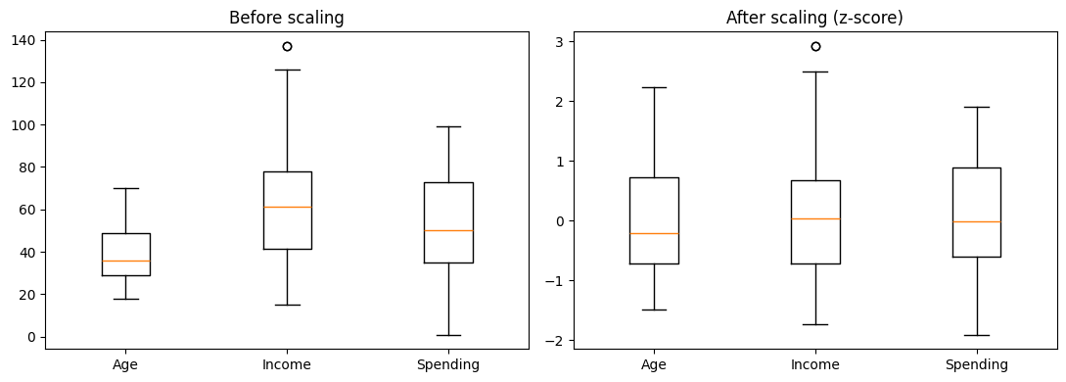
Figure 1. Feature distributions before and after z-score standardisation.

4.2 K-Means: Elbow and Silhouette
k | WCSS | Silhouette
2 | 389.39 | 0.3355
3 | 295.21 | 0.3578
4 | 205.23 | 0.4040
5 | 168.25 | 0.4166
6 | 133.87 | 0.4284
7 | 117.01 | 0.4172
8 | 103.87 | 0.4082
9 | 93.09 | 0.4177
10 | 82.39 | 0.4066

WCSS decreases as k increases, as each additional cluster gives the model more flexibility to fit the observations. The automatic elbow estimate is k=4, while the highest silhouette score occurs at k=6 (0.4284). Following the notebook's stated rule, k=6 is selected, with the elbow result used as a cross-check rather than a strict answer.
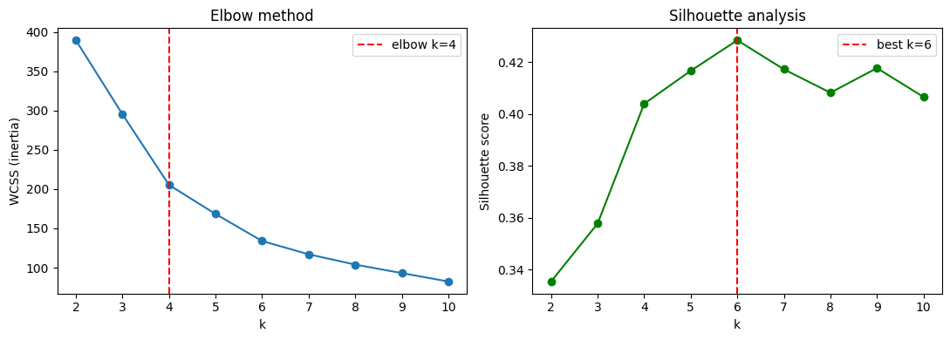
Figure 2. Elbow curve (WCSS) and silhouette score for k = 2–10.

4.3 K-Means versus K-Medoids
Comparison | Result
Selected k | 6
Adjusted Rand Index (labels) | 0.708
K-Means cluster sizes | 45, 39, 33, 39, 23, 21
K-Medoids cluster sizes | 24, 39, 25, 35, 32, 45
Interpretation | K-Means centres are means; K-Medoids centres are actual observations (medoids).

The ARI of 0.708 indicates substantial, but not identical, agreement between the two partitions. A centroid can lie between observations and may be pulled by extreme values. A medoid is an actual customer record and is typically more robust to outliers. The notebook's matched centres are generally near each other, although one matched pair has a larger scaled distance of 1.239.

4.4 Agglomerative Clustering
Linkage | Cluster sizes (k=6) | Cophenetic correlation | Final merge height
Single | 2, 2, 193, 1, 1, 1 | 0.542 | 1.08
Complete | 39, 35, 57, 21, 32, 16 | 0.593 | 5.99
Average | 39, 52, 4, 31, 54, 20 | 0.668 | 2.72

Single linkage joins clusters according to the closest pair of points and exhibits the chaining effect: 193 observations fall into one cluster while the remaining clusters are tiny. Complete linkage uses the farthest pair and produces more compact groups. Average linkage uses average inter-cluster distance and gives the highest cophenetic correlation (0.668) among the three in this run.
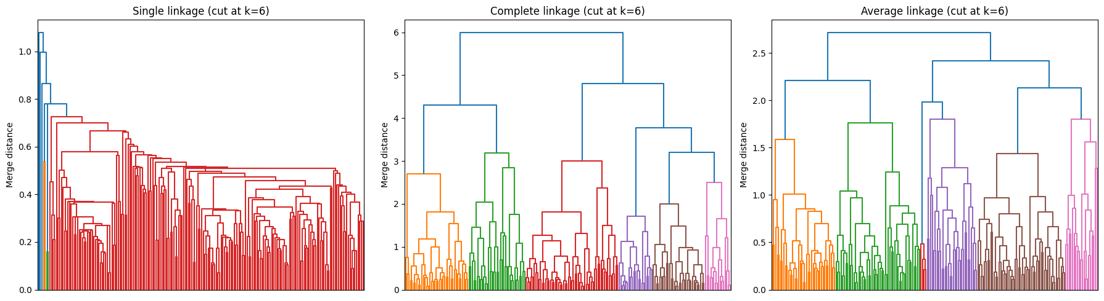
Figure 3. Dendrograms for single, complete, and average linkage.

4.5 DBSCAN and Noise
Parameter / outcome | Value
min_samples | 6
Automatic k-distance knee estimate | 0.786 (not used because it was judged too large)
Chosen eps | 0.55
Clusters found | 5
Noise points | 55 / 200 (27.5%)
Retained coverage | 72.5%

The selected DBSCAN settings identify five clusters and mark 55 observations as noise. The notebook's actual run reports 27.5% noise, rather than 40% as stated in Analysis Question 3; the question is answered hypothetically in Section 5. DBSCAN's eps parameter controls neighbourhood radius, while min_samples controls how many nearby points are needed to establish a dense region.
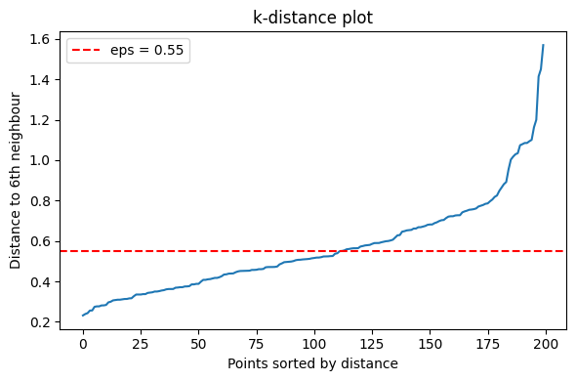
Figure 4. Sorted k-distance plot used to guide the DBSCAN eps choice.

4.6 PCA Visualisation
PCA reduces the three standardised features to two components for plotting. The explained variance ratios are 0.443 and 0.333, for a total of 0.776 (77.6%). Thus, the 2D plot retains most, but not all, of the variation in the three-feature dataset.
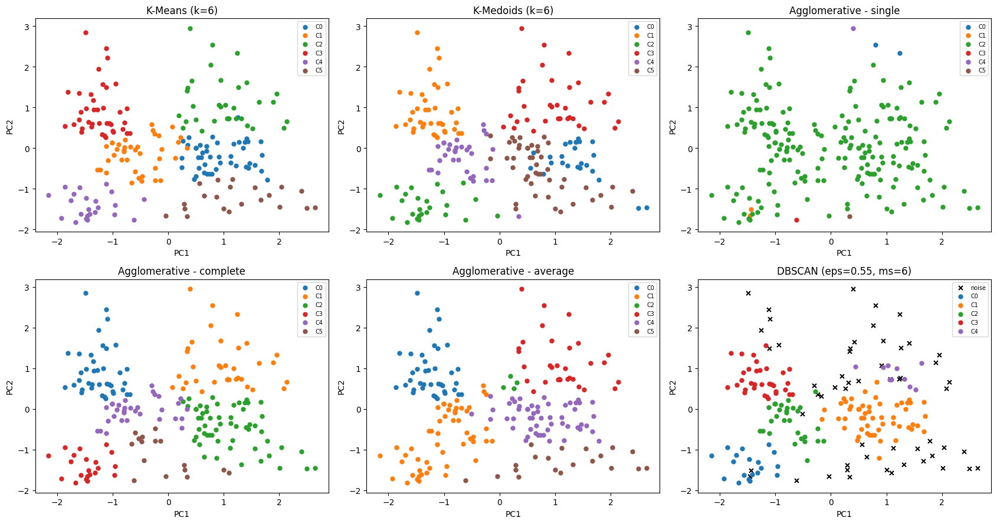
Figure 5. PCA 2D projections coloured by the cluster labels from each algorithm.

4.7 Evaluation Metrics
Algorithm | Clusters | Coverage % | WCSS | Silhouette | Davies–Bouldin | Dunn
K-Means (k=6) | 6 | 100.0 | 133.87 | 0.428 | 0.825 | 0.062
K-Medoids (k=6) | 6 | 100.0 | 147.39 | 0.379 | 0.943 | 0.059
Agglomerative – single | 6 | 100.0 | 550.68 | -0.043 | 0.637 | 0.130
Agglomerative – complete | 6 | 100.0 | 157.07 | 0.375 | 1.000 | 0.105
Agglomerative – average | 6 | 100.0 | 165.30 | 0.390 | 0.865 | 0.122
DBSCAN (eps=0.55, ms=6) | 5 | 72.5 | 66.20 | 0.484 | 0.686 | 0.168

Lower WCSS and Davies–Bouldin are generally preferred; higher silhouette and Dunn values are generally preferred. K-Means has the strongest silhouette among the Mall Customers K-Means/K-Medoids/agglomerative results, while DBSCAN has the highest silhouette and Dunn values in this table but retains only 72.5% of the observations. DBSCAN scores therefore must be interpreted together with its coverage. WCSS is computed using each cluster's mean for consistency across algorithms. The Dunn index is defined here as the minimum distance between points in different clusters divided by the maximum within-cluster diameter.

4.8 K-Means versus DBSCAN on make_moons
Method | ARI vs. true labels | Clusters | Coverage % | Silhouette | Davies–Bouldin | Dunn
K-Means (k=2) | 0.445 | 2 | 100.0 | 0.496 | 0.811 | 0.023
DBSCAN | 1.000 | 2 | 100.0 | 0.389 | 1.018 | 0.223

DBSCAN achieves an ARI of 1.000 against the generated ground-truth labels, while K-Means achieves 0.445. The two make_moons clusters are curved crescents, not compact spherical groups. K-Means assigns points according to distance from centroids and tends to divide the moons with a roughly straight boundary. DBSCAN groups density-connected points and can recover clusters with arbitrary shapes.
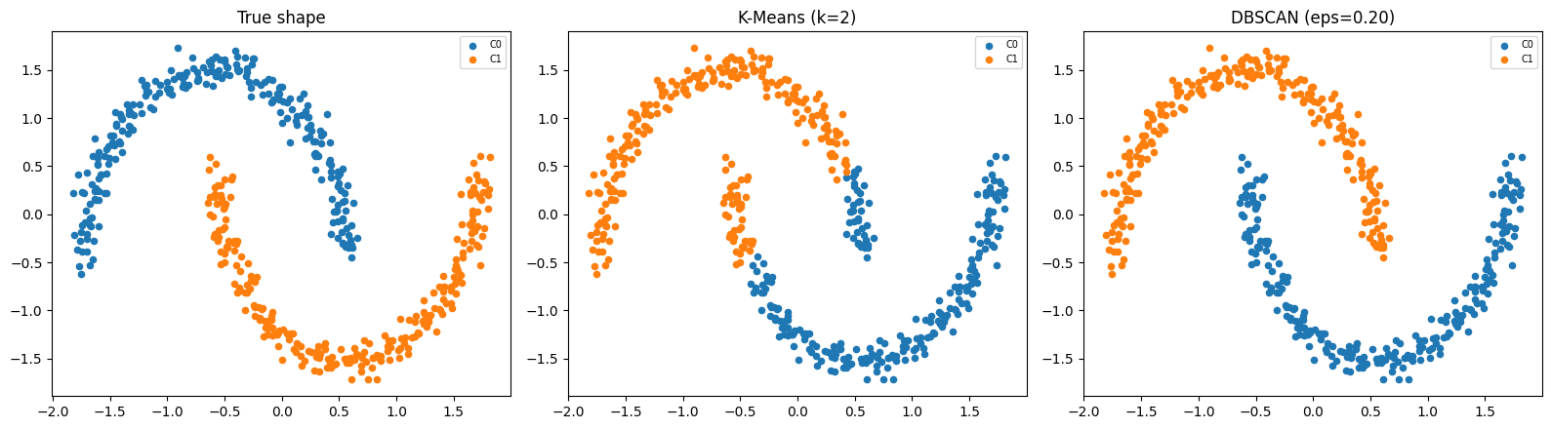
Figure 6. Ground-truth make_moons labels compared with K-Means and DBSCAN.

5. Analysis Questions

1. WCSS always falls as k grows, so why can it still be used to choose k?
WCSS is useful because the important signal is not that it decreases, but how quickly it decreases. At first, adding clusters often reduces WCSS substantially. After a certain point, each extra cluster produces only a small improvement. The elbow method looks for this bend, where diminishing returns begin. WCSS should not be used alone; it is helpful to cross-check the elbow with silhouette score and domain needs.

2. On make_moons, K-Means fails and DBSCAN succeeds. Explain the reason in terms of the shape assumption each algorithm makes.
K-Means represents each cluster by a centroid and assigns each point to its nearest centroid. This favours roughly spherical or convex clusters separated by straight Voronoi boundaries. The make_moons dataset has two interleaving crescent shapes, so K-Means cuts across the curves and mixes the two groups. DBSCAN groups points that are connected through sufficiently dense neighbourhoods; it does not require circular clusters and can follow the curved moons. In this run, DBSCAN's ARI is 1.000 versus 0.445 for K-Means.

3. Your DBSCAN run labels 40% of the points as noise. Name two parameter changes that would reduce that, and the risk each one carries.
First, increase eps so each point has a larger neighbourhood and more points can become density-reachable. Risk: nearby clusters may merge, and some outliers may be absorbed into clusters. Second, decrease min_samples so fewer neighbours are required for a point to be considered a core point. Risk: sparse areas and random outliers may be accepted as clusters, making the result more sensitive to noise. These are general parameter effects for the hypothetical 40% noise case; the attached notebook's actual Mall Customers run reports 27.5%.

6. Conclusion
This experiment demonstrates that standardisation is essential for fair distance-based clustering and that different algorithms produce different partitions even on the same data. The elbow suggested k=4, but the notebook selected k=6 because it achieved the highest silhouette score. K-Medoids produced a reasonably similar partition to K-Means while using actual observations as representatives. Single linkage showed severe chaining, whereas complete and average linkage produced more balanced cluster sizes. DBSCAN identified five clusters and marked 27.5% of the Mall Customers observations as noise. Finally, the make_moons experiment illustrated the key strength of density-based clustering: it can recover non-convex shapes that centroid-based K-Means struggles to represent.

