**Spring Boot REST Basics**

In Spring Boot, builtin Web Server - Tomcat is used, and default port is 8080 (Port number can be changed from **application.properties** file, using **server.port**)

REST is Request/Response based

REST stands for REpresentational State Transfer

REST API uses HTTP(Hyper Text Transfer Protocol)

REST & HTTP are stateless

REST is Platform independent, Language independent

REST is used to develop distributed Software Systems

Spring Boot App can be created from Spring Initializr <https://start.spring.io>

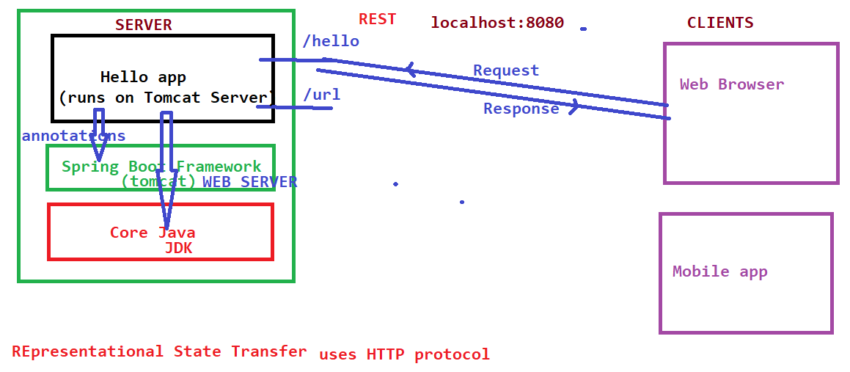

REST is used to build/develop SOA – Service Oriented Architecture

**HTTP Methods:**

Any Business enterprise application may need to perform CRUD operations on the Resources. For example Ticket Booking, Insurance Portal, etc… To facilitate such Use Cases various HTTP Methods are provided.

For example consider Ticket as Resource

1. Book a new Ticket - POST Method
2. Fetch Ticket details - GET Method
3. Cancel a Ticket - DELETE method
4. Update Ticket - PUT method

Below Http methods are used to perform CRUD operations

GET Method – to perform Read operations - @GetMapping

POST Method – to perform Create - @PostMapping

PUT Method – to perform Update - @PutMapping

DELETE Method – to perform Delete - @DeleteMapping

Web Client and Web Server/App interaction has Http Request and Http Response

In Spring Boot application, all REST End points need to be provided in a class annotated with @RestController

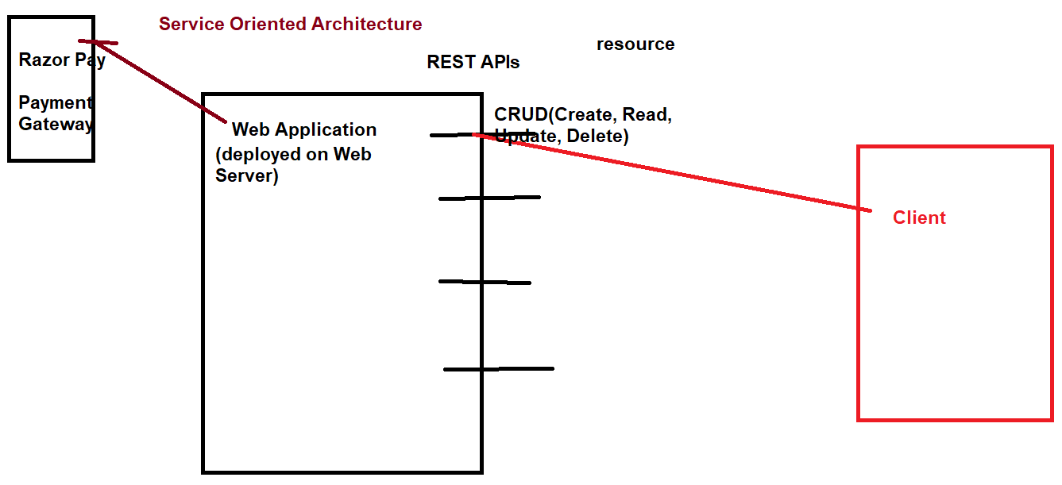

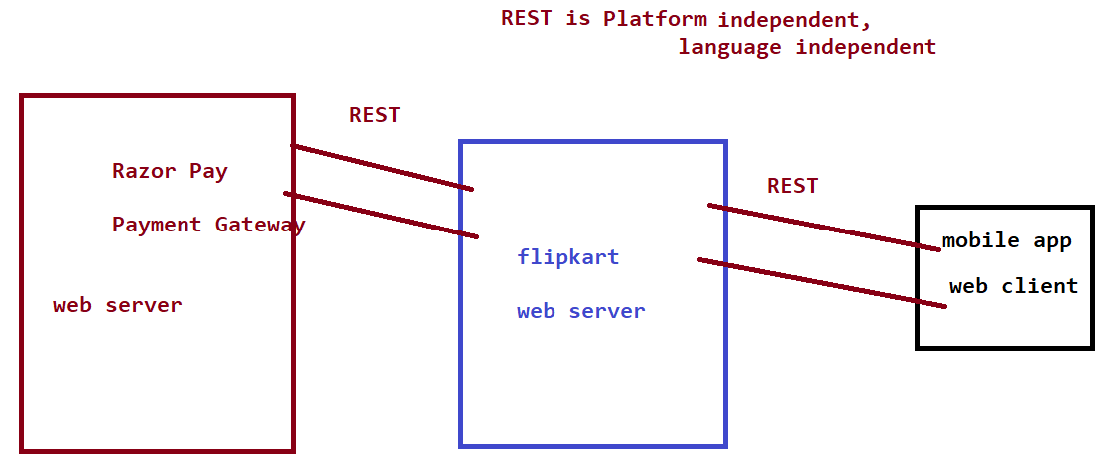

**What Http Request can have:**

url(link) may include port number

Headers

Cookie(s)

Which Http method

Query Parameters(www.xyz.com/mnop?a=b&c=d&e=f),

Path Parameters(www.xyz.com/mnop/val1/val2)

Http request can have Header & Body(additional data may be in JSON format)

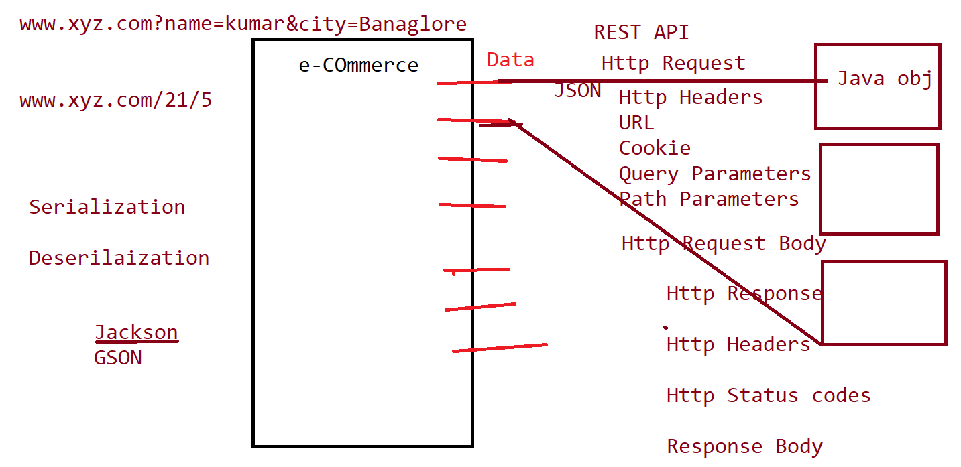

**What Http Response can have:**

1. Http Status code - provides information if request has been processed successfully or not.

Below are various Http Status Codes

2NN – success, request is being served

3NN - redirection

4NN – (url)resource not found, unauthorized/forbidden

5NN - Exception or internal server error

1. Header
2. Cookie
3. Http Response body(may be in JSON format. For eg. All tickets of a specific passenger)

Sample Built-in Headers:

Content-Type: application/json

MIME Type(Multipurpose Internet Mail Extension)

Can there be multiple RestControllers in single application?

Yes

Can multiple rest end points use same Http method?

Yes

Can multiple rest end points use same url, each with different http method?

Yes

Two different rest end points with same url and using same Http method?

Bean

Dependency Injection

Serilization: Converting Java object to JSON/XML

Deserilization: Converting JSON/XML back to Java object

**Spring Boot Application Architecture:**

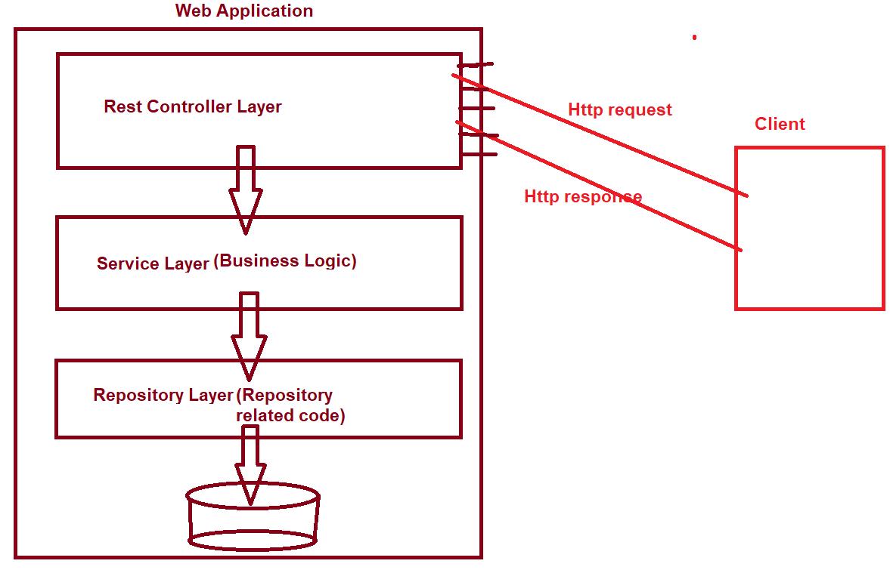

Web Application should be divided into Controller, Service, Repository Layers

Controller Layer: includes REST API related code only

Service Layer: includes Business Logic, should not have direct DB interaction or REST related code

Repository Layer: includes repository/database interaction related source code only

To run Project from command line

mv spring-boot:run