


Client-Side Development
Coursework Two
Module Code (CRN): COM109 (65807)
Module Coordinator:
Lecture:

Student Name: Washif Hasan Piyal
Student Id:
Bo Number:
GitHub Repository Link: https://github.com/Gaurav97697/Cline-Slide-Dev-CW2

1. Introduction
As a client-side development project team member, I specifically focused on creating the Home and About Us pages, including all the relevant JavaScript features needed for them. For the Home page, I designed a sticky navigation header and incorporated responsive call-to-action buttons. In addition, I implemented a Hero Section that was visually appealing so that it would capture the user’s attention while providing easy navigation. On the About Us page, I organized the content to include three distinct sections Our Story, Meet the Team and Customer Testimonials so that the brand identity, the team identity, and the customer experience were all articulated clearly.

2. Implementing Home page
The most important part of our website’s home page is the Header Section. This header is actually the main navigation hub of the entire website. I designed it to be sticky, so that no matter how far the user scrolls down, the header is always visible at the top. This allows users to easily access the navigation menu and important buttons at any time.
Home page html code:
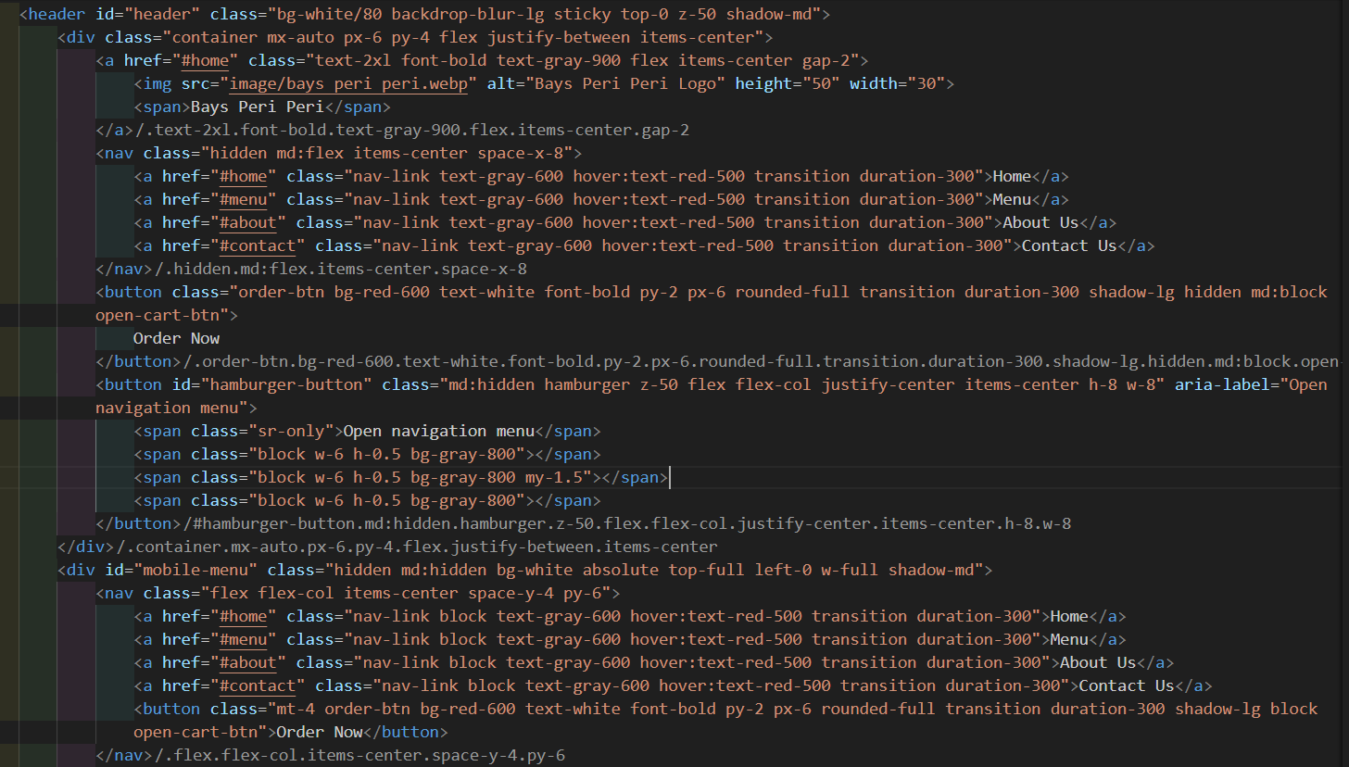
I have organized the header into three main sections. First, I have placed the logo on the left side in the Logo and Branding section using an image tag. The name “Bays Peri Peri” is placed in bold text next to the logo, so that the brand identity is clearly understood.
Second, in the middle is the Navigation Menu. Here I have placed four links: Home, Menu, About Us, and Contact Us. I have used Tailwind CSS’s hover effect on each link. As a result, the text color will turn red when the user hovers over it. This gives the user an interactive visual experience. In addition, I have used the hidden md:flex class to keep this menu section visible only on medium and large screens.
Third, I have placed a Call-to-Action button on the right side “Order Now”. It’s a round red button with bold text. I’ve made the button more attractive by using a rounded border, shadow effect, and transition. The purpose of this button is to encourage users to order quickly, which directly helps increase conversions.
Finally, I’ve also looked at Responsive Design. I’ve added a separate hamburger button (md:hidden) for mobile screens. When the user clicks on the hamburger icon, a dropdown menu opens. That dropdown again has the same four links and a separate “Order Now” button. This makes it easy for users to navigate and order even on small screens.
Right after the header, I’ve created a Hero Section at the beginning of the homepage. The main purpose of this section is to grab the user’s attention and clearly highlight the main message of our brand.

Home page html code:
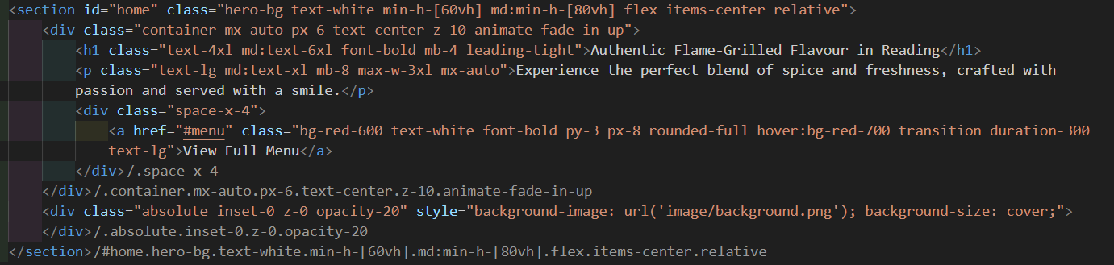
Inside the Hero Section, I’ve used a large heading <h1> that says “Authentic Flame-Grilled Flavour in Reading”. I’ve designed the heading in large (text-4xl and md:text-6xl) and bold, so that it stands out. Below this, I have added a paragraph <p> that highlights the features of our food: “Experience the perfect blend of spice and freshness, crafted with passion and served with a smile.” This text is written in an emotional and attractive way for the users.
Then I have added a Call-to-Action Button, which says “View Full Menu”. I have used bg-red-600 and hover:bg-red-700 in the design of this button, so that the color of the button changes when the mouse is moved. I have also added rounded-full, font-bold, px-8 py-3 and transition effect to make the button more visually beautiful and attractive. The main purpose of this button is to take the user directly to the Menu Section.
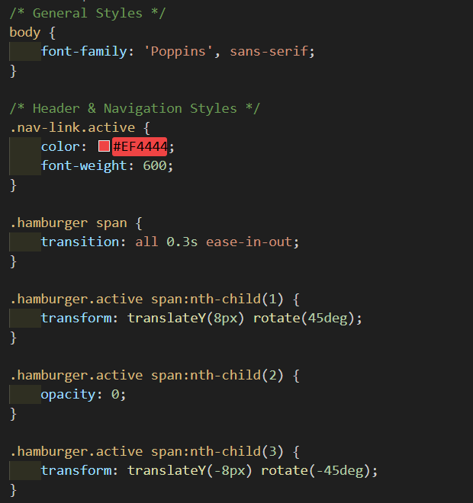
In the background of the Hero Section, I have used an image (background-image: url('image/background.png')) that covers the entire section. To clearly show the content on top of it, I have used opacity-20, so that the background image looks slightly blurred and the main text remains clear.
Overall, the homepage Header and Hero Section design conveys the brand's core message to the user first, ensures easy navigation, and helps them take action quickly. This is very effective from a UX perspective, as the user can understand the main theme of the website at first glance, get a user-friendly experience on all devices, and easily be interested in ordering.

3. About Us Page design and Code Explanation
When designing the About Us page of my website, I basically divided it into three major sections Our Story, Meet the Team, and Customer Testimonials. I used separate div and sections for each section, so that the content could be visually organized nicely.

Screenshot of about page html code:
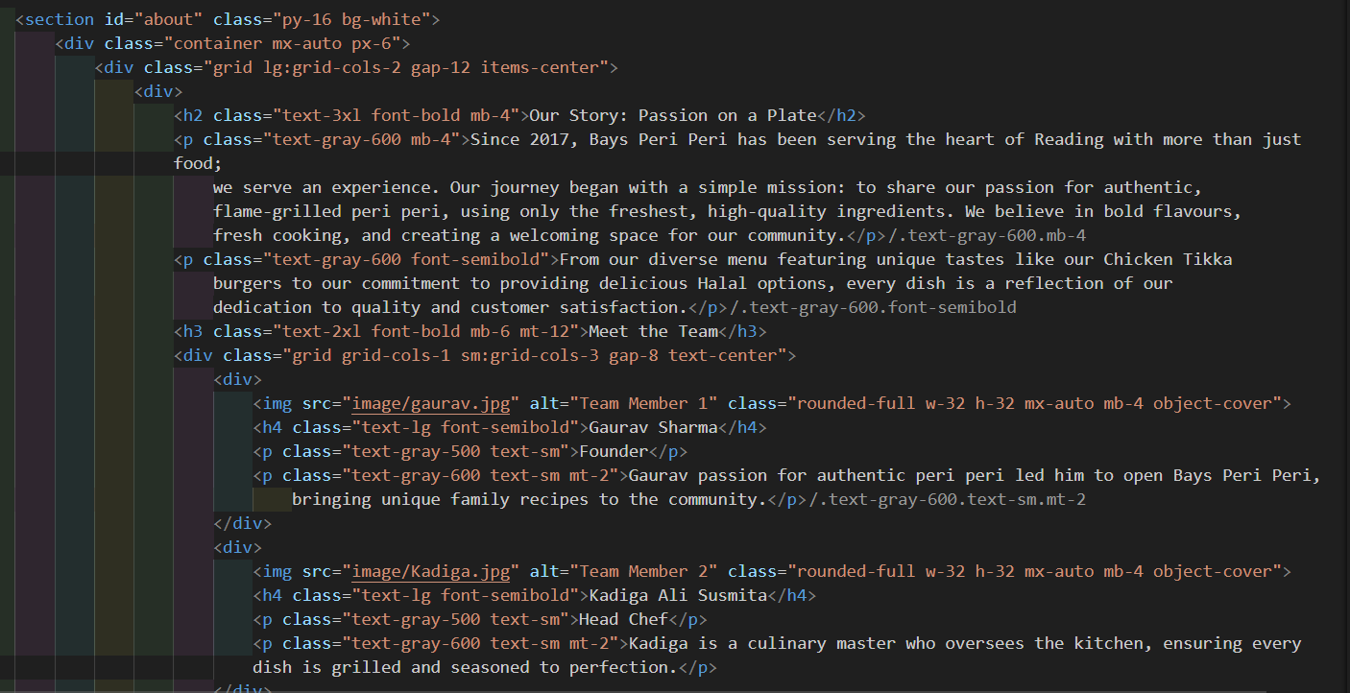
Our History Section: At the beginning of the HTML code, I used a large heading (<h2>) “Our Story: Passion on a Plate”. Below this, I wrote the brand’s history and mission within the <p> tag. I wanted this section to give the user an immediate idea of our brand. That’s why I used bold text (<strong>) to highlight Halal Options and Commitment to Quality.
Meet the Team Section: In this section I used a <div>, where I added the names, images, and brief descriptions of the three team members – Founder, Head Chef, and Restaurant Manager.I used a utility class like Tailwind to make the images appear rounded (like rounded-full). This makes the images look professional. I've added a subtle hover effect to each team card using the transition property like the .popular-dish-card class. transition: transform 0.3s ease-in-out, box-shadow 0.3s ease-in-out; When the user hovers over the image, the card moves up slightly (translateY(-5px)) and adds a shadow.
What Our Customer Say: Then I designed a separate column “What Our Customers Say”. Here I have written the customer reviews in a <div> block and mentioned the name below each one. I have used a light-yellow background (bg-yellow-100) for each review card, so that it looks different from the rest of the content. The padding and margin are used in the card in such a way that the text is clean and readable. I have used the box-shadow property to give a subtle hover effect. Even if you don’t want to give a separate animation for the testimonials, you can give a smooth entry using .animate-fade-in-up.
Responsive Design and UX: I have designed the entire page using a grid-based layout. This results in “Our Story” on the left side, “Meet the Team” below, and “Customer Testimonials” on the right side on desktop. In mobile view, they are stacked one below the other, which is in line with responsive design principles. I have used @keyframes fade-in-up in the Hero/Heading section, so that the text appears to slowly rise up. I have used @keyframes pulse for the button, so that it has a subtle scale animation and draws the user’s attention.
4. Explain the JavaScript Code:
Screenshot of the Home-manu Handle code
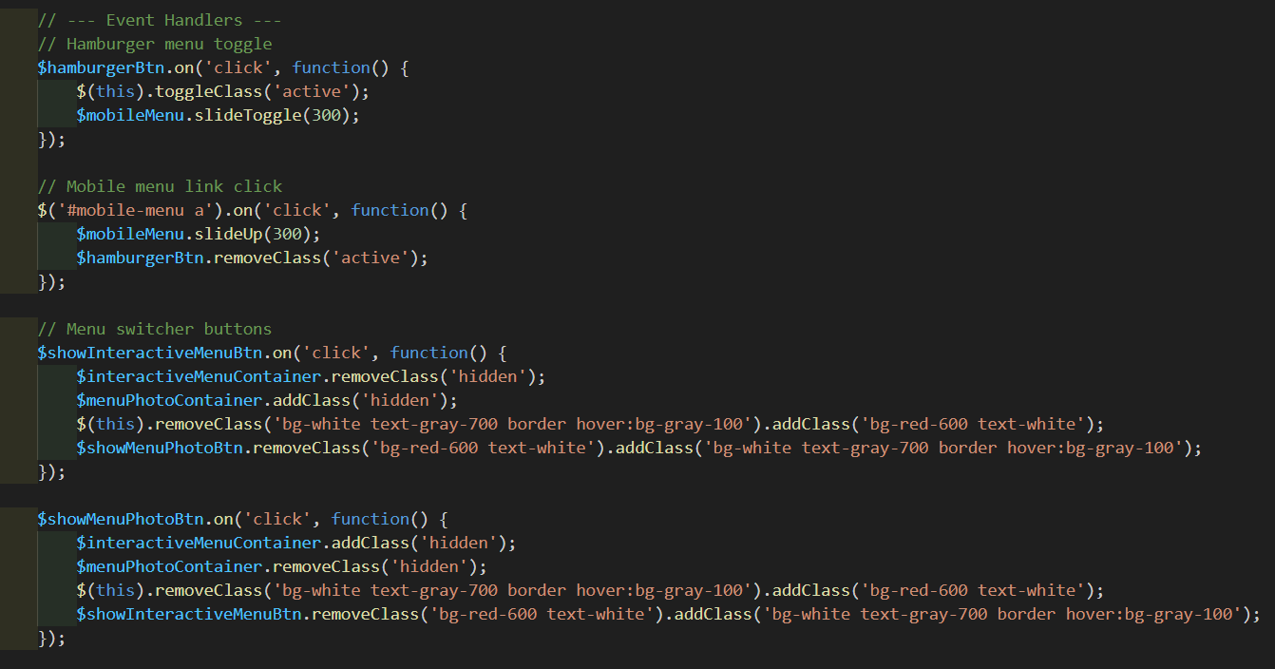
The key reason why this code was developed is to create interactive navigation menus and enable menu switching capabilities on a website. on mobile responsive sites, a key portion of the user experience (UX chat) involves menus. In mobile friendly sites, a menu that is responsive, interactive, and aesthetically friendly enhances navigation greatly. jQuery is implemented in this example to provide an easy and fast, clean way to deal with DOM manipulation, class toggling and animation, among other things.
Hamburger Menu Toggle event handler: In the first part, I added the Hamburger Menu Toggle functionality. When the user clicks on hamburgerBtn, the visual state of the button is changed using toggleClass('active'). That is, the user can easily understand whether the button is now opening or closing the menu. At the same time, the menu is opened or closed in 300 milliseconds by calling $mobileMenu.slideToggle(300). This slide animation gradually shows the menu instead of suddenly bringing it into view, which creates a more natural and smooth experience for the user. This feature is especially important in mobile view, because the screen is small and the user can be confused if the menu opens suddenly.
Mobile Menu Link Click Handler: A separate Click Handler has been made for all links in the mobile menu in the second step. In this case, the menu gets closed automatically after the user clicks on a link through the $mobileMenu.slideUp(300) function. This fades the mobile menu out. In the same instance, hamburgerBtn.removeClass(‘active’) is executed to return the toggle button visual state back to its idle state. This automated closing feature is beneficial for the user since the menu gets hidden automatically, keeping the interface uncluttered.

Menu Switcher Buttons: Then another big part of the code is the Menu Switcher Buttons. Two different views are kept here one is the Interactive Menu and the other is the Photo Menu.
This feature is mainly to toggle two different views according to the user's needs. Sometimes customers only want to see the text-based interactive menu, while some may be interested in seeing the pictures of the dishes.
1. When $showInteractiveMenuBtn is clicked, then:
- The interactive menu is visible through $interactiveMenuContainer.removeClass('hidden').
- At the same time, the photo menu is hidden using $menuPhotoContainer.addClass('hidden').
- For styling, the button is given the bg-red-600 text-white class to indicate that it is active, and those classes are removed from the other button and kept in a normal state (bg-white text-gray-700 border hover:bg-gray-100).
2. On the other hand, clicking on $showMenuPhotoBtn does the opposite.
- The photo menu is visible with $menuPhotoContainer.removeClass('hidden').
- The interactive menu is hidden with $interactiveMenuContainer.addClass('hidden').
- The button style is inverted again, so that it is clear to the user which view is currently active.
This view toggling system allows users to select their preferred view with a single click, which greatly increases the interactivity and flexibility of the website.
Overall, the UI interaction in this code block is controlled with the help of jQuery. The Hamburger button toggles the responsive mobile menu, the menu auto-closes when clicking on a link, and two buttons can be used to smoothly switch between the Interactive Menu and the Photo Menu. Dynamic visual feedback is provided in the user interface through class management, which makes the website more interactive and user-friendly.

Output:
Home Page
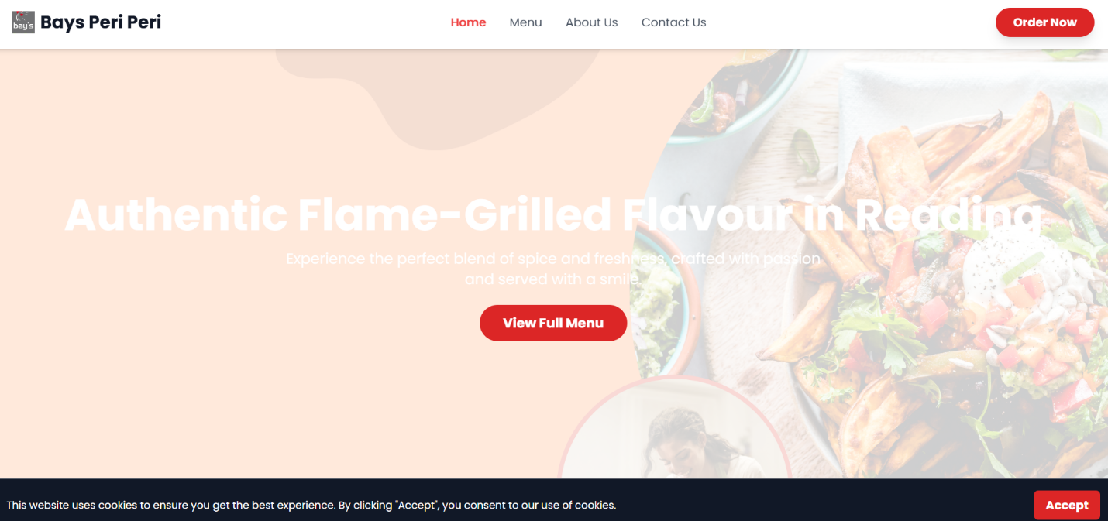

About Page
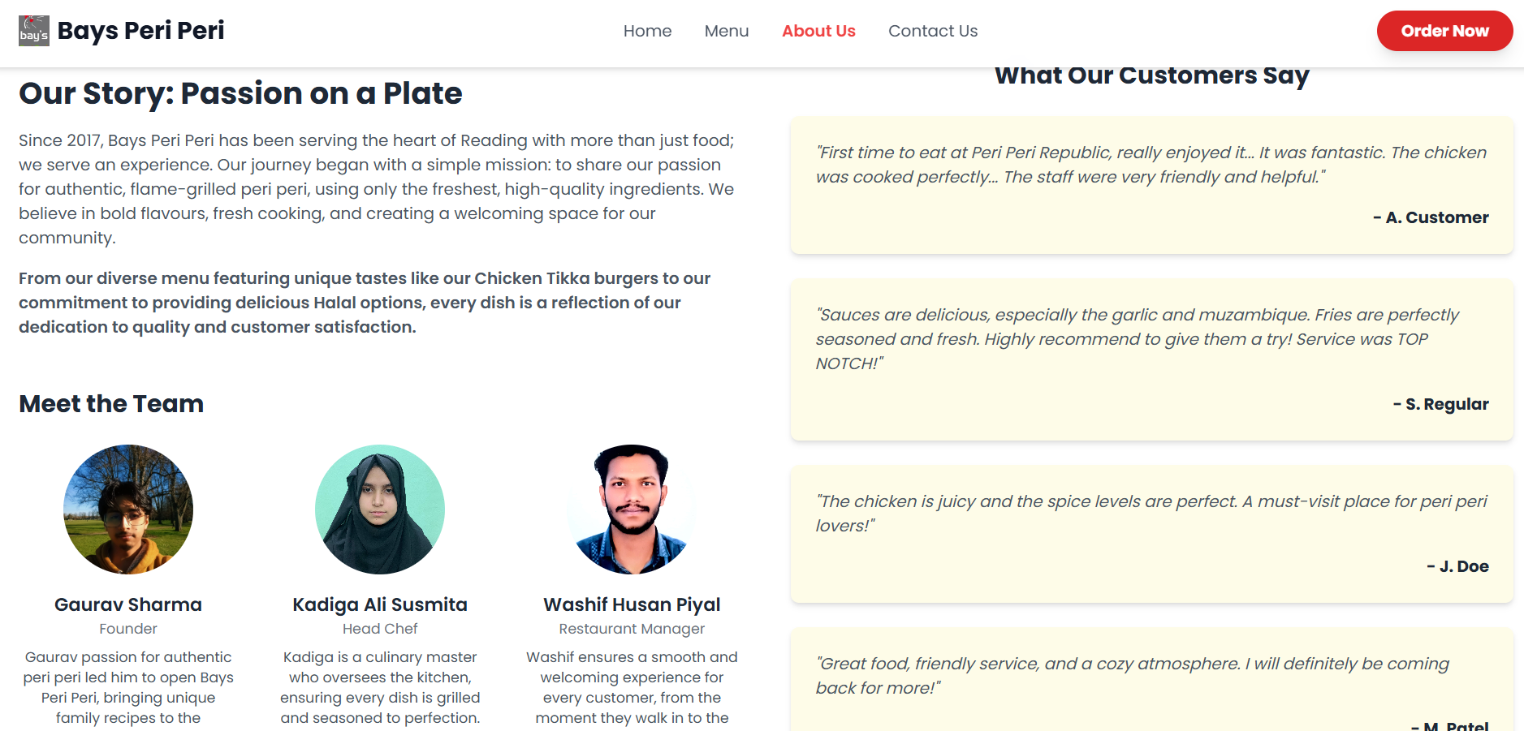

5. Conclusion
My contribution to this project was to give the website a complete and user-friendly look by designing, developing and implementing the related JavaScript functionality for the Home and About Us pages. The core message of the brand as well as user engagement are complemented with a modern sticky header, engaging Hero Section, and an effective Call-to-Action on the Home page. The brand's history, team profile, and customer testimonials on the About Us page are significantly boosting brand identity and credibility and are now more accessible thanks to better organization.
The addition of responsive navigation, hamburger menu toggle, and the Menu Switcher feature to the JavaScript section of the site further enhances the comfort and interactivity of the user experience.
The project has visually beautified the site, improved user experience, and increased the functionality of the website all three critical components to the project's success.

