**Tableau**

Course-End Project Problem Statement



**Name: Ashab Shaikh**

**Course-End Project: Sales Analysis**

**Problem Statement:**

DigiComp is a global enterprise that, among other things, caters to designing, developing, manufacturing and marketing products like - clothing materials.

DigiComp has expanded its presence across the globe, and the business wants to get an in-depth analysis of its sales so as to make better sales decisions. So, DigiComp has decided to use Tableau Dashboards to consolidate the data from multiple sources, and carry out the sales analysis. This will help the sales department to access the data from remote locations that would increase the overall timeliness, find inefficiencies, and make better decisions.

As a Tableau developer, you are tasked with creating an interactive Sales Dashboard in Tableau for the Sales department to use it for ad-hoc analysis and reporting.

**Description of the Datasets:**

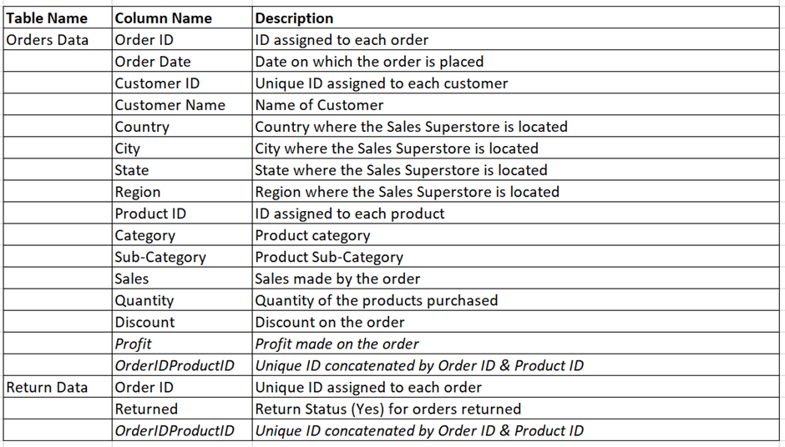

**Perform Data Visualization:**

Perform the following using charts and visuals:

*\*Note: The italicized words indicate the actual columns in the dataset.*

1. Analyse the *Sales/Profit* for all the months of 2017 as a continuous line chart and area chart.
2. Show *Category-*wise *Sales* as Packed Bubbles Chart suggesting categories with highest to lowest sales.
3. Create a Treemap chart showing *Sales* by *Category* and *Sub-Category*.
4. Visualize *Sales* vs *Profit* on a Scatter Plot with *Category* and *Sub-Category* breakdown.
5. Compute aggregated values for all Sales KPIs like *Total Sales, Profit, Profit Ratio, Discount* in a Table view.
6. Analyse the *Sales* for all the quarters of all the years across *State*, and *Category* as a Highlight Table. Highlight the columns by Profit.
7. Connect to the ***Return Data*** dataset, and blend it with ***Orders*** data to compute the *number of orders returned* for each Product *Category* in 2016.
8. Show *Sales/Quantity* of Product *Category* in each *Region* as a Stacked Bar Chart.
9. Determine the top 5 *products* and top 5 *customers* by *Sales*, i.e., *Products* and *Customers* that are generating the highest revenue as a bar chart.
10. Visualize *Sales* by *State* where the sales variation is highlighted by color as a Map Chart.
11. Visualize Sales & *Profit* analysis by *Customer* on a Scatter Plot.
12. Represent the *Number of orders* received by *Quantity* bins as a Histogram.
    1. Create Quantity bins.
    2. Use Measure Count of Quantity as calculation.
    3. Drag Count of Quantity in Row Shelf and Quantity bins in column shelf
13. Create an interactive fixed size floating layout Dashboard that can be shared with the leaders using the above analysis.
14. Create a story with the following visuals:

*\*Note: The below-listed visuals are done as part of tasks 1 to 6.*

* 1. *Sales/Profit* for all the months of 2017
  2. Category-wise *Sales*
  3. *Sales* by *Category* and Sub-Category.
  4. *Sales* vs *Profit*
  5. Aggregated values for all *Sales* KPIs and
  6. Sales for all the quarters for all the years across *State*, and *Category*.

Deliverables:  
  
 **Task 1: Analyze the Sales/Profit for all the months of 2017 as a continuous line chart and area chart.**

* Create a new worksheet.
* Drag the "Order Date" field to the columns shelf and select "Month" as the date part.
* Drag the "Sales" and "Profit" fields to the rows shelf.
* Change the chart type to "Line Chart" and "Area Chart" respectively.
* Add the "Order Date" field to the color shelf for differentiation.  
    
    
  **Task 2: Show Category-wise Sales as Packed Bubbles Chart suggesting categories with highest to lowest sales.**
* Create a new worksheet.
* Drag the "Category" and "Sales" fields to the view.
* Change the chart type to "Packed Bubbles."
* Add the "Category" field to the label shelf for better identification.  
    
    
  **Task3: Create a Tree map chart showing Sales by Category and Sub-Category.**
* Create a new worksheet.
* Drag the "Category" and "Sub-Category" fields to the rows and columns shelves respectively.
* Drag the "Sales" field to the color shelf and change it to "Sum."
* Change the chart type to "Tree map."  
    
  **Task 4: Visualize Sales vs Profit on a Scatter Plot with Category and Sub-Category**

**breakdown.**

* Create a new worksheet.
* Drag the "Sales" and "Profit" fields to the rows and columns shelves.
* Drag the "Category" and "Sub-Category" fields to the detail shelf for better identification.
* Change the chart type to "Scatter Plot."  
    
  **Task 5: Compute aggregated values for all Sales KPIs like Total Sales, Profit, Profit Ratio, Discount in a Table view.**
* Create a new worksheet.
* Drag the "Category," "Sub-Category," "Sales," "Profit," "Discount," and
* "Quantity" fields to the rows and columns shelves.
* Right-click on the "Sales," "Profit," "Discount," and "Quantity" fields and
* select "Aggregation > Sum."

**Task 6: Analyze the Sales for all the quarters of all the years across State, and Category as a Highlight Table. Highlight the columns by Profit.**

* Create a new worksheet.
* Drag the "State," "Category," "Sales," and "Quarter" fields to the rows and
* columns shelves.
* Change the chart type to "Highlight Table."
* Drag the "Profit" field to the "Color" mark and change it to "Average."  
    
  **Task 7: Connect to the Return Data dataset, and blend it with Orders data to**

**compute the number of orders returned for each Product Category in 2016.**

* Connect to the Return Data dataset and blend it with the Orders data using
* the common field "Order ID."
* Create a new worksheet.
* Drag the "Category" and "Returned" fields from the Return Data dataset to
* the rows and columns shelves respectively.
* Filter the "Returned" field to show only the "Yes" values.
* Add the "Year" filter and select "2016."  
    
    
  **Task 8: Show Sales/Quantity of Product Category in each Region as a Stacked Bar Chart.**
* Create a new worksheet.
* Drag the "Region," "Product Category," "Sales," and "Quantity" fields to the
* rows and columns shelves.
* Change the chart type to "Stacked Bar Chart."  
    
    
  **Task 9: Determine the top 5 products and top 5 customers by Sales, i.e., Products**

**and Customers that are generating the highest revenue as a bar chart.**

* Drag "Product Name" from the "Data" pane to the "Columns" shelf.
* Drag "Sales" from the "Data" pane to the "Rows" shelf
* Click on "Sales" in the "Rows" shelf and select "Aggregation" > "Sum"
* Click on the "Sort" button on the "Sales" card and select "Top" > "By Field"
* "Sales" > "Top 5".
* Drag "Customer Name" from the "Data" pane to the "Color" card.
* Click on the "Show Me" button and select "Horizontal Bar Chart".
* Adjust the formatting and layout as desired.   
  This will give you a horizontal bar chart showing the top 5 products and top 5 customers by sales.  
    
    
  **Task 10: Visualize Sales by State where the sales variation is highlighted by color**

**as a Map Chart.**

* Drag "State" from the "Data" pane to the "Columns" shelf.
* Drag "Sales" from the "Data" pane to the "Rows" shelf.
* Click on "Sales" in the "Rows" shelf and select "Aggregation" > "Sum".
* Click on the "Map" chart type button in the "Show Me" pane.
* Click on "Color" in the "Marks" card and select "Sales".
* Adjust the formatting and layout as desired.
* This will give you a map chart showing sales by state where the sales
* variation is highlighted by color.

**Task 11: Visualize Sales & Profit analysis by Customer on a Scatter Plot.**

* Drag "Sales" from the "Data" pane to the "Columns" shelf.
* Drag "Profit" from the "Data" pane to the "Rows" shelf.
* Drag "Customer Name" from the "Data" pane to the "Detail" card
* Adjust the formatting and layout as desired.
* This will give you a scatter plot showing Sales & Profit analysis by Customer  
    
    
  **Task 12: Represent the Number of orders received by Quantity bins as a Histogram.**

**a. Create Quantity bins.**

**b. Use Measure Count of Quantity as calculation.**

**c. Drag Count of Quantity in Row Shelf and Quantity bins in column shelf**

* Create Quantity bins by right-clicking on "Quantity" in the "Data" pane and selecting "Create Bins".
* Drag "Count of Quantity" to the "Rows" shelf.
* Drag "Quantity (bins)" to the "Columns" shelf.
* Click on the "Histogram" chart type button in the "Show Me" pane.
* Adjust the formatting and layout as desired.
* This will give you a histogram showing the number of orders received by quantity bins.  
    
    
  **Task 13: Create an interactive fixed size floating layout Dashboard that can be shared with the leaders using the above analysis.**
* Click on "New Dashboard" in the "Dashboard" menu.
* Drag and drop the visualizations created in the previous tasks onto the dashboard.
* Resize and rearrange the visualizations as desired.
* Add filters, parameters, and other controls as necessary.
* Adjust the formatting and layout as desired.
* This will give you an interactive fixed size floating layout dashboard that can be shared with the leaders.  
    
  **Task 14: Create a story with the following visuals:**

**\*Note: The below-listed visuals are done as part of tasks 1 to 6.**

**A. Sales/Profit for all the months of 2017**

**B. Category-wise Sales**

**C. Sales by Category and Sub-Category.**

**D. Sales vs Profit**

**E. Aggregated values for all Sales KPIs and**

**F. Sales for all the quarters for all the years across State, and Category.**

* + Click on the "New Story" option in the toolbar, or select "New Story" from the "File" menu.
  + In the story view, click on "New Blank Point".
  + Select the visualization you want to add to the story, for example, "Sales/Profit for all the months of 2017".
  + Adjust the size and position of the visualization on the story canvas.
  + Repeat steps 3 and 4 for all the visualizations you want to include in the story.
  + Add captions and annotations to each visualization to explain the insights and trends.
  + Use the "Blank" option to add text, images or shapes to the story.
  + Use the "Sheets" option to add a sheet, which is a combination of multiple visualizations.
  + Use the "Dashboard" option to add a dashboard, which is a collection of related visualizations that are displayed together.
  + Use the "Web Page" option to add a web page, which is a live webpage that displays external content.
  + Preview the story to see how it will appear when published or shared.
  + Save the story as a packaged workbook or publish it to Tableau Server or Tableau Online.
  + Share the story with your team or stakeholders via email or a URL.
  + Here's an example of a story in Tableau that includes the following visualizations:
  + Sales/Profit for all the months of 2017
  + Category-wise Sales
  + Sales by Category and Sub-Category.
  + Sales vs Profit
  + Aggregated values for all Sales KPIs and
  + Sales for all the quarters for all the years across State, and Category.

**The story is titled "Digi Comp Sales Analysis" and includes the following sections:**

* Introduction: This section provides a brief overview of DigiComp and the purpose of the sales analysis.
* Monthly Sales and Profit: This section includes a line chart that shows the sales and profit for each month of 2017. The chart highlights the months with the highest and lowest sales and profit.
* Category Sales: This section includes a horizontal bar chart that shows the sales for each category. The chart highlights the top 3 categories by sales.
* Sub-Category Sales: This section includes a stacked bar chart that shows the sales for each sub-category within the top 3 categories. The chart highlights the sub-categories with the highest sales within each category.
* Sales vs Profit: This section includes a scatter plot that shows the relationship between sales and profit. The chart highlights the products with the highest sales and profit.
* KPIs: This section includes a table that shows the aggregated values for all the sales KPIs. The table highlights the top 5 products and customers by sales, and the states with the highest and lowest sales.
* Quarterly Sales: This section includes a treemap that shows the sales for each quarter of all the years across state and category. The chart highlights the states and categories with the highest sales in each quarter.
* Conclusion: This section summarizes the key insights and findings from the sales analysis, and suggests some actions that DigiComp can take to improve its sales performance.