# WhatsApp Pay



**Project for CBAP**

**Project Submitted By: Ashab Shaikh**

Table of content

1. Introduction

2. Project Tasks

3. Problem Definition and Solution

4. Advantages of the WhatsApp Pay

5. Project Objectives

6. BACCM model & Task – 1: Identifying stakeholders

7. Task – 2:Identify risks in this new feature - Strategy Analysis

8. Task – 3:SWOT analysis for WhatsApp Pay feature

9. Task – 4:Identify the Transition State of WhatsApp Pay

10. Task – 5:Create as-is and future process map

11. Task – 6: Scope Finding - Use the case diagram (UML) or context diagram

12. Task – 7: Main features that need to be developed

13. Task – 8: In-scope and Out-of-scope items

14. Task – 9: Business requirements, both the functional and non-functional requirements.

15. Task – 10: Wireframes or mock screens.

**Introduction :**

WhatsApp is a messaging and Voice over IP (VoIP) service owned by Facebook. It allows users to send text and voice messages, make voice and video calls, and share images, documents, and other media. WhatsApp runs on mobile devices but is also accessible from desktop computers. WhatsApp has over 2 billion users worldwide as of today. It has become the primary means of electronic communication in multiple countries across the Globe.

**Project Tasks:**

1. IIdentifying stakeholders – Create a list of stakeholders (as taught in Business Analysis Planning and Monitoring Knowledge Area)
2. Identify risks in this new feature (Identify them using the Strategy Analysis Knowledge Area)
3. Do a SWOT analysis for WhatsApp Pay feature (SWOT – Strengths, Weaknesses, Opportunities and Threats). This is the SWOT Technique taught in class
4. Identify the Transition State of WhatsApp Pay (Identify them using the Strategy Analysis Knowledge Area)
5. Create as-is and future process map (using flowcharts). You can use any of the popular tools in the market like Microsoft Visio, Lucid Chart, Creately, Pidoco, or Balsamiq
6. As a Business Analyst working on this project, find out the scope of this system. To find the scope you can use Use Case diagram (UML) or Context diagram
7. Write down the main features that need to be developed
8. Write the in-scope and out-of-scope items for this software
9. Write out the Business Requirements, both Functional and Nonfunctional Requirements
10. Draw wireframes or mock screens for any 2 of the features namely book record creation and any other feature as deemed fit by the student. (Use the technique prototyping or wireframing that is taught in the training). You can use any of the wireframing tools like Microsoft PowerPoint, Microsoft Word, Balsamiq, Sketch, Adobe XD, Adobe Illustrator, Figma, UXPin, InVision Studio, InVision Freehand, or Moqups.

**Problem Definition and Solution**:

**Problem Statement:**

Today across the globe people are moving to digital payment services such as Google Pay, PayPal, and others. Mobile wallets are in massive demand. The transaction value of the global mobile payments market was USD 3714.5 billion in 2019 and is expected to reach USD 12,407.5 billion by 2025, registering a CAGR of 23.8%. WhatsApp being one of the leading mobile messaging apps wants to get a slice of this growing digital payment market.

WhatsApp has decided to take the plunge into this digital payment market. They have launched a new feature namely, WhatsApp Payments to be known as WhatsApp Pay in Brazil in June 2020. WhatsApp promises to disrupt the global digital payments ecosystem with WhatsApp Pay.

**Solution**:

WhatsApp will integrate the customer’s debit card or credit card into their app. That is, while chatting with your peers, you can transfer the money to them. There will be no separate app that the customers need to download to access this payment feature. This feature would be provided to users as an update in the existing WhatsApp messaging app. The user can use WhatsApp pay feature by updating the WhatsApp messaging app.

**Advantages of the WhatsApp Pay:**

* Easy peer to peer payments. You can send money to your family, friends, or relatives all through WhatsApp.
* Users need not go to the bank or use wallets, bank apps, or NEFT to transfer money.
* It will be a one-click payment.
* Easy and user-friendly interface of WhatsApp would make digital payments seamless and there will be no need to enter details at multiple page loads.

**Project Objectives:**

* Have at least 1 million users use WhatsApp pay feature within the first 3 months of launch.
* Over 1 year of its launch have 30% of user base using WhatsApp pay.

Task – 1

**Business Analysis Core Concept: (BACCM)**

|  |  |
| --- | --- |
| Need | * Today across the globe people are moving to digital payment services such as Google Pay, PayPal, and others. Mobile wallets are in massive demand. WhatsApp being one of the leading mobile messaging apps wants to get a slice of this growing digital payment market. |
| Change | * WhatsApp needs a transformation to allow users to send and receive hassle-free and user-friendly money transactions in addition to the existing communication. * WhatsApp customers are required to make payments without having to download any additional software. The same app can handle messaging, voice/video calls, and payments with only install some updates. |
| Solution | * WhatsApp should create a good user-friendly, scalable and secure payment solution without making any difference to the current functionalities**.** |
| Context | * WhatsApp customers * Bank (debit card provider). * Credit card providers. * WhatsApp Management * Developers * IT Department * Update for providing the new easy, secure and scalable features |
| Value | * Customers will get a Secure, Scalable and user-friendly smart payment facility in an existing application * WhatsApp can be increased their customer base by adding the new features. |
| Stakeholders | External Stakeholders   * WhatsApp Users * Bank, Debit card & Credit card providers * UPI / Payment service providers * Reserve Bank, NPCI & Other Government Authorities (TRAI, Police etc) * Domain SME   **Business Analyst**  Internal Stakeholders   * Project Manager * Programmers * Implementation Team – IT * Tester * Help Desk |

**Stakeholders:**

The Stakeholders involved are described using the Onion Diagram:

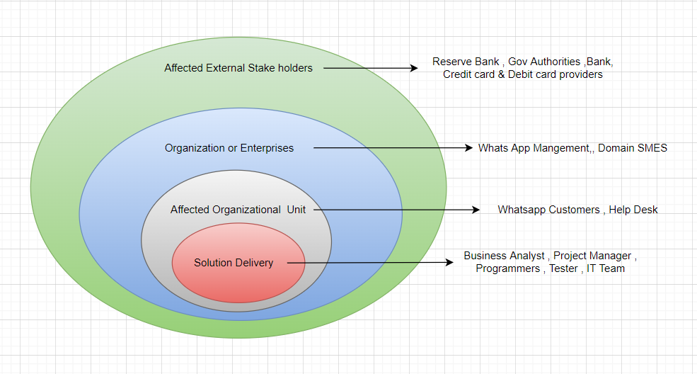

Task – 2

**Identify risks - Strategy Analysis:** A fishbone diagram / Ishikawa or cause-and-effect diagram is used to identify and organize the possible causes of a problem

Fish bone Diagram

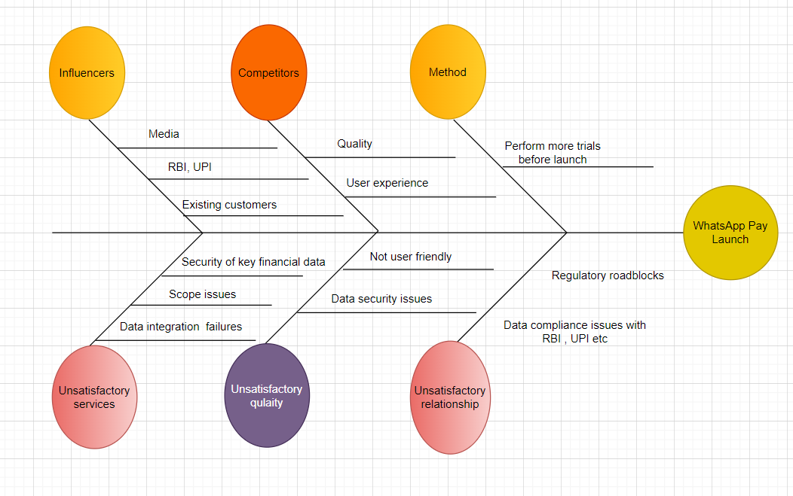

Task – 3

**SWOT Analysis:** An analysismodel used to understand influencing factors and how they may affect aninitiative.

**WEAKNESS**

* **Strong Economic Regulations & Policies**
* **Time consuming process for testing and discussions with govt. Authorities.**

**STRENGTHS**

* **Large active customer base**
* **Strong technical background**
* **User friendly**
* **Good brand image**

**THREATS**

* **Data security concerns about existing customers**
* **Data Compliance issues with RBI & UPIs**
* **Other present debates on Fraud & Hackers**

**OPPORTUNITIES**

* **Can be reached to low level economy**
* **Less Competitors the Indian market**
* **Due to internet expansion reachability will increase even in remote village area.**
* **Fast growing climate of digital transactions in Globe**

Task – 4

**Transition State of WhatsApp Pay:**Clearly defined transition states help ensure that the organizationcontinues to deliver value and remain competitive throughout all the phases ofthe change

**Current State:**

* WhatsApp has over 2 billion users worldwide as of today
* It has become the primary means of electronic communication in multiple countries across multiple continents, including Latin America, the Indian subcontinent, and large parts of Europe and Africa.
* WhatsApp currently provides Text, Media, Voice and Video services to the users globally.
* Today across the globe people are moving to digital payment services. Mobile wallets are in massive demand. So the WhatsApp need to use the huge user base across globe for money transactions which will result in huge revenue.
* So,WhatsApp launched a feature in the existing app which is called as WhatsApp Pay in Brazil alone.

**Future State:**

* WhatsApp will launch the Payment application in India.
* If the WhatsApp Pay is a success in India, then WhatsApp will launch this new Pay feature to the rest of the world.

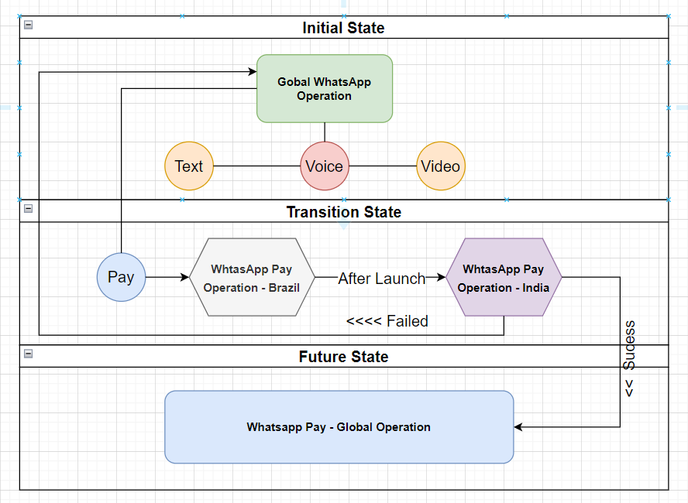

Task – 5

**Create as-is and future process map**

5.1 - As – is Process Map of the Current State

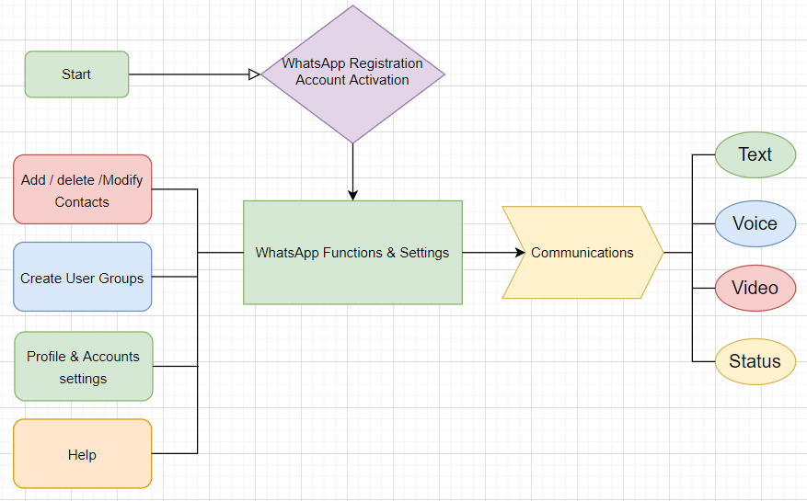

5.2 - Future Process Map for the System

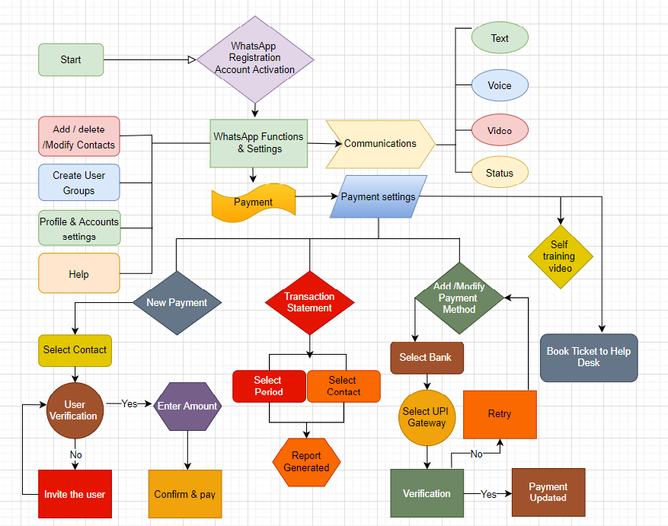

Task – 6

**Scope Finding - Use the case diagram (UML) or context diagram**

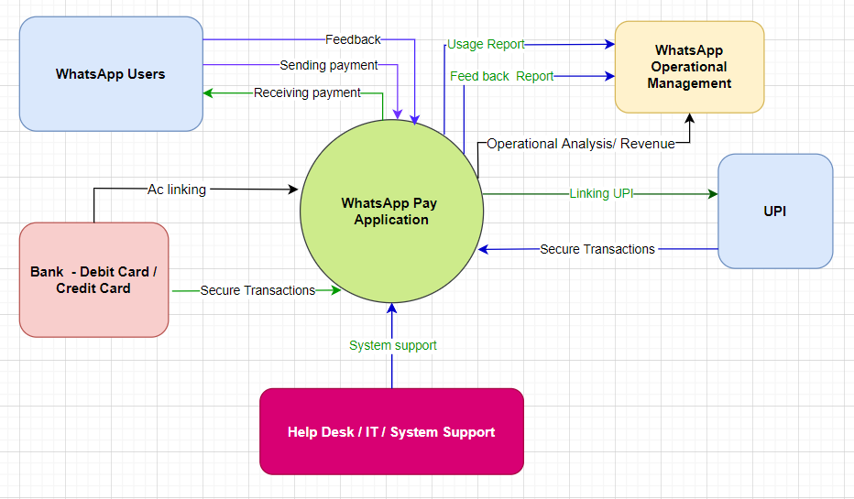

Task – 7

**Main features that need to be developed:**

* Bank details – Credit card, Debit card details and QR codes can be updated in the application.
* It should be user friendly, that means no need to enter details multiple times.
* It should be in one click, no need to go to or redirected to any bank sites or other application.
* Customers need access to add/update / modify / delete optionsfor bank details in this system.
* Regulators - All the process and data should be visible to the team whenever required for checking the security and quality, etc.

Task – 8

**In-scope and Out-of-scope items**

• Payment TransactionReports

• QR Code Transactions

• SupportMultiple language

• Enable access to Govt. Authorities

for the required data

**In-scope**

• Add and update Bank account details

• Link Debit or Credit cards

• UPI Pin for Bank transactions via UPI

• OTP for Debit/Credit card transactions

• Payment Notifications

**Out-scope**

* The linked Bank account balance and details are not in scope.
* Recipients who don’t have bank account linked in WhatsApp is not in scope.
* No wallet, All the transactions through bank account only.

Task – 9

**Business requirements, both the functional and non-functional requirements.**

**Requirements Classification Schema:**

Client has given them the following requirements:

To transfer money using WhatsApp pay there will be 2 methods on the WhatsApp app.

Method 1:

* To use the WhatsApp Pay feature the user needs to have a bank account with its debit card or a credit card
* Users shall select the person they want to send money to from their WhatsApp contact list
* Users shall click on payments option in their chat settings
* Users shall enter the amount they wish to transfer
* Users will then enter a security Pin
* Users will click on the transfer button
* Money is transferred
* The sender and the receiver will both receive a payment notification on their chat window once the fund transfer has been made.
* In cases where the user is requesting money, tap on request and wait for the person to accept your request.
* The feature should be available in multiple languages

Method 2:

* User goes on the main page of WhatsApp and opens the payments option.
* User then taps on the QR code showing next to their name to show their QR code using which people can send them money.
* User taps on the new payment option located on the bottom right of the display.
* User selects a contact or the scan QR code option.
* The rest of the process remains the same as above.

Business requirements:

* Have at least 1 million users use WhatsApp pay feature within the first 3 months of launch.
* Over 1 year of its launch have 30% of user base using WhatsApp pay.

Stakeholder requirements:

* WhatsApp Management – They need to append their customer base
* WhatsApp customers – They need a secure and user-friendly function to do the payment
* Bank, NPCI& Other Debit card and Credit Card providers – Need to connect and give access to the required data.
* Help Desk – Need access to the required data of customers for checking the feedback, quality, issues, errors etc.

Solution requirements:

1. Functional requirements:

* Registration
* Login
* Payment options in Different Method - Payment in Chat Screen and Payment with QR Code.
* Update Bank Details
* Payment modify field for modify before the submission
* After process, both parties required a notification
* Customers can be updated the feedback
* Customers can be able to generate the report

1. non-functional requirements or quality of service requirements:

* Scalability & Performance: Scalable for Different Languages
* Availability: System need to be light and fast
* Usability: Should be user friendly
* Compliance: NPCI & Reserve Bank compliances and policy

Transition requirements:

* Training materials and self-explanatory videos should be available at online
* Make sure the safety and back up for all the payment process in case of any internet or system failure.
* Banking process should be very safe and smooth.

Task – 10

**Wireframes or mock screens.**

