What is CHOF (Children’s Hope Foundation)
Children’s Hope Foundation (CHOF) is a nonprofit organization located in southwestern Uganda. It was founded in 2024. It is registered with local government under registration number ………/2026. CHOF was founded with a purpose of solving conservation challenges in southwestern Uganda while eradicating household poverty among members, promoting community welfare, health and sensitizing children and Youth on the development programs
Origin of CHOF
The existence of CHOF emerged from the community suffering as a result of protected natural resources among the area.
Ibambiro community is within the boundaries of Queen Elizabeth national park. For the people living within this community are being seen as problems instead of looking at them as an opportunity. The reasons are multiple whereby wild animals in Queen Elizabeth destroy their gardens, attack their temporary households and sometimes kill people and their domestic animals in the community. This also affects their access to health care because of walking long distances to health facilities are dangerous and hiring vehicles is expensive too. Child labor, family neglect and early pregnancies among children and Youth.
Because of these challenges, communities have neglected conservation of these natural resources. A number of members decided to do something about it and formed CHOF as a local community-based organization to work with communities to conserve the nature for the benefit for us all and empower the local community with the resources to help them.
Motto
Making a Difference Together
Vision
Empowering Children and Youth to reach their full potential and create a brighter future.
Mission
To provide comprehensive support and resources to children and youth, empowering them to overcome challenges and achieve their full potential.

Story of Founder and Executive Director: NDYAMUHAKI ABDALLAH

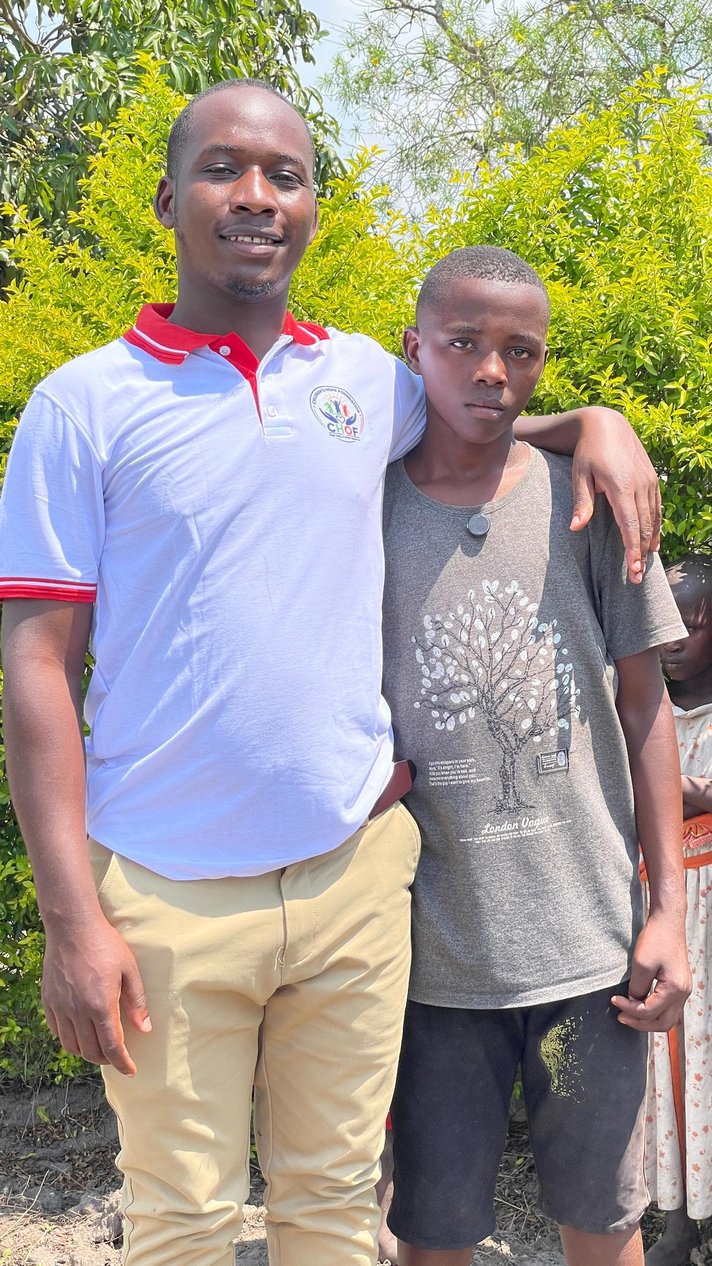

Abdallah holds a certificate in Information and Technology, he also holds a diploma in social work and social administration.
He witnessed firsthand the struggles that many children and young people faced—poverty, lack of access to education, early school dropouts, and the silent weight of lost potential.
As a child, Abdallah walked long distances to school, often without basic supplies. Some of his friends never made it past primary school. Others disappeared into early marriages, child labor, or the uncertainty of survival. These were not just stories to him—they were faces, names, and memories that stayed with him.
What troubled him most was not just the hardship, but the feeling that these children were being forgotten.
As he grew older, NDYAMUHAKI ABDALLAH began to see something clearly: the cycle would not break on its own. Someone had to act. Someone had to believe that children in villages like Kyenyabutongo deserved the same opportunities as anyone else.
That realization became a turning point.
With determination shaped by lived experience, Abdallah pursued education and personal growth, holding onto a vision that one day he would return—not just as someone who made it out, but as someone who came back to lift others up.
That vision gave birth to Children’s Hope Foundation (CHOF).
He founded the organization in Kyenyabutongo village not by accident, but by intention. It is the place where the need was real and urgent. He understood the community, its challenges, its strengths, and its untapped potential.
CHOF began as a small initiative with a big heart. Abdallah focused on what he knew mattered most: education, empowerment, and protection. He worked to support vulnerable children to stay in school, to provide mentorship to young people, and to create safe spaces where dreams could be nurtured instead of silenced. There were challenges—limited resources, skepticism, and the sheer scale of need. But ABDALLAH carried something stronger than all of that: purpose. He believed that change does not always begin with large funding or global recognition. Sometimes, it begins with one person who refuses to look away.
Under his leadership as Founder and Executive Director, CHOF grew into more than an organization—it became a symbol of hope in the community. Parents began to believe again. Children began to dream again. Youth began to see paths beyond their immediate struggles.
NDYAMUHAKI ABDALLAHS story is not just about founding an NGO. It is about turning pain into purpose, witnessing into action, and belief into impact.
And in Kyenyabutongo village, where the journey began, his work continues—one child, one story, one future at a time. MAKING A DIFFERENCE TOGETHER.
Motto:
Making a Difference Together
Vision:
Empowering Children and Youth to reach their full potential and create a brighter future.
Mission:
To provide comprehensive support and resources to children and youth, empowering them to overcome challenges and achieve their full potential.
Objectives:
- Improve access to education.
- Enhance health and well-being.
- Promote personal development.
- Strengthen family and community ties.
- Advocate for children rights.
- Break the cycle of poverty.
Core Principles:
- Child centered: Putting the needs and wellbeing of children and youth first.
- Inclusive: Embracing diversity and promoting equal opportunity for all.
- Empowering: Fostering independence, self-esteem and confidence in children and youth.
- Comprehensive: Addressing the holistic needs of children and youth including education, health and personal development.
Current Main Activities:
- Rescue of 17 street children from streets of Kihihi town council in KANUNGU DISTRICT who are now in a good and safe place as they need to attend school as also.
- Establishment of a vegetable garden for the children in Kyenyabutongo and to prevent malnutrition among these children.
- We have managed to rescue 201 vulnerable children in KYENYABUTONGO. They have all been taken to the house which is at least not linking and of which some of them are orphans and others were abandoned by their families and whereby among these children 21 children are HIV positive.
- We formed 6 CHOF mothers’ groups whereby these groups consist of widows and teenage mothers and single mothers. These 6 groups each consist of 40 women. These women corporate together to uplift their families with hens and home utensils.
- We assisted a physically challenged and vulnerable youth with a wheel chair; he was also helped to attend craft making course for a couple of months whereby he gained skills and after that he was also supported with a startup capital to start up a small workshop to make sandals and other handicrafts.
- We created a children choir in Kyenyabutongo that helps in educating these children and help to prevent stigma.
- We helped a youth suffering from severe elephantiasis with a monthly medication that helps him in pain.
Planned activities in future (depending on funding)
- Rescue of another 20 street children who are currently staying on the streets of kihihi town council in Kanungu district.
- Establishment of a CHOF home for these vulnerable children in Kyenyabutongo who were taken to school as they are homeless and which will as well act as a center for CHOF Uganda.
- Training of CHOF mothers on how to weave classic and professional crafts that they will sell to earn a living.
- Further training of the CHOF children choir and also purchase some musical instruments and tools as they use jerrycans as drums, this will help the children to develop different dancing skills and songs.
- We want to start HIV/AIDS sensitization in Kyenyabutongo village and neighboring villages
- Combating child sexual abuse and exploitation among vulnerable children including marginalized groups such as pygmy communities and Banyabutumbi communities with knowledge and livelihood skills.
- ⁠Addressing the high levels of child abuse, early marriages, child labor and lack of reporting mechanisms in remote and underserved communities when children have limited access to protection services and education.
- ⁠ ⁠Supporting single mothers’/ child mothers from the marginalized groups of people.

