

American International University-Bangladesh (AIUB)  
**Department of Computer Science  
Faculty of Science &Technology (FST)  
Spring 21_22**

**Section: G**  
**Group No: 05**

**PROJECT TITLE**

A software Engineering project submitted

By

|  |  |  |  |  |
| --- | --- | --- | --- | --- |
| **Semester: Summer_21_22** | | **Section:** | **Group Number:** | |
| SN | Student Name | Student ID | Contribution (CO1+CO2+CO3) | Individual Marks |
| 09 | Tasnova Ahmed Apon | 20-41971 | System Test Plan + UI/UX Design |  |
| 14 | Ashaduzzaman Hamim | 20-42062-1 | Project Management T plan+ UI/UX Design |  |
| 31 | Abdulla Al Imran | 20-43271-1 | Product And Project Description+ UI/UX Design |  |
| 32 | Iftekhar Ahmed | 20-43316-1 | Risk Analysis + UI/UX Design |  |
| 36 | Shamiur Rahman Shakir | 20-43543-1 | PRODUCT AND PROJECT DESCRIPTION + UI/UX Design |  |

The project will be Evaluated for the following Course Outcomes

|  |  |
| --- | --- |
| Your Project will be Evaluated based on the following marking criteria | Total Marks |
|  |
| Requirements Analysis (functional, quality, and project requirements) [5Marks] |  |
| System Design (UI/UX design) & Test case [5Marks] |  |
| Project Management Planning [5Marks] |  |
| Submission, Completeness, Spelling, Grammar and Organization [5Marks] |  |

Submission Date:

Description of Student’s Contribution in the Project work

|  |
| --- |
| Student Name: Tasnova Ahmed Apon  Student ID: 20-41971  Contribution in Percentage (20%):  Contribution in the Project:   * Contribution Description 1 * Contribution Description 2   ___________________  Signature of the Student |
| Student Name: Ashaduzzaman Hamim  Student ID: 20-42062-120  Contribution in Percentage (20%):  Contribution in the Project:   * Contribution Description 1 * Contribution Description 2   ___________________  Signature of the Student |
| Student Name: : Abdulla Al Imran  Student ID: 20-43271-1  Contribution in Percentage (20%):  Contribution in the Project:   * Contribution Description 1 * Contribution Description 2   ___________________  Signature of the Student |
| Student Name: Iftekhar Ahmed  Student ID: 20-43316-1  Contribution in Percentage (20%):  Contribution in the Project:   * Contribution Description 1 * Contribution Description 2   ___________________  Signature of the Student |
| Student Name: Shamiur Rahman Shakir  Student ID: 20-43543-1  Contribution in Percentage (20%):  Contribution in the Project:   * Contribution Description 1 * Contribution Description 2   ___________________  Signature of the Student |

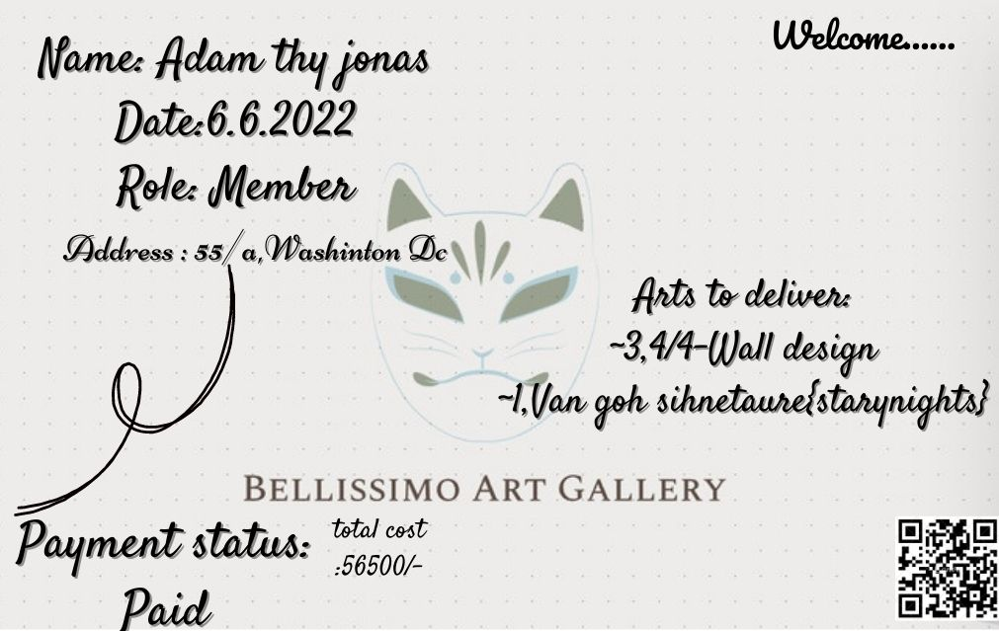

# 1.PRODUCT AND PROJECT DESCRIPTION

## System Features

Account creation option for both buyer and seller. The seller can put their arts on the website gallery. The buyer can have a look to the gallery and can buy any of the arts. Buyer can pay with online payment method. Free delivery service.

## System Quality Attributes

1. AVAILABILITY: System availability indicates that a software-driven system will repair any operating faults so that service outage periods would not exceed a specific time value. Our system will maintain this quality attribute.
2. PERFORMANCE: It is the ability of a system in the form of responsiveness to various actions within a certain period.
3. USABILITY: Usability is described as how the user is utilizing a system effectively and the ease of which users can learn to operate or control the system.
4. INTEGRITY: It is the ability of a system to resist or block malicious or unauthorized attempts that destroy the system and at the same time provide access to legitimate users.
5. FLEXIBILITY: It is the ability of a system to adapt to future changes
6. Maintainability: It is the ability of a software application to maintain easily and support changes cost-effectively.
7. Interoperability:It is the ability of two or more systems to communicate or exchange data easily and to use the data that has been exchanged.

## Project Requirements

**Budget:**

**1**.Per Developer Salary Per Working Hour = 500 Taka

Developer Salary in 10 months Total Developer Salary = 500 * 1640 * 4 =32,80,000 Taka

Requirement Analysis:

Time Needed: 1 month (22 Working Days = 176 Working Hour)

Total Req Analysis Expense = 300*176=52,800 Taka

Transportation Cost Estimation: 10,000 Taka

Training & Hardware Expenses Estimation: 100,000 Taka

Rent Expenses:

Room Per Month = 12, 000Taka

Total in 10 Months=120,000 Taka Total Utilities in 10 Months: 20,000 Taka Maintenance (Till 6 Months after Delivery):

Expense Per Hour = 2000 taka

Total Estimated Time Needed for Maintenance = 60Hours

Total Estimated Maintenance Expense = 60*2000 = 120,000 Taka

Electricity cost:

Per month- 10000 Taka

Total in 10 Month =100000 Taka

Total Estimated Expense: 32,80,000+52,800+ 10,000+ 100,000+ 120,000+ 20,000+120,000+100000 = 38,02,800

Profit: 20% of Total Estimated Expense = 38,02,800 * 20%= 740,560 Taka

Project Budget: 38,02, 800 + 740,560 = 44,43,360Taka

# SYSTEM DESIGN SPECIFICATION

## UI/UX Design



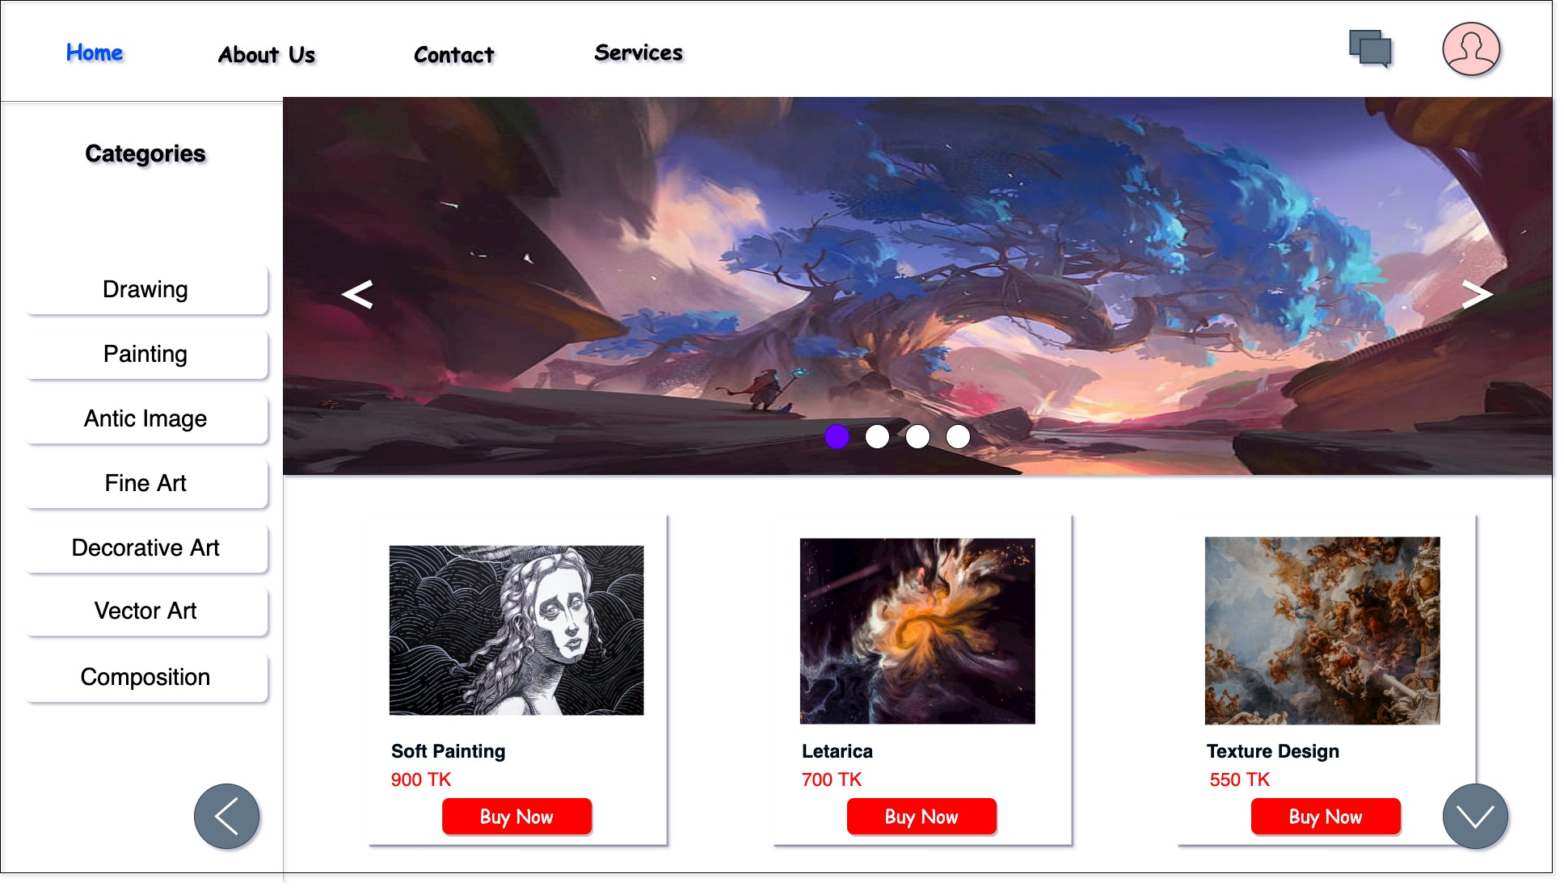

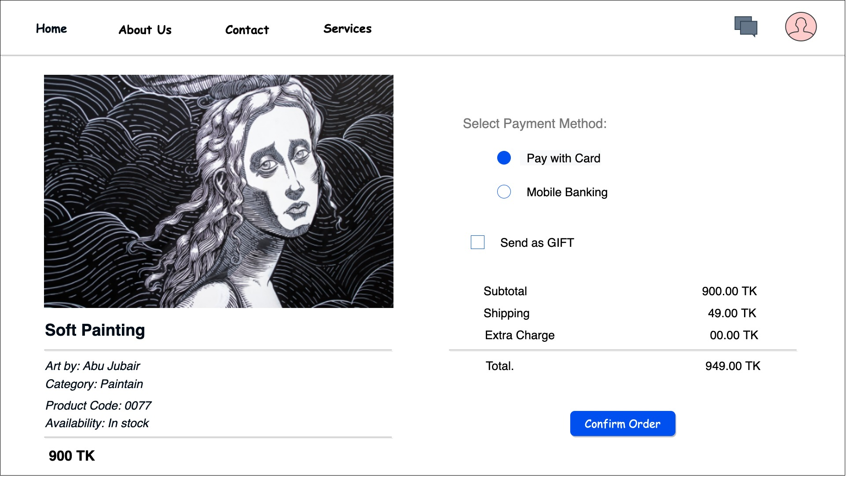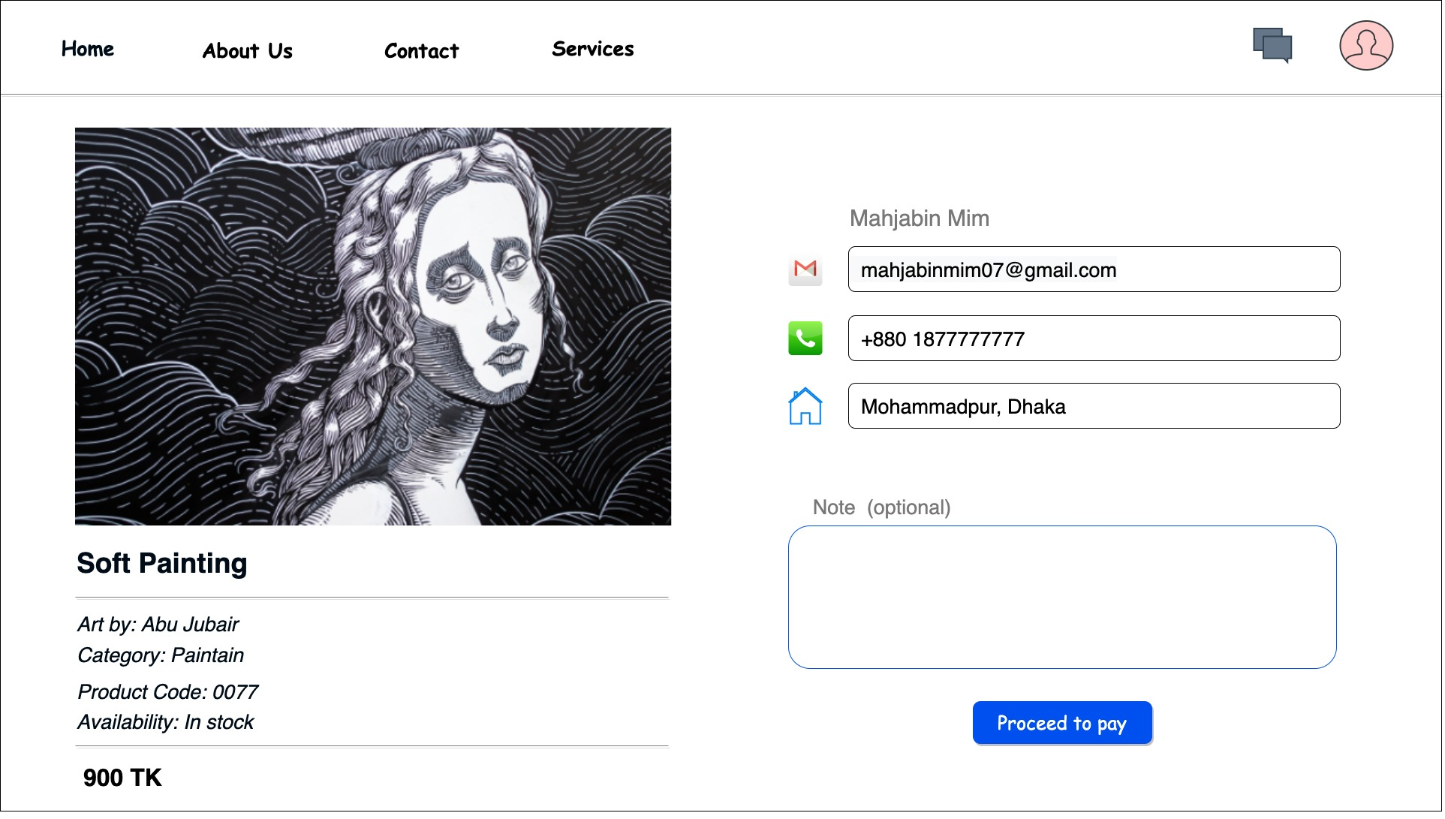

# 3 Requirement Analysis

**Functional Requirement**

1. First, we need to analyze the number of products ordered. What kind of products are they?
2. Next, product categories are analyzed. And the product must be separated.
3. Then the number of suppliers ordered by the user is analyzed. That is, how many users are interested in buying those products.
4. Checks whether the product belongs to the provider. The product must be tested before it reaches the user
5. If not found in a single supplier, the number of suppliers that have all products in stock is analyzed. Then send notifications to users about the provider. Advertisements must be created for this.

6. If not found, find the vendor with the most products and find the distance from other vendors with the remaining products. Remember the sooner the less the less.

7. Then select a minimum distance and notify the user. After contacting us, we will place an order with your consent. After receiving the order deliver it to the user

**Priority Level**: High

**Precondition:** Orders must be placed and the customer must approve the arranged supplier.

**Cross-Reference:** Null

**System Quality Attributes**

**QA 1 - Usability:** After placing an order, the scan will start and it will take 1 minute to 2 minutes to display the desired supplier list.

**Priority Level:** High.

**Precondition:** User must confirm the item**.**

**Cross-reference:** NULL

**SYSTEM TEST PLAN**

**Test Levels**

Unit, Bottom Up, and Smoke testing will be included in the testing for the web-based project. Bottom-up integration testing must require at least one full-time independent test tester. However, due to budget and schedule constraints imposed, the majority of testing will be performed by the Test Manager with support from the Development Teams. This is why the selection of the development team has to be achieved very carefully

**Unit testing** is a testing method that uses all independent modules tested to determine if there are any problems caused by the developer himself. Before unit tests can be accepted and passed to testers, the programmer must provide proof of unit tests list of test cases, sample output, error information. Test participants will also get all information about unit tests

# SYSTEM TEST PLAN

|  |  |  |  |  |  |
| --- | --- | --- | --- | --- | --- |
| Project Name: Online Art Gallery | | | Test Designed by: Abdulla Al Imran | | |
| Test Case ID: FR_1 | | | Test Designed date: 08/06/22 | | |
| Test Priority (Low, Medium, High): Medium | | | Test Executed by: | | |
| Module Name: Sign Up Session | | | Test Execution date: | | |
| Test Title: Verify Sign Up | | | | | |
| Description: Test website Sign Up | | | | | |
| Precondition (If any): User must have valid Email/ Mobile Number | | | | | |
| Test Steps | Test Data | Expected Results | | Actual Results | Status (Pass/Fail) |
| 1. Go to the website 2. Click Sign up 3. Enter username 4. Enter password 5. Confirm Your Password 6. Click submit | Username: AIUB SE  Password: 123abc | User should Sign Up into the application | |  |  |
| Post Condition: User is validated with database and successfully Sign Up to account. Created new account. The account details are Saved in the database. | | | | | |

|  |  |  |  |  |  |  |
| --- | --- | --- | --- | --- | --- | --- |
| Project Name: Online Art Gallery | | | Test Designed by: Tasnova Ahmed Apon | | | |
| Test Case ID: FR_2 | | | Test Designed date: 08/06/22 | | | |
| Test Priority (Low, Medium, High): Medium | | | Test Executed by: | | | |
| Module Name: Add arts on the website | | | Test Execution date: | | | |
| Test Title: Verify adding option | | | | | | |
| Description: Test adding any art on the gallery website. | | | | | | |
| Precondition (If any): User must have a verified account. | | | | | | |
| Test Steps | Test Data | Expected Results | | Actual Results | Status (Pass/Fail) | |
| 1. Go to the website 2. Click login 3. Enter username and password 4. Go to the add option 5. Add a particular art 6. Confirm your password 7. Submit | Username: AIUB SE  Password: 123abc  Adding an art | User Can add their art/crafts on the website. | |  |  | |
| Post Condition: User can add any art/craft and the art is uploaded on the galley website. The art details are Saved in the database along with the account information. | | | | | | |
| Project Name: Online Art Gallery | | | Test Designed by: Tasnova Ahmed Apon | | |
| Test Case ID: FR_3 | | | Test Designed date: 08/06/22 | | |
| Test Priority (Low, Medium, High): Medium | | | Test Executed by: | | |
| Module Name: Buy arts from the website | | | Test Execution date: | | |
| Test Title: Verify buying option | | | | | |
| Description: Test buying any art from the gallery website. | | | | | |
| Precondition (If any): User must have a verified account. | | | | | |
| Test Steps | Test Data | Expected Results | | Actual Results | Status (Pass/Fail) |
| 1. Go to the website 2. Click login 3. Enter username and password 4. Go to the buy option 5. Select an art 6. Add a payment option 7. Confirm your location 8. Submit | Username: AIUB SE  Password: 123abc  Can select an art  Can view products on the cart  Online payment option | User Can buy their art/crafts on the website. | |  |  |
| Post Condition: User can buy any art/craft from the galley website. The purchasing details are Saved in the database along with the account information. | | | | | |

# PROJECT MANAGEMENT PLAN

## Project Scheduling

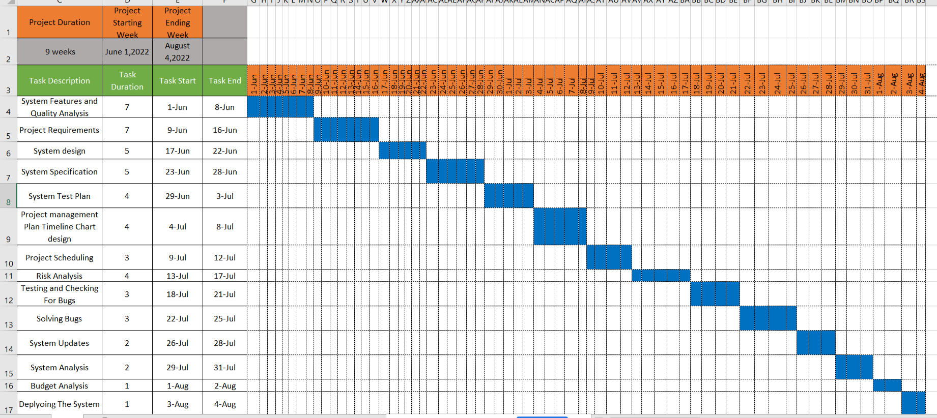

## Risk Analysis

|  |  |  |  |  |
| --- | --- | --- | --- | --- |
| **S/N** | **Risk Description** | **Probability** | **Impact** | **Mitigation Plan** |
| 1 | Real time performance problems | 60% | Significant | Simulation, prototyping, tuning |
| 2 | Budget estimate | 40% | Catastrophic | Multiple estimation design to cost |
| 3 | Technical problem | 30% | Catastrophic | Technical Analysis |
| 4 | Lack of Training | 80% | Marginal | Staffing with top talent |