

American International University-Bangladesh (AIUB)  
**Department of Computer Science  
Faculty of Science &Technology (FST)  
Spring 22 23**

**“Travel Management System”**

Software Requirement Engineering

1. Problem Domain ………………………………………………….…….….1
   1. Background to the problem ……………………………………………1
   2. Solution to the problem ………………………………….………….…2
2. Solution Description ……………………………………………...………..3
   1. System Features ………………………………………….......……..….3
   2. UML Diagrams …………………………………………………….…4-6
3. Social Impact ……………………………………………………………….7
4. Development Plan with Project Schedule ……………………...............…..8 - 9
5. Marketing Plan …………………………………………………………….11
   1. Swat Analysis For Marketing………………………………….……..…..10
   2. AIDA Model ……………………………………………….………11-12
6. Cost and Profit Analysis ………………………………………….…….13-15
7. References ……………………………………………..………………….19
8. **PROBLEM DOMAIN**
   1. **Background to the Problem**

For someone who works a lot in their daily life, organizing and carefully planning a trip is not always difficult. Finding reliable information might occasionally make it difficult to plan the perfect tour for these people.

Even if someone can learn a little bit about planning a trip, their knowledge base may be small.

Additionally, since each agency provides a set of agendas, it may be challenging to find the option to change the tour schedule. People who lack basic budgeting skills or who are limited financially may find themselves unable to take a tour. There may be a problem if an agency sends someone along with a group of people he doesn't know. Not all services, such as lodging, transportation, and dining, are provided in one place. In their leisure time, individuals constantly seek to feel rejuvenated. People who love to travel frequently go on tours. while taking a holiday. Nevertheless, they frequently have a depressingly bad trip experience. They occasionally ran out of time to plan a trip because of their hectic daily schedules. They enter communicate with any agency and forward them with a couple of outsiders. But due to the fact that the excessive cost, it won't be feasible for him to travel by himself or in a small group.

* 1. **Solution to the Problem**

our website containing all the data a user needs to book a trip or research any location.To have

the finest trip experience, there will be a variety of packages. Tour plan can be adjusted by users

according to their needs. Everything a user needs to plan their trip, From the transport to variety

of activities that are available in those places, if any guide needed for the user everything will be

included in the website . All user identities will be confirmed in order to guarante,We committed

to offering this so that the user would have a suitable solution.A person who is busy or who has

no previous experience with travel or tour planning can utilize the specific program and gain

advantages. The suggested solution can be helpful to someone who has never visited an area

before. This system can meet all of a person's requirements when they go on a tour, which will

benefit both the tourism industry and the user. This may provide the foreign visitor a favorable

impression of our nation and increase their desire to travel there.

1. **SOLUTION DESCRIPTION**

**System Features :**

**Admin Feature :**

⏺ Admin can log in

⏺Admin can add new package.

⏺ Amin can update any feature.

⏺ Admin can delete any feature.

⏺ Admin can change password.

⏺ Admin can see customer’s package

⏺ Admin can see Total product Bill

**User System :**

⏺ System Can verify password

⏺ Payment System

⏺ Customer can Booked travel packaged fro system

⏺ System can calculate Total bill.

**Customer Feature:**

⏺ Customer can login

⏺ Customer update profile

⏺ Customer can select package

⏺ Customer can select payment method (Cash or card)

⏺ Customer can change password

⏺ Customer can see all package

* 1. **UML Diagrams (Any 3 types)**

**USE CASE DIAGRAM :**

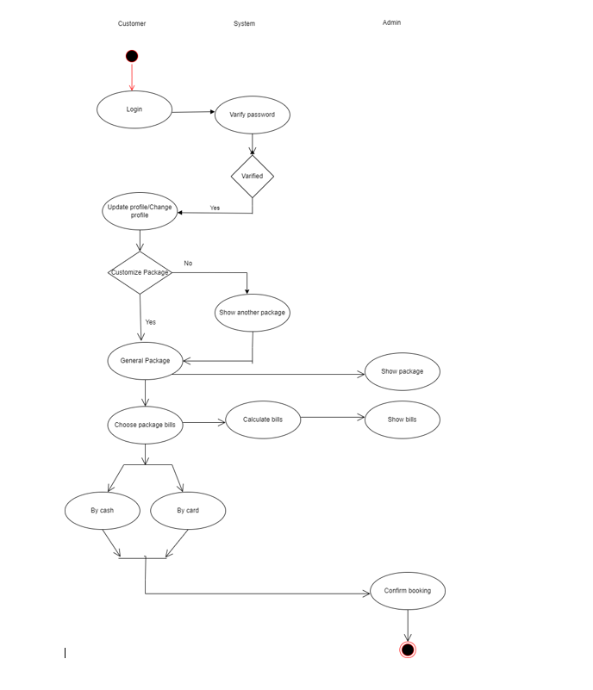

Fig: Use Case Diagram

Activity Diagram :

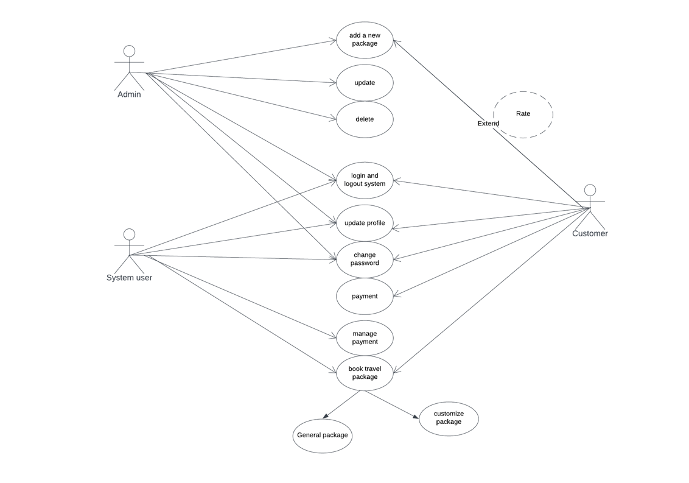

*Fig : activity diagram*

E R Diagram:

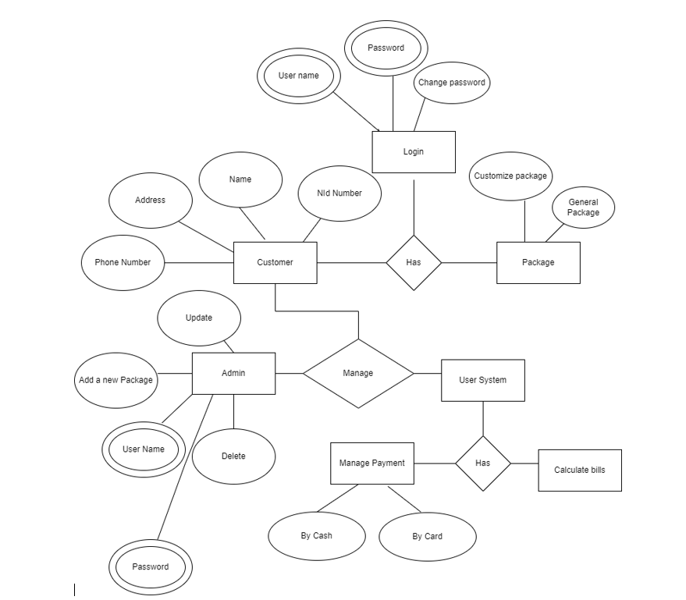

*Fig : E R Diagram*

1. **Social Impact**

Software for travel management is nowadays not just for large corporations. Small and medium-sized businesses benefit a lot when they manage their travel using software designed for enterprises rather than booking on consumer sites and having trouble finding invoices.

No matter if you have used travel management software for some time or are just beginning to research this category of software, we cover everything you need to know about key features, vendor possibilities, and the market as a whole.

⏺ **Reduce Risk:**

Invoicing and other procedures like invoice verification become more efficient and less prone to costly errors. It is easier to conduct audits without making mistakes when you implement cloud services and other automated solutions into your travel and expense management plan. This helps the firm to provide external auditors with the data they need and maintains you in compliance.

⏺ **Reduce travel expense:**

The visibility of such a corporate program would help organizations identify trends and patterns, gain a better understanding of employee travel spending and spending habits, and ultimately develop analytical ways to control excessive travel costs.

⏺ **Increased staff productivity**:

Organizations that do away with these old management and travel procedures free up their employees, who can then concentrate all of the time spent on scheduling their business trips to their duties.

⏺ **shifting to automoted:**

a business can reduce the amount of time staff members spend supervising and aiding various travel-related operations. For a number of crucial reasons, your company should deliberately invest in automated travel and expense management.

1. **Development Plan with Project Schedule**

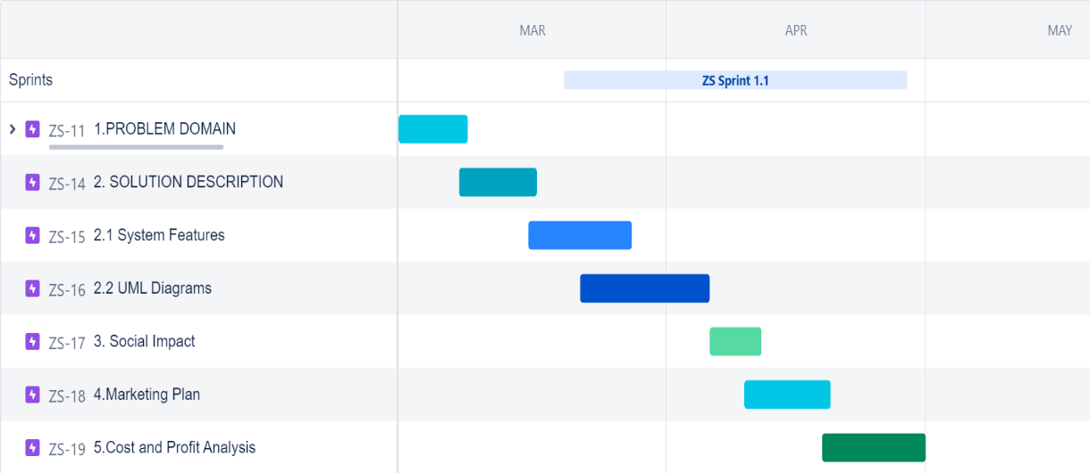

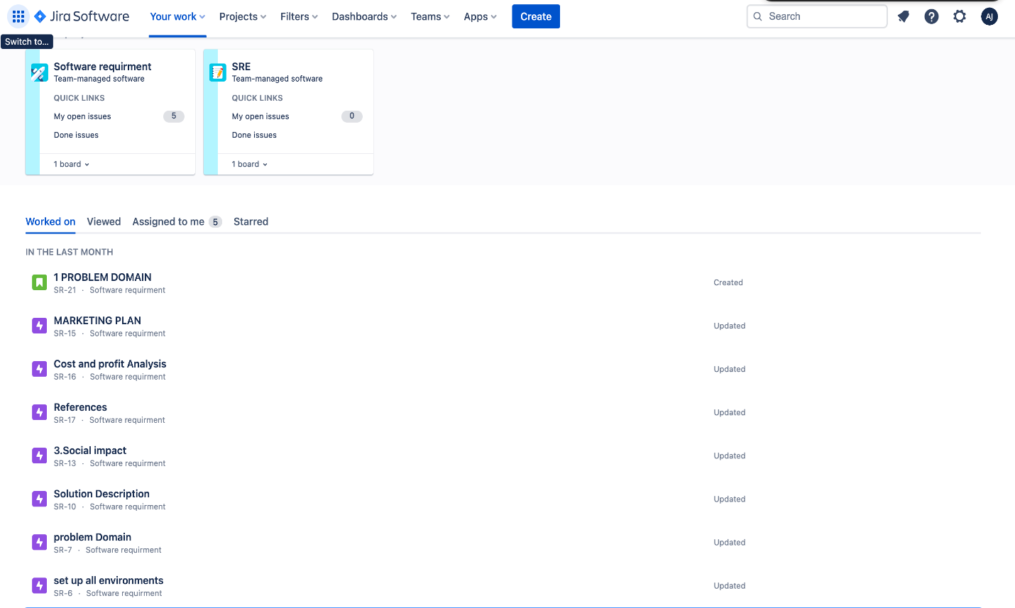

Jira Tool

**Marketing Plan :**

⏺ Marketing is vital for the operation of any business. We'll start by focusing on social network advertising or promotion through social media. People frequently share personal information on social media, and advertisers store and use this information to create target audiences. For that, we can use the advertising services provided by YouTube, Twitter, LinkedIn, Facebook, ⏺Instagram, Snapchat, and Whatsapp. It will be simpler for us to locate and get in touch with travelers. We can produce online video advertisements (OVC) to grab customers' interest.

⏺ Additionally, we can collaborate with social media influencers for promotion (like travel vloggers) and choose them to represent our brand. This will help our branding.

⏺ Outdoor marketing is another use for "advertising umbrellas," especially in well-known tourist areas. We can also advertise on LED screens located all over the cities.

**SWAT ANALYSIS FOR MARKETING :**

SWOT analysis is a strategic planning tool that can be used to help businesses identify their strengths, weaknesses, opportunities, and threats. It can be particularly useful in marketing because it can help businesses better understand the competitive landscape, and identify areas where they can improve their marketing efforts

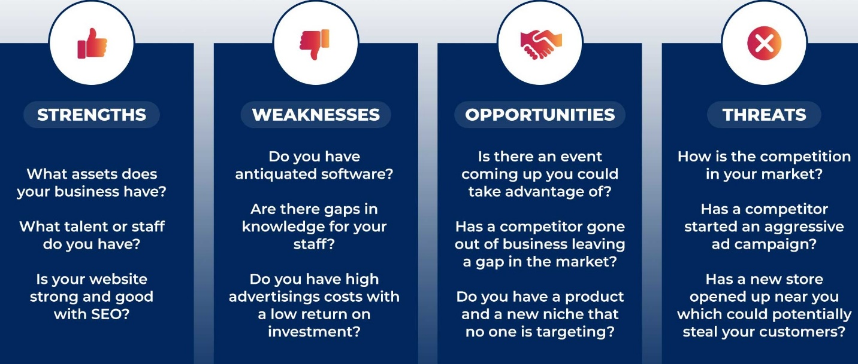

AIDA MODEL :

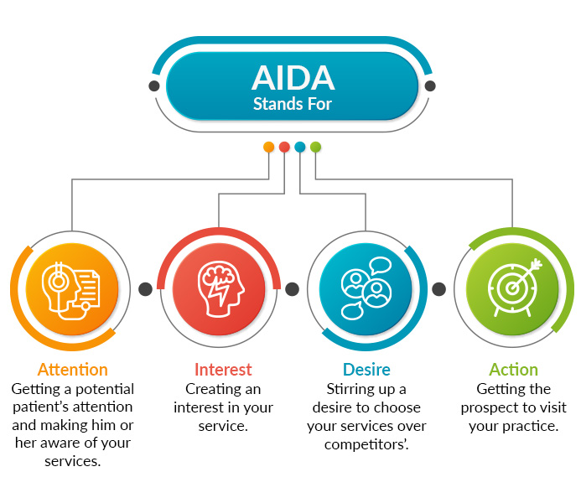

**1**.Attention: Capture the attention of your target audience with a headline that highlights the benefits of your travel management system.

•Use eye-catching visuals and graphics that showcase the key features and benefits of your system.

•Run targeted social media ads that promote your system to potential customers.

•Use influencer marketing to generate interest and awareness among your target audience.

**2.** Interest: Once you have captured your audience's attention, generate interest in your travel management system by highlighting its features and capabilities.

•Develop educational content that explains how your system can help businesses save time and

Money

•Share case studies and customer success stories that showcase how your system has helped other businesses manage their travel more efficiently.

•Create webinars and product demos that showcase your system's features and functionality

**3**.Desire: Create a desire for your travel management system by highlighting the unique benefits and advantages that it offers.

•Show how your system can streamline the travel booking and approval process, saving time and increasing efficiency.

•Highlight the cost savings and ROI that businesses can achieve by using your system.

• Use customer reviews and testimonials to showcase the success that businesses have had with your system.

**4.Action:** Encourage potential customers to take action and purchase your travel management system.

• Make it easy for potential customers to purchase your system with a clear and easy-to-use checkout process.

• Offer a free trial or demo of your system to encourage potential customers to try it out.

• Use email campaigns and retargeting ads to follow up with potential customers and encourage them to take action.

By using the AIDA model, you can create a comprehensive marketing plan for your travel management system that captures your audience's attention, generates interest, creates desire, and encourages action.

1. **Cost and Profit Analysis**

**COCOMO MODEL**

In COCOMO model we know,

Effort = a (KLOC)^b (person-month)

Development Time = c (Effort)^d (month)

Here,

Line of code ( LOC) = 30000

Kloc = 30

a = 2.4

b = 1.05

c = 2.5

d = 0.38

Effort = a (Kloc)^b

= 2.4(30)^1.05

= 85.34(peron month)

Person Months, PM = c(Effort)^d month

=2.5(85)^0.35 month

=14.26 month

= 11.83 month

Development Time, DM: (2.4*11.8368) =6.626 =7 Months =1232 Working

Devoloping salary in hour = 600 tk

Total devolping costing = 600 * 1232 = 73,9200

Rent expense:

Room per month = 8000 Taka

Total in 12 months = 96000 TakA

Other cost for Room with internet = 3000 * 12 = 36,000

Total cost = 99600 taka

Project Manager Salary:

Per month= 30,000 Taka

Total in 12 months = (30000*12) =360,000 Taka

Accountant Salary:

Per month salary =8,000 Taka

Total in 12 Months = (8000*12) =84,000 Taka

Total marketing cost : 500000 tk

hardware expense estimation : 100000Taka

Requirement Analysis: 100000 taka

Others cost =1000000

**Total cost**

Total cost = 739200 + 99,600 + 100000 + 84,000 + 360000+ 500000 + 60000+ 1000000

= 1,863,800

Total Profit

20% of Total estimated expense =2,121,200*20% = 372560 TAKA

|  |  |
| --- | --- |
| **Area** | **Cost (BDT)** |
| Developer Salary | 73,9200 |
| Rent expense | 99,600 |
| hardware expense estimation | 10,0000 |
| Requirement Analysis | 10,0000 |
| Maintenance | 60,000 |
| Project Manager Salary | 360,000 |
| Accountant Salary | 84,000 |
| Marketing Cost | 500000 |
| Total estimated expense | 1,862,800 |
| Profit | 372560 |

1. **Reference**

1.<https://www.tripadvisor.com>

2.Travel Booking BD - A popular travel booking website in Bangladesh, offering flights, hotels, and holiday packages.

3. <https://www.agoda.com> . Agoda - Provides a wide range of accommodation options in Bangladesh, including hotels, resorts, and vacation rentals.

4.Cocomo model . <https://www.geeksforgeeks.org/software-engineering-cocomo-model5>

5.Digiviger .com (<https://digivizer.com/blog/social-media-ad-targeting-guide/>)

6.<https://www.trip.com/>

1. AIDA MODEL (<https://blog.hubspot.com/marketing/aida-model#:~:text=The%20AIDA%20model%20describes%20the,%2C%20and%20Action%20(AIDA)>.