
NEW YORK CITY COLLEGE OF TECHNOLOGY
THE CITY UNIVERSITY OF NEW YORK
300 JAY STREET, BROOKLYN, NY 11201-1909

Department of Computer Engineering Technology
CET 3510 - OL25 - Microcomputer Systems Technology lab

LABORATORY REPORT No_02

Lab_No_02 Data Format and Date Conversion

Professor: Dr. Rubén Velásquez, Ph.D.
Spring 2021

Student’s Name: Ashahi Shafin
Student’s ID: 23607352

Preparation date: Due date:
February 17, 2021 February 24, 2021

- Table of content

- Table of content
- Objective
- Laboratory tools to perform the task
- Source code
Laboratory No_02 Example 2.2
- Source code Line Description
Laboratory No_02 Example 2.2
- Explaining the output results
Laboratory No_02 Example 2.2
- Program Flow Chart
- Table
- Comments
10.Conclusion

- OBJECTIVE

Laboratory No 2. The basic storage unit for all data in x86 computer is a byte. Find the integer storage size in byte(s) and the maximum and minimum values for different data types. Understand data formats of signs numbers and unsigned numbers practice number conversion among decimal, hexadecimal, and binary numbers.

- LABORATORY TOOLS TO PERFORM THE TASK
Computer NZXT
Microsoft visual studio 2019 Software
Microsoft Word 2019 Software
Microsoft Notepad Software

- SOURCE CODE

Laboratory No_01 Example 2.2

Source Code
#include "stdio.h"
#include<iostream>
#include<bitset>

using namespace std;

int main(void)
{
printf(" Lab_No_02_Data_Formats_and_Data_Conversion\n");
printf(" Module: C++ progrmming \n");
printf(" Ashahi Shafin, ID#23607352\n");
printf(" CET3510-OL25\n");
printf(" Presentation date: February 17, 2021\n");
printf(" Due date: February 24, 2021\n");
printf(" Example 2.2 dataFormatTemp.cpp\n");
printf(" file name: 2.2 dataFormatTemp.cpp\n");
printf("-----------------------------------------------------------------------------\n");

char c1;
unsigned char uc1;
short int i1;
signed char sc1;
unsigned short us1;
unsigned int ui1;

//Data type of char
cout <<"The minimun value of a char"<< CHAR_MIN << endl;
cout <<"The maximun value of a char"<< CHAR_MAX << endl;
cout <<"The stoeage bytes of a char is"<< sizeof(c1) << endl;

cout <<"Input a hexidececimal munchber in the data type, for example 8a" <<endl;
scanf_s("%x", &c1)
// bitset display the number of bits in 8*sizeof(c1);
bitset<8 * sizeof(c1)> charBits(c1);
cout <<"The converted binary valueis "<< charBits << endl;
printf("The converted decimal value is %i \n", c1);
printf("-----------------------------------------------------------------------------\n");

//Data type of signed char
cout <<"The minimun value of a signed char"<< UCHAR_MAX << endl;
cout <<"The stoeage bytes of a sigened char is"<< sizeof(uc1) << endl;

cout <<"Input a hexidececimal munchber in the data type, for example 8a"<< endl;
scanf_s("%x", &uc1)
// bitset display the number of bits in 8*sizeof(uc1)
bitset<8 * sizeof(uc1)> ucharBits(uc1);
cout <<"The converted binary valueis "<< ucharBits << endl;
printf("The converted decimal value is %i \n", uc1);
printf("-----------------------------------------------------------------------------\n");

//Data type of signed short int
cout <<"The minimun value of a short int"<< SHRT_MIN << endl;
cout <<"The maximun value of a short int"<< SHRT_MAX << endl;
cout <<"The stoeage bytes of a short int is"<< sizeof(i1) << endl;

cout <<"Input a hexidececimal munchber in the data type, for example 8a"<< endl;
scanf_s("%x", &i1)
// bitset display the number of bits in 8*sizeof(i1)
bitset<8 * sizeof(i1)> shortBits(i1);
cout <<"The converted binary valueis "<< shortBits << endl;
printf("The converted decimal value is %i \n", i1);
printf("-----------------------------------------------------------------------------\n");

//Data type of signed int
cout <<"The minimun value of a signed char"<< SCHAR_MIN << endl;
cout <<"The maximun value of a signed char"<< SCHAR_MAX << endl;
cout <<"The stoeage bytes of a signed char is"<< sizeof(sc1) << endl;

cout <<"Input a hexidececimal munchber in the data type, for example 8a"<< endl;
scanf_s("%x", &sc1)
// bitset display the number of bits in 8*sizeof(sc1)
bitset<8 * sizeof(sc1)> scharBits(sc1);
cout <<"The converted binary valueis "<< scharBits << endl;
printf("The converted decimal value is %i \n", sc1);
printf("-----------------------------------------------------------------------------\n");

//Data type of unsigned short int
cout <<"The minimun value of a signed char"<< USHRT_MAX << endl;
cout <<"The stoeage bytes of a sigened char is"<< sizeof(us1) << endl;

cout <<"Input a hexidececimal munchber in the data type, for example 8a"<< endl;
scanf_s("%x", &us1)
// bitset display the number of bits in 8*sizeof(us1)
bitset<8 * sizeof(us1)> ushortBits(us1);
cout <<"The converted binary valueis "<< ushortBits<< endl;
printf("The converted decimal value is %i \n", us1);
printf("-----------------------------------------------------------------------------\n");

//Data type of sgned unsigened int
cout <<"The minimun value of a unsigned int"<< INT_MIN << endl;
cout <<"The maximun value of a unsigned int"<< INT_MAX << endl;
cout <<"The stoeage bytes of a unsigned int is" << sizeof(ui1) << endl;

cout <<"Input a hexidececimal munchber in the data type, for example 8a"<< endl;
scanf_s("%x", &ui1)
// bitset display the number of bits in 8*sizeof(ui1)
bitset<8 * sizeof(ui1)> intBits(ui1);
cout <<"The converted binary valueis "<< intBits << endl;
printf("The converted decimal value is %i \n", ui1);
printf("-----------------------------------------------------------------------------\n");

system("pause");
exit(0);
return 0;
}

- SOURCE CODE LINE DESCRIPTION

Laboratory No_02 Example 2.2

Line | Source Code Description
01 | #include "stdio.h"
The stdio.h (standard library header) is a file with ".h" extension that contains the prototypes of standard input-output functions used in c.
02 | #include<iostream>
h, iostream provides basic input and output services for C++ programs. iostream uses the objects cin , cout , cerr , and clog for sending data to and from the standard streams input, output, error (unbuffered), and log (buffered) respectively.
03 | #include<bitset>
Bitset is a container in C++ Standard Template Library for dealing with data at the bit level.
04 | using namespace std;
So when we run a program to print something, “using namespace std” says if you find something that is not declared in the current scope go and check std. using namespace std; are used. It is because computer needs to know the code for the cout, cin functionalities and it needs to know which namespace they are defined.
05 | int main(void)  {  MAIN PROGRAM  }
In C and C++ int main(void) means that the function takes NO arguments. ... Int main(void) is used in C to restrict the function to take any arguments, if you do not put void in those brackets, the function will take ANY number of arguments you supply at call.
06 | printf("*****************************************************************************\n")
Output console to indicate separation marked with asterisks within parentheses.
07 | char c1;  unsigned char uc1;  short int i1;  signed char sc1;  unsigned short us1;  unsigned int ui1;
A variable's type determines the values that the variable can have and the operations that can be performed on it.
08 | cout <<"The minimun value of a char"<< CHAR_MIN << endl;  cout <<"The maximun value of a char"<< CHAR_MAX << endl;  cout <<"The stoeage bytes of a char is"<< sizeof(c1) << endl;  cout <<"Input a hexidececimal munchber in the data type, for example 8a" <<endl;
The cout object in C++ is an object of class ostream. It is used to display the output to the standard output device i.e. monitor. It is associated with the standard C output stream stdout.
09 | scanf_s("%x", &c1)
The scanf_s() function reads data from the standard input stream stdin and writes the data into the location given by argument. Each argument must be a pointer to a variable of a type that corresponds to a type specifier in format. If copying takes place between strings that overlap, the behavior is undefined.
10 | bitset<8 * sizeof(c1)> charBits(c1);
Bitset is a container in C++ Standard Template Library for dealing with data at the bit level.
11 | cout <<"The converted binary valueis "<< charBits << endl;
The cout object in C++ is an object of class ostream. It is used to display the output to the standard output device i.e. monitor. It is associated with the standard C output stream stdout.
12 | printf("The converted decimal value is %i \n", c1);
Output console display information within parenthesis and what in c1.
13 | cout <<"The minimun value of a signed char"<< UCHAR_MAX << endl;  cout <<"The stoeage bytes of a sigened char is"<< sizeof(uc1) << endl;  cout <<"Input a hexidececimal munchber in the data type, for example 8a"<< endl;
The cout object in C++ is an object of class ostream. It is used to display the output to the standard output device i.e. monitor. It is associated with the standard C output stream stdout.
14 | scanf_s("%x", &uc1)
The scanf_s() function reads data from the standard input stream stdin and writes the data into the location given by argument. Each argument must be a pointer to a variable of a type that corresponds to a type specifier in format. If copying takes place between strings that overlap, the behavior is undefined.
15 | bitset<8 * sizeof(uc1)> ucharBits(uc1);
Bitset is a container in C++ Standard Template Library for dealing with data at the bit level.
16 | cout <<"The converted binary valueis "<< ucharBits << endl;
The cout object in C++ is an object of class ostream. It is used to display the output to the standard output device i.e. monitor. It is associated with the standard C output stream stdout.
17 | printf("The converted decimal value is %i \n", uc1);
Output console display information within parenthesis in uc1.
18 | cout <<"The minimun value of a short int"<< SHRT_MIN << endl;  cout <<"The maximun value of a short int"<< SHRT_MAX << endl;  cout <<"The stoeage bytes of a short int is"<< sizeof(i1) << endl;  cout <<"Input a hexidececimal munchber in the data type, for example 8a"<< endl;
The cout object in C++ is an object of class ostream. It is used to display the output to the standard output device i.e. monitor. It is associated with the standard C output stream stdout.
19 | scanf_s("%x", &i1)
The scanf_s() function reads data from the standard input stream stdin and writes the data into the location given by argument. Each argument must be a pointer to a variable of a type that corresponds to a type specifier in format. If copying takes place between strings that overlap, the behavior is undefined.
20 | bitset<8 * sizeof(i1)> shortBits(i1);
Bitset is a container in C++ Standard Template Library for dealing with data at the bit level.
21 | cout <<"The converted binary valueis "<< shortBits << endl;
The cout object in C++ is an object of class ostream. It is used to display the output to the standard output device i.e. monitor. It is associated with the standard C output stream stdout.
22 | printf("The converted decimal value is %i \n", i1);
Output console display information within parenthesis in i1.
23 | cout <<"The minimun value of a signed char"<< SCHAR_MIN << endl;  cout <<"The maximun value of a signed char"<< SCHAR_MAX << endl;  cout <<"The stoeage bytes of a signed char is"<< sizeof(sc1) << endl;  cout <<"Input a hexidececimal munchber in the data type, for example 8a"<< endl;
The cout object in C++ is an object of class ostream. It is used to display the output to the standard output device i.e. monitor. It is associated with the standard C output stream stdout.
24 | scanf_s("%x", &sc1)
The scanf_s() function reads data from the standard input stream stdin and writes the data into the location given by argument. Each argument must be a pointer to a variable of a type that corresponds to a type specifier in format. If copying takes place between strings that overlap, the behavior is undefined.
25 | bitset<8 * sizeof(sc1)> scharBits(sc1);
Bitset is a container in C++ Standard Template Library for dealing with data at the bit level.
27 | cout <<"The converted binary valueis "<< scharBits << endl;
The cout object in C++ is an object of class ostream. It is used to display the output to the standard output device i.e. monitor. It is associated with the standard C output stream stdout.
28 | printf("The converted decimal value is %i \n", sc1);
Output console display information within parenthesis in sc1.
29 | cout <<"The minimun value of a signed char"<< USHRT_MAX << endl;  cout <<"The stoeage bytes of a sigened char is"<< sizeof(us1) << endl;  cout <<"Input a hexidececimal munchber in the data type, for example 8a"<< endl;
The cout object in C++ is an object of class ostream. It is used to display the output to the standard output device i.e. monitor. It is associated with the standard C output stream stdout.
30 | scanf_s("%x", &us1)
The scanf_s() function reads data from the standard input stream stdin and writes the data into the location given by argument. Each argument must be a pointer to a variable of a type that corresponds to a type specifier in format. If copying takes place between strings that overlap, the behavior is undefined.
31 | bitset<8 * sizeof(us1)> ushortBits(us1);
Bitset is a container in C++ Standard Template Library for dealing with data at the bit level.
32 | cout <<"The converted binary valueis "<< ushortBits<< endl;
The cout object in C++ is an object of class ostream. It is used to display the output to the standard output device i.e. monitor. It is associated with the standard C output stream stdout.
33 | printf("The converted decimal value is %i \n", us1);
Output console display information within parenthesis in uc1.
34 | cout <<"The minimun value of a unsigned int"<< INT_MIN << endl;  cout <<"The maximun value of a unsigned int"<< INT_MAX << endl;  cout <<"The stoeage bytes of a unsigned int is" << sizeof(ui1) << endl;  cout <<"Input a hexidececimal munchber in the data type, for example 8a"<< endl;
The cout object in C++ is an object of class ostream. It is used to display the output to the standard output device i.e. monitor. It is associated with the standard C output stream stdout.
35 | scanf_s("%x", &ui1)
The scanf_s() function reads data from the standard input stream stdin and writes the data into the location given by argument. Each argument must be a pointer to a variable of a type that corresponds to a type specifier in format. If copying takes place between strings that overlap, the behavior is undefined.
36 | bitset<8 * sizeof(ui1)> intBits(ui1);
Bitset is a container in C++ Standard Template Library for dealing with data at the bit level.
37 | cout <<"The converted binary valueis "<< intBits << endl;
The cout object in C++ is an object of class ostream. It is used to display the output to the standard output device i.e. monitor. It is associated with the standard C output stream stdout.
38 | printf("The converted decimal value is %i \n", ui1);
Output console display information within parenthesis in ui1.
39 | sytem(“pause”);
System("pause") runs the Windows command-line "pause" program and waits for that to terminate before it continues execution of the program , the console window stays open so you can read the output.
40 | exit(0);
In the C Programming Language, the exit function calls all functions registered with atexit and terminates the program. File buffers are flushed, streams are closed, and temporary files are deleted.
41 | return 0;
Terminates the execution of a function and returns control to the calling function (or to the operating system if you transfer control from the main function). Execution resumes in the calling function at the point immediately following the call.

- EXPLANING OUTPUT RESULTS

Laboratory No_02 Example 2.2

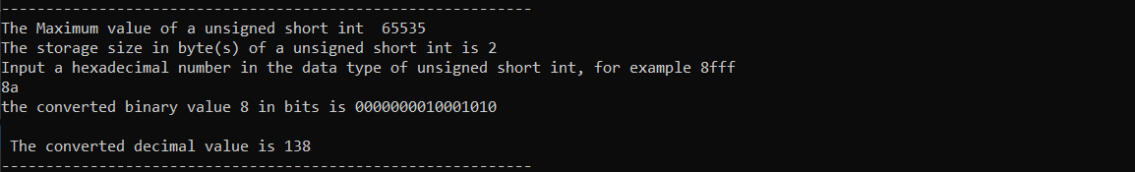
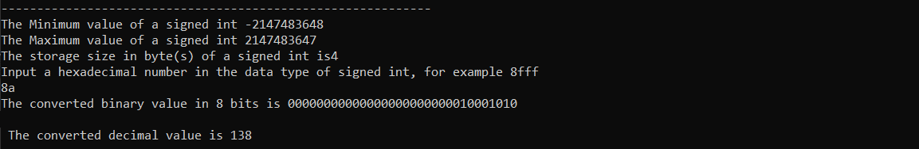
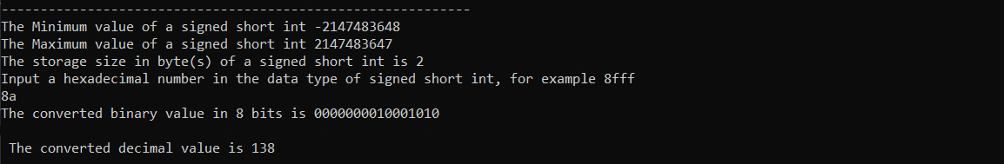
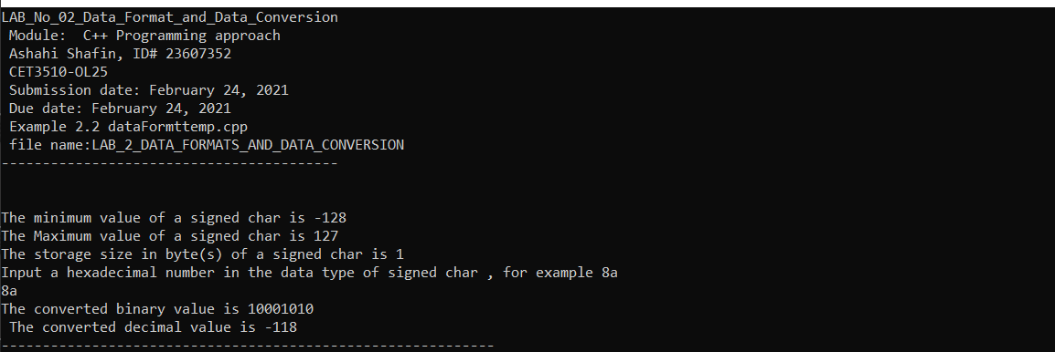
- This is the output console of example 2.2 for laboratory 2. It show the CHAR_MIN and MAX UCHAR_MAX SHRT_MIN and MAX SCHAR_MIN and MAX USHRT_MAX INT_MIN and MAX in 8 bit however this lab would be longer if we have added the 16 and 32 bit display and would take too long to explain. They would have also make the output very long.

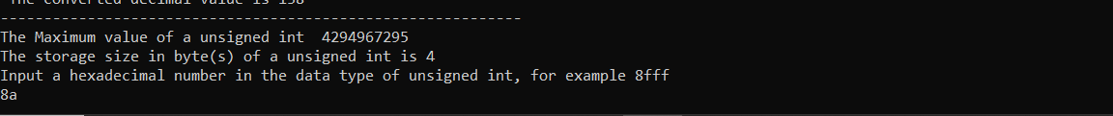
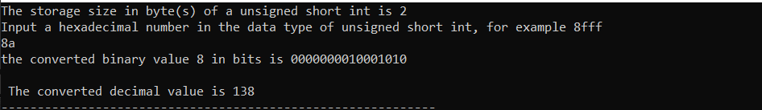
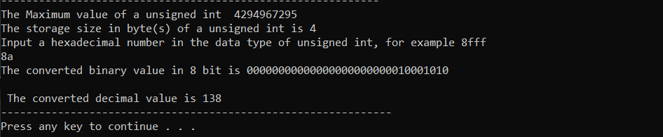

- PROGRAM FLOW CHART:

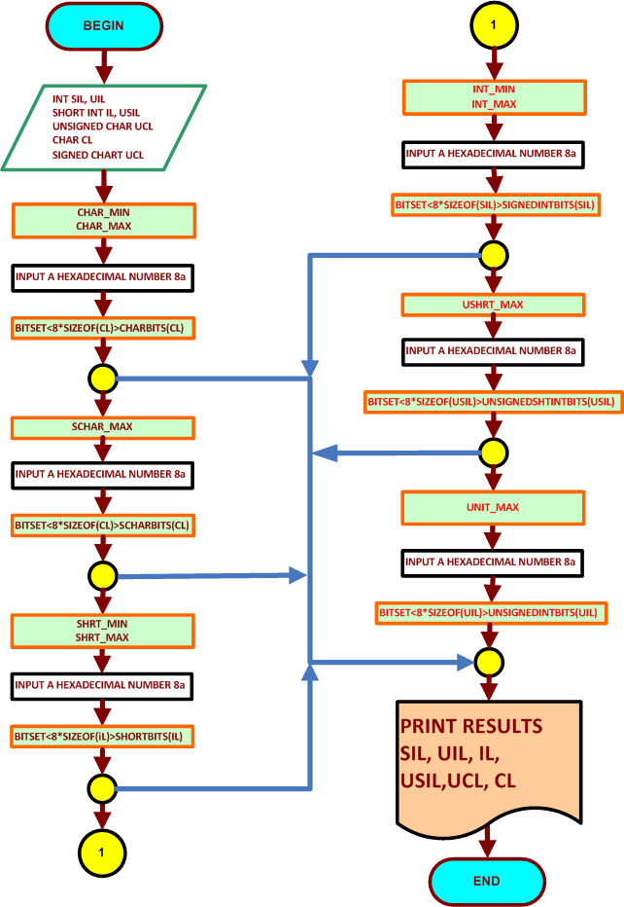

- COMMENTS

Comments on Outputs shows how 8-bit conversion work while using variables and making work char short signed unsigned and int. with this we can see what are going to be max and min for these variables. And it show which bit rate we are using in our case we only used 8 bit

- CONCLUSION

In this experiment, the module shows us the max and min for char short int unsigned char short char and unsigned short and after that it will ask us to convert 8a into binary and decimal. This was also used in a 8 bit method because if we did this 16 and 32 bits then the lab will be much longer and the output will be off the screen. The thing I had problem with this lab was coding it because I keep on getting errors and had to fix them in fact I had 14 errors and it was because I cout as count so I had hard time trying to see what I did wrong since count is real word I got confused.

A day in real life can be used with this code is a computer because they use many different type of bit like 8 16 32 64 and they use binary an decimals to communicate the files and max and min value can show how much they can hold in a drive. The computer also using this in order to transfer data and it can show you how bunch bit it taking to transfer and it will be very useful for a lot of people when they look into file transferring.

