
NEW YORK CITY COLLEGE OF TECHNOLOGY
THE CITY UNIVERSITY OF NEW YORK
300 JAY STREET, BROOKLYN, NY 11201-1909

Department of Computer Engineering Technology
CET 3510 - OL25 - Microcomputer Systems Technology lab

LABORATORY REPORT No_05

Lab_No_05 Addressing Modes

Professor: Dr. Rubén Velásquez, Ph.D.
Spring 2021

Student’s Name: Ashahi Shafin
Student’s ID: 23607352

Preparation date: Due date:
March 10, 2021 March 17, 2021

- Table of content

- Table of content
- Objective
- Laboratory tools to perform the task
- Source code
Laboratory No_05 Example 5.2
- Source code Line Description
Laboratory No_05 Example 5.2
- Explaining the output results
Laboratory No_05 Example 5.2
- Program Flow Chart
- Table
- Comments
10.Conclusion

- OBJECTIVE

Laboratory No 5.

- LABORATORY TOOLS TO PERFORM THE TASK
Computer NZXT
Microsoft visual studio 2015 Software
Microsoft Word 2019 Software
Microsoft Notepad Software

- SOURCE CODE

Laboratory No_05 Example 5.2

Source Code
#include <iostream>
using namespace std;

int main()
{
printf(" Lab_No_05_Addressing_Modes\n");
printf(" Module: C++ progrmming \n");
printf(" Ashahi Shafin, ID#23607352\n");
printf(" CET3510-OL25\n");
printf(" Presentation date: March 10, 2021\n");
printf(" Due date: March 17, 2021\n");
printf(" Example 5.2 addressingModesTemp.cpp\n");
printf(" file name: 5.2 addressingModesTemp.cpp\n");
printf("-----------------------------------------------------------------------------\n");

const int n = 5; //the dimension of an array
//more delclaration and initilization here
unsigned int u32_arr[n] = { 0x00000041, 0x00000052, 0xabcd1169, '1234', 'aABc'};
unsigned int u0, u1, u2, u3, u4;
unsigned int *uPtr;
int i; // used as index
int u0_addr, u1_addr, u2_addr, u3_addr, u4_addr;

signed int i32_arr[n] = { 0x00000041, 0x00000052, 0xabcd1169, '1234', 'aABc' };
signed int i0, i1, i2, i3, i4;
signed int *iPtr;
int i0_addr, i1_addr, i2_addr, i3_addr, i4_addr;

cout << "+++++++++++++++++++++++++++++++++++++++++++++++++++++++++++++++++++++++++++++++\n";
//Display hxadecimal and decimal value each element of the unsigned int array
cout << "The value of each element of 32 bit unsigned int array" << endl << endl << endl;
for (i = 0; i < n; i++)
{
cout<<"The value and the size of element" <<dec<<i;
cout << " in an array are 0x" << hex << u32_arr[i]
<< "and " << sizeof(u32_arr[i]) << "byte(s)" << endl;
}
printf("-----------------------------------------------------------------------------\n");
uPtr = u32_arr;
//Display the 32-bit address in hexadecimal format
cout << "The memory address of the array is 0x" << hex << uPtr << endl;

//The retrieved value from different address modes
_asm
{
//EBX holds the address of element 0 in the array
mov EBX, uPtr;

/*u0 holds the retrieved value from the indirect address contained
in the register EBX*/
mov EAX, [EBX];
mov u0, EAX;
mov u0_addr, EBX;

/*EBX is increased by 4 due u32_arr is an unsigned int array (4 bytes)
EBX holds the address of element 1 in the array*/
mov ECX, 4H;
add EBX, ECX;

/*u1 holds the retrieved value from the indirect address contained
in the register EBX*/
mov EAX, [EBX];
mov u1, EAX;
mov u1_addr, EBX;

/*EBX+4H holds the address of element 2 in the array
u2 holds the retrieved values from the register relative addressing*/
mov EAX, [EBX + 4H];
mov u2, EAX;

//EDI hold the address of element 2 in an array
mov EDI, EBX;
add EDI, 4H;
mov u2_addr, EDI;

/*EBX+8H holds the address of element 3 in the array
u3 holds the retrieved value from the register relative addressing*/
mov EAX, [EBX + 8H];
mov u3, EAX;

//EDI holds the address of element 3 in the array
mov EDI, EBX;
add EDI, 8H;
mov u3_addr, EDI;

/*EBX+12H holds the address of element 4 in the array
u4 holds the retrieved value from the register relative addressing*/
mov EAX, [EDI + 4H];
mov u4, EAX;

//EDI holds the address of element 4 in the array
mov ESI, EDI;
add ESI, 4H;
mov u4_addr, ESI;
}

//Display the retrieved value from different address modes
cout << "--------------------------------------------------------------" << endl;
cout << "The retrieved values 0x" << hex << u0 << "\t at the address of 0x" << hex << u0_addr << endl;
cout << "The retrieved values 0x" << hex << u1 << "\t at the address of 0x" << hex << u1_addr << endl;
cout << "The retrieved values 0x" << hex << u2 << "\t at the address of 0x" << hex << u2_addr << endl;
cout << "The retrieved values 0x" << hex << u3 << "\t at the address of 0x" << hex << u3_addr << endl;
cout << "The retrieved values 0x" << hex << u4 << "\t at the address of 0x" << hex << u4_addr << endl;
cout << "+++++++++++++++++++++++++++++++++++++++++++++++++++++++++++++++++++++++++++++++++++\n";

//Display hexadecimal and decimal values each element of the signed int array
cout << "--- The value of each element of 32-bit signed int array ----" << endl << endl << endl;
for (i = 0; i < n; i++)
{
cout << "The value and the size of element " << dec << i;
cout << " in an array are 0x" << hex << i32_arr[i] << " and " << sizeof(i32_arr[i]) << " byte(s) " << endl;
}
printf("---------------------------------------------------------------\n");
iPtr = i32_arr;

//Display the 32-bit address in hexadecimal format
cout << "The memory address of the array is 0x" << hex << iPtr << endl;

//The retrieved value from different address modes
_asm
{
//EBX holds the address of element 0 in the array
mov EBX, iPtr;

/*i0 holds the retrieved value from the indirect address contained
in the register EBX*/
mov EAX, [EBX];
mov i0, EAX;
mov i0_addr, EBX;

/*EBX is increased by 4 due i32_arr is an signed int array (4 bytes)
EBX holds the address of element 1 in the array*/
mov ECX, 4H;
add EBX, ECX;

/*i1 holds the retrieved value from the indirect address contained
in the register EBX*/
mov EAX, [EBX];
mov i1, EAX;
mov i1_addr, EBX;

/*EBX+4H holds the address of element 2 in the array
u2 holds the retrieved values from the register relative addressing*/
mov EAX, [EBX + 4H];
mov i2, EAX;

//EDI hold the address of element 2 in an array
mov EDI, EBX;
add EDI, 4H;
mov i2_addr, EDI;

/*EBX+8H holds the address of element 3 in the array
i3 holds the retrieved value from the register relative addressing*/
mov EAX, [EBX + 8H];
mov i3, EAX;

//EDI holds the address of element 3 in the array
mov EDI, EBX;
add EDI, 8H;
mov i3_addr, EDI;

/*EBX+12H holds the address of element 4 in the array
i4 holds the retrieved value from the register relative addressing*/
mov EAX, [EDI + 4H];
mov i4, EAX;

//EDI holds the address of element 4 in the array
mov ESI, EDI;
add ESI, 4H;
mov i4_addr, ESI;
}

//Display the retrieved value from different address modes
cout << "--------------------------------------------------------------" << endl;
cout << "The retrieved values 0x" << hex << i0 << "\t at the address of 0x" << hex << i0_addr << endl;
cout << "The retrieved values 0x" << hex << i1 << "\t at the address of 0x" << hex << i1_addr << endl;
cout << "The retrieved values 0x" << hex << i2 << "\t at the address of 0x" << hex << i2_addr << endl;
cout << "The retrieved values 0x" << hex << i3 << "\t at the address of 0x" << hex << i3_addr << endl;
cout << "The retrieved values 0x" << hex << i4 << "\t at the address of 0x" << hex << i4_addr << endl;
cout << "\n\n\n\n\n";

system("pause");
exit(0);
return 0;

}

- SOURCE CODE LINE DESCRIPTION

Laboratory No_05 Example 5.2

Line | Source Code Description
01 | #include "stdio.h"
The stdio.h (standard library header) is a file with ".h" extension that contains the prototypes of standard input-output functions used in c.
02 | #include<iostream>
h, iostream provides basic input and output services for C++ programs. iostream uses the objects cin , cout , cerr , and clog for sending data to and from the standard streams input, output, error (unbuffered), and log (buffered) respectively.
03 | int main(void)  {  MAIN PROGRAM  }
In C and C++ int main(void) means that the function takes NO arguments. ... Int main(void) is used in C to restrict the function to take any arguments, if you do not put void in those brackets, the function will take ANY number of arguments you supply at call.
04 | printf("++++++++++++++++++++++++++++++++++++++++++++++++++++++++++++++++++++++++++++\n");  printf("----------The address of each element of 32 bit array--------\n\n");
Output console to indicate separation marked with asterisks within parentheses.
05 | int const size = 4;  int i32_arr[size] = { 0x8000000, 0x0000ffff, -660000, 6600000};  int *ivPtr0, *ivPtr1, *ivPtr2, *ivPtr3;  int md[4], madd[4];  int i;
A variable's type determines the values that the variable can have and the operations that can be performed on it.
06 | ivPtr0 = &i32_arr[0];  ivPtr1 = &i32_arr[1];  ivPtr2 = &i32_arr[2];  ivPtr3 = &i32_arr[3];
the array, which stores a fixed-size sequential collection of elements of the same type. An array is used to store a collection of data, but it is often more useful to think of an array as a collection of variables of the same type.
07 | for (i = 0; i<size; i++)
A for loop is a repetition control structure that allows you to efficiently write a loop that needs to execute a specific number of times.
08 | printf("The value of element %d in an array is 0x%X (hex), %d (decimal)\n",  i, i32_arr[i], i32_arr[i], i32_arr[i]);
Output console to indicate separation marked with asterisks within parentheses.
09 | printf("++++++++++++++++++++++++++++++++++++++++++++++++++++++++++++++++++++++++++++\n");  printf("----------The address of each element of 32 bit array--------\n\n");
Output console to indicate separation marked with asterisks within parentheses.
10 | for (i = 0; i<size; i++)
A for loop is a repetition control structure that allows you to efficiently write a loop that needs to execute a specific number of times.
11 | printf("The memory address of element %d in an array is 0x%x (hexidecimal),\n", i, ivPtr0+i);  printf("+++++++++++++++++++++++++++++++++++++++++++++++++++++++++++++++++++++++++++\n");  printf("----------The size information in bytes of an 32 bit array--------\n");  printf("The total numbers in bytes of an 32 bit array with 4 elements in %d bytes\n",
Output console to indicate separation marked with asterisks within parentheses.
12 | sizeof (i32_arr));
The sizeof is a keyword, but it is a compile-time operator that determines the size, in bytes, of a variable or data type. The sizeof operator can be used to get the size of classes, structures, unions and any other user defined data type. The syntax of using sizeof is as follows − sizeof (data type)
13 | for (i = 0; i<size; i++)
A for loop is a repetition control structure that allows you to efficiently write a loop that needs to execute a specific number of times.
14 | md[i] = sizeof(i32_arr[i]);  madd[i] = sizeof(ivPtr0+i);
The sizeof is a keyword, but it is a compile-time operator that determines the size, in bytes, of a variable or data type. The sizeof operator can be used to get the size of classes, structures, unions and any other user defined data type. The syntax of using sizeof is as follows − sizeof (data type)
15 | printf("----------------------------------------\n");  printf("The size of element %d is %d bytes\n", i, md[i]);  printf("The size of the address of the element %d is %d bytes\n ", i, madd[i]);
Output console to indicate separation marked with asterisks within parentheses.
16 | system("pause");
This is a Windows-specific command, which tells the OS to run the pause program. This program waits to be terminated, and halts the exceution of the parent C++ program. Only after the pause program is terminated, will the original program continue.
17 | return 0;
Terminates the execution of a function and returns control to the calling function (or to the operating system if you transfer control from the main function). Execution resumes in the calling function at the point immediately following the call.

- EXPLANING OUTPUT RESULTS

Laboratory No_05 Example 5.2

- This is the output console of example 5.2 for laboratory 5. It shows 32-bit array with 4 elements. It also shows the hex and decimal value of the 4 elements. After that it show the address of the 4 elements. Then it shows the size information in bytes. Also we did not do 8 or 16 bit because than it would be too long.

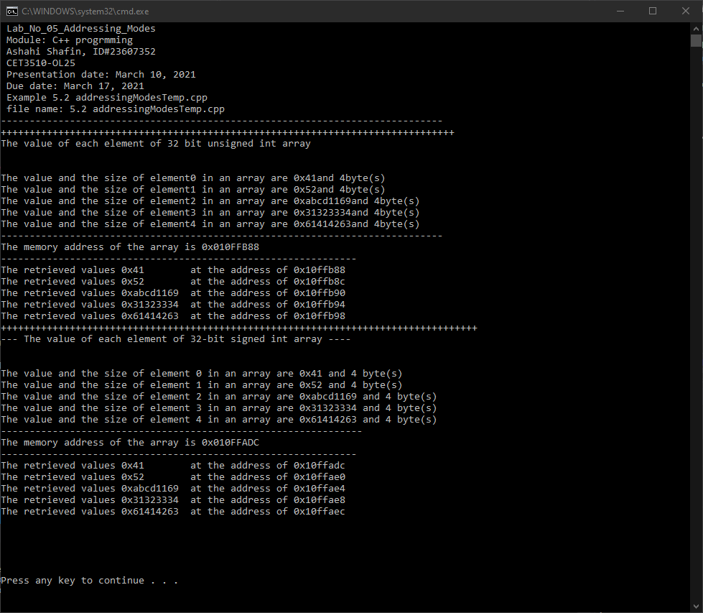

- PROGRAM FLOW CHART:

- Table No 5.2 data type, memory contents, and memory addresses
Data type | Variable name | Memory content (hexadecimal) | Address (hexadecimal)
unsigned int | u32_arr[0]
unsigned int | u32_arr[1]
unsigned int | u32_arr[2]
unsigned int | u32_arr[3]
unsigned int | u32_arr[4]
signed int | i32_arr[0]
signed int | i32_arr[1]
signed int | i32_arr[2]
signed int | i32_arr[3]
signed int | i32_arr[4]

- COMMENTS

Comments on Outputs shows how Elements are getting the hex and decimal value and getting the address and storge information as well.

- CONCLUSION

In this experiment, the module shows

A real-life application for laboratory No

