
NEW YORK CITY COLLEGE OF TECHNOLOGY
THE CITY UNIVERSITY OF NEW YORK
300 JAY STREET, BROOKLYN, NY 11201-1909

Department of Computer Engineering Technology
CET 3510 - OL25 - Microcomputer Systems Technology lab

LABORATORY REPORT No_04

Lab_No_04 Data Memory Address

Professor: Dr. Rubén Velásquez, Ph.D.
Spring 2021

Student’s Name: Ashahi Shafin
Student’s ID: 23607352

Preparation date: Due date:
March 03, 2021 March 10, 2021

- Table of content

- Table of content
- Objective
- Laboratory tools to perform the task
- Source code
Laboratory No_04 Example 4.3
- Source code Line Description
Laboratory No_04 Example 4.3
- Explaining the output results
Laboratory No_04 Example 4.3
- Program Flow Chart
- Table
- Comments
10.Conclusion

- OBJECTIVE

Laboratory No 4. To access and explain the computer memory addresses. To develop a program for moving data between the CPU and RAM and find the contents and addresses for each memory variable. To exam the address relationship among the memory variables and declared pointers. To find the size of a variable in bytes.

- LABORATORY TOOLS TO PERFORM THE TASK
Computer NZXT
Microsoft visual studio 2015 Software
Microsoft Word 2019 Software
Microsoft Notepad Software

- SOURCE CODE

Laboratory No_04 Example 4.3

Source Code
#include <stdio.h>
#include <iostream>
int main()
{
printf(" Lab_No_04_Memory_Addresses\n");
printf(" Module: C++ progrmming \n");
printf(" Ashahi Shafin, ID#23607352\n");
printf(" CET3510-OL25\n");
printf(" Presentation date: March 03, 2021\n");
printf(" Due date: March 10, 2021\n");
printf(" Example 4.3 addressContentTemp32bits.cpp\n");
printf(" file name: 4.3 addressContentTemp32bits.cpp\n");
printf("-----------------------------------------------------------------------------\n");

int const size = 4;
int i32_arr[size] = { 0x8000000, 0x0000ffff, -660000, 6600000}; //32 bit array
int *ivPtr0, *ivPtr1, *ivPtr2, *ivPtr3; //they are used to store the addresses
int md[4], madd[4];
int i; // used as index

//address for each element in an array i32_arr[4]
ivPtr0 = &i32_arr[0];
ivPtr1 = &i32_arr[1];
ivPtr2 = &i32_arr[2];
ivPtr3 = &i32_arr[3];

//Display Hax value, decimal value, and char value for each element of t array
printf("++++++++++++++++++++++++++++++++++++++++++++++++++++++++++++++++++++++++++++++\n");
printf("----------The address of each element of 32 bit array--------\n\n");
for (i = 0; i<size; i++)
{
printf("The value of element %d in an array is 0x%X (hex), %d (decimal)\n",
i, i32_arr[i], i32_arr[i], i32_arr[i]);
}
//Display address in hexadecimal for each element of the array
printf("++++++++++++++++++++++++++++++++++++++++++++++++++++++++++++++++++++++++++++++\n");
printf("----------The address of each element of 32 bit array--------\n\n");
for (i = 0; i<size; i++)

{
printf("The memory address of element %d in an array is 0x%x (hexidecimal),\n", i, ivPtr0+i);
}
printf("++++++++++++++++++++++++++++++++++++++++++++++++++++++++++++++++++++++++++++++\n");

//Find the total numbers in byte of array i32_arr[4]
printf("----------The size information in bytes of an 32 bit array--------\n");
printf("The total numbers in bytes of an 32 bit array with 4 elements in %d bytes\n",
sizeof (i32_arr));

//Find the number of bytes of each element
for (i = 0; i<size; i++)
{
md[i] = sizeof(i32_arr[i]);
madd[i] = sizeof(ivPtr0+i);
printf("----------------------------------------\n");
printf("The size of element %d is %d bytes\n", i, md[i]);
printf("The size of the address of the element %d is %d bytes\n ", i, madd[i]);
}

system("pause");
return 0;

}

- SOURCE CODE LINE DESCRIPTION

Laboratory No_04 Example 4.3

Line | Source Code Description
01 | #include "stdio.h"
The stdio.h (standard library header) is a file with ".h" extension that contains the prototypes of standard input-output functions used in c.
02 | #include<iostream>
h, iostream provides basic input and output services for C++ programs. iostream uses the objects cin , cout , cerr , and clog for sending data to and from the standard streams input, output, error (unbuffered), and log (buffered) respectively.
03 | int main(void)  {  MAIN PROGRAM  }
In C and C++ int main(void) means that the function takes NO arguments. ... Int main(void) is used in C to restrict the function to take any arguments, if you do not put void in those brackets, the function will take ANY number of arguments you supply at call.
04 | printf("++++++++++++++++++++++++++++++++++++++++++++++++++++++++++++++++++++++++++++\n");  printf("----------The address of each element of 32 bit array--------\n\n");
Output console to indicate separation marked with asterisks within parentheses.
05 | int const size = 4;  int i32_arr[size] = { 0x8000000, 0x0000ffff, -660000, 6600000};  int *ivPtr0, *ivPtr1, *ivPtr2, *ivPtr3;  int md[4], madd[4];  int i;
A variable's type determines the values that the variable can have and the operations that can be performed on it.
06 | ivPtr0 = &i32_arr[0];  ivPtr1 = &i32_arr[1];  ivPtr2 = &i32_arr[2];  ivPtr3 = &i32_arr[3];
the array, which stores a fixed-size sequential collection of elements of the same type. An array is used to store a collection of data, but it is often more useful to think of an array as a collection of variables of the same type.
07 | for (i = 0; i<size; i++)
A for loop is a repetition control structure that allows you to efficiently write a loop that needs to execute a specific number of times.
08 | printf("The value of element %d in an array is 0x%X (hex), %d (decimal)\n",  i, i32_arr[i], i32_arr[i], i32_arr[i]);
Output console to indicate separation marked with asterisks within parentheses.
09 | printf("++++++++++++++++++++++++++++++++++++++++++++++++++++++++++++++++++++++++++++\n");  printf("----------The address of each element of 32 bit array--------\n\n");
Output console to indicate separation marked with asterisks within parentheses.
10 | for (i = 0; i<size; i++)
A for loop is a repetition control structure that allows you to efficiently write a loop that needs to execute a specific number of times.
11 | printf("The memory address of element %d in an array is 0x%x (hexidecimal),\n", i, ivPtr0+i);  printf("+++++++++++++++++++++++++++++++++++++++++++++++++++++++++++++++++++++++++++\n");  printf("----------The size information in bytes of an 32 bit array--------\n");  printf("The total numbers in bytes of an 32 bit array with 4 elements in %d bytes\n",
Output console to indicate separation marked with asterisks within parentheses.
12 | sizeof (i32_arr));
The sizeof is a keyword, but it is a compile-time operator that determines the size, in bytes, of a variable or data type. The sizeof operator can be used to get the size of classes, structures, unions and any other user defined data type. The syntax of using sizeof is as follows − sizeof (data type)
13 | for (i = 0; i<size; i++)
A for loop is a repetition control structure that allows you to efficiently write a loop that needs to execute a specific number of times.
14 | md[i] = sizeof(i32_arr[i]);  madd[i] = sizeof(ivPtr0+i);
The sizeof is a keyword, but it is a compile-time operator that determines the size, in bytes, of a variable or data type. The sizeof operator can be used to get the size of classes, structures, unions and any other user defined data type. The syntax of using sizeof is as follows − sizeof (data type)
15 | printf("----------------------------------------\n");  printf("The size of element %d is %d bytes\n", i, md[i]);  printf("The size of the address of the element %d is %d bytes\n ", i, madd[i]);
Output console to indicate separation marked with asterisks within parentheses.
16 | system("pause");
This is a Windows-specific command, which tells the OS to run the pause program. This program waits to be terminated, and halts the exceution of the parent C++ program. Only after the pause program is terminated, will the original program continue.
17 | return 0;
Terminates the execution of a function and returns control to the calling function (or to the operating system if you transfer control from the main function). Execution resumes in the calling function at the point immediately following the call.

- EXPLANING OUTPUT RESULTS

Laboratory No_03 Example 4.3

- This is the output console of example 4.3 for laboratory 4. It shows 32-bit array with 4 elements. It also shows the hex and decimal value of the 4 elements. After that it show the address of the 4 elements. Then it shows the size information in bytes. Also we did not do 8 or 16 bit because than it would be too long.

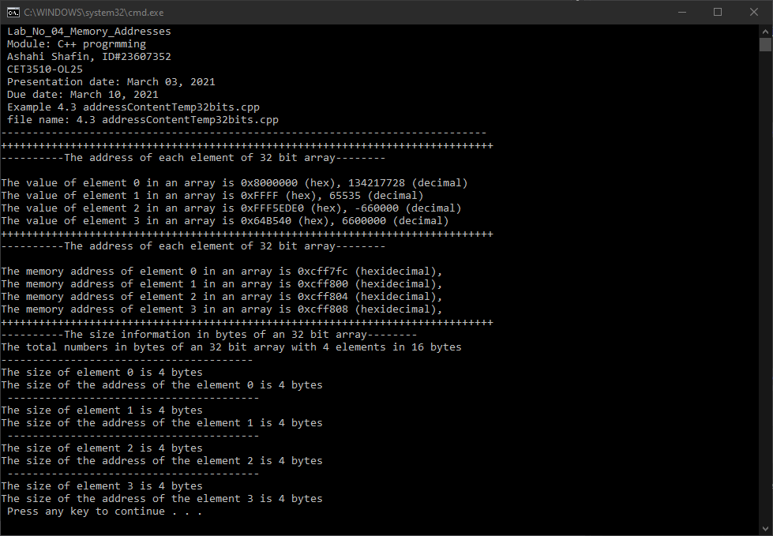

- PROGRAM FLOW CHART:

- Table No 4.3 data type, memory contents, and memory addresses

Data type | Variable name | Hexadecimal | Decimal | Address
int (an array with 4 elements) | i32_arr[0] | 0x8000000 | 134217728 | 0x3dfed0
int (an array with 4 elements) | i32_arr[1] | 0xFFFF | 65535 | 0x3dfed4
int (an array with 4 elements) | i32_arr[2] | 0xFFF5EDE0 | -660000 | 0x3dfed8
int (an array with 4 elements) | i32_arr[3] | 0x64B540 | 6600000 | 0x3dfedc

- COMMENTS

Comments on Outputs shows how Elements are getting the hex and decimal value and getting the address and storge information as well.

- CONCLUSION

In this experiment, the module shows when you add elements to your variable it can find the hexadecimals, decimals, addresses, and size information. These are also in 32 bits because if we did 8 and 16 bit this lab would be much longer, and it will have more variable. That will make the output too long and then take a lot of time and explaining. What I had a hard time toing in this lab was making the code because I put 3 extra semicolon and didn’t realized I put them since I’m used to putting it at the end of every line.

A real-life application for laboratory No 4 is a computer because the computer they use these variables to commutate with each other this is also very helpful with data transferring when it decode and decode it. With the addresses you tell which computer it is and what size they can have.

