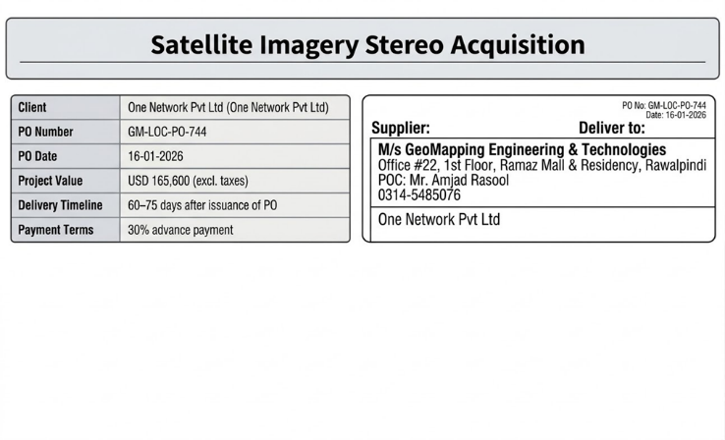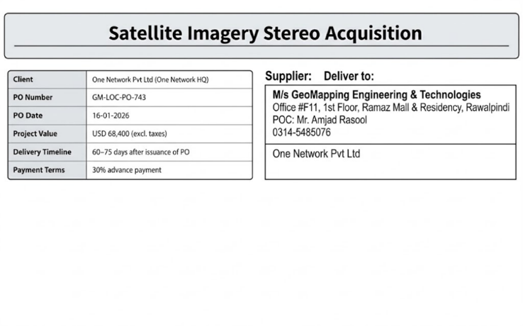
Sr. No. | Project | Status
01 | Satellite-Based Identification of Minerals in the Sakhakot Area Using Hyperspectral Imagery | Completed
02 | Satellite Imagery Stereo Acquisition (600 sq. km, 2m resolution), PO GM-LOC-PO-743 | Completed
03 | Satellite Imagery Stereo Acquisition (600 sq. km, 2m resolution), PO GM-LOC-PO-744 | Completed
04 | Hill Torrent Digital Survey of Koh-E-Suleman Range, Dera Ghazi Khan (web dashboard for water body inventory) | Completed




