Git is a DevOps tool for source code management—an open-source version control system (VCS) used to handle small to very large projects efficiently. [Git is used](https://www.simplilearn.com/tutorials/git-tutorial/what-is-git) to tracking changes in the source code

Download the [latest version of Git](https://git-scm.com/downloads) and choose the 64/32 bit version. After the file is downloaded, install it in the system. Once installed, select Launch the Git Bash, then click on finish. The Git Bash is now launched.

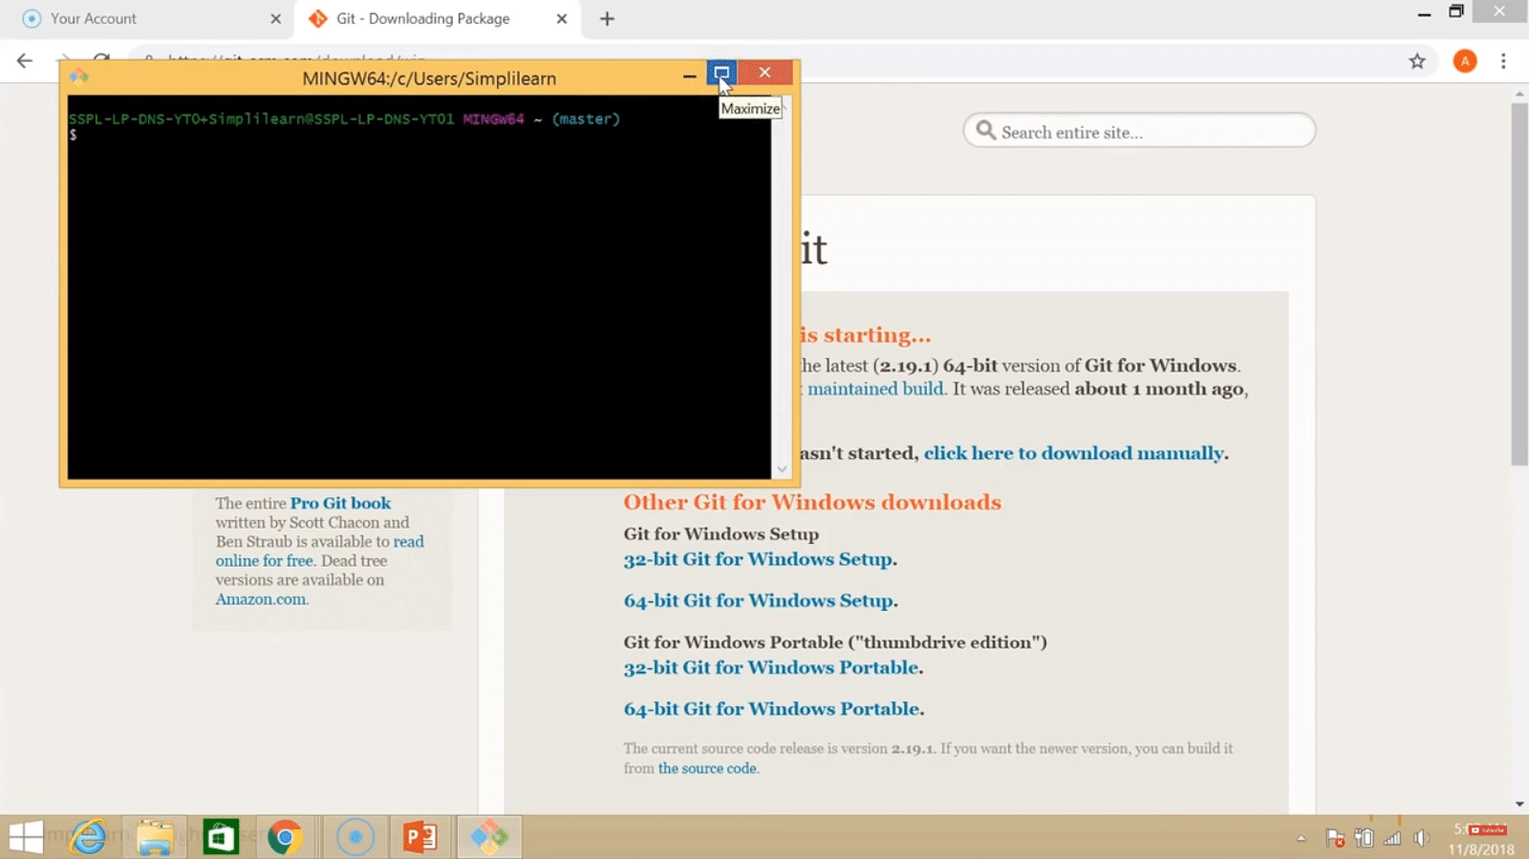

Step 2:

Check the Git version:

|  |
| --- |
| $ git --version |

Step 3:

For any help, use the following command:

|  |
| --- |
| $ git help config |

This command will lead you to a browser of [config commands](https://www.simplilearn.com/tutorials/git-tutorial/git-commands). Basically, the help the command provides a manual from the help page for the command just following it (here, it's config).

Another way to use the same command is as follows:

|  |
| --- |
| $ git config --help |

Step 4:

Create a local directory using the following command:

|  |
| --- |
| $ mkdir test  $ cd test |

Step 5:

The next step is to initialize the directory:

|  |
| --- |
| $ git init |

Step 6:

Go to the folder where "test" is created and create a text document named "demo." Open "demo" and put any content, like "Hello Simplilearn." Save and close the file.

Step 7:

Enter the Git bash interface and type in the following command to check the status:

|  |
| --- |
| $ git status |

Step 8:

Add the "demo" to the current directory using the following command:

|  |
| --- |
| $ git add demo.txt |

Step 9:

Next, make a commit using the following command:

|  |
| --- |
| $ git commit -m "committing a text file" |

Step 10:

Link the Git to a [Github](https://www.simplilearn.com/tutorials/git-tutorial/what-is-github" \o "Github" \t "_blank) Account:

|  |
| --- |
| $ git config --global user.username |

Note: simplilearn-github is the username on the Github account.

Step 11:

Open your Github account and create a new repository with the name "test\_demo" and click on "Create repository." This is the remote repository. Next, copy the link of "test\_demo."

Step 12:

Go back to Git bash and link the remote and local repository using the following command:

|  |
| --- |
| $ git remote add origin <link> |

Here, <link> is the link copied in the previous step.

Step 13:

Push the local file onto the remote repository using the following command:

|  |
| --- |
| $ git push origin master |

Step 14:

Move back to Github and click on "test\_demo" and check if the local file "demo.txt" is pushed to this repository.