**Jenkins**

**Prepared By,**

Asha Mary M

**Jenkins :**

* **Jenkins** – an open source automation server which enables developers around the world to reliably build, test, and deploy their software
* Jenkins is an open source continuous integration/continuous delivery and deployment (CI/CD) automation software DevOps tool written in the Java programming language.

**why it is used?**

* It is used to implement CI/CD workflows, called pipelines.
* Jenkins is an open-source automation tool written in Java with plugins built for Continuous Integration purposes.

* Jenkins is used to build and test your software projects continuously making it easier for developers to integrate changes to the project, and making it easier for users to obtain a fresh build.

**Steps to Install Jenkins on Windows**

1. Install Java Development Kit (JDK)
2. Set the Path for the Environmental Variable for JDK
3. Download and Install Jenkins
4. Run Jenkins on Localhost 8080
5. Jenkins Server Interface
6. Build and Run a Job on Jenkins.

# **How to Download and Install Jenkins on Windows**

**Software Requirements:**

Jenkins in need latest version of Java Development Kit (JDK 8) or Java Runtime Environment (JRE).

**Prerequisites:**

* 256 MB of RAM
* 1 GB of drive space

**Recommended hardware configuration for a team:**

* 2 GB+ of RAM
* 40 GB+ of drive space

**Set the Path for the Environmental Variable for JDK**

* Go to windows in search environment variable in set java path



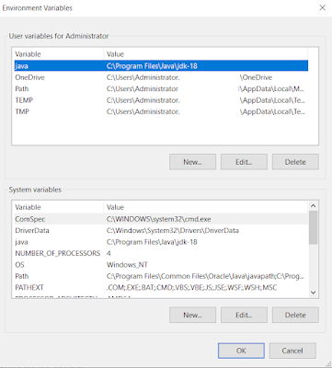

* Windows in go to <https://www.jenkins.io/download/> download the Jenkins msi package.

* Go to the download folder installed the msi package.

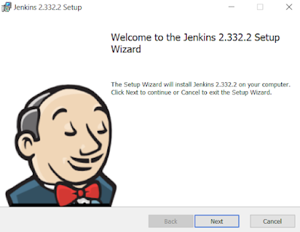

* Once download Jenkins after click on the next tab.

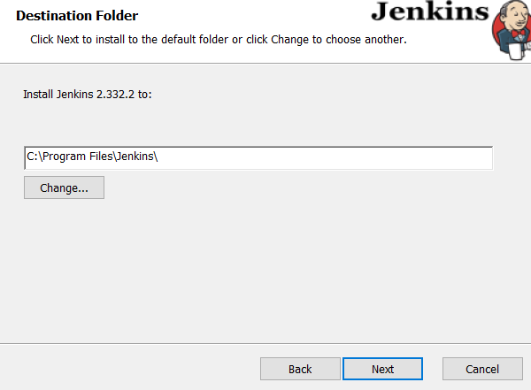

* Select the Jenkins installation folder. By default C drive in save Jenkins folder

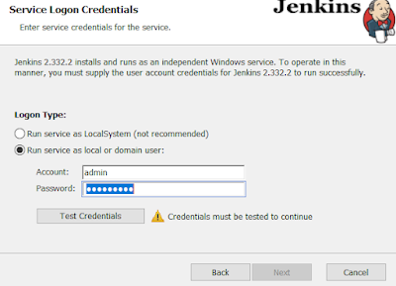

* Type the domain username and password after click on the next tab.

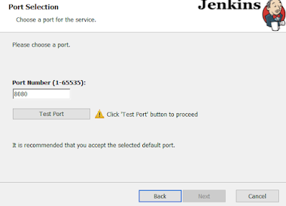

* Type the Jenkins localhost port number. By default port number is 8080. Clock on the next tab

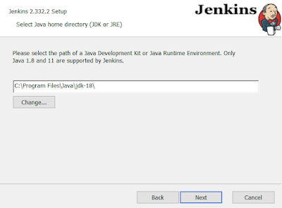

* Select the Program files in Java jdk  folder location. Click on the next button

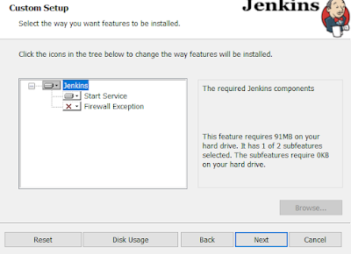

* Click on the Next tab.

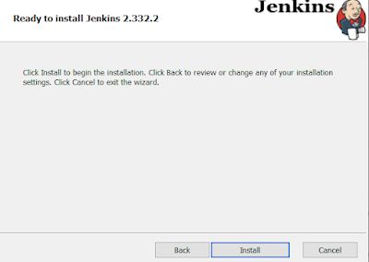

* Click on the Jenkins install tab.

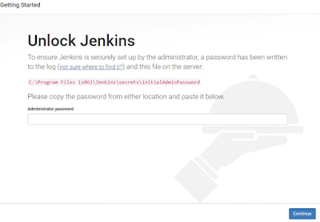

* Jenkins open the Administrator initial password location and set the Jenkins administrator password

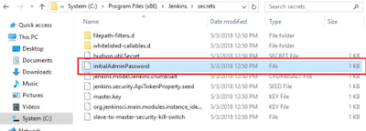

* Jenkins in select the customize plugin or Suggested selected plugin.

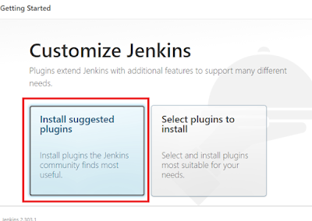

* After started the the installation of plugin. Start the process.

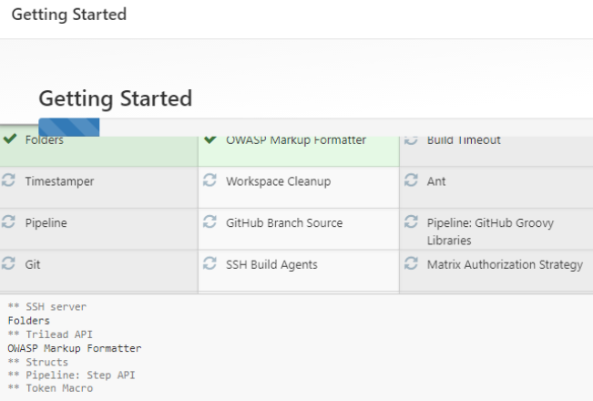

* Jenkins start of Instance configuration URL  [http://localhost:8080](http://localhost:8080/) . Click on the Save and Finish button.

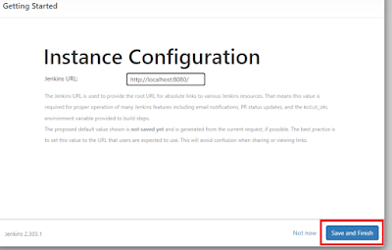

After browser in Open  [http://localhost:8080](http://localhost:8080/) This is a Jenkins URL.