Project ID:
R26-IT-132

- Topic (12 words max)
AI-Based Hyper-Local Aviation Weather Forecast Verification System for Sri Lankan Monsoon Patterns

- Research group the project belongs to
CoEAI - Centre of Excellence for AI

- Specialization of the project belongs to
Information Technology (IT)

- If a continuation of a previous project:
Project ID | R26-IT-132
Year | 2026

- Brief description of the research problem including references (300 words max) – references not included in word count.
Weather forecasting plays a critical role in aviation safety and operational decision-making. Pilots rely on aviation weather reports such as the Terminal Aerodrome Forecast and METAR aviation weather report to obtain atmospheric information before aircraft take-off and landing. These reports provide parameters including temperature, wind speed, wind direction, atmospheric pressure, and humidity that directly influence aircraft performance and airport operations.
Most aviation weather forecasting systems rely on large-scale numerical weather prediction models such as the Global Forecast System and the ECMWF weather model. Although these models provide reliable regional and global predictions, they often fail to accurately represent localized atmospheric variations occurring at individual airport terminals. This limitation becomes particularly significant in tropical regions where weather patterns can change rapidly within small geographic areas.
Sri Lanka experiences complex meteorological conditions influenced by monsoon circulation systems including the Southwest Monsoon, Northeast Monsoon, and two inter-monsoon periods. These seasonal systems frequently produce sudden changes in wind patterns, pressure fluctuations, humidity variations, and convective weather conditions. Previous studies have demonstrated that machine learning techniques such as artificial neural networks can successfully model monsoon rainfall patterns in Sri Lanka [1], while other studies have explored machine learning-based models for short-term weather prediction using historical meteorological datasets [2]. In aviation meteorology, high-impact weather hazards such as thunderstorms, lightning activity, turbulence, and strong winds significantly affect flight safety and airport operations [5]. Research has also identified convective weather systems as major aviation hazards in tropical flight regions [3], and climatological studies conducted at Bandaranaike International Airport indicate frequent lightning activity that may disrupt aviation operations [4].
The primary stakeholders affected by this problem include pilots, air traffic controllers, aviation meteorological officers, and airport operational managers who depend on accurate forecasts for safe flight operations. Inaccurate weather predictions may lead to flight delays, increased operational costs, and potential safety risks. This research belongs to the Artificial Intelligence and Data Science research cluster within the aviation meteorology domain. By developing an AI-based hyper-local aviation weather forecasting and verification system trained using airport-level observations, the study contributes to SDG 9 (Industry, Innovation and Infrastructure), SDG 11 (Sustainable Cities and Communities), and SDG 13 (Climate Action) through improved aviation safety and efficient transportation systems.

The primary stakeholders affected by this problem include pilots, air traffic controllers, aviation meteorological officers, and airport operational managers who depend on accurate forecasts for safe flight operations. Inaccurate weather predictions may lead to flight delays, increased operational costs, and potential safety risks. This research belongs to the Artificial Intelligence and Data Science research cluster within the aviation meteorology domain. By developing an AI-based hyper-local aviation weather forecasting and verification system trained using airport-level observations, the study contributes to SDG 9 (Industry, Innovation and Infrastructure), SDG 11 (Sustainable Cities and Communities), and SDG 13 (Climate Action) through improved aviation safety and efficient transportation systems.

References

[1] | A. P. a. Wickramagamage, Monsoon Rainfall Forecasting in Sri Lanaka Using Artificial Neural Networks, 2011. https://ieeexplore.ieee.org/abstract/document/6038085
[2] | S. K. Jayawardena, Machine Learning Based Weather Prediction Model for Short Term Weather Prediction in Sri Lanka, 2021. https://ieeexplore.ieee.org/abstract/document/9606077
[3] | Z. Wang, "Analysis of the Most Common Aviation Weather Hazard and Its Key Mechanisms over the Yangon Flight Information Region," Journal of Meteorology, 2022. https://onlinelibrary.wiley.com/doi/full/10.1155/2022/5356563
[4] | R. Jayasinghe, "Climatology of Lightning Activities over Bandaranaike International Airport in Sri Lanka," Atmospheric Research Study.
[5] | H. W. a. M. Sprenger, "A Review of High Impact Weather for Aviation Meteorology," Pure and Applied Geophysics, Springer, 2019. https://link.springer.com/article/10.1007/s00024-019-02168-6
[6] | S. R. Jeong, "AI Framework for Automated Terminal Aerodrome Forecasting," Aviation Journal, 2024. https://journals.vilniustech.lt/index.php/Aviation/article/view/25334
[7] | X. Shi, "Convolutional LSTM Network: A Machine Learning Approach for Precipitation Nowcasting," NIPS, 2015.  https://proceedings.neurips.cc/paper/2015/hash/07563a3fe3bbe7e3ba84431ad9d055af-Abstract.html

References

[8] | M. Chen, "Deep Learning for Weather Forecasting: A Review," Atmospheric Research, 2020.  https://www.taylorfrancis.com/chapters/edit/10.1201/9781003716389-54/artificial-intelligence-real-time-weather-forecasting-using-neural-networks-surender-kumar-sharma-dileep-kumar-pandiya-vilas-ramrao-joshi-payal-bansal-deepak-sharma
[9] | J. D. a. P. Bauer, "Challenges and Design Choices for Global Weather and Climate Models Based on Machine Learning," Geoscientific Model Development, 2018.  https://gmd.copernicus.org/articles/11/3999/2018/
[10] | Y. R. a. S. Lerch, "Neural Networks for Postprocessing Ensemble Weather Forecasts," Monthly Weather Review, 2018.  https://journals.ametsoc.org/view/journals/mwre/146/11/mwr-d-18-0187.1.xml

- Brief description of Existing Research and Systems (300 words max)
Several operational systems and research studies have been developed to support aviation weather forecasting and meteorological analysis. Aviation forecasting products such as the Terminal Aerodrome Forecast and METAR aviation weather report are widely used to provide weather predictions and real-time observations for airport operations. These reports include information on wind speed, wind direction, visibility, temperature, and cloud conditions, which are essential for safe aircraft take-off and landing. In addition, global numerical weather prediction models such as the Global Forecast System and the ECMWF weather model are widely used to generate regional and global weather forecasts based on atmospheric physics.
Existing research has explored the use of artificial intelligence and machine learning techniques for weather prediction. Studies have shown that Artificial Neural Networks can be used to forecast monsoon rainfall patterns in Sri Lanka [1]. Similarly, machine learning-based weather prediction models have been developed to predict short-term atmospheric conditions using historical meteorological data [2]. Other studies have analyzed aviation weather hazards such as thunderstorms, lightning activity, and turbulence, identifying them as significant risks to aviation safety in tropical flight regions [3][5]. Climatological research conducted at Bandaranaike International Airport has also identified frequent lightning activity and convective weather conditions that may disrupt aviation operations [4].
Recent advancements in artificial intelligence have introduced automated aviation forecasting systems and deep learning techniques for atmospheric prediction. For example, AI frameworks have been proposed for automated terminal aerodrome forecasting systems [6], while deep learning architectures such as convolutional LSTM networks have been used for precipitation forecasting and weather nowcasting [7]. Additional studies have explored machine learning approaches for global weather modeling and forecasting improvements [8][9][10].
Despite these developments, most existing systems focus on regional or global weather prediction rather than hyper-local forecasting for specific airport terminals. In addition, many studies do not consider seasonal monsoon patterns that significantly influence weather conditions in tropical regions. Therefore, there is a research gap in developing AI-based hyper-local aviation weather forecasting and verification systems specifically designed for airport environments influenced by monsoon-driven weather patterns.

- Brief description of the solution's nature, including a conceptual diagram (maximum 500 words).
This research proposes an AI-based hyper-local aviation weather forecasting and verification system designed for airport-level weather prediction at Bandaranaike International Airport. The system aims to address the limitations identified in Section 6, where existing aviation weather forecasting systems primarily rely on global numerical weather prediction models such as the Global Forecast System and the ECMWF weather model. Although these models provide reliable large-scale forecasts, they are not specifically optimized for localized atmospheric variations occurring at airport terminals.
The proposed system addresses this research gap by developing hyper-local machine learning models trained using airport-level historical meteorological observations. The system generates a three-hour ahead (T+3h) static weather forecast and compares it with official aviation forecasts to evaluate reliability and provide decision support for aviation operations.
System Perspective (Input – Process – Output)
Input
The system receives multiple sources of meteorological data including:
- Airport weather sensor data (temperature, wind speed, wind direction, pressure)
- Satellite weather observations
- Aviation weather reports such as METAR aviation weather report and Terminal Aerodrome Forecast
- Historical airport weather datasets collected since 2019
These inputs provide real-time and historical atmospheric observations necessary for training and evaluating the forecasting models.
Process
The system first performs data preprocessing and monsoon classification, where the weather data is categorized according to Sri Lanka’s seasonal weather regimes:
- Southwest Monsoon
- Northeast Monsoon
- First Inter-Monsoon
- Second Inter-Monsoon
Based on the identified seasonal pattern, a season-specific artificial intelligence model is selected to generate weather predictions. The forecasting engine then produces short-term weather predictions for the next three hours including temperature, wind conditions, pressure, and humidity.
The system then performs forecast verification by comparing the predicted weather values with official aviation weather reports such as METAR and TAF. A confidence score calculator evaluates the reliability of the predictions based on historical accuracy and data consistency.
Additionally, the system includes a model self-improvement module, which stores forecast errors and performance metrics in order to retrain and improve the prediction models over time.
Output
The final output of the system is presented as a pilot weather guidance card that summarizes predicted weather conditions and reliability indicators. The output may also include warning alerts such as wind hazards or atmospheric instability using visual or auditory signals.
By combining hyper-local weather prediction with forecast verification, the system provides an intelligent aviation weather guidance tool that can support safer and more efficient flight operations.

The system then performs forecast verification by comparing the predicted weather values with official aviation weather reports such as METAR and TAF. A confidence score calculator evaluates the reliability of the predictions based on historical accuracy and data consistency.
Additionally, the system includes a model self-improvement module, which stores forecast errors and performance metrics in order to retrain and improve the prediction models over time.
Output
The final output of the system is presented as a pilot weather guidance card that summarizes predicted weather conditions and reliability indicators. The output may also include warning alerts such as wind hazards or atmospheric instability using visual or auditory signals.
By combining hyper-local weather prediction with forecast verification, the system provides an intelligent aviation weather guidance tool that can support safer and more efficient flight operations.

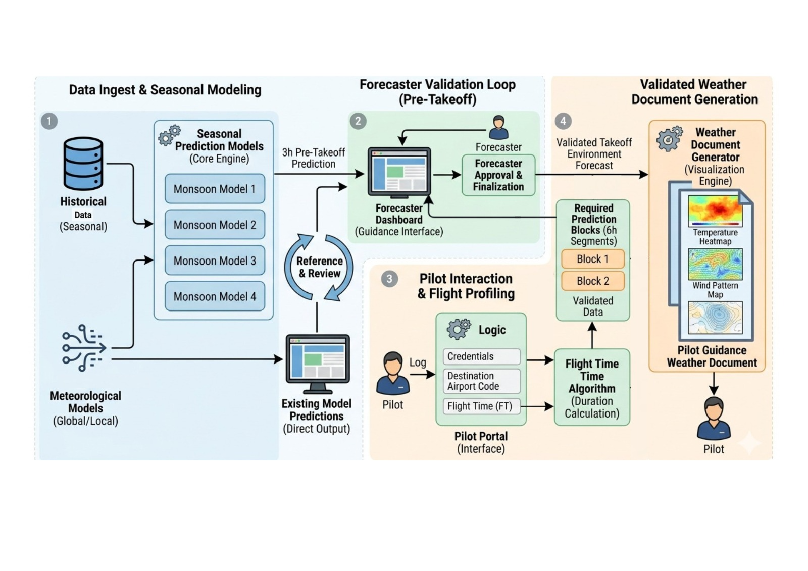

- Brief overview of the availability of necessary specialized domain expertise, knowledge, and data. (500 words max)
This research project focuses on designing and developing an AI-based hyper-local aviation weather forecasting and verification system for airport environments influenced by tropical monsoon patterns. The study integrates several interdisciplinary areas including aviation meteorology, artificial intelligence, time-series forecasting, data analytics, and decision-support systems for aviation operations. The research team’s academic background and guidance from research supervisors ensure that the required domain knowledge, technical expertise, and data resources necessary for the successful completion of this project are accessible.
Developing Expertise in a Specific Domain
Members of the project team will develop specialized knowledge related to aviation meteorology and tropical weather systems through literature reviews, academic coursework, and consultation with research supervisors. Key topics such as monsoon circulation systems, aviation weather hazards, and airport meteorological observations will be studied through peer-reviewed research articles, meteorological reports, and aviation weather documentation. Understanding aviation weather reporting standards such as the Terminal Aerodrome Forecast and METAR aviation weather report will also help members gain insight into how weather information is generated and interpreted in aviation environments.
Knowledge and Skill Building for Technologists
The technological knowledge required for the project will be developed through a combination of practical implementation, previous academic coursework, and self-learning. The project team will apply skills in programming, machine learning, and data science to develop forecasting models capable of predicting short-term weather conditions. Members will strengthen their understanding of time-series forecasting, machine learning model training, data preprocessing, and predictive analytics techniques. In addition, knowledge related to artificial intelligence frameworks, statistical analysis, and visualization techniques will support the development and evaluation of forecasting models. These skills will enable the team to design and implement an intelligent weather forecasting system that supports aviation decision-making.
Technologies Used
The proposed system will be developed using modern data science and artificial intelligence technologies. Programming will primarily be performed using Python, while machine learning models will be implemented using frameworks such as TensorFlow, PyTorch, and Scikit-learn. Data preprocessing and analysis will be carried out using libraries such as Pandas and NumPy. Visualization tools will be used to evaluate model performance and analyze weather patterns. These technologies provide the computational capability required to process meteorological datasets and implement predictive forecasting models.
Data Collection Methods
The project primarily relies on historical meteorological observations collected from Bandaranaike International Airport since 2019. These datasets include atmospheric variables such as temperature, wind speed, wind direction, pressure, and humidity recorded by airport weather monitoring systems. Additional supporting datasets such as satellite observations and global meteorological datasets may also be used to improve prediction accuracy. Aviation weather reports including METAR observations and TAF forecasts will be used to compare and validate the performance of the developed forecasting models.
Ethical Considerations and Clearance
This research does not involve human participants, personal data, or sensitive information. The study relies only on meteorological and environmental datasets collected for operational or scientific purposes. Therefore, formal ethical clearance related to human subject research is not required. However, all data used in the research will follow appropriate data usage guidelines and proper attribution practices to ensure responsible and ethical research conduct.

Data Collection Methods
The project primarily relies on historical meteorological observations collected from Bandaranaike International Airport since 2019. These datasets include atmospheric variables such as temperature, wind speed, wind direction, pressure, and humidity recorded by airport weather monitoring systems. Additional supporting datasets such as satellite observations and global meteorological datasets may also be used to improve prediction accuracy. Aviation weather reports including METAR observations and TAF forecasts will be used to compare and validate the performance of the developed forecasting models.
Ethical Considerations and Clearance
This research does not involve human participants, personal data, or sensitive information. The study relies only on meteorological and environmental datasets collected for operational or scientific purposes. Therefore, formal ethical clearance related to human subject research is not required. However, all data used in the research will follow appropriate data usage guidelines and proper attribution practices to ensure responsible and ethical research conduct.

- Objectives and Novelty
Main Objective

The main objective of this research is to develop an AI-based hyper-local aviation weather forecasting and verification system for Sri Lankan monsoon environments, capable of generating short-term (T+3 hour) weather forecasts for airport terminals using historical meteorological observations. The proposed system will utilize machine learning models trained on airport-level weather datasets to predict key atmospheric parameters including temperature, wind speed and direction, atmospheric pressure, and humidity.
In addition, the system aims to incorporate season-specific forecasting models based on Sri Lanka’s monsoon patterns, including the Southwest Monsoon, Northeast Monsoon, First Inter-Monsoon, and Second Inter-Monsoon periods. By analyzing these seasonal atmospheric patterns, the proposed system seeks to improve the accuracy of localized weather predictions for aviation operations.
Furthermore, the research will implement a forecast verification and reliability evaluation mechanism by comparing AI-generated forecasts with official aviation weather reports such as METAR observations and TAF forecasts. Based on prediction accuracy and historical performance analysis, the system will generate a pilot-oriented weather guidance output with confidence indicators that can assist aviation personnel in evaluating short-term weather conditions before flight operations.
Overall, the research aims to contribute to the development of an intelligent decision-support tool for aviation meteorology, capable of improving short-term weather forecasting accuracy at airport terminals located in tropical monsoon regions.

Member Name with Registration No | Sub Objective | Tasks | Novelty
Sankadeepa W.D.I  IT22113986 | Develop a pressure-humidity-temperature coupled prediction model for the Northeast Monsoon to improve short-term aviation weather prediction. | - Collect historical weather data from Bandaranaike International Airport, preprocess time-series data, build a multi-variable machine learning model, evaluate prediction accuracy and forecast verification.  - Weather Visualization  Create visual representations of validated weather data such as temperature heatmaps and wind pattern maps to help pilots easily understand weather conditions. | Develop a coupled atmospheric prediction model that learns the relationship between pressure, humidity, and temperature instead of predicting them independently.
Ranasingha R.A.A.D  IT22269720 | Develop a wind pattern prediction model for the Southwest Monsoon to analyze wind variations affecting aviation operations. | - Analyze historical wind speed and direction data, extract seasonal wind patterns, train machine learning models for wind prediction, evaluate wind forecast performance.  - Pilot Portal  Develop the pilot interaction interface where pilots can log in and enter flight details such as destination airport code and flight time. This module handles authentication and input validation. | Develop a runway-oriented wind prediction system that converts predicted wind direction into crosswind and headwind components relevant to aircraft operations.
Jayawardhana H.M.S.I  IT22619976 | Develop a rapid weather change detection model for the First Inter-Monsoon period. | - Analyze cloud ceiling heights and visibility reduction patterns. Detect sudden onset of fog or low-level clouds. Build ML models to identify rapid atmospheric shifts affecting visual range.  - Flight Time Processing  Develop the flight time processing module to analyze the flight time provided by the pilot and prepare the required weather prediction duration. The system will organize the prediction time into blocks and prepare the data for further weather analysis. | Cloud & Visibility Prediction Model, specialized for the First Inter-Monsoon. Threshold alerts for "Below Minimum" conditions.
Jayathilaka P.K.V.K  IT22069504 | Develop a predictive model based on relative humidity and pressure (QNH) variations for the Second Inter-Monsoon. | - Analyze the correlation between high humidity peaks and pressure drops. Build ML models to predict atmospheric stability and localized pressure changes.  - Weather Document Generation  Develop the module to compile validated weather data into a structured pilot guidance document. The system will organize the weather information and generate a clear weather report that can be delivered to pilots before takeoff. | Humidity & QNH Stability Model. Reliability scoring based on pressure trend accuracy.

- This part is to be filled by the Supervisor and the Co-supervisor of the Project.

- This research topic possesses a comprehensive scope suitable for a final-year project.
Yes |  | No

- The proposed topic exhibits novelty.
Yes |  | No

- The student group can successfully execute the proposed project.
Yes |  | No

- The proposed sub-objectives reflect the students' areas of specialization.
Yes |  | No

- Any other comments:

 | Title | First Name | Last Name | Signature
Supervisor | Computer Systems and Network Engineering Program Coordinator / Senior  Lecturer | Ms. Shashika | Lokuliyana
Co-Supervisor
External Supervisor
Summary of external supervisor’s (if any) experience and expertise

