Database Creation
CREATE USER olist_dwh IDENTIFIED BY olist_dwh;
GRANT CONNECT, RESOURCE, DBA TO olist_dwh;
ALTER USER olist_dwh QUOTA UNLIMITED ON USERS;

Session alter set container = xepdb1;
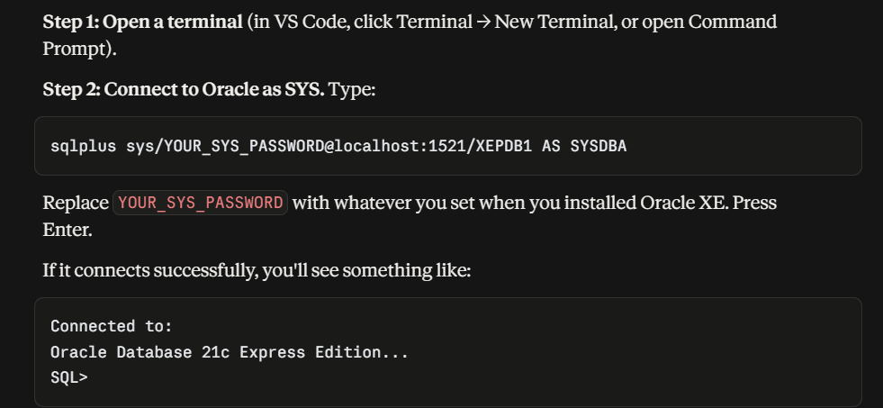
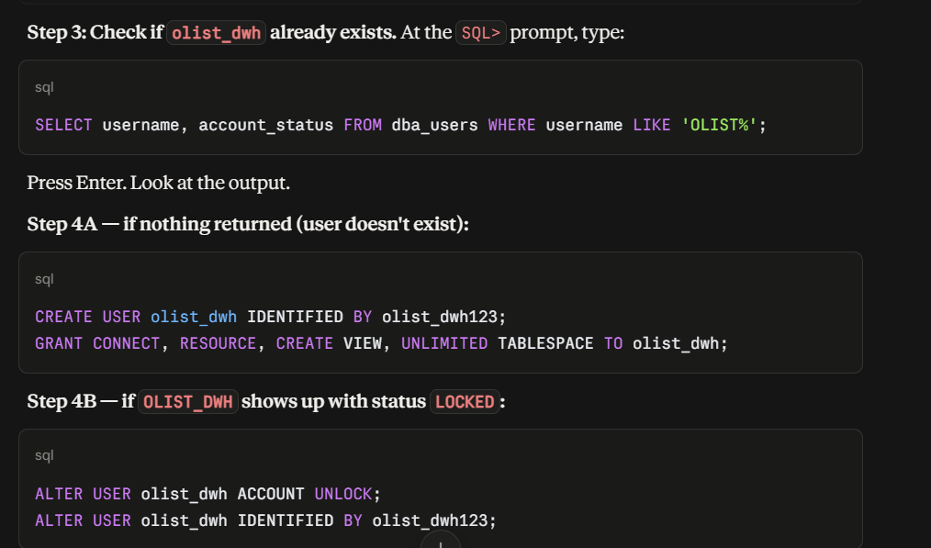
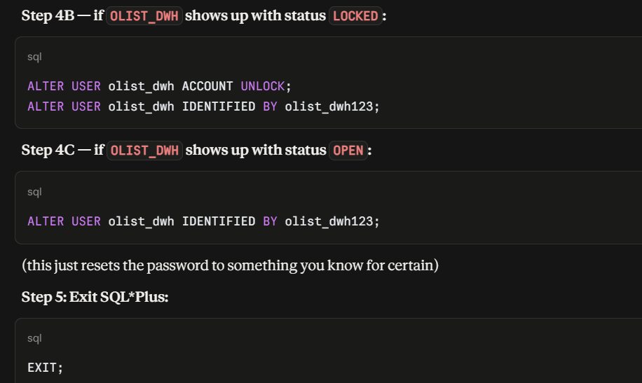
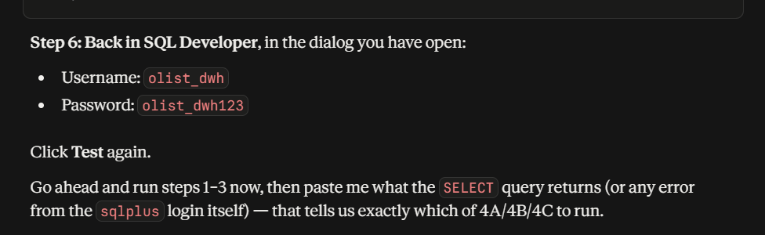
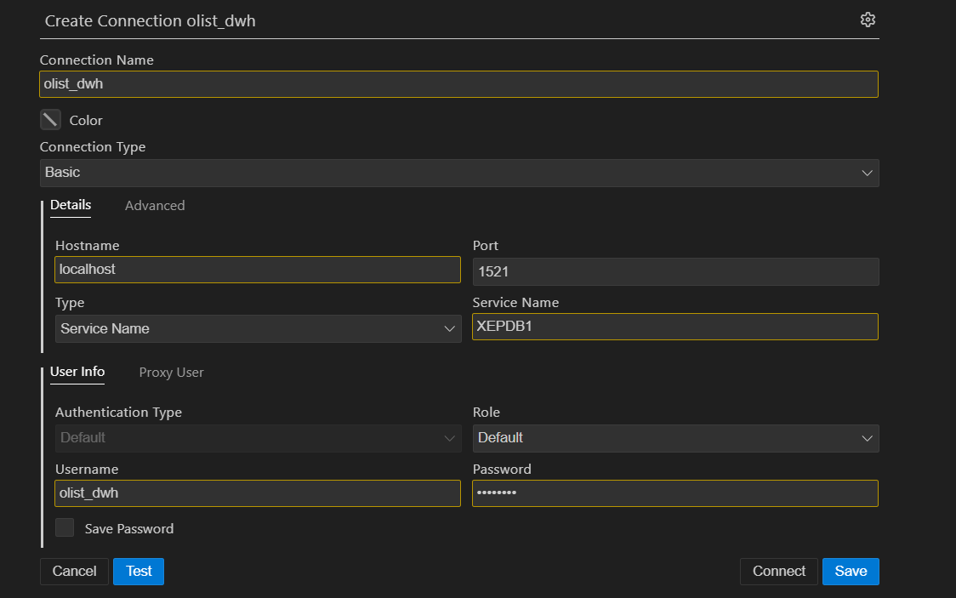
Password :- dwh12345

Here's the full flow, laid out simply and in order.

The big picture — where Power BI fits
1. Load data into Oracle (you're doing this now)
↓
2. Verify the data loaded correctly
↓
3. Write OLAP queries directly in SQL (Part B of your assignment)
↓
4. Connect Power BI to Oracle
↓
5. Build the data model (relationships)
↓
6. Recreate those same OLAP insights as DAX measures + visuals
↓
7. Design dashboard pages
↓
8. Write the business report from what the dashboard shows
The key idea: OLAP analysis isn't a separate detour before Power BI — it's the thinking you do first in SQL, which you then translate into visuals. You figure out "what questions matter" using SQL queries, then Power BI just displays those same answers as interactive charts instead of text output.

Step 1 — Confirm your load worked
Before anything else, run your check_tables_oracle.py / row-count script. You need real numbers in all 5 tables before building anything on top.

Step 2 — Do OLAP analysis in SQL first (this is your Part B)
This step answers: "what's actually interesting in this data?" You write and run SQL queries directly against Oracle (SQL Developer, or your Python scripts) for things like:
- Total revenue by category and state, with subtotals (roll-up)
- Revenue by quarter, year-over-year change (trend analysis)
- Top sellers ranked within each category (ranking)
- Revenue sliced by specific states/categories (slice/dice)
- Revenue pivoted across states as columns (pivot)
Why do this before Power BI: SQL is faster to test and debug than building dashboard visuals from scratch. Once a query returns the right numbers in SQL, you already know what the dashboard should show — Power BI becomes just a presentation layer for insights you've already validated.

Step 3 — Connect Power BI to your Oracle database
Install Oracle Instant Client (Power BI needs this to talk to Oracle), then in Power BI: Get Data → Oracle Database → enter server/credentials → Import mode → select all 5 tables → Load.
This pulls a copy of your actual Oracle data into Power BI's own internal storage.

Step 4 — Build the data model (tell Power BI how tables connect)
Go to the Model view. Power BI needs to know FACT_ORDERS.customer_key links to DIM_CUSTOMER.customer_key, and similarly for product/seller/time. Usually detected automatically from your foreign keys; if not, drag to connect them manually. Mark DIM_TIME as your official date table.
This step is what turns 5 separate tables into one connected model Power BI can query across — exactly what your star schema was designed for.

Step 5 — Turn your SQL OLAP queries into DAX measures
For every SQL query you wrote in Step 2, you write an equivalent short formula in Power BI's language (DAX):
- Total revenue → SUM(payment_value)
- Year-over-year % → a DAX time-intelligence formula
- Top sellers ranked → a RANKX formula
You're not inventing new analysis here — you're just re-expressing the same SQL logic in a form Power BI's visuals can use interactively.

Step 6 — Build the actual dashboard visuals
Drag fields and measures onto the canvas: bar charts, line charts, matrix tables, KPI cards, slicers (dropdown filters for year/category/state). Each visual should map back to one of your Step 2 SQL queries — you're just giving that same insight a visual, clickable form.

Step 7 — Add interactivity
Add slicers (filter dropdowns) so anyone viewing the dashboard can click "2018," "electronics," or "SP" and watch every chart update together. This is the main advantage over static SQL output — one dashboard, many angles, no rewriting queries.

Step 8 — Write the business report
Take a few screenshots, and for each one write 2-3 sentences: what question does this answer, what's the actual insight, why does it matter for the business. This becomes your written report, and doubles nicely as material for your assignment's Part D reflection.

Right now, you're between Step 1 and Step 2. Once your 07_load.py finishes successfully, the natural next move is: should we write your Part B SQL queries first (ROLLUP, LAG, RANK — this is required assignment content), and then move to Power BI afterward using those same queries as your blueprint?

What is the difference between postgresql and mysql
Here's the practical difference, kept simple:

Quick summary
Both are free, open-source relational databases. The differences matter more for advanced use cases than for learning/portfolio projects — but here's what's actually different:
 | PostgreSQL | MySQL
Reputation | More feature-rich, closer to "does everything correctly by the book" | Simpler, historically faster for basic read-heavy workloads
Data types | Richer — supports JSON, arrays, custom types natively | More limited, though modern versions added JSON support too
Standards compliance | Very strict SQL standard compliance | Looser, more forgiving (sometimes silently does unexpected things)
Best for | Complex queries, analytics, data integrity-heavy apps | Simple web apps, high-speed simple read/write (historically WordPress, PHP apps)
Used by | Instagram, Spotify, Netflix (rare), most modern data teams | Facebook (early), WordPress sites, many startups' backend
Industry trend (data/analytics roles specifically) | Increasingly preferred | Still common, more on the "web app backend" side than "analytics" side

Why this matters for you specifically
For data science / analytics work (which is what you're going for), PostgreSQL tends to be the better skill to have because:
- It handles complex queries, window functions, and large analytical workloads more robustly
- It's the SQL flavor most cloud data warehouses (Redshift, Snowflake, even some BigQuery syntax) are modeled closest to
- Most data science job postings that mention a specific SQL database lean Postgres over MySQL
MySQL is still very common and worth knowing, but it's more associated with web application backends (a website's login system, e-commerce cart, etc.) than with analytics/data warehousing work.
Bottom line for your CV: learning PostgreSQL is the slightly more strategic choice given you're targeting data science internships — which lines up with what I recommended earlier (Postgres + DBeaver for your second portfolio project).

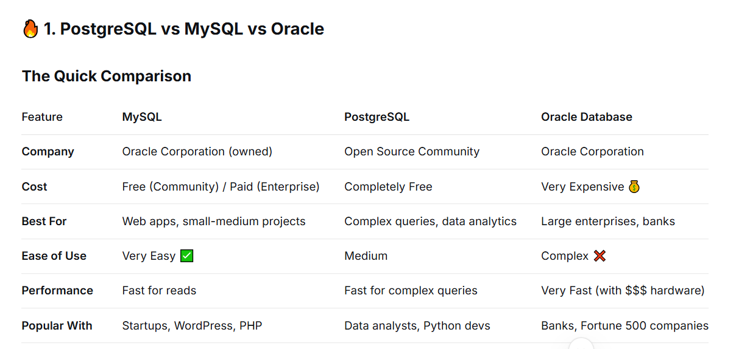

🔍 2. What is MySQL?

In Simple Terms
MySQL is a free, popular database that stores data in tables. It's like a giant Excel spreadsheet that many people can use at the same time.

Where You See It
- WordPress websites (like blogs)
- Facebook (early days)
- Small to medium businesses
- E-commerce websites

Sample Code
sql
-- MySQL syntax
CREATE TABLE customers (
customer_id INT PRIMARY KEY,
name VARCHAR(100),
email VARCHAR(100)
);

INSERT INTO customers VALUES (1, 'John Doe', 'john@email.com');
SELECT * FROM customers;

🔍 3. What is PostgreSQL?

In Simple Terms
PostgreSQL (or "Postgres") is a more advanced, free database that can handle very complex data and queries. It's like MySQL's smarter older sibling.

Where You See It
- Data analytics platforms
- GIS applications (maps/location data)
- Apple (uses it for iCloud)
- Uber (uses it for some services)
- Instagram (uses it for some data)

Sample Code
sql
-- PostgreSQL syntax (very similar to MySQL)
CREATE TABLE customers (
customer_id SERIAL PRIMARY KEY,
name VARCHAR(100),
email VARCHAR(100)
);

INSERT INTO customers (name, email) VALUES ('John Doe', 'john@email.com');
SELECT * FROM customers;

What Makes PostgreSQL Special?
- Can store JSON data (like documents)
- Better at complex analytics
- Handles geographic data (maps)
- More strict with data (less errors)

🔍 4. What is Oracle Database?

In Simple Terms
Oracle Database is the expensive, professional-grade database used by big companies. It's the "Rolls Royce" of databases.

Where You See It
- Banks (handles billions of transactions)
- Government agencies
- Telecom companies (AT&T, Verizon)
- Airline reservation systems
- Amazon (some internal systems)

Sample Code
sql
-- Oracle syntax (slightly different)
CREATE TABLE customers (
customer_id NUMBER PRIMARY KEY,
name VARCHAR2(100), -- Note: VARCHAR2 in Oracle
email VARCHAR2(100)
);

INSERT INTO customers VALUES (1, 'John Doe', 'john@email.com');
SELECT * FROM customers;

What Makes Oracle Special?
- Handles very large databases (petabytes of data)
- Extremely reliable (99.999% uptime)
- Very fast (with expensive hardware)
- Has many advanced features others don't
- Comes with 24/7 support

🛠️ 5. Databases vs Workbenches - The Difference

Database Management System (DBMS)
This is the actual software that stores and manages your data.
DBMS | Type | Company
MySQL Server | Database Engine | Oracle
PostgreSQL Server | Database Engine | Open Source
Oracle Database | Database Engine | Oracle

SQL Client / Workbench
This is the tool you use to talk to the database.
Tool | For Which Database | What It Does
MySQL Workbench | MySQL | Visual tool to write queries, design tables, manage data
pgAdmin | PostgreSQL | Visual tool to manage Postgres databases
SQL Developer | Oracle Database | Oracle's official query tool
DBeaver | All Databases (Universal) | Works with MySQL, Postgres, Oracle, and more
DataGrip | All Databases | Professional SQL IDE

📊 Visual Comparison
text
┌─────────────────────────────────────────────────────────────────────┐
│ YOUR COMPUTER │
├─────────────────────────────────────────────────────────────────────┤
│ │
│ DATABASE ENGINE (Runs in the background) │
│ ┌─────────────────────────────────────────────────────────────┐ │
│ │ MySQL Server │ PostgreSQL Server │ Oracle Database │ │
│ │ (Stores data) │ (Stores data) │ (Stores data) │ │
│ └─────────────────────────────────────────────────────────────┘ │
│ │
│ TOOLS YOU USE TO ACCESS IT (Like a remote control) │
│ ┌─────────────────────────────────────────────────────────────┐ │
│ │ │ │
│ │ MySQL Workbench → For MySQL │ │
│ │ pgAdmin → For PostgreSQL │ │
│ │ SQL Developer → For Oracle │ │
│ │ DBeaver → For ALL databases │ │
│ │ Power BI → For Visualizing data │ │
│ │ │ │
│ └─────────────────────────────────────────────────────────────┘ │
│ │
└─────────────────────────────────────────────────────────────────────┘

🎯 Which One Should You Use?

Choose MySQL IF:
- ✅ You're building a website or web app
- ✅ You want something easy to learn
- ✅ You're on a budget (free)
- ✅ You need something fast to set up

Choose PostgreSQL IF:
- ✅ You're doing data analysis
- ✅ You need complex queries (advanced SQL)
- ✅ You want to store JSON or geospatial data
- ✅ You're a data analyst or data scientist

Choose Oracle IF:
- ✅ You work for a large enterprise
- ✅ You need extremely high reliability
- ✅ Your company already uses it
- ✅ You have a big budget for licenses

🛠️ Your Current Setup

What You Have:
text
Your Olist Project:
┌─────────────────────────────────────────────────────────────┐
│ │
│ Database: Oracle Cloud (or Oracle Database) │
│ Tool used: Oracle SQL Developer │
│ Purpose: Analyze e-commerce data │
│ │
└─────────────────────────────────────────────────────────────┘

What Your Friend Used:
text
Your Friend's Project:
┌─────────────────────────────────────────────────────────────┐
│ │
│ Database: MySQL / PostgreSQL │
│ Tool used: MySQL Workbench / pgAdmin │
│ Purpose: Analyze data with SQL queries │
│ │
└─────────────────────────────────────────────────────────────┘

📝 Quick Reference Card
Term | What It Means | Example
Database | Where data is stored | A library full of books
DBMS | Software managing the database | The library catalog system
MySQL | A free, popular DBMS | Used by millions of websites
PostgreSQL | A free, advanced DBMS | Used for complex analytics
Oracle Database | An expensive enterprise DBMS | Used by banks
MySQL Workbench | Tool for MySQL | GUI to write SQL queries
pgAdmin | Tool for PostgreSQL | GUI to manage Postgres
Oracle SQL Developer | Tool for Oracle | Oracle's query tool

🗣️ Summary in 3 Sentences
- MySQL, PostgreSQL, and Oracle are all databases - they store your data in an organized way.
- The difference is MySQL is simple and free, PostgreSQL is advanced and free, and Oracle is professional and expensive.
- A workbench is just the tool you use to write SQL queries and interact with these databases.

For your Olist project: You're currently using Oracle Database with SQL Developer as your tool. Your friend likely used MySQL/PostgreSQL with MySQL Workbench/pgAdmin - but the SQL you write is very similar!

