EduSphere 360 — School Operating System
Enterprise Product Walkthrough & Capabilities Specifications Sheet (Client Review)
1. Enterprise Architecture & Product Vision
EduSphere 360 represents a paradigm shift in K-12 institutional management software. Unlike traditional, administrative-heavy ERP platforms that rely on nested menu bars, cards, and static rows of metrics, EduSphere 360 is engineered as a high-density, multi-persona School Operating System (School OS). It adapts dynamically to the context of five key institutional stakeholders: Principals, Administrators, Teachers, Parents, and Students.
The system's core design values are visual density, operation-focused flows, and instant context-awareness. Built on a modern Next.js framework, Zustand state containers, and styling centered around a customized HSL theme palette, it offers an executive-level, fluid interface. It utilizes clean typography (Arial/Helvetica), custom SVG indicators, and is 100% responsive across desktop, tablet, and mobile screens, ensuring a seamless experience for all users.
2. Principal Command Center (Executive Level)
The Principal Command Center serves as the central hub of administrative oversight. It is designed to provide high-level insights, push immediate announcements, and review institutional compliance without wading through dense metrics tables.
Layout & Interface Architecture:
• Top Command Bar: Displays the current calendar date in a structured format alongside quick access action buttons: 'Audit Reports', 'Send Notice', and 'Schedule PTM'.
• Today's School Snapshot: A top banner displaying the current Academic Year (2026-2027) and critical compliance checkmarks (e.g. attendance target status in 4 classes, risk alerts, scheduled parent meetings, Science Exhibition countdown, fee collection rate, and a custom vertical scrollbar when briefing count exceeds 6).
• Main Command Grid: Structured in a 70% left column for action-oriented lists (Today's Priority Actions, Active Institutional Broadcasts) and a 30% right column dedicated to analytics visualization (Weekly Attendance Rates, Grade Averages).
• Compliance Alerts Panel: An expandable drawer showing at-risk students who have dropped below performance indexes or attendance targets.
Core Features & Functional Workflows:
• Notice Broadcaster: An interface allowing school leadership to publish Circulars to all stakeholders. Categorized by 'Notice', 'Academic', 'Event', or 'Urgent', notices show up immediately on all other portals.
• PTM Booking Studio: Scheduler enabling the Principal to schedule class-wide or student-specific Parent-Teacher Meetings. Allows setting date, time, virtual platform (e.g. Google Meet) or physical room, and adding notes.
• On-Demand Institutional Audits: Instant modal audit generator compiling GPA trends, financial ledgers, operational ratios, and attendance indexes into structured, reviewable reports.
Contextual Data & Operation Example:
In the live demonstration, the Principal view shows a fee collection rate of 95.3% (Total Expected: ₹19.3L, Total Paid: ₹18.4L, Outstanding: ₹90k). The Principal sees Vivaan Mehta flagged as 'High Risk' due to a chronic attendance drop (71.4%) and academic decline (average below 60% in sciences). The Principal schedules an urgent PTM meeting for Vivaan on Saturday, June 27, 2026, at 11:30 AM with teacher Dr. Amit Sharma, writing specific instructions: 'Critical meeting to discuss attendance decline and recent low marks in Calculus.' The booking immediately reflects on Dr. Amit Sharma's roster and Vivaan's parent dashboard.

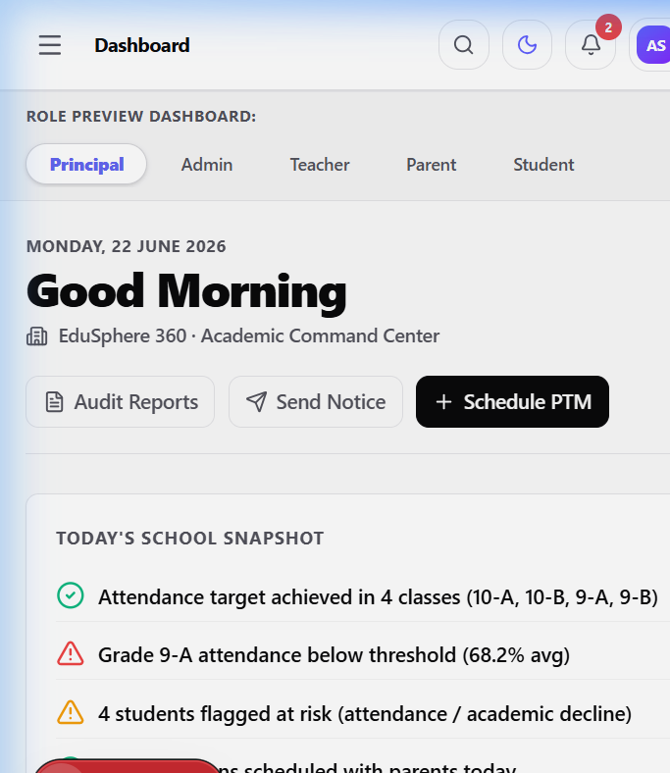
Figure: Principal Command Center - Executive Dashboard & Command Console
3. Administrative Workspace (Registries & Resource Scheduler)
The Administrative Workspace is designed for school registrars and operation staff to maintain student registries, manage the faculty directory, coordinate admissions, and handle timetabling allocations.
Layout & Interface Architecture:
• Tabbed Sub-navigation: Fast switching between 'Active Registry', 'Admit New Student', 'Faculty List', and 'Timetable Studio'.
• Responsive Data Tables: Heavy-density tables that adapt to mobile layouts, showing contact detail rows and status pill indicators.
• Interactive Scheduler Board: A visual matrix matching weekday, period intervals (P1 to P6), classroom room allocations, and instructors.
Core Features & Functional Workflows:
• Student Directory & Registry: Central table displaying Student Names, unique Roll Numbers, Section assignment, Attendance Rate, outstanding fee balances, and Risk Level. It allows searching by student or parent details.
• New Enrollment Portal: Registrar staff can enter student details (name, gender, class, parent name, email, phone). On submission, the system automatically assigns class roll numbers (e.g. 10A08) and sets up their initial grades ledger.
• Faculty Registry: Tracks teacher records, emails, departments (Mathematics, Science, English, Social Sciences), their assigned class sections, and the specific subjects they are certified to teach.
• Timetable Studio: Direct visual editor to modify or schedule room numbers and teachers to a structured calendar period list.
Contextual Data & Operation Example:
In the live dashboard view, the student registry displays a complete list of pupils including Diya Patel (Roll No: 10A02, 98.4% attendance, Fee: Paid) and Aditya Rao (Roll No: 10B01, 92.1% attendance, Fee: Pending ₹35,000). The registrar clicks 'Admit New Student', enters enrollment details, and submits. The new student is assigned roll number 10A08 (for class 10-A). This increment updates the active class student count instantly, and triggers a system-wide notification: 'New Admission: [Student Name] has been enrolled in 10-A'.

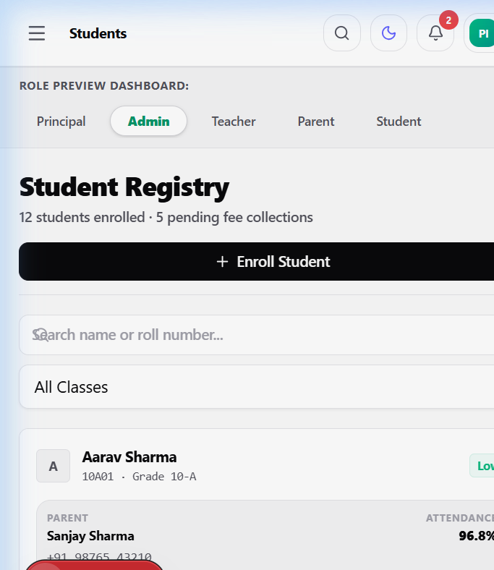
Figure: Administrative Workspace - registries and timetable scheduling studio
4. Educator Workspace (Rosters & Marks Ledger)
A streamlined workspace for teachers to record class progress, mark daily rolls, submit grades, and publish homework.
Layout & Interface Architecture:
• Class Context Selector: Dropdown controls allowing teachers to switch between their assigned classes (10-A, 10-B, 9-A) and subjects (Mathematics, Physics, Chemistry).
• Interactive Roster: A grid list of pupils with instant-tap options for 'Present', 'Absent', and 'Late' states.
• Ledger Desk: Spreadsheet-like input fields allowing teachers to update marks directly, immediately computing averages and updated academic alerts.
Core Features & Functional Workflows:
• Daily Roll Call: Teachers select the calendar date, review the class list, toggle attendance states, and click 'Submit Attendance'. The system recalculates attendance percentages, triggering alerts if a student falls under the 75% critical threshold.
• Gradebook Registry: A ledger listing student grades across subjects. Teachers can modify grade percentages. If a student's average drops below 60%, they are dynamically reassigned to 'High Risk' and a warning reason is logged.
• Homework Desk & Assignment Publisher: A simple form to post new assignments, including title, description, class, subject, and due date. The system lists pending vs. graded counts, allowing teachers to click 'Grade Submissions' to review, score out of 100, and leave comments.
Contextual Data & Operation Example:
Dr. Amit Sharma logs in and views the Grade 10-A Mathematics registry. He updates Aarav Sharma's gradebook marks. He reviews the homework submission for the assignment 'Newtonian Mechanics Lab Report'. Finding that Aarav Sharma has submitted it, Dr. Sharma grades it 95% and writes: 'Excellent algebraic proofs!'. Aarav's overall Mathematics grade is immediately recalculated to 94%, and a notification is dispatched to Aarav's parent, Sanjay Sharma.

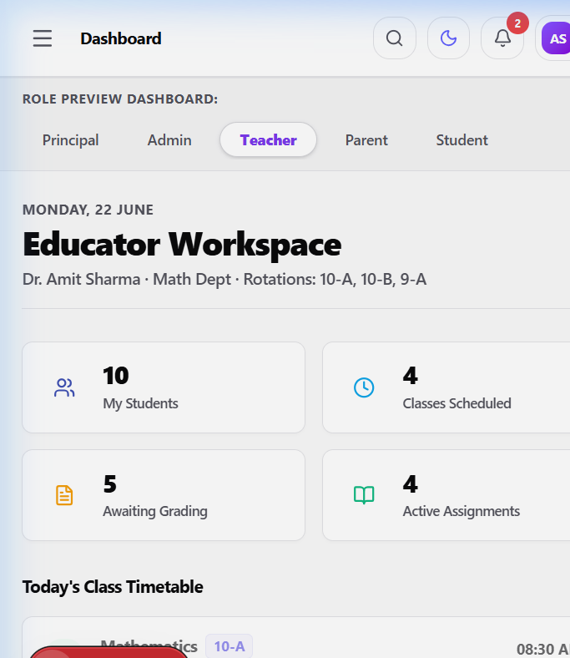
Figure: Educator Workspace - Roster attendance and class gradebook ledger
5. Parent Portal (Tuition & Progress Tracker)
The Parent Portal is designed to keep families closely connected to the school. It gives them direct access to academic progress, billing ledgers, scheduled PTMs, and communication feeds with their children's teachers.
Layout & Interface Architecture:
• Student Context Switcher: A top-right dropdown allowing parents with multiple enrolled children to switch dashboards with one click.
• Unified Communications Hub: A chat interface containing chat feeds, typing indicators, and support agents.
• Financial Ledger Section: An itemized billing invoice that lists fee details, outstanding balances, and simulated payment options.
Core Features & Functional Workflows:
• Academic & Homework Tracker: Displays student average scores and a timeline of homework assignments, color-coded by status: green for 'Graded', amber for 'Submitted', and grey/red for 'Pending'.
• Tuition Billing Portal: Details school fees including basic tuition, activities, transport, and lab fees. If a balance is pending, the parent can click 'Pay Now' to launch a secure sandbox transaction.
• PTM RSVPs: Lists scheduled meetings, displaying the assigned teacher, time, date, platform, and meeting notes, allowing the parent to RSVP instantly.
Contextual Data & Operation Example:
Swati Mehta logs in to monitor her son, Vivaan Mehta (Grade 10-A). She sees a 'High Risk' warning badge due to Vivaan's 71.4% attendance. She reviews his grades (Mathematics: 58%, Physics: 45%) and notes an upcoming PTM scheduled on June 27, 2026, at 11:30 AM (virtual on Google Meet). She switches to the billing ledger to pay Vivaan's outstanding Term 1 tuition fees (₹45,000). She clicks 'Pay Now' which clears the balance, updates Vivaan's fee status to 'Paid' instantly, and outputs a payment receipt.

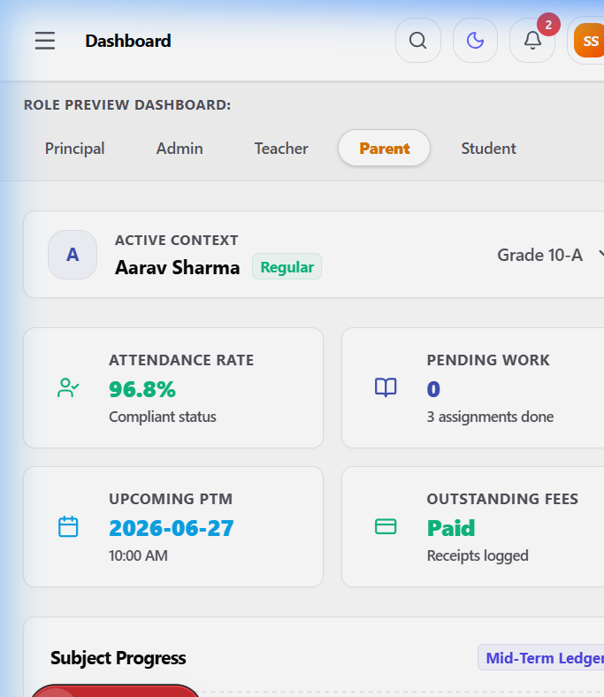
Figure: Parent Portal - child context switcher, tuition billing and academic tracker
6. Student Portal (Virtual Locker & Timetable)
The Student Portal is an interactive workspace designed to engage students in their academic progress, allowing them to view daily class schedules, submit homework, and view their achievements.
Layout & Interface Architecture:
• Personalized Locker Dashboard: A greeting panel displaying academic metrics (overall grades average, attendance index, pending tasks count).
• Achievement Cabinet: Displays badges (e.g. 'Math Champion', 'Perfect Attendance', 'Creative Writer') to reward student performance.
• Active Period Timeline: A timetable grid highlighting active, past, and upcoming periods with room numbers and teacher details.
Core Features & Functional Workflows:
• Timetable Tracker: A day-by-day scheduler showing active periods. Highly helpful for student organization.
• Virtual Locker (Homework Submission Desk): Lists all assigned homework, detailed instructions, subjects, and due dates. Students click 'Submit' to upload their assignment, changing its status to 'Submitted'.
• Academic Progression Ledger: Displays grades received, teacher feedback, and subject performance trends.
Contextual Data & Operation Example:
Aarav Sharma logs in to his student dashboard. He views his greeting panel: average score is 90.2% and presence rate is 96.8%. He has two earned badges: 'Math Champion' and 'Perfect Attendance'. He checks his calendar, notices he has an English poetry assignment due on June 24th, and his Mathematics homework due on June 25th. He opens his virtual locker, selects 'Quadratic Equations Practice Set', and submits his document. The assignment status updates to 'Submitted' and is immediately listed for Dr. Amit Sharma to grade.

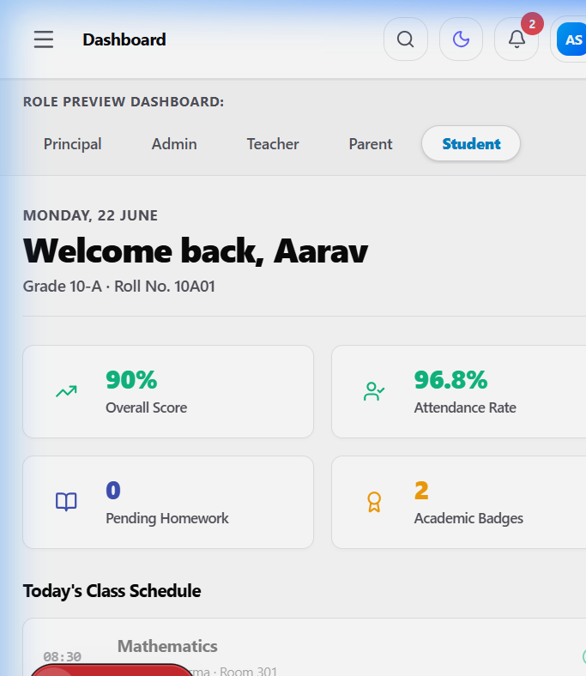
Figure: Student Portal - Virtual Locker, Timetable Tracker and Achievement Cabinet
7. System Integration & Deployment Readiness
EduSphere 360 is built with modern web technologies that guarantee data consistency and responsive layout execution. The system's modular state design separates registry databases, assignment sheets, and schedule configurations. All user state data is managed on the client side using Zustand, which mimics database operations, ensuring that actions in one view (such as a teacher grading an assignment) are instantly propagated across related views (such as the parent reviewing the grade).
This platform is fully optimized for Vercel, allowing for rapid deployment. With its flexible design, comprehensive multi-persona layout, and responsive frameworks, EduSphere 360 serves as a robust foundation for modern educational administrative operations.

