An Internship Report
On
Python Fundamentals for Beginners

Submitted in partial fulfillment of the requirement for the Degree of Bachelor of Technology

(SESSON 2023-24) DEPARTMENT OF MECHANICAL ENGINEERING
CHAMELI DEVI GROUP OF INSTITUTIONS, INDORE

Submitted by:
Adarsh Goswami (0832ME221004)

Submitted To:
Mr. Kostub Kale

RAJIV GANDHI PROUDYOGIKI VISHWAVIDYALAYA BHOPAL (M.P)

CHAMELI DEVI GROUP OF INSTITUTIONS, INDORE

CERTIFICATE OF ORIGINALITY OF WORK

I Adarsh goswami Enrollment No. 0832ME221004 Student of Mechanical Engineering Branch IV Semester, have undergone the 6 Week internship at Great Learning Academy. I have worked on the Python Fundamentals for Beginners project / domains / technologies during my internship period.

Name of Student:- Adarsh Goswami
Enrollment No. :-0832ME221004
IV Semester / ME-A

CHAMELI DEVI GROUP OF INSTITUTIONS, INDORE


CERTIFICATE

This is to certify that Mr. Adarsh goswami of B.Tech(Mechanical engineering ) Enrollment No. 0832ME221004 has completed/partially completed his/her Internship of Four weeks from date 20/03/2024 to 04/05/2024 at Great Learning Academy during the Academic Year 2023-2024 as partial fulfillment of the B.Tech (Mechanical Engineering) course.

Coordinator Head of the Department

Attached Certificate of Internship

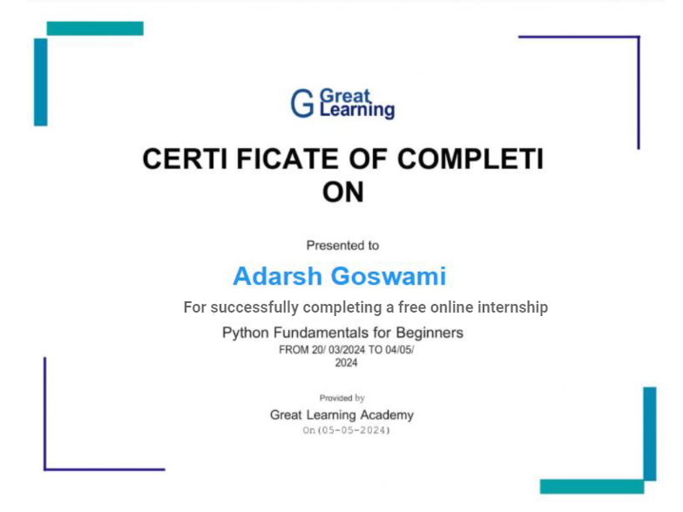

ACKNOWLEDGEMENT

I extend my sincerest appreciation to Great Learning for granting me the invaluable opportunity to partake in an enriching internship experience. This opportunity has been instrumental in broadening my horizons, allowing me to delve deeper into my field of interest and gain practical insights that transcend the confines of academia.
I am profoundly grateful for the mentorship, guidance, and support extended throughout my tenure as an intern. The exposure provided by Great Learning has been instrumental in shaping my professional journey, fostering skills, and nurturing a deeper understanding of the industry landscape. My heartfelt thanks go to the entire team at Great Learning for their unwavering encouragement, belief in my potential. This internship has not only enhanced my knowledge but has also instilled a sense of confidence and commitment to excel in my chosen career path.
I am immensely grateful for the trust and confidence vested in me during this internship. It has been an honor to contribute my skills and learn from the seasoned professionals at Great Learning.
Thank you once again for this incredible opportunity. I am eager to apply the knowledge and expertise gained here to make meaningful contributions in my future endeavors.

With sincere gratitude,
Adarsh Goswami

Table of Content

CONTENTS | PAGE NO.
Introduction of the Project | 7 - 8
Description of the Project | 9
Technical Details of the Project | 10 - 20
Certificate of Internship | 4
Conclusion | 21

Introduction of the Project

From Great Learning as the part of training program at Online Platform, I have worked completely which based on Python Fundamentals for Beginners. On this language I did multiple questions and also improve my technical logics this was very interesting for me and also more knowledgeable.

Python is a widely used high-level, general-purpose, interpreted, dynamic programming language. Its design philosophy emphasizes code readability, and its syntax allows programmers to express concepts in fewer lines of code than would be possible in languages such as C++ or Java. The language provides constructs intended to enable clear programs on both a small and large scale.

Python supports multiple programming paradigms, including object-oriented, imperative and functional programming or procedural styles. It features a dynamic type system and automatic memory management and has a large and comprehensive standard library. Python interpreters are available for installation on many operating systems, allowing Python code execution on a wide variety of systems.

Object Oriented Programming Language

Object-oriented programming (OOP) is a programming paradigm based on the concept of "objects", which may contain data, in the form of fields, often known as attributes; and code, in the form of procedures, often known as methods. A distinguishing feature of objects is that an object's procedures can access and often modify the data fields of the object with which they are associated (objects have a notion of "this" or "self").

In Object Oriented programming, computer programs are designed by making them out of objects that interact with one another. There is significant diversity in object oriented programming, but most popular languages are class-based, meaning that objects are instances of classes, which typically also determines their type.

History

Python was conceived in the late 1980s, and its implementation was started in December 1989 by Guido van Rossum at CWI in the Netherlands as a successor to the ABC language (itself inspired by SETL) capable of exception handling and interfacing with the Amoeba operating system. Van Rossum is Python's principal author, and his continuing central role in deciding the direction of Python is reflected in the title given to him by the Python community, benevolent dictator for life (BDFL).

“Python is an experiment in how much freedom programmers need. Too much freedom and nobody can read another's code; too little and expressiveness is endangered.”

- Guido van Rossum

Description of the Project
Data Type
(this is called dynamic typing). Data types determine whether an object can do something, or whether it just would not make sense. Other programming languages often determine whether an operation makes sense for an object by making sure the object can never be stored somewhere where the operation will be performed on the object (this type system is called static typing). Python does not do that. Instead it stores the type of an object with the object, and checks when the operation is performed whether that operation makes sense for that object

Python has many native data types. Here are the important ones:

Booleans are either True or False.

Numbers can be integers (1 and 2), floats (1.1 and 1.2), fractions (1/2 and 2/3), or even complex numbers.

Strings are sequences of Unicode characters, e.g. an HTML document.

Bytes and byte arrays, e.g.. a JPG image file.

Lists are ordered sequences of values.

Tuples are ordered, immutable sequences of values.

Sets are unordered bags of values.

Technical Description

Variable
Variables are nothing but reserved memory locations to store values. This means that when you create a variable you reserve some space in memory.
Based on the data type of a variable, the interpreter allocates memory and decides what can be stored in the reserved memory. Therefore, by assigning different data types to variables, you can store integers, decimals or characters in these variables.

Ex: counter = 100 # An integer assignment miles = 1000.0 # A floating point name = "John" # A string

String
In programming terms, we usually call text a string. When you think of a string as a collection of letters, the term makes sense.
All the letters, numbers, and symbols in this book could be a string. For that matter, your name could be a string, and so could your address.
Creating Strings
In Python, we create a string by putting quotes around text. For example, we could take our otherwise useless

- "hello “+”world" | "hello world" | # concatenation
- "hello"*3 | "hellohellohello" | # repetition
- "hello"[0] | "h" | # indexing
- "hello"[-1] | "o" | # (from end)
- "hello"[1:4] | "ell" | # slicing
- len("hello") | 5 | # size
- "hello" < "jello" | 1 | # comparison
- "e" in "hello" | 1 | # search

Python Operator

Arithmetic Operator
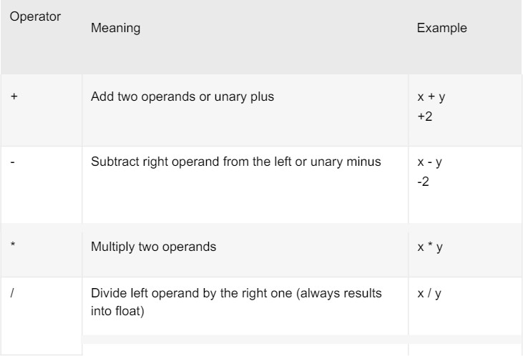
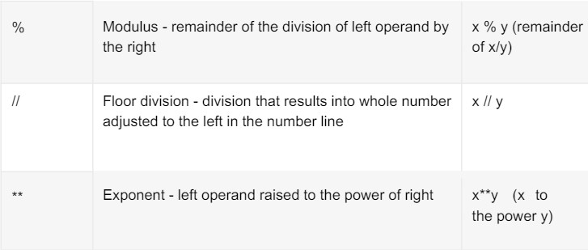

Tuples
A tuple is a sequence of immutable Python objects. Tuples are sequences, just like lists. The differences between tuples and lists are, the tuples cannot be changed unlike lists and tuples use parentheses.

Accessing Values in Tuples:
To access values in tuple, use the square brackets for slicing along with the index or indices to obtain value available at that index. For example − tup1 = ('physics', 'chemistry', 1997, 2000); tup2 = (1, 2, 3, 4, 5, 6, 7 ); print "tup1[0]: ", tup1[0] print "tup2[1:5]: ", tup2[1:5]

When the above code is executed, it produces the following result − tup1[0]: physics tup2[1:5]: [2, 3, 4, 5]

Basic Tuples Operations
Tuples respond to the + and * operators much like strings; they mean concatenation and repetition here too, except that the result is a new tuple, not a string. In fact, tuples respond to all of the general sequence operations we used on strings in the prior chapter.
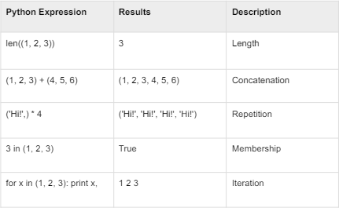

List
The list is a most versatile data type available in Python which can be written as a list of comma- separated values (items) between square brackets. Important thing about a list is that items in a list need not be of the same type.
Creating a list is as simple as putting different comma-separated values between square brackets. For example − list1 = ['physics', 'chemistry', 1997, 2000]; list2 = [1, 2, 3, 4, 5 ]; list3 = ["a", "b", "c", "d"];
Similar to string indices, list indices start at 0, and lists can be sliced, concatenated and so on.

Accessing Values in Lists:
To access values in lists, use the square brackets for slicing along with the index or indices to obtain value available at that index. For example − list1 = ['physics', 'chemistry', 1997, 2000]; list2 = [1, 2, 3, 4, 5, 6, 7 ]; print "list1[0]: ", list1[0] print "list2[1:5]: ", list2[1:5]
Output: list1[0]: physics list2[1:5]: [2, 3, 4, 5]
Update: list = ['physics', 'chemistry', 1997, 2000]; print "Value available at index 2 : " print list[2] list[2] = 2001; print

"New value available at index 2 : " print list[2]
Output: Value available at index 2 :
1997 New value available at index 2 :
2001
Delete: list1 = ['physics', 'chemistry', 1997, 2000]; print
list1 del list1[2]; print "After deleting value at index 2 : " print list1
['physics', 'chemistry', 1997, 2000]
Output: After deleting value at index 2 : ['physics', 'chemistry', 2000]
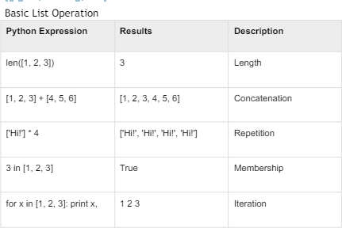

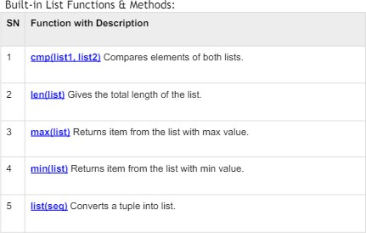

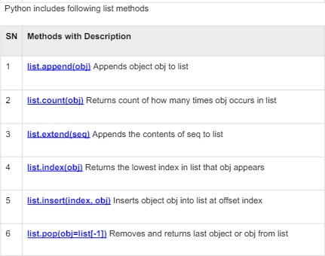
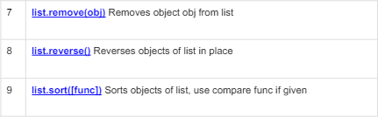

Loop definition
Programming languages provide various control structures that allow for more complicated execution paths.

A loop statement allows us to execute a statement or group of statements multiple times. The following diagram illustrates a loop statement −

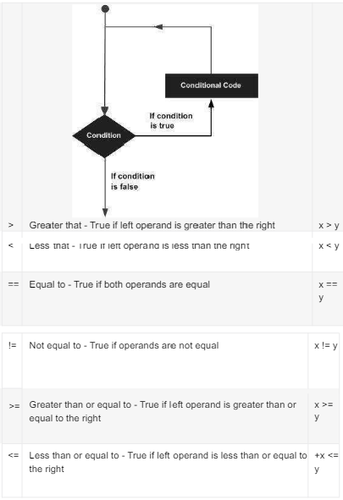

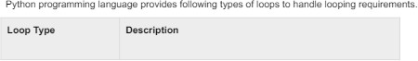

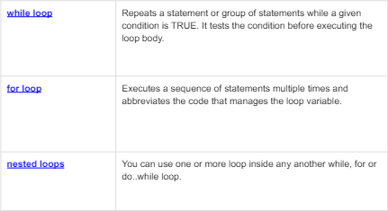

Loop Example:
For Loop:
>>> for mynum in [1, 2, 3, 4, 5]:

print ("Hello", mynum ) Hello 1
Hello 2
Hello 3
Hello 4
Hello 5

While Loop:
>>> count = 0 >>while(count< 4):
print 'The count is:', count count = count + 1 The count is: 0
The count is: 1
The count is: 2 The count is: 3

Conditional Statements:
Decision making is anticipation of conditions occurring while execution of the program and specifying actions taken according to the conditions.

Decision structures evaluate multiple expressions which produce TRUE or FALSE as outcome. You need to determine which action to take and which statements to execute if outcome is TRUE or FALSE otherwise.
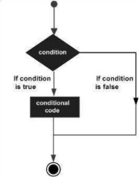

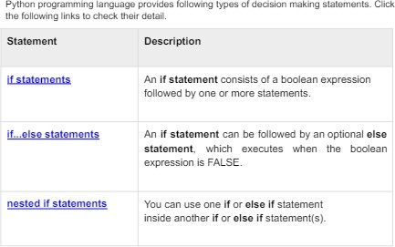

Example:
If Statement:
a=33 b=200
If b>a:
print(“b”)

If...Else Statement:
a=200 b=33
if b>a:
print(“b is greater than a”)

else:
print(“a is greater than b”)

Function
Function blocks begin with the keyword def followed by the function name and parentheses ( ( ) ).
Any input parameters or arguments should be placed within these parentheses. You can also define parameters inside these parentheses. The first statement of a function can be an optional statement - the documentation string of the function.
The code block within every function starts with a colon (:) and is indented.
The statement return [expression] exits a function, optionally passing back an expression to the caller. A return statement with no arguments is the same as return None.
Syntax:
Def functionname(parameters): “function_docstring” Function_suite Return[expression]

Example:
Def printme(str);

“this print a passed string into this function” print str

Return
1. # Function definition is here def printme( str ): "This prints a passed string into this function" print str return;

# Now you can call printme function printme("I'm first call to user defined function!") printme("Again second call to the same function")

SCOPE OF PYTHON
- - Science
  - Bioinformatics

- System Administration
  - Unix
  - Web logic
  - Web sphere

- Web Application Development

Conclusion

I believe the trial has shown conclusively that it is both possible and desirable to use Python as the principal teaching language:

- It is Free (as in both cost and source code).
- It is trivial to install on a Windows PC allowing students to take their interest further. For many the hurdle of installing a Pascal or C compiler on a Windows machine is either too expensive or too complicated;
- It is a flexible tool that allows both the teaching of traditional procedural programming and modern OOP; It can be used to teach a large number of transferable skills;
- It is a real-world programming language that can be and is used in academia and the commercial world;
- It appears to be quicker to learn and, in combination with its many libraries, this offers the possibility of more rapid student development allowing the course to be made more challenging and varied;
and most importantly, its clean syntax offers increased understanding and enjoyment for students.

