Two’s Complement Comparator

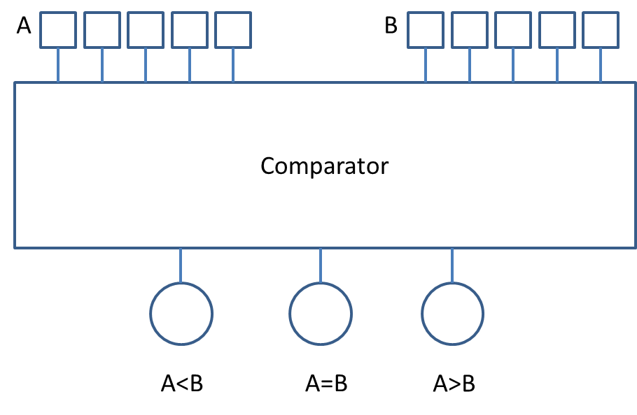

**SPECIFICATIONS**

INPUTS:

A – a 5 bit two’s complement number  
B – a 5 bit two’s complement number

OUTPUTS:

LESS THAN – 1 if A < B, otherwise 0  
EQUAL TO – 1 if A = B, otherwise 0  
GREATER THAN – 1 if A > B, otherwise 0

**INSTRUCTIONS**  
1) Create the comparator as a sub-circuit as described in class (i.e. all the wiring should be inside a circuit named comparator, not inside the MAIN circuit).

2) Once the comparator is created, you will place the comparator inside the MAIN circuit and wire the inputs and outputs to it similar to the diagram above.

3) Test your circuit. Make sure that it works with at least the following test cases:

a) 2 positive numbers  
 b) 2 negative numbers  
 c) a positive and a negative number

4.