Assignment -1

Use of Formulas Sum, Average, If, Count, Counta, Countif & Sumif

Roll No Student Name Hindi English Math Physics Chemistry Total Average Grade

(In these below Assignments you all have to write only functions and it’s parameter what will you select no need to write or create this table in Excel )



1. **g :--> Q.1 Find the Total Number & Average in all Subjects in Each Student .**

**Ans: Total =SUM(Hindi+English+Math+Physics+Chemistry)**

**Average= AVERAGE(Hindi+English+Math+Physics+Chemistry)**

**Q.2 Find Grade Using If Function - If Average Greater >15 then "A" Grade otherwise "B" Grade**

**Ans: =IF(Average>15, "A", "B")**

**Q.3 How Many Student "A" and "B" Grade (Use of Countif)**

**Ans: =COUNTIF(Grade, “=A”), =COUNTIF(Grade, “=B”)**

**Q.4 Student Ashok and Manoj Total Number and Average (Use of Sumif)**

**Ans: Total =SUMIF(Student name, “ASHOK”, Total),**

**Average = SUMIF(Student name, “ASHOK”, Average)**

**Q.5 Count how many Students (Use of Counta)**

**Ans: =COUNTA(Student name)**

**Q.6 How Many Student Hindi & English Subject Number Grater Then > 20 and <15( Use of Countif)**

**Ans:** **=COUNTIF(Hindi, “>20”), =COUNTIF(English, “<15”)**

Assignment -2

Use of Formulas - Product, If, Counta, Countif, Sumif



**Q.1 Using of Product Formula for Calculate Amount = Qty*Rate**

**Ans: =PRODUCT(QTY, RATE)**

**Q.2 How Many Items in a List**

**Ans: =COUNTA(ITEMS)**

**Q.3 How Many Items qty Greater Then > 20 and Less Then <20**

**Ans: =COUNTIF(QTY, “>20”), =COUNTIF(QTY, “<20”)**

**Q.4 Calculate Item Computer Qty, Rate and Amount using Sumif Formula**

**Ans: =SUMIF(ITEMS, “COMPUTER”, QTY)**

**=SUMIF(ITEMS, “COMPUTER”, RATE)**

**=SUMIF(ITEMS, “COMPUTER”, AMOUNT)**

**Q.5 If Items Amount is Greater > 500000, Then Items "Expensive" otherwise "Lets Buy it".**

**Ans: =IF(AMOUNT>500000, “Expensive”, “Lets Buy it”)**

**Assignment -3**

**Use of Formulas - Sum, NestedIf, Counta, Countif, Sumif, Vlookup**

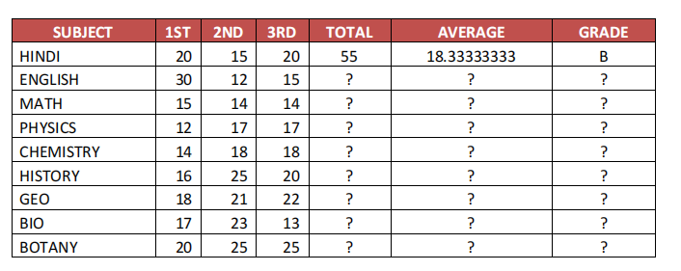

**Q.1 HOW MANY SUBJECT ? (**Use of Counta )

**Ans: =COUNTA(SUBJECT)**

**Q.2 HOW MANY SUBJECT 1 PAPER GREATER THAN 20 ? (**Use of Countif )

**Ans: =COUNTIF(1ST, “>20”)**

**Q.3 SUBJECT HINDI, MATH & ENGLISH TOTAL NO. & GRADE (** Use of Vlookup)

**Ans: TOTAL=VLOOKUP(HINDI, TABLE_RANGE, 5, 0), GRADE= VLOOKUP(HINDI, TABLE_RANGE, 7, 0)**

**TOTAL=VLOOKUP(MATH, TABLE_RANGE, 5, 0), GRADE= VLOOKUP(MATH, TABLE_RANGE, 7, 0)**

**TOTAL=VLOOKUP(ENGLISH, TABLE_RANGE, 5, 0), GRADE= VLOOKUP(ENGLISH, TABLE_RANGE, 7, 0)**

**Q.4 IF AVE. GREATHER THAN 20 THEN "A", IF AVE. GREATEHR THAN 15 AVE. "B" OTHERWISE "C"**

**Ans: =IF(AVERAGE>20, “A”, IF(AVERAGE>15, “B”, “C”))**

**Q.5 SUBJECT PHYSICS, MATHS & ENGLISH TOTAL /AVERAGE(** Use of Vlookup)

**Ans: TOTAL=VLOOKUP(PHYSICS, TABLE_RANGE, 5, 0), AVERAGE= VLOOKUP(PHYSICS, TABLE_RANGE, 6, 0)**

**TOTAL=VLOOKUP(MATH, TABLE_RANGE, 5, 0), AVERAGE= VLOOKUP(MATH, TABLE_RANGE, 6, 0)**

**TOTAL=VLOOKUP(ENGLISH, TABLE_RANGE, 5, 0), AVERAGE= VLOOKUP(ENGLISH, TABLE_RANGE, 6, 0)**

**Assignment -4 (Salary Sheet)**

**Use of Formulas - Sum, NestedIf, Counta, Countif, Sumif, Vlookup**

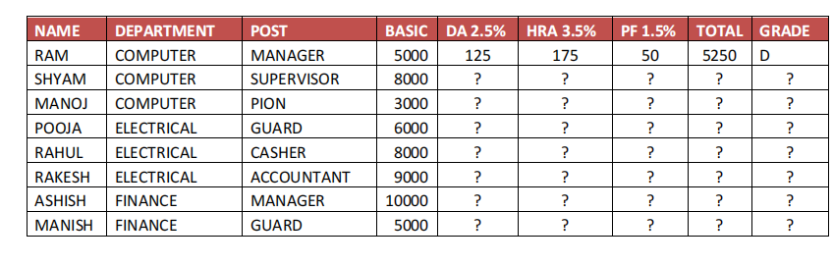

**Q.1 HOW MANY EMPLOYEE IN COMPUTER, FINANCE, ELECTRICAL DEPARTMENT**

Use of Countif

**Ans: =COUNTIF(DEPARTMENT, “=COMPUTER”)**

**=COUNTIF(DEPARTMENT, “=FINANCE”)**

**=COUNTIF(DEPARTMENT, “=ELECTRICAL”)**

**Q.2 HOW MANY BASIC SALARY IN COMPUTER DFPARTMENT ONLY?**

Use of Sumif

**Ans: =SUMIF(DEPARTMENT, “COMPUTER”, BASIC)**

**Q.3 MANOJ, ASHISH POST & GRADE**

Use of Vlookup

**Ans: =VLOOKUP(MANOJ, TABLE_RANGE, 3, 0), =VLOOKUP(MANOJ, TABLE_RANGE, 9, 0)**

**=VLOOKUP(ASHISH, TABLE_RANGE, 3, 0), =VLOOKUP(ASHISH, TABLE_RANGE, 9, 0)**

**Q.4 IF TOTAL SALALRY IS GREATER THEN 20000 THEN "A", IF TOTAL SALARY GREATER THEN 10000 THEN "B",**

**OTHERWISE "C**

**Ans: =IF(TOTAL>20000, “A”, IF(TOTAL>10000, “B”, “C”))**

**Q.5 HOW MANY EMPLOYEE IS MANAGER & GUARD?**

Use of Countif

**Ans: =COUNTIF(POST, “=MANAGER”)**

**=COUNTIF(POST, “=GUARD”)**

**Assignment -6**

**Use of Formulas - Counta, Countif, Sumif, Hlookup,**

**Conditional Formatting**

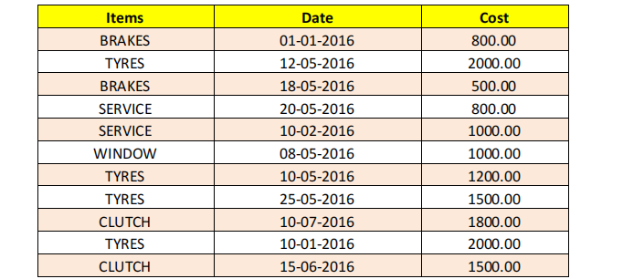

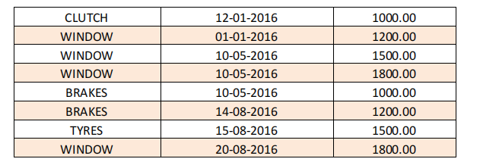

**Q.1 HOW MANY ITEMS ?**

Use of Counta

**Ans: =COUNTA(Items)**

**Q.2 HOW MANY BRAKE, WINDOW & TYRES HAVE BEEN BOUGHTS?**

Use of Countif

**Ans: =COUNTIF(Items, “=BRAKE”)**

**=COUNTIF(Items, “=WINDOW”)**

**=COUNTIF(Items, “=TYRES”)**

**Q.3 HOW MANY ITEMS COST IS >1000 & BELOW > = 1000?**

Use of Countif

**Ans: =COUNTIF(Cost, “>1000”)**

**=COUNTIF(Cost, “<=1000”)**

**Q.4 HIGHLIGHT TYRES ITEM & 500 BETWEEN 2000 COST.**

Use of Conditional F

**Ans: Select the data, go to conditional formatting, select highlight cell rules, select between, enter 500 and 2000, select the color.**

**Q.5 ITEMS COLOUMN IS 15, 18 & 20 ITEMS NAME?**

Use of Hlookup

Ans:

**Q.6 Total Cost of Window and Brakes Items?**

Use of Sumif

**Ans: =SUMIF(Items, “WINDOW”, Cost) +**

**SUMIF(Items, “BRAKES”, Cost)**

**Assignment -7**

**Create Pivot Table Using Data**

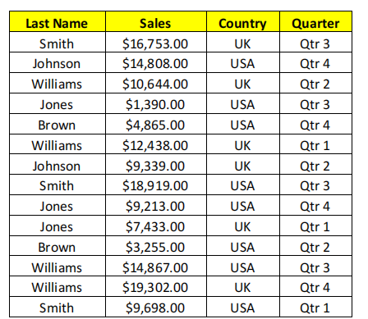



**Assignment -8**

**USE OF HLOOKUP**

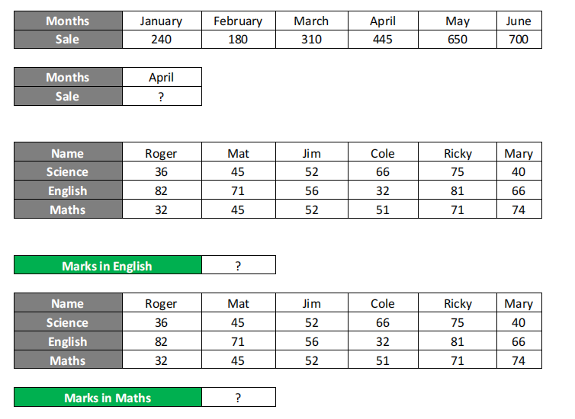

**Ans: April Sale =HLOOKUP(April, Table_range, 2, 0)**

**Roger Marks in English =HLOOKUP(Roger, Table_range, 3, 0)**

**Roger Marks in Maths =HLOOKUP(Roger, Table_range, 4, 0)**

**Use of Sumif**

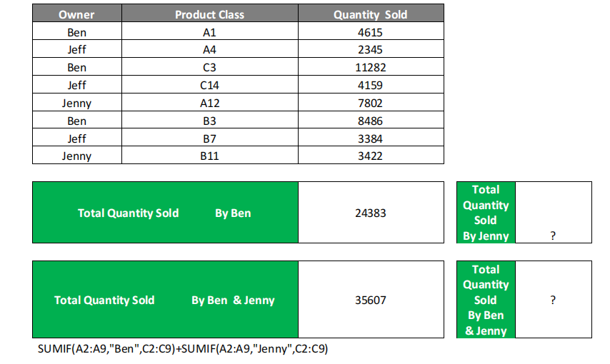

**Ans: Total Quantity Sold by Jenny = SUMIF(A2:A9, “Jenny”, C2:C9)**

**Total Quantity Sold by Ben & Jenny = SUMIF(A2:A9, “Ben”, C2:C9) + SUMIF(A2:A9, “Jenny”, C2:C9)**

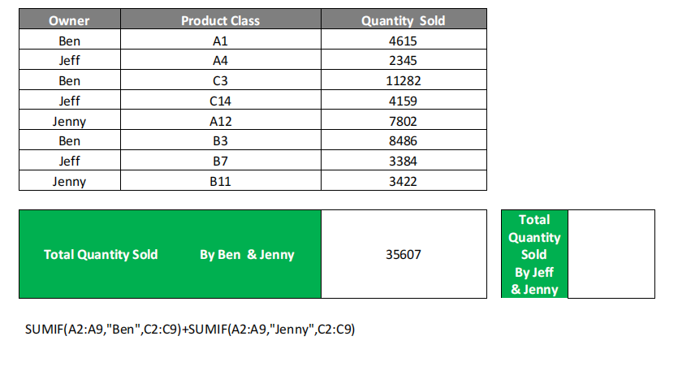

Ans: **Total Quantity Sold by Jeff & Jenny = SUMIF(A2:A9, “Jeff”, C2:C9) + SUMIF(A2:A9, “Jenny”, C2:C9)**

**Assignment -10**

***USE OF VLOOKUP***

***WITH CONDITION TRUE/FALSE***

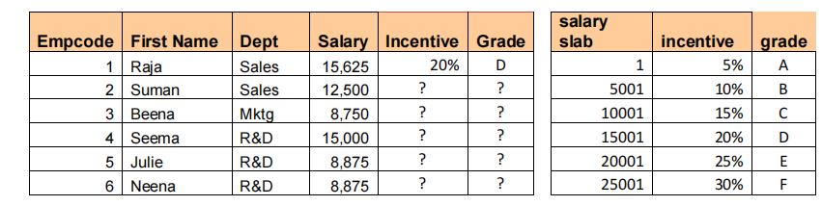

**Ans: Incentive =VLOOKUP(Salary, 2nd Table range, 2, 1)**

**Grade = VLOOKUP(Salary, 2nd Table range, 3, 1)**



Assignment-11

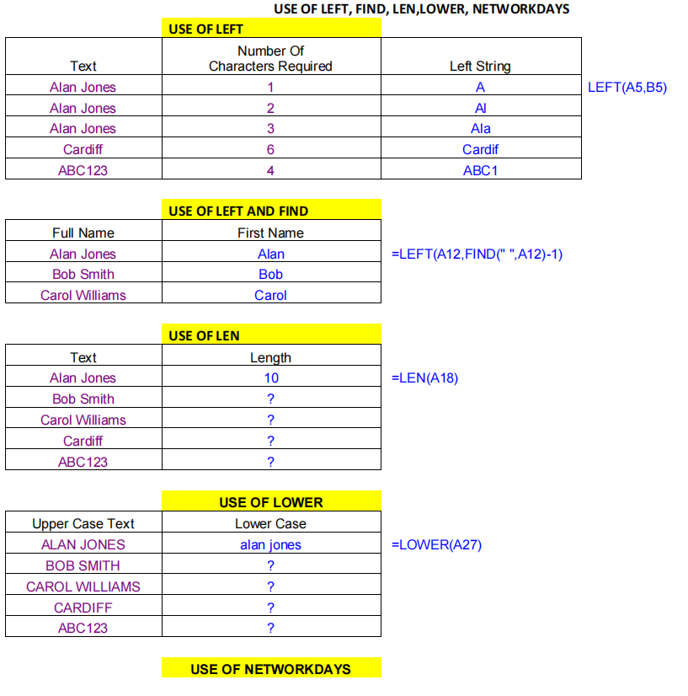



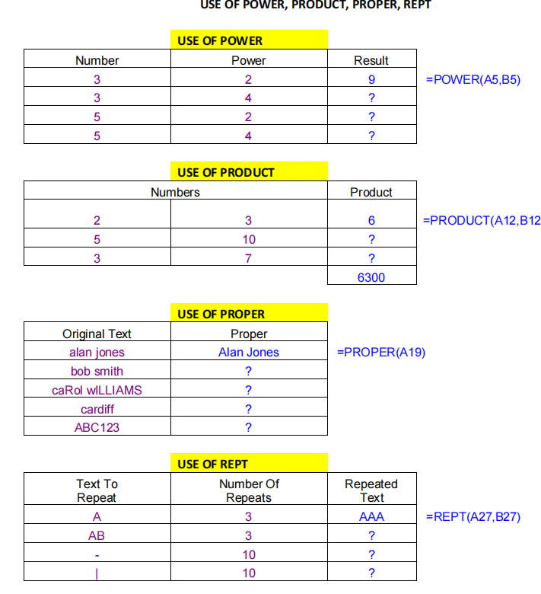

SOLUTION:



**Assignment-12**

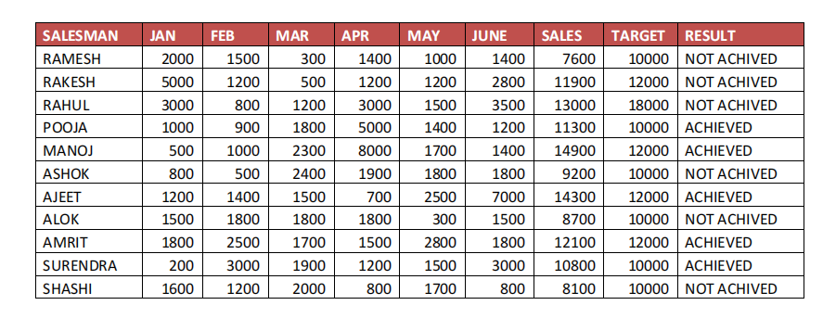

Q.1 How many salesman? Salesman Ajeet Target & Result?

USE OF COUNTA AND VLOOKUP

Ans: =COUNTA(SALESMAN)

AJEET TARGET =VLOOKUP(AJEET, TABLE_RANGE, 9, 0)

AJEET RESULT =VLOOKUP(AJEET, TABLE_RANGE, 10, 0)

Q.3 Rahul Pooja & Ashok Target & result?

USE OF VLOOKUP

Ans: RAHUL TARGET =VLOOKUP(RAHUL, TABLE_RANGE, 9, 0)

RAHUL RESULT =VLOOKUP(RAHUL, TABLE_RANGE, 10, 0)

POOJA TARGET =VLOOKUP(POOJA, TABLE_RANGE, 9, 0)

POOJA RESULT =VLOOKUP(POOJA, TABLE_RANGE, 10, 0)

ASHOK TARGET =VLOOKUP(ASHOK, TABLE_RANGE, 9, 0)

ASHOK RESULT =VLOOKUP(ASHOK, TABLE_RANGE, 10, 0)

Q.4 How Many Salesman Achived Target.

USE OF COUNTIF

Ans: =COUNTIF(RESULT, “=ACHIEVED”)

Q.5 Which SalesMan Jan Sales 2000, & Feb Sales is 2500?

USE OF LOOKUP

Ans: LOOKUP VALUE should be in first column. It will show error.

Q.6 How Many salesMan sales Jan Months Sales >2000 & March Sales

<=1500 ?

USE OF COUNTIF

Ans: =COUNTIF(JAN, “>2000”)

=COUNTIF(MAR, “<=1500”)

Q.7 Jan to Target Highlights 2000 between 5000, Font Red &

Background Yellow?

USE OF CONDITIONAL FORMATTING

Ans: **Select the data from Jan to Target, go to conditional formatting, select highlight cell rules, select between, enter 2000 and 5000, select the font red & background yellow.**

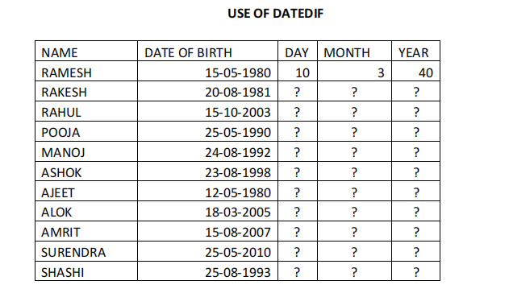

Q.1 HOW MANY STUDENT?

Q.2 STUDENT SURENDRA IS HOW MANY YEAR OLD?

Q.3 HOW MANY STUDENT AGE GREATER THAN 20 YEARS?

Q.4 IF STUDENT AGE IS GREATHER THAN 20 THEN STUDENT ADULT / CHILD?

Q.5 HOW MANY STUDENT AGE IS >= 25 YEARS?