WEEK 1 DATA PREPARATION & EXPLORATORY DATA ANALYSIS
Titanic Passenger Survival Dataset — Python / Pandas EDA
Data Science Project Documentation | Estimated Effort: 30–35 Hours

1. Executive Summary
This report documents a complete Week 1 data-preparation workflow using the publicly available Titanic passenger dataset from Kaggle. The objective was to simulate the early stages of a data science project: acquire data, inspect its quality, clean and preprocess it with Python, perform exploratory data analysis (EDA), create meaningful visualizations, and document insights.
The source training dataset contains 891 passenger records and 12 columns. The initial inspection identified missing values in Age (177), Cabin (687), and Embarked (2) and 0 exact duplicate rows. Age was imputed using group-wise medians, Embarked was filled using its mode, and Cabin was removed because approximately 77% of its values were missing. No duplicate records were found.
After cleaning, the dataset contained 891 records and 13 analytical columns. The overall survival rate was 38.4%. Female passengers had a survival rate of 74.2%, compared with 18.9% for male passengers. Survival also varied substantially by ticket class.

2. Project Objectives
- Acquire a publicly available dataset relevant to a data-analysis problem.
- Inspect structure, data types, missing values, and duplicate records.
- Clean and preprocess the dataset using Pandas and Python.
- Use summary statistics to understand numerical and categorical variables.
- Create at least three visualizations to identify patterns and relationships.
- Document the rationale behind every major cleaning decision.
- Summarize insights and identify possible areas for further analysis.

3. Dataset Acquisition
Dataset selected: Titanic — Machine Learning from Disaster, Kaggle. The Kaggle competition provides a training file (train.csv) containing 891 passenger records with the survival outcome available. Variables include passenger class, sex, age, family relationships, ticket, fare, cabin, and port of embarkation.
Public source: https://www.kaggle.com/competitions/titanic/data
Dataset objective: understand which passenger characteristics were associated with survival.
The dataset is suitable for this task because it contains numerical and categorical variables, missing values, and interpretable relationships that are useful for demonstrating data cleaning and EDA.

3.1 Key Variables
Variable | Type | Description
Survived | Integer / binary | 0 = did not survive, 1 = survived
Pclass | Integer / categorical | Passenger ticket class: 1, 2, or 3
Sex | Categorical | Passenger sex
Age | Float | Passenger age in years
SibSp | Integer | Siblings/spouses aboard
Parch | Integer | Parents/children aboard
Fare | Float | Passenger fare
Cabin | Categorical | Cabin identifier
Embarked | Categorical | Port of embarkation

4. Methodology
The analysis followed a reproducible pipeline: data acquisition → initial inspection → data-quality assessment → cleaning → feature preparation → descriptive statistics → visualization → interpretation.
Recommended working environment: Python 3.x, Pandas, NumPy, Matplotlib, and Jupyter Notebook/VS Code.

4.1 Initial Data Inspection
The first inspection checked the dataset shape, first records, data types, missing values, and duplicate rows.
import pandas as pd
df = pd.read_csv("train.csv")
print(df.shape)
print(df.head())
print(df.info())
print(df.isna().sum())
print(df.duplicated().sum())
Inspection result: 891 rows × 12 columns; 0 duplicate rows; missing values were concentrated in Cabin (687), Age (177), and Embarked (2).

5. Data Cleaning and Preprocessing

5.1 Duplicate Records
The dataset contained 0 exact duplicate rows. Therefore, no rows were removed for duplication. The duplicate check was retained in the workflow so that the process is reproducible for future datasets.

5.2 Missing Age Values
There were 177 missing Age values. Instead of using a single overall median, the analysis used the median age within each combination of passenger class and sex. This preserves important demographic differences while avoiding the loss of 177 observations.
df["Age"] = df.groupby(["Pclass", "Sex"])["Age"].transform(
lambda s: s.fillna(s.median())
)

5.3 Missing Embarkation Values
Only 2 Embarked values were missing. Because the variable is categorical and the number of missing records is very small, the most frequent category (mode) was used.
df["Embarked"] = df["Embarked"].fillna(df["Embarked"].mode()[0])

5.4 Cabin Variable
Cabin had 687 missing values out of 891 records (77.1%). Because most observations lack cabin information, using direct imputation would create a large amount of artificial information. Cabin was therefore removed from this basic analytical dataset. In a more advanced project, a feature such as cabin-known/unknown could be engineered instead.

5.5 Data Types and Feature Engineering
Categorical fields were standardized as string values, numeric fields were explicitly converted to numeric types, and two simple derived variables were created: FamilySize and IsAlone. These variables make it easier to study whether travelling with family was associated with survival.
df["FamilySize"] = df["SibSp"] + df["Parch"] + 1
df["IsAlone"] = (df["FamilySize"] == 1).astype(int)

5.6 Data Quality Summary
Quality Check | Before | Action | After
Rows | 891 | No rows removed for duplicates | 891
Duplicate rows | 0 | Checked; none found | 0
Missing Age | 177 | Group-wise median imputation | 0
Missing Embarked | 2 | Mode imputation | 0
Missing Cabin | 687 | Dropped high-missingness column | Column removed

6. Exploratory Data Analysis

6.1 Summary Statistics
Age: mean 29.1 years, median 26.0, minimum 0.4, maximum 80.0. Fare: mean 32.20, median 14.45, maximum 512.33.
Overall survival rate: 38.4%. Passenger class survival rates were approximately 63.0% for Class 1, 47.3% for Class 2, and 24.2% for Class 3.

6.2 Visualization 1 — Missing Values
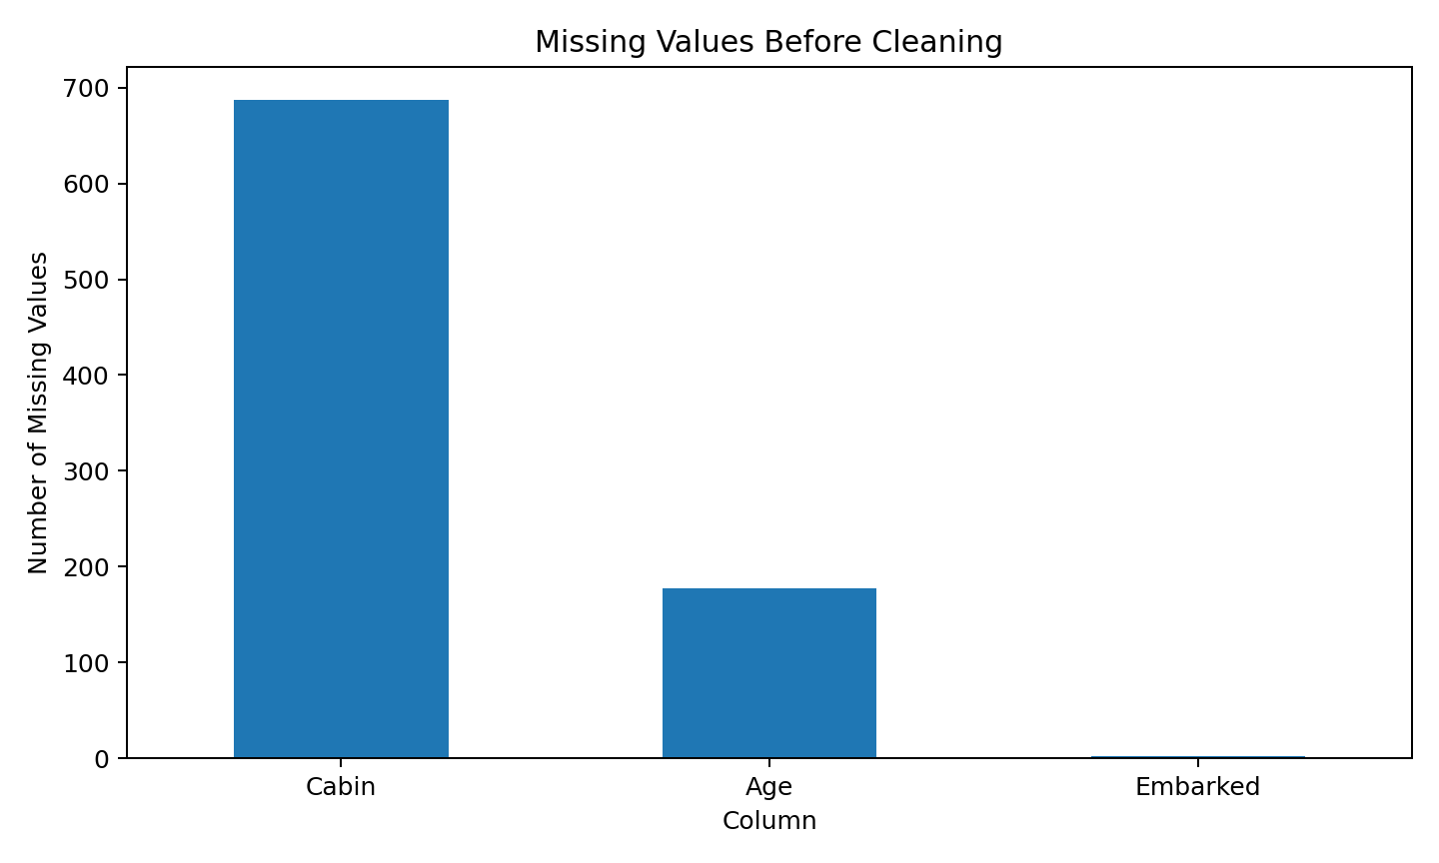
Figure 1. Missing values identified before cleaning.
The missing-value profile shows that Cabin is the dominant data-quality issue, followed by Age. Embarked has only two missing observations. This supports the decision to remove Cabin for the basic analysis while imputing Age and Embarked.

6.3 Visualization 2 — Survival by Sex
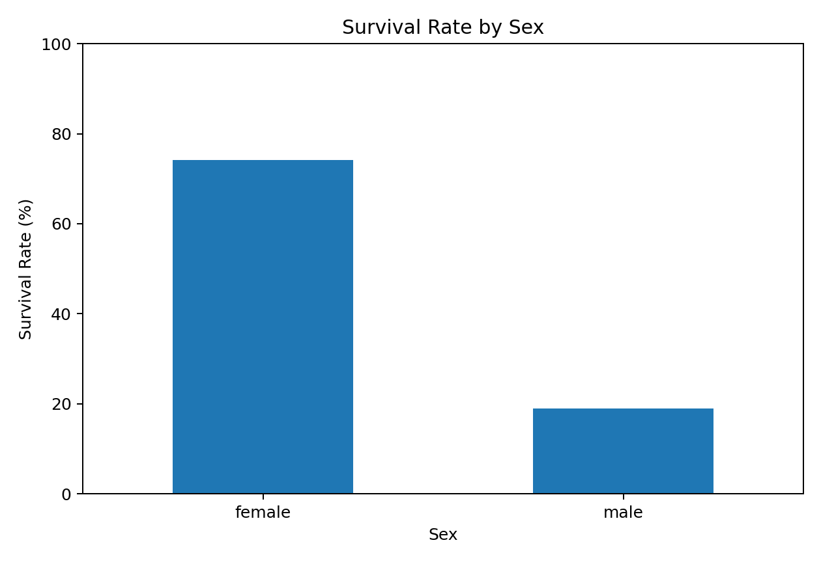
Figure 2. Survival rate by passenger sex.
Female survival was approximately 74.2% compared with 18.9% for males. This is one of the strongest patterns in the dataset and suggests that sex is highly informative for survival analysis.

6.4 Visualization 3 — Survival by Passenger Class
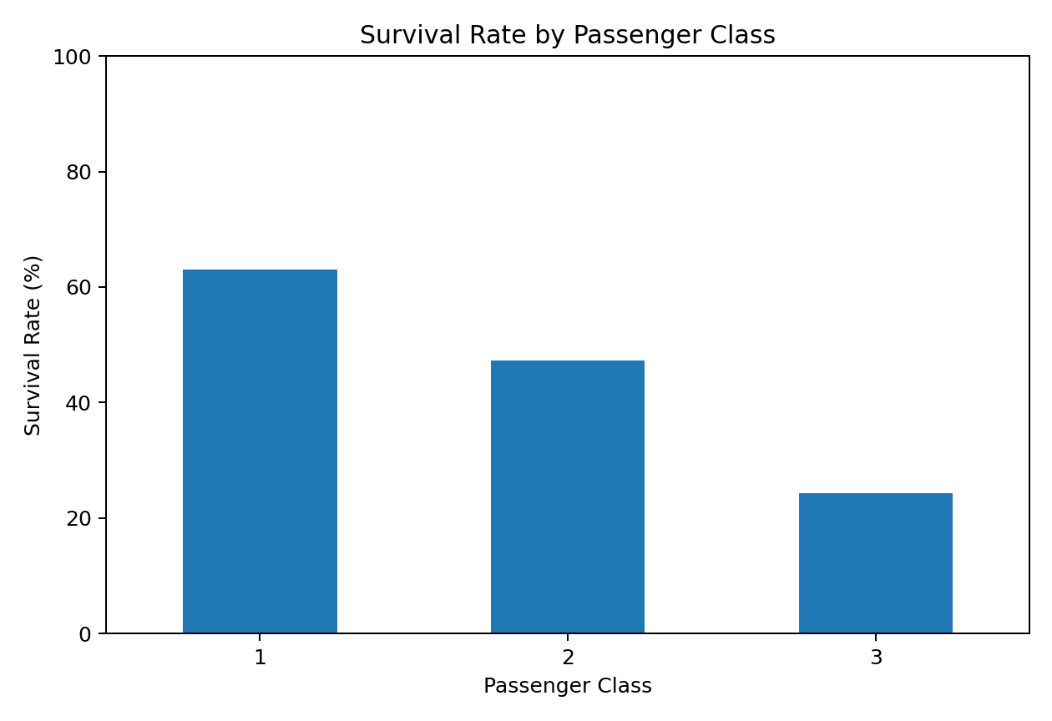
Figure 3. Survival rate by passenger class.
Survival decreased consistently as passenger class increased numerically: Class 1 had about 63.0% survival, Class 2 about 47.3%, and Class 3 about 24.2%. This indicates a strong association between socio-economic class and survival.

6.5 Additional Visualization — Age Distribution
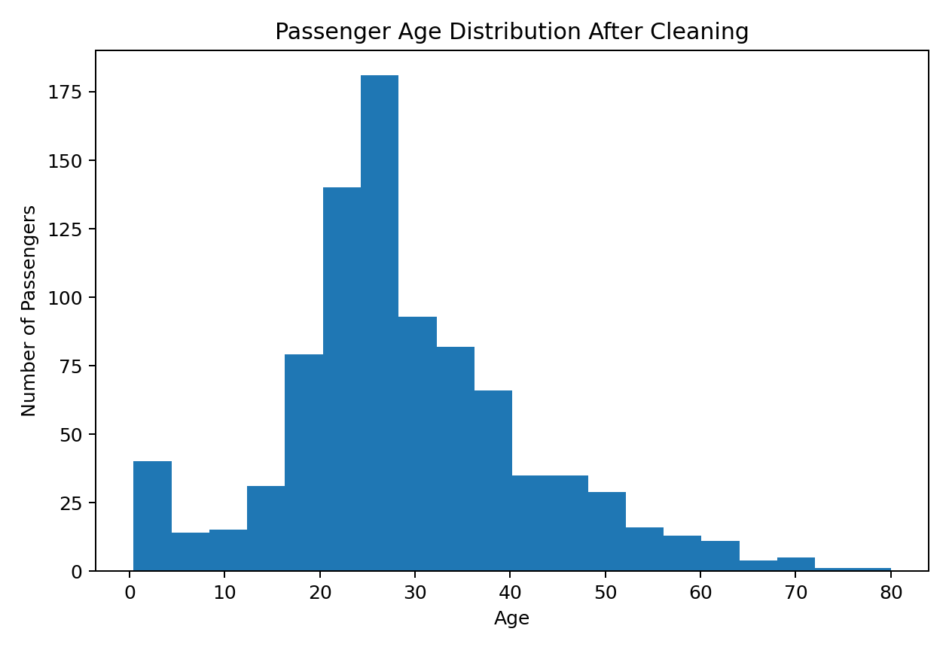
Figure 4. Distribution of passenger ages after missing-value treatment.
Most passengers were adults, with fewer observations at very young and very old ages. The imputation process allows the full passenger sample to be retained for exploratory comparisons.

6.6 Additional Visualization — Correlation Matrix
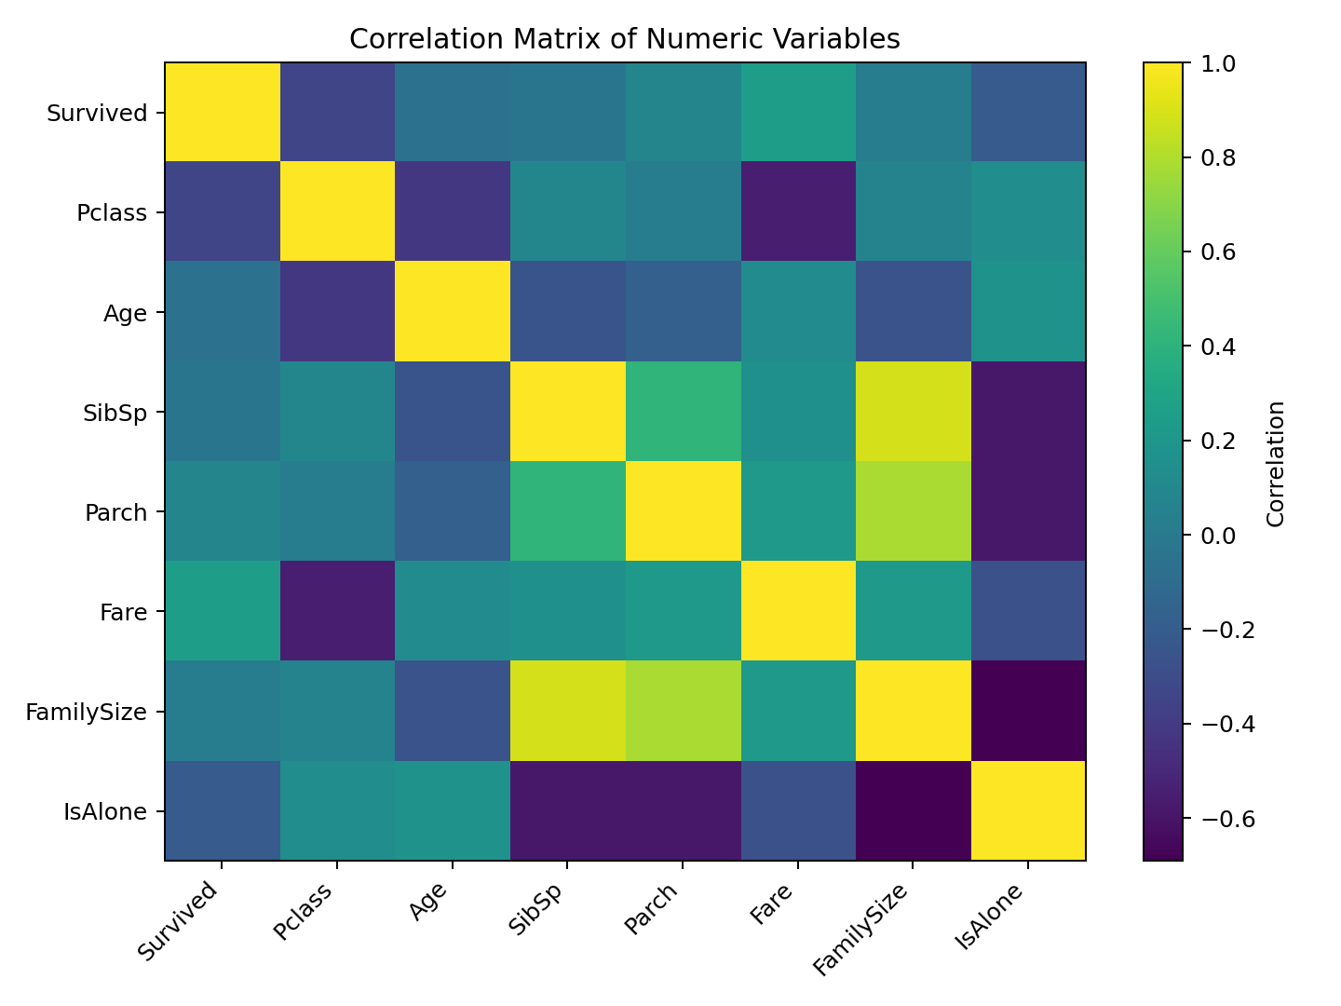
Figure 5. Correlation matrix for numeric variables.
The correlation matrix provides a quick view of linear relationships. Fare tends to be associated with passenger class, while FamilySize is strongly related to SibSp and Parch because it is constructed from them. Correlation should not be interpreted as causation.

7. Key Insights
- Overall survival was approximately 38.4%, so most passengers in the training dataset did not survive.
- Sex was strongly associated with survival: approximately 74.2% of females survived versus 18.9% of males.
- Passenger class showed a clear gradient: Class 1 had the highest survival rate (63.0%), while Class 3 had the lowest (24.2%).
- Missing data was not random across variables: Cabin was missing for the majority of passengers, making direct imputation inappropriate for a simple analysis.
- Age required careful treatment because dropping all records with missing ages would reduce the analytical sample unnecessarily.
- Family-related variables provide opportunities for additional feature engineering, particularly family size, travelling alone, and group-level relationships.

8. Potential Areas for Further Analysis
- Build a logistic regression or decision-tree model to predict survival.
- Compare survival by combinations such as Sex × Pclass and Age × Pclass.
- Engineer title from Name (Mr, Mrs, Miss, Master, etc.) and evaluate its predictive value.
- Create FamilySize categories and compare survival among solo, small-family, and large-family travellers.
- Explore fare outliers and normalize fare by family or ticket group.
- Treat Cabin as a missingness indicator rather than simply discarding it in a more advanced project.
- Perform train/test splitting and cross-validation before evaluating predictive models.

9. 30–35 Hour Work Plan
Activity | Estimated Hours | Work Completed
Dataset selection and acquisition | 3 h | Selected Kaggle Titanic training data and documented source
Initial inspection and data profiling | 4 h | Shape, data types, missing values, duplicates
Data cleaning and preprocessing | 8 h | Missing-value handling, duplicate checks, types, feature creation
Exploratory data analysis | 8 h | Summary statistics, group comparisons, correlation analysis
Visualization creation and interpretation | 5 h | Five documented visualizations
Report writing and code documentation | 5 h | Methodology, rationale, insights, code snippets
Final review and quality check | 2 h | Formatting, consistency, and completeness
Total | 35 h | Within the requested 30–35 hour timeframe

10. Consolidated Python Workflow
import pandas as pd
import matplotlib.pyplot as plt
# 1. Load data
df = pd.read_csv("train.csv")
# 2. Remove exact duplicates
df = df.drop_duplicates()
# 3. Standardize categorical fields
df["Sex"] = df["Sex"].astype("string").str.strip()
df["Embarked"] = df["Embarked"].astype("string").str.strip()
# 4. Impute Age using Pclass + Sex group medians
df["Age"] = df.groupby(["Pclass", "Sex"])["Age"].transform(
lambda s: s.fillna(s.median())
)
# 5. Impute missing Embarked values
df["Embarked"] = df["Embarked"].fillna(df["Embarked"].mode()[0])
# 6. Drop Cabin because of very high missingness
df = df.drop(columns=["Cabin"])
# 7. Feature engineering
df["FamilySize"] = df["SibSp"] + df["Parch"] + 1
df["IsAlone"] = (df["FamilySize"] == 1).astype(int)
# 8. Basic EDA
print(df.describe())
print(df.groupby("Sex")["Survived"].mean())
print(df.groupby("Pclass")["Survived"].mean())
# 9. Example visualization
df.groupby("Pclass")["Survived"].mean().mul(100).plot(kind="bar")
plt.ylabel("Survival Rate (%)")
plt.show()

11. Conclusion
This Week 1 exercise demonstrates the complete data-preparation lifecycle expected at the beginning of a data science project. The Titanic dataset was inspected for structural and quality issues, cleaned using defensible rules, and explored through summary statistics and visualizations. The analysis shows strong differences in survival by sex and passenger class, while also demonstrating why missing-data treatment must be based on the meaning and extent of the missingness.
The resulting dataset is suitable for a next-stage predictive modelling exercise. The most important lesson from this task is that data preparation is not simply about deleting incomplete rows: each cleaning decision should preserve useful information, avoid introducing artificial patterns, and be clearly documented.

12. References
Kaggle. Titanic — Machine Learning from Disaster. Dataset and data dictionary.
https://www.kaggle.com/competitions/titanic/data
Python Software Foundation. Python documentation.
Pandas documentation: data loading, missing-value handling, grouping, and descriptive statistics.
Matplotlib documentation: plotting and visualization.

