Chapter 1
Problem Identification & Feasibility Study
1. Problem Identification
Title of the Project
Learning Management System (LMS)
Problem Statement
In traditional educational setups, managing course materials, tracking student progress, and distributing assignments often rely on disjointed physical paperwork or scattered digital files. Students frequently struggle to access lecture notes, submit assignments on time, or track their grades in one centralized location, leading to confusion and missed deadlines.
The proposed Learning Management System (LMS) provides a centralized, web-based platform where instructors can easily share resources and manage courses, while students can seamlessly access materials, submit assignments, and track their academic performance.
Need for the Project
- Centralizes Resources: Keeps all lectures, notes, and syllabus details in a single, accessible repository.
- Simplifies Assignment Workflow: Streamlines the process of uploading assignments and returning graded feedback.
- Improves Communication: Keeps students informed about upcoming deadlines and class announcements.
- Eco-Friendly & Efficient: Minimizes paper waste and manual tracking for both students and instructors.
- Enhances Tracking: Allows students to view their progress and grades in real-time.
2. Problem Justification and Scope Definition
Justification
With the rapid shift toward hybrid and digital education, schools and universities require robust, lightweight solutions to manage learning. Developing a simplified, functional LMS addresses these modern administrative challenges, easing the burden on educators and giving students a structured, stress-free path to academic success.

Scope of the Project
In Scope | Out of Scope
User Registration & Login (Roles: Student, Teacher) | Live Video Conferencing / Video Streaming
Course Enrolment & Class Announcements | Integrated Proctored Exams (AI Proctoring)
File Uploading (Notes, Syllabus, Handouts) | Online Fee Payment Gateway
Assignment Submission & Grading Panel | Private Chat/Messaging System
Gradebook & Performance Tracking | Automatic Certificate Generation
3. Stakeholder Identification
Stakeholder | Role
Student | Enroll in courses, downloads materials, submits assignments, and views grades.
Teacher / Instructor | Creates courses, uploads materials, posts announcements, and grades student work.
System Administrator | Manages user accounts, maintains course catalogs, and oversees database health.
4. Feasibility Analysis
A. Technical Feasibility
The project can be built using robust, widely supported web technologies that are accessible, free, and standard for student projects.
- Software:
  - Frontend: HTML, CSS, JavaScript (Bootstrap for responsive design)
  - Backend: Python (Flask)
  - Database: MySQL (for managing user accounts, enrollments, grades, and paths to uploaded files)
- Hardware:
  - Standard Laptop/Desktop
  - Internet Connection
The chosen stack is completely open-source, highly documented, and highly suitable for a fast development cycle.
B. Economic Feasibility
Item | Estimated Cost
Software | ₹0 (Open Source tools like VS Code, Python, MySQL)
Development | ₹0 (Self-developed student project)
Hosting | ₹2,000/year (Optional, can be hosted locally for evaluation)
Hardware | Existing Laptop/Desktop
Total Cost | ₹2,000 (Approx. / Optional)
C. Operational Feasibility
The system features a clean, intuitive layout that requires virtually zero technical training. Teachers can easily manage their curriculum, and students can confidently navigate courses from any device, ensuring high user adoption rates.
Functional & Non-Functional Requirements
Functional Requirements
- User Registration and Login (Student and Teacher accounts).
- Teacher interface to create courses and post announcements.
- File upload system (PDF, PPT, DOCX) for course materials.
- Assignment submission portal with file upload capability for students.
- Grading dashboard for teachers to view submissions and assign marks.
- Student dashboard to view individual grades and upcoming tasks.
Non-Functional Requirements
- Performance: Page response and file upload confirmation in less than 3 seconds.
- Security: Secure user passwords using salted cryptographic hashing (e.g., bcrypt).
- Reliability: High database availability so course data is not lost.
- Usability: Responsive UI that works smoothly on both mobile devices and desktops.
- Scalability: Able to comfortably support up to 500 concurrent active users.
Use Case Analysis
Actors
- Student
- Teacher
- Admin
Use Cases
- Register / Login
- Enroll in Course
- Post Course Material (Teacher)
- Submit Assignment (Student)
- Grade Submissions (Teacher)
- View Grades (Student)
- Manage Database/Users (Admin)
Requirement Prioritization
Requirement | Priority
User Login (Roles: Student/Teacher) | Must Have
Course Material Upload & Download | Must Have
Assignment Submission Portal | Must Have
Teacher Grading Panel | Must Have
Announcements / Notice Board | Should Have
Interactive Discussion Forum | Could Have
Live Virtual Classrooms | Won't Have
Constraints and Assumptions
Constraints
Type | Example
Budget | Limited to ₹15,000 (kept as low as possible).
Time | Must be fully developed and tested within one academic semester.
Technology | Constrained to standard web stack: HTML, CSS, JavaScript, Python, MySQL.
Hardware | Development and deployment must run smoothly on standard personal laptops.
Assumptions
- Users (students and teachers) have stable internet access.
- Users have basic digital literacy (knowing how to upload files, type, and navigate a web browser).
- The school/institution provides the teacher with correct student rosters for enrollment.
- The system administrator will handle occasional server/database backups.

Chapter :2
Software Development Life Cycle (SDLC) Planning
2.1 Selection of SDLC Model
Selected SDLC Model: Prototype Model

The Prototype Model is selected for the "Learning Management System (LMS)" project because it allows the development of a working prototype before the complete system is fully deployed. An LMS involves multiple user roles—such as Students, Instructors, and Administrators—each requiring distinct features like course viewing, assignment submission, and grade management. Building an initial prototype allows stakeholders to interact with the system early, evaluate the user interface, provide feedback, and suggest functional improvements.
This model is suitable because web application development, role-based user flows, and database interactions benefit significantly from continuous testing and refinement. It reduces development risks, prevents costly design overhauls, improves overall software quality, and ensures that the final LMS meets academic requirements through iterative feedback.
• Enhanced User Satisfaction: Users get a hands-on experience with the system long before deployment, ensuring high acceptance rates among students and faculty.
• Early Detection of Usability Issues: Navigation bottlenecks, confusing layouts, or redundant user actions are caught during the early design phase rather than post-launch.
• Flexibility in Accommodating Changes: Any modifications in academic requirements, grade calculation logic, or workflow steps can be easily adapted during iterative feedback sessions.
• Reduction of Unclear Requirements: Missing functional specifications—such as file size limits for assignment submissions or notification preferences—are naturally uncovered through real-time prototype usage.

2.2 Work Breakdown Structure (WBS)
Hierarchical Work Breakdown Structure

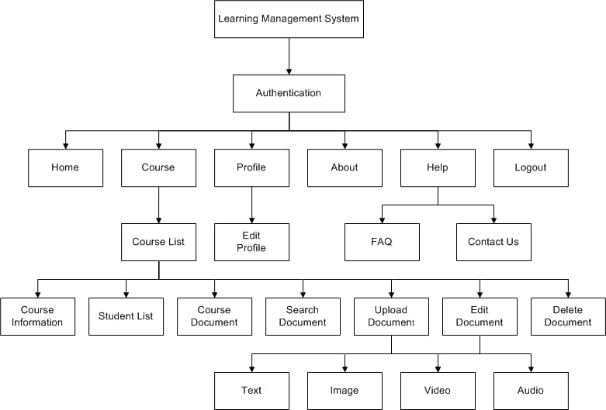

2.3 Project Timeline (Gantt Chart)
Here is the properly formatted Gantt Chart table for your LMS project, with the task schedule clearly organized from 1 July to 30 September
LMS Project Development Timeline (Gantt Chart)
Task / Activity | July (Jul) |  |  |  | August (Aug) |  |  |  | September (Sep) |  |  |  | October (Oct)
Task / Activity | Jul W1 | Jul W2 | Jul W3 | Jul W4 | Aug W1 | Aug W2 | Aug W3 | Aug W4 | Sep W1 | Sep W2 | Sep W3 | Sep W4 | Oct W1
Task / Activity | 4 Jul | 11 Jul | 18 Jul | 25 Jul | 1 Aug | 8 Aug | 15 Aug | 22 Aug | 5 Sep | 12 Sep | 19 Sep | 26 Sep | 3 Oct
Problem Identification & Feasibility Study
Requirement Engineering
SDLC Planning
UML Modeling
System Architecture Design
Frontend Development
Backend Development
Core Feature Implementation
Testing & Bug Fixing
Deployment & Security Testing
Documentation & Final Submission

2.4 Resource Requirements
A. Human Resources
Resource | Resource
Student Developer | Web architecture design, database administration, programming, system integration, testing, and documentation
Project Guide | Provides academic guidance, reviews technical architecture, and tracks progress
End User (Student/Teacher) | Tests system prototypes, performs daily operations, and provides feedback

B. Hardware Requirements
Resource | Specifications
Laptop / Desktop | Intel Core i3 or Above, 8 GB RAM
Development Server | Localhost Environment (XAMPP / Node Server)
Storage | 20 GB free disk space for project assets & database

C. Software Requirements
Resource | Specifications
Operating System | Windows 10/11
Code Editor | Visual Studio Code (Latest Version)
Programming Languages | HTML5, CSS3, JavaScript / Python / PHP
Database Management System | MySQL / PostgreSQL / MongoDB
Web Server Environment | Apache / Nginx / Node.js Runtime
Web Browser | Google Chrome / Mozilla Firefox

D. Estimated Budget
Item | Specifications | Estimated Cost (₹)
Web Domain Name | .com / .in domain registration | ₹ 0
Web Hosting & Database Server | Basic shared cloud hosting plan | ₹ 0
SSL Certificate | HTTPS Security (Free via Let's Encrypt) | ₹ 0
Documentation & Printing | Project reports & hardcover binding | ₹ 0
Total Estimated Cost |  | ₹ 0

CHAPTER 3:
System Modeling using UML
3.1 Use Case Diagram:-
A Use Case Diagram represents the interaction between users (actors) and the Learning Management System (LMS). It shows the major functions provided by the system and how different users access those functions.

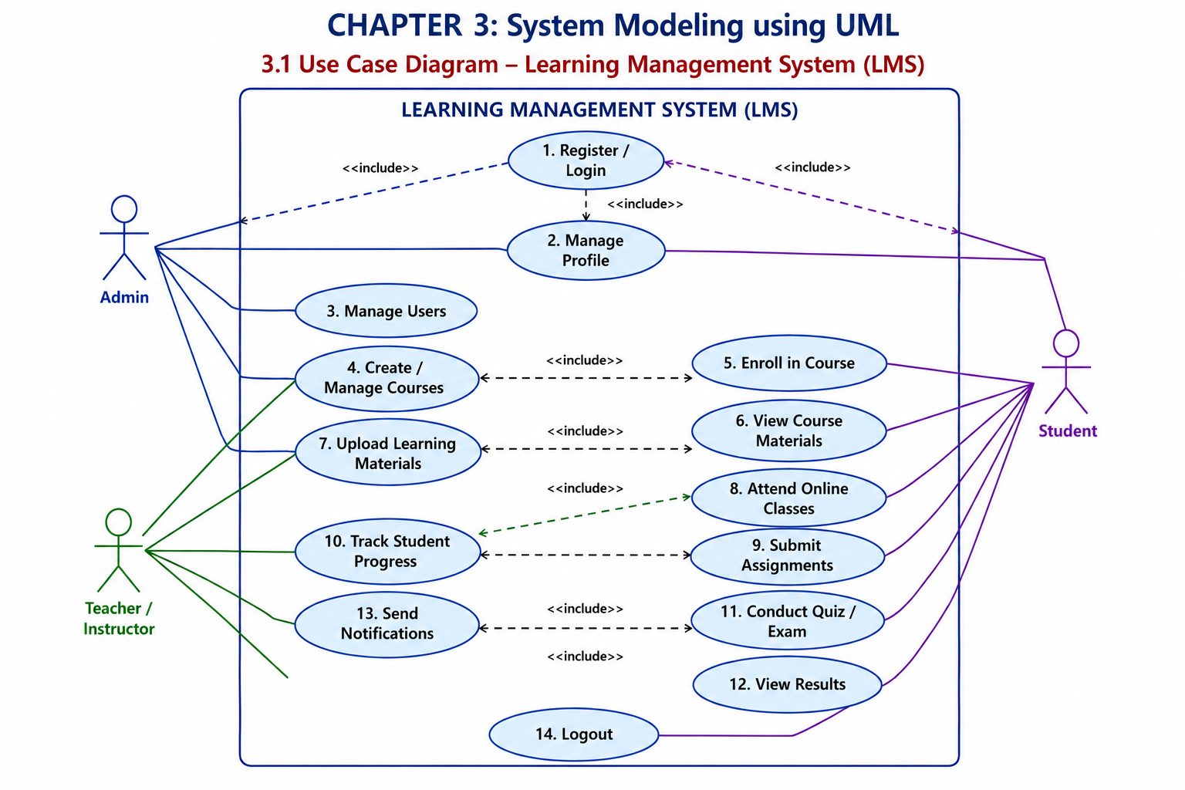

3.2 ER Diagram:-
The ER diagram shows the main entities of the Learning Management System, their attributes, and the relationships between Admin, Teacher, Student, Course, Material, Assignment, and Quiz

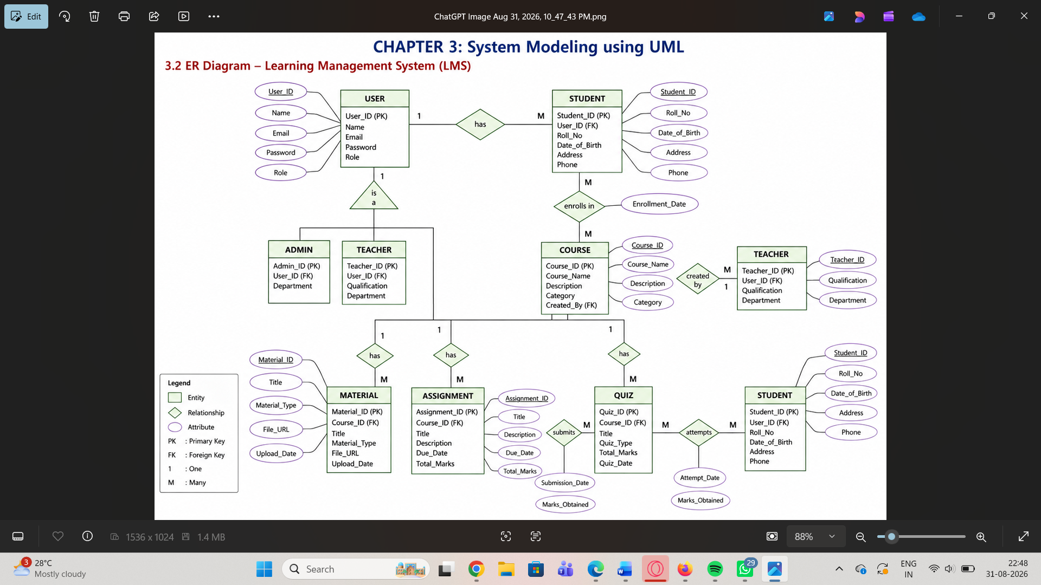

3.3 Class Diagram:-
The diagram shows the main classes of the LMS, including User, Admin, Teacher, Student, Course, Material, Assignment, Quiz, Question, and Submission, along with their attributes, methods, inheritance, and relationships.

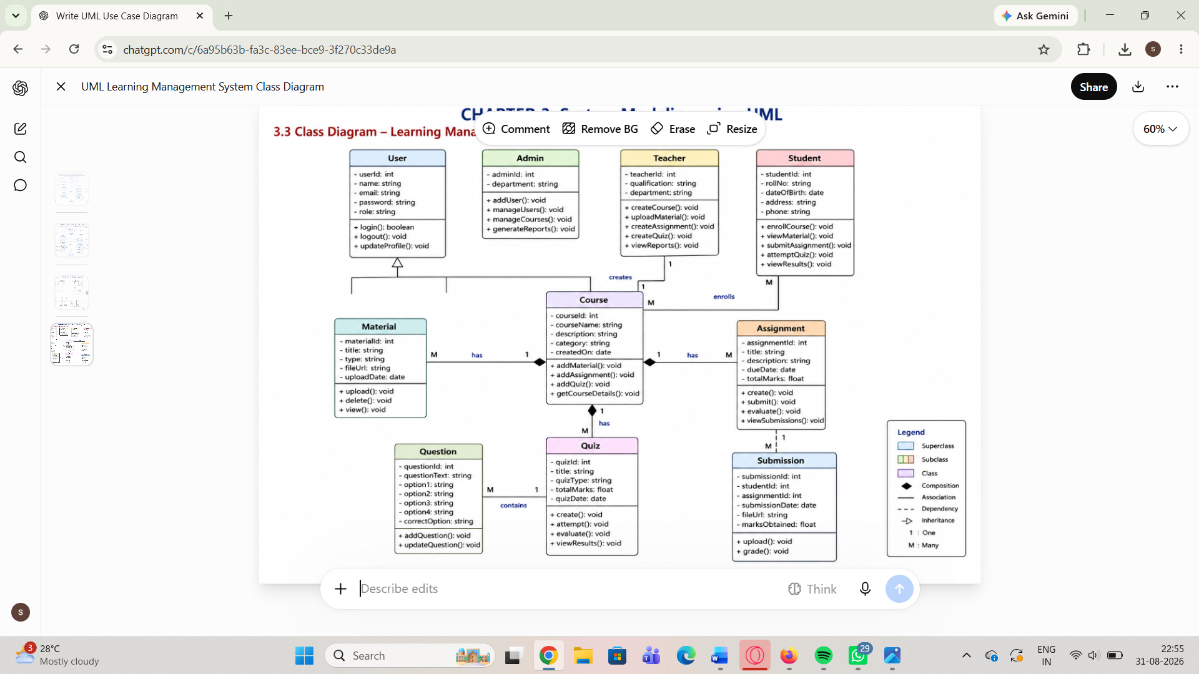

3.4 Sequence diagram:-
The sequence diagram illustrates the step-by-step interaction between the Student, Web/Mobile Interface, Authentication Service, Course Service, Assignment Service, Submission Service, Notification Service, and Database during LMS activities such as login, course enrollment, and assignment submission.

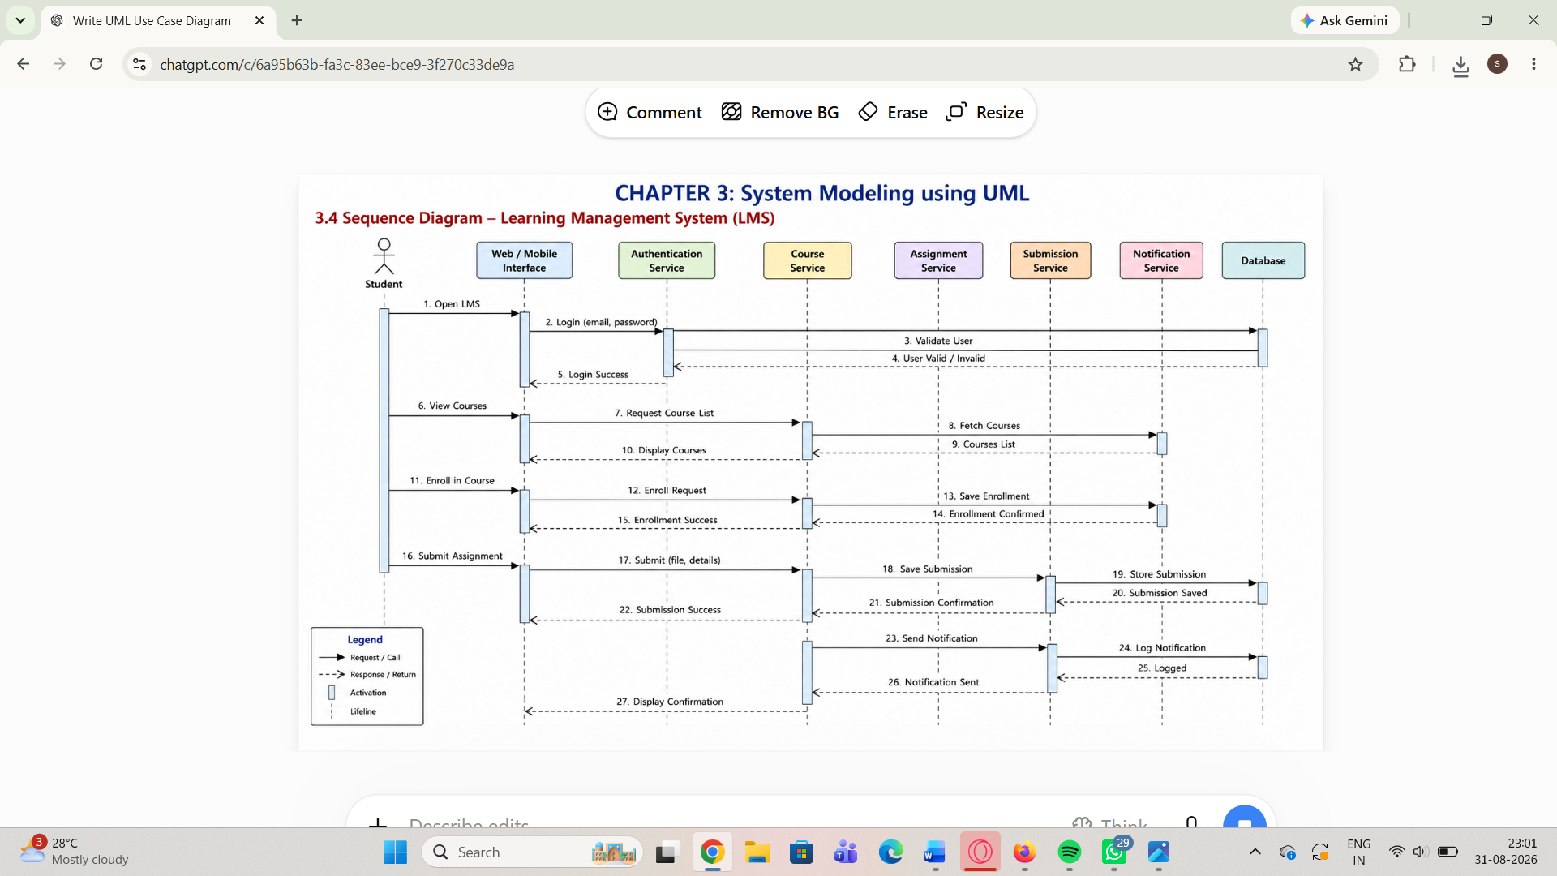

3.5 Activity diagram:-
The activity diagram represents the workflow of the LMS, showing how students and teachers interact with the system. It includes login validation, course enrollment, accessing materials, assignment submission, result evaluation, database operations, and logout.

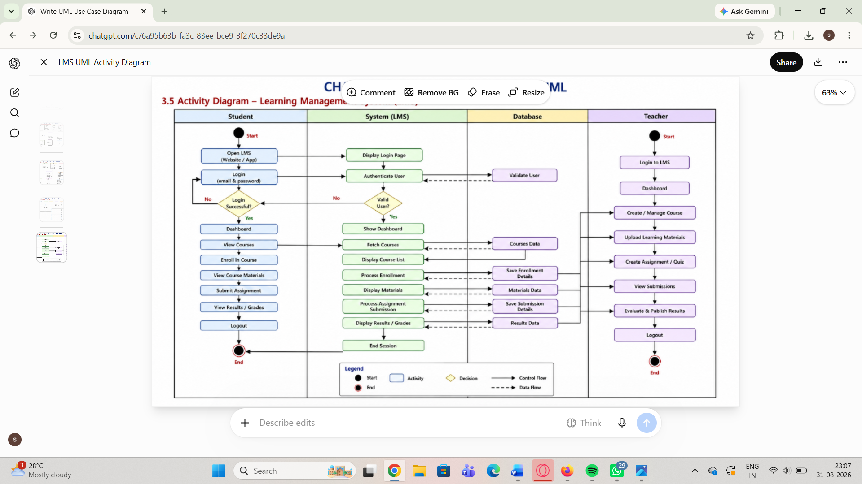

3.6 Deployment diagram:-
The deployment diagram shows the physical architecture of the LMS, including Student, Teacher, and Admin devices, Web Server, Application Server, Database Server, Email Server, and File Storage Server. It also represents the communication protocols such as HTTPS, REST API, TCP/IP, and SMTP.

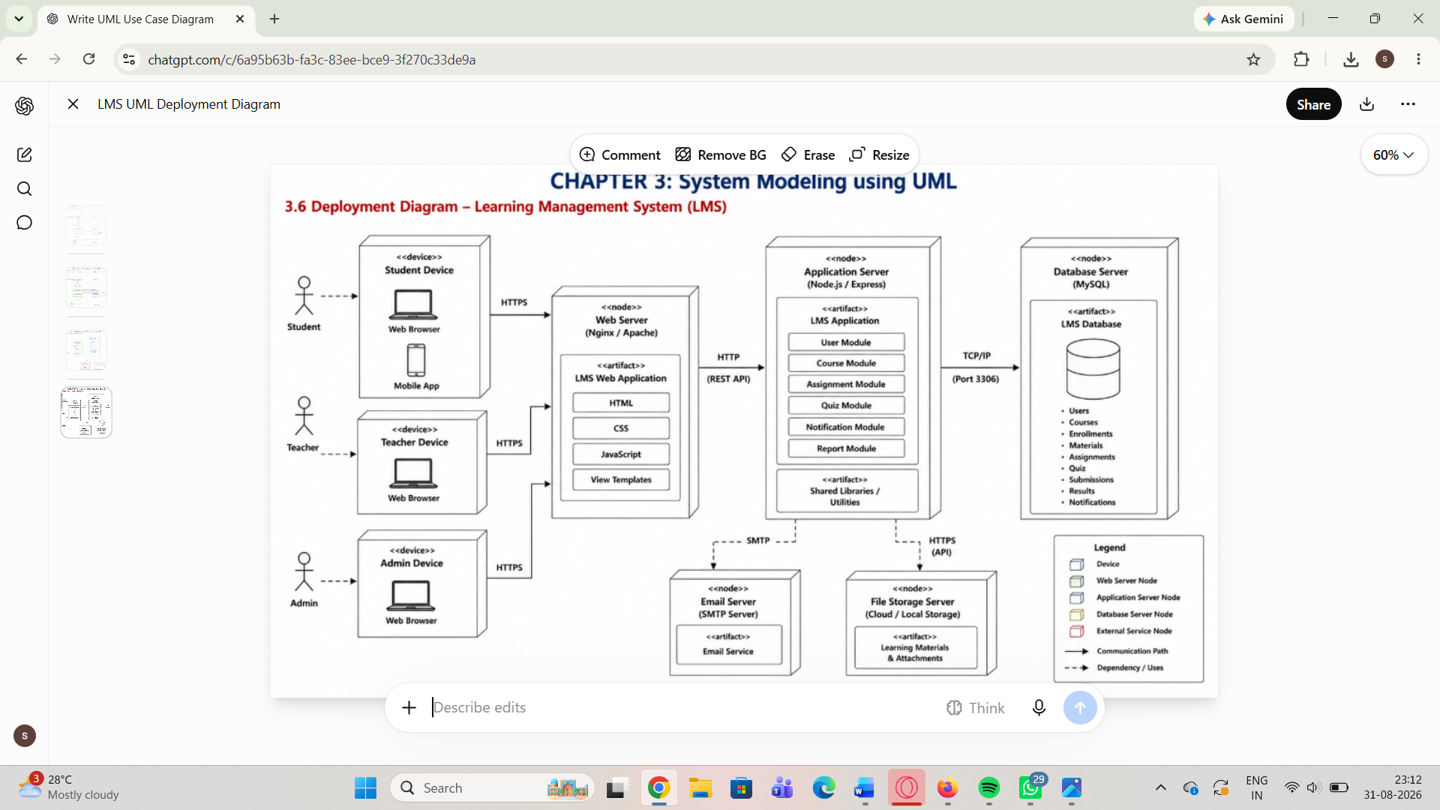

CHAPTER 4:
System Architecture Design
4.1 Frontend Architecture

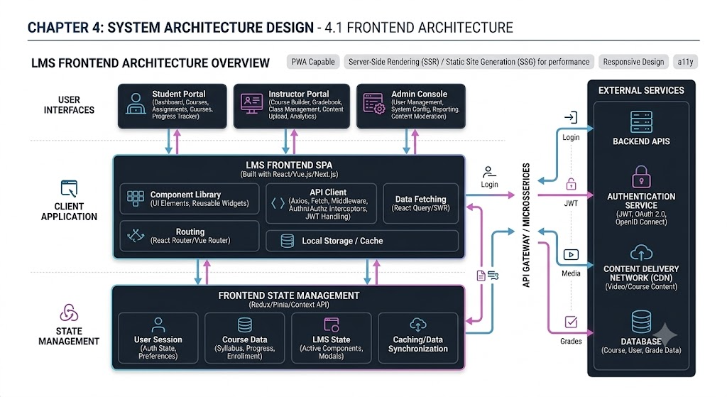

4.2 Backend Architecture:-
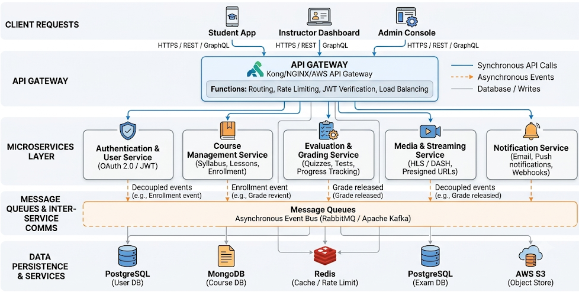

4.3 Database Schema Design:-
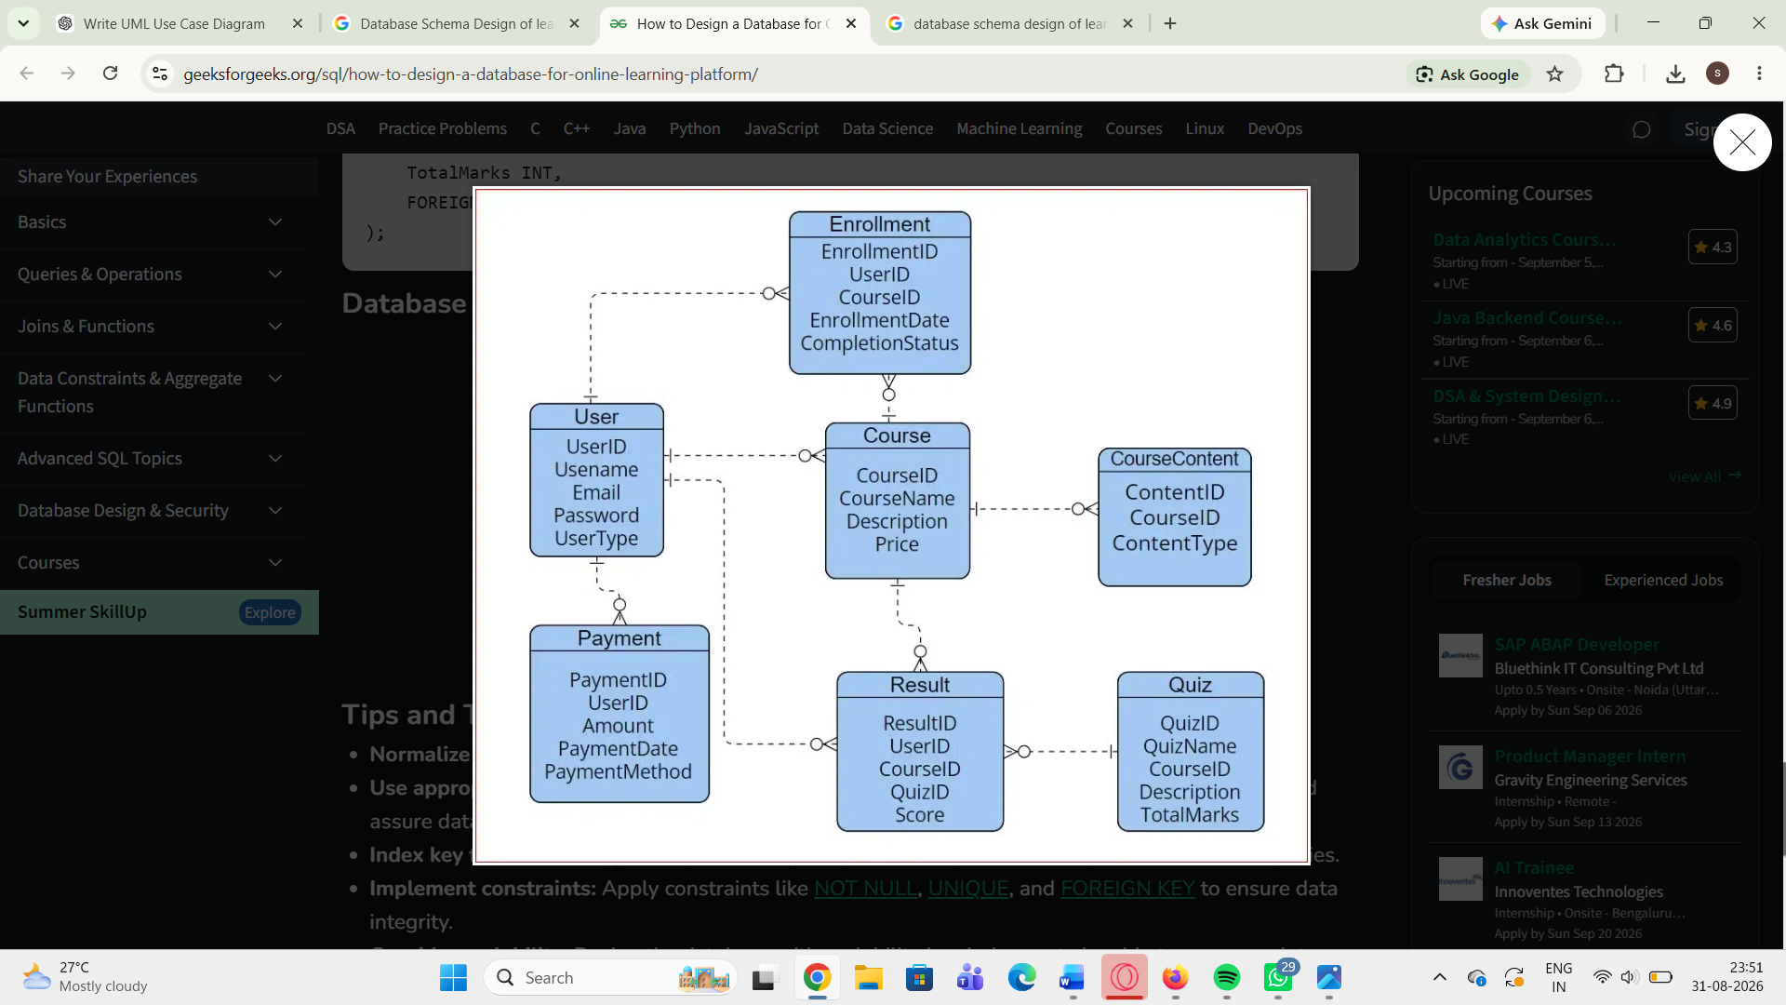

4.4 Api structure :-

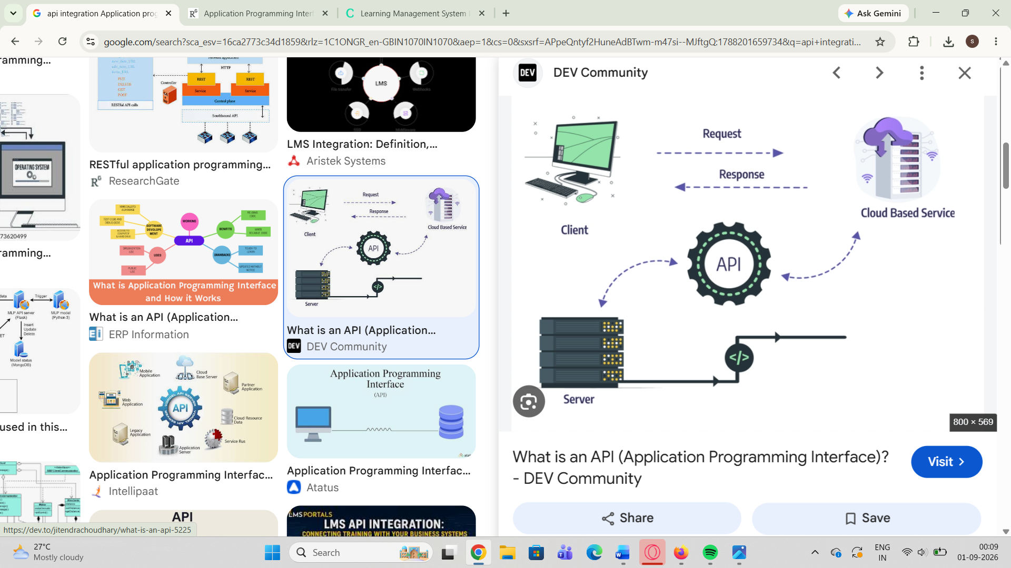

4.5 Security Consideraton :-

