POST-TRADE REVIEW
Full Swing Trade Failure Analysis - VINDHYATEL | DATAPATTNS | FINCABLES
Prepared for | Sentinel swing scanner review
Scope | VINDHYATEL, DATAPATTNS, FINCABLES; Jun 2026 scan batch
Scan date | 20 Jun 2026, 20:58 IST
Entry window | 22-24 Jun 2026
Review date | 27 Jun 2026
Primary finding | Daily trend scoring was strong, but timing and market-context gates were missing.

Executive Summary
MAIN CONCLUSION
These were not three unrelated bad trades. The same scan batch selected stocks after extended moves, then allowed entries during a weak, directionless market window. The scanner recognized daily trend strength but did not protect the entry with market-regime, relative-strength, volume, and 15-minute structure gates.

The system was biased toward stocks that had already moved hard. That made the labels look attractive, especially 'Fresh Breakout' and 'Sector Leader', but the actual entry conditions were late. In VINDHYATEL the entry came into a reversal spike; in DATAPATTNS and FINCABLES, the intraday structure had already broken before the tracker marked entry.
The result is a scanner that looked strong on paper but was selecting exhausted momentum. The fix is not to add more targets or average down. The fix is to stop saving or activating swing entries unless the broad market, stock leadership, volume sponsorship, and 15-minute structure all agree.

Outcome Snapshot
Stock | Status | P&L | Entry | CMP/Exit | Core Issue
VINDHYATEL | SL hit | -9.45% | 2424.52 | 2141.20 | Late-stage entry after a 152% move; reversal hit immediately after activation.
DATAPATTNS | Active/open | -4.16% | 4702.40 | 4506.60 | Entry happened two days after the peak; 15-minute structure was already lower-high/lower-low.
FINCABLES | Active/open | -1.92% | 1138.41 | 1116.50 | Weak RS55 and below-average RVOL; label said sector leader but sponsorship was not present.

WHY ENTRIES WERE ALREADY IN LOSSES
The swing tracker uses a stop-entry style: a stock can be scanned on one date, then become 'entered' only when price later touches the entry level. If the scan runs at night or after the move has already faded, CMP can be below entry while the tracker still records that an entry trigger happened. The tighter rule is to treat stale or broken 15-minute structure as 'do not enter', even if the daily chart still looks strong.

Common Failure Pattern
Metric | VINDHYATEL | DATAPATTNS | FINCABLES
Scan score | 90.8 | 90.9 | 89.7
Result | -9.45% closed | -4.16% open | -1.92% open
RS55 | 135.31 strong | 47.71 weak | 39.11 weakest
RVOL | 1.2x marginal | 1.1x marginal | 0.75x below avg
Nifty context | ADX 18.73 neutral | ADX 18.73 neutral | ADX 18.73 neutral
15m at entry | Reversing spike | Declining 2 days | Declining 1 day
R:R | 2.1:1 marginal | 2.1:1 marginal | 3.1:1 best
Verdict | No trade | No trade | No trade

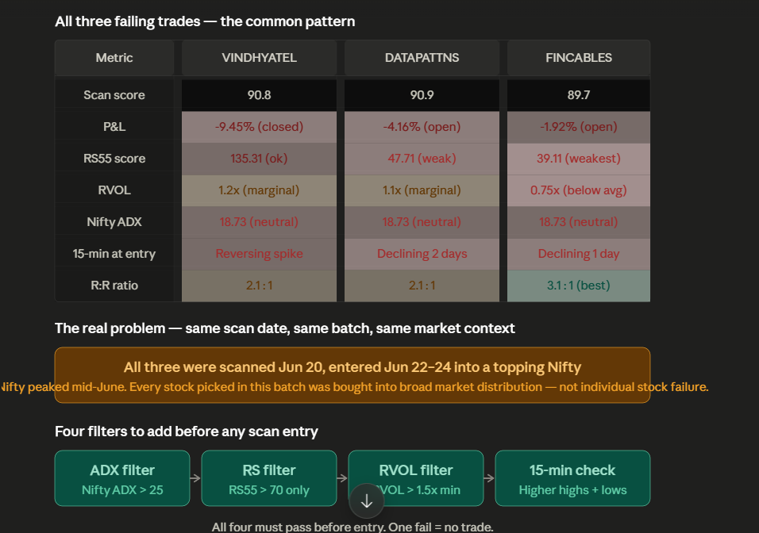
Figure 1. The same scan batch shared weak market context, marginal volume, and missing 15-minute confirmation.

Trade 1: VINDHYATEL
VERDICT
The scanner called this a fresh breakout, but the chart shows a late-stage parabolic move. A stock that has already travelled from roughly 960 to 2424 is no longer a clean early breakout; it is a chase unless it rebuilds a tight base.

Field | Value | Interpretation
Entry | 2424.52 | Entry was close to the exhaustion area, not near a fresh base.
SL | 2195.47 | Risk was about 229 points, roughly 9.5%.
Target | 2909.42 | A 20% target was too far for a 5-10 day tactical swing after such an extended move.
Score | 90.8 | High score was inflated by trend strength without timing protection.
Market context | Nifty ADX 18.73 | Directionless broad market reduced follow-through odds.

- Late-stage move: the stock had already run about 152% before the scan batch was activated.
- No proper consolidation base: a valid swing breakout needs a controlled pause, not a vertical spike.
- Volume confirmation was weak on the shorter timeframe, so the move looked more like exhaustion than accumulation.
- The SL was wide enough to damage P&L while the target required another large extension.
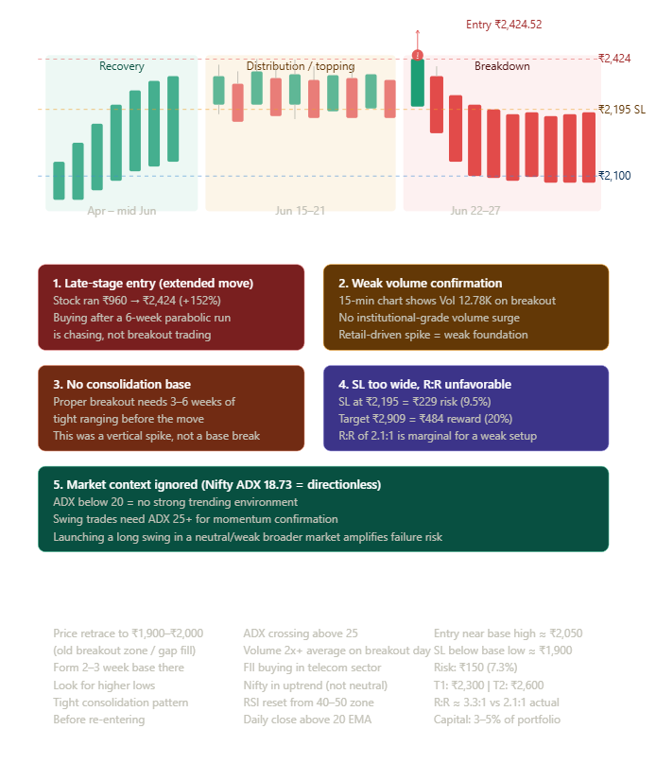
Figure 2. VINDHYATEL failure map: recovery, topping/distribution, then breakdown after a late entry.

Trade 2: DATAPATTNS
VERDICT
DATAPATTNS was not a clean entry on 24 Jun. The daily trend was strong, but the 15-minute structure had already shifted into lower highs and lower lows from 22 Jun onward.

Field | Value | Interpretation
Entry | 4702.40 | Entry was roughly 4% below the recent peak but after structure had already turned down.
SL | 4343.31 | Remaining cushion was about 3.6% from the reviewed CMP.
Target | 5642.88 | Target required a strong continuation that the 15-minute chart no longer supported.
RS55 | 47.71 | Underperforming more than half the market; not a leadership-grade swing candidate.
Sector label | Aviation | Potentially wrong context because DATAPATTNS is a defence electronics business.

- The trade entered two sessions after the top instead of during a fresh expansion from a base.
- The 15-minute chart already showed a confirmed downtrend, so daily trend alone should not have allowed activation.
- RS55 below 50 should be a hard warning; for swing momentum, the minimum should be 70 and preferably 80+.
- The sector tag mismatch can feed the wrong sector-breadth and industry-strength assumptions into scoring.
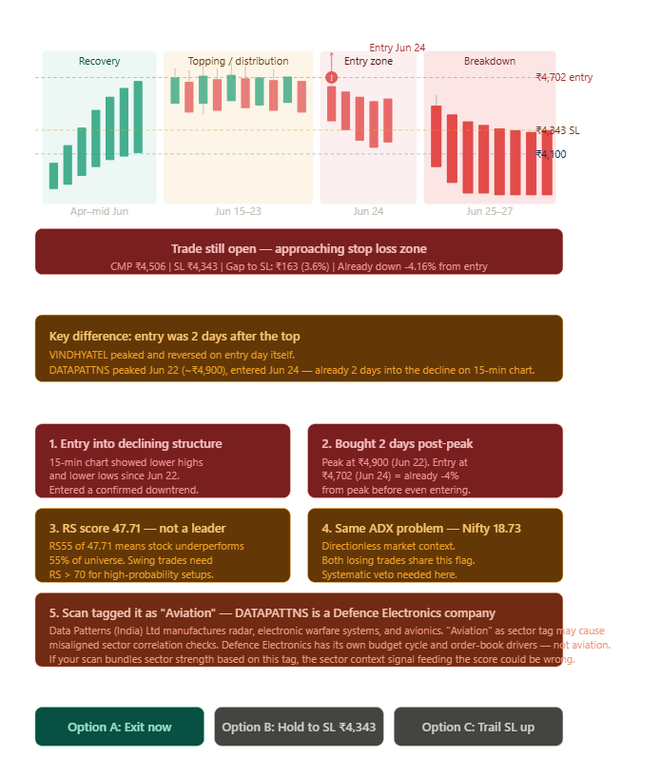
Figure 3. DATAPATTNS entry came after the peak, with intraday structure already deteriorating.

Trade 3: FINCABLES
VERDICT
FINCABLES was the weakest quality setup. RS55 at 39.11 and RVOL at 0.75x should have been hard vetoes. A stock cannot be treated as a sector leader when 61% of the market is outperforming it.

Field | Value | Interpretation
Entry | 1138.41 | Entry occurred after the peak zone near 1190+ had already failed.
SL | 1060.74 | About 5% cushion remained at review, but the underlying signal quality was weak.
Target | 1366.09 | Target was too ambitious relative to weak volume and market context.
RS55 | 39.11 | Bottom-third relative strength; not leadership.
RVOL | 0.75x | Below-average volume means no strong institutional sponsorship.

- The setup label said 'Sector Leader', but the RS55 and RVOL data contradicted that label.
- The 15-minute chart had already shifted lower before entry; this was not fresh demand.
- Best R:R on paper did not compensate for poor entry timing and weak participation.
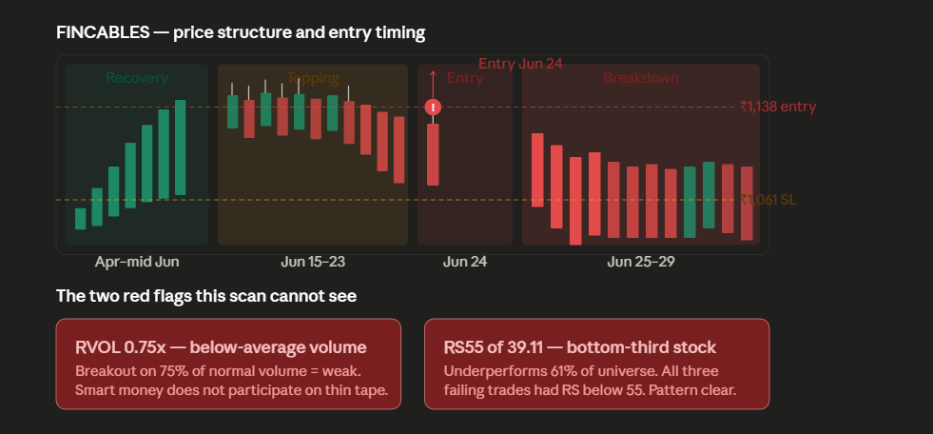
Figure 4. FINCABLES had weak participation and entered after topping behavior had started.

Root Cause Analysis
- The scanner over-weighted daily trend strength and under-weighted timing. Stage 2 trend is necessary, but it is not sufficient.
- The system did not reject broad-market weakness. Nifty ADX at 18.73 meant no strong directional market support.
- The scanner allowed weak relative strength. DATAPATTNS and FINCABLES both had RS55 below 50.
- Volume sponsorship was not enforced. FINCABLES had RVOL 0.75x and the others were only marginal.
- The tracker did not require 15-minute confirmation before activation, so daily setups entered after intraday breakdowns.

Pre-Entry Filter Gate
POLICY
A swing candidate should not be saved as actionable unless every gate passes. One failed gate means watch only or reject.

Gate | Minimum Rule | Reason
Market regime | Nifty or BankNifty ADX >= 25 and trend not bearish | Avoid launching long swings into a directionless or topping market.
Relative strength | RS55 >= 70 | Only trade stocks outperforming most of the universe.
Volume sponsorship | RVOL >= 1.5x on breakout/trigger | Confirm institutional participation instead of thin breakouts.
15-minute structure | Higher highs and higher lows before activation | Avoid entries after intraday structure is already broken.
Extended-move guard | Reject if 20d/40d run is excessive without a tight base | Prevent buying after the move has already happened.
Risk cap | Swing risk ideally <= 6%; target 5-10 day realistic range | Prevent wide stops and far-away targets from distorting score.

Stock | ADX Gate | RS Gate | RVOL Gate | 15m Gate | Final Decision
VINDHYATEL | Fail | Pass | Fail | Fail | No trade
DATAPATTNS | Fail | Fail | Fail | Fail | No trade
FINCABLES | Fail | Fail | Fail | Fail | No trade

Targets and P&L
WHY TARGETS LOOKED TOO HIGH
The original swing target model behaved more like a 15-20% continuation objective. That is too far for tactical 5-10 day swing trades, especially after an extended daily run. The target should now be closer to realistic 5-10 day movement and capped by structure, volatility, and recent resistance.

P&L should be read as the percentage move from the recorded entry to the latest CMP or exit price. For watchlist names where entry has not triggered, P&L should stay blank because no live position exists. If a scan is run at night, the system must not pretend an entry is active unless the trigger is valid on a market candle after the scan and the pre-entry gates are still valid.

Open Position Framework
RISK NOTE
This section is a process framework, not financial advice. The app should show signal quality and invalidation clearly; the trader still decides position handling.

Position | Current Read | Process Choice
DATAPATTNS | Still above SL but selling character has shifted; RS55 is weak and 15m structure broke before entry. | Do not add. Either exit on thesis failure or trail risk tightly instead of waiting for a wide SL.
FINCABLES | Not in freefall, but RS55 and RVOL are weak; the setup lacks sponsorship. | Do not treat a bounce as renewed strength unless RS/RVOL and 15m structure recover.

Valid Re-Entry Criteria
Requirement | What Good Looks Like
Base quality | A tight 2-6 week base or orderly pullback near a clear support area.
Market support | Nifty trend positive with ADX >= 25, or sector-specific breadth clearly strong.
Leadership | RS55 >= 70, preferably 80+, and sector/industry tag verified.
Volume | Breakout or reclaim day on RVOL >= 1.5x; stronger setups show 2x+.
15m structure | Higher highs and higher lows before entry; no lower-high sequence into trigger.
Risk | SL below a real structure low; risk preferably <= 6%; target realistic for 5-10 sessions.

Operational SOP for Future Scans
- Run the swing scanner only after the latest daily candle has settled, then timestamp the scan clearly.
- Before saving a candidate, evaluate the pre-entry gates and store pass/fail reasons with the record.
- Keep candidates in watchlist until live price triggers entry and the 15-minute structure remains valid.
- Hide duplicates if a stock is already in watchlist or active tracker, unless the old trade is closed.
- Show blank P&L for unentered watchlist trades and calculate active P&L only from entry to CMP/exit.
- Review failed batches by scan date, not only by stock name, because correlated failures usually come from market context.

Lessons
- A high score is not a trade unless it survives market regime, RS, RVOL, and lower-timeframe structure.
- Fresh breakout means fresh expansion from a base, not a stock that has already moved vertically.
- Sector leader labels must be backed by RS and sector breadth, not just price momentum.
- Targets should match the intended holding period. For 5-10 day swings, far-away 15-20% objectives can mislead users.
- The scanner should reject fewer but better names, not produce many impressive-looking candidates.

Implementation Note
No mobile API contract change is required for this review by itself. Mobile clients should expect fewer swing picks after the stricter filters. Existing fields can still be displayed, but the app should treat watchlist, active, target, and SL states separately and should not show P&L for unentered watchlist trades.
Recommended UI copy for users: 'Swing scan results are candidates, not instant entries. Entry becomes active only after price triggers and market/structure checks remain valid.'

Disclaimer
This document is for post-trade process review and educational analysis only. It is not investment advice, a recommendation to buy or sell securities, or a guarantee of future performance. All trading decisions remain the responsibility of the trader.

