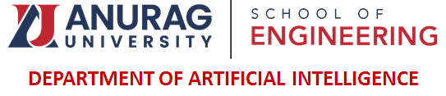
INTEGRATED PROJECT- I

TITLE OF PROJECT
AI BASED WATER DISTRIBUTION MANAGEMENT
BATCH NAME : AI ELDORADO’S
BATCH NO : B15
TEAM SIZE : 4

NAMES OF TEAM MEMBERS:
24EG107B60 V.SIRIVENNELA
24EG107B61 M.ABHINAI NAIDU
24EG107B62 S.TILAK
24EG107B63 K.SAI AASHISH

