Unit 2 – Notes
Uninformed Search
Uninformed search strategies, also known as blind search strategies, are methods used in artificial intelligence (AI) for navigating through a search space or graph without any knowledge about the specific problem domain. These strategies do not use any domain- specific information; instead, they rely on the general structure of the problem

Key Concepts
- Search Space: The set of all possible states that can be reached in the problem.
- Initial State: The starting point of the search.
- Goal State: The state which needs to be reached to solve the problem.
- Successor Function: A function that generates the next possible states from the current state.
- Path Cost: The cost associated with moving from one state to another.

Search in Intelligent Systems
Search is a fundamental concept in artificial intelligence (AI) and intelligent systems. It involves exploring a space of possible solutions to find a goal or an optimal solution.
Intelligent systems utilize various search strategies to navigate through this space efficiently. These strategies can be broadly categorized into uninformed (blind) and informed (heuristic) search methods.

Search Problem Definition Key Components:
- Initial State: The starting point of the search.
- Goal State: The desired outcome or solution.
- Successor Function: A function that generates possible next states from a given state.
- State Space: The set of all possible states reachable from the initial state.
- Path Cost: The cost associated with moving from one state to another.
- Search Tree: A tree representation of the state space where nodes represent states and edges represent actions leading to those states.

Blind Search Algorithms
Blind search algorithms, also known as uninformed search algorithms, explore the search space without any additional information about the goal's location beyond the problem's definition. These algorithms systematically explore all possible states to find a solution, without using domain-specific knowledge or heuristics.

Implementing Blind Search Algorithms
In the context of artificial intelligence, blind search algorithms (also known as uninformed search algorithms) operate without any domain-specific knowledge beyond the problem definition. They systematically explore the search space to find a solution. Two common blind search algorithms are Breadth-First Search (BFS) and Depth-First Search (DFS)

Breadth-FirstSearch(BFS)

  - Uninformed search technique
  - First In First Out (FIFO)
  - Queue
  - Complete level by level
  - Shallowest Node
  - Nodes (Vertex)
  - Edges

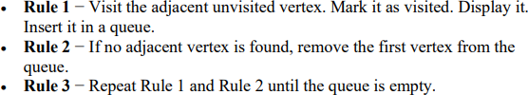

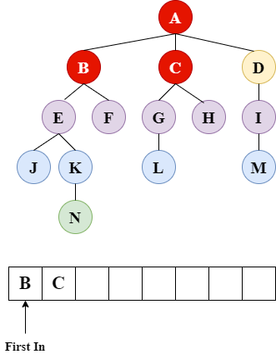
Example

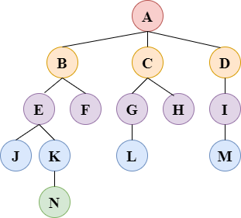
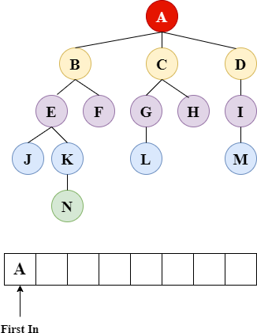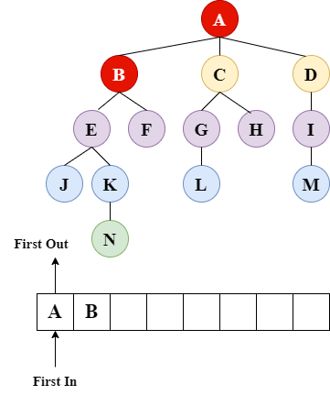

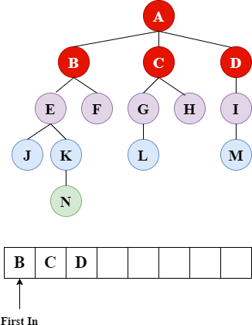
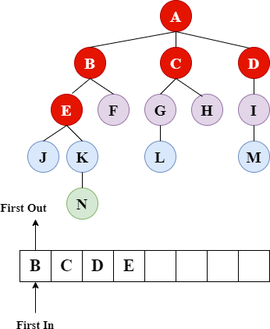
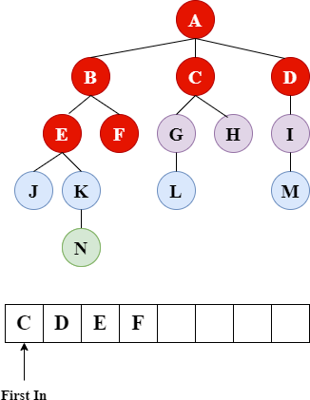
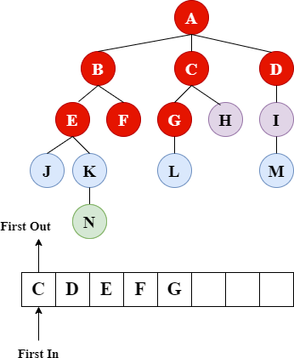

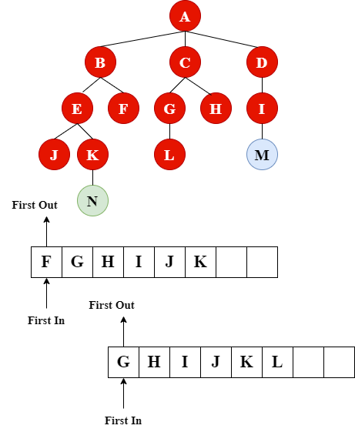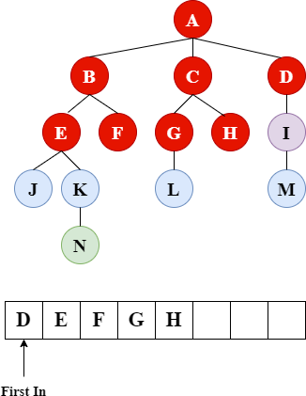

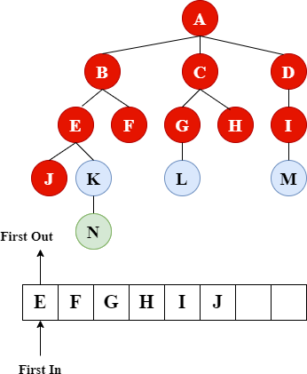

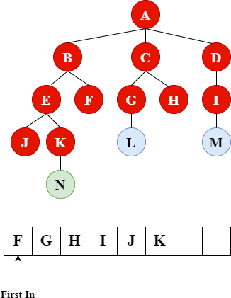

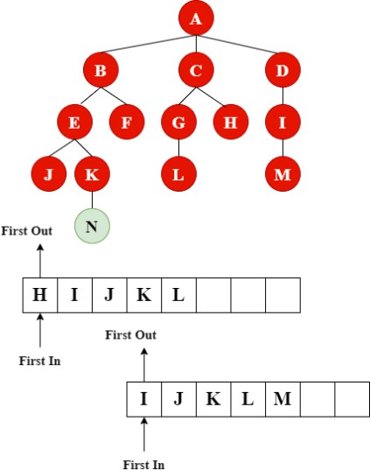

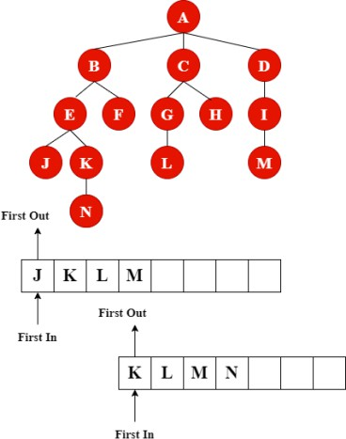
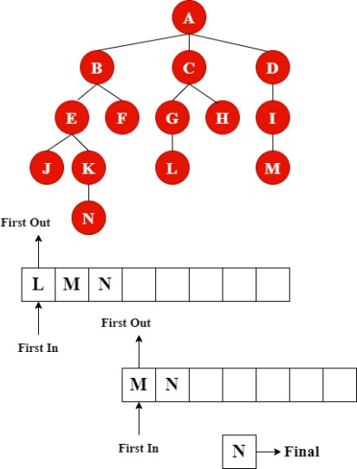

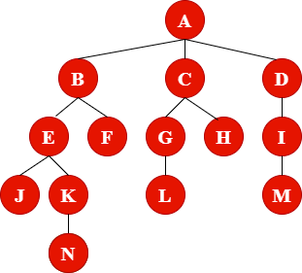

Optimal Time Complexity Calculation O (V+E)
Where V - is the number of Nodes, E – is the number of Edges

O(b^{d})

Where b – is the branch factor, d – is the depth From example: to search element from A to G
b = 3 d = 2 → 3² = 9

Performance Metrics
- Time Complexity: BFS have a time complexity of O(b^{d}) where b is the branching factor and d is the depth of the shallowest solution.
- Space Complexity: BFS has a space complexity of O (b^{d}) whereas
- Completeness: BFS is complete (it will find a solution if one exists)

Depth-First Search (DFS)
- Uninformed search technique
- Last in First Out (LIFO)
- Stack
- Deepest Node
- Incomplete
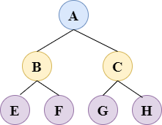
- Backtracking

Example 1:

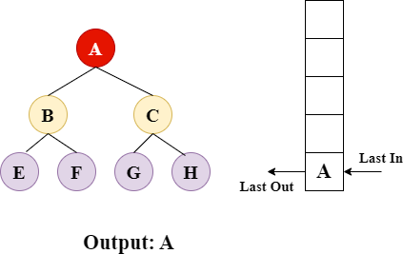
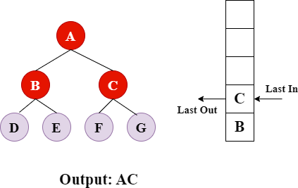
G
F
E
D

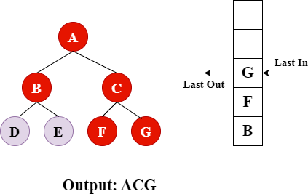
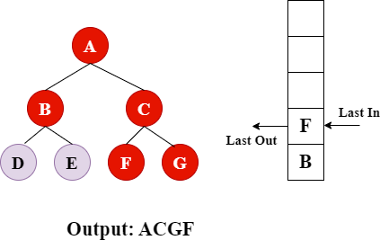

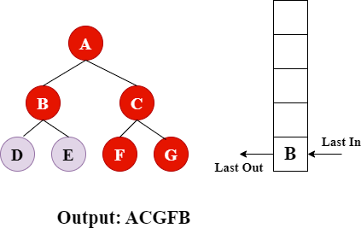

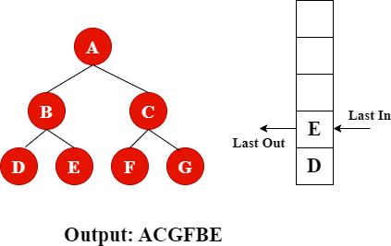

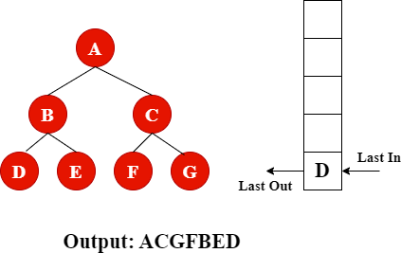

Optimal Time Complexity Calculation O (V+E)
Where V - is the number of Nodes E – is the number of Edges

O(bd)
Where b – is the branch factor d – is the depth From example: to search element from A to G
b = 2
d = 2
22 = 4

Performance Metrics
- Time Complexity: DFS have a time complexity of O(bd) where b is the branching factor and d is the depth of the shallowest solution.
- Space Complexity: DFS has a space complexity of O (bd)
- Completeness: DFS is complete (it will find a solution if one exists)

State Space Graph
A state space graph is a powerful tool used in artificial intelligence, computer science, and related fields to represent and solve problems. It is a graphical representation of all possible states and transitions in a given problem, allowing us to systematically explore and navigate through the problem space.

Key Concepts

- States: Each node in the graph represents a distinct state of the problem. A state encapsulates all the relevant information about the problem at a particular point in time. 2. Actions/Transitions: Each edge between nodes represents an action or transition that moves the problem from one state to another. An action can be anything that changes the state, such as making a move in a game, performing a weighing in the False Coin Problem, or any other decision.
- Initial State: The starting point of the problem is represented by the initial node (or root node in a tree representation).
- Goal State: The desired solution or end state of the problem is represented by one or more goal nodes.

Example: False Coin Problem

There are 12 coins, one of which is known to be false, or counterfeit. It is not known, however, whether the false coin is lighter or heavier than the others. An ordinary balance scale can be used to determine if any two sets of coins weigh the same or if one set is heavier or lighter than the other. To solve the problem, you should be able to create a procedure to identify the false coin by weighing only three combinations of coins

Problem Definition

Initial State: All 12 coins are unknown. We represent the state as a list of coins. S0: [C1, C2, C3, C4, C5, C6, C7, C8, C9, C10, C11, C12]
- Goal State: Identify the false coin and whether it is heavier or lighter.

- Actions and Transitions Actions correspond to weighing different combinations of coins. Each weighing splits the state into three possible outcomes: Heavier Lighter Both sides equal

Employing State Space Search algorithm

- First Weighing: Weigh 4 coins against 4 coins.(Split equally the 12 coins into 3 group) Three possible outcomes:
  - Heavier: The false coin is among the 4 which is heavier
  - Lighter: The false coin is among the 4 which is lighter.
  - Equal: The false coin is among the 4 not weighed.

- Second Weighing:

  - Based on the outcome of the first weighing, select a subset of coins for the second weighing.
  - If the first weighing was equal, weigh 3 coins against 3 coins from the unweighed set.
  - If the first weighing was not equal, weigh 3 coins from the heavier side against 3 coins from the lighter side.
- Third Weighing:

  - Based on the second weighing, choose appropriate coins for the third weighing.
  - If second weighing was equal, weigh 1 coin against 1 coin from the remaining suspects.
  - If second weighing was not equal, choose 2 coins from the lighter/heavier group and weigh 1 against 1, using the third coin if necessary.

First Weighing:
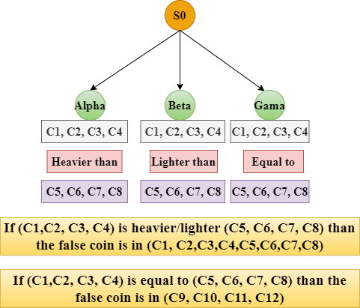
- Second Weighing: If Alpha, choose the following

  - S2: Weigh [C1, C2, C3] against [C5, C6, C7]
  - Alpha M: [C1, C2, C3] heavier than [C5, C6, C7]
  - Alpha N: [C1, C2, C3] lighter than [C5, C6, C7]
  - Alpha O: [C1, C2, C3] equal to [C5, C6, C7] -> False coin is [C4, C8]

- Second Weighing

Second Weighing: If Beta, choose the following

  - S2a: Weigh [C1, C2, C3] against [C5, C6, C7]
  - Beta M: [C1, C2, C3] heavier than [C5, C6, C7]
  - Beta N [C1, C2, C3] lighter than [C5, C6, C7]
  - Beta O: [C1, C2, C3] equal to [C5, C6, C7] -> False coin is [C4, C8]

Second Weighing
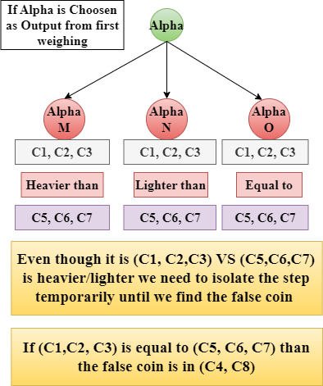
Second Weighing: If Gama, choose the following

  - S2b: Weigh [C9, C10, C11] against [C1, C2, C3]
  - Gama M: [C9, C10, C11] heavier than [C1, C2, C3]
  - Gama N: [C9, C10, C11] lighter than [C1, C2, C3]
  - Gama O: [C9, C10, C11] equal to [C1, C2, C3] -> False coin is [C12]

2. Second Weighing:
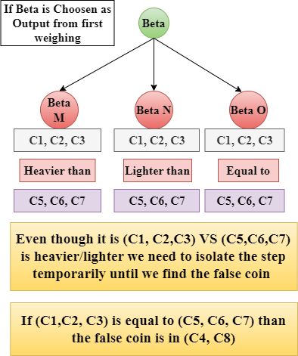

- Third Weighing: If Alpha O and Beta O, weigh the remaining suspects

  - S3(Alpha O/ Beta O) : Weigh [C4] against [C8]
  - S3 (Gama O) : Weigh [C12] against any known normal coin
  - Delta M: [C4] heavier -> False coin is [C4] (if previously in lighter group)
  - Delta N: [C4] lighter -> False coin is [C4] (if previously in heavier group)
  - Delta O: [C4] equal to [C8] -> False coin is [C8]
  - Zeta: [C12] heavier/lighter -> False coin is [C12]

3. Third Weighing
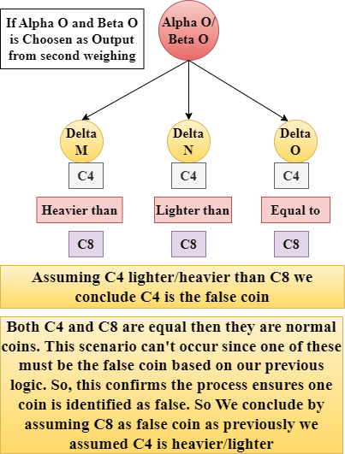
3. Third Weighing
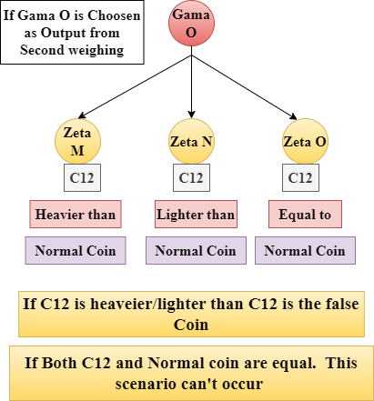

- Third Weighing
The state-space tree for a problem contains all states that a problem could be in, as well as all possible transitions between these states. In fact, because loops often occur, such a structure is more generally called a state-space graph.

Generate and Test Paradigm

The Generate-and-Test Paradigm (also known as the generate-and-test method) is a fundamental approach in artificial intelligence (AI) used to solve problems by generating possible solutions and then testing them to see if they satisfy the problem's requirements. It is a basic heuristic method, often used when more sophisticated methods are not available or practical. It follows a Depth First Search (DFS) method.

Components of the Generate-and-Test Paradigm

  - Generate: This step involves generating potential solutions. The generation process can be random, systematic, or based on some heuristic that narrows down the search space.
  - Test: Each generated solution is then tested to determine if it meets the criteria for a successful solution. If a solution passes the test, it is accepted; if it fails, it is discarded, and another solution is generated and tested.
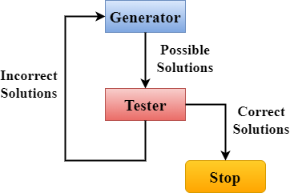

Process

The generate-and-test paradigm can be broken down into a simple iterative process:

  - Initialization: Start with an initial state or initial set of possible solutions.
  - Generation: Produce a new candidate solution.
  - Testing: Evaluate the candidate solution against the problem's constraints or goal criteria. Termination: If the candidate solution meets the criteria, accept it as the solution and terminate the process. If not, repeat the generation and testing steps until a satisfactory solution is found or a stopping condition is reached (e.g., a maximum number of iterations).

Algorithms:

  - Generate all possible solutions
  - Select one solution among the possible solutions
  - If a solution is found and acceptable, quit. Otherwise, return to step 1

Approaches:

  - Generating complete solutions and
  - Generating random solutions

Properties:

  - Complete
  - Non redundant
  - Informed

Example Traveling Salesman problem (TSP)

A salesman has a list of cities, each of which he must visit exactly once. There are direct roads between each pair of cities on the list. Find the route the salesman should follow for the shortest possible round trip both starts and finishes at any one of the cities Traveler need to visit n cities Know the distance between each pair of cities Want to know the shortest route that visits all the cities once
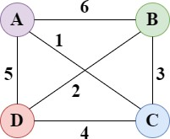

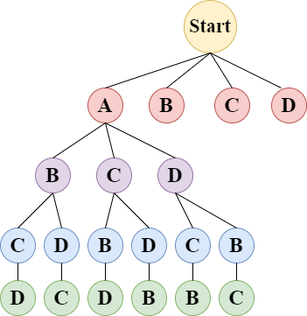

Search for | Path | Length of Path
1 | ABCD | 19
2 | ABDC | 18
3 | ACBD | 12
4 | ACDB | 13
5 | ADCB | 18
6 | ADBC | 16

The shortest path is selected as ACBD as the length is 12

Backtracking
Backtracking is a fundamental algorithmic technique used in artificial intelligence and computer science to solve problems recursively by trying to build a solution incrementally. If a partial solution violates the problem's constraints, the algorithm backtracks to the previous step and tries a different path. This method is particularly useful for problems involving combinatorial search and constraint satisfaction

Key Components
  - Recursive Search: The core of backtracking involves exploring potential solutions using recursion.
  - Partial Solutions: Solutions are built incrementally, extending partial solutions step- by-step.
  - Constraints: At each step, the algorithm checks whether the current partial solution violates any constraints.
  - Backtracking: If a partial solution is found to be invalid, the algorithm "backtracks" to the previous step and tries a different path

How Backtracking Works
  - Start with an Empty Solution: Begin with an empty solution and extend it step-by- step.
  - Check Constraints: At each step, check if the current partial solution satisfies the constraints.
  - Extend Solution: If the constraints are satisfied, extend the solution by taking another step.
  - Backtrack: If a constraint is violated, backtrack to the previous step and try a different option.
  - Repeat: Continue this process until a complete solution is found or all possible solutions have been tried

Examples
  - N-Queens Problem: Place N queens on an N×N chessboard so that no two queens threaten each other.

  - Sudoku: Fill a 9×9 grid with numbers so that each row, column, and 3×3 subgrid contains all digits from 1 to 9.

Example: N-Queens Problem
Problem Statement: Place 4 queens on an 4×4 chessboard so that no two queens attack each other.

Backtracking Approach:
  - Start with an empty board.
  - Place a queen in the first column of the first row.
  - Move to the next column and place a queen in a position that doesn't conflict with the previously placed queens.
  - If no valid position is found in the current column, backtrack to the previous column and move the queen to the next valid position.
  - Continue this process until all queens are placed on the board or all possibilities are exhausted

Example: N-Queens Problem Conditions:
  - No row should contain more than one queen
  - No column should contain more than one queen
  - No diagonal should contain more than one queen
  - There should be o row. Column without one queen

Example: N-Queens Problem
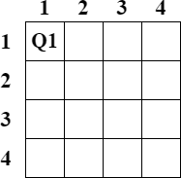

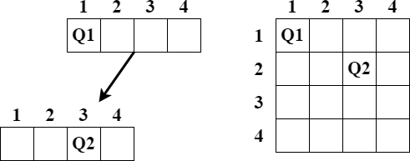

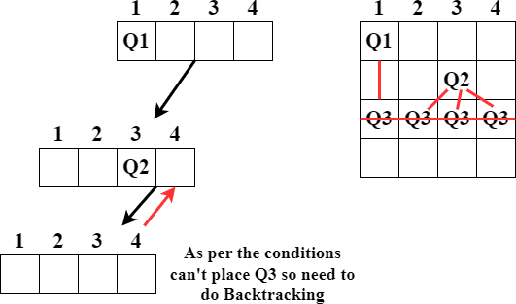
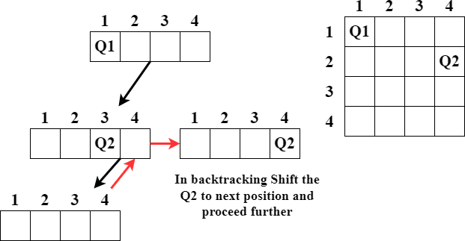
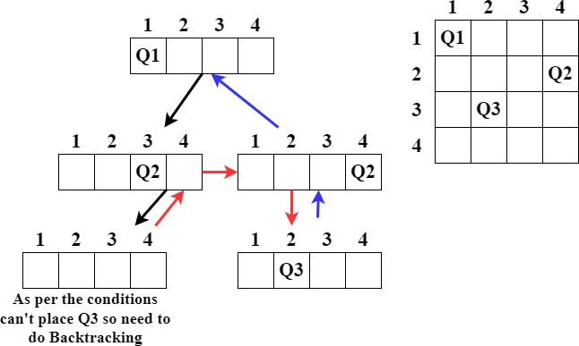

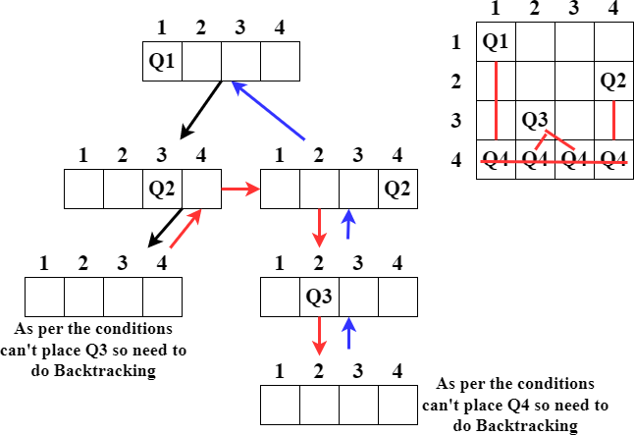

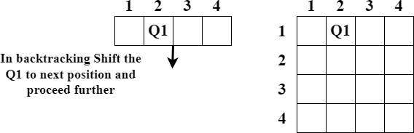

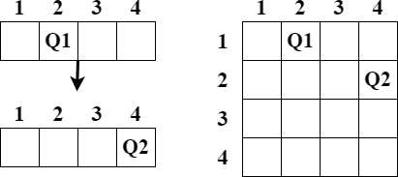

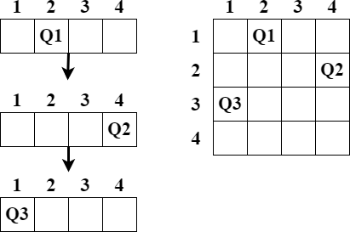

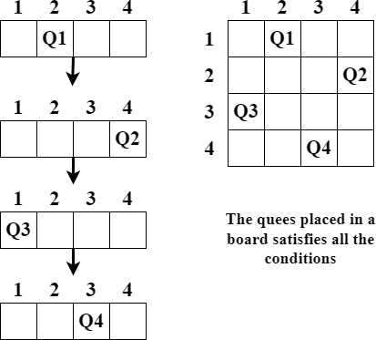

Advantages of Backtracking
  - Simplicity: Easy to implement and understand.
  - Flexibility: Can be applied to a wide range of problems.
  - Optimality: Can find the optimal solution for certain problems by exploring all possible solutions.

Disadvantages of Backtracking
  - Inefficiency: Can be computationally expensive for large problems due to the exhaustive search.
  - Redundancy: May revisit the same partial solutions multiple times.

A Greedy Algorithm

A greedy algorithm is a simple, intuitive algorithm that is used in optimization problems. The algorithm makes a series of choices, each of which looks best at the moment, with the hope of finding the global optimum. Greedy algorithms are used because they are generally straightforward to implement and can provide solutions to complex problems quickly, although they do not always guarantee an optimal solution.

Characteristics of Greedy Algorithms

  - Greedy Choice Property: A local optimum is chosen at each step with the hope of finding a global optimum.
  - Optimal Substructure: A problem has an optimal substructure if an optimal solution to the problem contains optimal solutions to the sub problems.

Example: Dijkstra's Algorithm

Dijkstra's algorithm is a classic example of a greedy algorithm. It is used to find the shortest path from a source node to all other nodes in a weighted graph with non-negative weights.

Steps of Dijkstra's Algorithm

Initialization:

  - Set the distance to the source node to 0 and to all other nodes to infinity.
  - Mark all nodes as unvisited. Create a set of all the unvisited nodes called the unvisited set.
  - Set the initial node as the current node.

Visit the Unvisited Node with the Smallest Distance:

  - For the current node, consider all its unvisited neighbors and calculate their tentative distances through the current node.
  - Compare the newly calculated tentative distance to the current assigned value and assign the smaller one. For example, if the current node A has a distance of 6, and the edge connecting it with a neighbor B is 2, then the distance to B through A will be 6 +

2 = 8. If B was previously marked with a distance greater than 8, then change it to 8. If not, leave it as is.

Mark the Current Node as Visited:

  - A visited node will not be checked again.

Set the Unvisited Node with the Smallest Tentative Distance as the New "Current Node":
  - Repeat steps 2-4 until all nodes are visited.

Example: Dijkstra's Algorithm

Mark all nodes as unvisited

Assign to all nodes a tentative distance value
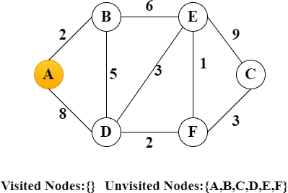
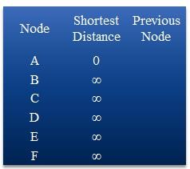

For the current node calculate the distance to all unvisited neighbor Update shortest distance, if new distance is shorter than old distance
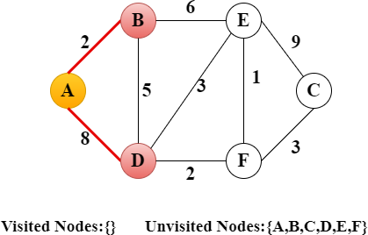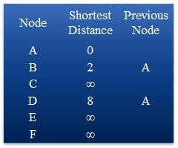

Mark current node is visited
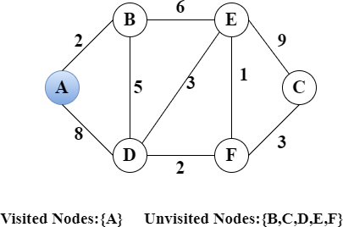
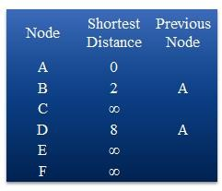

Choose new current node from unvisited nodes with minimal distance
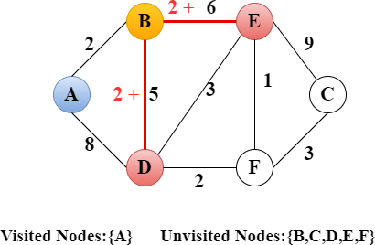
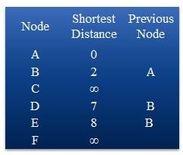

Mark current node is visited
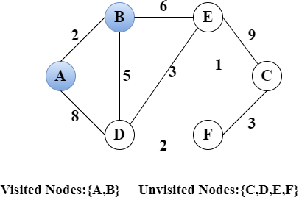
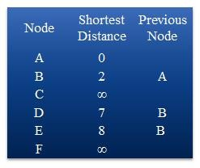

Choose new current node from unvisited nodes with minimal distance
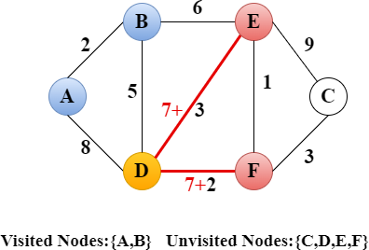
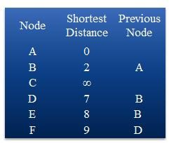

Mark current node is visited
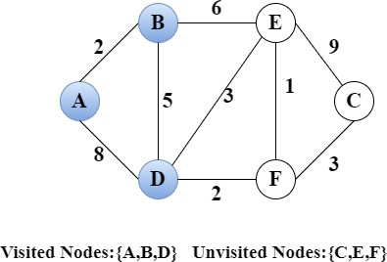
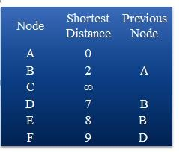

Choose new current node from unvisited nodes with minimal distance
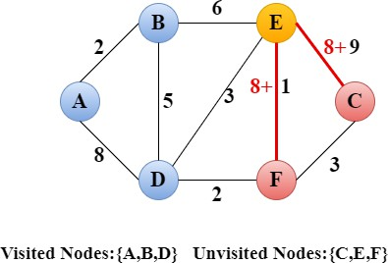
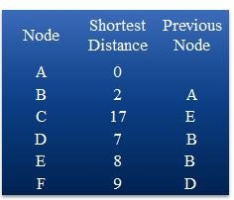

Mark current node is visited
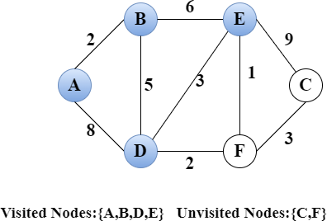
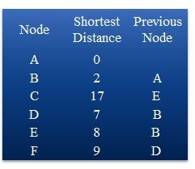

Choose new current node from unvisited nodes with minimal distance
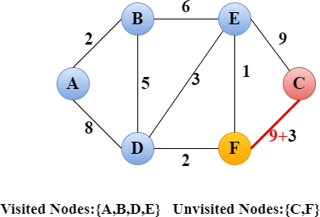
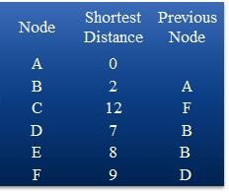

Mark current node is visited
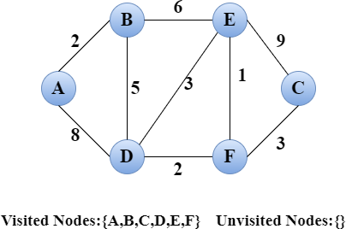
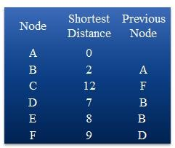

Find the shortest route from A to C
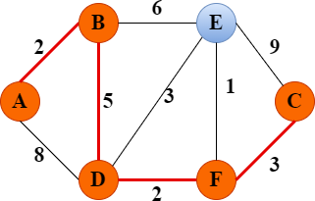
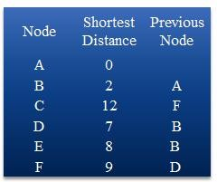

Dijkstra's algorithm is a prime example of a greedy algorithm. At each step, it makes a locally optimal choice by selecting the node with the smallest tentative distance, hoping to eventually find the shortest path to all nodes. While Dijkstra's algorithm guarantees the shortest path in graphs with non-negative weights, it's important to note that not all problems are suited to greedy approaches, as they may not always yield a global optimum.

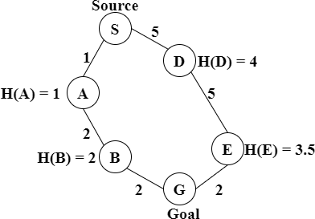
Informed Search

In artificial intelligence (AI), informed search (also known as heuristic search) refers to search strategies that use problem- specific knowledge beyond the definition of the problem itself to find solutions more efficiently than uninformed search strategies (such as breadth- first or depth-first search)

Informed Search
- Information about the Goal State is present
- Better than uninformed search
- Finds optimal Solution to reach the Goal state
- It finds the minimum path cost
- It uses the heuristic search and Heuristic function F(n) = G(n) + H(n)

F(n) – Overall Cost G(n) – Path cost
H(n) – Heuristic Value

Basic of Informed search
- Search with information
- Use knowledge to find steps to solution
- It gives the quick solution
- Less Complexity (Time, Space)
- It is a search which tries to reduce amount of search that must be done by making intelligent choices for the nodes that are selected for expansion
- Examples : A* , Best first search and Beam search

Example

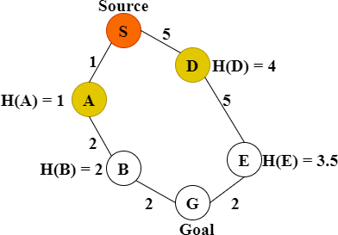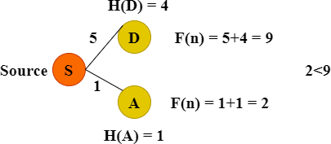

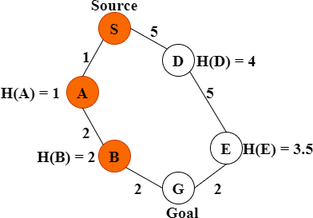
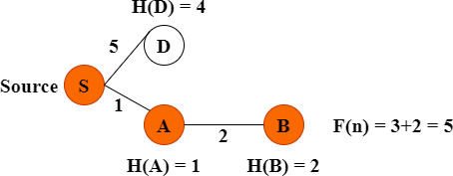

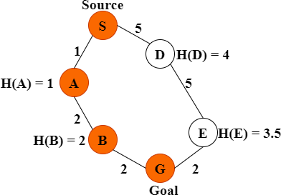
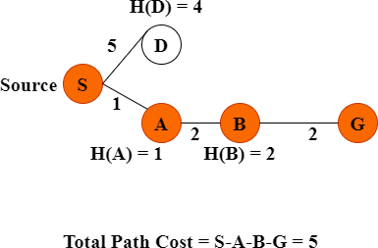

Advantages of Informed Search
- Efficiency: Informed search algorithms can significantly reduce the search space by using heuristic information, leading to faster problem-solving compared to uninformed search algorithms.
- Optimality: When using admissible and consistent heuristics, algorithms like A* are guaranteed to find the optimal solution.
- Scalability: Heuristic search methods can handle larger problem spaces more effectively than uninformed methods because they prioritize the most promising paths

- Flexibility: The heuristic function can be tailored to specific problems, making informed search methods adaptable to a wide range of applications.
- Practicality: Informed search is particularly useful in real- world applications such as navigation, robotics, and game AI, where finding efficient solutions quickly is crucial

Disadvantages of Informed Search
- Heuristic Design: Designing an effective heuristic function can be challenging and requires domain-specific knowledge. A poor heuristic can degrade performance, making the search inefficient or even leading to incorrect solutions.
- Computational Overhead: While the search process can be faster, computing the heuristic function for each node can add computational overhead, especially if the heuristic is complex.
- Memory Usage: Informed search algorithms like A* require storing all generated nodes in memory, which can lead to high memory consumption, especially for large problem spaces
- Completeness: While algorithms like A* are complete, some informed search methods may not guarantee finding a solution if the heuristic function is not well- designed or if the search space is infinite.
- Dependency on Heuristic Accuracy: The performance of informed search algorithms heavily depends on the accuracy of the heuristic. An inaccurate heuristic can mislead the search, causing it to explore non-optimal paths extensively

Heuristic search

Heuristic search involves using heuristics, or rules of thumb, to guide the search process towards a goal. Heuristics are strategies derived from previous experiences with similar problems. They aim to improve the efficiency of the search process by reducing the number of possibilities that need to be explored.

Common Heuristic Search Algorithms
- Best-First Search (BFS): Uses a priority queue to explore nodes based on a heuristic value, typically aiming to expand the most promising node first. Example: Greedy Best-First Search.
- A* Search: Combines the strengths of Uniform-Cost Search and Greedy Best-First Search by using both the cost to reach a node (g) and the estimated cost to get from the node to the goal (h).
Heuristic Function: f(n)=g(n)+h(n)

Common Heuristic Search Algorithms
- Hill-Climbing: An iterative algorithm that starts with an arbitrary solution and makes incremental changes to improve it, selecting the neighbor with the highest value. Variants: Simple Hill-Climbing, Steepest-Ascent Hill-Climbing

Heuristic Functions
Heuristic functions are critical in guiding the search. Good heuristics are problem-specific and should be designed to provide an accurate estimate of the cost or distance to the goal.
- Admissible Heuristics: Never overestimate the cost to reach the goal (used in A* search).
- Consistent Heuristics: For every node n and every successor n′ of n generated by any action a, the estimated cost of reaching the goal from n is no greater than the step cost of getting to n′ plus the estimated cost of reaching the goal from n′.

Applications
Heuristic search techniques are widely used in various fields, including:

- Path finding and Navigation: Algorithms like A* are used in robotics, video games, and GPS navigation systems.
- Game Playing: Algorithms like Minimax with heuristics are used in chess, Go, and other strategic games.
- Optimization Problems: Techniques like genetic algorithms and simulated annealing are used for complex optimization problems in engineering and operations research

Advantages and Disadvantages

Advantages:
- Can significantly reduce the search space and time required to find a solution.
- Flexible and can be adapted to a wide range of problems.

Disadvantages:
- Heuristic functions can be difficult to design and may require domain-specific knowledge.
- May not guarantee the optimal solution if the heuristic is not well-chosen

Example – 8 Puzzle Problem
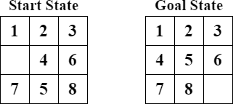
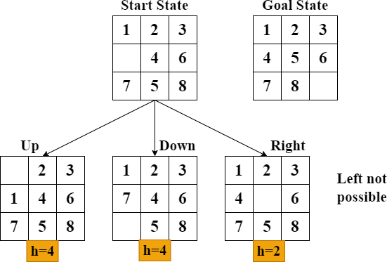

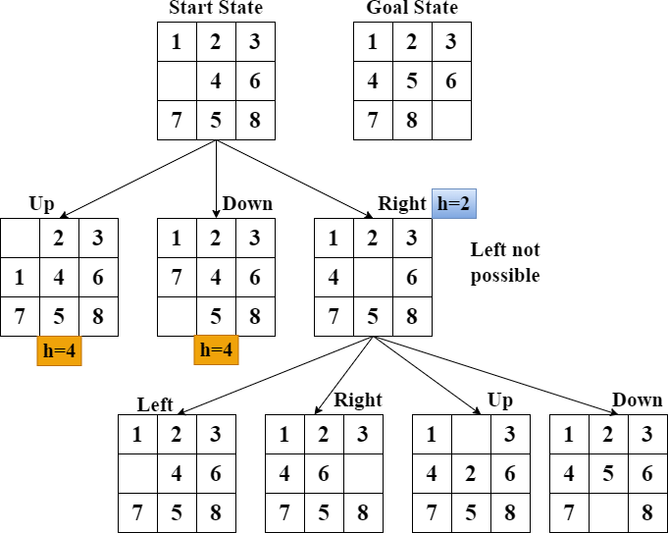

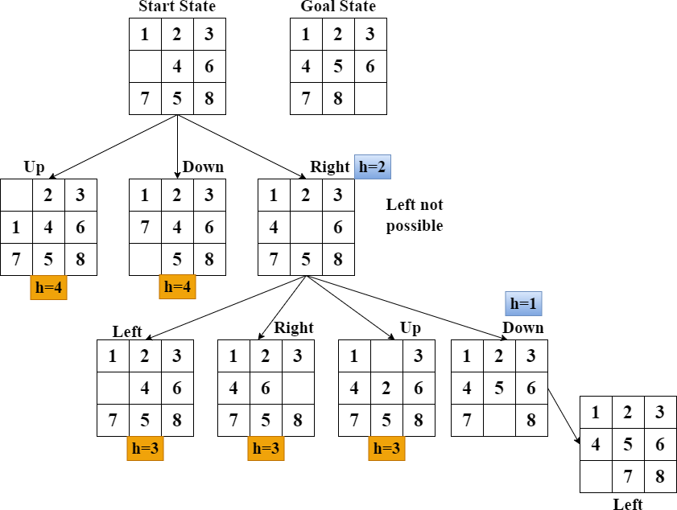

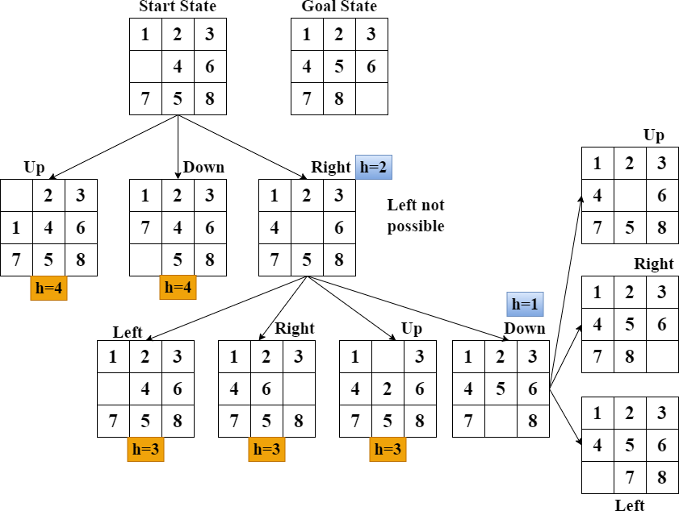

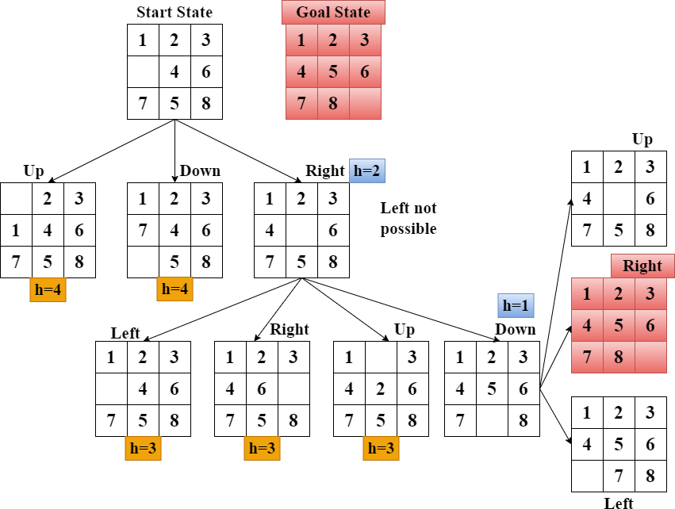

Hill Climbing Search
Hill climbing is a local search algorithm used for mathematical optimization problems. It is an iterative algorithm that starts with an arbitrary solution to a problem, then attempts to find a better solution by incrementally changing a single element of the solution

Hill Climbing Important points
- Variant of generate and test method in which feedback from test procedure is used to help generate decide which direction to move in search space.
- Local search algorithm
- It uses greedy approach
- No Backtracking involved
- Always moves in a single direction
- It is similar to DFS
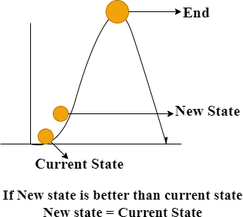

Hill Climbing Algorithm Steps
- Define the current state as a Initial State
- Loop until the Goal state is achieved
- Apply an operation to current state and get a new state
- Compare the new state with the goal state
- Quit if the goal state is achieved
- Evaluate new state with heuristic function and compare it with the current state
- If the new state is close to the goal compare to the current state and update the current state

Hill Climbing Flowchart
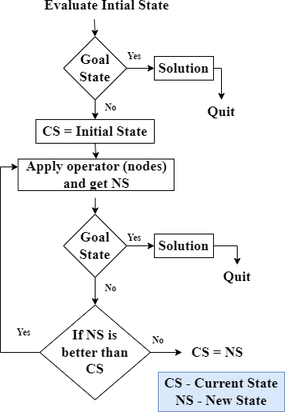

Advantages and Disadvantages

Advantages:
- Simple to implement and understand.
- Efficient for problems with small search spaces.

Disadvantages:
- Can get stuck in local maxima/minima.
- No guarantee of finding the global optimum
- Sensitive to the choice of the initial solution

Limitations
- Local maxima: State which is better than all of its neighbors but nor better than some other state which is not directly connected to that state.
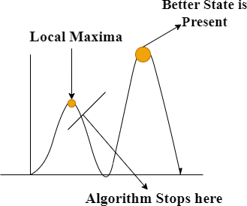

- Plateau: Flat area of search space in which all neighbors have same values
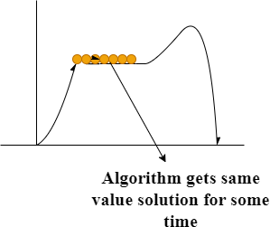

- Ridges: Creating a sequence of local maxima but all of them are not directly connected
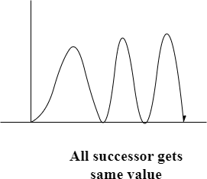

Example – 8 Puzzle
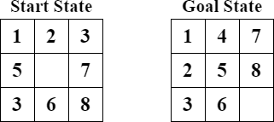
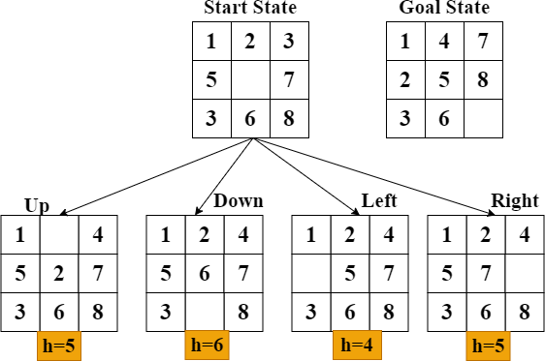

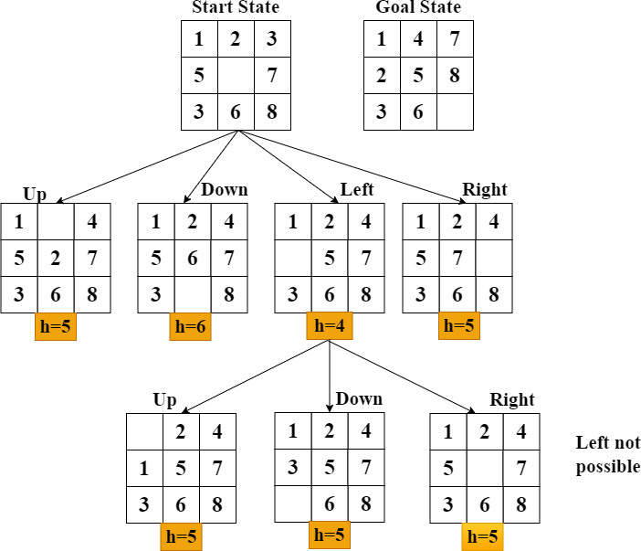

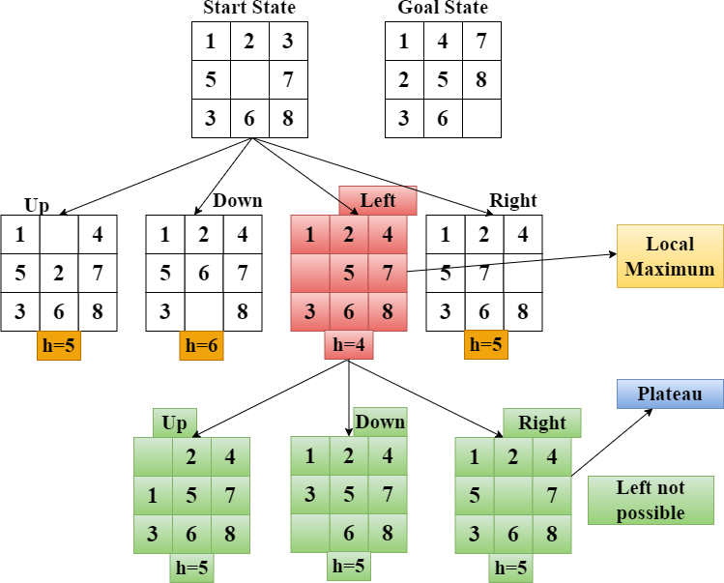

Steepest Ascent Hill climbing
  - In Steepest – Ascent Hill Climbing multiple points are checked
  - In this algorithm it selects the best among the children states that are better than the current state.
  - All moves are considered and best one is selected as next state
  - Examines all neighboring node and selects the node closest to the solution as next node
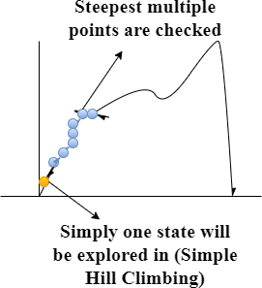

Steepest Ascent Hill climbing Flowchart

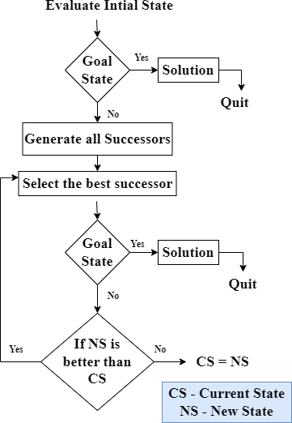

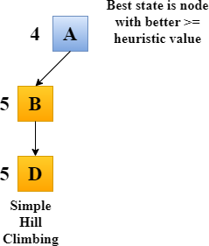

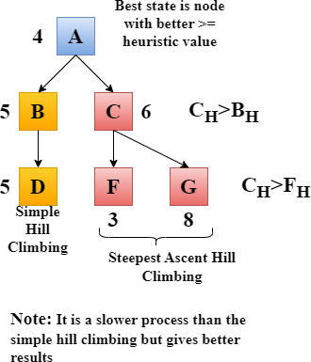

Hill climbing is a fundamental heuristic search technique used in AI and optimization problems. It is especially useful when the problem space is well- behaved and the risk of local optima is low. However, for more complex problems with many local optima, other algorithms like simulated annealing or genetic algorithms may be more appropriate.

Best-First Search

Best-first search is a search algorithm that explores a graph by expanding the most promising node chosen according to a specified rule. It uses a priority queue and can be considered a variant of breadth-first search, but instead of expanding nodes in the order they were discovered, it uses an evaluation function to decide the order of expansion
  - It comes under informed search technique which uses heuristic method.
  - Uses the concept of Priority queue and heuristic search
  - To search the graph space, The Best First Search (BFS) method uses two lists for tracking the traversal.
  - An ‘Open’ list which keeps track of the current ‘Immediate’ nodes available for traversal and ‘ Closed’ list that keeps track of the nodes already
  - Nodes are given priority based on their heuristic value.
  - It uses Greedy approach. Gives good solution but may or may not give optimal solution

Algorithm for Best-First Search

Create two empty lists: Open and Closed

  - Step 1: Place the starting node into the priority queue OPEN
  - Step 2: IF the OPEN is empty, stop and return failure. Else
  - Step 3: Remove the first node n, from the OPEN and places it in the CLOSED list.
  - Step 4: Expand the node n, and generate the successors of node n
  - Step 5: Check each successor of node n, and find whether any node is a goal node or not. If any successor node is foal node, then return success and terminate the search, else proceed to Step 6
  - Step 6: For each successor node, insert them into OPEN based on h(n) value, provided it is not in CLOSE list
  - Step 7: Return to Step 2
    - H(n) = estimated cost from node n to the goal.

Heuristic function used is straight line distance Start State is A and Goal State is G
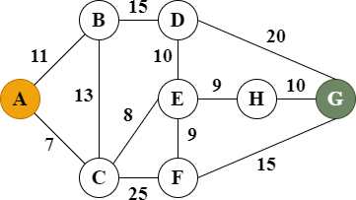

Place the starting node into the priority queue OPEN
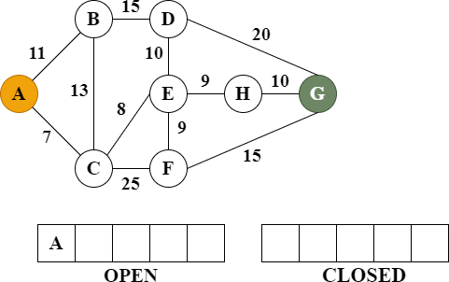
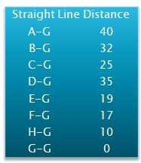

Remove the first node A, from the OPEN and place it in the CLOSED list
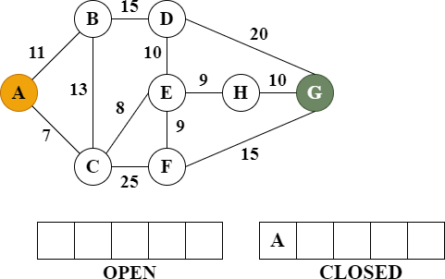
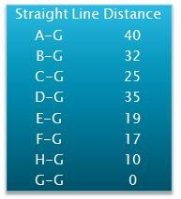

Explore its successor nodes and based on their heuristic value insert them into OPEN
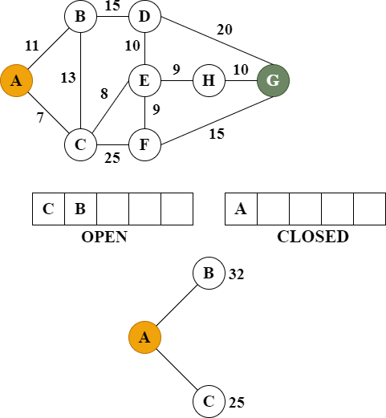

Remove first node from OPEN, add it to CLOSE. And explore its successor nodes and based on their heuristic value insert them into OPEN
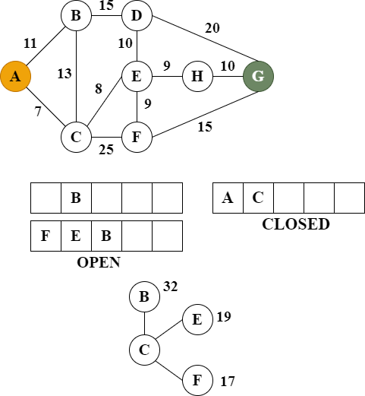

Remove first node from OPEN, add it to CLOSE. And explore its successor nodes and based on their heuristic value insert them into OPEN. Here successor node is Goal node. So Goal is reached and algorithm returns the path from start to goal node

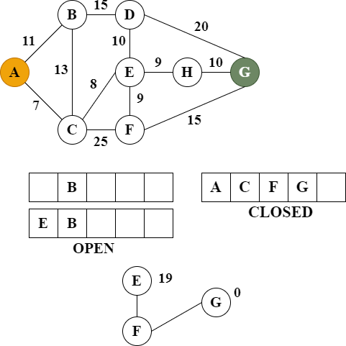

So Goal is reached and algorithm returns the path from start to goal node The time complexity of the algorithm is given by O (n*logn)
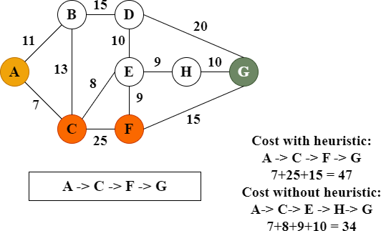

Advantages:

- More efficient than Breadth First Search and Depth First Search algorithms

Disadvantages:

- Chances of getting stuck in a loop are higher
- This algorithms is not optimal

Applications

- Best-first search algorithms, especially used in various AI applications, including:
- Path finding in games and robotics.
- Solving puzzles (e.g., the 8-puzzle problem).
- Planning and scheduling tasks.
- Natural language processing tasks like parsing and machine translation.

Beam Search
Beam search is a heuristic search algorithm used primarily in the fields of artificial intelligence and machine learning, particularly in natural language processing and speech recognition. It is an optimization of the best-first search that reduces the search space by only exploring a limited set of the most promising nodes at each level.
- Optimized version of Best First Search
- Heuristic Search Algorithm
- Explores a Graph by expanding the most promising node in the limited set
- Reduces the memory requirement
- Greedy algorithm
- The Beam Width (K) is given and the nodes searched according to the beam value

Key Concepts
- Beam Width (K): The number of nodes retained at each level of the search. A larger beam width increases the chance of finding an optimal solution but also increases computational complexity.
- Heuristic Function: Used to estimate the score or cost of a node. The accuracy of this function greatly impacts the efficiency and effectiveness of the beam search

Algorithm for Beam Search
- Initialization: Start with an initial node (e.g., the root of a tree or the initial state in a sequence prediction task).
- Expand Nodes: Generate all possible successor nodes from the current set of nodes.
- Scoring: Assign a heuristic value to each successor node. This score typically represents the likelihood of reaching a goal state through that node
- Pruning: Select a predetermined number K of the highest- scoring nodes (this number K is known as the beam width). Prune the rest of the nodes, discarding them from the search space.
- Repeat: Repeat the expansion, scoring, and pruning steps until a goal state is reached or a certain number of levels have been processed.
- Output: The search continues until the goal state is found or the process is terminated after a fixed number of levels. The sequence of steps leading to the goal state is then returned as the solution.

Advantages and Disadvantages Advantages

Advantages
- Efficiency: Beam search is more efficient than exhaustive search methods because it reduces the number of nodes explored.
- Scalability: It can handle larger search spaces by adjusting the beam width.

Disadvantages
- Suboptimal Solutions: Since beam search prunes nodes at each level, it may miss the optimal solution if it’s not within the top K nodes at any level.
- Memory Usage: Requires memory to store the beam width number of nodes at each level.

Applications
- Natural Language Processing: Used in tasks like machine translation, text generation, and speech recognition to predict sequences of words or tokens.
- Game AI: Helps in decision-making processes where multiple potential moves must be evaluated.
- Robotics: Assists in path planning and navigation by efficiently exploring possible routes.

Beam search strikes a balance between breadth-first search (exploring all possible paths) and depth-first search (exploring one path fully before backtracking), making it a powerful tool for many AI applications

Example – Best First

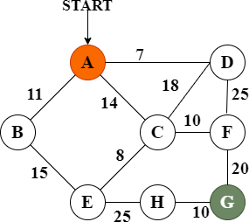
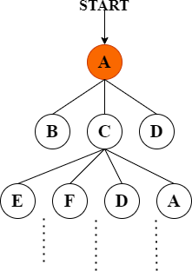

Example – Beam Search

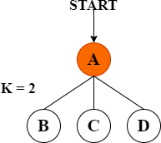

K = Beam width

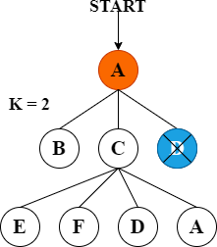

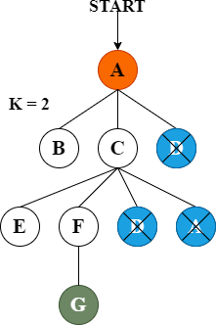

Difference

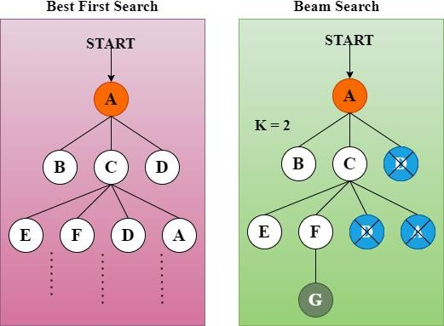

A* (A-star) search
A* (A-star) search is a popular and widely used algorithm in artificial intelligence for finding the shortest path from a start node to a goal node in a graph. It is particularly known for its efficiency and accuracy in solving path finding and graph traversal problems
- Uses heuristic function h(n) and cost to reach the node ‘n’ from start state g(n)
- Finds shortest path through search space
- Fas and optimal result.
  - F(n) = g(n) + h(n)
- F(n) – Estimated Cost
- G(n) – Cost to reach node
- H(n) – Heuristic value

A* (A-star) search Advantages:
- Best searching algorithms
- Optimal and complete
- Solving Complex problems

Disadvantages:
- Dose not always produces shortest
- Complexity issues
- Requires memory

Algorithm for A* (A-star) search
- Initialize: Add the start node to the open list with f(start)=g(start)+h(start), where g(start)=and h(start) is the heuristic estimate.
- Loop: While the open list is not empty:
- Current Node: Remove the node with the lowest fff-value from the open list. This is the current node.
- Goal Test: If the current node is the goal node, reconstruct the path from the start
- node to the goal node and return it
- Generate Successors: For each successor of the current node:
  - Calculate the tentative g-value for the successor (current node's g-value plus the cost to move from the current node to the successor).

  - If the successor is in the closed list and the new g-value is lower, skip this successor.
  - If the successor is not in the open list or the new g-value is lower:
  - Update the successor's g-value.
  - Calculate the successor's f-value.
  - Set the successor's parent to the current node.
  - If the successor is not in the open list, add it.
- Add to Closed List: Add the current node to the closed list.
- Failure: If the open list is empty and the goal node was not reached, return failure (no path exists)

Properties of A* Search
- Completeness: A* is complete, meaning it will find a solution if one exists.
- Optimality: A* is optimal if the heuristic function is admissible and consistent.
- Time Complexity: Depends on the heuristic; can be exponential in the worst case.
- Space Complexity: Can be high due to storing all generated nodes in memory

Applications
- Path finding in Games: Finding the shortest path for characters or units in a game.
- Robotics: Navigating robots through a physical space.
- Map Routing: Finding the shortest path in maps or GPS navigation systems

Example
