Architecture c4

Individual diagram

Dyulgeryan, Vartan

# 1. System Context (C1)

# 2. Containers (C2)

# 3. Components (C3)

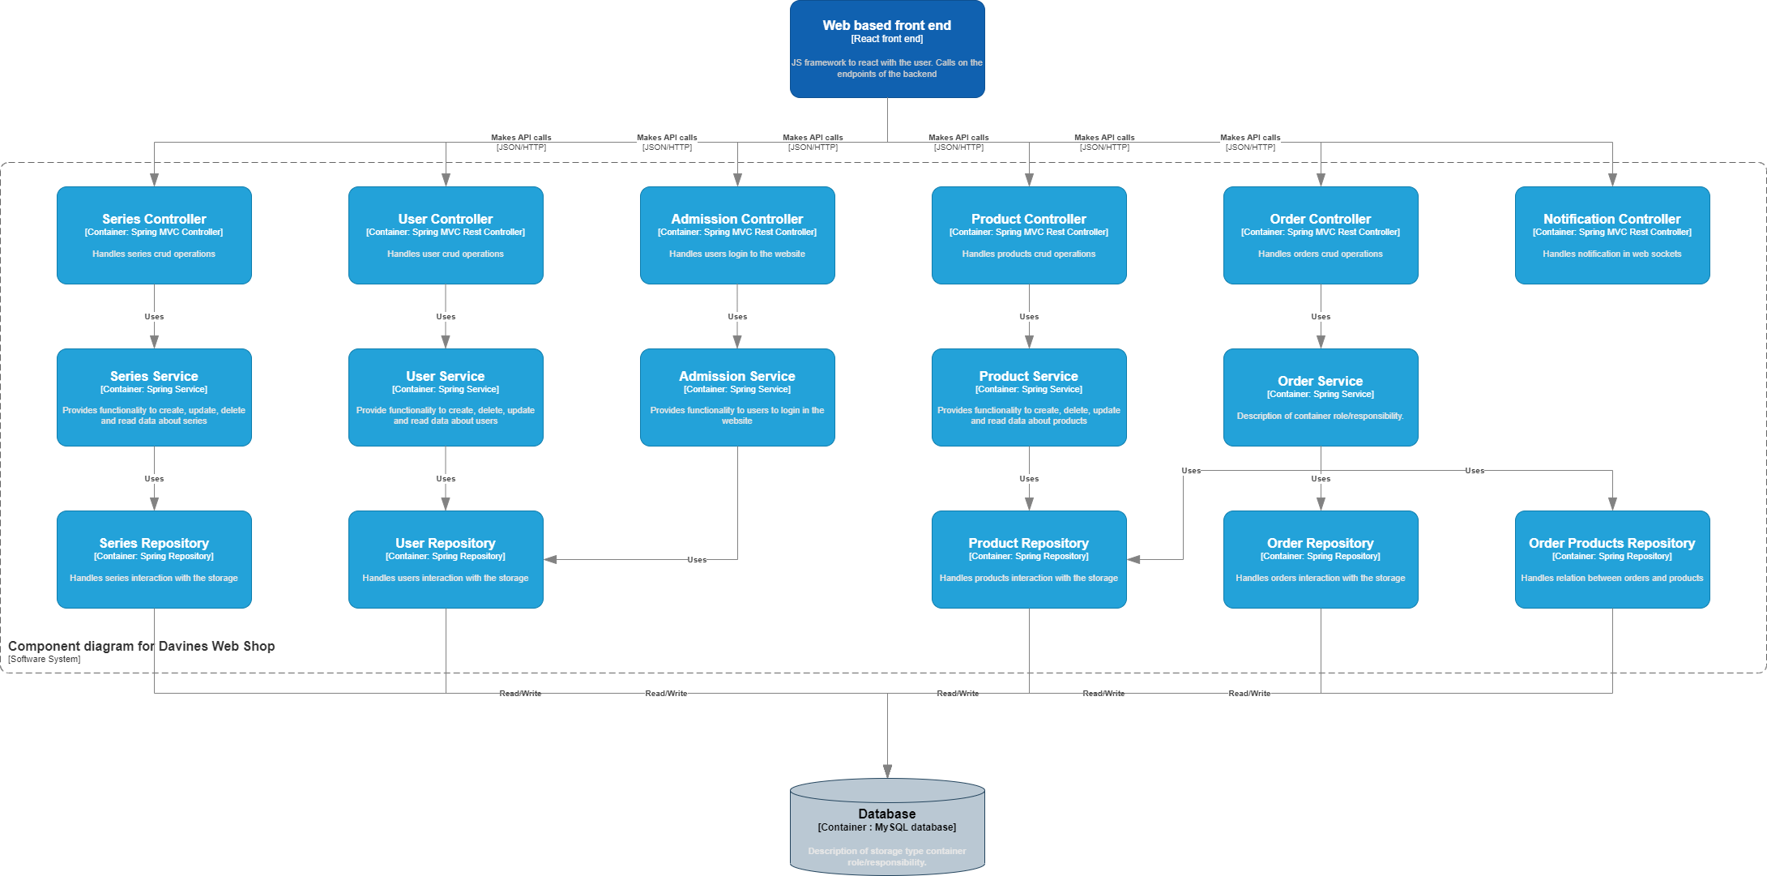

# 4. Code (C4)

