DiamondBack Insights

Team Members - [Asheer Mogal](mailto:asheerm@umd.edu), [Aniket Nikhil Chafekar](mailto:achaf10@umd.edu), [Rohit Abbireddi](mailto:rohit07@umd.edu), [Pranayreddy Anthareddy](mailto:pranay18@umd.edu)

Mission Statement

To create a comprehensive database of historical rankings for UMD graduate programs from multiple sources, enabling in-depth analysis of trends and benchmarking to provide data-driven insights that strengthen the school's reputation.

Mission Objectives

* To compile and analyze historical ranking data to determine the top 5 ranked graduate programs at the University of Maryland. This analysis will spotlight the university's premier offerings based on consistent high performance over a five-year period.
* To assess how the rankings of UMD graduate programs have evolved in comparison to peer institutions over the last five years. This will help in understanding competitive dynamics and pinpointing areas of strength and improvement.
* To identify and understand the key factors that contribute to the success of the highest-ranked graduate programs at UMD. Factors like graduation rates, employment rates, and average salaries will be considered.
* To analyze the overall performance of UMD graduate programs by evaluating their average rankings and the frequency of appearances in the top 10 over the past five years. This will provide insights into the consistency and prominence of these programs.
* To gather and analyze ranking data for UMD graduate programs from different publications over the past five years. The analysis will focus on understanding how various publications have ranked these programs and the frequency of their appearances in these rankings, guiding outreach and relationship-building efforts.

Business Requirements

* The Program entity contains information about specific graduate degree programs offered by the University of Maryland's Robert H. Smith School of Business. Attributes include the program ID, name, degree type, duration, and tuition cost. The program ID serves as the primary key for this entity.
* The Publication entity stores data about external ranking publications like Bloomberg, Economist, and US News that provide rankings for the UMD graduate programs. Attributes include the publication ID, publication name, and URL link to the rankings. Publication ID is the primary key.
* The Ranking Factors entity describes the different criteria and metrics used by ranking publications to grade programs, such as Ranking factor index, graduation rate, employment rate, average salaries etc. Ranking factor index serves as the primary key for this entity.
* The Rank entity stores the historical rankings data, with attributes to identify the rank position, and ranking year. Rank year is the primary key for this.

ER Schema and Diagram

Entities, Attributes and Primary/Foreign Keys

* Program (**prgId**, prgName, prgType, prgDuration, prgTuition)
* Publication (**pubId**, pubName, pubURL)
* RankingFactors (**rfsFactorIndex**, rfsGradRate, rfsEmpRate, rfsAvgSalary)
* Rank(**rankId** ,rankYear, rankPosition)

Relationships, Attributes, Degrees, Participating Entities and Constraints

Has: Binary Relationship

1 Program to 1 or many Ranks

1 Rank to 1 Program

Give: Ternary Relationship

1 Rank to 1 Publisher and 1 or many Ranking Factors

1 Factor to 1 Rank and 1 Publisher

1 Publisher to 1 Rank and 1 or many Factors

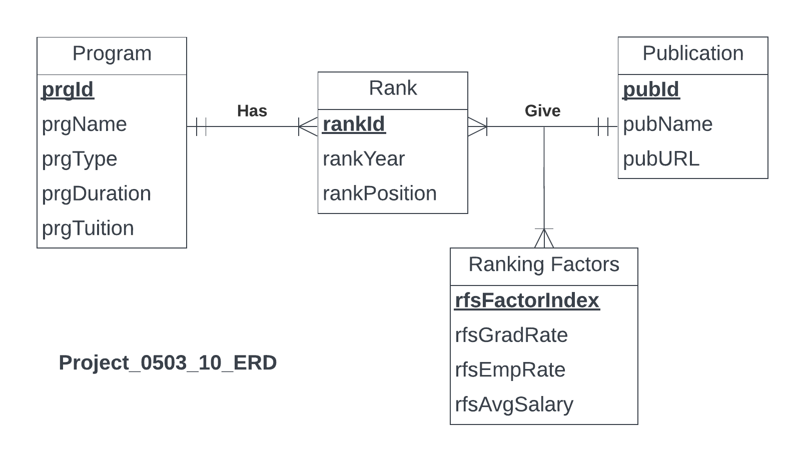

**Relations**

* Program (**prgId**, prgName, prgType, prgDuration, prgTuition)
* Publication (**pubId**, pubName, pubURL)
* RankingFactors (**rfsFactorIndex**, rfsGradRate, rfsEmpRate, rfsAvgSalary)
* Rank(**rankId**, rankYear, ***prgId***, rankPosition)
* Give(***pubId***, ***rfsFactorIndex***, ***rankYear***)

**Business Rules**

[R1] If a program is removed from the Program entity, its associated ranking data in the Rank entity should not be deleted. This ensures that historical ranking information is preserved for analysis, even if the program itself is no longer active or offered.

[R2] When details of a program (like name, type, duration, etc.) in the Program entity are updated, these changes should cascade to the Rank entity. This ensures that the ranking data always reflects the most current information about the programs.

[R3] If a publication is removed from the Publication entity, the rankings provided by that publication in the Rank entity should remain intact. This preserves the historical record of rankings, which is crucial for trend analysis over time.

[R4] When there are updates to a publication's details (like name or URL) in the Publication entity, these changes should be reflected in the Rank entity. This ensures consistency and accuracy in the source of ranking data.

[R5] Deleting an entry from the Give relationship should not result in the deletion of the corresponding publication in the Publication entity. This maintains the integrity of publication data independent of specific ranking factor associations.

[R6] If there's an update to a publication in the Publication entity, this update should be reflected in the Give relationship. This ensures that the relationship always contains the latest information about the publications.

[R7] If an entry in the Give relationship is deleted, it should not affect the RankingFactors entity. This allows for the preservation of ranking criteria even if specific instances of their application are removed.

[R8] Changes made to the ranking factors in the RankingFactors entity should be updated in the Give relationship. This ensures that the criteria used by publications for ranking in specific years are always current and accurate.

[R9] If a rank is deleted from the Rank entity, the corresponding entry in the Give relationship should also be removed. This keeps the relationship data consistent and relevant, ensuring that it only reflects existing ranks.

[R10] When rank details are updated in the Rank entity, these updates should be propagated to the Give relationship. This ensures that the ternary relationship accurately reflects the latest ranking information, including year, position, and associated factors.

**Referential Integrity**

| **Relation** | **Foreign Key** | **Base Relation** | **Primary Key** | **Business Rule on Delete** | **Constraint: ON DELETE** | **Business Rule on Update** | **Constraint: ON UPDATE** |
| --- | --- | --- | --- | --- | --- | --- | --- |
| Rank | prgId | Program | prgId | R1 | NO ACTION | R2 | CASCADE |
| Rank | pubId | Publication | pubId | R3 | NO ACTION | R4 | CASCADE |
| Give | pubId | Publication | pubId | R5 | NO ACTION | R6 | CASCADE |
| Give | rfsFactorIndex | RankingFactors | rfsFactorIndex | R7 | NO ACTION | R8 | CASCADE |
| Give | rankYear | Rank | rankYear | R9 | CASCADE | R10 | CASCADE |

**Sample Data**

**1. Program**

| **prgId** | **prgName** | **prgType** | **prgDuration** | **prgTuition** |
| --- | --- | --- | --- | --- |
| P101 | MBA Full-Time | MBA | 2 years | $90,000 |
| P102 | MS in Business Analytics | MS | 1 year | $50,000 |
| P103 | Executive MBA | MBA | 1.5 years | $70,000 |
| P104 | PhD in Managerial Economics | PhD | 4 years | $30,000 |
| P105 | MS in Finance | MS | 1 year | $45,000 |
| P106 | MS in Supply Chain Management | MS | 1.5 years | $50,000 |
| P107 | MS in Information Systems | MS | 2 years | $60,000 |

**2. Publication**

| **pubId** | **pubName** | **pubURL** |
| --- | --- | --- |
| PB01 | Bloomberg | [https://www.bloomberg.com](https://www.bloomberg.com/) |
| PB02 | Economist | [https://www.economist.com](https://www.economist.com/) |
| PB03 | US News | [https://www.usnews.com](https://www.usnews.com/) |
| PB04 | Forbes | [https://www.forbes.com](https://www.forbes.com/) |
| PB05 | Financial Times | [https://www.ft.com](https://www.ft.com/) |
| PB06 | Business Insider | [https://www.businessinsider.com](https://www.businessinsider.com/) |
| PB07 | The Wall Street Journal | [https://www.wsj.com](https://www.wsj.com/) |

**3. RankingFactors**

| **rfsFactorIndex** | **rfsGradRate** | **rfsEmpRate** | **rfsAvgSalary** |
| --- | --- | --- | --- |
| RF01 | 90% | 95% | $100,000 |
| RF02 | 85% | 90% | $90,000 |
| RF03 | 92% | 88% | $110,000 |
| RF04 | 80% | 93% | $85,000 |
| RF05 | 88% | 91% | $95,000 |
| RF06 | 93% | 89% | $105,000 |
| RF07 | 87% | 92% | $98,000 |

**4. Rank**

| **rankId** | **rankYear** | **prgId** | **rankPosition** |
| --- | --- | --- | --- |
| R001 | 2023 | P101 | 1 |
| R002 | 2023 | P102 | 2 |
| R003 | 2023 | P103 | 3 |
| R004 | 2023 | P104 | 4 |
| R005 | 2023 | P105 | 5 |
| R006 | 2022 | P106 | 6 |
| R007 | 2022 | P107 | 7 |
| R008 | 2022 | P101 | 2 |
| R009 | 2022 | P102 | 3 |
| R010 | 2022 | P103 | 4 |

**5. Give**

| **pubId** | **rfsFactorIndex** | **rankId** |
| --- | --- | --- |
| PB01 | RF01 | 2023 |
| PB02 | RF02 | 2023 |
| PB03 | RF03 | 2023 |
| PB04 | RF04 | 2023 |
| PB05 | RF05 | 2023 |
| PB06 | RF06 | 2022 |
| PB07 | RF07 | 2022 |
| PB01 | RF02 | 2022 |
| PB02 | RF03 | 2022 |
| PB03 | RF04 | 2022 |