DiamondBack Insights

**Introduction:**

The DiamondBack Insights project is designed to establish a comprehensive database focusing on the historical rankings of Smith school graduate programs offered by the University of Maryland (UMD). The project's scope encompasses collecting and analyzing data from various ranking publications to track and assess trends in these rankings over the past five years. This analysis aims to provide valuable insights into the competitive standing of UMD's graduate programs, spotlight areas for improvement, guide strategic outreach efforts, and ultimately contribute to enhancing the school's reputation.

**Pre-requisites:**

1. Microsoft SQL Server
2. Lucid Chart

**Files shared:**

1. Project_0503_10_ERD
2. Project_0503_10_Proposal.docx
3. Project_0503_10_droptable.sql
4. Project_0503_10_createtable.sql
5. Project_0503_10_insert.sql
6. Project_0503_10_dropview.sql
7. Project_0503_10_createview.sql
8. Project_0503_10_Presentation.pptx

Summary of the contents of each SQL and other files:

**1. The Lucid chart (`Project_0503_10_ERD`):** The ERD in this Lucid Chart outlines the database structure for analyzing Smith school graduate program rankings. It includes entities like Program, Publication, RankingFactors, and Rank, each with specific attributes. Key relationships are depicted, such as the connection between programs and their ranks, and a ternary relationship linking ranks to publications and ranking factors, capturing the complexity of graduate program rankings data.

**2. The project proposal document (`Project_0503_10_Proposal.docx`):** This provides a description of the DiamondBack Insights project, including the mission statement and a detailed explanation of the database's purpose. It outlines the team members involved and delves into technical aspects such as the database structure, entities involved, and their relationships. The document also addresses data integrity and consistency rules, referential integrity, and includes sample data for entities like Program, Publication, RankingFactors, Rank, and Give.

**3. Drop Table SQL (`Project_0503_10_droptable.sql`):** This script provides the SQL commands to drop tables from the database. It's useful for cleaning up or resetting the database structure during development or testing phases.

**4. Create Table SQL (`Project_0503_10_createtable.sql`):** This script creates tables for the database. It includes definitions for entities like Program, Publication, RankingFactors, Rank, and Give. Each table is defined with appropriate attributes and primary keys. Foreign key relationships are also established, notably in the Rank and Give tables.

**5. Insert Data SQL (`Project_0503_10_insert.sql`):** This file contains SQL INSERT statements for populating the database with data. It includes insertions into various tables like Give, suggesting the script is used to seed the database with initial data for analysis.

**6. Drop View SQL (`Project_0503_10_dropview.sql`):** Similar to the drop table script, this one is for dropping views from the database. This can be used to remove views that are no longer needed or to refresh the views based on updated table structures or data.

**7. Create View SQL (`Project_0503_10_createview.sql`):** This file contains SQL commands for creating views. It appears to focus on generating insights such as identifying the top 5 ranked UMD graduate programs over the past 5 years. The views are created using JOIN operations on tables like Program and Rank, and include aggregations like AVG() to calculate average rankings.

**8. The PowerPoint presentation (`Project_0503_10_Presentation.pptx`):** It includes a detailed overview of the project, team members, sources and users of the database, and the mission statement. It outlines the mission objectives, presents an ER diagram and a relational schema, and discusses various business transactions with a focus on program average rank and top appearances. The presentation concludes with views for program average rank and top-ranked programs, and a thank you slide.

**Data Sources:**

| <https://www.rhsmith.umd.edu/programs> |
| --- |
| [https://www.bloomberg.com](https://www.bloomberg.com/) |
| [https://www.economist.com](https://www.economist.com/) |
| [https://www.usnews.com](https://www.usnews.com/) |
| [https://www.forbes.com](https://www.forbes.com/) |
| [https://www.ft.com](https://www.ft.com/) |
| [https://www.businessinsider.com](https://www.businessinsider.com/) |
| [https://www.wsj.com](https://www.wsj.com/) |
| [https://www.princetonreview.com](https://www.princetonreview.com/) |

**Testing the DiamondBack Insights project:**

This involves several key steps, ensuring that each aspect of the database system functions as intended and meets the project's objectives:

**1. Review Project Documentation:** Start by thoroughly reviewing the project proposal (`Project_0503_10_Proposal.docx`) and presentation (`Project_0503_10_Presentation.pptx`). This will provide a clear understanding of the project's goals, database schema, and expected outcomes.

**2. Database Setup and Initialization:** Use `Project_0503_10_createtable.sql` to create the database tables as defined in the ERD (`Project_0503_10_ERD`). Populate the tables with data using `Project_0503_10_insert.sql`. This data will be essential for testing the views and other functionalities.

1. **Drop tables before creating:** Execute the following statements from `Project_0503_10_droptable.sql
   1. 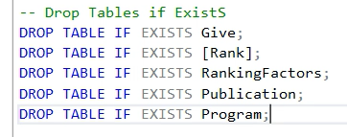
2. **Create tables:** Execute the following statements from `Project_0503_10_createtable.sql`
   1. 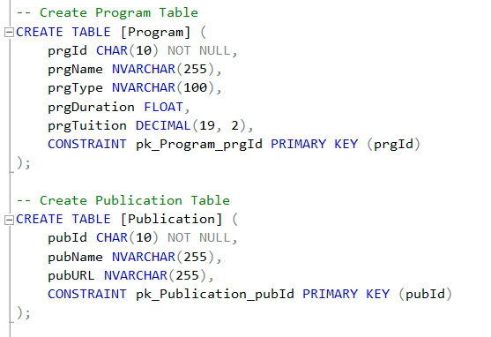
3. **Insert values:** Execute the following insert statements from `Project_0503_10_insert.sql`
   1. 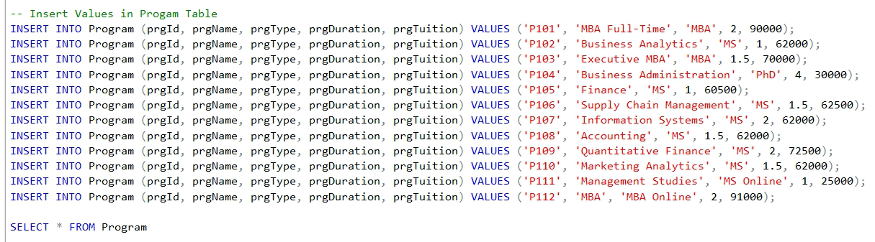
4. **Check the output:** Execute the SELECT statement from the same file to check the table with values inserted in it.
   1. 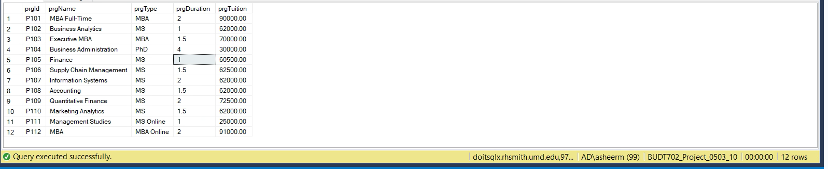

**3. Create and Test Views:** Execute `Project_0503_10_createview.sql` to create views in the database. These views are designed to analyze and present data in specific formats based on the project requirements. Test each view by running queries to fetch data from them. For instance, a view designed to show the top 5 ranked programs should be queried and the results verified against the expected outcome.

1. **Drop views before creating:** Execute the following statements from `Project_0503_10_dropview.sql
   1. 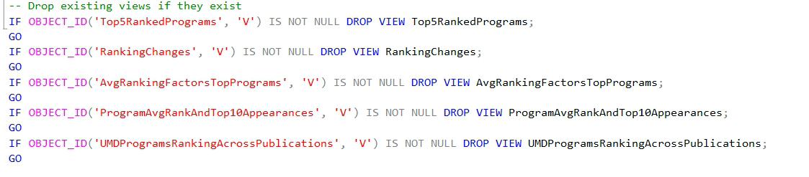
2. **Create views:** Execute the following statements from `Project_0503_10_createview.sql`
   1. 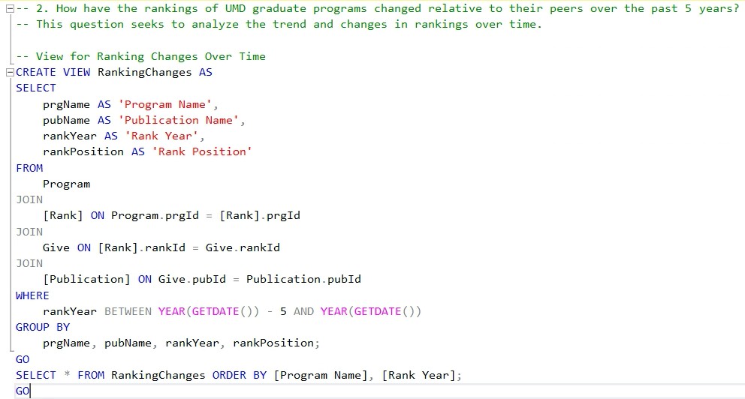
3. **Check the output:** Execute the SELECT statement at the end of each view in the same file mentioned above.
   1. 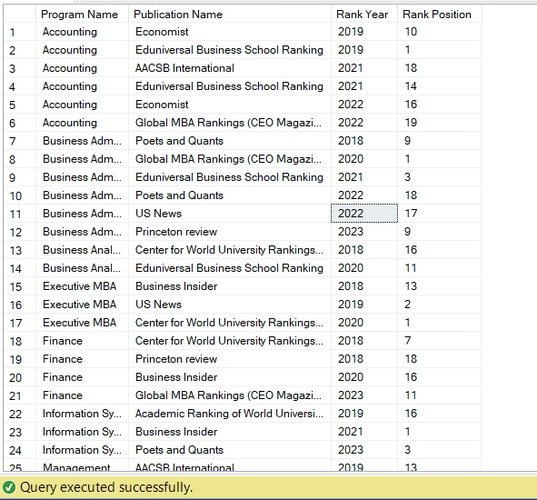

**4. Data Validation and Accuracy Checks:** Ensure the data displayed in the views matches expected results, especially in terms of accuracy and relevance.

**5. Cleanup and Final Checks:** After testing, use `Project_0503_10_droptable.sql` and `Project_0503_10_dropview.sql` as needed to clean up the database environment, removing tables and views. This step is crucial if you plan to rerun tests after making adjustments based on initial findings.

**6. Review and Adjust:** Review the test results and compare them with the project's objectives. Identify any discrepancies or areas for improvement. Make necessary adjustments to the database schema, views, or data, and retest as needed to ensure the project meets its intended goals.

**References:**

1. Hoffer, Jeffrey A., Ramesh, V., & Topi, Heikki "Modern Database Management" : This book is utilized as a primary reference for database management principles, offering technical guidance and best practices in database design and management.
2. Bloomberg, The Economist, and US News: These publications are referenced for providing ranking data for the University of Maryland's graduate programs, essential for the project's analysis.
3. [The University of Maryland's Official Website](https://www.rhsmith.umd.edu/programs): The project relies on information from the university's official smith school grad programs platform for accurate and current details about its graduate programs.
4. DiamondBack Insights Project Proposal and Presentation Documents: These internal documents outline the project's mission, objectives, and methodologies, forming a core part of the project's foundational framework.