Under the Wave off Kanagawa
Katsushika Hokusai | ca. 1830–32 | Record IMG-EA0001

1. Original Image
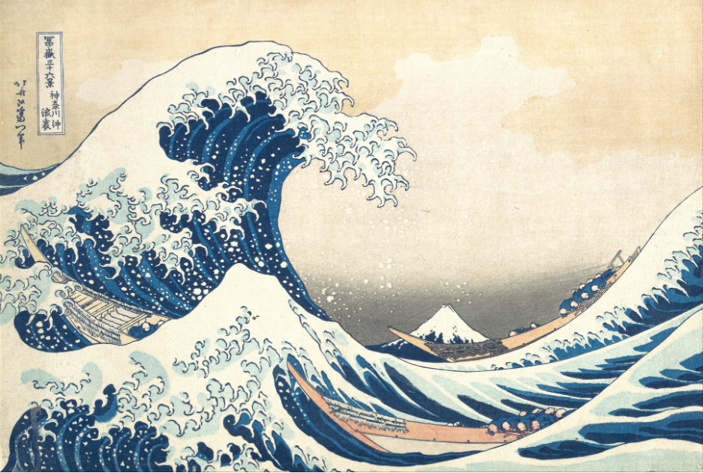
IMG-0001. Katsushika Hokusai, Under the Wave off Kanagawa (Kanagawa oki nami ura), also known as The Great Wave, ca. 1830–32. Woodblock print; ink and color on paper. The Metropolitan Museum of Art.
Source IDs cited below are resolved in the batch Sources and Uncertainty workbook.

2. Record Summary
Record ID | IMG-EA0001
Original title | 「富嶽三十六景 神奈川沖浪裏」
English title | Under the Wave off Kanagawa (Kanagawa oki nami ura), from the series Thirty-six Views of Mount Fuji (Fugaku sanjūrokkei)
Alternative title | The Great Wave
Creator | Katsushika Hokusai (Japanese, 1760–1849)
Creation date | ca. 1830–32
Country | Japan
Cultural region | East Asia
Historical period | Edo period (1615–1868)
Image type | Print
Medium | Woodblock print; ink and color on paper
Dimensions | 10 1/8 × 14 15/16 in. (25.7 × 37.9 cm)
Primary subject | Three boats beneath a large ocean wave
Secondary subjects | Boat crews, sea, Mount Fuji, Japanese inscription
Source institution | The Metropolitan Museum of Art
Collection or object number | JP1847

3. Image Description

3.1 Short Description
Three long, narrow boats cross a turbulent sea beneath a large curling wave. Many small figures bend forward inside the boats, while Mount Fuji appears as a low triangular form in the distance. Deep blue and pale blue water contrasts with cream paper and tan boat hulls. Vertical Japanese text appears in the upper left.

3.2 Detailed Visual Description
A towering wave rises across the left and center of the composition and curls toward the right. Its crest breaks into repeated hooked shapes outlined in dark blue, with pale foam extending like separate fingers. Smaller waves fill the foreground. Three narrow boats cut diagonally through the water: one crosses the lower center, another runs along the right edge, and a third is partly visible at lower left. Multiple small figures are arranged in rows inside the boats. Their bodies bend forward, and most wear dark blue garments with light circular or rectangular details. Individual facial features and the exact number of people are not reliably visible. A white, triangular mountain with a darker base appears low in the center-right background, framed by the curve of the wave and the nearest boat. The sky is a largely unbroken cream field. Japanese inscription blocks occupy the upper-left corner. Flat areas of blue, cream, gray, and tan are defined by precise linear contours and repeated foam patterns.

4. Formal Features
Field | Analysis
Composition | The large wave forms an arch across the center-left. The boats create long diagonals, while the distant mountain stabilizes the open center-right space.
Viewpoint or camera angle | A slightly elevated, oblique viewpoint reveals the interiors of the boats and layered wave crests.
Shot scale | Not applicable to a camera image; the print uses a broad landscape view in which people appear very small.
Spatial depth | Overlap, diagonal placement, and strong differences in scale separate the foreground wave, boats, and distant mountain.
Lighting | No single directional light source is represented. Form is defined mainly through flat color and tonal contrast.
Colour palette | Deep blue, medium blue, pale blue, cream, gray, and muted tan.
Contrast | Dark blue contours and water masses contrast sharply with pale foam, sky, and the snow-covered mountain.
Visual focus | The curling wave is the primary focus; the distant mountain and the three boats form secondary points of attention.
Texture | Foam is rendered through repeated hooked contours and speckled white marks; the sky and boat hulls are comparatively flat.
Movement or stillness | Curving contours, diagonally tilted boats, and repeated foam patterns create strong forward and downward motion.
Medium-specific features | Flat color fields, crisp carved outlines, layered blues, and repeated printed patterns are characteristic of polychrome woodblock printing.

5. Historical Context and Purpose

5.1 Historical Context
The Metropolitan Museum of Art dates this print to ca. 1830–32 and identifies it as part of Hokusai’s Thirty-six Views of Mount Fuji, produced during Japan’s Edo period [IMG-0001-S01]. The Met reports that the Eijudo printing firm advertised the series for the New Year festivities of 1831 and promoted its use of Prussian blue, a pigment newly available to the print market [IMG-0001-S02]. Scientific analysis of The Met’s impression found that printers layered Prussian blue with indigo to intensify the dark water and increase visual depth [IMG-0001-S02]. Edo-period polychrome woodblock prints were collaborative objects: a designer, carver, printer, and publisher all contributed to production [IMG-0001-S03]. The work therefore belongs to a commercial print system as well as to Hokusai’s individual artistic practice.

5.2 Image Purpose and Circulation
Verified original purpose. The image was issued as one print in the publisher-advertised Thirty-six Views of Mount Fuji series [IMG-EA0001-S01; IMG-EA0001-S02]. Probable purpose. It functioned as a commercially circulated artwork for the urban print market; The Met notes that publishers commonly issued ukiyo-e prints as commercial ventures and that impressions could be made in large quantities [IMG-EA0001-S03]. Current institutional use. The Met preserves, catalogs, interprets, and provides digital access to this impression. The exact first purchaser, initial print run, and earliest circulation figures are not verified.

