Name: Ashen Lakshitha Fonseka

Student ID: 102238586

Tutor: Shibli Saleheen

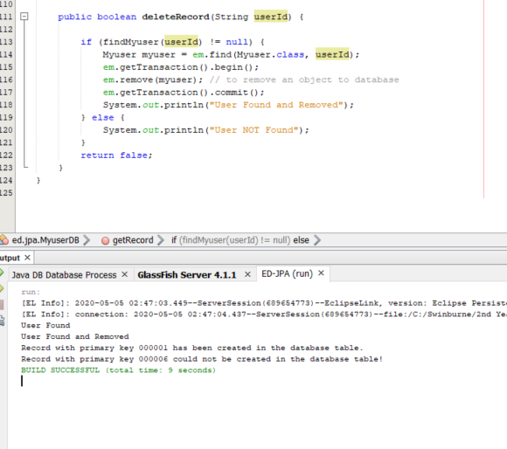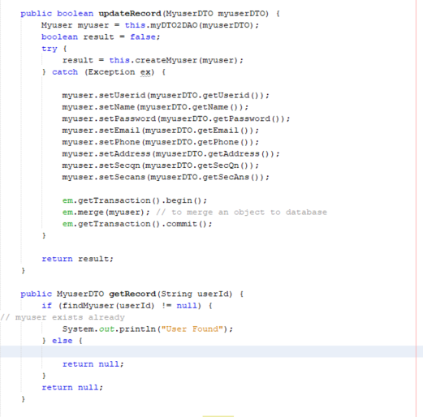

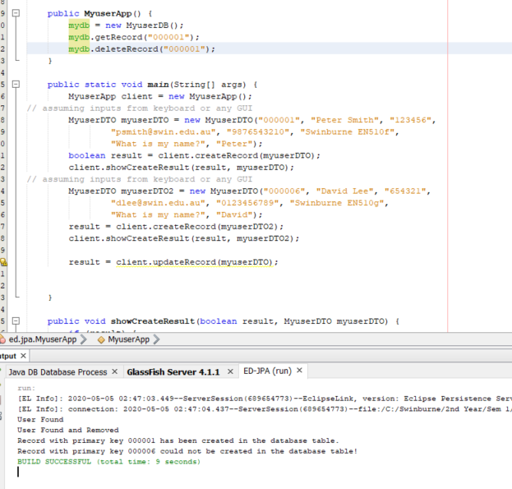

**ORM** means object relation mapping which helps to convert and store the object type data into the data base directly it this case Myuser class doing the ORM work.

In lab 02 Myuser class worked as the Data Transfer Object **DTO,** but in here it worked as the **ORM**

I this lab we directly access the data base to convert and store data so we use different domain for that.