CSCI 4448: Project Part 3

Progress Report

# Summary

This first period was spent getting to know how to develop for the android platform and getting all initial menu screens up and at least running. We have gotten to the point of having many undocumented test cases for each screen, but have not made them formal yet.

The two of us basically pair programed for the entire program thus far, and for the next iteration will be working on our own to finish game play and to get login to work properly.

Thus far, no design patterns have been used, but will be for the game play aspect of the application.

## Screenshots

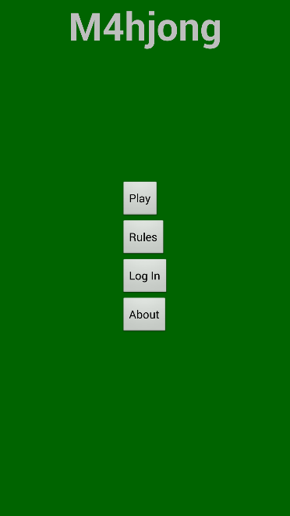 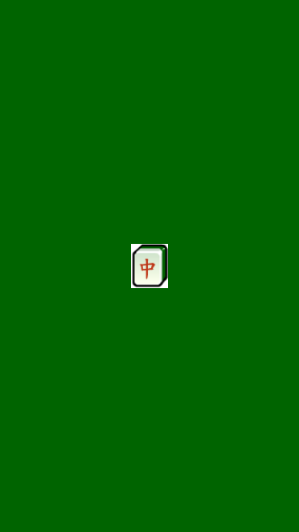 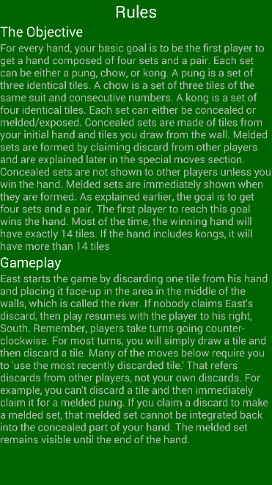

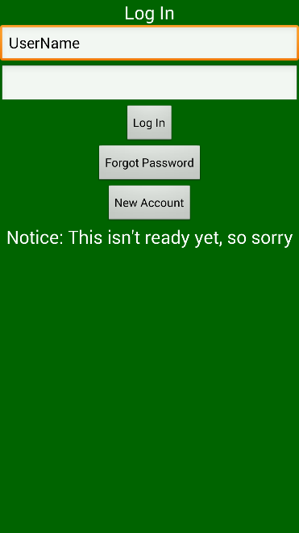 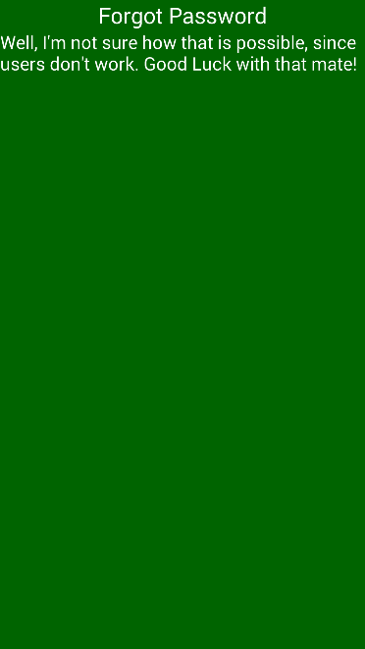 

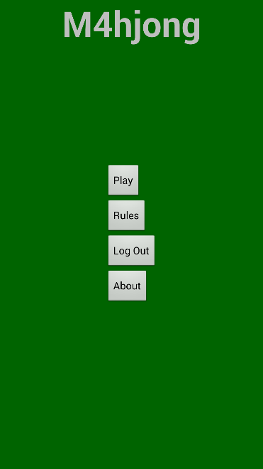 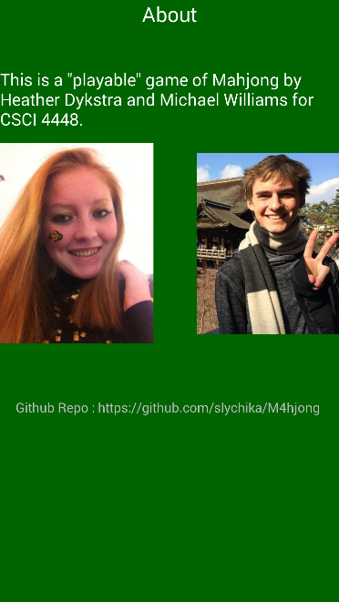

## Breakdown of Work

|  |  |
| --- | --- |
| Team Member | Effort |
| Heather Dykstra | 50% |
| Michael Williams | 50% |

# Class Diagram

# Plans for Next Iteration

To get the basic game play functionality and log in finished. This will probably not hit very many, if any of our stretch goals as we were unable to get as much programming in these last two weeks as we had wanted to.