CSCI4448 – Object Oriented Analysis and Design

Project Part 3

1. *What features were implemented and a class diagram showing the final set of classes and relationships of the system.*

The following features were implemented:

- Users can view rules

- We got user navigation to work

- We got user log in to work

- We got to see a hand and be able to discard a piece from your hand

The following was not completed:

- No stretch Goals

- No real game play

Class Diagram:

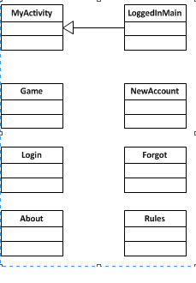

2. *Did you make use of any design patterns in the implementation of your final prototype? If so, how? If not, where could you make use of design patterns in your system?*

We used the singleton design pattern for our game itself, to make sure only one instance would be running.

We also used model-view-controller design structure for how one would interact with the application. Model = > XML code

View => Java Code

Controller => User interaction

We would have kept our strategy design pattern for player vs player interaction if we would have had more time/resources

3. *How the final system changed from the design you presented in Project Part 2. Compare your class diagrams.*

The final system is not nearly as completed as we wanted it to be. Mostly, our class diagram is more focused on our views and not on the game like we thought it would be. We ended up spending a lot more time on views than we thought we would need to.

4. *What have you learned about the process of analysis and design now that you have stepped through the process to create, design and implement a system?*

First and foremost, I learned not to get yourself into too much. I realize now, that if this had been more of a full time project, that I would have had the opportunity to get it working as well as I wanted. In addition, I learned that two people on a team is not enough to get much done, and that it really takes more time than either of us had to give it. I also learned that it is important to know a system before jumping in and coding it. I spent a lot of time refactoring and redefining views, simply because I did not know how android worked and how different things can make the android platform run really slow on any device.