**Cycle 5**

**Input-Output, File Management and exception handling**

1. Write a Java Program to merge data from two files into a third file. (Handle all file related exceptions)

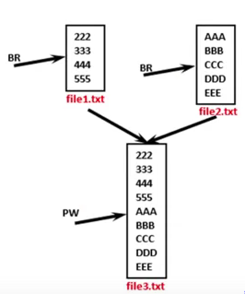

2. Write a Java Program to perform file merge operation where merging should be done by line by line alternatively. (Handle all file related exceptions)

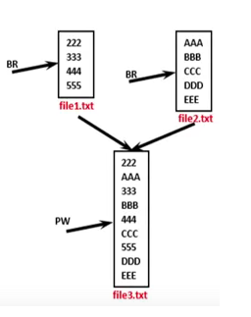

3. Write a Java program that reads a set of real numbers from a file and displays the minimum, maximum, average, and range of the numbers in the file. The user should be able to enter the name of the input file from the keyboard.

4. Write a program that reads the contents of a file and creates an exact copy of the file, except that each line is numbered. For example, if the input file contains the following text:

*Two roads diverged in a yellow wood,*

*And sorry I could not travel both*

*And be one traveler, long I stood*

*And looked down one as far as I could*

*To where it bent in the undergrowth;*

then the output file should appear something like this:

*1: Two roads diverged in a yellow wood,*

*2: And sorry I could not travel both*

*3: And be one traveler, long I stood*

*4: And looked down one as far as I could*

*5: To where it bent in the undergrowth;*

The user should be able to enter the names of the input and output files from the keyboard.

5. Write a Java program that reads a line of integers, and then displays each integer, and the sum of all the integers. (Use StringTokenizer class of java.util)

6. Write a Java program that displays the number of characters, lines and words in a text file.

7. Create a class Student with attributes roll no, name, age and course (use user inputs).If age of student is not in between 15 and 21 then generate an exception to handle it.

8. Write a Java program to define a class salesman with the attributes name, salesman code, sales amount and commission(use user inputs). The Company calculates the commission of a salesman according to the following formula:

(i) 8% if sales <2000

(ii) 10% sales if sales>=2000 and but <=5000

(iii) 12% if sales exceeds 5000

Create salesman objects and find the commission of sales. **Generate and handle exceptions if sales amount is less than 0.**