Course information: CS 148

Your Name: Xun Zhang

Assignment: Final Project

Trading platform: Katharsis

Version <1.0>

Table Of Contents

Time Log 3

Introduction 5

Purpose 5

Definitions, acronyms, and abbreviations 5

Overall Description 6

Story Board 7

Data Dictionary 7

ER- Diagram 9

Schema 10

Specific requirements 11

|  |  |  |  |
| --- | --- | --- | --- |
| Time Log | | | |
| Estimated time to complete assignment => | | | 60 Hours |
| Date | Time Spent  (in hours) | Description | Author |
| 11/7 | 4 | Database ERD setup | All members |
| 11/8 | 2 | Edited ERD, Fix connection problem | All members |
| 11/9 | 2 | Edited ERD, Deleted some unnecessary tables | All members |
| 11/10 | 3 | Redesigned the page and ERD | All members |
| 11/11 |  | Left the original 16th group | Xun Zhang |
| 11/12 | 0.4 | Re-plan the web page structure and clarify the function of the web page | Xun Zhang |
| 11/17 | 2 | Redesign of database structure | Xun Zhang |
| 11/19 | 4 | Work on the form.php- Complete the input function of the form | Xun Zhang |
| 11/21 | 11 | Work on the form.php- Modified the input function of the form, added email confirmation function and adjusted css | Xun Zhang |
| 11/22 | 8 | Work on the form.php- Complete the email confirmation function and continue to adjust the css | Xun Zhang |
| 11/23 | 11 | Work on the form.php. Modified sanatize.php, added new validation functions and continued to adjust the css of the page, added form.js | Xun Zhang |
| 11/24 | 13 | Modified form.php, added new validation functions and continued to adjust the css of the page, added sql.php | Xun Zhang |
| 11/25 | 8 | Modify form.js, form.php and continue to adjust the css of this page, modify sql.php | Xun Zhang |
| 11/26 | 11 | Added login.php, logout.php. Continue to adjust css | Xun Zhang |
| 11/28 | 14 | Added the pop-up prompt effect and tooltips of the registration page and adjusted the css of the page. Add homepage.php and homepage.js | Xun Zhang |
| 11/29 | 13 | Further improve the user deletion and query functions; modify the css of this page | Xun Zhang |
| 11/30 | 9 | Finished nav and nav styles, revised footer and top. Add special effects to homepage.php | Xun Zhang |
| 12/1 | 12 | Completed the function of adding items and fixed the bugs in the registration page and login page. | Xun Zhang |
| 12/2 | 7 | Added about.php, shop.php, setting.php . Modify total css | Xun Zhang |
| 12/3 | 4 | Complete submission contents.138.4 | Xun Zhang |
|  |  |  |  |
|  | 138.4 | <=Total Time Spent |  |
|  |  |  |  |

# Introduction

### Purpose

The purpose of this document is to describe the requirement specification for the web site “Katharsis”(*https://xzhang.w3.uvm.edu/cs148/live-final/form.php*).

The intended audience for this document is Robert Erickson and other users.

*First it is the contract between you and the client. Second it is for the developer of the site. Two primary goals are:*

1. *Client gets a very good understanding of what you will be delivering.*
2. *Developer has a very good understanding of what they are going to create.*

Users:

The navigation button is the round white button in the upper right corner of the page. After clicking the button, it expands the list of pages that can be jumped to. The navigation title of the current page is pink. Complete the registration on the homepage and activate the account after confirming the email address through registration. Log in to the activated account to go to the Home page to view the products that the user has added. After clicking the product that needs to be deleted in the table, you can delete all the selected products by clicking the "dele" button above the table. After selecting the specific type you want to view in the selection list, you can click the "Go To" button below the selection list to view only the selected products. In the Add Products page, you can add products to your warehouse by entering product information and clicking the submit button. Click Log Out to log out

For the Admin,

The page that the administrator can directly enter has not yet been developed. Design idea: You can choose to view activated accounts and inactive accounts. You can delete the selected account directly. You can directly activate the inactive account. Enter the time (date) to view all transaction records at that time.

### Definitions, acronyms, and abbreviations

*Sample for the client:*

ER Diagram – a diagram to represent the data you want to save with your system

W3 Validation – refers to both Html and CSS validation tool provided by the W3c.org. the html validator is located at:

<http://validator.w3.org/>

with the CSS validator located at:

<http://jigsaw.w3.org/css-validator/>

# Overall Description

This website is mainly used for commodity transactions between users. Due to limited time and energy, many functions are yet to be developed. Welcome to join at any time, please contact (xzhang@uvm.edu; 853639081@qq.com)

# Story Board

Don’t have.

# Data Dictionary

Paste your Data Dictionary here. The final version is easy to get by exporting to the screen in phpMyadmin

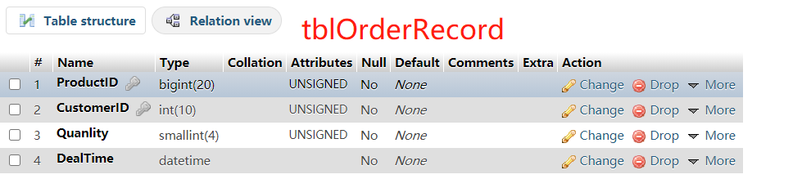

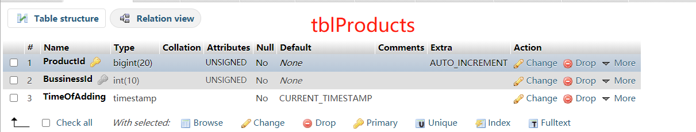

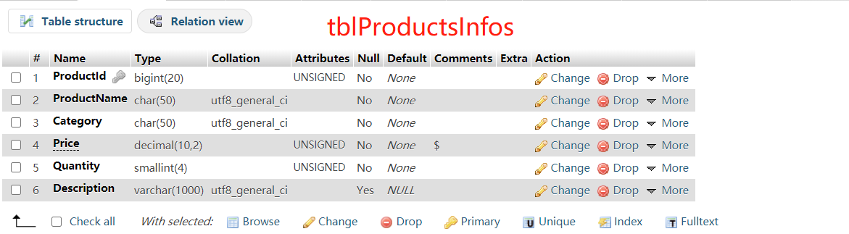

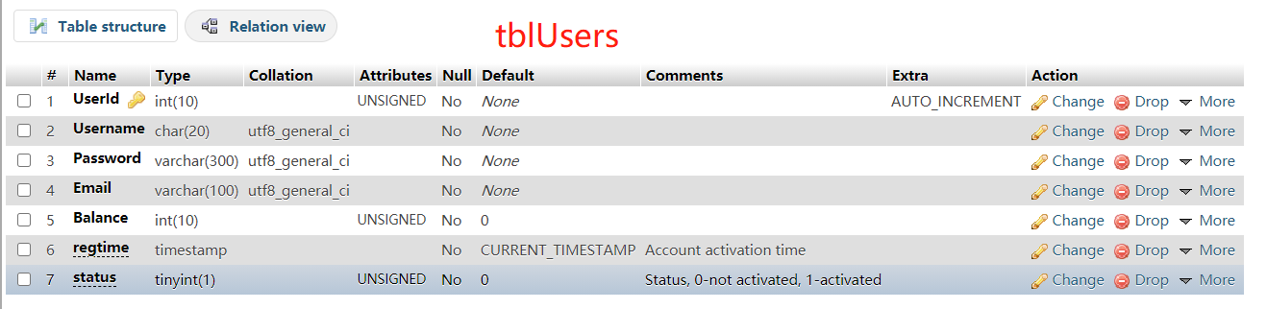

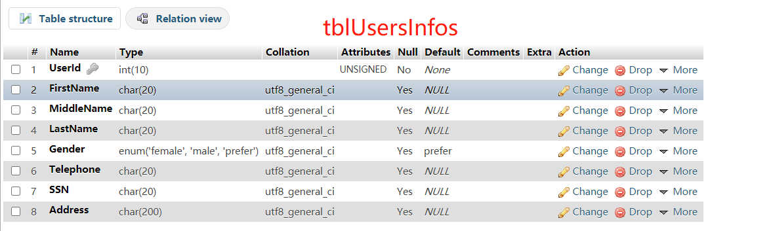

# ER- Diagram

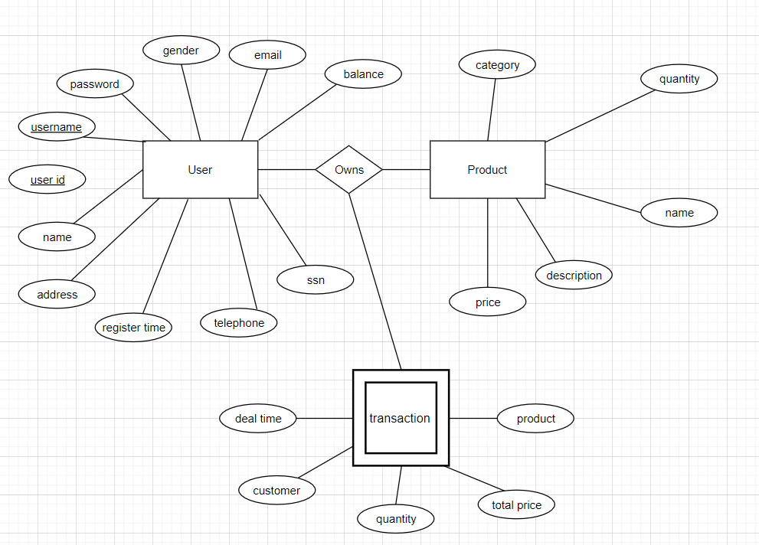

# Schema

# Specific requirements

1. *~~You fill out~~* ~~– This is where you would put the exact detail of what you want for the project. For example:~~
2. *Title for main page*: *https://xzhang.w3.uvm.edu/cs148/live-final/form.php.*
3. *Meta Description*: *An autonomous trading platform between users.*
4. *Meta Character set*: UTF - 8
5. *Logo*:



1. *Main page photo*: *.* 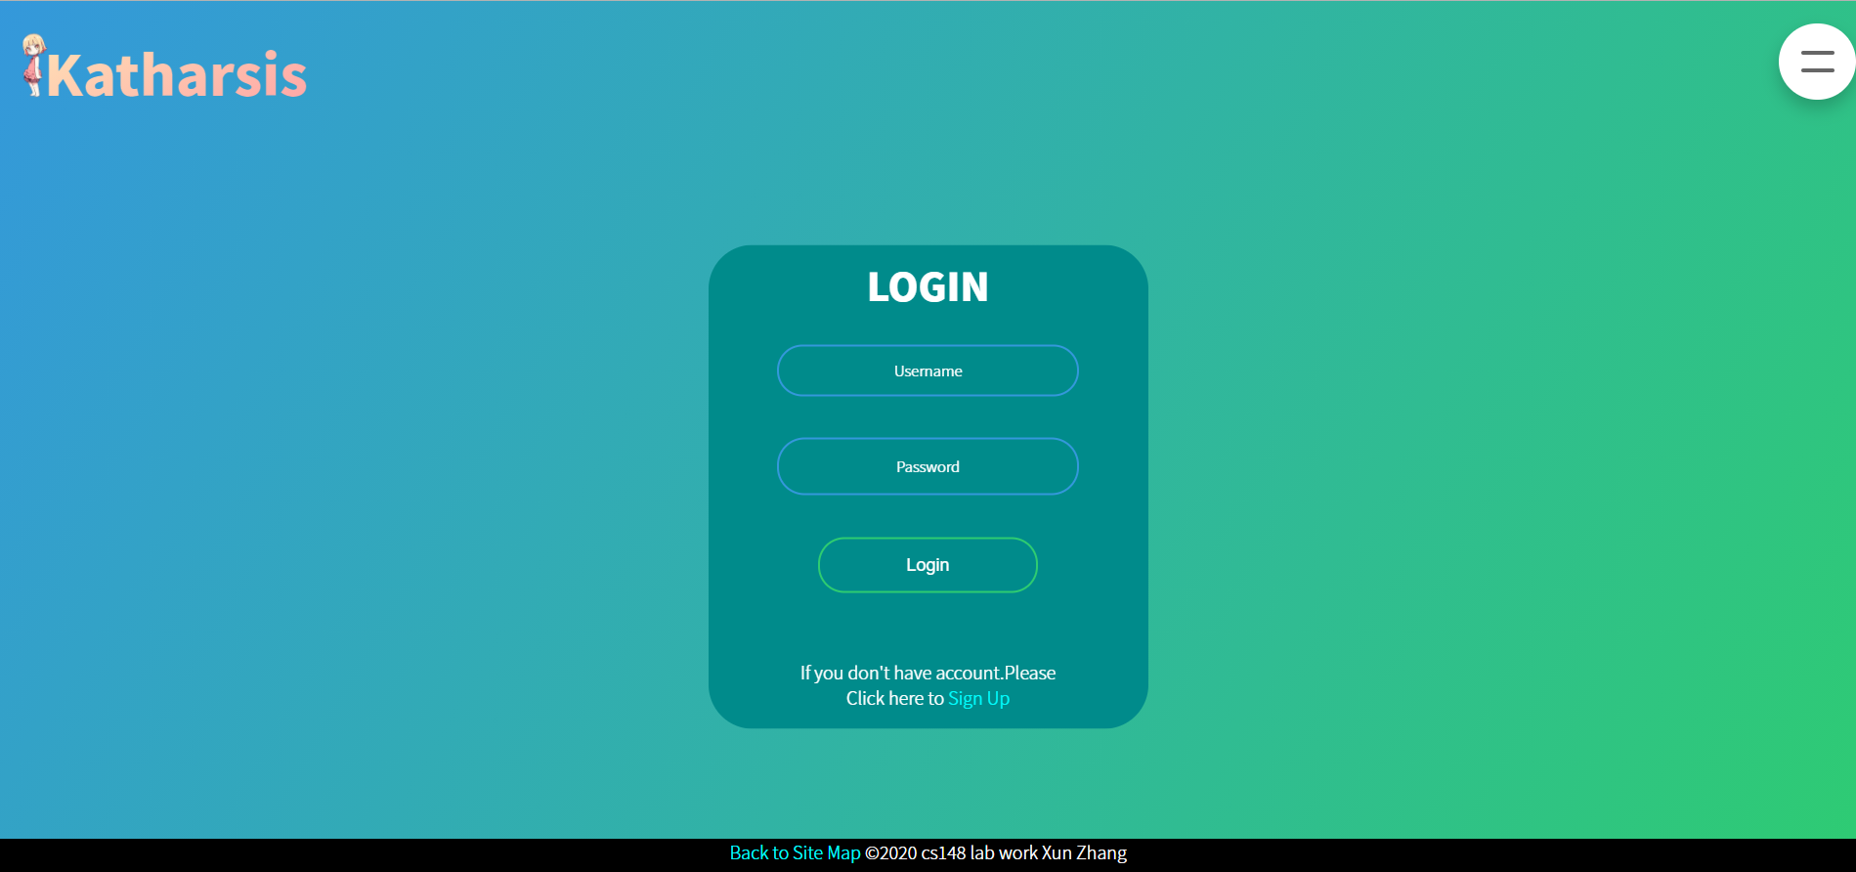

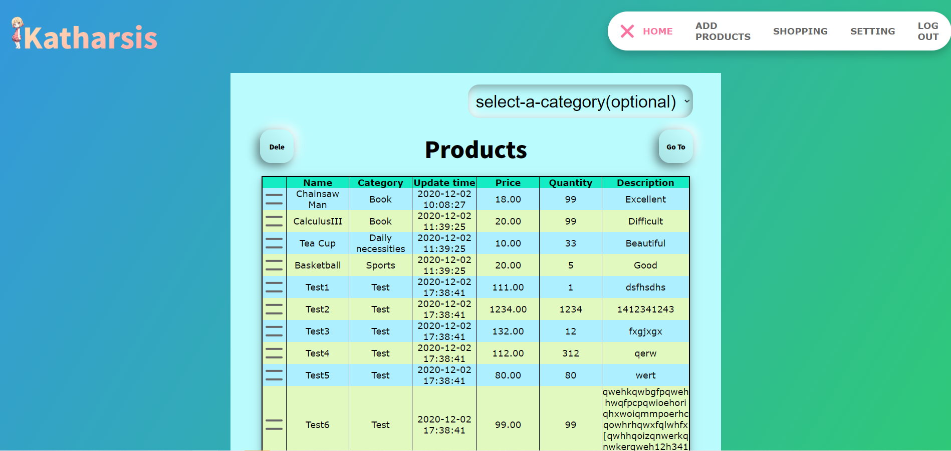

1. *Content can be found here*:

***In the login page, please input the username*: xzhang**

***The password*: Zx123123**

***And you can see the sample*.**

1. I hope you get the idea. The goal would be the developer would be able to make the entire site based on this document and the client would see you have included everything.