CloudStack

TBD: Give Kedar a roundup of all networking stuff, about advanced networking, so he can mark it up

Quick Installation Guide

For CloudStack v. 3.0

Revised November 18, 2011

Copyright © 2011 Citrix Systems, Inc. All rights reserved. Specifications are subject to change without notice. The Cloud.com logo, Cloud.com, and CloudStack are trademarks or registered trademarks of Citrix Systems, Inc. All other brands or products are trademarks or registered trademarks of their respective holders.

Contents

1 What Is CloudStack? 5

1.1 What Can CloudStack Do? 6

1.2 Deployment Architecture 7

1.2.1 Management Server Overview 8

1.2.2 Cloud Infrastructure Overview 9

1.2.3 Network 10

2 Overview of Basic Installation Steps 11

3 Minimum System Requirements 12

3.1 Machine 1: Management Server, Database, and Storage 12

3.2 ​Machine 2: Hypervisor 12

4 Management Server Single-Node Installation 13

4.1 About the Management Server 13

4.2 System Requirements for Management Server 13

4.3 Management Server Installation Overview 13

4.4 Operating System and OS Preparation 14

4.5 Install the Management Server (Basic Install) 14

4.6 Database Single-Node Installation 15

4.7 Management Server Installation Complete! Next Steps 16

5 Log In to the CloudStack UI 17

6 Provision Your Cloud Infrastructure 18

7 Add a Zone 19

7.1 About Zones 19

7.2 Adding a Zone 20

8 Add a Pod 22

8.1 About Pods 22

8.2 Adding a Pod 22

9 Add a Cluster 24

9.1 About Clusters 24

9.2 Add a Cluster 24

10 Add Hosts 26

10.1 About Hosts 26

10.2 Install XenServer on the Host 26

10.3 Add the Host to CloudStack 27

11 Add Primary and Secondary Storage 28

11.1 About Primary and Secondary Storage 28

11.2 Adding Primary Storage 29

11.3 Adding Secondary Storage 29

11.3.1 System Requirements for Secondary Storage 29

11.3.2 Steps to Add Secondary Storage 29

12 Initialization and Testing 31

13 Troubleshooting 33

13.1 Checking the Management Server Log 33

13.1.1 Checking the Log File 33

13.2 Can't Add Host 33

13.3 Console Proxy VM Issues 33

14 Contacting Support 34

# What Is CloudStack?

CloudStack™ is a software platform that pools computing resources to build public, private, and hybrid Infrastructure as a Service (IaaS) clouds. CloudStack manages the network, storage, and compute nodes that make up a cloud infrastructure. Use CloudStack to deploy, manage, and configure cloud computing environments.

**Who Should Read This**

If you are new to CloudStack or you want to learn more about concepts before installing and running CloudStack, read this overview.

If you just want to get started, you can skip to Overview of Installation Steps on page 35.

Extending beyond individual virtual machine images running on commodity hardware, CloudStack provides a turnkey cloud infrastructure software stack for delivering virtual datacenters as a service – delivering all of the essential components to build, deploy, and manage multi-tier and multi-tenant cloud applications. Both open-source and Premium versions are available, with the open-source version offering nearly identical features.

Typical users are service providers and enterprises. With CloudStack, you can:

* Set up an on-demand, elastic cloud computing service. Service providers can sell self‑service virtual machine instances, storage volumes, and networking configurations over the Internet.
* Set up an on-premise private cloud for use by employees. Rather than managing virtual machines in the same way as physical machines, with CloudStack an enterprise can offer self-service virtual machines to users without involving IT departments.

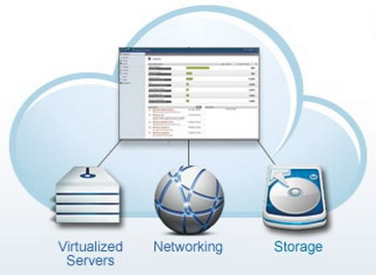

## What Can CloudStack Do?

**Multiple Hypervisor Support**

CloudStack works with a variety of hypervisors. A single cloud deployment can contain multiple hypervisor implementations. You have the complete freedom to choose the right hypervisor for your workload.

CloudStack is designed to work with open source Xen and KVM hypervisors as well as enterprise-grade hypervisors such as VMware vSphere, Oracle VM, and Citrix XenServer.

**Massively Scalable Infrastructure Management**

CloudStack can manage tens of thousands of servers installed in multiple geographically distributed datacenters. The centralized management server scales linearly, eliminating the need for intermediate cluster-level management servers. No single component failure can cause cluster- or cloud-wide outage. Periodic maintenance of the management server can be performed without affecting the functioning of virtual machines running in the cloud.

**Automatic Configuration Management**

CloudStack automatically configures each guest virtual machine’s networking, storage, and authentication settings. It can also integrate with physical components such as switches, routers, load balancers, and firewalls.

CloudStack internally manages a pool of virtual appliances to support the cloud itself. These appliances offer services such as firewalling, routing, DHCP, VPN access, console proxy, storage access, and storage replication. The extensive use of virtual appliances greatly simplifies the installation, configuration, and on-going management of a cloud deployment.

**Graphical User Interface**

CloudStack offers an administrator's Web interface, used for provisioning and managing the cloud, as well as an end-user's Web interface, used for running VMs and managing VM templates. The UI can be customized to reflect the desired service provider or enterprise look and feel.

**Standard API Support**

CloudStack provides an API the provides programmatic access to all the management features available in the UI. The API is maintained and documented.

**More Information**

This Quick Installation Guide covers only the functionality required for a basic trial setup. You can find out more about CloudStack's many features in our documentation:

* CloudStack Advanced Installation Guide
* CloudStack Administrator's Guide

## Deployment Architecture

A CloudStack installation consists of two parts: the Management Server and the cloud infrastructure that it manages. When you set up and manage a CloudStack cloud, you provision resources such as hosts, storage devices, and IP addresses into the Management Server, and the Management Server manages those resources.

The Management Server provides a Web interface for the cloud administrator to manage the cloud, and another Web interface for users to manage their virtual machines (VMs) running in the cloud.

The minimum installation consists of one Management Server and an infrastructure of one host. A more full-featured installation consists of a highly-available Management Server farm and up to thousands of hosts using any of several advanced networking setups.

### Management Server Overview

The Management Server:

* Provides the web user interfaces for the administrator and end users.
* Provides the APIs for the CloudStack platform.
* Manages the assignment of guest VMs to particular hosts.
* Manages the assignment of public and private IP addresses to particular accounts.
* Manages the allocation of storage to guests’ virtual disk images.
* Manages snapshots, templates, and ISO images, possibly replicating them across data centers.
* Provides a single point of configuration for the cloud.

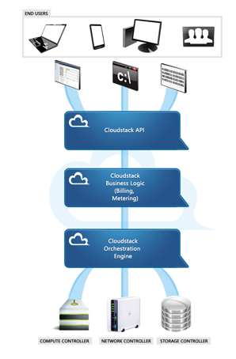

Management Server Components

For more, see Management Server Single-Node Installation on page 13.

### Cloud Infrastructure Overview

As its name implies, the Management Server is there to manage something -- one or more zones (typically, datacenters) containing host computers where guest virtual machines will run. The cloud infrastructure is organized as follows:

* **Zone**: Typically, a zone is equivalent to a single datacenter. A zone consists of one or more pods and primary storage. See About Zones on page 19 and About Primary and Secondary Storage on page 28.
* **Pod**: A pod is usually one rack of hardware. It includes a layer-2 switch and one or more clusters. See see About Pods on page 22.
* **Cluster**: A cluster consists of one or more hosts and secondary storage. See About Clusters on page 24 and About Primary and Secondary Storage on page 28.
* **Host**: A single compute node within a cluster. The hosts are where the actual cloud services run in the form of guest virtual machines. See About Hosts on page 26.

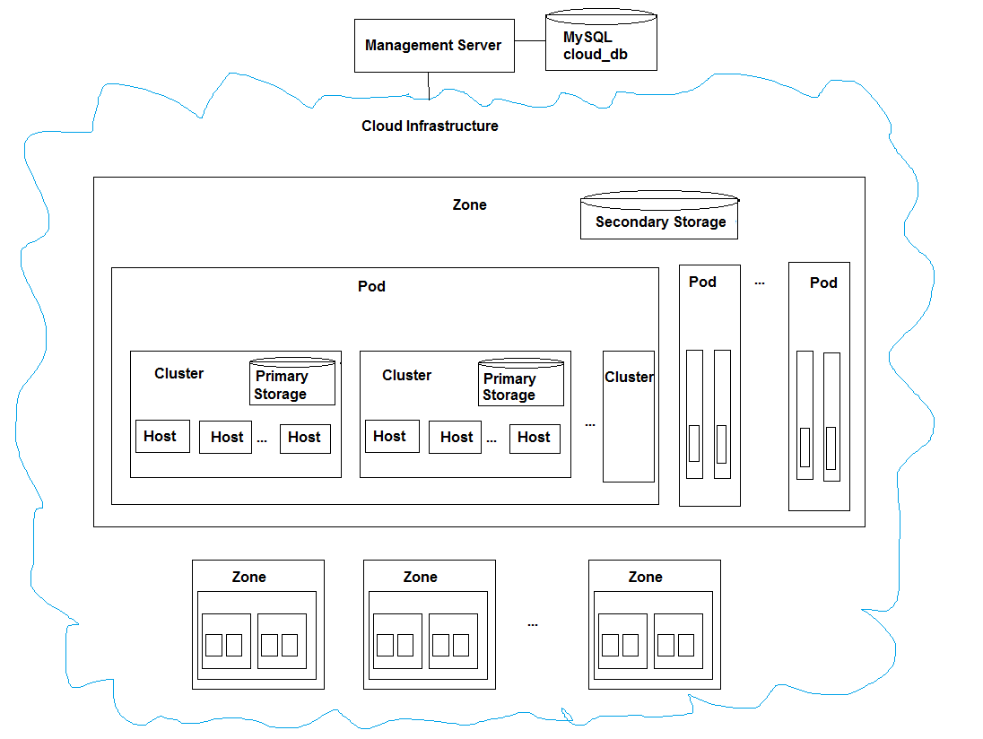

### Network

CloudStack offers two types of networking scenario: basic and advanced. In the Basic Installation, we use basic networking.

#### Basic Networking

Basic networking provides the following:

* A single, untagged VLAN.
* DHCP and DNS provided by the CloudStack virtual router.
* Security groups to control user access to cloud resources. Security groups are not used in the Basic Installation, but you can find out more about them in the Advanced Installation Guide.

When basic networking is used in a zone, all guests allocated in that zone share a single untagged VLAN. The network interface in the host that is connected to this untagged VLAN must be named cloud-guest. In XenServer, set the network name-label to “cloud-guest”.

### Advanced Networking

We won't go into much detail about advanced networking here, since we're doing a Basic Installation. When you are ready, you can find out more in the CloudStack Advanced Installation Guide.

Advanced networking provides the following:

* Multiple VLANs for isolation
* VPN
* Virtual router is gateway
* Load balancer available
* 1:1 NAT
* Metering data

# Overview of Basic Installation Steps

**Prepare**

1. Make sure you have the required hardware ready (p. 12)

**Install the CloudStack software**

1. Install the CloudStack Management Server (p. 13)
2. Start the CloudStack UI (p. 17)

**Provision your cloud infrastructure**

1. Add a zone and pod (p. 18, p. 21)
2. Add a cluster and host (p. 24, p. 26)
3. Set up primary and secondary storage (p. 28)

**Try using the cloud**

1. Initialization and testing (p. 31)



# Minimum System Requirements

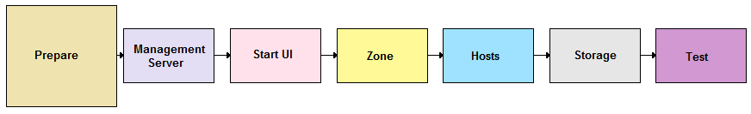

Before you can start even the simplest CloudStack trial installation, you'll need two computers that match the following requirements.

## Machine 1: Management Server, Database, and Storage

This machine will run the Management Server and MySQL database node, as well as acting as primary and secondary storage. Primary storage is used for storing the guest VM root disks as well as additional data disk volumes. Secondary storage is used for templates and snapshots. In a Basic Installation, we will use localdisk on the same node with the Management Server for both types of storage.

* Operating system: RHEL/CentOS 5.4+ 64-bit or RHEL6 64-bit
* 64-bit x86 CPU (more cores results in better performance)
* 4 GB of memory
* 250 GB of local disk (more results in better capability; 500 GB recommended)
* At least 1 NIC
* Statically allocated IP address
* Fully qualified domain name as returned by the hostname command

## ​Machine 2: Hypervisor

For a small-scale setup, you only need one additional machine that meets the following requirements:

* The host must be certified as compatible with XenServer. See the Citrix Hardware Compatibility Guide: <http://hcl.xensource.com/>
* Must be 64-bit and must support HVM (Intel-VT or AMD-V enabled).
* You must re-install Citrix XenServer if you are going to re-use a host from a previous install.
* 64-bit x86 CPU (more cores results in better performance)
* Hardware virtualization support required
* 4 GB of memory
* 30 GB of local disk
* At least 1 NIC
* Statically allocated IP Address

# Management Server Single-Node Installation

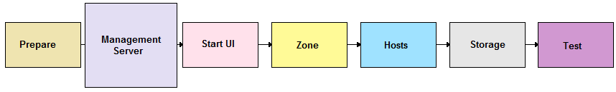

When you have the correct hardware ready, the first step of a CloudStack Basic Installation is to install the CloudStack Management Server. This section describes installing a single Management Server and installing MySQL on the same machine.

## About the Management Server

The Management Server is the CloudStack software that manages cloud resources. By interacting with the Management Server through its UI or API, you can configure and manage your cloud infrastructure.

The Management Server is a dedicated server or VM. It controls allocation of virtual machines to hosts and assigns storage and IP addresses to the virtual machine instances. The CloudStack Management Server runs in a Tomcat container and requires a MySQL database for persistence.

For a Basic Installation, you will install a single instance of the CloudStack Management server. If you decide to scale up later, you can install multiple Management Servers in a cluster with a load balancer.

## System Requirements for Management Server

* Operating system: RHEL/CentOS 5.4+ 64-bit or RHEL6 64-bit
* 64-bit x86 CPU (more cores results in better performance)
* 2 GB of memory
* 80 GB of local disk
* At least 1 NIC
* Statically allocated IP address
* Fully qualified domain name as returned by the hostname command

## Management Server Installation Overview

The Management Server download includes everything you need to get started, except MySQL. This includes the Management Server software as well as dependencies.

The procedure for the installation is:

1. Prepare the operating system.
2. Install the Management Server.
3. Install MySQL.

## Operating System and OS Preparation

The Management Server requires RHEL/CentOS 5.4 64 bit or later. You can download CentOS 64-bit via the following link: <http://isoredirect.centos.org/centos/5/isos/x86_64/>. The OS must be prepared to host the Management Server using the following steps.

NTP is recommended.

1. Log in to your OS as root. All the following commands should be run as root.
2. Check for a fully qualified hostname.

# hostname --fqdn

This should return a fully qualified hostname such as "kvm1.lab.example.org". If it does not, edit /etc/hosts so that it does.

1. Disable SELinux.

Set SELinux up to be permissive by default.

* 1. First, set the SELINUX variable in /etc/selinux/config to “permissive”. This ensures that the CloudStack Agent can run properly on system reboot.
  2. Then set SELinux to permissive until the system is rebooted:

# setenforce permissive

1. Make sure that the Management Server can reach the Internet.

# ping www.citrix.com

1. (RHEL 6.x) If you do not have a Red Hat Network account, you need to prepare a local Yum repository.
   1. If you are working with a physical host, insert the RHEL 6.0 installation CD. If you are using a VM, attach the RHEL6 ISO.
   2. Mount the CDROM to /media.
   3. Create a repo file at /etc/yum.repos.d/rhel6.repo. In the file, insert the following lines:

[rhel]

name=rhel6

baseurl=file:///media

enabled=1

gpgcheck=0

## Install the Management Server (Basic Install)

1. Install the CloudStack packages. You should have a file in the form of “CloudStack-NNNN.tar.gz”. Untar the file and then run the install.sh script inside it:

# tar xzf CloudStack-2.2.12-1-centos.tar.gz

# cd CloudStack-2.2.12-1-centos

# ./install.sh

Setting up the temporary repository...

Cleaning Yum cache...

Loaded plugins: fastestmirror

11 metadata files removed

Welcome to the CloudStack Installer. What would you like to do?

M) Install the Management Server

A) Install the Agent

B) Install BareMetal Agent

S) Install the Usage Monitor

D) Install the database server

Q) Quit

> M

1. Choose “M” to install the Management Server software.

## Database Single-Node Installation

1. On the same computer, re-run install.sh and choose “D” to install MySQL.

# ./install.sh

Setting up the temporary repository...

Cleaning Yum cache...

Loaded plugins: fastestmirror

11 metadata files removed

Welcome to the CloudStack Installer. What would you like to do?

A) Install the Agent

B) Install BareMetal Agent

S) Install the Usage Monitor

D) Install the database server

U) Upgrade the CloudStack packages installed on this computer

R) Stop any running CloudStack services and remove the CloudStack packages from this computer

Q) Quit

> D

1. Edit the MySQL configuration (/etc/my.cnf or /etc/mysql/my.cnf, depending on your OS) and insert the following lines in the [mysqld] section. You can put these lines below the datadir line. The max_connections parameter should be set to 350 multiplied by the number of Management Servers you are deploying. This example assumes 1 Management Server, since we are doing a Basic Installation.

innodb_rollback_on_timeout=1

innodb_lock_wait_timeout=600

max_connections=350

log-bin=mysql-bin

binlog-format = 'ROW'

**NOTE:** The binlog-format variable is supported in MySQL versions 5.1 and greater. It is not supported in MySQL 5.0. In some versions of MySQL, an underscore character is used in place of the hyphen in the variable name. For the exact syntax and spelling of each variable, consult the documentation for your version of MySQL.

1. Best Practice: On RHEL and CentOS, MySQL does not set a root password by default. It is very strongly recommended that you set a root password as a security precaution. Run the following commands, and substitute your own desired root password for <password>.

# service mysqld start

# mysql –u root

mysql> SET PASSWORD = PASSWORD('<password>');

1. Set up the database. The following command creates the cloud user on the database.

* In dbpassword, specify the password to be assigned to the cloud user. You can choose to provide no password.
* In deploy-as, specify the username and password of the user deploying the database. In the following command, it is assumed the root user is deploying the database and creating the cloud user.

# cloud-setup-databases cloud:<dbpassword>@localhost --deploy-as=root:<password>

1. Configure the OS for the Management Server using the following command. This command will set up iptables, sudoers, and start the Management Server.

# cloud-setup-management

## Management Server Installation Complete! Next Steps

Congratulations! You have now installed CloudStack Management Server. What should you do next?

* Even without adding any cloud infrastructure, you can run the UI to get a feel for what's offered and how you will interact with CloudStack on an ongoing basis. See Log In to the CloudStack UI on page 17.
* When you're ready, use the UI to add cloud infrastructure and try running some virtual machines on it. See Provision Your Cloud Infrastructure on page 18.

# Log In to the CloudStack UI

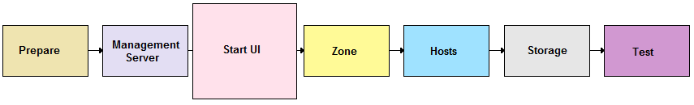

After the Management Server software is installed and running, you can run the CloudStack user interface. This UI is there to help you provision, view, and manage your cloud infrastructure.

1. Open your favorite Web browser and go to this URL:

http://management-server-ip-address:8080/client

1. Log in with the default administrator username "admin" and password "password." Leave Domain blank; this defaults to the ROOT domain.

The Installation Wizard appears.

1. When prompted, choose a new password.
2. Choose Basic Setup. You're just trying CloudStack out, and you want a guided walkthrough of the simplest possible configuration so that you can get started using CloudStack right away. We'll help you set up a cloud with the following features: basic networking; a single CloudStack management node; and a single host running VMs under the XenServer hypervisor.

The Installation Wizard will remain on screen. Its prompts should give you all the information you need, but if you want just a bit more detail, you can follow along in this Guide. Continue to Provision Your Cloud Infrastructure on page 18.

# Provision Your Cloud Infrastructure

After the Management Server is installed and running, you need to add the compute resources for it to manage. This section tells how to use the CloudStack UI to describe your infrastructure to CloudStack.

**Background Concepts**

See About the Cloud Infrastructure on page 16.

(Advanced Guide only) When provisioning a cloud infrastructure, you must decide the following:

* How many hosts to place in a cluster
* How many primary storage servers to place in a cluster and total capacity for the storage servers
* How many clusters to have per pod
* How many pods to have per zone
* How much secondary storage to deploy in a zone

Log in to the CloudStack UI (see p. 17), then follow these procedures to provision your cloud infrastructure:

1. Add a Zone on page 19
2. Add a Pod on page 22
3. Add a Cluster on page 24
4. Add Hosts on page 26
5. Add Primary and Secondary Storage on page 28
6. Initialization and Testing on page 31

# Add a Zone

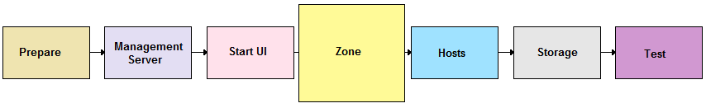

## About Zones

A zone is the largest organizational unit within a CloudStack deployment. A zone typically corresponds to a single datacenter, although it is permissible to have multiple zones in a datacenter. The benefit of organizing infrastructure into zones is to provide physical isolation and redundancy. For example, each zone can have its own power supply and network uplink, and the zones can be widely separated geographically (though this is not required).

A zone consists of:

* One or more pods, which contain clusters of hosts (see p. 22)
* Secondary storage, which is shared by all the pods in the zone
* One or more layer-3 switches

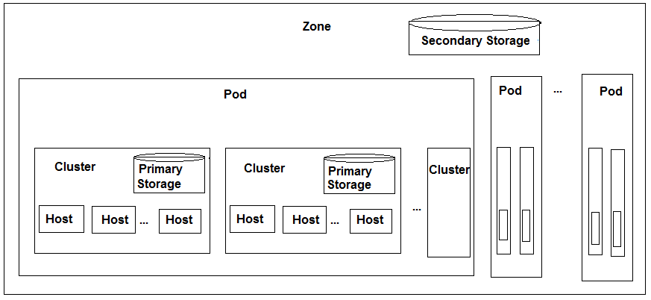

(Advanced Guide only) Zones are visible to the end user. For example, when a user starts a virtual machine, one of the steps is to select the zone where the VM will run. And if a user creates a private VM template, the user must copy the template to any additional zones where the user wants the template to be available.

Zones can be public or private. Public zones are visible to all users. This means that any user can create a guest in that zone. Private zones are reserved for a specific domain. Only users in that domain or its subdomains can create guests in that zone.

Hosts in the same zone can access each other directly, without going through a firewall. Hosts in different zones can access each other through statically configured VPN tunnels.

## Adding a Zone

These steps assume you have already logged in to the CloudStack UI and chosen Basic Installation (see p. 17).

Note: per Kedar: the order of screens should be the same as in old Admin guide. This wizard is not 100% yet. TBD

1. The Zone page of the Installation Wizard appears.

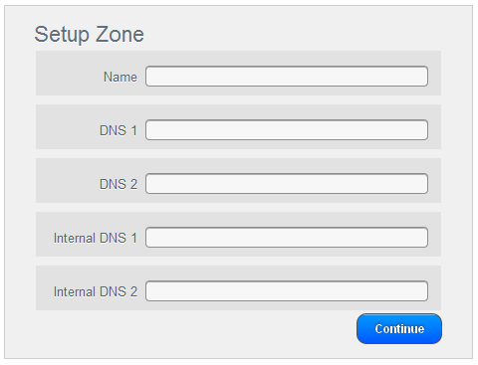

CloudStack distinguishes between internal and public DNS. Internal DNS is assumed to be capable of resolving internal-only hostnames, such as your NFS server’s DNS name. Public DNS is provided to the guest VMs for DNS resolution. You can enter the same DNS server for both types, but if you do so, you must make sure that both private and public IP addresses can route to the DNS server. Note that you must provide at least one public DNS server and at least one Internal DNS server.

1. Enter the following details.

* **Name**. A name for the zone.
* **DNS 1 and DNS2**. These are DNS servers for use by guest VMs in the zone. These DNS servers will be accessed via the public network you will add later. The public IP addresses for the zone must have a route to the DNS server named here.
* **Internal DNS 1 and DNS2**. These are DNS servers for use by system VMs in the zone. These DNS servers will be accessed via the private network interface of the System VMs. The private IP address you provide for the pods must have a route to the DNS server named here.

1. Click Continue. The Set Up IP Range screen appears. This should actually appear last! TBD

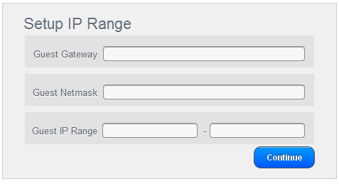

1. Enter the following details.

* **Guest Gateway**. The gateway that the guests should use.
* **Guest Netmask**. The netmask in use on the subnet the guests will use.
* **Guest IP Range**. The range of IP addresses that will be available for allocation to guests in this zone. If one NIC is used, these IPs should be in the same CIDR as the pod CIDR.

1. Click Continue.

Your zone is now added.

# Add a Pod

## About Pods

A pod often represents a single rack. Hosts in the same pod are in the same subnet.

A pod is the second-largest organizational unit within a CloudStack deployment. Pods are contained within zones. Each zone can contain one or more pods; in the Basic Installation, you will have just one pod in your zone.

A pod consists of:

* One or more clusters (see p. 24)
* One or more layer-2 switches

A pod can contain several clusters. In the Basic Installation, you will have just one cluster in your pod.

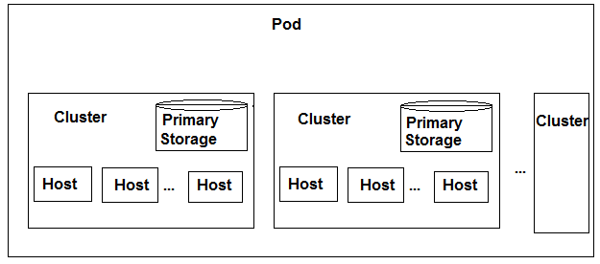

## Adding a Pod

These steps assume you have already logged in to the CloudStack UI, chosen Basic Installation, and added a zone.

1. Click Continue. The Add Pod screen appears.

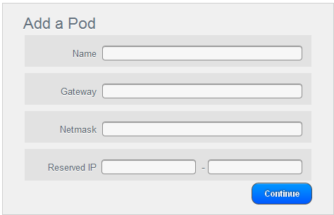

1. Enter the following details.

* **Name**. A name for the pod.
* **Gateway**. The gateway for the hosts in that pod.
* **Guest Netmask**. The netmask in use on the subnet the guests will use.
* **Reserved IP**: This is the IP range in the private network that the CloudStack uses to manage Secondary Storage VMs and Console Proxy VMs. These IP addresses are taken from the same subnet as computing servers. You therefore need to make sure computing servers and Management Servers use IP addresses outside of this range. These two values combine to give the system control over a certain IP address range, and leave you in control of allocation for IP addresses in the CIDR but outside of the start and end range. In the screenshot we have start=192.168.154.2 and end=192.168.154.7. These computing servers and Management Servers can use IP addresses .8 to .254 and the CloudStack can use .2 to .7 for System VMs.
* Click Continue.

Your pod is now added.

# Add a Cluster

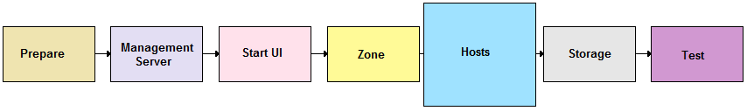

You need to tell CloudStack about the hosts that it will manage. Hosts exist inside clusters, so before you begin adding hosts to the cloud, you must add at least one cluster.

## About Clusters

A cluster provides a way to group hosts. The hosts in a cluster all have identical hardware, run the same hypervisor, are on the same subnet, and access the same shared storage. Virtual machine instances (VMs) can be live-migrated from one host to another within the same cluster, without interrupting service to the user.

A cluster is the third-largest organizational unit within a CloudStack deployment. Clusters are contained within pods, and pods are contained within zones.

CloudStack allows multiple clusters in a cloud deployment, but for a Basic Installation, we only need one cluster.

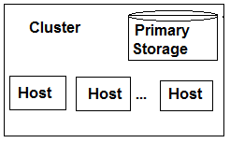

(Advanced Guide only) If local storage is used, there can be only one host in the cluster. Otherwise, the maximum number of hosts allowed in a cluster depends on the hypervisor. See the Best Practices section in the Advanced Installation Guide.

VMware clusters are a bit different. They are managed by a vCenter server. You must register the vCenter server with CloudStack. There may be multiple vCenter servers per zone. Each vCenter server may manage multiple VMware clusters.

## Add a Cluster

These steps assume you have already logged in to the CloudStack UI, chosen Basic Installation, and added a zone and pod.

1. Click Continue. The Add Cluster screen appears.

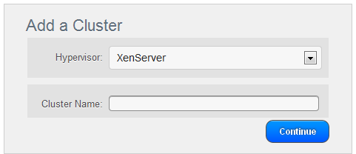

1. In Hypervisor, be sure XenServer is selected.
2. Enter a name for the cluster. This can be text of your choosing and is not used by CloudStack.
3. Click Continue.

Your cluster is now added.

# Add Hosts



After adding a cluster to your CloudStack configuration, you can start adding hosts. Each cluster can contain one host or hundreds of hosts (see Best Practices in the Advanced Installation Guide for some hints on practical limits). In a Basic Installation, you need only one host.

## About Hosts

A host is a single computer. Hosts provide the computing resources that run the guest virtual machines. Each host has hypervisor software installed on it to manage the guest VMs (except for bare metal hosts, which are a special case discussed in the Advanced Installation Guide). For example, a Linux KVM-enabled server, a Citrix XenServer server, and an ESXi server are hosts. In a Basic Installation, we use a single host running XenServer.

The host is the smallest organizational unit within a CloudStack deployment. Hosts are contained within clusters, clusters are contained within pods, and pods are contained within zones.

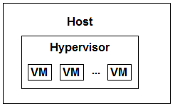

Hosts in a CloudStack deployment:

* Provide the CPU, memory, storage, and networking resources needed to host the virtual machines
* Interconnect using a high bandwidth TCP/IP network and connect to the Internet
* May reside in multiple data centers across different geographic locations
* May have different capacities (different CPU speeds, different amounts of RAM, etc.), although the hosts within a cluster must all be homogeneous

## Install XenServer on the Host

1. Download XenServer from the Citrix Website (<http://www.citrix.com/lang/English/lp/lp_1688615.asp>) and install it on your second machine. Follow the Citrix XenServer Installation Guide.
2. Set the XenServer network name-label to “cloud-guest”. In a Basic Installation, all guest VMs share a single untagged VLAN. The network interface in the host that is connected to this untagged VLAN must be named cloud-guest.

## Add the Host to CloudStack

These steps assume you have already installed XenServer on your host, logged in to the CloudStack UI, chosen Basic Installation, and added a zone, pod, and cluster.

1. Click Continue. The Add Host screen appears.

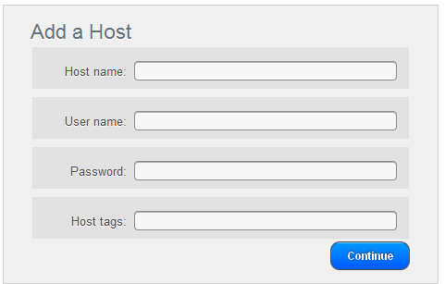

1. Provide the following details.

* **Host Name**. The DNS name or IP address of the host.
* **Username**. Usually root.
* **Password**. This is the password for the user named above (from your XenServer install).
* **Host Tags (Optional)**. Any labels that you use to categorize hosts for ease of maintenance.

1. Click Continue.

Your host is now added.

# Add Primary and Secondary Storage

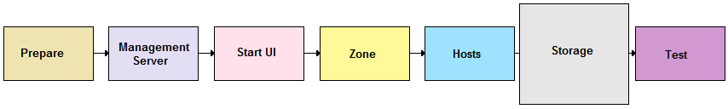

You need to tell CloudStack about the primary and secondary storage devices that are available. In a Basic Installation, we use local disk for both.

## About Primary and Secondary Storage

A CloudStack cloud infrastructure makes use of two types of storage: primary storage and secondary storage. Both of these can be iSCSI or NFS servers, or localdisk.

**Primary storage** is associated with a cluster, and it stores the disk volumes of each guest VM for all the VMs running on hosts in that cluster. The primary storage server is typically located close to the hosts.

(Advanced Guide only) So primary storage stores disk volumes…but what is a volume? In CloudStack, a volume is a unit of storage available to a guest VM. Volumes are either root disks or data disks. The root disk has “/” in the file system and is usually the boot device. Data disks provide for additional storage (e.g. As “/opt” or “D:”). Every guest VM has a root disk and a data disk. End users can mount multiple data disks to guest VMs. Users choose data disks from the disk offerings created by administrators. The user can create a template from a volume as well; this is the standard procedure for private template creation. Volumes are hypervisor-specific: a volume from one hypervisor type may not be used on a guest of another hypervisor type.

**Secondary storage** is associated with a zone, and it stores the following:

* Templates – OS images that can be used to boot VMs and can include additional configuration information, such as installed applications
* ISO images – OS images that can be bootable or non-bootable
* Disk volume snapshots – saved copies of VM data which can be used for data recovery or to create new templates

The items in secondary storage are available to all hosts in the zone. There is usually one instance of secondary storage for hundreds of hosts.

(Advanced Guide only) CloudStack is designed to work with all standards-compliant iSCSI and NFS servers. As long as the hypervisor in your cluster supports a given server, CloudStack can work with it. For example:

* Dell EqualLogic™ for iSCSI
* Network Appliances filers for NFS and iSCSI
* Scale Computing for NFS

## Adding Primary Storage

These steps assume you have already logged in to the CloudStack UI, chosen Basic Installation, and added a zone, pod, cluster, and host.

1. Click Continue. The Add Primary Storage screen appears.

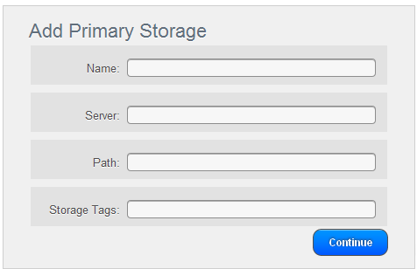

1. Provide the following details.

* **Name**. The name of the storage device.
* **Server (for NFS, iSCSI, or PreSetup)**. The IP address or DNS name of the storage device.
* **Path (for NFS)**. In NFS this is the exported path from the server. **Path (for SharedMountPoint). With KVM this is the path on each host that is where this primary storage is mounted. For example, "/mnt/primary".**
* **Tags (optional)**. A comma-separated list of any desired tags that you use to categorize storage devices.

1. Click Continue.
2. **Set system.vm.local.storage.required to true.**

The primary storage is now added.

## Adding Secondary Storage

You will need to add secondary storage. Secondary storage is used to store templates, ISOs, and snapshots.

### (Advanced Guide Only) System Requirements for Secondary Storage

* NFS storage appliance or Linux NFS server
* 100GB minimum capacity

### Steps to Add Secondary Storage

These steps assume you have already logged in to the CloudStack UI, chosen Basic Installation, and added a zone, pod, cluster, host, and primary storage.

1. Secondary storage must be seeded with a template that is used for CloudStack system VMs. This must be done for each Secondary storage server. First, mount the secondary storage on your Management Server. This example assumes the path on the secondary storage server is /nfs/share.

# mount -t nfs servername:/nfs/share /mnt/secondary

1. On the Management Server, run the following command to retrieve and decompress the system VM template.

This process will require approximately 10 GB of free space on the local file system and up to 30 minutes each time it runs.

# /usr/lib64/cloud/agent/scripts/storage/secondary/cloud-install-sys-tmplt -m /mnt/secondary -u http://download.cloud.com/releases/2.2.0/systemvm.vhd.bz2 -h xenserver -F

1. When the script has finished, unmount secondary storage.

# umount /mnt/secondary

1. In the Basic Installation Wizard, click Continue. The Add Secondary Storage screen appears.

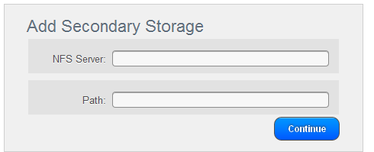

1. Provide the following details for the secondary storage server:

* **Server**. The IP address of the server. Is this the IP address of their own Management Server machine?
* **Path**. The exported path from the server. Is this localdisk?

1. Click Continue.

The Basic Installation's cloud infrastructure is now provisioned.

# Initialization and Testing

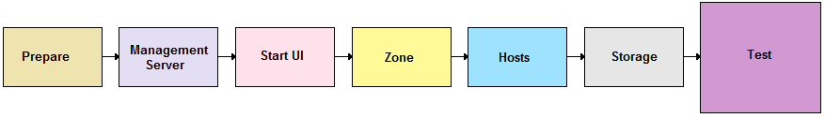

These steps assume you have already installed the Management Server, logged in to the CloudStack UI, chosen Basic Installation, and added a zone, pod, cluster, host, primary storage, and secondary storage.

1. In the Basic Installation Wizard's final screen, click Launch.

CloudStack will perform its initialization. This can take several minutes or more, depending on the speed of your network. During this initialization process, several things happen:

* CloudStack starts the Secondary Storage VM and Console Proxy VM from the system VM template downloaded into the zone. To view the status of this step, In the System Section, Virtual Resources, System VMs section you will see the status of these VMs listed first as Creating, then as Starting, then as Running. You can click on Refresh in the upper right to update the status.
* After the Secondary Storage VM is running, the Management Server will initiate download of a CentOS template. To check download status, log in to the UI as root and go to Templates - My Templates. The status will show “Storage agent or storage VM disconnected” until the Secondary Storage VM is running. Then the status will change to show that the download is in progress. You can click Refresh to update the download percentages.
* Once the CentOS template is downloaded, it will be uncompressed by the Secondary Storage VM. This is a large file and this operation will take several minutes. The Management Server will then update the template’s status to Ready.

Confirm that these steps have completed successfully. The administrator's Dashboard should be displayed in the CloudStack UI.

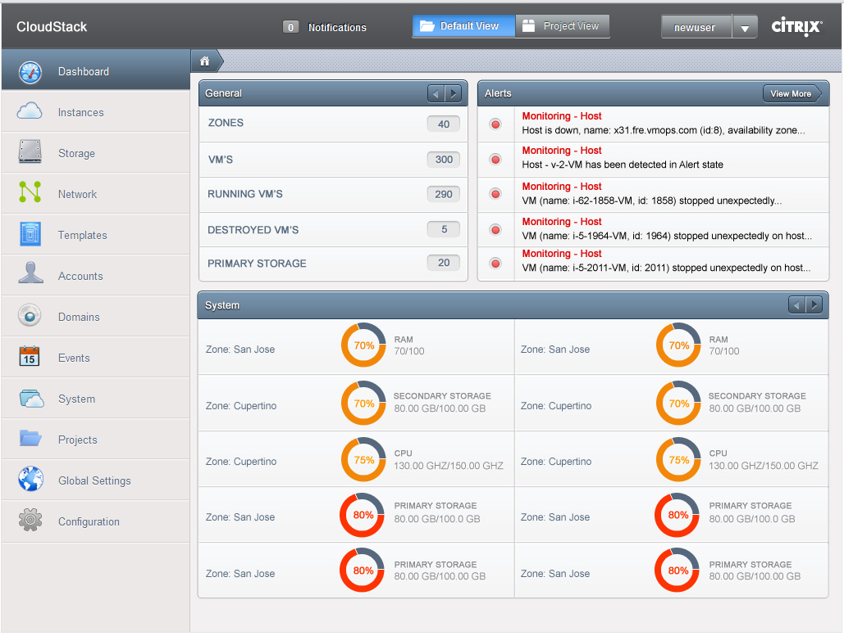

Now use the following steps to try creating a virtual machine:

1. Create a new user account. Click Accounts - My Accounts, then click Add Account. Follow the prompts to create a new user.
2. Log out, then log in again as the new user.
3. Go to the Instances tab. Click My Instances.
4. Click Add Instance and follow the steps in the wizard.
   1. In the template selection screen, you likely have only the provided CentOS template available.
   2. Select a service offering. Be sure that the hardware you have allows starting the selected service offering.
   3. If desired, add another data disk. This is a second volume that will be available to but not mounted in the guest. For example, in Linux on XenServer you will see /dev/xvdb in the guest.
   4. Choose the primary network for the guest. In the Basic Installation, you should have only one option here.
   5. Optionally give your VM a name and a group. Use any descriptive text you would like.
   6. Click Submit. Your VM will be created and started.

Congratulations! You have successfully completed a Basic CloudStack Installation.

# Troubleshooting

## Checking the Management Server Log

A quick step to look for errors in the management server log is this:

# grep -i -E 'exc|unable|fail|invalid|leak|invalid|warn' /var/log/cloud/management/management-server.log

### Checking the Log File

You can also check the log file /var/log/cloud/cloud.log for any error messages.

## Can't Add Host

A host must have a statically allocated IP address. Host addition will error and fail if a dynamically-assigned address is present.

## Contacting ****Support****

Cloud.com support is available to help you plan and execute your installation. The support team is available at support@cloud.com or via the support portal at <http://cloud.com/community/support>.