

Open Source Strategies: OpenTAPS Funambol Module

Developer's Guide

0.1 08/08/07 | Cameron Smith | Initial Draft
0.2 16/08/07 | Cameron Smith | Flow diagrams
0.3 20/08/07 | Cameron Smith | Class diagram
0.4 02/09/07 | Cameron Smith | Initialization; 3rd-party libraries
0.5 12/09/07 | Cameron Smith | Deployment
1.0 19/09/07 | Cameron Smith | First complete version
1.1 03/11/07 | Cameron Smith | Document address purpose type mappings

This document is for developers at OSSI who wish to alter the code of, or debug, the OpenTAPS Funambol Module (OTFM) inside a new or existing OpenTAPS server installation.

Writing Conventions
Please note that, throughout this document, unless otherwise stated, all text strings, commands and other configuration values are case-sensitive and should be used exactly as written in the text.

Abbreviations 3
Abbreviations 3
Abbreviations 3
Abbreviations 3
Abbreviations 3
Introduction 4
Introduction 4
Introduction 4
Introduction 4
Introduction 4
Prerequisites 4
Prerequisites 4
Prerequisites 4
Prerequisites 4
Prerequisites 4
Design Objectives/Principles 4
Design Objectives/Principles 4
Design Objectives/Principles 4
Design Objectives/Principles 4
Design Objectives/Principles 4
Design Constraints 4
Design Constraints 4
Design Constraints 4
Design Constraints 4
Design Constraints 4
Runtime View 5
Runtime View 5
Runtime View 5
Runtime View 5
Runtime View 5
Module startup 7
Module startup 7
Module startup 7
Module startup 7
Module startup 7
Use of external libraries 8
Use of external libraries 8
Use of external libraries 8
Use of external libraries 8
Use of external libraries 8
Funambol PIM (funambol-common-pim-6.0.3.jar) 8
SIGA Framework (siga-fwk-bsd.jar) 8
Spring (spring-2.0.6.jar) 8
Source View 9
Source View 9
Source View 9
Source View 9
Source View 9
Class Structure 10
Class Structure 10
Class Structure 10
Class Structure 10
Class Structure 10
Concepts 12
Concepts 12
Concepts 12
Concepts 12
Concepts 12
First-time-Install 12
First-time-Install 12
First-time-Install 12
First-time-Install 12
First-time-Install 12
Build/Upgrade 14
Build/Upgrade 14
Build/Upgrade 14
Build/Upgrade 14
Build/Upgrade 14
References 14
References 14
References 14
References 14
References 14

Abbreviations
DSS – Funambol Data Synchronization Server
FOP – Funambol Outlook Plugin
JEE – Java Enterprise Edition (the artist formerly known as J2EE)

Introduction
This document describes OTFM from three different perspectives. You should read all of them, however they are broken up ease of explanation (which is, given the nature of a written document, sequential!) and reference:
- Runtime View: how the various actors (people and systems) in a sync map to running processes at the operating-system level, and how the data flows between them when a sync is performed
- Source View: how the code which implements the above runtime setup is structured, and where it is located in the SCM repository.
- Deployment view: key points to understand about how the “source” becomes a running process at system startup time.

Before we get on to the detail, please consider the following general issues:

Prerequisites
This section describes the requirements that any reader should fulfill before attempting to make use of this manual.
- A good general ability in the following technical/programming areas:
- Java Standard Edition, version 1.5 or above, including all the new language features introduced in Java 5, as well as JDBC and JNDI
- Java Enterprise Edition, specifically the structure of a “web application” and [Servlet Spec. 2.4], chapters SRV.9 & SRV.10
- RDBMS manipulation via DDL and DML, specifically the PostgreSQL variant
- how to write well-formed XML
- Linux basics including filesystem structure, permissions system, and process manipulation
- TCP/IP basics including IP addressing, port identification, and a basic understanding of routing and domain name resolution
- Basic knowledge of the Spring 2.x IOC container and specifically how to configure it in a JEE webapp (see [Spring Ref. Guide] Chap. 3, esp. 3.8.1)
- A basic understanding of the core concepts and working of the SyncML protocol (now officially called the OMA DS protocol) [OMA DS 1.2 Spec].
- A good understanding of the OFBiz Entity and Service engines, and specifically the data model from the Party and CRMSFA components
- Have successfully setup OTFM and got it working according to [OTFM Admin Guide].

Design Objectives/Principles
OTFM was designed with the following objectives in mind:
- Minimize the differences between the DSS as incorporated in OTFM, and a “standard” DSS installed in a standalone Tomcat server.
- Maximize use of third-party libraries and minimize code which “reinvents the wheel”.
- Avoid including any libraries or code incompatible with OT's dual-licensing scheme.
- Include a sensible “OOTB” configuration for OTFM which conforms to the most typical usage scenario for OTFM, to avoid the complicated setup steps which a standalone DSS install normally requires.

Design Constraints
The design had to deal with certain “given” constraints, stemming from fundamental features of OT and Funambol:
- The DSS is hardcoded to assume non-transactional JDBC connections – that is, it only works with AUTOCOMMIT=true
- The DSS can only get from JNDI the JDBC DataSource from which it obtains connections to its sync. management schema.
- OT relies on the OFBiz framework JNDI provider, which is in fact simply the extremely limited Sun RMI reference implementation, and does not allow normal java POJOs to be conveniently stored there

Runtime View
The fundamental process to understand at runtime is how a sync request, initiated by a client device, is received and managed by the DSS, which delegates to the OTFM at certain key moments.

The diagram below shows how the participants are distributed as operating system processes.

Client PC
Outlook

Server

OT JVM
FOP

OTFM
Entity Engine
DSS
SyncSource

Service Engine

Note that, although both the DSS and the Entity Engine are hosted within the same OT JVM, they use different database schemas. The Entity Engine uses the schema configured in entityengine.xml, obviously. Whereas the DSS uses a separate, dedicated schema configured via opentaps-sync-config.xml (see below). In a production scenario, it is important that both these schemas are included in backup/restore procedures.

We can see that a sync is always initiated by the FOP, and causes a SyncML conversation, transported over HTTP, to take place with the server. On the server-side, this conversation is handled by the DSS servlet which is deployed inside a webapp within the OTFM OFBiz module. In turn, the DSS delegates the OT-specific work of each sync to an instance of SyncSource ([Funambol DSS Arch.], Chap. 3) which knows how to manipulate entities and call services.

The sequence diagram below shows, in a simplified fashion, the core participants in a sync. After the diagram, each major step is explained:
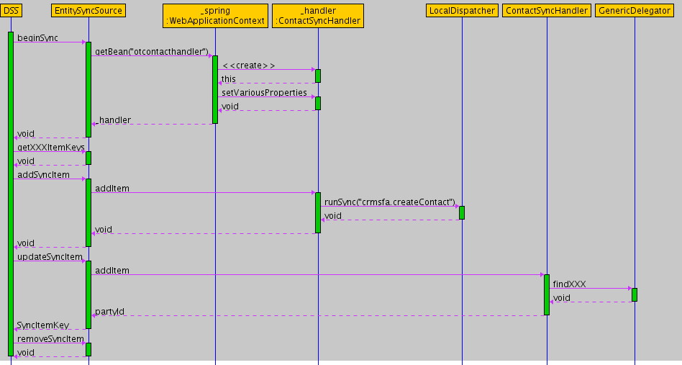
- The DSS, on receiving a SyncML request to sync an external device with an OTFM datasource, allocates a dedicated thread to this request. This thread creates (if necessary) and gains exclusive access to an instance of EntitySyncSource.
- The DSS calls the object defined in OTFM_HOME/config/Funambol.xml#officer to perform authentication of the client device and user which requested the synch. If successful, an instance of Sync4jPrincipal is created to represented the authenticated user, and made available to the sync source via the SyncContext object. For OTFM, this object, configured at com/funambol/server/security/OFBizUserLoginOfficer.xml must be an instance of OFBizUserLoginOfficer, which ultimately performs authentication by calling the standard OFBiz userLogin service.
- The DSS calls the beginSync method on the EntitySyncSource instance, warning it that a sync is about to start, and providing it with a SyncContext object. At this point, the EntitySyncSource obtains a unique (i.e. not shared by any other threads), pre-configured instance of EntitySyncHandler from the Spring application context. The exact type of the EntitySyncHandler depends on the type of record (contact, calendar, etc) of the SyncSource. Basically, the URI with which the SyncSource has been installed in the DSS (e.g. “otcontact”) will be suffixed with “Handler” and the resulting string (e.g. “otcontactHandler”) will be used as the the unique name of a bean in the Spring application context.
- The DSS calls the SyncSource methods on the EntitySyncSource instance, in a sequence defined by [Funambol DSS Arch.], section 2.5, in order to determine what, if any, alterations need to be performed on the client and server datasets, to bring them back into a matching state.
- The DSS asks its SyncEngine to calculate the “changeset”. Basically it asks both the server SyncSource (i.e. the EntitySyncSource) plus the client SyncSource (actually an in-memory stub built up by the DSS with data received from the client device) for all new, updated and deleted items. It then decides what, if any changes to each dataset need to be made for them both to end up the same. A full discussion of how this works can be found in [Funambol DSS Arch.], chap. 2.
- The DSS analyses the changeset and calls the corresponding add, update and remove methods on the EntitySyncSource to persist the changes. The EntitySyncSource converts from the record transport format (ex. VCARD) to a Java Bean representing the record data in a structured manner, manages JDBC Transactionality, and delegates the actual record alteration work to the EntitySyncHandler. Therefore it is this handler's job to convert between the JavaBean record format, and any relevant GenericValues representing Entity data.
- Finally, the DSS informs the client device, via SyncML, of the corresponding add, update and remove operations which it should peform.

Module startup
The fundamental sync. process (which occurs each time a client device requests a sync) is described above. However it may be useful to have a deeper understanding of how each of the actors in the sequence diagram above is loaded into the OFBiz JVM, at the moment of OT startup. Look at the sequence diagram below, which represents this in a stylized fashion, then read the step-by-step guide which follows.
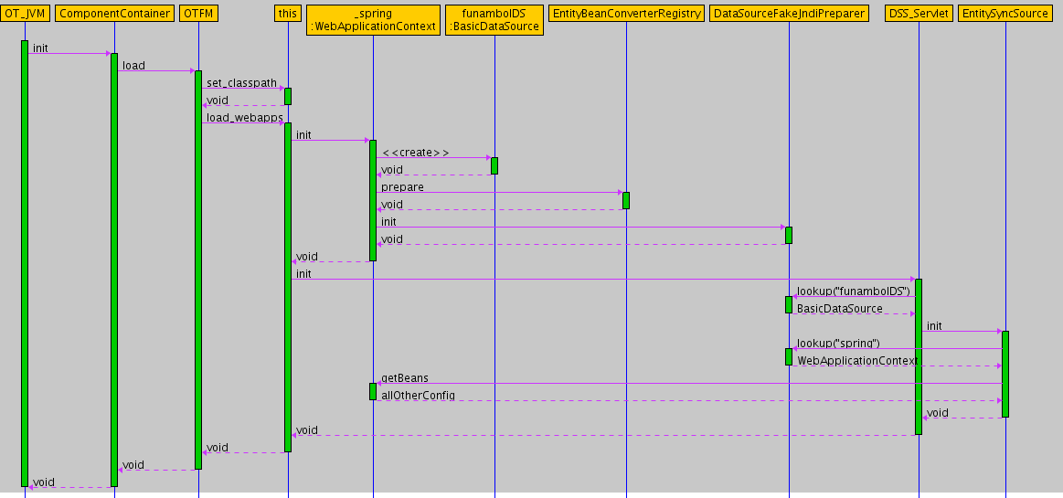
- The OT JVM is started (either manually by an administrator, or by the operating system as a service). One of the tasks it performs is to ask the ComponentContainer to look for and load all OFBiz components. (A detailed discussion of how this bootstrapping works is well beyond the scope of this document, however you can get an idea of the configuration files involved by looking at the sketch [OFBiz Startup Sequence]).
- One of the components loaded up is the OTFM. Among other startup tasks, it...
2.1 Loads the Spring Application Context as a Web App Listener, as described in [Spring Ref. Guide], chap. 3.8.1. This in turn creates and holds in memory, a set of objects which will later be called upon to help with the sync processing. Apart from this, it creates two objects fundamental to the OTFM architecture:
- a JEE DataSource pointing at the DSS database schema
- a very simple in-memory JNDI implementation (from SIGA Framework) which then registers the Spring Application Context itself, as well as the DataSource, with certain names.
Finally, it uses the SystemPropertiesSetter to set the JVM System Property funambol.ds.home which is essential for the DSS to find its configuration directory.
2.2 Loads the DSS Servlet, which among other things....
- gets hold of the DataSource via doing a lookup on the in-memory JNDI implmentation
- loads up any configured SyncSource instances, based on a combination of information under the config directory, and in its database schema.
3 Therefore, the EntitySyncSource is prepared by the DSS servlet. At this stage, it can only perform general tasks common to all syncs – because when a client sync happens, a separate instance of EntitySyncSource will be created and held by the syncing thread. This initial setup works as follows:
- get hold of the Spring application context via doing a lookup on the in-memory JNDI implmentation
- find-out any remaining configuration by asking Spring for relevant beans

Use of external libraries
The DSS uses a lot of third-party libraries, mostly in a poorly-documented fashion. It is beyond the scope of this document to explain these libraries. However, this section explains how the OTFM specifically uses third-party libraries.

Funambol PIM (funambol-common-pim-6.0.3.jar)
This library is not necessary for basic DSS hosting within OT. However OTFM's record-specific handlers use it because it contains the parser for converting VCARD data to Java Beans, as well as the classes for these Java Beans (for instance com.funambol.common.pim.contact.Contact which represents a VCARD contact record.

SIGA Framework (siga-fwk-bsd.jar)
This library is necessary for basic DSS function within OT, as well as record-specific handling. It provides the following functionalities:
- a way to configure JVM System Properties via Spring (SystemPropertiesSetter)
- a simple in-memory JNDI implementation (MapBasedJndiInitialContextFactory)
- a way to traverse OFBiz Entity relations via a query-string format (EntityPreparer)
- a configurable engine for mapping data to-from complex Java Beans and java.util.Maps (EntityBeanConverterRegistry)

Spring (spring-2.0.6.jar)
This library is necessary for basic DSS function within OT, as well as record-specific handling. It basically provides the “glue” which holds all the other bits of OTFM together, as well as a single centralized location (opentaps-sync-config.xml) to configure these bits.

Source View
The code which performs the above work can be found in the following SVN directory:
svn://svn.opentaps.org/opentaps_all/versions/1.0/trunk/hot-deploy

Typically, this code will be checked out as part of a general SVN checkout of OT.

At runtime, the following directories are essential:

Directory | Description
build/
+classes/ | Code compiled from src/ during development.
+lib/ | Code from classes/ packaged for production use
config/ | DSS XML config files, copied from DSS distrib and tweaked for OT-specific integration.
lib/
+core/ | DSS core libraries, copied from DSS dist. The DSS will simply not startup without these libraries.
+ext/ | Third-party libraries which the OTFM code proper depends on.  DSS and OT-FBol module dependencies
+modules/ | Funambol and OT-specific modules which the OTFM code depends on.
webapp/ | Funambol code and configuration which is not Java source. Copied from DSS distrib with some OT specific additions.
+WEB-INF/
+opentaps-sync-config.xml | OT specific configuration for D1, D2.x, in Spring format
+web.xml | J2EE standard webapp config. Copied from DSS distrib with some OT specific additions
+ofbiz-component.xml | OFBiz format component configuration file, which will load DSS along with any necessary OT-specific additions, when startofbiz.bat/sh is run. It is very important that the classpath is set correctly here.

Class Structure
The principal classes involved are shown in the diagram on the next page. As they do not correspond in a simple way to Java packages, they have been colour-coded to show their role in the architecture. The table below summarizes each role and class.
Role | Class/Interface | Description
DSS Sync Architecture | SyncSource | Minimal interface which any Funambol-compliant connector must offer. The DSS creates one instance of this per sync, and uses it inside a dedicated thread.
 | MergeableSyncSource | Extended interface which permits a SyncSource to manage its own record merging
 | SyncItem | Standard format in which all records are represented when passed between DSS and SyncSource
 | SyncItemKey | Standard format for representing only the unique key of a SyncItem, between DSS and SyncSource
OTFM Architecture | EntitySyncSource | OTFM core implementation of MergeableSyncSource.
 | EntitySyncHandler | Interface for a handler which knows
 | EntitySyncHelper | Utility methods common to all record types
OTFM Record-specific Handler | ContactSyncHandler | Knows how to handle CONTACT records
Funambol Record-specific value object | Contact | A structured representation of a CONTACT record, compatible with VCARD or SIF formats.
OFBiz basic classes | GenericValue, LocalDispatcher, GenericDelegator | You already know what these guys do! ContactSyncHandler uses them to do its work.

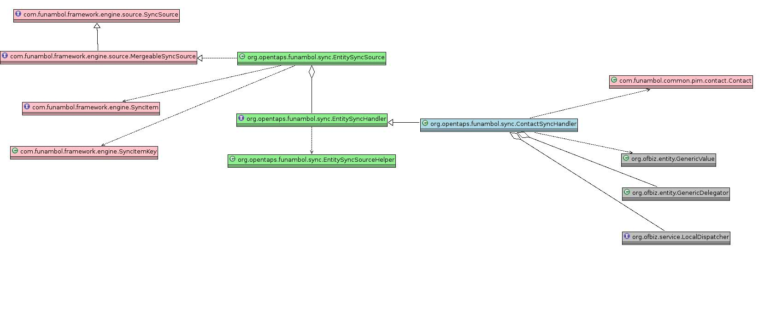

Deployment View
The [OTFM Admin Guide] explains how to perform a deployment. This section explains why the deployment works the way it does.

Concepts
There are three key concepts which govern the deployment mechanism:
- Minimalism: OTFM as it is structured in SVN should be as close to the final deployed structure as possible. This is is a principle which applies through OFBiz and OT (although as far as the current author is aware, this has never been explicitly documented).
- Preservation of Data through upgrades: it should be possible to separate a first-time install (which performs all necessary steps for setting up OTFM) from an upgrade of OTFM (which simply adds new functionality without wiping any existing production data that has been accumulated)
- Out-of-the-box: if someone correctly follows the install procedures in [OTFM Admin Guide] they should work immediately without any additional adjustments, and without any messages of ERROR or higher level, appearing in any log files.

First-time-Install
The table below shows the install steps from [OTFM Admin Guide] in the left-hand column. In the right-hand column it contains an explanation of what each step does, from a developer point of view.

 | Step | Explanation
1 | Stop OT. | We will be altering OT's classpath and module set, so a restart is necessary. To avoid any file locks being held, we stop the OT JVM before performing any other work.
2 | Edit OT_HOME/hot-deploy/component-load.xml and un-comment the line for  <load-component component-location="${ofbiz.home}/hot-deploy/funambol"/> | By default, OT comes with OTFM deactivated, so we use standard OFBiz module configuration file to activate it (that is, include it in the set of components which the OT JVM loads at startup).
3 | Open OTFM_HOME/webapp/WEB-INF/opentaps-sync-config.xml in a text editor and look for the section 1.1. Beneath this, find the <entry key=”funambol.ds.home”…/> tag and set its value attribute to the absolute or relative path of OTFM_HOME. For instance something like: “/opt/opentaps/hot-deploy/funambol”. Save your changes! | The DSS requires a directory tree of XML config files to be able to startup. It is unfortunately hardcoded to look for this tree in a subdirectory called config below the directory set in the JVM system property funambol.ds.home.  This config step simply tells OTFM helper code to set the given value into that JVM system property, BEFORE the JVM loads the DSS. You could just as well set this property via a -Dfunambol.ds.home switch on the command-line in your OFBiz startup script, but it is much more convenient to set it here.
4 | If your PostgreSQL cluster is on a different machine than the current one, then, still in opentaps-sync-config.xm, alter the value of <property name=”url” /> in section 1.3, accordingly. You will also need to alter the value of the jdbc.url property in OTFM_HOME/install/install.properties | The DSS uses its own database schema to maintain configuration, client device and synchronization state information. This schema is separate from the OFBiz Entity Engine schema and therefore may or may not be in the same Database cluster/instance. The OOTM installation of OTFM assumes that this schema is in the same cluster as the Entity Engine schema. The config files work as follows:  - install.properties: points the install.xml ant script at the DSS schema  - opentaps-sync-config.xml: points the running DSS at the DSS schema
5 | Navigate to OT_HOME/framework/base/lib/commons and copy into it the PostgreSQL JDBC driver jar. We recommend using postgresql-8.2-505.jdbc3.jar which is provided along with otfm.zip for your convenience. If you use any other version of the driver, you will also need to alter the value of the jdbc.classpath property in OTFM_HOME/install/install.properties accordingly. Note that this driver jar has NOTHING DO TO WITH any driver jars in OT_HOME/framework/entity/lib/ ! | This step is not intuitive, so read the explanation closely. The reason we have to put the JDBC driver jarfile in the commons directory (rather than, for instance, just depending on the one in framework/entity/lib/jdbc) is that...  - OTFM uses commons-dbcp to prepare a JDBC DataSource, which it then exposes to DSS via JNDI (see section Module Startup above)  - commons-dbcp loads the JDBC Driver in standard JDBC fashion, using Class.forInstance().  - Class.forInstance() looks for the given class within the current classloader.  - The OFBiz framework classloader hierarchy, effectively creates a separate classloader instance for every directory which contains jarfiles  - This means that commons-dbcp can only load driver classes which are available from the same classloader as commons-dbcp.jar is loaded from  - Which, given that commons-dbcp.jar is already included in OFBiz core at OT_HOME/framework/base/lib/commons, means that the JDBC Driver jar has to go in this directory too!
6 | Configure an HTTP (non-secure) connector on port 8080 in OT_HOME/framework/base/config/ofbiz-container.xml. It could be on any port but for this manual we will assume it is 8080. | If you wish to access the DSS via a secure connector, then you can configure it here – but in that case you must set the correct URL in the FOP configuration
7 | From OT_HOME execute the following command, to prepare the default config tree. At the prompt type 'y':  ./ant -f hot-deploy/funambol/build.xml config | This step is a pain, but it is necessary because the DSS configuration management is sloppily coded, and tries to load ANY file or folder under the OTFM_HOME/config directory as if it were an XML file. So it will try to load any .SVN subdirs it finds, and obviously fail, as they are not XML files!
8 | 1. psql -U superuser  #<password>  2. create user funambol password 'funambol';  3. create database funambol owner funambol;  4. \q  5. psql funambol funambol  #<password>  6. List all tables - you should see "No relations found":  \dt | These are standard Postgresql steps for setting up a new schema in an existing cluster on localhost, called 'funambol'. The owner of the schema also has username and password 'funambol'.
9 | ./ant –f hot-deploy/funambol/install/install.xml install | This step creates the empty DSS schema, based on OTFM_HOME/install/modules/postgresql/init_schema.sql  The content of this file was copied straight from the standard DSS and not altered in any way.
10 | ./ant –f hot-deploy/funambol/install/install.xml install-sync-module | This step registers the OTFM sync module as a “template”. That is, a module from which a specific connector instance could be created.
11 | ./ant –f hot-deploy/funambol/install/install.xml install-sync-source | This step registers the OOTB specific sync source instances for OTFM. (One for Contacts, one for Tasks etc.). Notice that it is at this point that we register in the DB, the location (relative to OTFM_HOME/config) of the XML configuration file which contains the final configuration information for each sync source instance.  If you wanted to configure multiple sync sources with different URLs, you could use this task as a template.

Build/Upgrade
Once you have OTFM up and running, you may wish to deploy a changed version of the source code. This is simple to do:
- Stop OT
- From OT_HOME, run:
./ant –f hot-deploy/funambol/build.xml install-sync-source classes
- Start OT again

Configuration Notes
All OTFM-specific configuration is contained in the opentaps-sync-config.xml

This file is a standard Spring 2.0 beans configuration file. Those aspects which can be safely altered by an administrator are described in [OTFM Admin Guide]. This section describes some additional aspects which a developer MAY wish to alter, subject to requisite testing.

Address Purpose-Type mapping
An address in OT must have at least one “purpose” (stored in PartyContactMechPurpose and enumerated in PartyContactMechPurposeType). However it also permits multiple purposes (for instance, Shipping Address may be same as Home Address if a contact works from home).
In contrast, Outlook has a much less flexible treatment of addresses in two respects:
- Only a maximum of 3 addresses is permitted
- The type of each address is fixed (Home, Business, Other), that is each address has one and only one purpose
OTFM therefore works with the lowest common denominator which is Outlook. Each OT purpose is mapped to exactly one Outlook “purpose”. It is possible to alter these mappings via opentaps-sync-config.xml, after which an OT restart should be performed. The following table shows the default mappings and the corresponding config elements should you wish to alter them.
OT -> Outlook
OT Purpose | Outlook address | Config Element (alter the part of the key after the last colon to desired partyContactMechPurposeTypeId)
Other Location | Other | <entry key="PostalAddress:com.funambol.common.pim.contact.Contact:OTHER_LOCATION">
General Location | Business | <entry key="PostalAddress:com.funambol.common.pim.contact.Contact:GENERAL_LOCATION">
Home Location | Home | <entry key="PostalAddress:com.funambol.common.pim.contact.Contact:HOME_LOCATION">
Outlook -> OT
OT Purpose | Outlook purpose | Config Element (alter the part of the key before the colon to desired partyContactMechPurposeTypeId)
Other Location | Other | <entry key="OTHER_LOCATION:com.funambol.common.pim.contact.Contact">
General Location | Business | <entry key="GENERAL_LOCATION:com.funambol.common.pim.contact.Contact">
Home Location | Home | <entry key="HOME_LOCATION:com.funambol.common.pim.contact.Contact">

References
[Funambol DSS Arch.] Funambol DS Server Architecture & Design Document, rev. 1.28, Stefano Fornari & Stefano Nichele, Funambol Team.

[Funambol Outlook Plugin Guide] http://download.forge.objectweb.org/sync4j/Outlook_Plugin_UG.pdf

[OFBiz Startup Sequence] OFBIZ_HOME/hot-deploy/funambol/docs/man/ot_fbol_init.jpg

[OMA DS 1.2 Spec] Open Mobile Alliance, OMA-TS-DS_Protocol–V1_2-20060710-A, 10th July 2006. http://www.openmobilealliance.org/release_program/ds_archive.html

[OTFM Admin Guide] OFBIZ_HOME/hot-deploy/funambol/docs/man/otfm_admin_guide.doc

[Servlet Spec. 2.4] Java Servlet Specification, version 2.4, Sun Microsystems

[Spring Ref. Guide] http://static.springframework.org/spring/docs/2.0.x/reference/index.html

