

DATABASE SYSTEMS

***FINAL PROJECT***

***IVOR PAINE MEMORIAL HOSPITAL***

***SUBMITTED BY:*** *ASHER FARHAN (19I-0618)*

*HAMZA REHAN (19I-0484)*

*HAMZA AFRIDI (19I-0729)*

*USAMA KHALID (19I-407)*

**Project Title and Introduction:**

**Title:**

Ivor Memorial Hospital System

**Introduction:**

In order to achieve our goal i.e. IVOR hospital management system. We analyzed all the given requirements mention in the given pdf. And develop a set of concepts for hospital management system. Apart from requirements we also implement some real world terminologies and also fulfill the given requirements. After analyzing the requirements we give it the shape of ERD. And after we move towards creating tables for storing some dummy record.

ERD describes the main logical structure of hospital management system and ERD is given along with a file name as ERD.

**ENTITY RELATIONSHIP DIAGRAM**

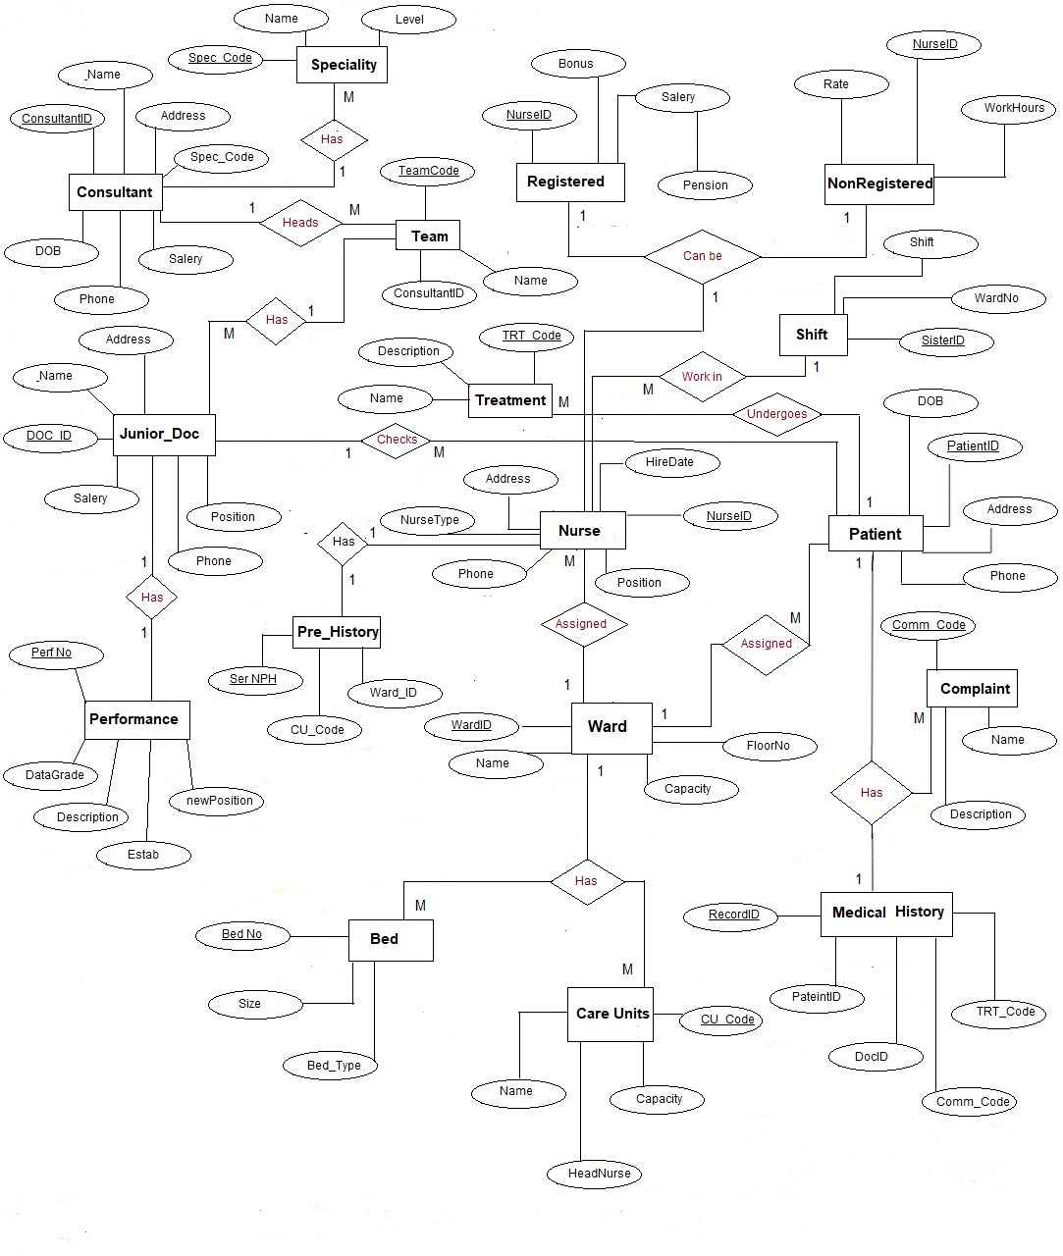

**RELATIONAL MAPPINGS**

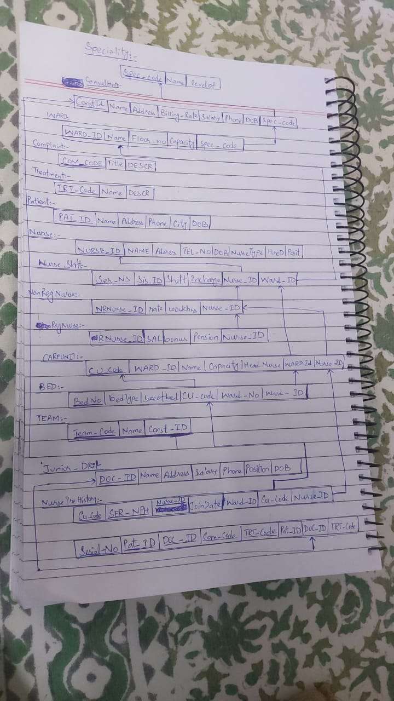

**TABLES DESCRIPTION AND SQL**

1. S*pecialty*

**CREATE TABLE Speciality**

**(**

**Spec_Code char(5),**

**Name varchar(35) unique,**

**levelof int,**

**constraint S_PK1 PRIMARY KEY (Spec_Code)**

**);**

This tables is defined by its primary key that is char fixed length. And an attribute defining its name. Level means at which level does this specialty belongs. Unique constraint is applied for only name cause each Specialty has unique name according to given requirements.

1. *Consultant*

**CREATE TABLE Consultant**

**(**

**Const_ID char(8),**

**Name varchar(35) not null,**

**Address varchar(60),**

**Billing_Rate number(4),**

**Salary number(8,2),**

**Phone varchar(20) unique,**

**DOB varchar(25) not Null,**

**Spec_Code char(5),**

**position varchar(20),**

**constraint c_pk1 PRIMARY KEY (Const_ID),**

**constraint fcpk1 FOREIGN KEY (Spec_Code)**

**references Speciality(Spec_Code)**

**);**

As many doctor could be consultant so as consultant super type is doctor so after

Mapping we choose option 2 for mapping and make consultant apart. And its

Primary key is Const Id that is actually doctor id which came as foreign key but play

the role of primary key. Other attributes like address, DOB are same that each doctor has. Each consultant has specialty so spec_code works as foreign key in this table.

1. *Ward*

**CREATE TABLE WARD**

**(**

**Ward_ID char(5),**

**Name varchar(35) unique,**

**Floor_no number(2),**

**Capacity number(3),**

**Spec_Code char(5),**

**constraint wpk1 PRIMARY KEY (Ward_ID),**

**constraint fkp1 FOREIGN KEY (Spec_Code)**

**references Speciality(Spec_Code)**

**);**

Ward id is its primary key and name defines which ward is it. Each ward caters certain specialty so one ward has many specialty so spec code become as foreign key in this table other attribute defines its name , capacity etc. Ward name is unique because each ward has its own name and differentiate by its name so constraints is applied on name.

1. *Complaint*

**CREATE TABLE Complaint**

**(**

**COM_CODE NUMBER(5),**

**TITLE VARCHAR(20) NOT NULL,**

**DESCR VARCHAR(40),**

**CONSTRAINT COM_PK PRIMARY KEY(COM_CODE)**

**);**

Code is primary key that uniquely identifies its each record. While title is name of complain that is should not be null constraint is applied on title is null. Description is defined by as details of complain.

1. Treatment

**CREATE TABLE TREATMENT**

**(**

**TRT_CODE char(5),**

**NAME VARCHAR(35) NOT NULL,**

**DESCR VARCHAR(40),**

**CONSTRAINT TRT_PK PRIMARY KEY(TRT_CODE)**

**);**

code is its primary key that uniquely identifies its all rows. Name defined treatment name.Not null constraint is applied cause treatment name should not be null.

Description consists of details that could be null.

1. *Patient:*

**CREATE TABLE PATIENT**

**(**

**PAT_ID char(8),**

**NAME VARCHAR(35) NOT NULL,**

**ADDRESS VARCHAR(60),**

**Phone VARCHAR(25) unique,**

**City varchar(25),**

**DOB varchar(25) not Null,**

**CONSTRAINT pat_PK PRIMARY KEY(PAT_ID)**

**);**

id is its primary key. And Date of birth should not be null on the other hand name of patient should not be null. Id determines its each tuple.

1. *Nurse*

**CREATE TABLE Nurse**

**(**

**Nurse_ID char(8),**

**NAME VARCHAR(30) NOT NULL,**

**ADDRESS VARCHAR(60),**

**TELNO VARCHAR(20) UNIQUE,**

**DOB Date not Null,**

**NurseType varchar(5),**

**HireDate Date not NULL,**

**position varchar(20),**

**constraint nnnpk1 PRIMARY KEY(Nurse_ID)**

**);**

Nurse is super type of register nurse and non-register nurse. So the comman attributes that belong to both reg nurse and non reg nure came in here. Hire date should not null not null constraint is applied. Each nurse has unique telephone #. And name of nurse should not be null.id is its primary key.

1. *Nurse Shift*

**CREATE table NurseShift**

**(**

**Ser_NS number(10),**

**Sis_ID char(8),**

**Shift varchar(10) not Null,**

**Incharge_ward char(5),**

**constraint nspk2 PRIMARY KEY (Ser_NS,Sis_ID,incharge_ward),**

**constraint a1 FOREIGN KEY (Sis_ID)**

**references Nurse(Nurse_ID),**

**constraint a2 FOREIGN KEY (Incharge_ward)**

**references Ward(Ward_ID)**

**);**

This table hold the record of each nurse that works as sister in any ward it also maintain the previous history of nurse that in which ward nurse work as sister before and nurse id is primary key that came from nurse. While incharge ward is foreign key that came form ward. It explains that which nurse works as sister in which ward. Shift defines their shifts like day or night.

1. *Register Nurses*

**CREATE TABLE RegNurse**

**(**

**RNurse_Id char(8),**

**SAL number(8,2) not null,**

**bonus number(6,2),**

**pension number(6,2),**

**constraint regNqq_pk1 PRIMARY KEY (RNurse_ID),**

**constraint regN_pk1 FOREIGN KEY (RNurse_ID)**

**references Nurse(Nurse_ID)**

**);**

Rnurse Id determines its primary key that came from nurse as foreign key. It inherit all attributes of nurse by making a join with nurse using id. It has its own salary and bonus and pension because they are permanent and works for particular time.

1. *Non-Register Nurse*

**CREATE TABLE NonRegNurse**

**(**

**NRNurse_ID char(8),**

**rate int not null,**

**workHrs int,**

**constraint nonregN_asapk1 PRIMARY KEY (NRNurse_ID),**

**constraint regNaa_pk1 FOREIGN KEY (NRNurse_ID)**

**references Nurse(Nurse_ID)**

**);**

Id is its primary key that came from nurse id and works as foreign key in this table .this table hold the data for non reg nurses and also holds their extra attributes like rate, working hours, etc. Not null constraint is applied on rate.

1. *CareUnit*

**CREATE TABLE CAREUNIT**

**(**

**CU_code char(8),**

**ward_ID char(5),**

**name varchar(30) not null,**

**capacity int,**

**Head_Nurse char(8),**

**constraint cu_pk PRIMARY KEY(CU_CODE),**

**CONSTRAINT cu_fk1 FOREIGN KEY(ward_ID) REFERENCES WARD(WARD_ID),**

**CONSTRAINT cu_fk2 FOREIGN KEY(Head_Nurse) REFERENCES RegNurse(RNURSE_ID)**

**);**

Each careunit has its own code and its uniquely identifies all record from this table. As 1 ward has many careunits . ward id works as foreign key in this table and name of care should not be null means not null constraint is applied. Each care unit has head nurse that is register nurse so register nurse id works as foreign key in ths table.

1. *Bed*

**CREATE TABLE BED**

**(**

**BedNo int not null,**

**bedtype varchar(30),**

**sizeOfBed varchar(15),**

**CU_Code char(8),**

**Ward_No char(5),**

**constraint bd_pk PRIMARY KEY(BedNo),**

**CONSTRAINT bd_fk1 FOREIGN KEY(CU_Code) REFERENCES CAREUNIT(cu_code),**

**CONSTRAINT bd_fk12 FOREIGN KEY(Ward_No) REFERENCES Ward(Ward_ID)**

**);**

Each bed has its unique number and also its type and size. Bed no is primary key cause in whole hospital all beds have their own unique number. Bed belongs ward and many beds belong to care unit that have ben assign to admit patient.

So ward id and care unit code works as foreign key in this table.bed no should not be null. Not null constraint is applied on table bed no.

1. *Team*

**CREATE TABLE TEAM**

**(**

**Team_Code char(8),**

**Name varchar(30) unique,**

**Const_ID char(8),**

**constraint tm_pk PRIMARY KEY(Team_code),**

**CONSTRAINT tm_fk1 FOREIGN KEY(Const_ID) REFERENCES Consultant(Const_ID)**

**);**

Each consultant has team of doctor. And each consultant has 1 team. So team number is primary key of team table and also const id who head the team. On the other hand const id works as foreign key in this table cause consultant has team so due to total participation it came in this table. Each team has unique name and unique constraint is applied on team name.

1. *Junior Doctor*

**CREATE Table JuniorDR**

**(**

**Doc_ID char(8),**

**Name varchar(35) not null,**

**ADDRESS varchar(60),**

**Salary Number(8,2),**

**Phone varchar(15) unique,**

**Positon varchar(20) not null,**

**DOB varchar(25) Not NUll,**

**constraint jd_pk1 PRIMARY KEY (Doc_ID)**

**);**

Id is primary key that uniquely identifies its each tuple. Each doctor has name should not be null. Phone of each doctor should be unique means unique constraint is applied on phone. Dob should not be null and not null constraint is applied on name, position.

1. *Nurse previous History*

**CREATE Table NursePreHistory**

**(**

**Ser_NPH number(10),**

**Nurse_ID char(8),**

**JoinDate date not Null,**

**CU_Code char(8),**

**Ward_id char(5),**

**constraint NPH PRIMARY KEY (Ser_NPH,Nurse_ID,CU­_Code),**

**constraint NPH_Fk1 FOREIGN KEY (CU_CODE)**

**references CAREUNIT(CU_CODE)**

**constraint NPH_Fk12 FOREIGN KEY (Nurse_ID)**

**references NURSE(Nurse_ID)**

**);**

This table hold the record of nurse wether reg or non reg nurse. Its hold in which ward current nurse works and its previous ward. Ward id came from ward and works as foreign key in this table. On the other hand cu id works as foreign key in this table and refers to careunit. Serial no refers to auto increment number to hold all records.

1. *Care unit Admit*

**CREATE TABLE CU_Admit**

**(**

**Ser_CU number(10),**

**pat_id char(8),**

**Cu_code char(8),**

**admit_date date not Null,**

**bedNo int,**

**constraint CuA_pk PRIMARY KEY(Ser_CU,pat_id,CU_CODE),**

**CONSTRAINT CuA_fk1 FOREIGN KEY(pat_id) REFERENCES PATIENT(pat_id),**

**CONSTRAINT CuA_fk2 FOREIGN KEY(Cu_code) REFERENCES CAREUNIT(Cu_code),**

**CONSTRAINT CuA_fk4 FOREIGN KEY(BedNo) REFERENCES BED(bedNo)**

**);**

This table hold record of patient admission in which care unit patient has been admitted. Careunit code works as foreign key in this table. Bed no specifies that on which bed patient had been admitted. Serial no is auto increment no to hold duplicate records. Patient id woks as foreign key in this table. Not null constraint is applied on admit date.

1. *Patient Inchagre*

**CREATE Table Pataint_Incharge**

**(**

**Ser_PatINC number(10),**

**pat_Id char(8),**

**Doc_ID char(8),**

**Inc_Date Date not Null,**

**constraint pi_pk1 PRIMARY KEY (pat_Id,Ser_PatINC,Doc_ID),**

**constraint pi_fk1 FOREIGN KEY (pat_id)**

**references Patient(pat_id),**

**constraint pi_fk2 FOREIGN KEY (Doc_id)**

**references juniorDr(Doc_id)**

**);**

This tables holds the record of patient that which patient had which in charge doctor.

Patient I came as foreign key from table patient. On the other hand doctor id camas form juniordr and works as foreign key in this table.

1. *Medical History*

**CREATE Table Medical_Histroy**

**(**

**Serial_no number(10),**

**pat_Id char(8),**

**Doc_ID char(8),**

**TRT_Code char(5),**

**Com_Code number(5),**

**Start_Date Date not Null,**

**End_Date Date not Null,**

**constraint pi_pk15 PRIMARY KEY (Serial_no,pat_Id,Doc_ID,Com_Code,TRT_Code),**

**constraint pi_fk15 FOREIGN KEY (pat_id)**

**references Patient(pat_id),**

**constraint pi_fk25 FOREIGN KEY (Doc_id)**

**references juniorDr(Doc_id),**

**constraint pi_fk254 FOREIGN KEY (Com_code)**

**references complaint(COm_code),**

**constraint pi_fk255 FOREIGN KEY (trt_code)**

**references Treatment(TRT_Code)**

**);**

This table hold the data of each patient treatment cross ponding to complaints. And a treatment # also which is surrogate key. Along with this doc id who perform treatment and treat code and complain code are composite primary key. Extra attributes are start date and end date. Doc id works as foreign key in this table and treatment code also and complain code also.

1. *Doctor Team*

**CREATE TABLE DOCTEAM_REC**

**(**

**Team_Code char(8),**

**Doc_ID char(8),**

**joinDate date,**

**endDate date,**

**constraint DTREC_pk PRIMARY KEY(Team_code,Doc_ID),**

**CONSTRAINT DTREC_fk1 FOREIGN KEY(Team_Code) REFERENCES TEAM(Team_Code),**

**CONSTRAINT DTREC_fk2 FOREIGN KEY(Doc_ID) REFERENCES JuniorDR(Doc_ID)**

**);**

This table hold record that which doctor belongs to which team and doctor may belong to more then team at different times. Doctor id works as foreign key and composite primary key in this table. And team code also.

1. *Performance*

**CREATE TABLE PERFORMANCE**

**(**

**SerPerf_NO number(10),**

**Doc_ID char(8),**

**Team_Code char(8),**

**DATE_GRADE varchar(3),**

**perf_description varchar(60),**

**fromDate date,**

**toDate date,**

**estab varchar(60),**

**newPosition varchar(30),**

**constraint perf_pk PRIMARY KEY(SerPerf_No,Doc_ID,Team_code),**

**CONSTRAINT perf_fk1 FOREIGN KEY(Doc_ID) REFERENCES JuniorDR(Doc_ID),**

**CONSTRAINT perf_fk2 FOREIGN KEY(Team_Code) REFERENCES TEAM(Team_Code)**

**);**

This table hold the record of performance history of doctor that a consultant assign to them. doc id woks as foreign key in this table and also primary key on the other hand team code is also foreign key and primary key also. Performance # is surrogate key which is also primary key in this table.

**Assumptions:**

* Nurses works only in care units for caring the patients.
* Patients can also enter into wards without any treatment.
* For caring of patients in ward each ward has a day and night sister.
* Set of Treatments are predefined.
* A Doctor can also change team of one consultant.
* Nurses can also change their shifts.
* Sisters can switch from one ward to another ward.
* Patient can also admit again into same or different ward.
* Patient can also admit again into same or different care unit.
* Bed is Assign to Admit Patient.
* Ward and care units both have beds.
* A consultant can have only one specialty.

**12 QUERIES**

use Hospital

--===============Query 1====================

select a.const_id,d.Doc_Id,a.name,d.name

from consultant a,DocTeam_rec b, juniorDr d,team c

where a.const_id=c.Const_id

and c.team_code=b.team_code

and b.Doc_id=d.Doc_ID;

--==============================================

--==============Query no 2-=====================

select a.name,b.sis_id,b.shift,c.name,c.head_nurse

from ward a,careunit c,nurseshift b

where a.ward_id=c.ward_id

and a.ward_id=b.incharge_ward;

--==================================

--===============Quer 3=====================

select Pat_id,Com_code,TRT_Code,Start_date,End_Date

from medical_histroy;

--=====================================

--===================Quer 4====================

select a.Doc_ID,a.pat_id,e.name,d.head_nurse,f.name

from pataint_Incharge a,JuniorDr b,CU_Admit c,careunit d,patient e,nurse f

where b.Doc_id=a.DOc_Id

and b.positon='Junior HouseMan'

and c.pat_id=a.pat_id

and c.cu_code=d.cu_code

and a.pat_id=e.pat_id

and f.nurse_id=d.head_nurse;

--===============================================

--========================Quer 5=========================

select c.const_id, c.name, e.name,e.spec_code from consultant c ,speciality e where c.spec_code not in(

select d.spec_code from consultant d where d.const_id != c.const_id) and c.spec_code=e.spec_code;

--=======================================================

--=====================Query 6==================================

select m.*,t.*,c.*,p.*

from medical_histroy m,treatment t,complaint c,performance p

where m.trt_code=t.trt_code

and c.com_code=m.com_code

and m.doc_id=p.doc_id

order by c.com_code,t.trt_code

;

--==========================================================

--=====================Query 7===========================

select p.name,c.com_code,c.title, t.trt_code,t.name

from patient p inner join medical_histroy mh

on p.pat_id=mh.pat_id

join treatment t on t.trt_code=mh.trt_code

inner join complaint c on c.com_code=mh.com_code

where mh.pat_id in (

select m.pat_id

from medical_histroy m

where m.pat_id=mh.pat_id and m.com_code!=mh.com_code);

--==========================================================

--============================Query 8======================

select p.pat_id, p.name, m.trt_code, m.com_code

from patient p inner join medical_histroy m

on p.pat_id=m.pat_id

order by m.com_code , m.trt_code;

--=================================================

--================Query 9===========================

select * from performance

where Doc_id='doc_0003';

--=============================================

--===================================Query 10========================

select * from medical_histroy a,cu_admit b

where a.pat_ID=b.pat_id

AND A.pat_id='0001';

--==================================================

--======================Query 11============================

select t.trt_code, t.name, mh.*

from medical_histroy mh inner join treatment t

on mh.trt_code=t.trt_code

where mh.com_code='$c1'

and mh.start_date between '$d1' and '$d2'

and mh.end_date between '$d1' and '$d2'

order by mh.trt_code;

--=========================================================

--=====================Query 12--========================

select positon, count(doc_id)

from juniordr

group by positon

union

select position, count(const_id)

from consultant

group by position

union

select position , count(nurse_id)

from nurse

group by position;

--==========================================================