Mileage for October 2026
First 10,000 miles paid at £0.45, mileage after 10,000 paid at £0.25 per mile
Miles total 1286.4 miles
Amount to claim £578.88
Takes me to 4146.9 miles this year

2026/10/01 From home to Sample Store A (Farnborough) to Sample Office to home 66.5 miles
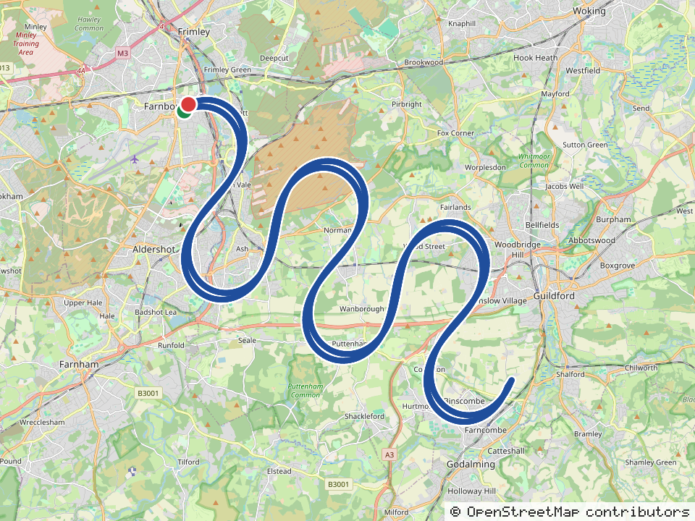
Route recorded by phone GPS (66.5 miles). Map data © OpenStreetMap contributors
2026/10/02 From home to Sample Store A (Farnborough) to home 51.5 miles
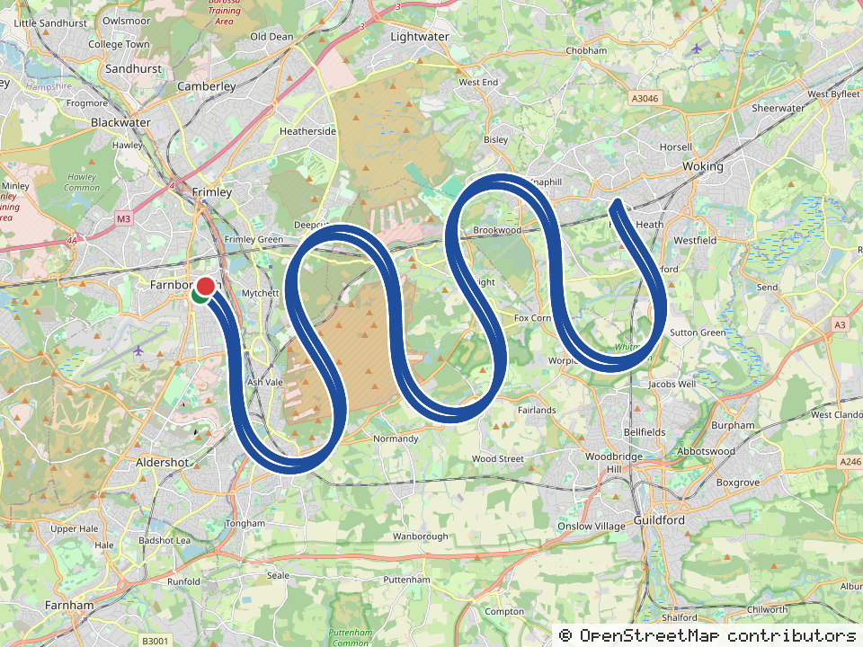
Route recorded by phone GPS (51.5 miles). Map data © OpenStreetMap contributors
2026/10/05 From home to Sample Store A (Farnborough) to home 51.5 miles
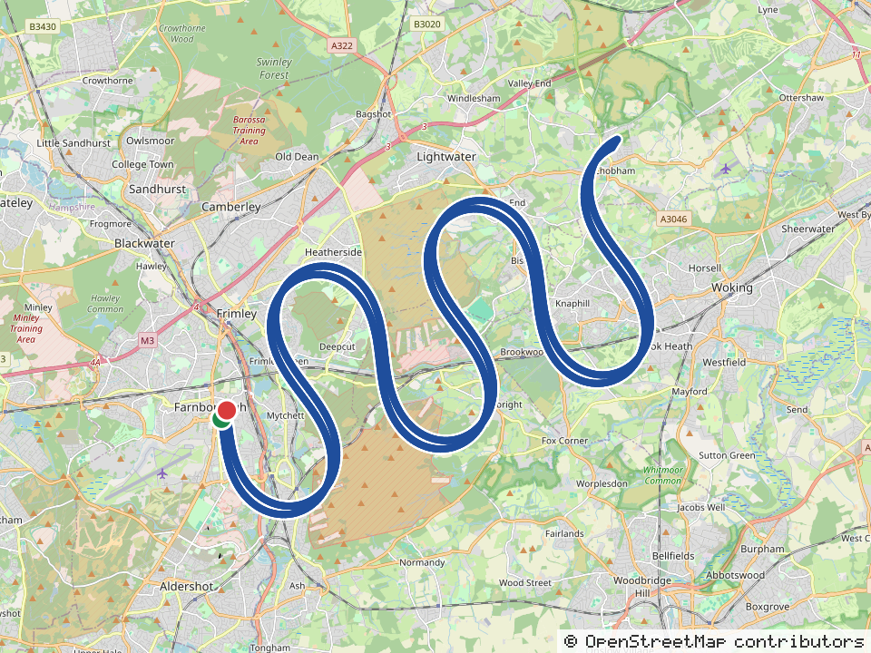
Route recorded by phone GPS (51.5 miles). Map data © OpenStreetMap contributors
2026/10/06 From home to Sample Store A (Farnborough) to Sample Store B (Yeading) to home 56.3 miles
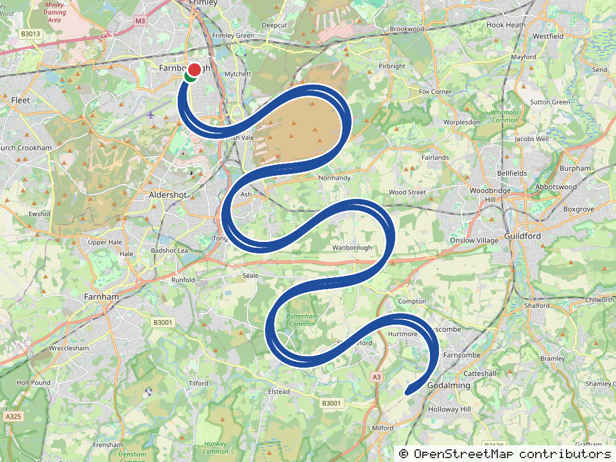
Route recorded by phone GPS (56.3 miles). Map data © OpenStreetMap contributors
2026/10/07 From home to Sample Store A (Farnborough) to Sample Hotel, Fleet Road, Fleet GU51 (long address to test wrapping in Excel and Word) to 444 Sample Great West Road, Brentford TW8 to Sample Office to home 84.5 miles
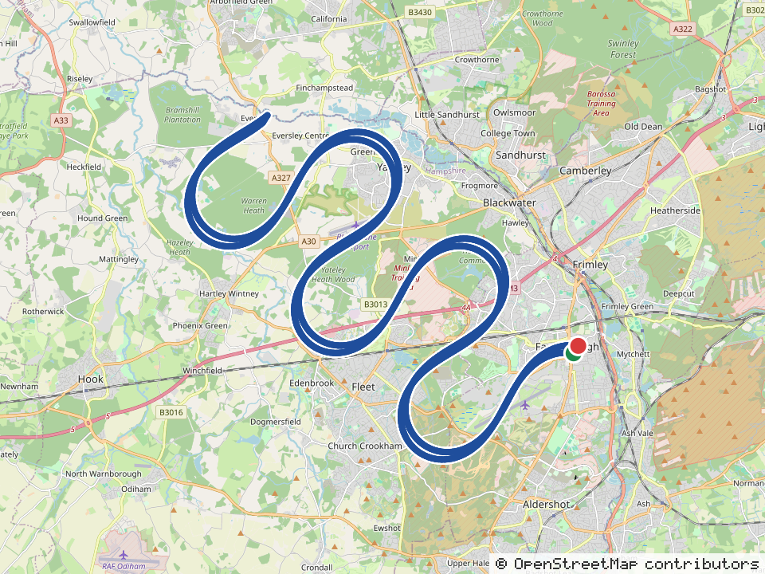
Route recorded by phone GPS (84.5 miles). Map data © OpenStreetMap contributors
2026/10/08 From home to 示例客户 · 伦敦办公室 to home 12.3 miles
2026/10/09 From home to Sample Store B (Yeading) to Sample Office to Sample Store A (Farnborough) to home 68.0 miles
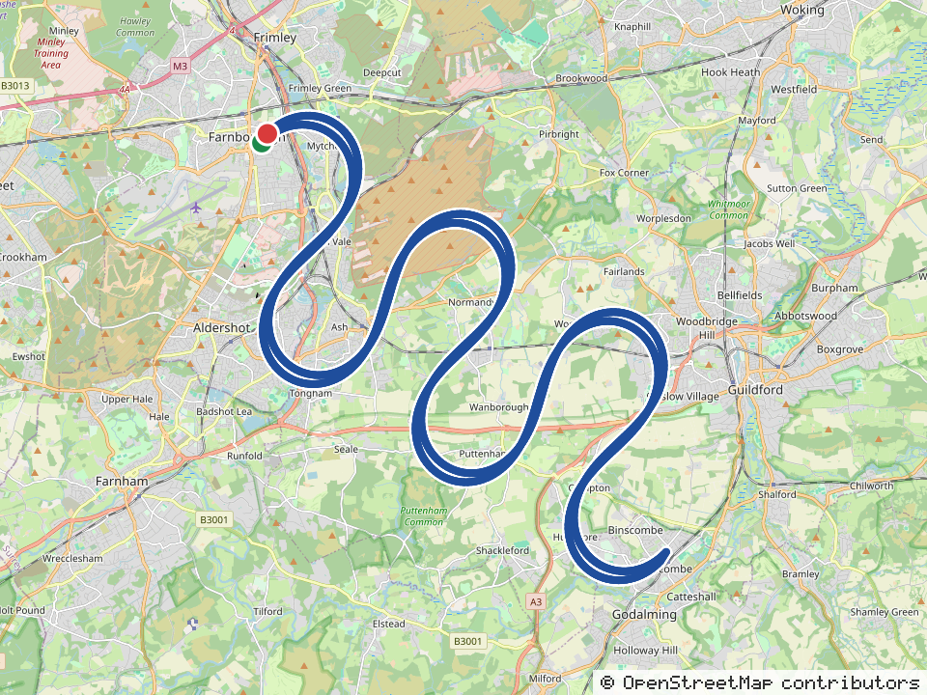
Route recorded by phone GPS (64.2 miles); claimed distance 68.0 miles (adjusted manually). Map data © OpenStreetMap contributors
2026/10/12 From home to Sample Store A (Farnborough) to home 51.5 miles
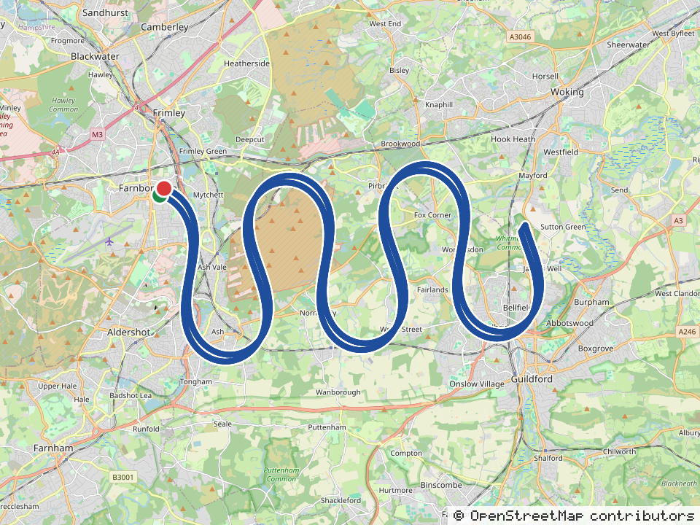
Route recorded by phone GPS (51.5 miles). Map data © OpenStreetMap contributors
2026/10/13 From home to Heathrow T5 (sample) to Sample Store A (Farnborough) to home 53.3 miles
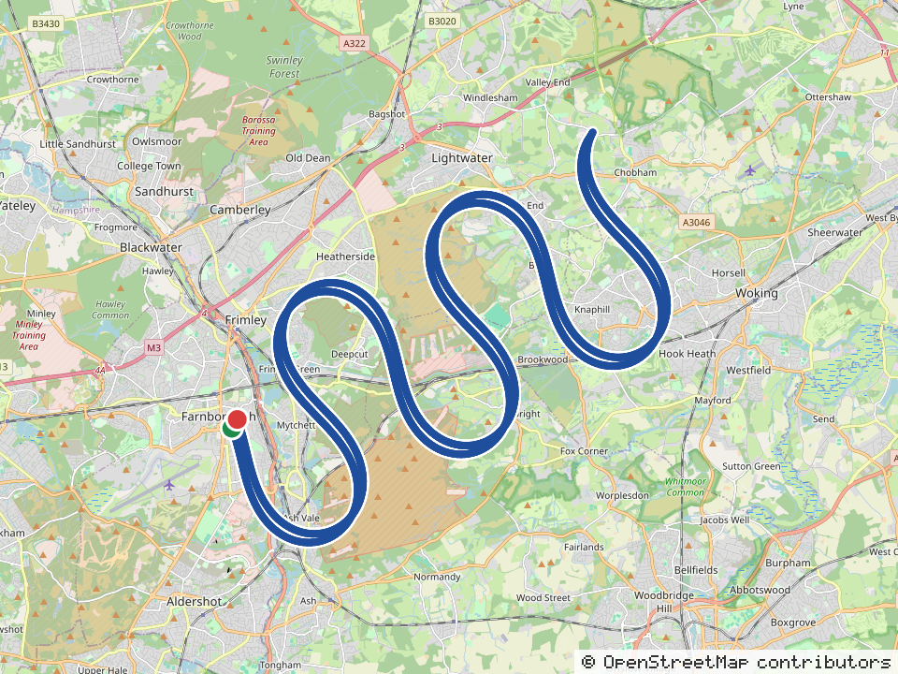
Route recorded by phone GPS (53.3 miles). Map data © OpenStreetMap contributors
2026/10/14 From home to Sample Store A (Farnborough) to Sample Restaurant to Sample Inn West to Sample Inn Town Centre to home 64.7 miles
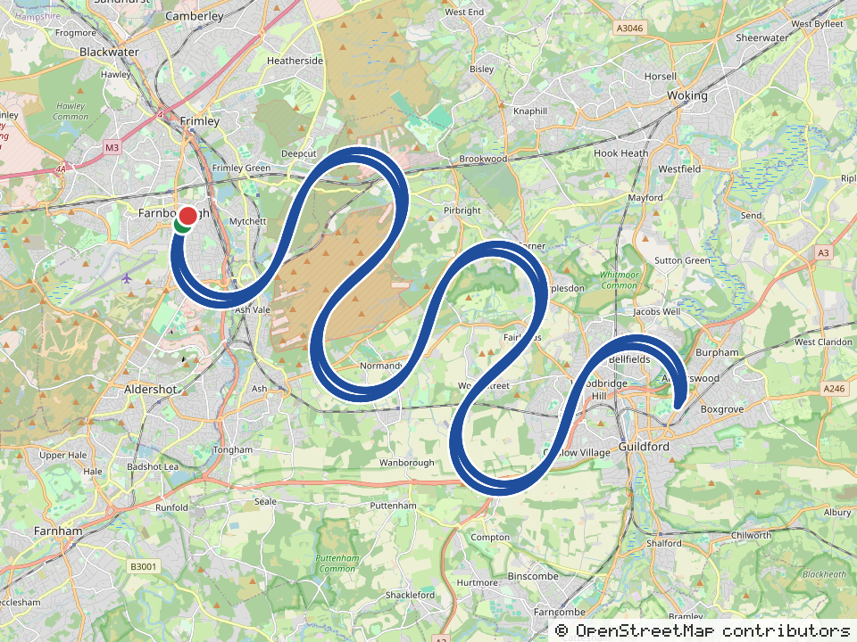
Route recorded by phone GPS (64.7 miles). Map data © OpenStreetMap contributors
2026/10/15 From home to Sample Store A (Farnborough) to Sample Store B (Yeading) to Heathrow T4 (sample) to home 68.3 miles
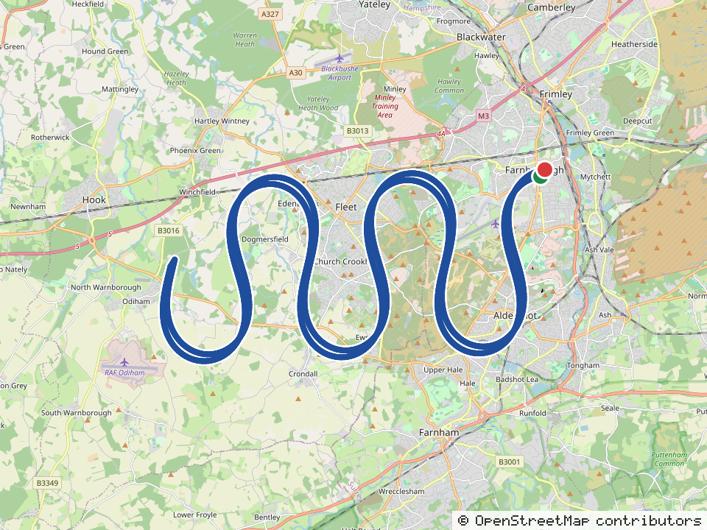
Route recorded by phone GPS (68.3 miles). Map data © OpenStreetMap contributors
2026/10/16 From home to Sample Store A (Farnborough) to home 51.5 miles
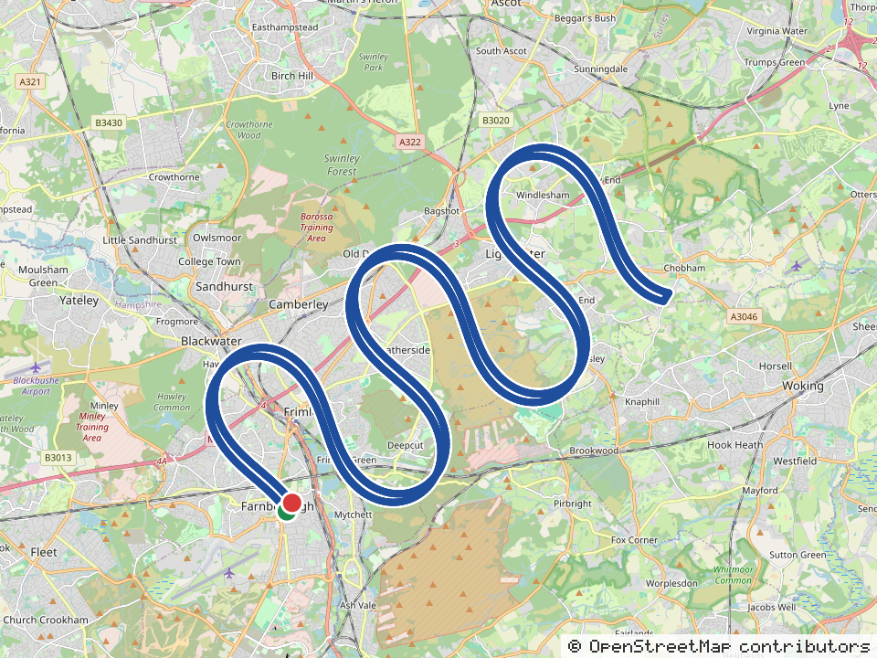
Route recorded by phone GPS (51.5 miles). Map data © OpenStreetMap contributors
2026/10/19 From home to Sample Store A (Farnborough) to home 53.6 miles
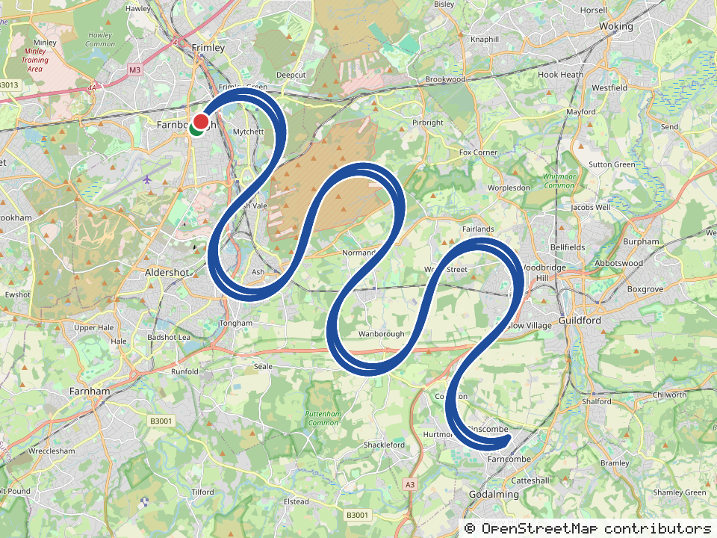
Route recorded by phone GPS (53.6 miles). Map data © OpenStreetMap contributors
2026/10/20 From home to Sample Store A (Farnborough) to Sample Hotel Fleet to home 75.9 miles
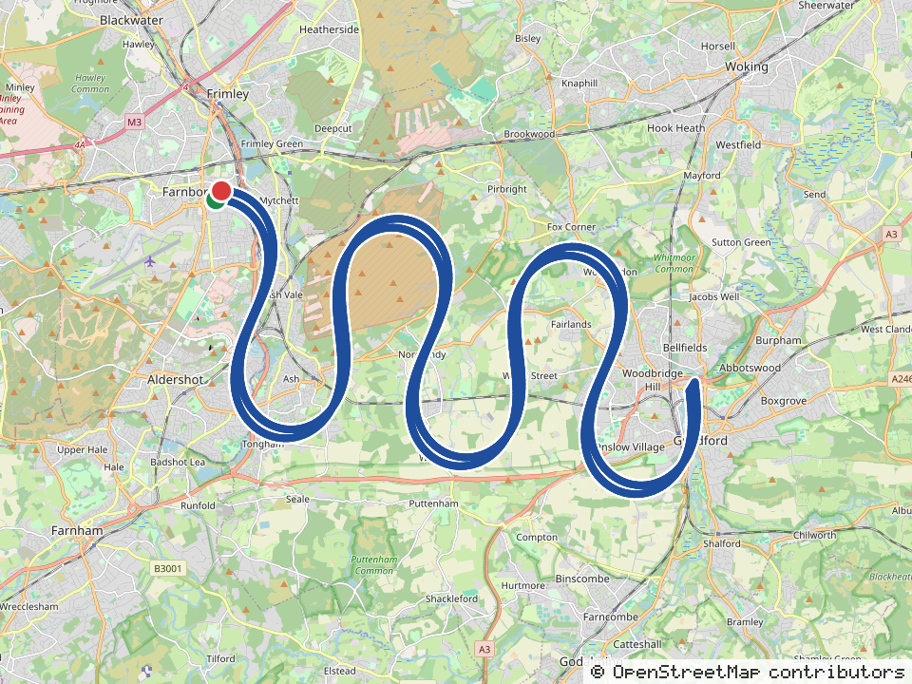
Route recorded by phone GPS (75.9 miles). Map data © OpenStreetMap contributors
2026/10/21 From home to Sample Store A (Farnborough) to Sample Office to home 73.5 miles
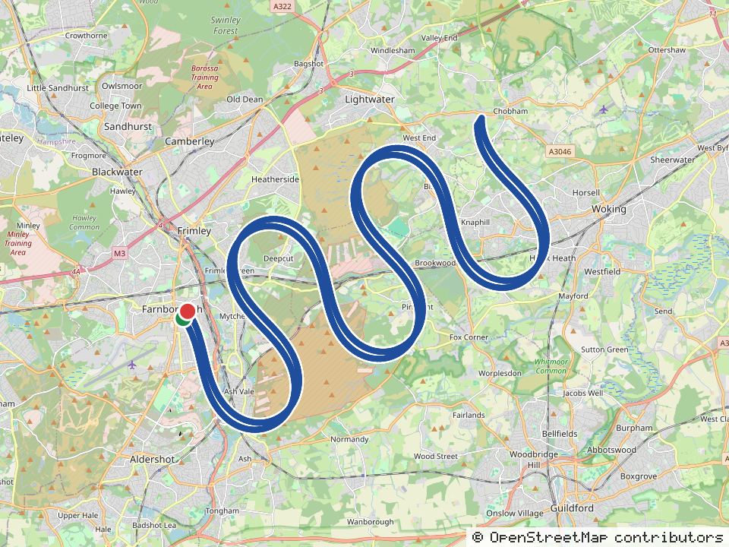
Route recorded by phone GPS (73.5 miles). Map data © OpenStreetMap contributors
2026/10/22 From home to Sample Office to Sample Store A (Farnborough) to home 68.6 miles
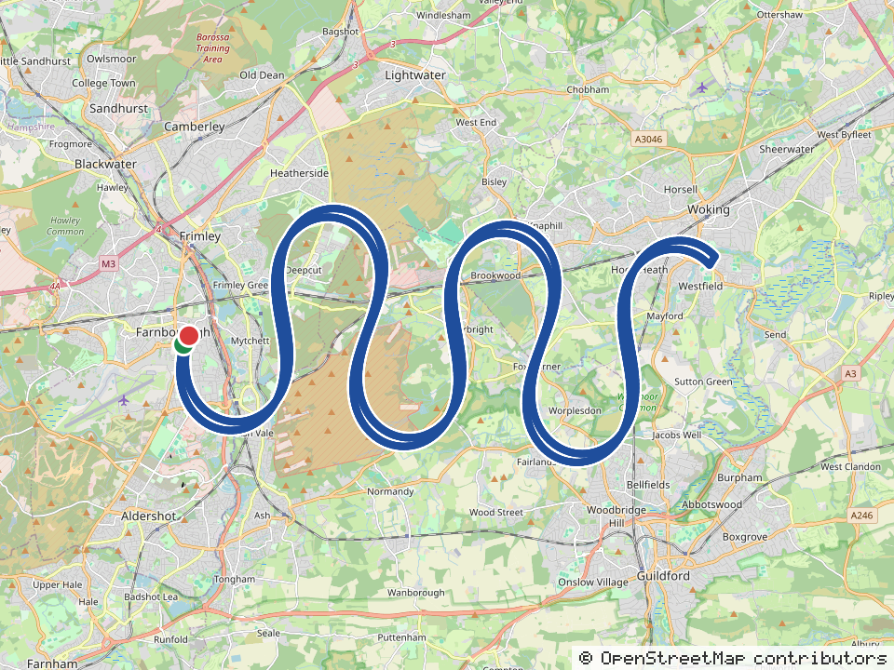
Route recorded by phone GPS (68.6 miles). Map data © OpenStreetMap contributors
2026/10/23 From home to Sample Store A (Farnborough) to Heathrow T4 (sample) to home 56.8 miles
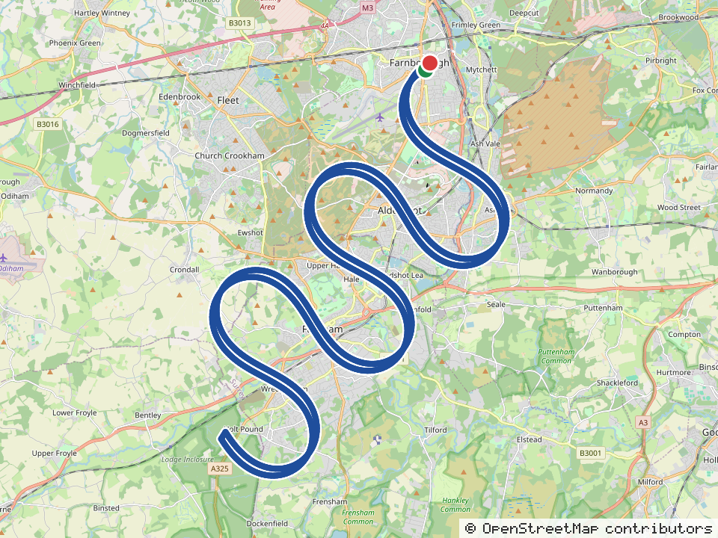
Route recorded by phone GPS (56.8 miles). Map data © OpenStreetMap contributors
2026/10/26 From home to Sample Store A (Farnborough) to home 61.1 miles
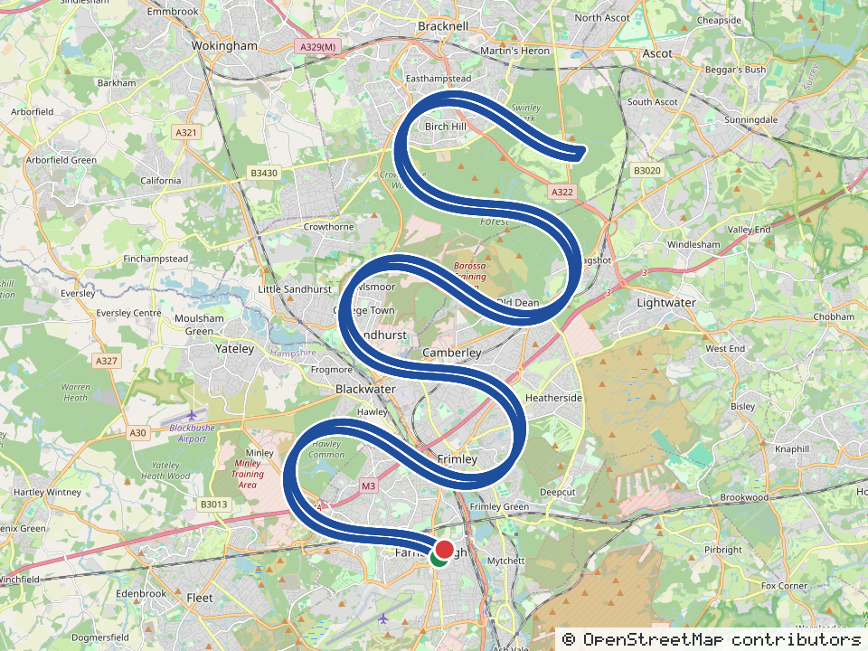
Route recorded by phone GPS (61.1 miles). Map data © OpenStreetMap contributors
2026/10/27 From home to Sample Store A (Farnborough) to home 51.5 miles
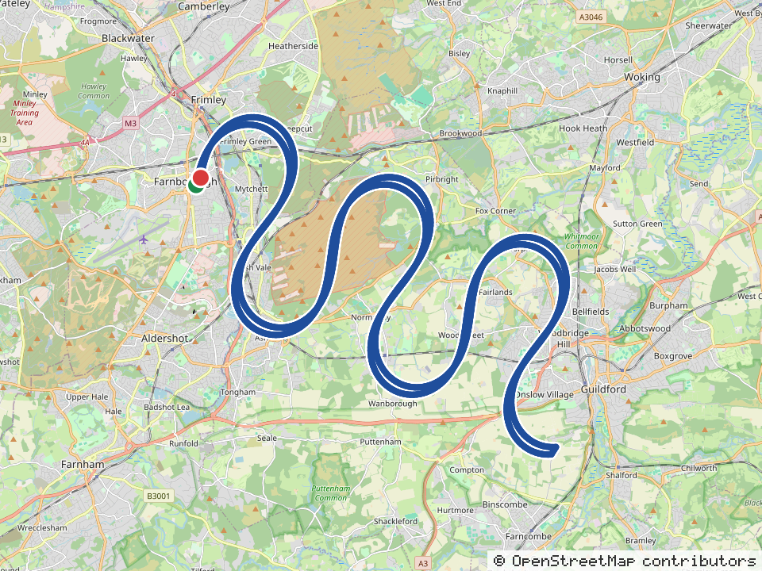
Route recorded by phone GPS (51.5 miles). Map data © OpenStreetMap contributors
2026/10/28 From home to Sample Store A (Farnborough) to Sample Office to home 70.8 miles
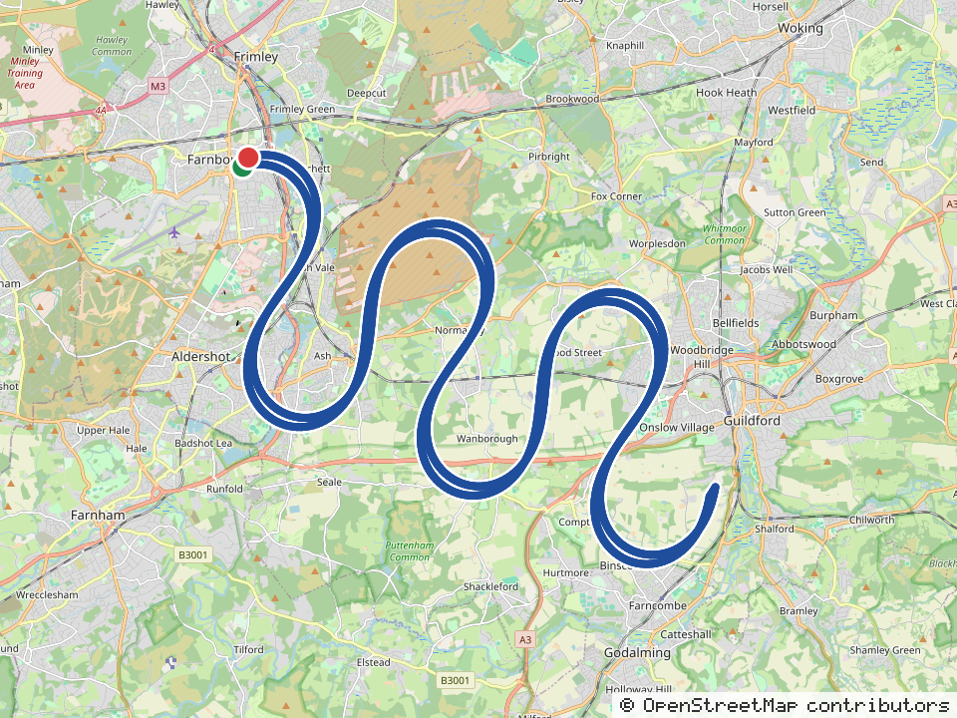
Route recorded by phone GPS (70.8 miles). Map data © OpenStreetMap contributors
2026/10/29 From Sample Office to Heathrow T5 (sample) to home 21.8 miles
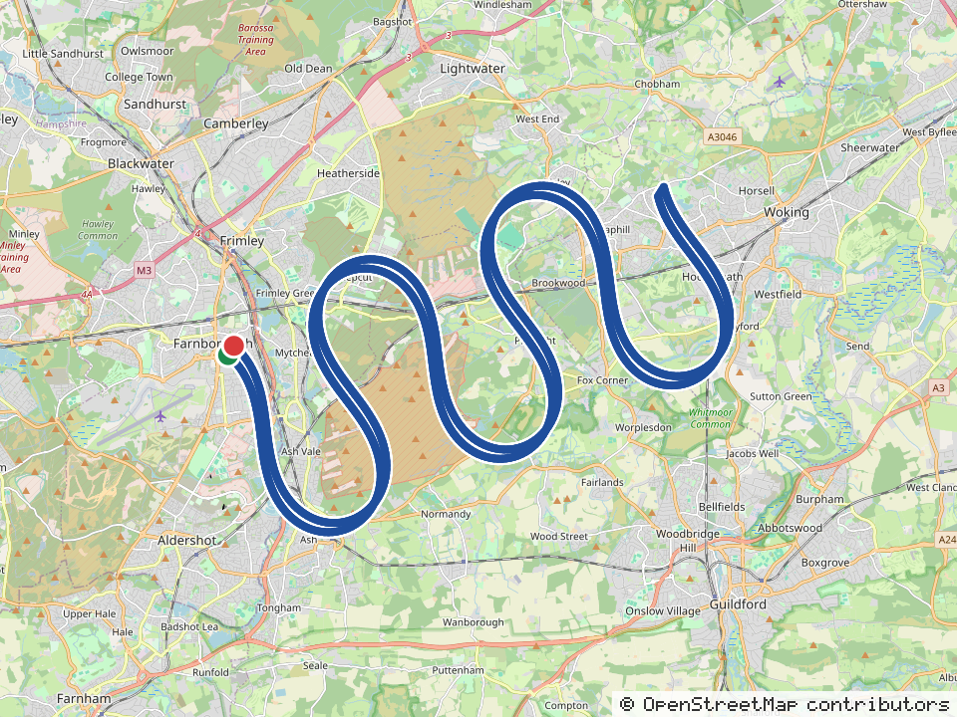
Route recorded by phone GPS (21.8 miles). Map data © OpenStreetMap contributors
2026/10/30 From home to Sample Supermarket HQ to Sample Office to home 72.9 miles
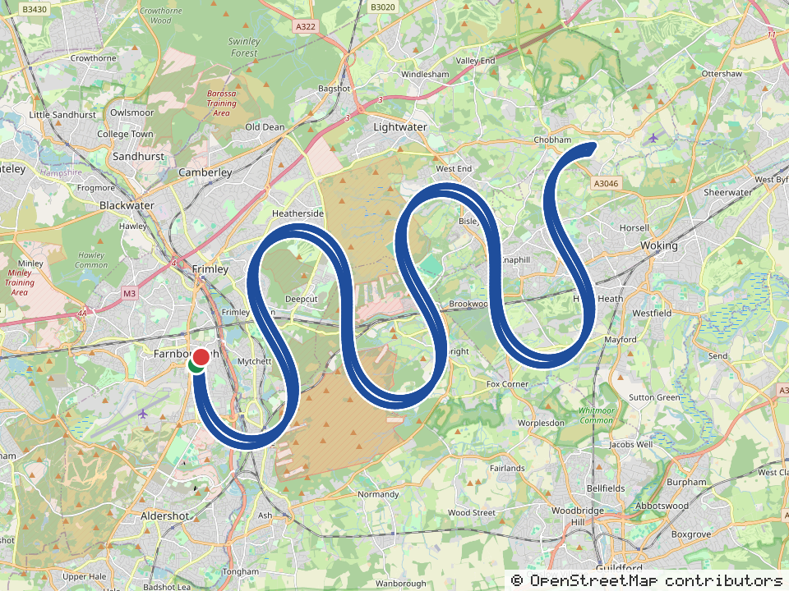
Route recorded by phone GPS (72.9 miles). Map data © OpenStreetMap contributors

