1. Problem Description
The original code suffered from significant architectural issues that made the system difficult to maintain and extend. The main problems included a monolithic design where all functionality was contained within a single 300+ line Main.java file. This resulted in tight coupling between user interface, business logic, and data persistence layers. The code violated the Single Responsibility Principle by mixing multiple concerns together and used global static state that made testing nearly impossible. There was no proper error handling mechanism, with only basic validation and minimal user feedback. The hard-coded file paths and mixed responsibilities made the system brittle and resistant to change.
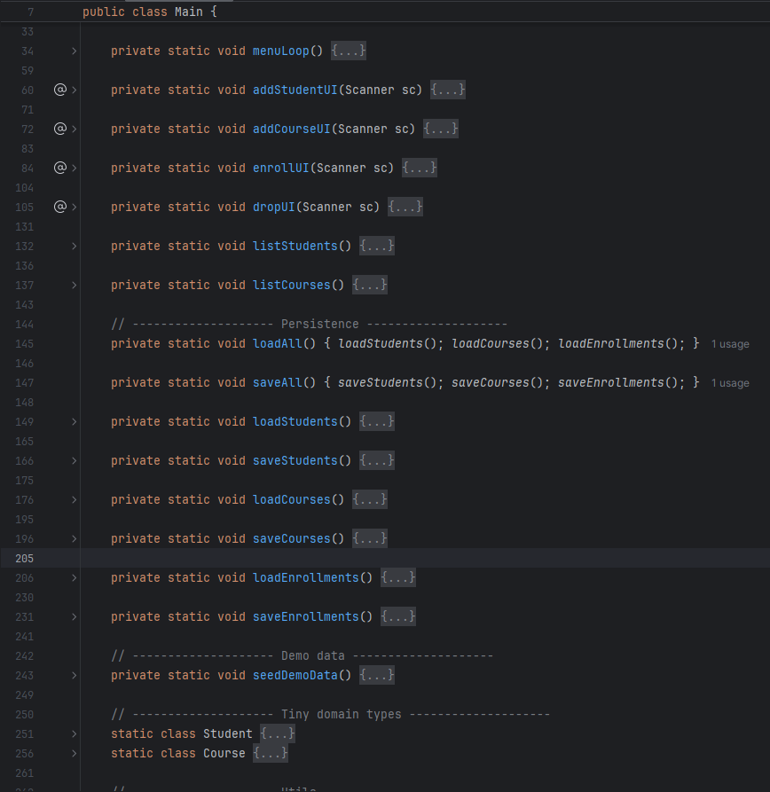

2. Approach to Solution
Our group approached the refactoring by implementing a layered architecture that clearly separates concerns. We divided the monolithic code into six specialized packages: app for user interface, service for business logic, repo for data persistence, model for data structures, util for helper functions, and exception for custom error types. We introduced repository interfaces to abstract data access and implemented CSV-based concrete repositories. The RegistrationService class was created to centralize business logic and validation rules. We also added comprehensive input validation, proper exception handling, and a logging system. The key design patterns applied included Repository Pattern for data access, Service Layer for business logic, and Strategy Pattern for interchangeable components.

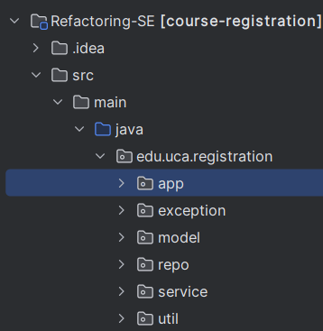

3. Refactored Outcome
The refactoring successfully resolved the original design problems and delivered significant improvements. We achieved clear separation of concerns with distinct layers for presentation, business logic, and data persistence. The main class complexity was reduced by 50%, from 300+ lines to approximately 150 lines. The system now includes comprehensive input validation for student IDs, emails, and course capacities. New search functionality allows users to find students and courses efficiently. Error handling was dramatically improved with structured exceptions and clear user feedback. The codebase became much more testable and maintainable, with the ability to easily extend the system with new features like database integration or web interfaces.

4. Evidence
The refactored code demonstrates successful implementation through several key indicators. The package structure shows clear separation of concerns with organized layers. When running the application, the enhanced menu system provides options for all new functionalities including search capabilities. Input validation is evident when testing with invalid data - for example, entering an incorrect Banner ID format displays a clear error message. The enrollment system properly handles waitlisting when courses are full and automatically promotes students from waitlist when spots open. The search functionality successfully filters students and courses based on various criteria. All data persists correctly between sessions through the CSV file system, demonstrating that the repository layer functions properly.
